

Bank Database management System

Course: Database Systems

Submitted by:
- Abdul Ahad bitf24a007
- Zain Ali bitf24a021
- Rana Ehtisham Adeel bitf24a041

Submitted to:

Dr. Asif Sohail

Submission: Project Report

Dated: 22nd December, 2025

PUNJAB UNIVERSITY COLLEGE OF INFORMATION TECHNOLOGY

1.Introduction:
A Bank Database Management System (BDBMS) is a fundamental component of banking operations, responsible for maintaining structured, reliable, and auditable records related to customers, accounts, employees, transactions, and loans. Due to the sensitive and financial nature of banking data, such systems must ensure high levels of data integrity, consistency, and traceability, which cannot be effectively achieved using traditional file-based approaches.
The objective of this project is to design and implement a relational database system that models the core operations of a manual banking environment, where customers interact with the bank through authorized employees. The system is developed using Oracle Database 11g XE and applies essential DBMS principles such as normalization, relational constraints, and controlled data access.
A defining design choice of this project is the adoption of a ledger-based transaction model, where all financial activities are recorded as immutable transaction entries. Instead of storing account balances directly, balances are calculated dynamically from transaction history to preserve accuracy and auditability. Although the scope of this project is academic, its design closely reflects real-world banking practices to demonstrate how scalable and reliable database systems are constructed.

2. Business Rules
The following business rules define the banking domain constraints that must always hold true, independent of system implementation:
- Each customer account belongs to exactly one branch.
- A customer may own one or more accounts, but an account belongs to only one customer.
- Customers do not perform database operations directly; all banking actions are executed through employees.
- Each employee is associated with exactly one branch.
- Each branch has exactly one manager.
- Only employees marked as active are permitted to perform banking operations.
- Transactions are allowed only on accounts that are active.
- A customer may apply for a loan only at the branch where their account exists.
- A loan must be approved by the manager of the same branch as the account.
- Managers are not authorized to approve loans belonging to other branches.
- A loan application initially remains in a pending state until approval or rejection.
- Once approved, a loan must record the approving manager and approval date.
- Financial transactions, once recorded, must never be modified or deleted.
- A fund transfer represents two financial movements: a debit and a corresponding credit.
- Account balances must not be stored explicitly and must be derived from transaction history.
- Inactive employees are not authorized to approve loans or perform transactions.
- All financial activities must be traceable to the employee who performed them.

Requirement Analysis

3. Requirement Analysis

3.1 Functional Requirements

Customer Management
- The system shall store customer details including full name, CNIC, contact information, and address.
- The system shall allow a customer to own one or more bank accounts.
- The system shall prevent customers from directly accessing or modifying database records.

Branch Management
- The system shall maintain multiple bank branches, each identified by a unique branch code.
- The system shall associate each account and employee with exactly one branch.
- The system shall enforce the constraint that each branch has exactly one manager.

Employee Management and Authorization
- The system shall store employee details, employment status, salary, and assigned role.
- The system shall associate each employee with a role that defines authorization privileges.
- The system shall restrict loan approval operations to employees with the manager role.
- The system shall prevent inactive employees from performing any banking operation.

Account Management
- The system shall associate each account with one customer and one branch.
- The system shall support account states such as Active, Frozen, and Closed.
- The system shall block deposits, withdrawals, and transfers on non-active accounts.

Transaction Management
- The system shall record all deposits, withdrawals, and transfers in a centralized transaction ledger.
- The system shall ensure that transaction records are immutable once created.
- The system shall generate a unique, human-readable transaction reference for each transaction.
- The system shall represent transfers as paired debit and credit entries.
- The system shall calculate account balances dynamically from transaction records.

Loan Management
- The system shall allow customers to apply for loans linked to their accounts.
- The system shall initially mark loan applications as pending.
- The system shall permit loan approval only by the manager of the same branch.
- The system shall record loan approval details including approver identity and approval date.
- The system shall prevent loan approval by managers from other branches.

3.2 Non-Functional Requirements

Data Integrity
- The system shall enforce primary and foreign key constraints to maintain referential integrity.
- The system shall restrict invalid domain values using check constraints and validation rules.

Consistency and Atomicity
- The system shall ensure that financial operations execute completely or not at all.
- The system shall prevent partial updates that could leave the database in an inconsistent state.

Auditability
- The system shall preserve complete historical transaction data for audit and traceability.
- The system shall avoid physical deletion of financial records.

Maintainability
- The system shall centralize business logic using procedures and triggers.
- The system shall provide database views to simplify reporting and data access.

Final Note
This project specification ensures that all critical banking rules and operational requirements are explicitly captured and enforced at the database level while remaining suitable for academic evaluation.
2.ERD:
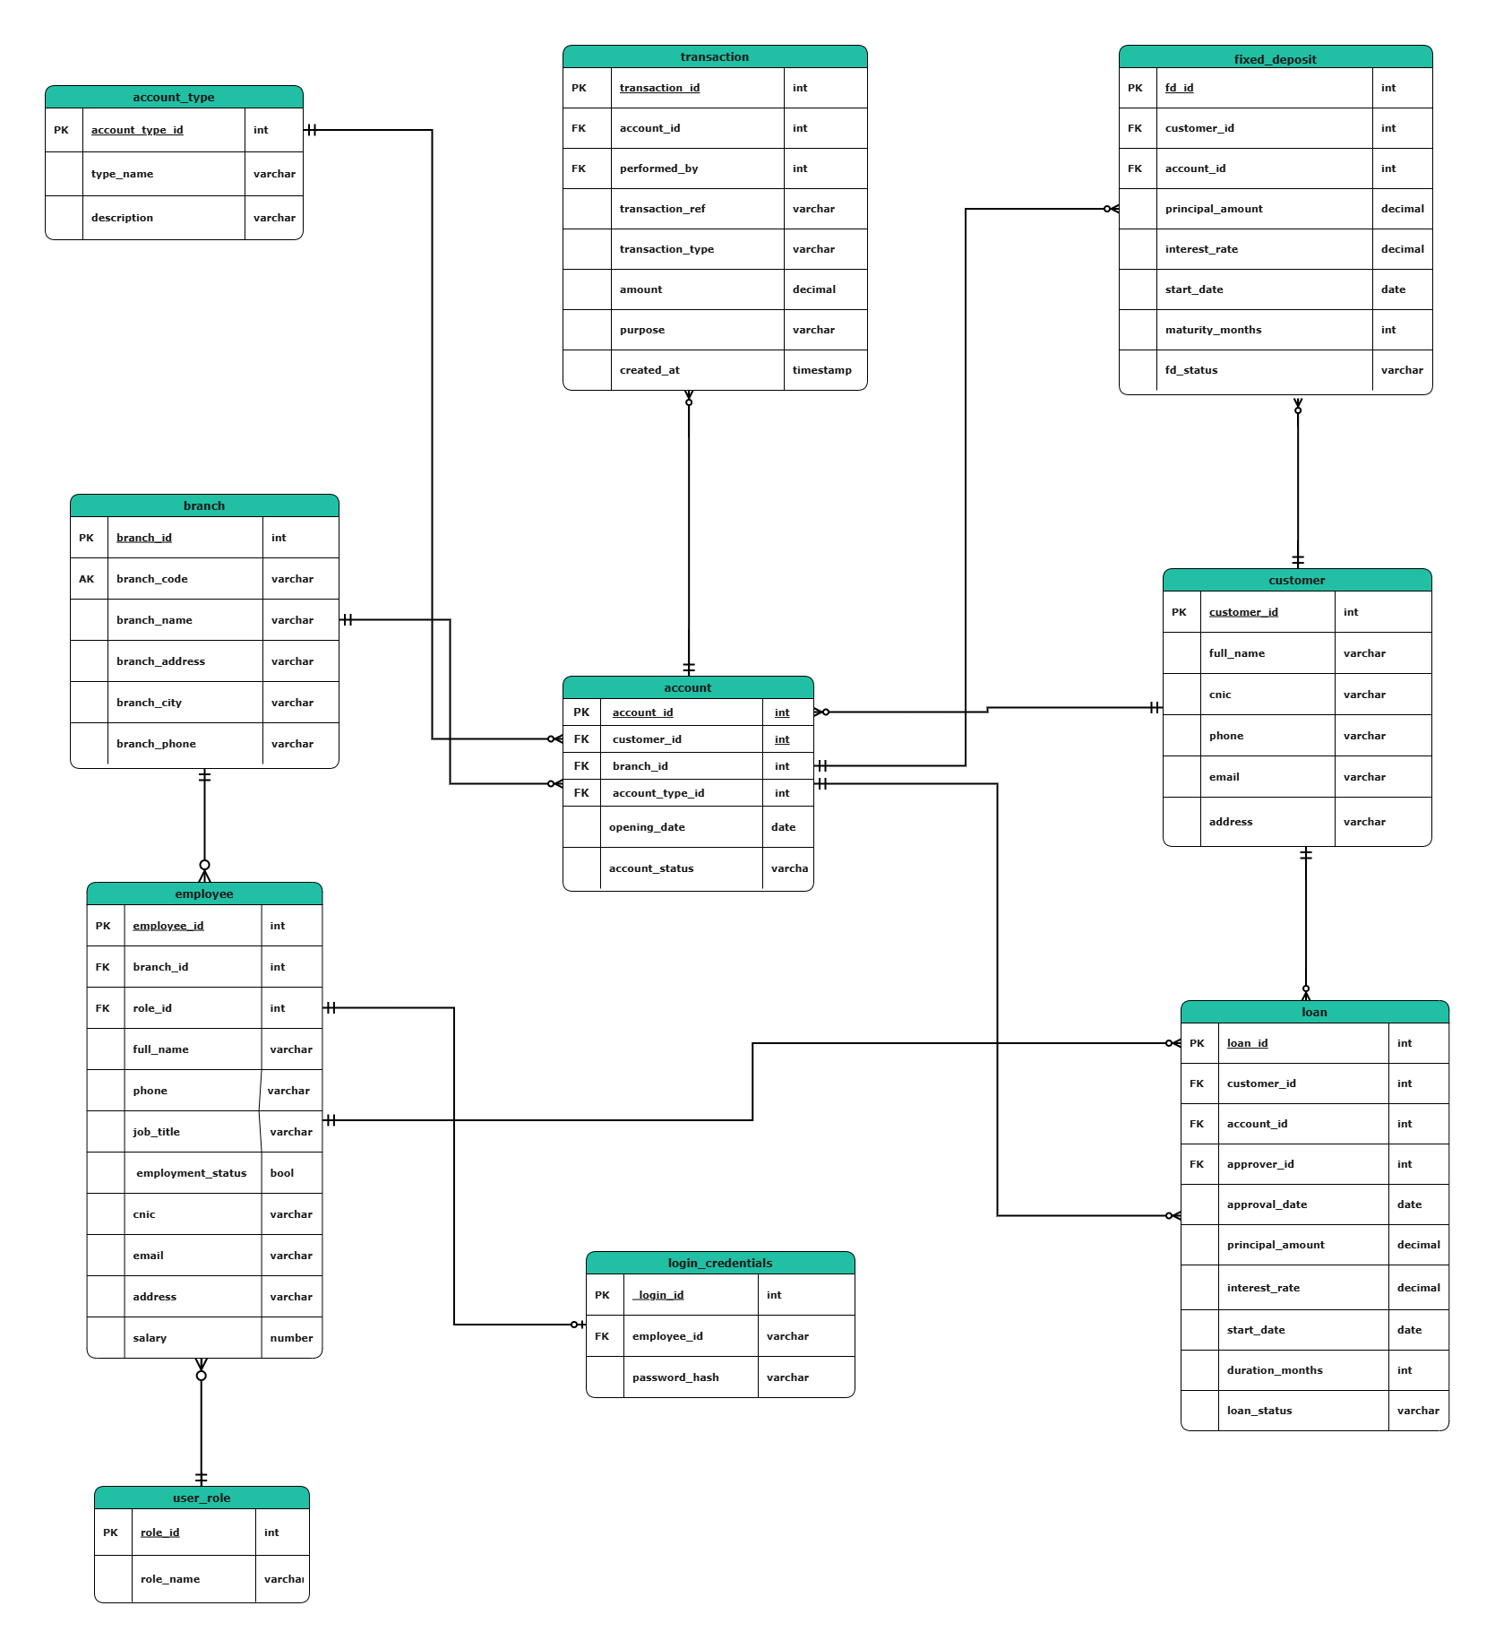

3.Construction of the Relational Schema:

BOTTOM-UP APPROACH

a.Identification of Raw Attributes:

One entity – List of attributes.
(customer_id, full_name, cnic, phone, email, address, employee_id, job_title, employment_status, branch_id,branch_code, role_id, branch_name, branch_address, branch_city, branch_phone, role_name, password_hash, account_id, account_type_id, opening_date, account_status, type_name, description, transaction_id, transaction_ref, transaction_type, amount, purpose, created_at,performed_by, loan_id, principal_amount, interest_rate, start_date, duration_months, loan_status, fd_id, maturity_months, fd_status,approver_id, approval_date)
b. Identification of Functional Dependencies
We now identify what uniquely determines what.
Customer
customer_id full_name, cnic, phone, email, address
Employee
employee_id full_name, cnic, phone, email, address,
job_title, employment_status, branch_id, role_id,salary
Branch
branch_id branch_code, branch_name, branch_address, branch_city, branch_phone
branch_code branch_name, branch_address, branch_city, branch_phone

Role
role_id role_name
Login Credentials
employee_id password_hash
Account Type
account_type_id type_name, description
Account
account_id customer_id, branch_id, account_type_id,
opening_date, account_status
Transaction
transaction_id account_id, transaction_ref, transaction_type,
amount, purpose, created_at,
performed_by
Loan
loan_id account_id, principal_amount, interest_rate,
start_date, duration_months, loan_status,approval_date, approver_id
Fixed Deposit
fd_id account_id, principal_amount, interest_rate,
start_date, maturity_months, fd_status

Critical business dependency applied:
account_id customer_id
Therefore:
- customer_id is not stored in LOAN or FIXED_DEPOSIT

c. Grouping of Attributes into Relations

Based upon the above attributes and entities, we can break down the list of attributes into following relations:
CUSTOMER (customer_id, full_name, cnic, phone, email, address)
EMPLOYEE (employee_id, full_name, cnic, phone, email, address, job_title, employment_status, branch_id, role_id, salary)
BRANCH (branch_id, branch_code, branch_name, branch_address, branch_city, branch_phone)
USER_ROLE (role_id, role_name)
LOGIN_CREDENTIALS (employee_id, password_hash)
ACCOUNT_TYPE (account_type_id, type_name, description)
ACCOUNT (account_id, customer_id, branch_id, account_type_id, opening_date, account_status)
TRANSACTION (transaction_id, account_id, transaction_ref, transaction_type, amount, purpose, created_at,performed_by)
LOAN (loan_id, account_id, principal_amount, interest_rate, start_date, duration_months, loan_status,approver_id, approval_date)
FIXED_DEPOSIT (fd_id, account_id, principal_amount, interest_rate, start_date, maturity_months, fd_status)

d. Normalization of Relations

CUSTOMER
(customer_id, full_name, cnic, phone, email, address)
Normalization
- 1NF: All attributes are atomic and single-valued. No repeating groups.
- 2NF: Primary key is single attribute (customer_id), so no partial dependency.
- 3NF: All non-key attributes depend only on customer_id. No transitive dependency.
- BCNF: customer_id is the only determinant and is a candidate key.

EMPLOYEE
(employee_id, full_name, cnic, phone, email, address, job_title, employment_status, branch_id, role_id,salary)
Normalization
- 1NF: All attributes are atomic. No repeating groups.
- 2NF: Primary key is single attribute (employee_id), so no partial dependency.
- 3NF: All non-key attributes depend only on employee_id. Branch and role details are referenced via foreign keys.
- BCNF: employee_id is the only determinant and is a candidate key.

BRANCH
(branch_id, branch_code ,branch_name, branch_address, branch_city, branch_phone)
Normalization
- 1NF: All attributes are atomic and single-valued.
- 2NF: Primary key is single attribute (branch_id), so no partial dependency.
- 3NF: All non-key attributes depend only on branch_id. No transitive dependency.
- BCNF: branch_id is the only determinant and is a candidate key.

USER_ROLE
(role_id, role_name)
Normalization
- 1NF: Attributes are atomic and single-valued.
- 2NF: Primary key is single attribute (role_id), so no partial dependency.
- 3NF: role_name depends only on role_id. No transitive dependency.
- BCNF: role_id is the only determinant and is a candidate key.

LOGIN_CREDENTIALS
(employee_id, password_hash)
Normalization
- 1NF: Attributes are atomic and single-valued.
- 2NF: Primary key is single attribute (employee_id), so no partial dependency.
- 3NF: password_hash depends only on employee_id. No transitive dependency.
- BCNF: employee_id is the only determinant and is a candidate key.

ACCOUNT
(account_id, customer_id, branch_id, account_type_id, opening_date, account_status)
Normalization
- 1NF: All attributes are atomic and single-valued.
- 2NF: Primary key is single attribute (account_id), so no partial dependency.
- 3NF: All non-key attributes depend only on account_id. No transitive dependency.
- BCNF: account_id is the only determinant and is a candidate key.

TRANSACTION
(transaction_id, account_id, transaction_ref, transaction_type, amount, purpose, created_at,performed_by)
Normalization
- 1NF: All attributes are atomic and single-valued.
- 2NF: Primary key is single attribute (transaction_id), so no partial dependency.
- 3NF: All non-key attributes depend only on transaction_id. No transitive dependency.
- BCNF (intent): transaction_id remains the sole determinant, so the relation aligns with BCNF intent for a ledger table.

LOAN
(loan_id, account_id, principal_amount, interest_rate, start_date, duration_months, loan_status)
Normalization
- 1NF: All attributes are atomic and single-valued.
- 2NF: Primary key is single attribute (loan_id), so no partial dependency.
- 3NF: Customer information is derived through ACCOUNT (not duplicated). No transitive dependency.
- BCNF: loan_id is the only determinant and is a candidate key.

FIXED_DEPOSIT
(fd_id, account_id, principal_amount, interest_rate, start_date, maturity_months, fd_status)
Normalization
- 1NF: All attributes are atomic and single-valued.
- 2NF: Primary key is single attribute (fd_id), so no partial dependency.
- 3NF: Customer information is derived through ACCOUNT (not duplicated). No transitive dependency.
- BCNF: fd_id is the only determinant and is a candidate key.

Primary Keys:
Table | Primary Key
BRANCH | branch_id
CUSTOMER | customer_id
USER_ROLE | role_id
EMPLOYEE | employee_id
ACCOUNT_TYPE | account_type_id
ACCOUNT | account_id
TRANSACTION | transaction_id
LOAN | loan_id
FIXED_DEPOSIT | fd_id
LOGIN_CREDENTIALS | employee_id

Foreign Key mappings:
ACCOUNT:
- ACCOUNT.customer_id CUSTOMER.customer_id
- ACCOUNT.branch_id BRANCH.branch_id
- ACCOUNT.account_type_id ACCOUNT_TYPE.account_type_id
EMPLOYEE:
- EMPLOYEE.branch_id BRANCH.branch_id
- EMPLOYEE.role_id USER_ROLE.role_id
LOGIN_CRENTIALS:
- LOGIN_CREDENTIALS.employee_id EMPLOYEE.employee_id
TRANSACTION:
- TRANSACTION.account_id ACCOUNT.account_id
- TRANSACTION.performed_by EMPLOYEE.employee_id
LOAN:
- LOAN.account_id ACCOUNT.account_id
- LOAN.customer_id CUSTOMER.customer_id
FIXED_DEPOSIT:
- FIXED_DEPOSIT.account_id ACCOUNT.account_id
- FIXED_DEPOSIT.customer_id CUSTOMER.customer_id

Candidate Keys:
Table | Candidate Key
CUSTOMER | cnic
EMPLOYEE | employee_cnic (if stored)
USER_ROLE | role_name
ACCOUNT_TYPE | type_name
LOGIN_CREDENTIALS | employee_id
Alternate Keys (AK):
Table | Alternate Key
CUSTOMER | cnic
USER_ROLE | role_name
ACCOUNT_TYPE | type_name

TOP-DOWN APPROACH
Top-Down approach means:
- Start from requirements
Listed in the requirements analysis portion (see above)
- Identify entities and relationships (ERD/EERD)
From the ERD (attached in section 2)
- Convert them into relations
- Assign keys and constraints
Key difference from Bottom-Up
Bottom-Up | Top-Down
Starts from attributes | Starts from entities
Dependency-driven | Requirement-driven
Proves normalization | Proves conceptual correctness
Theory-heavy | Design-heavy

Identify Core Entities from Requirements
Core Business Entities
- Customer
- Employee
- Branch
- Account
- Transaction
- Loan
- Fixed Deposit
Supporting / Lookup Entities
- User Role
- Account Type
- Login Credentials
ERD Model has already been added in part 2.

4. Description of Relations

Table Name: CUSTOMER
Attribute | Data Type | Size | Constraints
customer_id | NUMBER | 10 | Primary Key
full_name | VARCHAR2 | 50 | Not Null
cnic | VARCHAR2 | 15 | Not Null, Unique
phone | VARCHAR2 | 15 | Not Null
email | VARCHAR2 | 50 | Unique
address | VARCHAR2 | 150 | Not Null

Table Name: BRANCH
Attribute | Data Type | Size | Constraints
branch_id | NUMBER | 5 | Primary Key
branch_name | VARCHAR2 | 50 | Not Null
branch_address | VARCHAR2 | 150 | Not Null
branch_city | VARCHAR2 | 30 | Not Null
branch_phone | VARCHAR2 | 15 | Unique
branch_code | VARCHAR2 | 10 | unique

Table Name: USER_ROLE
Attribute | Data Type | Size | Constraints
role_id | NUMBER | 3 | Primary Key
role_name | VARCHAR2 | 20 | Not Null, Unique

Table Name: EMPLOYEE
Attribute | Data Type | Size | Constraints
employee_id | NUMBER | 10 | Primary Key
full_name | VARCHAR2 | 50 | Not Null
cnic | VARCHAR2 | 15 | Not Null, Unique
phone | VARCHAR2 | 15 | Not Null
email | VARCHAR2 | 50 | Unique
address | VARCHAR2 | 150 | Not Null
job_title | VARCHAR2 | 30 | Not Null
employment_status | VARCHAR2 | 10 | Check (IN ('ACTIVE','SUSPENDED','TERMINATED'))
branch_id | NUMBER | 5 | Foreign Key → BRANCH(branch_id)
role_id | NUMBER | 3 | Foreign Key → USER_ROLE(role_id)
salary | NUMBER | (10,2) | CHECK (salary > 0)

Table Name: LOGIN_CREDENTIALS
Attribute | Data Type | Size | Constraints
employee_id | NUMBER | 10 | Primary Key, Foreign Key → EMPLOYEE(employee_id)
password_hash | VARCHAR2 | 255 | Not Null

Table Name: ACCOUNT_TYPE
Attribute | Data Type | Size | Constraints
account_type_id | NUMBER | 3 | Primary Key
type_name | VARCHAR2 | 20 | Not Null, Unique
description | VARCHAR2 | 100 | Null

Table Name: ACCOUNT
Attribute | Data Type | Size | Constraints
account_id | NUMBER | 12 | Primary Key
customer_id | NUMBER | 10 | Foreign Key → CUSTOMER(customer_id)
branch_id | NUMBER | 5 | Foreign Key → BRANCH(branch_id)
account_type_id | NUMBER | 3 | Foreign Key → ACCOUNT_TYPE(account_type_id)
opening_date | DATE | — | Not Null
account_status | VARCHAR2 | 10 | Check (IN ('ACTIVE','FROZEN','CLOSED'))

Table Name: TRANSACTION
Attribute | Data Type | Size | Constraints
transaction_id | NUMBER | 15 | Primary Key
account_id | NUMBER | 12 | Foreign Key → ACCOUNT(account_id)
transaction_ref | VARCHAR2 | 20 | Not Null
transaction_type | VARCHAR2 | 6 | Check (IN ('DEBIT','CREDIT'))
amount | NUMBER | 12,2 | Check (amount > 0)
purpose | VARCHAR2 | 50 | Not Null
created_at | DATE | — | Not Null
performed_by | NUMBER | 10 | Foreign Key → EMPLOYEE(employee_id)

Table Name: LOAN
Attribute | Data Type | Size | Constraints
loan_id | NUMBER | 10 | Primary Key
account_id | NUMBER | 12 | Foreign Key → ACCOUNT(account_id)
principal_amount | NUMBER | 12,2 | Check (principal_amount > 0)
interest_rate | NUMBER | 5,2 | Check (interest_rate > 0)
start_date | DATE | — | Not Null
duration_months | NUMBER | 3 | Check (duration_months > 0)
loan_status | VARCHAR2 | 10 | Check (IN ('ACTIVE','CLOSED','DEFAULTED',’PENDING’,’APPROVED’))
approver_id | NUMBER | 12 | Foreign Key → EMPLOYEE(employee_id)
approval_date | Date | —- | —-

Table Name: FIXED_DEPOSIT
Attribute | Data Type | Size | Constraints
fd_id | NUMBER | 10 | Primary Key
account_id | NUMBER | 12 | Foreign Key → ACCOUNT(account_id)
principal_amount | NUMBER | 12,2 | Check (principal_amount > 0)
interest_rate | NUMBER | 5,2 | Check (interest_rate > 0)
start_date | DATE | — | Not Null
maturity_months | NUMBER | 3 | Check (maturity_months > 0)
fd_status | VARCHAR2 | 10 | Check (IN ('ACTIVE','MATURED','CLOSED'))

5. CREATE TABLE statements:

1.USER_ROLE
CREATE TABLE USER_ROLE (
role_id NUMBER(3),
role_name VARCHAR2(20) NOT NULL,

CONSTRAINT pk_user_role PRIMARY KEY (role_id),
CONSTRAINT uk_user_role_name UNIQUE (role_name)
);

2.BRANCH
CREATE TABLE BRANCH (
branch_id NUMBER(5),
branch_code VARCHAR2(10) NOT NULL,
branch_name VARCHAR2(50) NOT NULL,
branch_address VARCHAR2(150) NOT NULL,
branch_city VARCHAR2(30) NOT NULL,
branch_phone VARCHAR2(15),

CONSTRAINT pk_branch PRIMARY KEY (branch_id),
CONSTRAINT uk_branch_code UNIQUE (branch_code),
CONSTRAINT uk_branch_phone UNIQUE (branch_phone)
);

3️.ACCOUNT_TYPE
CREATE TABLE ACCOUNT_TYPE (
account_type_id NUMBER(3),
type_name VARCHAR2(20) NOT NULL,
description VARCHAR2(100),

CONSTRAINT pk_account_type PRIMARY KEY (account_type_id),
CONSTRAINT uk_account_type_name UNIQUE (type_name)
);

4️.CUSTOMER
CREATE TABLE CUSTOMER (
customer_id NUMBER(10),
full_name VARCHAR2(50) NOT NULL,
cnic VARCHAR2(15) NOT NULL,
phone VARCHAR2(15) NOT NULL,
email VARCHAR2(50),
address VARCHAR2(150) NOT NULL,

CONSTRAINT pk_customer PRIMARY KEY (customer_id),
CONSTRAINT uk_customer_cnic UNIQUE (cnic),
CONSTRAINT uk_customer_email UNIQUE (email)
);

5️.EMPLOYEE
CREATE TABLE EMPLOYEE (
employee_id NUMBER(10),
full_name VARCHAR2(50) NOT NULL,
cnic VARCHAR2(15) NOT NULL,
phone VARCHAR2(15) NOT NULL,
email VARCHAR2(50),
address VARCHAR2(150) NOT NULL,
job_title VARCHAR2(30) NOT NULL,
salary NUMBER(10,2) NOT NULL,
employment_status VARCHAR2(10) NOT NULL,
branch_id NUMBER(5),
role_id NUMBER(3),

CONSTRAINT pk_employee PRIMARY KEY (employee_id),
CONSTRAINT uk_employee_cnic UNIQUE (cnic),
CONSTRAINT uk_employee_email UNIQUE (email),
CONSTRAINT ck_employee_salary CHECK (salary > 0),
CONSTRAINT ck_employee_status
CHECK (employment_status IN ('ACTIVE','SUSPENDED','TERMINATED')),
CONSTRAINT fk_employee_branch
FOREIGN KEY (branch_id) REFERENCES BRANCH(branch_id),
CONSTRAINT fk_employee_role
FOREIGN KEY (role_id) REFERENCES USER_ROLE(role_id)
);

6️.LOGIN_CREDENTIALS
CREATE TABLE LOGIN_CREDENTIALS (
employee_id NUMBER(10),
password_hash VARCHAR2(255) NOT NULL,

CONSTRAINT pk_login_credentials PRIMARY KEY (employee_id),
CONSTRAINT fk_login_employee
FOREIGN KEY (employee_id)
REFERENCES EMPLOYEE(employee_id)
ON DELETE CASCADE
);

7️.ACCOUNT
CREATE TABLE ACCOUNT (
account_id NUMBER(12),
customer_id NUMBER(10),
branch_id NUMBER(5),
account_type_id NUMBER(3),
opening_date DATE NOT NULL,
account_status VARCHAR2(10) NOT NULL,

CONSTRAINT pk_account PRIMARY KEY (account_id),
CONSTRAINT ck_account_status
CHECK (account_status IN ('ACTIVE','FROZEN','CLOSED')),
CONSTRAINT fk_account_customer
FOREIGN KEY (customer_id) REFERENCES CUSTOMER(customer_id),
CONSTRAINT fk_account_branch
FOREIGN KEY (branch_id) REFERENCES BRANCH(branch_id),
CONSTRAINT fk_account_type
FOREIGN KEY (account_type_id) REFERENCES ACCOUNT_TYPE(account_type_id)
);

8️.TRANSACTION_LEDGER
CREATE TABLE TRANSACTION_LEDGER (
transaction_id NUMBER(15),
account_id NUMBER(12),
transaction_ref VARCHAR2(20) NOT NULL,
transaction_type VARCHAR2(6) NOT NULL,
amount NUMBER(12,2) NOT NULL,
purpose VARCHAR2(50) NOT NULL,
created_at DATE NOT NULL,
performed_by NUMBER(10),

CONSTRAINT pk_transaction_ledger PRIMARY KEY (transaction_id),
CONSTRAINT ck_tx_type
CHECK (transaction_type IN ('DEBIT','CREDIT')),
CONSTRAINT ck_tx_amount
CHECK (amount > 0),
CONSTRAINT fk_tx_account
FOREIGN KEY (account_id) REFERENCES ACCOUNT(account_id),
CONSTRAINT fk_tx_employee
FOREIGN KEY (performed_by)
REFERENCES EMPLOYEE(employee_id)
);

9️.LOAN
CREATE TABLE LOAN (
loan_id NUMBER(10),
account_id NUMBER(12),
principal_amount NUMBER(12,2) NOT NULL,
interest_rate NUMBER(5,2) NOT NULL,
start_date DATE NOT NULL,
duration_months NUMBER(3) NOT NULL,
loan_status VARCHAR2(10) NOT NULL,
approver_id NUMBER(10),
approval_date DATE,

CONSTRAINT pk_loan PRIMARY KEY (loan_id),
CONSTRAINT ck_loan_amount CHECK (principal_amount > 0),
CONSTRAINT ck_loan_rate CHECK (interest_rate > 0),
CONSTRAINT ck_loan_duration CHECK (duration_months > 0),
CONSTRAINT ck_loan_status
CHECK (loan_status IN ('PENDING','ACTIVE','CLOSED','DEFAULTED')),
CONSTRAINT fk_loan_account
FOREIGN KEY (account_id) REFERENCES ACCOUNT(account_id),
CONSTRAINT fk_loan_approved_by
FOREIGN KEY (approver_id)
REFERENCES EMPLOYEE(employee_id)
);

10. FIXED_DEPOSIT
CREATE TABLE FIXED_DEPOSIT (
fd_id NUMBER(10),
account_id NUMBER(12),
principal_amount NUMBER(12,2) NOT NULL,
interest_rate NUMBER(5,2) NOT NULL,
start_date DATE NOT NULL,
maturity_months NUMBER(3) NOT NULL,
fd_status VARCHAR2(10) NOT NULL,

CONSTRAINT pk_fixed_deposit PRIMARY KEY (fd_id),
CONSTRAINT ck_fd_amount CHECK (principal_amount > 0),
CONSTRAINT ck_fd_rate CHECK (interest_rate > 0),
CONSTRAINT ck_fd_maturity CHECK (maturity_months > 0),
CONSTRAINT ck_fd_status
CHECK (fd_status IN ('ACTIVE','MATURED','CLOSED')),
CONSTRAINT fk_fd_account
FOREIGN KEY (account_id) REFERENCES ACCOUNT(account_id)
);

6.Views:
View customer account
CREATE OR REPLACE VIEW vw_customer_accounts AS
SELECT c.customer_id, c.full_name AS customer_name,c.cnic,c.phone,c.email,a.account_id,a.account_status,a.opening_date,
b.branch_code,b.branch_name,b.branch_city FROM CUSTOMER c JOIN ACCOUNT a ON c.customer_id = a.customer_id JOIN BRANCH b ON a.branch_id = b.branch_id;
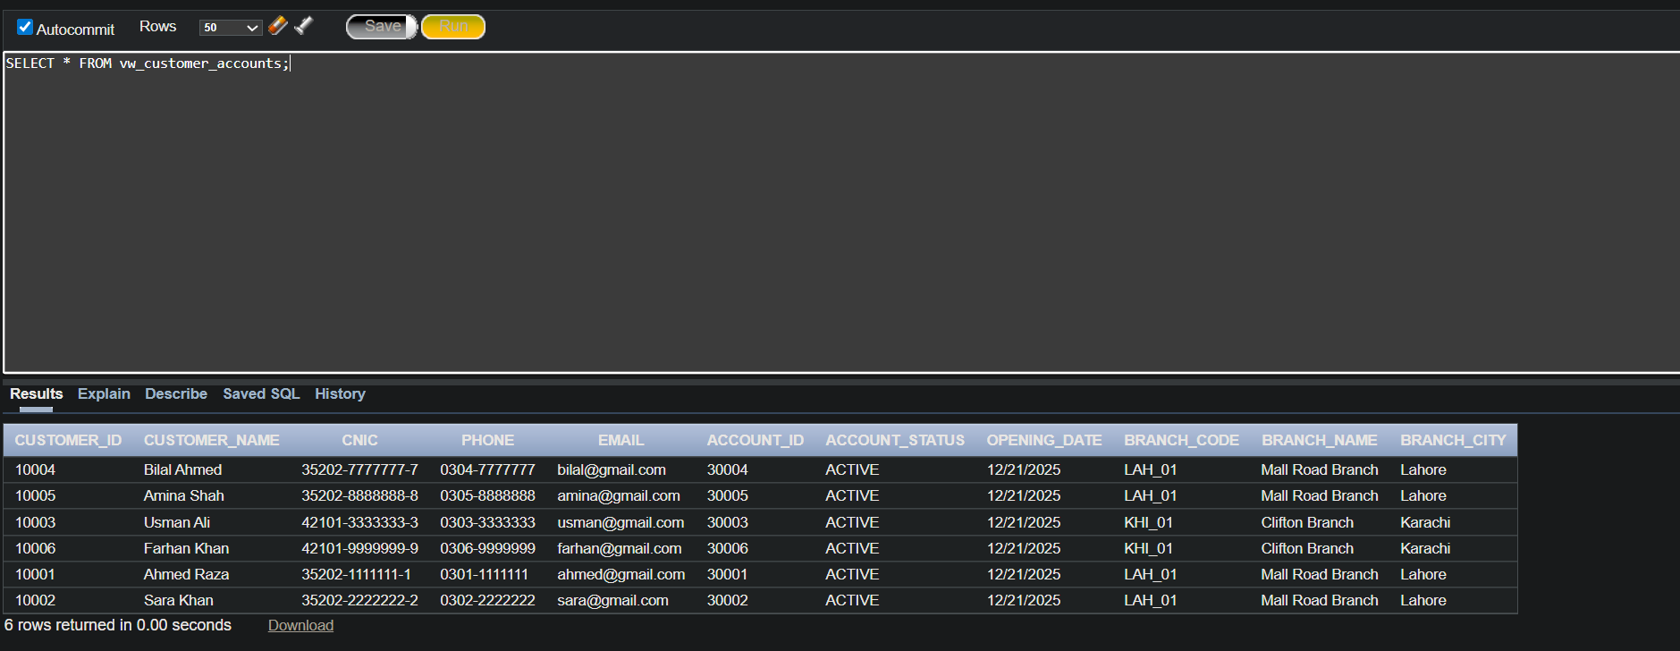

LOAN DETAILS
CREATE OR REPLACE VIEW vw_loan_details AS SELECT l.loan_id, l.account_id, c.customer_id, c.full_name AS customer_name, b.branch_code, b.branch_name, l.principal_amount, l.interest_rate, l.duration_months, l.loan_status, l.approval_date, e.employee_id AS approver_id, e.full_name AS approver_name FROM LOAN l JOIN ACCOUNT a ON l.account_id = a.account_id JOIN CUSTOMER c ON a.customer_id = c.customer_id JOIN BRANCH b ON a.branch_id = b.branch_id LEFT JOIN EMPLOYEE e ON l.approver_id = e.employee_id;
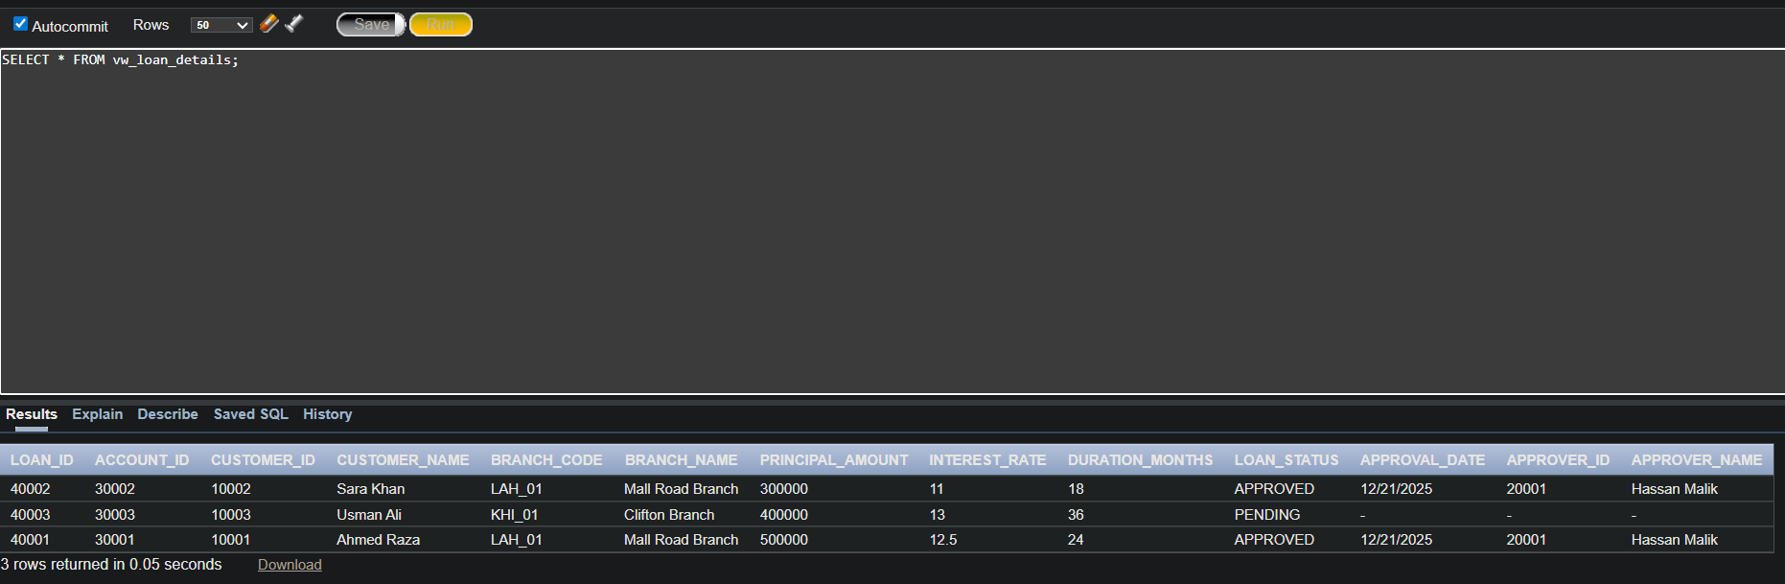
TRANSACTION HISTORY:
CREATE OR REPLACE VIEW vw_transaction_history AS SELECT t.transaction_id, t.transaction_ref, t.account_id,c.full_name AS customer_name, t.transaction_type,t.amount, t.purpose,t.created_at,e.full_name AS performed_by FROM TRANSACTION_LEDGER t JOIN ACCOUNT a ON t.account_id = a.account_id JOIN CUSTOMER c ON a.customer_id = .customer_id LEFT JOIN EMPLOYEE e ON t.performed_by = e.employee_id; 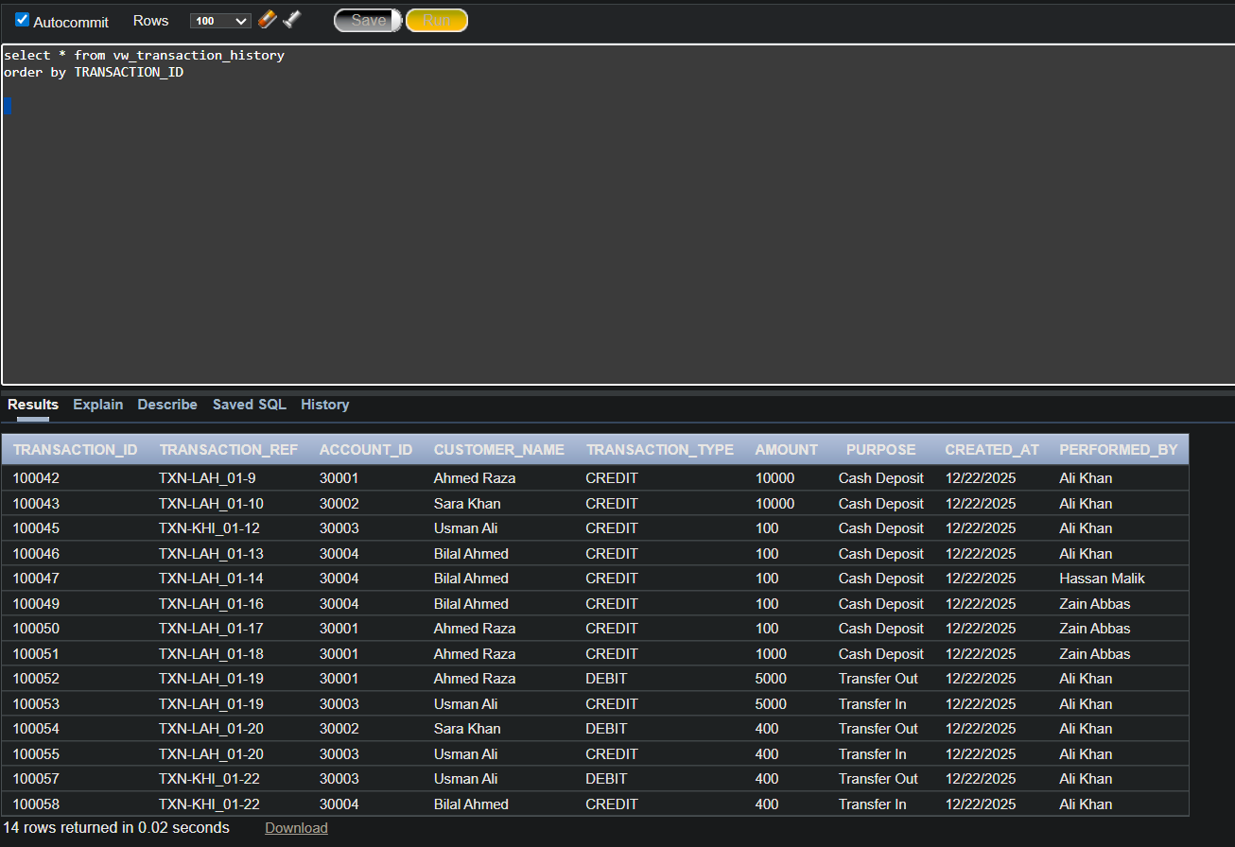

7: Reports (SELECT Queries):
1.Shows customer, account, branch, and current balance:
SELECT c.customer_id, c.full_name AS customer_name, a.account_id, b.branch_code, b.branch_name, get_account_balance(a.account_id) AS current_balance FROM CUSTOMER c JOIN ACCOUNT a ON c.customer_id = a.customer_id JOIN BRANCH b ON a.branch_id = b.branch_id ORDER BY c.customer_id;
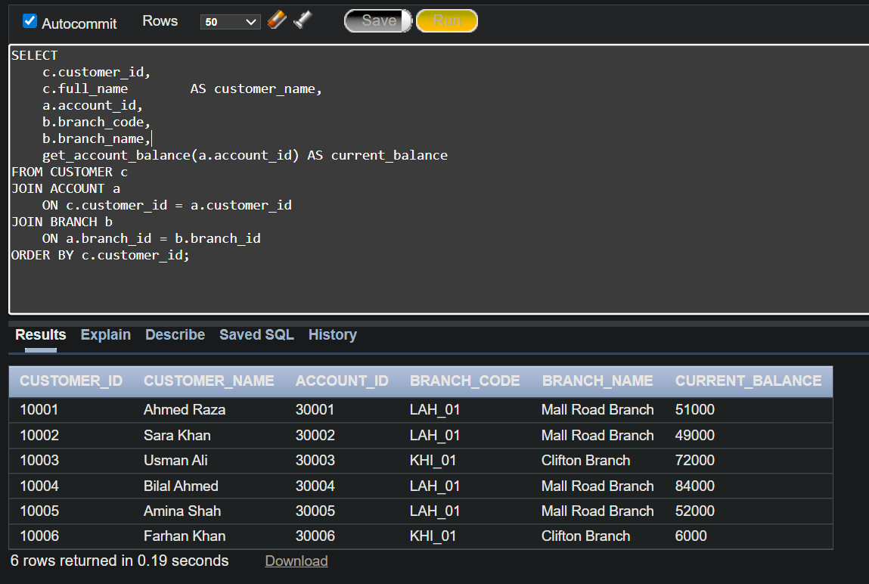

2.TRANSACTION STATEMENT FOR A GIVEN ACCOUNT:
SELECT t.transaction_id, t.transaction_ref, t.transaction_type, t.amount, t.purpose, t.created_at FROM TRANSACTION_LEDGER t WHERE t.account_id = 30001 ORDER BY t.created_at;

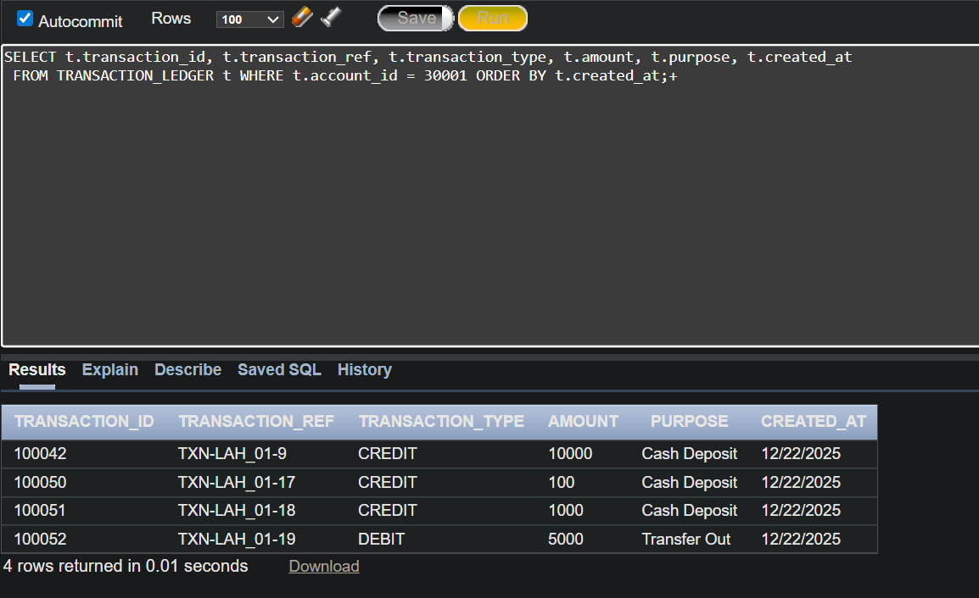
3. Pending loans:
SELECT l.loan_id, c.full_name AS customer_name, b.branch_code, l.principal_amount, l.duration_months, l.start_date FROM LOAN l JOIN ACCOUNT a ON l.account_id = a.account_id JOIN CUSTOMER c ON a.customer_id = c.customer_id JOIN BRANCH b ON a.branch_id = b.branch_id WHERE l.loan_status = 'PENDING';
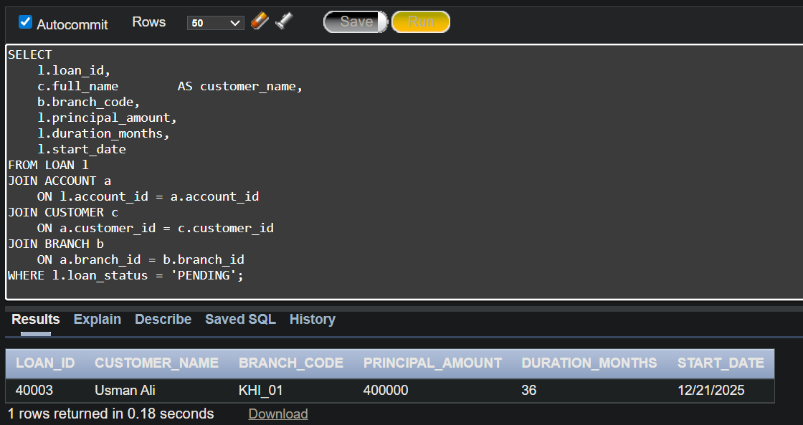
4. Transactions per employee:

SELECT e.employee_id, e.full_name AS employee_name, b.branch_code, COUNT(t.transaction_id) AS transactions_handled FROM EMPLOYEE e LEFT JOIN TRANSACTION_LEDGER t ON e.employee_id = t.performed_by JOIN BRANCH b ON e.branch_id = b.branch_id GROUP BY e.employee_id, e.full_name, b.branch_code ORDER BY transactions_handled DESC;
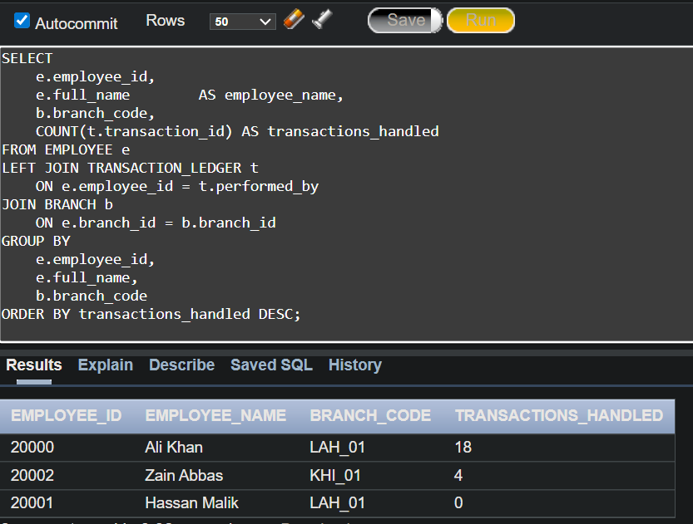

5. Customer Categorization Based on Total Balance
SELECT c.customer_id, c.full_name AS customer_name, SUM(get_account_balance(a.account_id)) AS total_balance, CASE WHEN SUM(get_account_balance(a.account_id)) >= 100000 THEN 'HIGH VALUE' WHEN SUM(get_account_balance(a.account_id)) BETWEEN 50000 AND 99999 THEN 'MEDIUM VALUE' ELSE 'LOW VALUE' END AS customer_category FROM CUSTOMER c JOIN ACCOUNT a ON c.customer_id = a.customer_id GROUP BY c.customer_id, c.full_name HAVING SUM(get_account_balance(a.account_id)) > 0 ORDER BY total_balance DESC;
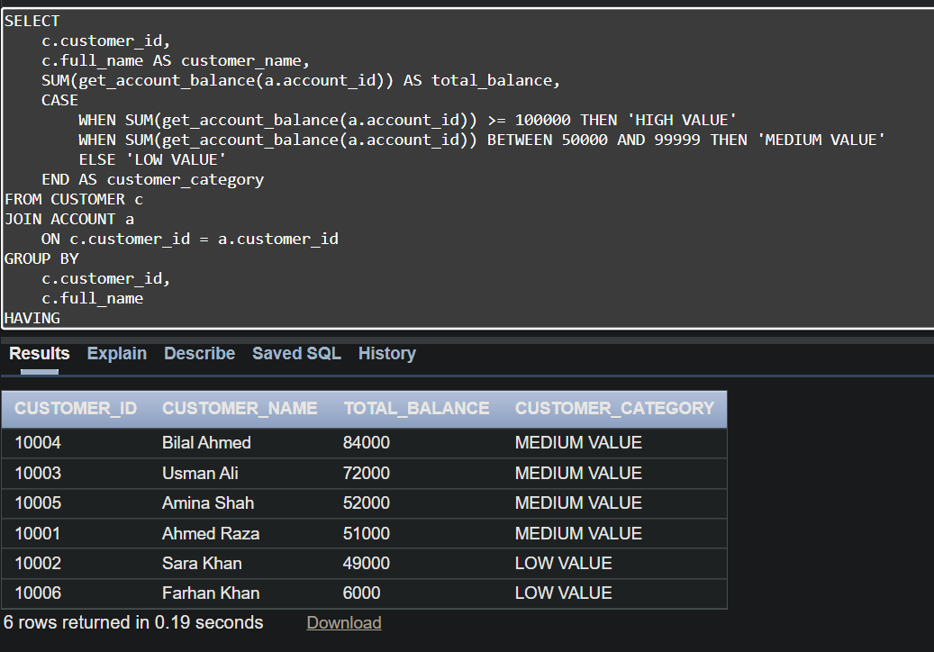
6. Account Activity Classification
SELECT a.account_id, c.full_name AS customer_name, b.branch_code, tx.txn_count, CASE WHEN tx.txn_count >= 5 THEN 'HIGH ACTIVITY' WHEN tx.txn_count BETWEEN 2 AND 4 THEN 'MODERATE ACTIVITY' ELSE 'LOW ' END AS activity_status FROM ACCOUNT a JOIN CUSTOMER c ON a.customer_id = c.customer_id JOIN BRANCH b ON a.branch_id = b.branch_id LEFT JOIN (SELECT account_id, COUNT(*) AS txn_count FROM TRANSACTION_LEDGER GROUP BY account_id) tx ON a.account_id = tx.account_id ORDER BY activity_status, a.account_id;
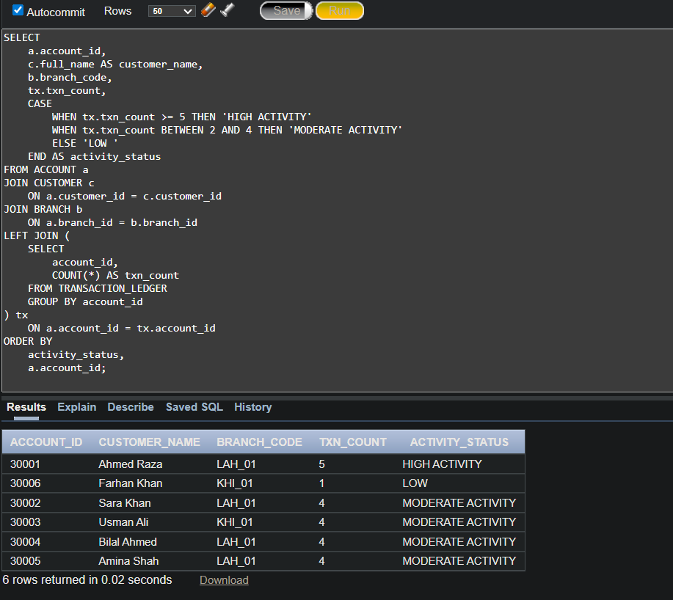

8. Functions:
Function 1
get_account_balance:
CREATE OR REPLACE FUNCTION get_account_balance (
p_account_id IN ACCOUNT.account_id%TYPE
) RETURN NUMBER
IS
v_balance NUMBER;
BEGIN
SELECT NVL(
SUM(
CASE
WHEN transaction_type = 'CREDIT' THEN amount
WHEN transaction_type = 'DEBIT' THEN -amount
END
), 0
)
INTO v_balance
FROM TRANSACTION_LEDGER
WHERE account_id = p_account_id;

RETURN v_balance;
END;
TEST:
SELECT get_account_balance(30001) AS balance
FROM dual;
Function 2
get_employee_role
CREATE OR REPLACE FUNCTION get_employee_role (
p_employee_id IN EMPLOYEE.employee_id%TYPE
) RETURN USER_ROLE.role_name%TYPE
IS
v_role USER_ROLE.role_name%TYPE;
BEGIN
SELECT r.role_name
INTO v_role
FROM EMPLOYEE e
JOIN USER_ROLE r
ON e.role_id = r.role_id
WHERE e.employee_id = p_employee_id;

RETURN v_role;
END;

Function 3
is_employee_active:

CREATE OR REPLACE FUNCTION is_employee_active (
p_employee_id IN EMPLOYEE.employee_id%TYPE
) RETURN BOOLEAN
IS
v_status EMPLOYEE.employment_status%TYPE;
BEGIN
SELECT employment_status
INTO v_status
FROM EMPLOYEE
WHERE employee_id = p_employee_id;

RETURN v_status = 'ACTIVE';
END;

FUNCTION 4
is_account_active:
CREATE OR REPLACE FUNCTION is_account_active (
p_account_id IN ACCOUNT.account_id%TYPE
) RETURN BOOLEAN
IS
v_status ACCOUNT.account_status%TYPE;
BEGIN
SELECT account_status
INTO v_status
FROM ACCOUNT
WHERE account_id = p_account_id;

RETURN v_status = 'ACTIVE';
END;

FUNCTION 5
get_account_branch:
CREATE OR REPLACE FUNCTION get_account_branch (
p_account_id IN ACCOUNT.account_id%TYPE
) RETURN BRANCH.branch_id%TYPE
IS
v_branch_id BRANCH.branch_id%TYPE;
BEGIN
SELECT branch_id
INTO v_branch_id
FROM ACCOUNT
WHERE account_id = p_account_id;

RETURN v_branch_id;
END;

FUNCTION 6
is_employee_manager:
CREATE OR REPLACE FUNCTION is_employee_manager (
p_employee_id IN EMPLOYEE.employee_id%TYPE
) RETURN BOOLEAN
IS
v_role USER_ROLE.role_name%TYPE;
BEGIN
v_role := get_employee_role(p_employee_id);
RETURN v_role = 'MANAGER';
END;
PROCEDURES:
PROCEDURE 1: create_employee
CREATE OR REPLACE PROCEDURE create_employee (
p_full_name IN EMPLOYEE.full_name%TYPE,
p_cnic IN EMPLOYEE.cnic%TYPE,
p_phone IN EMPLOYEE.phone%TYPE,
p_email IN EMPLOYEE.email%TYPE,
p_address IN EMPLOYEE.address%TYPE,
p_job_title IN EMPLOYEE.job_title%TYPE,
p_salary IN EMPLOYEE.salary%TYPE,
p_branch_id IN EMPLOYEE.branch_id%TYPE,
p_role_id IN EMPLOYEE.role_id%TYPE
)
IS
BEGIN
INSERT INTO EMPLOYEE (
employee_id,
full_name,
cnic,
phone,
email,
address,
job_title,
salary,
employment_status,
branch_id,
role_id
)
VALUES (
NULL,
p_full_name,
p_cnic,
p_phone,
p_email,
p_address,
p_job_title,
p_salary,
'ACTIVE',
p_branch_id,
p_role_id
);

COMMIT;
END;

TEST:
BEGIN
create_employee(
p_full_name => 'Test Employee2',
p_cnic => '35202-98765433-1',
p_phone => '03111222332',
p_email => 'test.employee2@email.com',
p_address => 'MULTAN',
P_JOB_TITLE => 'TELLER',
P_SALARY => 20000,
p_branch_id => 101,
p_role_id => 1 -- e.g. TELLER / MANAGER

);
END;

PROCEDURE 2: create_customer
CREATE OR REPLACE PROCEDURE create_customer (
p_full_name IN CUSTOMER.full_name%TYPE,
p_cnic IN CUSTOMER.cnic%TYPE,
p_phone IN CUSTOMER.phone%TYPE,
p_email IN CUSTOMER.email%TYPE,
p_address IN CUSTOMER.address%TYPE
)
IS
BEGIN
INSERT INTO CUSTOMER (
customer_id,
full_name,
cnic,
phone,
email,
address
)
VALUES (
NULL,
p_full_name,
p_cnic,
p_phone,
p_email,
p_address
);

COMMIT;
END;
TEST:
BEGIN
create_customer(
p_full_name => 'Test Customer',
p_cnic => '35202-1234567-9',
p_phone => '03001234567',
p_email => 'test.customer@email.com',
p_address => 'Lahore'
);
END;
PROCEDURE 3: create_account

CREATE OR REPLACE PROCEDURE create_account (
p_customer_id IN ACCOUNT.customer_id%TYPE,
p_branch_id IN ACCOUNT.branch_id%TYPE,
p_account_type_id IN ACCOUNT.account_type_id%TYPE
)
IS
BEGIN
INSERT INTO ACCOUNT (
account_id,
customer_id,
branch_id,
account_type_id,
opening_date,
account_status
)
VALUES (
NULL,
p_customer_id,
p_branch_id,
p_account_type_id,
SYSDATE,
'ACTIVE'
);

COMMIT;
END;
TEST
BEGIN
create_account(
p_customer_id => 10001,
p_branch_id => 101,
p_account_type_id => 2
);
END;

PROCEDURE 4: deposit money
CREATE OR REPLACE PROCEDURE deposit_money (
p_account_id IN ACCOUNT.account_id%TYPE,
p_amount IN NUMBER,
p_employee_id IN EMPLOYEE.employee_id%TYPE
) IS
v_branch_code BRANCH.branch_code%TYPE;
v_ref_no NUMBER;
v_txn_ref TRANSACTION_LEDGER.transaction_ref%TYPE;
BEGIN
-- Get branch code
SELECT b.branch_code
INTO v_branch_code
FROM ACCOUNT a
JOIN BRANCH b ON a.branch_id = b.branch_id
WHERE a.account_id = p_account_id;

-- Generate transaction reference
v_ref_no := TRANSFER_REF_SEQ.NEXTVAL;
v_txn_ref := 'TXN-' || v_branch_code || '-' || v_ref_no;

-- Insert credit entry
INSERT INTO TRANSACTION_LEDGER (
account_id,
transaction_ref,
transaction_type,
amount,
purpose,
performed_by
) VALUES (
p_account_id,
v_txn_ref,
'CREDIT',
p_amount,
'Cash Deposit',
p_employee_id
);
END;
TEST
BEGIN
deposit_money(30001, 10000, 20000);
END;

PROCEDURE 5: withdraw money
CREATE OR REPLACE PROCEDURE withdraw_money (
p_account_id IN ACCOUNT.account_id%TYPE,
p_amount IN NUMBER,
p_employee_id IN EMPLOYEE.employee_id%TYPE
) IS
v_balance NUMBER;
v_branch_code BRANCH.branch_code%TYPE;
v_ref_no NUMBER;
v_txn_ref TRANSACTION_LEDGER.transaction_ref%TYPE;
BEGIN
-- Balance check
v_balance := get_account_balance(p_account_id);
IF v_balance < p_amount THEN
RAISE_APPLICATION_ERROR(-20002, 'Insufficient balance');
END IF;

-- Get branch code
SELECT b.branch_code
INTO v_branch_code
FROM ACCOUNT a
JOIN BRANCH b ON a.branch_id = b.branch_id
WHERE a.account_id = p_account_id;

-- Generate tansaction reference
v_ref_no := TRANSFER_REF_SEQ.NEXTVAL;
v_txn_ref := 'TXN-' || v_branch_code || '-' || v_ref_no;

-- Insert debit entry
INSERT INTO TRANSACTION_LEDGER (
account_id,
transaction_ref,
transaction_type,
amount,
purpose,
performed_by
) VALUES (
p_account_id,
v_txn_ref,
'DEBIT',
p_amount,
'Cash Withdrawal',
p_employee_id
);
END;
TEST
BEGIN
withdraw_money(30001, 3000, 20000);
END;

PROCEDURE 6: Transfer money
CREATE OR REPLACE PROCEDURE transfer_money (
p_from_account IN ACCOUNT.account_id%TYPE,
p_to_account IN ACCOUNT.account_id%TYPE,
p_amount IN NUMBER,
p_employee_id IN EMPLOYEE.employee_id%TYPE
) IS
v_balance NUMBER;
v_branch_code BRANCH.branch_code%TYPE;
v_ref_no NUMBER;
v_txn_ref TRANSACTION_LEDGER.transaction_ref%TYPE;
BEGIN
-- Balance check
v_balance := get_account_balance(p_from_account);
IF v_balance < p_amount THEN
RAISE_APPLICATION_ERROR(-20001, 'Insufficient balance');
END IF;

-- Surce branch code
SELECT b.branch_code
INTO v_branch_code
FROM ACCOUNT a
JOIN BRANCH b ON a.branch_id = b.branch_id
WHERE a.account_id = p_from_account;

-- one logical reference for the transfer
v_ref_no := TRANSFER_REF_SEQ.NEXTVAL;
v_txn_ref := 'TXN-' || v_branch_code || '-' || v_ref_no;

-- debit
INSERT INTO TRANSACTION_LEDGER (
account_id, transaction_ref, transaction_type,
amount, purpose, performed_by
) VALUES (
p_from_account, v_txn_ref, 'DEBIT',
p_amount, 'Transfer Out', p_employee_id
);

-- credit
INSERT INTO TRANSACTION_LEDGER (
account_id, transaction_ref, transaction_type,
amount, purpose, performed_by
) VALUES (
p_to_account, v_txn_ref, 'CREDIT',
p_amount, 'Transfer In', p_employee_id
);
END;
TEST
BEGIN
transfer_money(30001, 30003, 5000, 20000);
END;

PROCEDURE 7: approve_loan
CREATE OR REPLACE PROCEDURE approve_loan (
p_loan_id IN LOAN.loan_id%TYPE,
p_manager_id IN EMPLOYEE.employee_id%TYPE
)
IS
v_manager_role_id USER_ROLE.role_id%TYPE;
v_emp_role_id EMPLOYEE.role_id%TYPE;
v_manager_branch EMPLOYEE.branch_id%TYPE;
v_loan_branch ACCOUNT.branch_id%TYPE;
v_status LOAN.loan_status%TYPE;
BEGIN

SELECT role_id
INTO v_manager_role_id
FROM USER_ROLE
WHERE role_name = 'MANAGER';

SELECT role_id, branch_id
INTO v_emp_role_id, v_manager_branch
FROM EMPLOYEE
WHERE employee_id = p_manager_id
AND employment_status = 'ACTIVE';

IF v_emp_role_id <> v_manager_role_id THEN
RAISE_APPLICATION_ERROR(
-20000,
'Only branch manager can approve loan'
);
END IF;

SELECT l.loan_status, a.branch_id
INTO v_status, v_loan_branch
FROM LOAN l
JOIN ACCOUNT a ON l.account_id = a.account_id
WHERE l.loan_id = p_loan_id;

IF v_status <> 'PENDING' THEN
RAISE_APPLICATION_ERROR(
-20000,
'Loan is not in pending state'
);
END IF;

IF v_manager_branch <> v_loan_branch THEN
RAISE_APPLICATION_ERROR(
-20000,
'Manager cannot approve loan of another branch'
);
END IF;

UPDATE LOAN
SET loan_status = 'APPROVED',
approver_id = p_manager_id,
approval_date = SYSDATE
WHERE loan_id = p_loan_id;

COMMIT;
END;

TRIGGERS:
1. TRANSACTION LEDGER IMMUTABILITY TRIGGER
Financial transactions must never be updated or deleted:
CREATE OR REPLACE TRIGGER trg_ledger_immutable
BEFORE UPDATE OR DELETE ON TRANSACTION_LEDGER
BEGIN
RAISE_APPLICATION_ERROR(
-20000,
'Transactions are immutable and cannot be modified or deleted'
);
END;

2. ACCOUNT STATUS PROTECTION TRIGGER
NO TRANSACTION ON INACTIVE ACCOUNTS:
CREATE OR REPLACE TRIGGER trg_block_inactive_account
BEFORE INSERT ON TRANSACTION_LEDGER
FOR EACH ROW
DECLARE
v_status ACCOUNT.account_status%TYPE;
BEGIN
SELECT account_status
INTO v_status
FROM ACCOUNT
WHERE account_id = :NEW.account_id;

IF v_status <> 'ACTIVE' THEN
RAISE_APPLICATION_ERROR(
-20000,
'Transactions are not allowed on inactive accounts'
);
END IF;
END;

3. EMPLOYEE STATUS PROTECTION TRIGGER
Inactive employees cannot perform transactions:
CREATE OR REPLACE TRIGGER trg_block_inactive_employee
BEFORE INSERT ON TRANSACTION_LEDGER
FOR EACH ROW
DECLARE
v_status EMPLOYEE.employment_status%TYPE;
BEGIN
SELECT employment_status
INTO v_status
FROM EMPLOYEE
WHERE employee_id = :NEW.performed_by;

IF v_status <> 'ACTIVE' THEN
RAISE_APPLICATION_ERROR(
-20000,
'Inactive employee cannot perform transactions'
);
END IF;
END;
4. TRIGGER FOR AUTOMATIC_ID_GENERATION
CREATE OR REPLACE TRIGGER TRG_TRANSACTION_LEDGER_ID
BEFORE INSERT ON TRANSACTION_LEDGER
FOR EACH ROW
BEGIN
IF :NEW.transaction_id IS NULL THEN
:NEW.transaction_id := TRANSACTION_LEDGER_ID_SEQ.NEXTVAL;
END IF;

IF :NEW.created_at IS NULL THEN
:NEW.created_at := SYSDATE;
END IF;
END;

