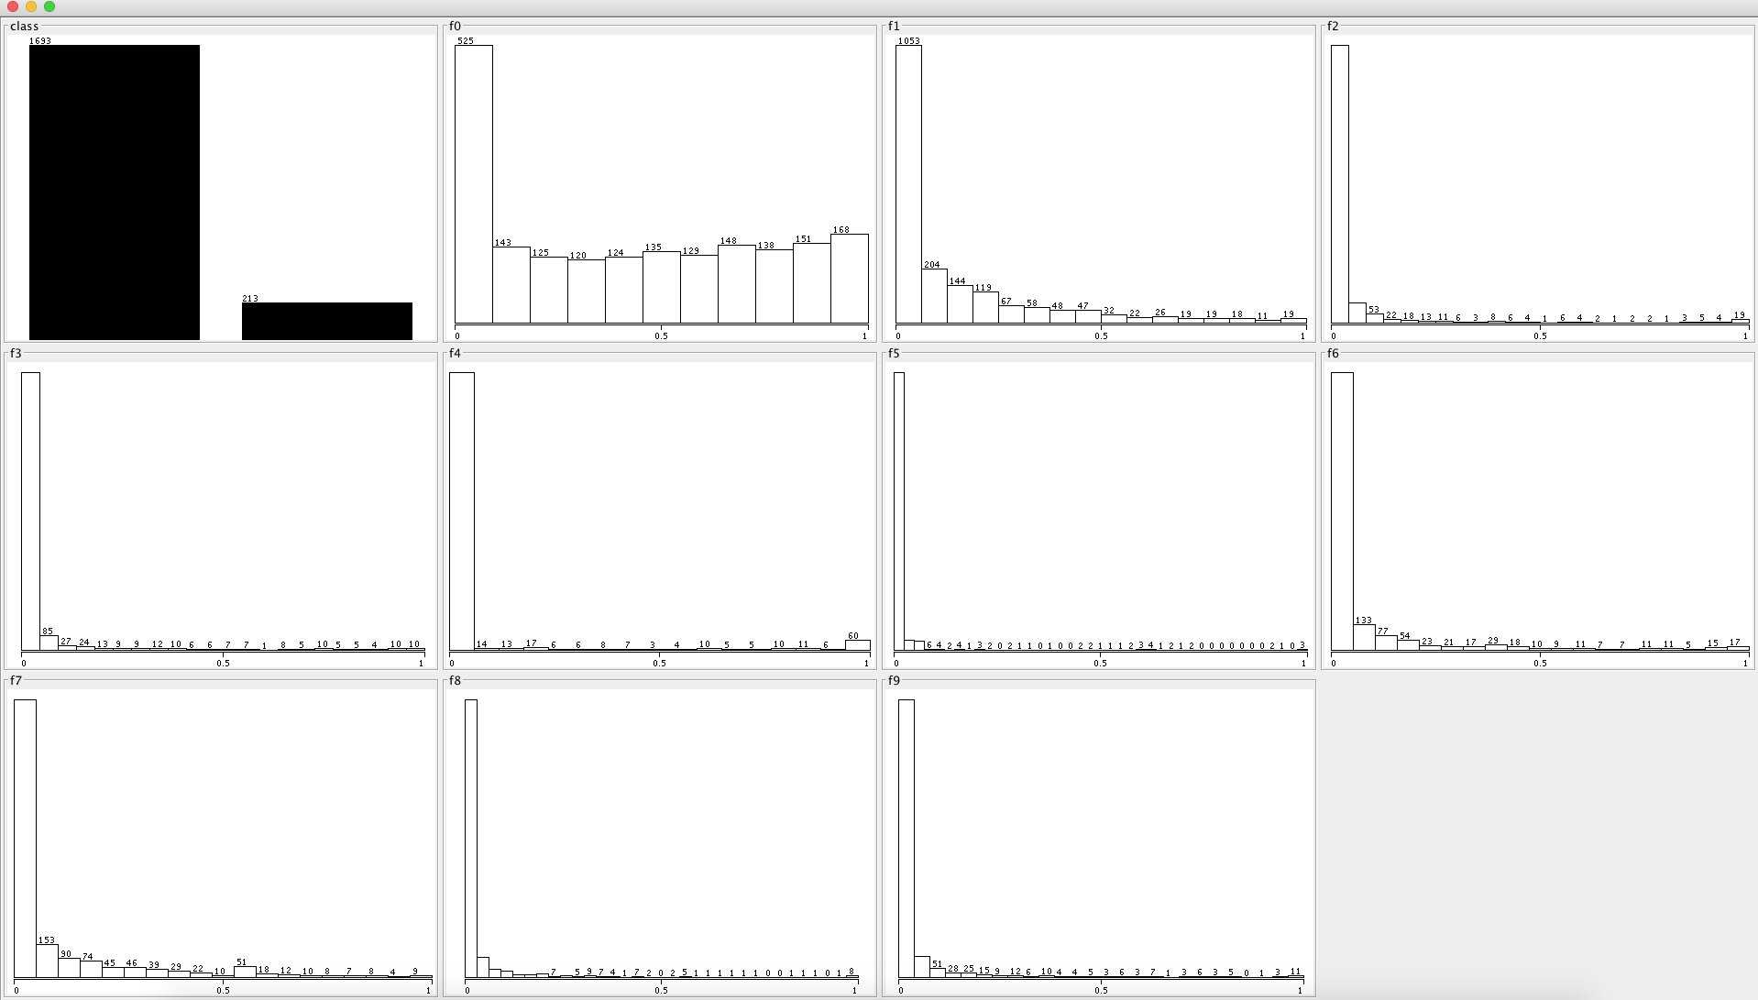

f0, f1 and feature 7 seems to be most important.

[(0, u'0.016\*like + 0.016\*just + 0.011\*love + 0.009\*want + 0.009\*peopl + 0.008\*one + 0.008\*know + 0.008\*day + 0.007\*time + 0.007\*make'),

(1, u'0.011\*just + 0.009\*thank + 0.008\*game + 0.007\*will + 0.007\*one + 0.007\*day + 0.007\*now + 0.007\*good + 0.006\*time + 0.006\*win'),

(7, u'0.018\*like + 0.016\*fuck + 0.016\*shit + 0.011\*just + 0.009\*bitch + 0.009\*lmao + 0.008\*free + 0.008\*know + 0.008\*ass + 0.007\*girl'),

