**10 Topic resulted from running topic modelling algorithm**

[(0, u'0.016*like + 0.016*just + 0.011*love + 0.009*want + 0.009*peopl + 0.008*one + 0.008*know + 0.008*day + 0.007*time + 0.007*make'),

(1, u'0.011*just + 0.009*thank + 0.008*game + 0.007*will + 0.007*one + 0.007*day + 0.007*now + 0.007*good + 0.006*time + 0.006*win'),

(2, u'0.058*photo + 0.030*post + 0.017*facebook + 0.013*harri + 0.010*video + 0.008*love + 0.008*loui + 0.008*album + 0.007*day + 0.006*pour'),

(3, u'0.027*follow + 0.019*dan + 0.018*stat + 0.016*one + 0.015*music + 0.014*check + 0.011*automat + 0.010*peopl + 0.010*download + 0.009*play'),

(4, u'0.345*updat + 0.052*con + 0.032*como + 0.027*del + 0.014*hay + 0.011*son + 0.010*sin + 0.009*soy + 0.008*tan + 0.008*solo'),

(5, u'0.084*video + 0.077*like + 0.023*day + 0.017*feel + 0.017*rain + 0.016*high + 0.016*press + 0.016*wind + 0.016*low + 0.015*temp'),

(6, u'0.006*news + 0.004*will + 0.004*say + 0.004*car + 0.003*call + 0.003*need + 0.003*polic + 0.003*time + 0.003*year + 0.003\***kill'**),

(7, u'0.018*like + 0.016*fuck + 0.016*shit + 0.011*just + 0.009*bitch + 0.009*lmao + 0.008*free + 0.008*know + 0.008*ass + 0.007*girl'),

(8, u'0.006*obama + 0.004*use + 0.004*read + 0.004*great + 0.003*food + 0.003*chang + 0.003*will + 0.003*influenc + 0.003*human + 0.003*stori'),

(9, u'0.022*love + 0.022*tweet + 0.020*vote + 0.012*second + 0.012*summer + 0.011*collect + 0.011*happi + 0.011*thank + 0.010*may + 0.010*one')]

Figure 1Top 20 user with negative sentiment and their feature vector distribution

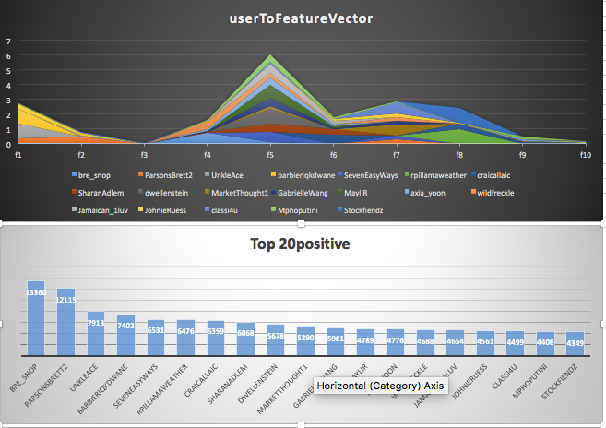

Figure 2Top 20 User with positive sentiment and their feature vector distribution

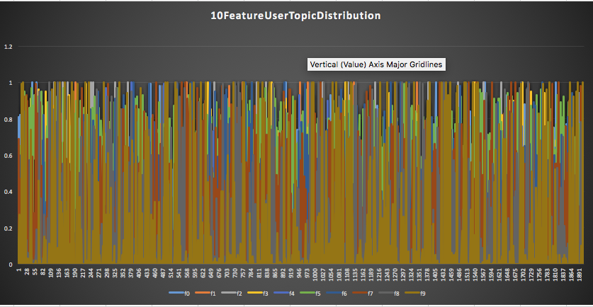

Figure 3OverAll distribution of 10 feature vector for 2000 users

Clustering: 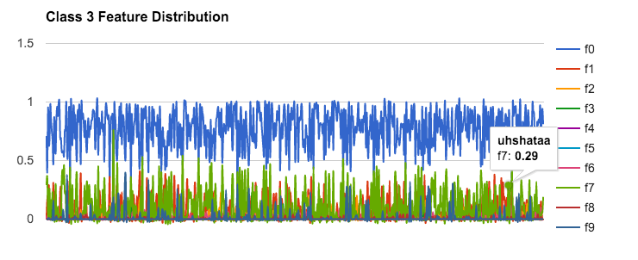

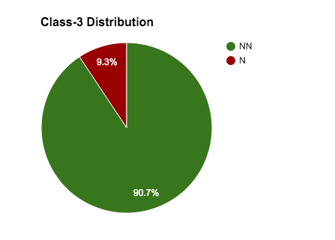

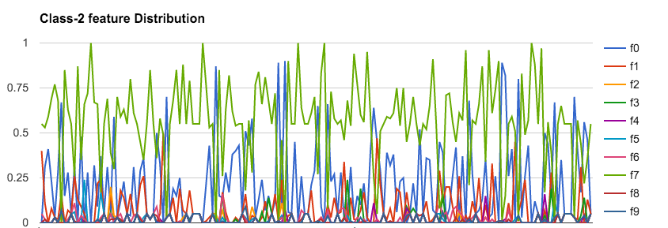

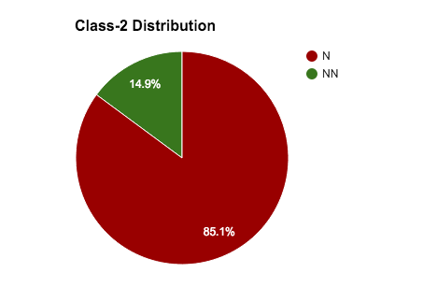

**Total N : For class 2 and 3 : 204**

**Total N in entire data set: 213**

**30 Dimension analysis**

**3, u'0.017*like + 0.015*just + 0.010*fuck + 0.009*one + 0.007*think + 0.007*know + 0.006*now + 0.006*good + 0.006*peopl + 0.006*look'**

**15, u'0.017*like + 0.016*just + 0.014*love + 0.012*want + 0.011*peopl + 0.009*someon + 0.009*life + 0.009*feel + 0.009*day + 0.008*know**

**(19, u'0.018*like + 0.015*just + 0.015*fuck + 0.013*shit + 0.009*know + 0.008*want + 0.008*need + 0.008*peopl + 0.008*bitch + 0.008*love')**

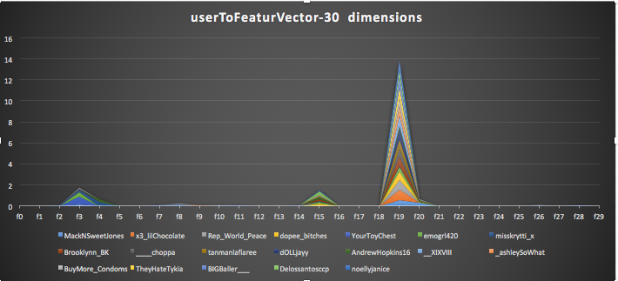

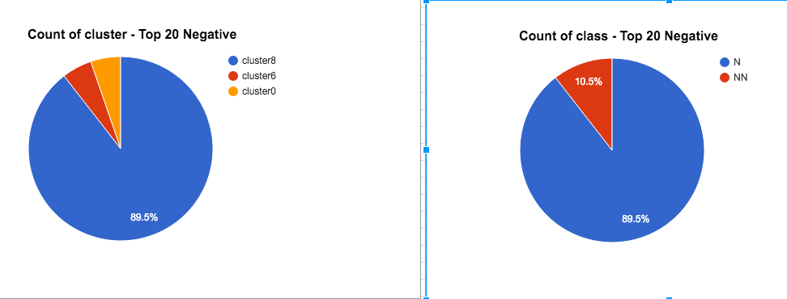

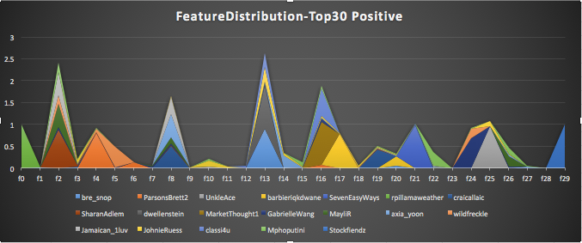

Looking at these graph its obvious how features are concentrated in case of N and all over in case of positive

