**1. ChoiceOFWords**

As a part of finding good features to work with, we wanted to study the choice of words used by people who used abusive language once almost one year ago. Hence data which was collected an year later is almost unbiased. It goes on to show a strong inclination that using foul language is almost an behavioural problem. While yje results are not screaming the difference between filtered and nonfiltered users as expected, they do show a strong signal.

**Methodology:**

We had two datasets. One 11k Filtered users and 11k Non Filtered users. One thing we do want to make abundantly clear that the filtered users are the users who were once, almost an year before filtered for using words related to alcohol.

1.1 Filtered users

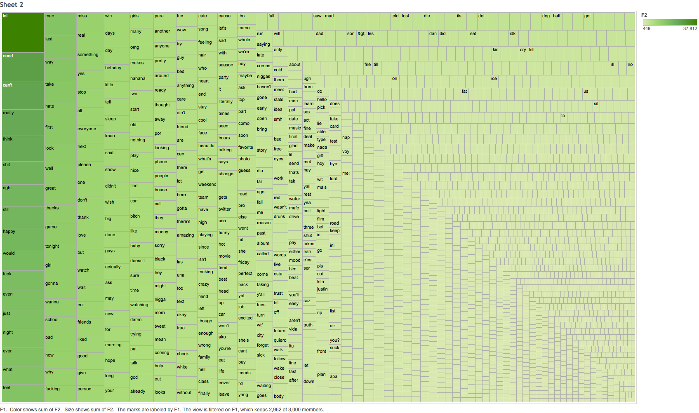

**Non Filtered Users**

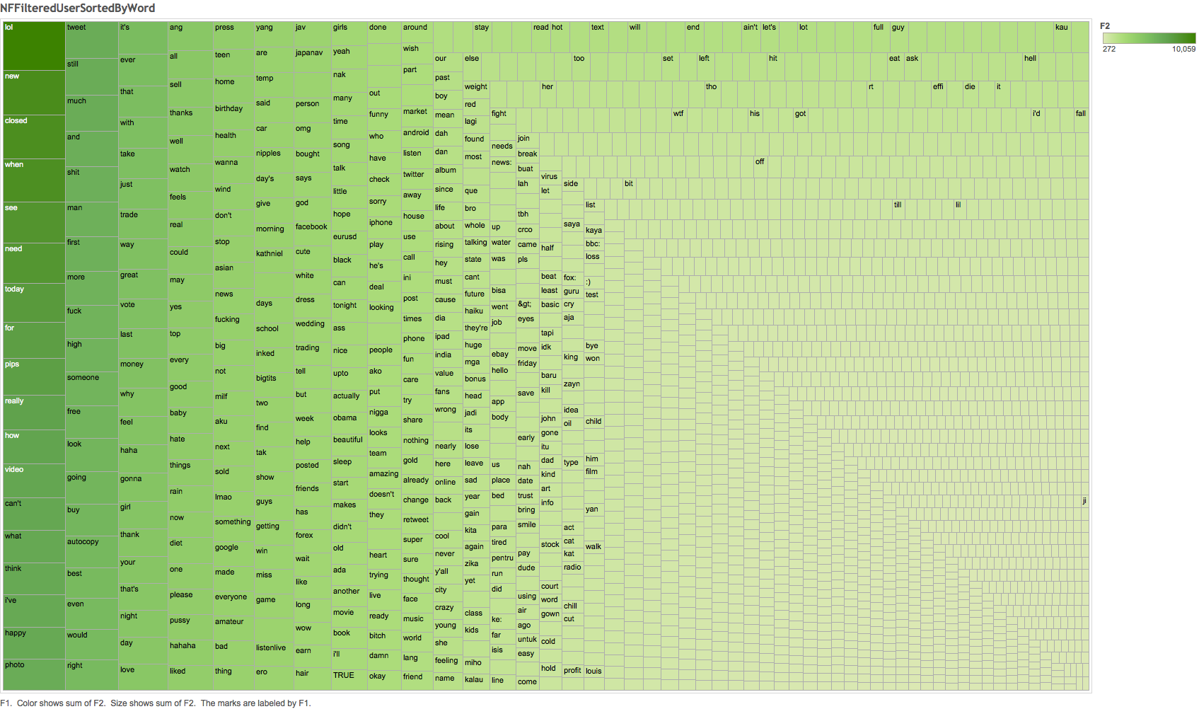

This analysis was done on 900 users ( randomly selected F/NF ). For the same set of 900 users, their last 3000 tweets were downloaded as well. However like any typical word analysis stopwords were removed. We did it using two stage ensemble approach.

If we look at the word choices, there seems to be “some” noticeable difference between the Filtered Vs Non Filtered users. Like choice of swear words appearing early and frequency is way too high.

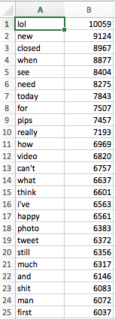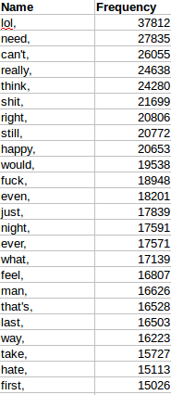

Figure Non Filtered users top 25 choice words

Figure Filtered users top 25 choice words

Stage 1: We used stopwords provided by python NLTK package.

The list was follows.

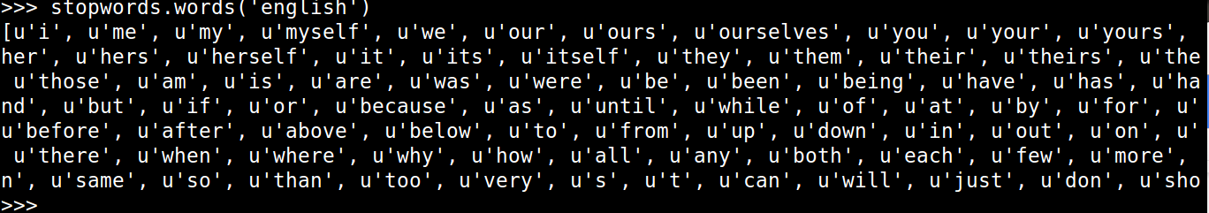

Step 2: After this some of the words we removed based on observation. The list of such words are

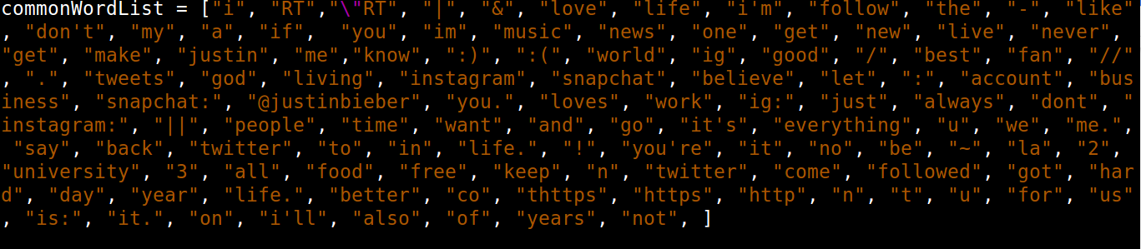

Some words like Weather, channel , Temp were removed intentionally from Non Filtered user set as they topped the list and while tracing back the cause of this, we figured out that among selected users 3 were weather channels which were constantly updating weather reports.

**Non Filtered users**