Reports (**Filtered**)

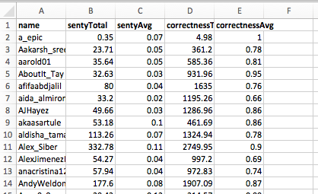

**NF-Filtered**

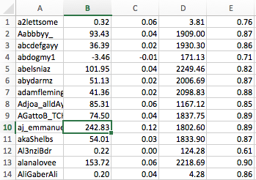

**Filtered: Sentiment Vs Correctness Total 2. Filtered: Sentiment Vs Correctness Average**

6.5 and 3.75 Width to height Ratio

Correctness Sorted – Viz to see if there is one curve has any obvious advantage

**Dictionary Approach**

Negative Sentiments.