|  |  |
| --- | --- |
| **1**  Lab Teaching Assistant:  **Armin Ghayur Sadigh** Assignment date: **dd/mm/yyyy** Submission date: **dd/mm/yyyy** | The University of CalgaryDepartment of Geomatics EngineeringENGO 634: Principles of Photogrammetry |
| [Lab title] UoC  **Group Members’ Names and addresses**  (address@mailprovider.ex)  Winter 2025 |

### ENGO 634: Principles of Photogrammetry

**Lab–1: Stereo viewing and metric information from vertical imagery**

#### Objectives

#### Problem 1a:

Align the provided stereo pair of aerial photographs until you see in 3D through the mirror stereoscope. Describe the steps you followed.

The steps to use the mirror stereoscope are as follows: ....

......

......

......

#### Problem 1b:

View the following stereo pair....

......

......

......

#### Problem 2a:

................................

Table 1 below describes the pixel coordinates of the fiducial marks:

Table 1: Coordinates of fiducial marks in left-handed image coordinate system

|  |  |  |
| --- | --- | --- |
| **Point ID** | **X (pixels)** | **Y (pixels)** |
| 1 | 100 | 200 |
| 2 | 200 | 100 |
| 3 | 300 | 100 |
| 4 | 400 | 250 |
| 5 | … | … |
| 6 | … | … |
| 7 | … | … |
| 8 | … | … |

......

......

......

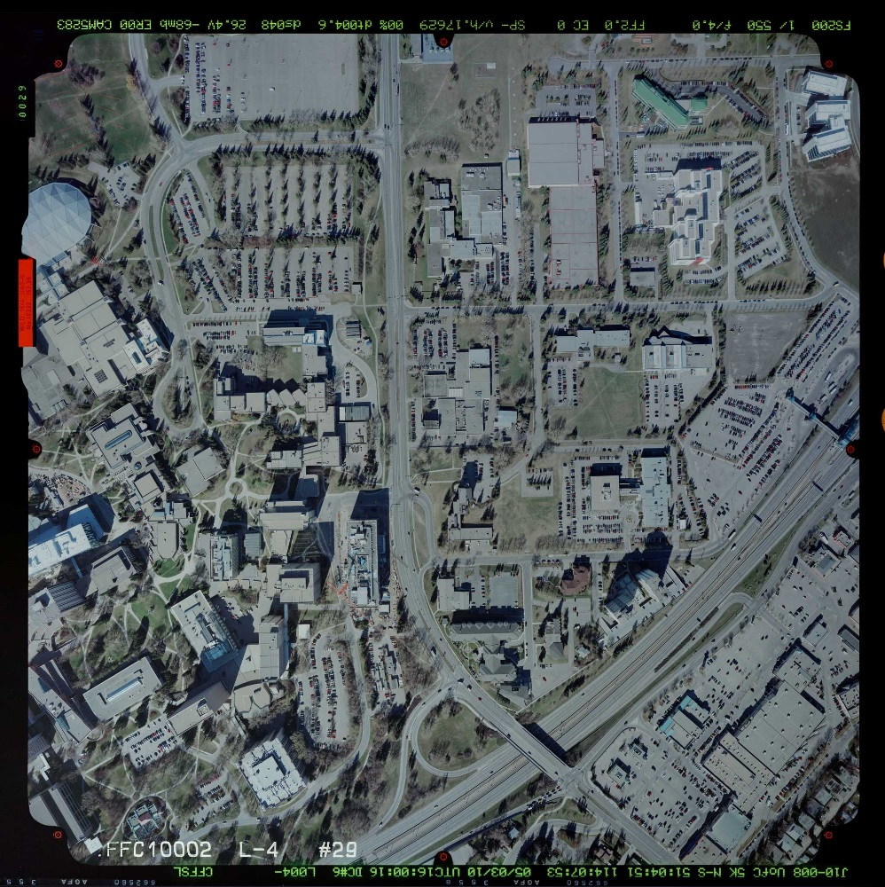

Figure 1: Image provided for lab 1 (dec_1_029.jpg)

### Appendix A: Code

# main.cpp

#include <iostream>

int main(int argc, char** argv)

{

std::cout << “Hello World!” << std::endl;

return 0;

}

### Appendix B: Field Sheets

Attach field sheets or additional information on these pages.