Contents

1.1 Creating a User 2

1.1.1 Copying user from existing one 2

1.1.2 Creating a new user 4

1.2 Changing password for locked user 5

## Creating a User

Go to Configuration🡪 Access Permissions🡪 Users

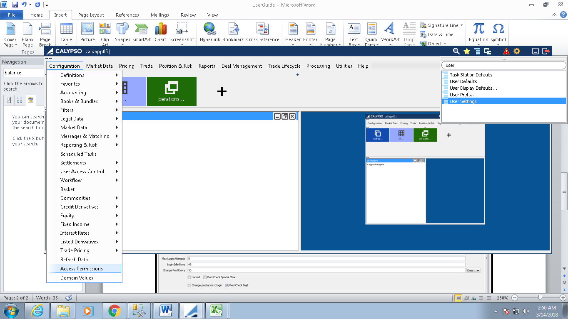

### Copying user from existing one

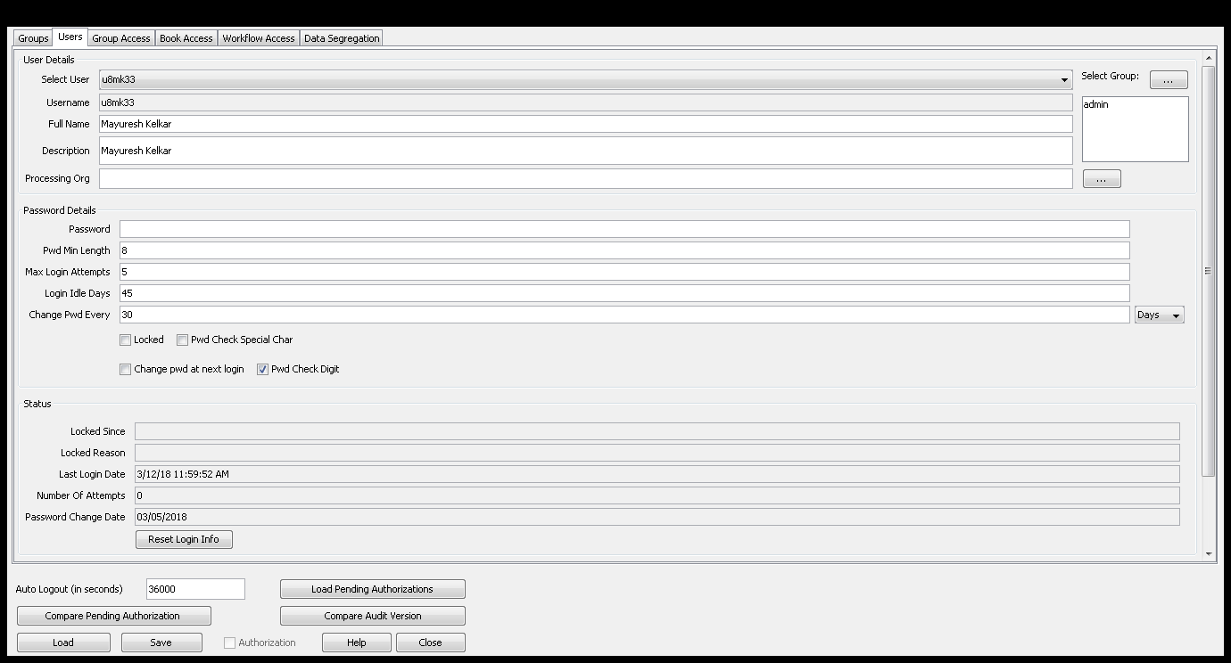

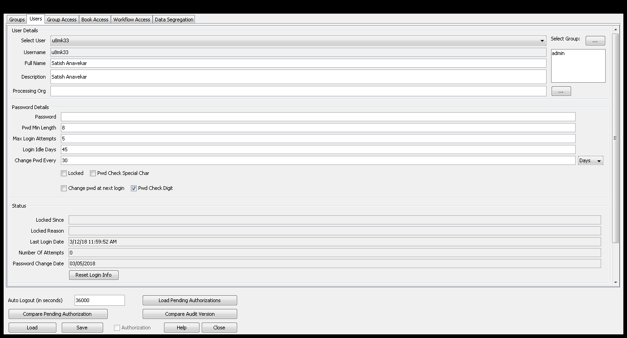

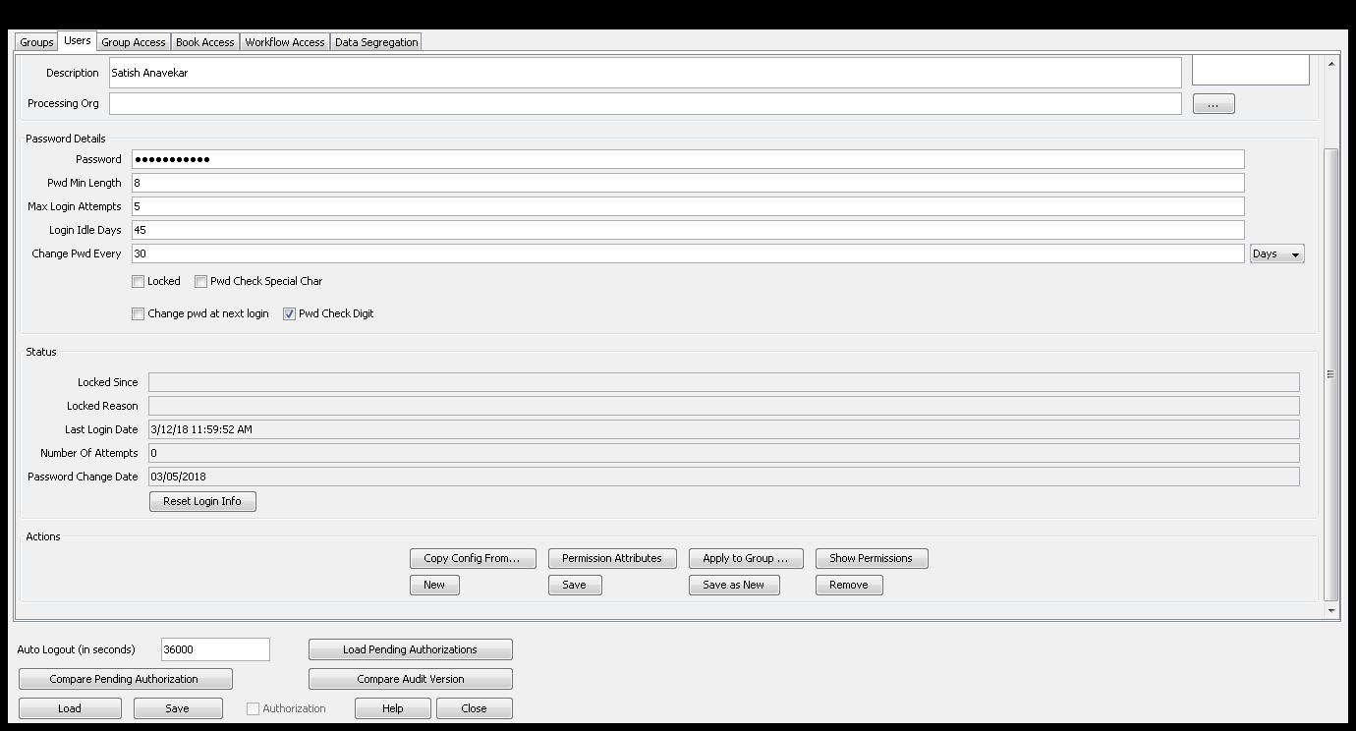

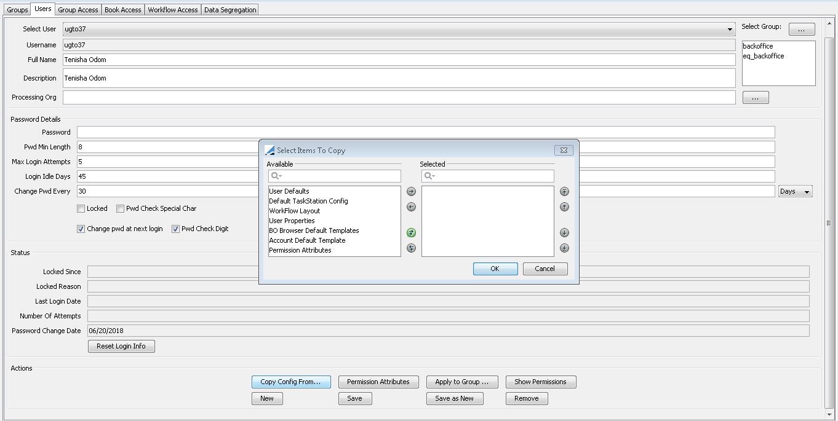

Select all configuration.

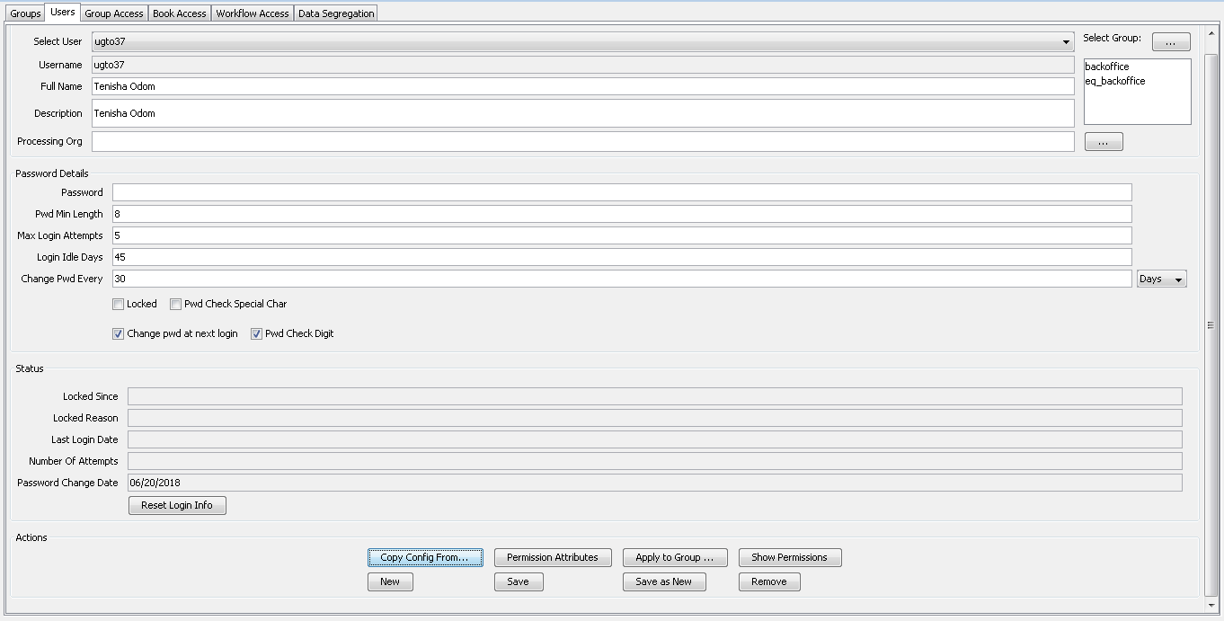

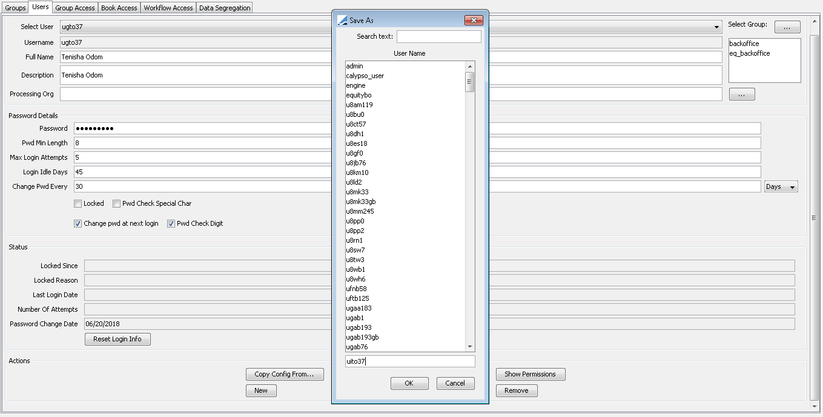

Put new user name.

Main Entry Customizer:

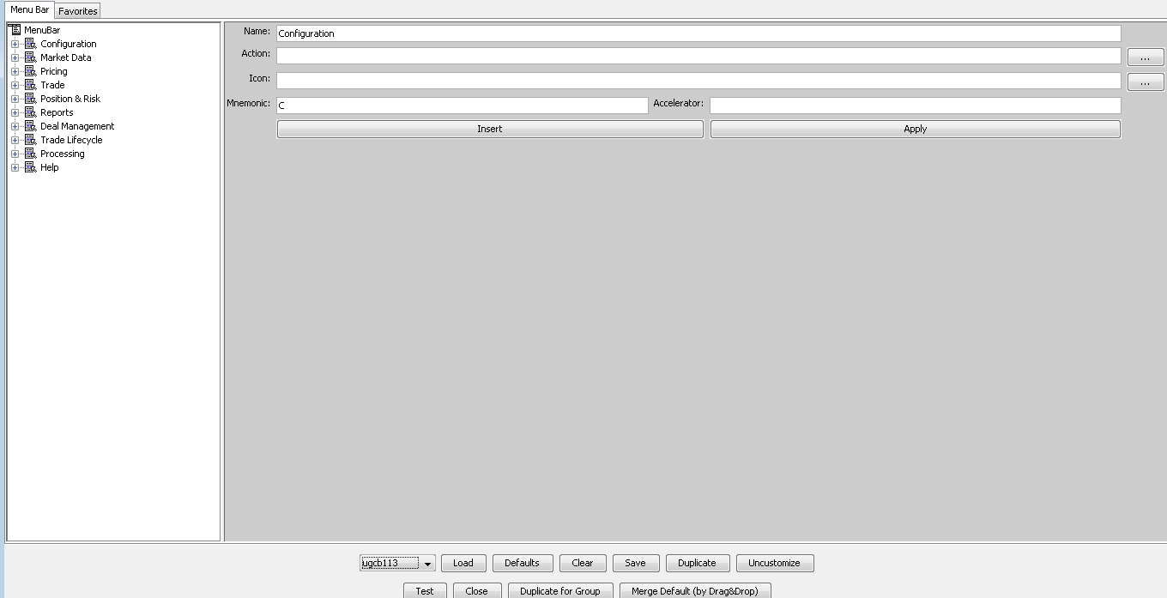

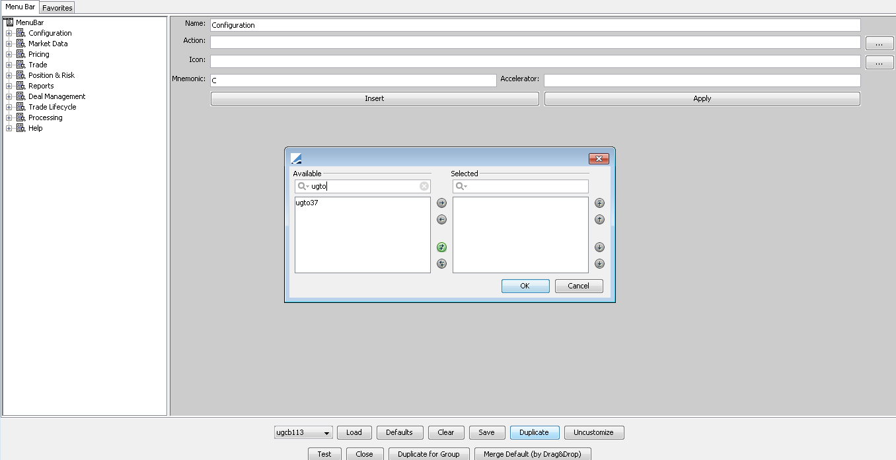

Enter the newly created user.

### Creating a new user

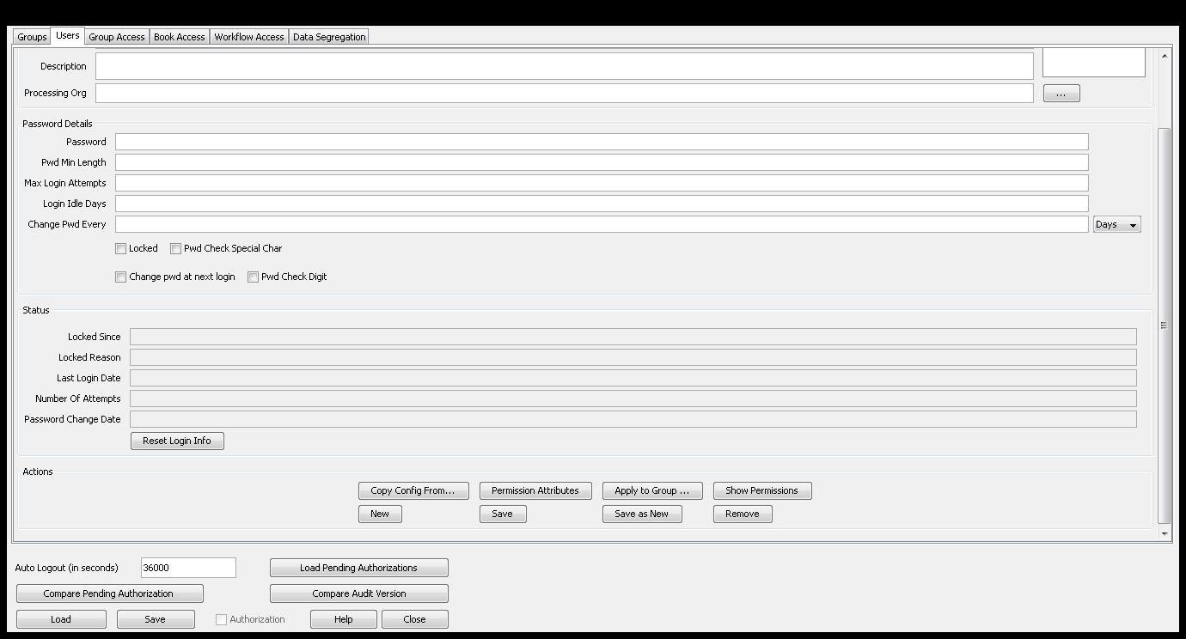

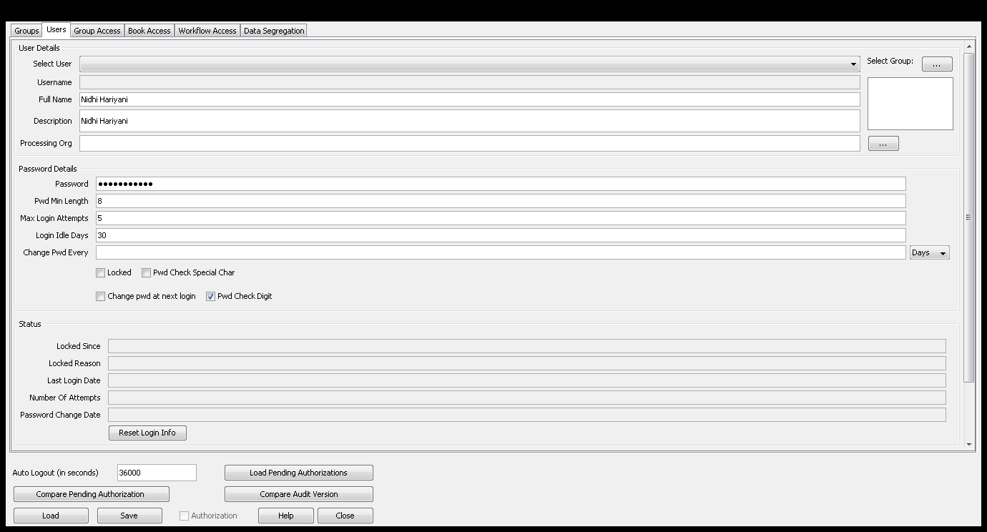

## Changing password for locked user

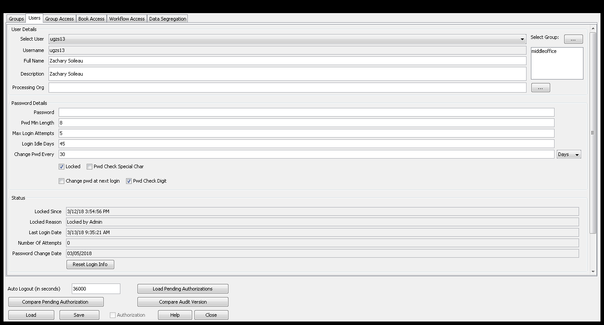

Uncheck locked🡪 Enter a new password

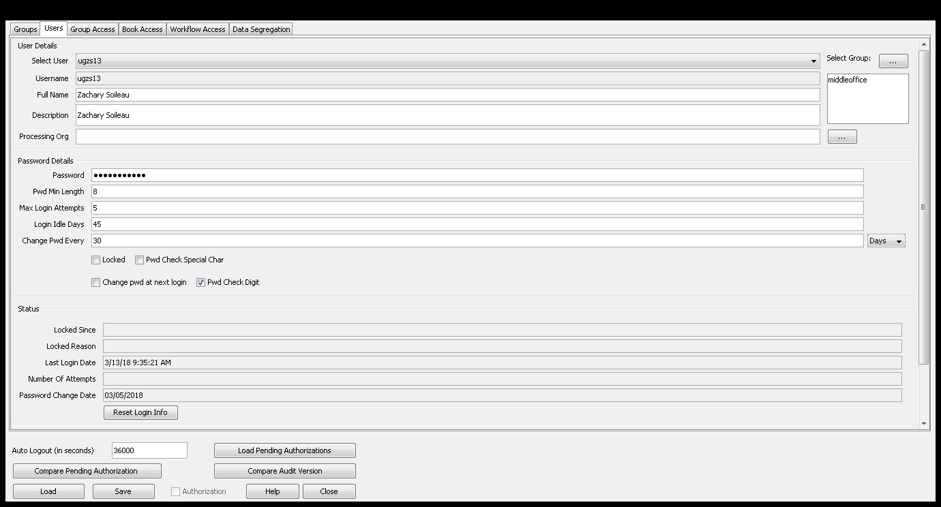

Reset Login Info🡪 Load🡪 Save

