Contents

1.1 Book Creation 2

1.1.1 Creation of new book 2

1.1.2 Creation of Accounting link 4

1.1.3 Creation of Accounting Rule 5

1.1.4 Creation of Accounts 5

1.1.5 Execute Query 7

1.1.6 Access Permission 7

## Book Creation

### Creation of new book

Configuration 🡪 Books & Bundles 🡪 Trading Book

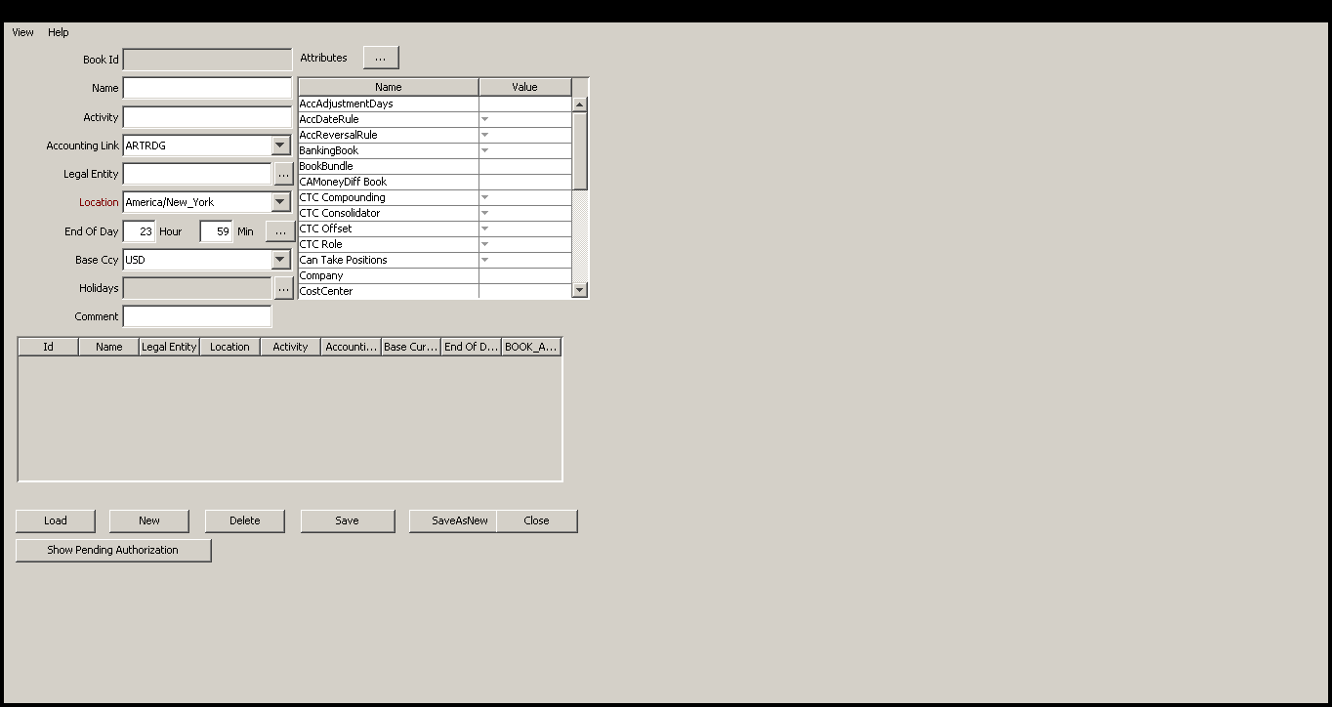

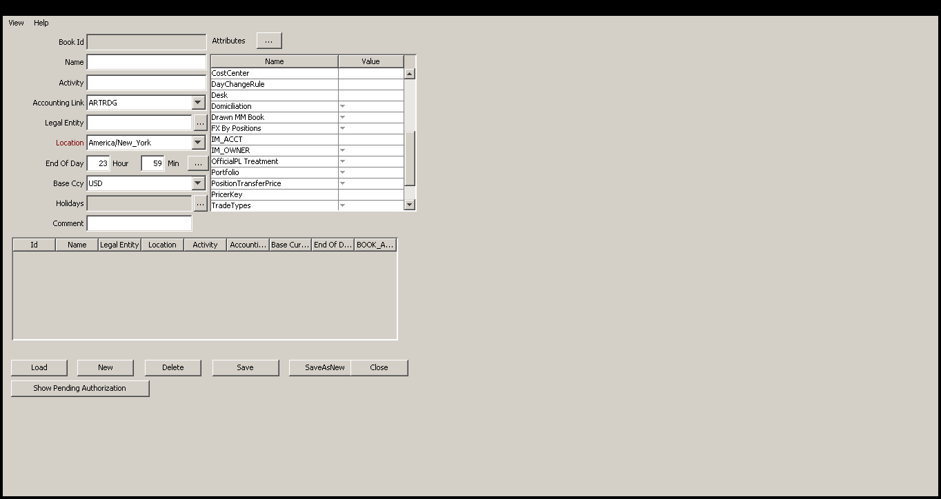

When book is created then every team needs to be aware of that book.

Important factor while creating books:

1. Book name: Unique identifier of book.
2. Accounting Link: Gives information about which accounting book is associated with the book.
3. Portfolio Attribute: Portfolio is the combination of book.
4. Trade Type :
5. Company :
6. Cost Center :

Book is authorized by accounting team.

### Creation of Accounting link

Configuration 🡪 Accounting 🡪 Books

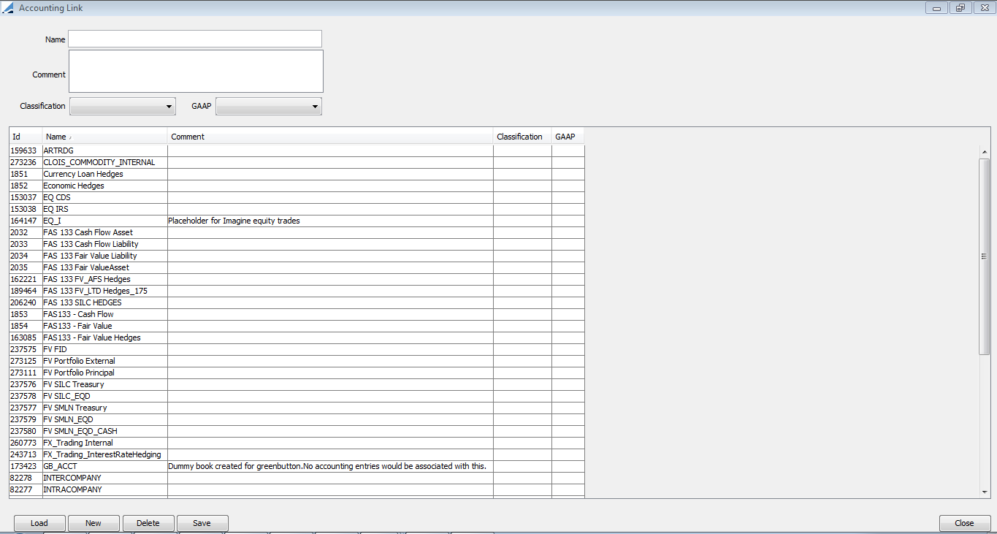

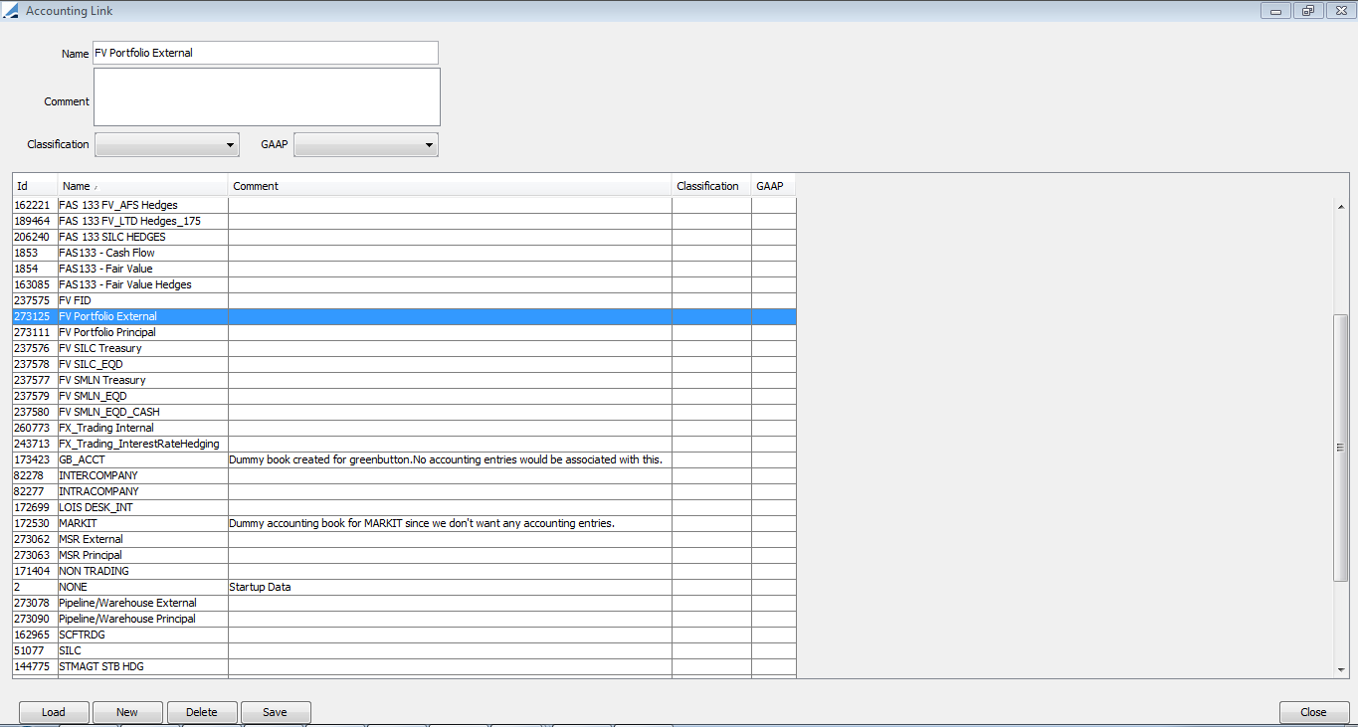

### Creation of Accounting Rule

Configuration 🡪 Accounting 🡪 Rules

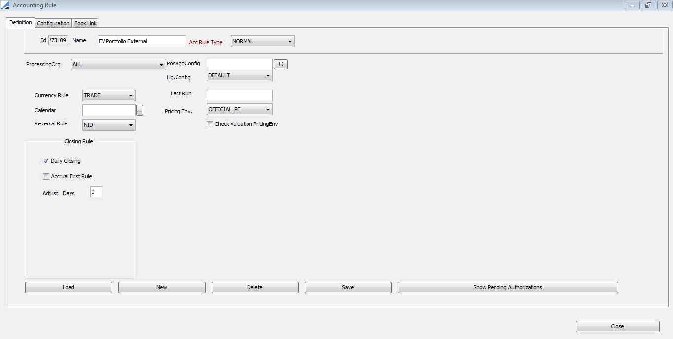

### Creation of Accounts

Configuration 🡪 Accounting 🡪 Accounts

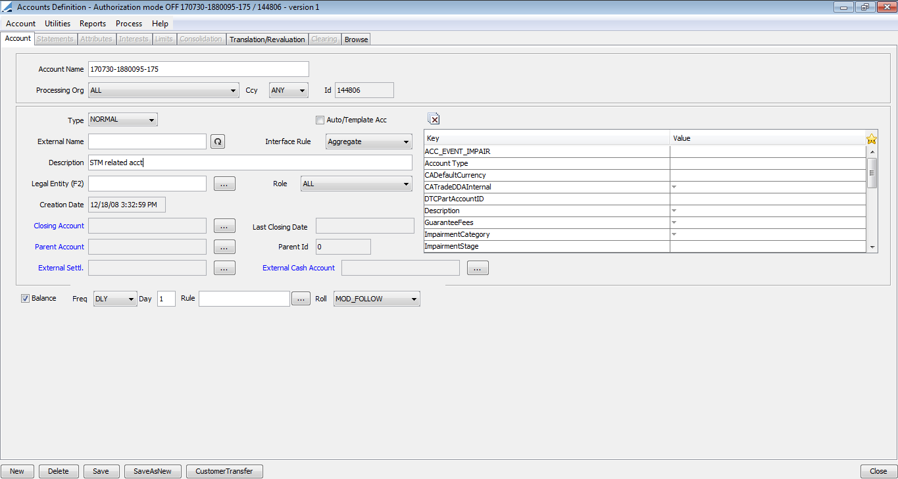

Configuration 🡪 Accounting 🡪 Rules 🡪 Book Link

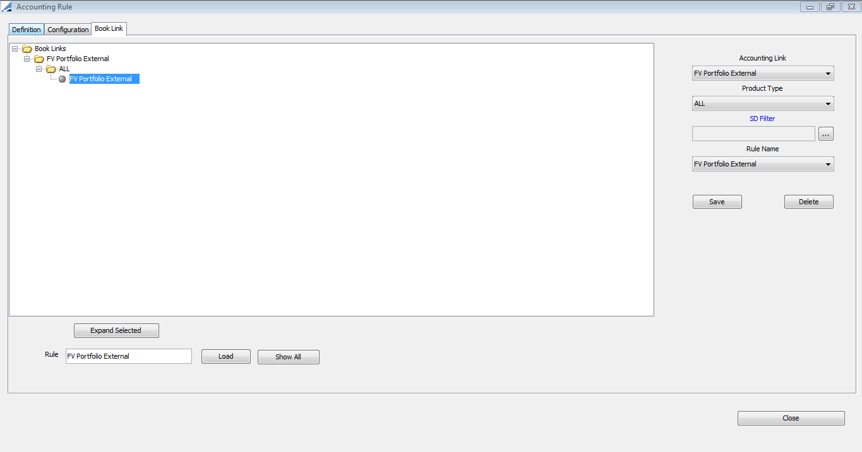

Configuration 🡪 Accounting 🡪 Rules 🡪 Configuration

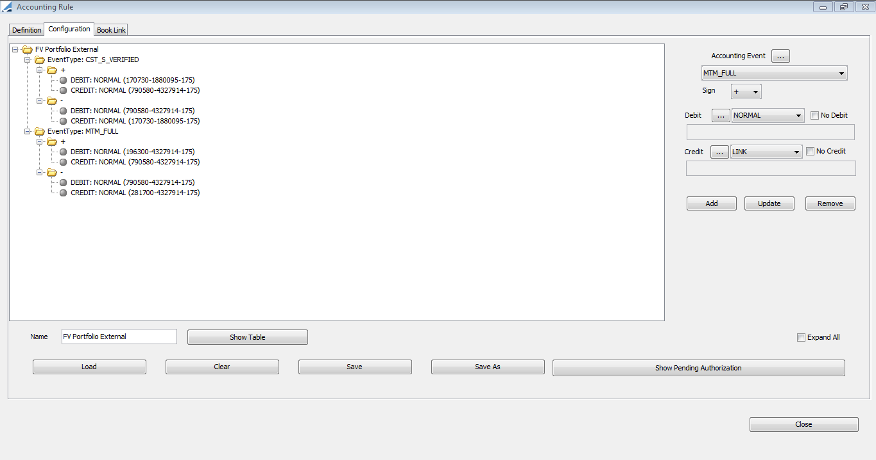

### Execute Query

Execute a query to find the trade filter against book name or book attribute portfolio.

**Query:**

select trade_filter_name,criterion_name,criterion_value from trade_filter_crit where criterion_name like 'Book' and criterion_value like 'COMMODITY';

### Access Permission

Configuration 🡪Access Permissions 🡪 Book Access

Select the Book Access panel to specify book permissions as applicable. For a given book, you can specify the currencies, currency pairs and products that can be traded in that book.

The book permissions apply regardless of the user. However, using the Group Access panel, you can specify the books that a group of users has access to.

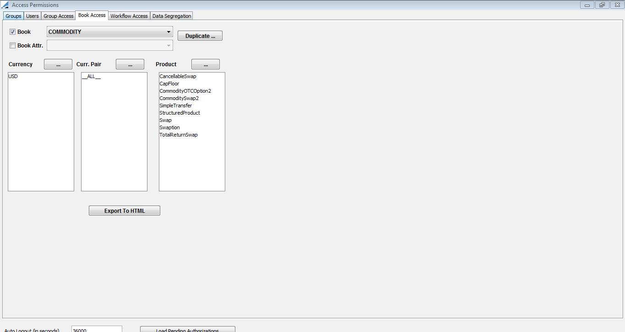

Configuration 🡪Access Permissions 🡪 Group Access

Select the Group Access panel to specify group permissions.

A group of users can be granted permission to execute certain applications and individual functions, and can be granted to access certain data. For example, a group can be granted read/write access on a given book, but if the group does not have the Modify Book function, the users of the group will not be able to modify the book.

Under the Access label, the Application Name and Functions entities allow granting permission to run applications and execute individual functions. The other entities allow granting access to data.

