Cryptography
HW #3
Sam Quinn
CS427
02/1/2016

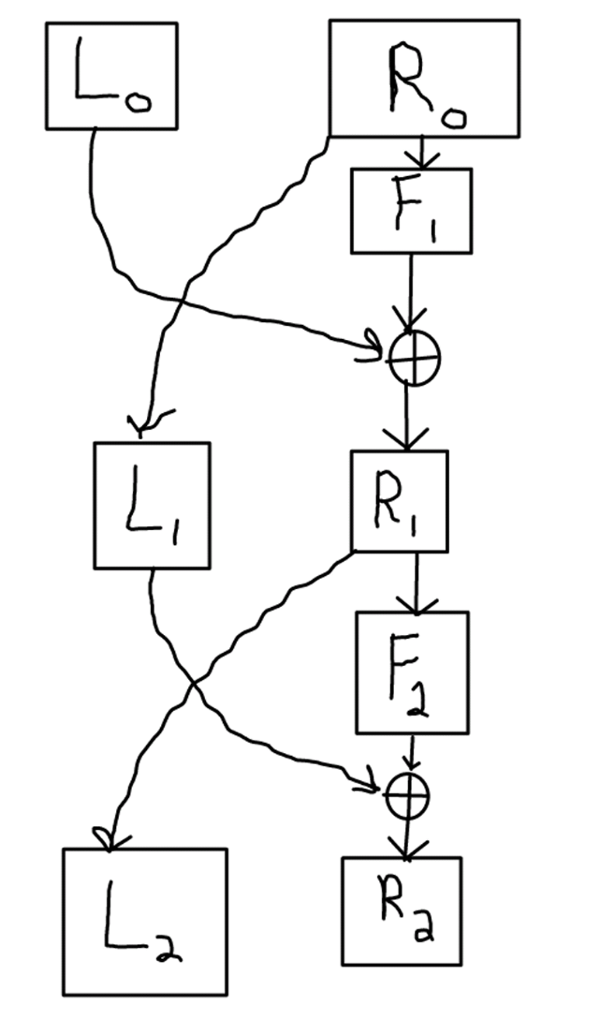
- Attack the left half of the function since it is the weaker half.
If we call the function on the left withand anything you want for . will create a value that will go into which is directly transferred to the left side without any modifications. Lets storeand call the the same encryption function with this time but with the same . This will produce a that is a exact complement of the. Because we are able to get a deterministic output for the cipher text this is not a secure PRP.

crypto_breaker() {
L0 = 1111, R0 = 1010
X1 = f(L0, R0)
L0 = 0000
X2 = f(L0, R0)

Return X1 (xor) X2 ?= L0
}

2.
a)
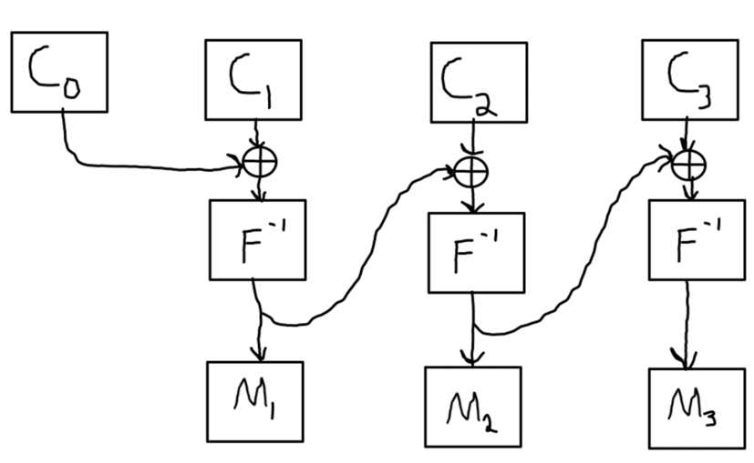
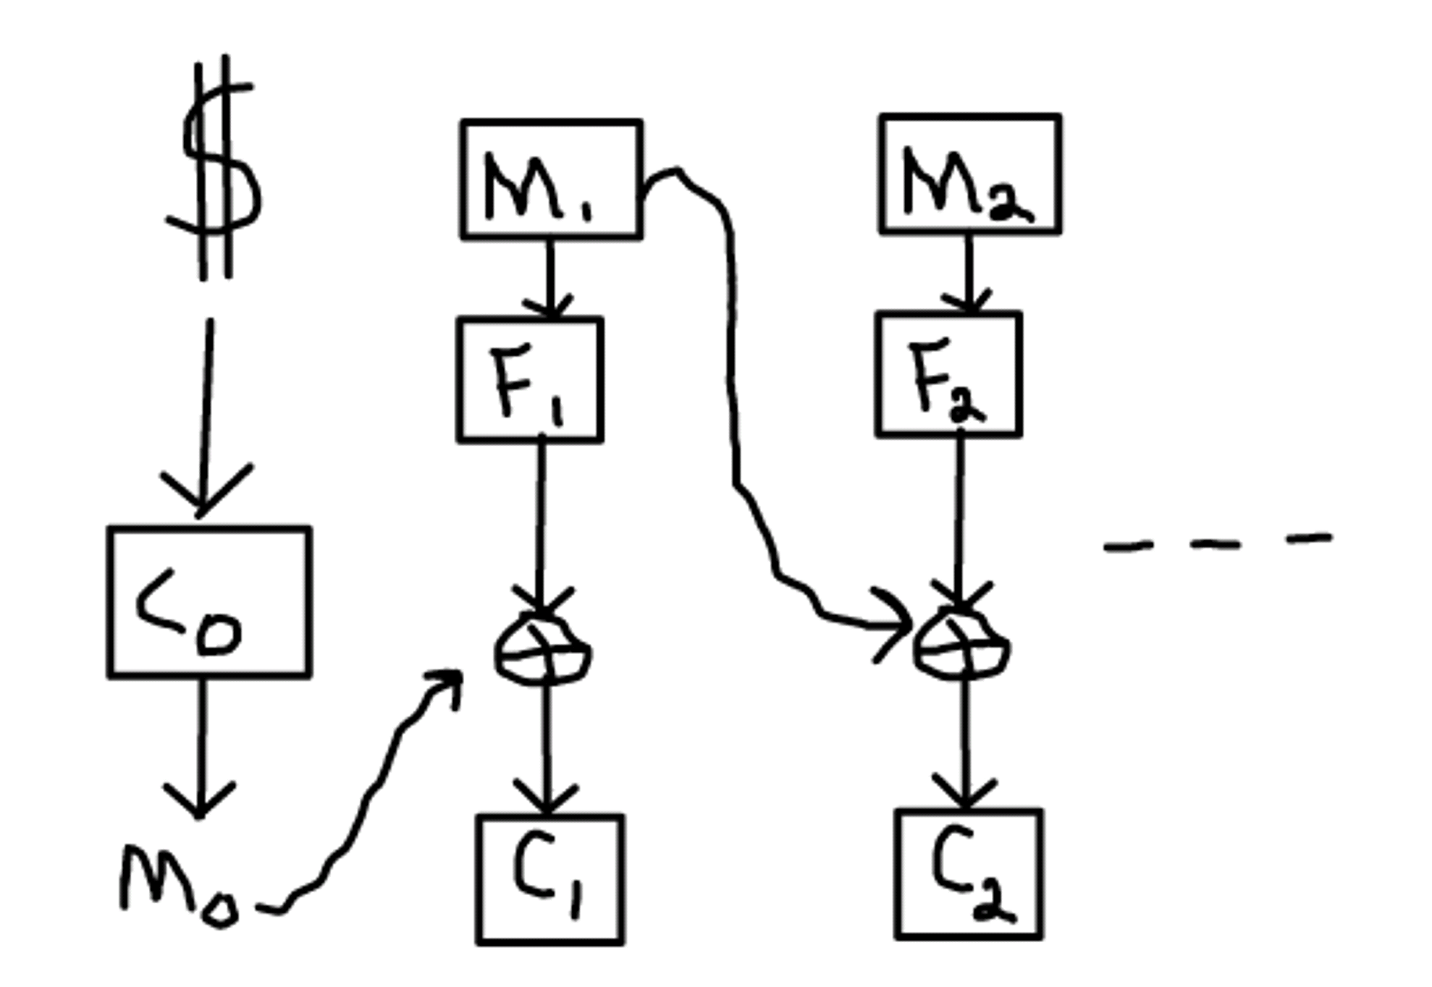
b) I was able to break this encryption with a choose plain text attack as described below:
If we pass to the function will xor the random deterministic value that comes out of and gets stored it into . Now since we can choose our plain text to pass to the function if we choose to pass as we will end up getting , and as we know anything that xors itself returns all zeros. Because we can get deterministic cipher text out of this encryption algorithm, it is not CPA secure. The advantages are
crypto_breaker() {
M1 ← 0000
M2 ← 0000
X||Y ← Enc(k, M1, M2)
X'||Y' ← Enc(k, Y, M2)
Return M1 ?= Y'
}

3.

This by far my most confusing distinguisher to date but I will try to explain why I believe that this will break CPA security. We start off by passing in a messagethat is intentionally (blen -1) bits long to force a pad. We will continue to pass the message in until the last bit covers both cases 0 and 1. When ever we find either one of the values we store the value at -(blen + 1) which is the bit that is used to pad the plain text message. This allows us to create a correlation between the last bit and the -(blen + 1) bit. The reason that we have to continue to run the program for an undetermined amount of time is due to the fact that the random IV could continue to produce the same value for the last bit and we will need to find the other case. This security could have been fixed if they would have added an xor on the last path from to . The advantage for this distinguisher is .
crypto_breaker() {
F0 = False
M1 ← 1111
M2 ← 000 // blen – 1
While ( (F0 & F1) != True) {
X ← Enc(k, M1, M2)
If X[-(blen + 1)] == 0
F0 ← True
D0 ← x[length(x)]
If X[-(blen + 1)] == 1
F1 ← True
D1 ← x[length(x)]
}
C ← Enc(k, M1, M2)
If last bit in C == D1
Return the C[-(blen+1)] bit is 1
Else
Return the C[-(blen+1)] bit is 0
}
4.
a) If an adversary was granted permission to choose their own IV a new CPA security definition could be to enforce that the user will not use the same IV more than once. If the adversary could reuse the same IV they could continue to use the same IV or even an IV that would always print the plain text out, either way this would break the CPA$ security. The solution could be for the encryption algorithm to store the IV used permanently and be added to a blacklist. When a new IV is passed in the IV will be added to a blacklist then the IV will be used in the encryption algorithm. This would not reveal any other details about the encryption algorithm since it uses OTP security.
b) If the adversary could choose both the plain text and the IV the adversary could always chose the complement. Even for random IVs if the adversary could see the IV before hand could intentionally choose plain text for the encryption algorithm to print out anything they wanted. This would not be secure because if you continue to add the chosen IV as the complement of the message plain text you will continue to get deterministic output. The advantage is.
crypto_breaker() {
IV ← {0,1}^lambda
M = complement IV
C ← Enc(k,IV,M1)
Return C ?= {0}
}

