Cryptography
Homework # 4
Sam Quinn
CS427
2/17/2016

1)
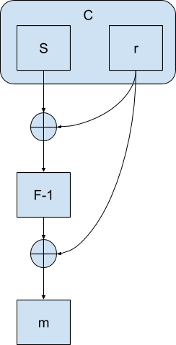
a)

Dec(k, s, r):
Return (F-1(s (xor) r)) (xor) r)

b) This particular encryption algorithm is vulnerable to a precompute attack.

Crypto_Crusher():
m ← {0,1}
(s, r) <- Enc(k, m , r)
r' = 0000
s' = s (xor) r
m' = Dec(k, s', r')
Return (m' (xor) r ?= m)

The specific precompute attack as described in the Crypto_Crusher function above will attack the Encryption with a Chosen Cyphertext Attack. We will first call the encryption algorithm which will give us a tuple containing s and r. We are able to change the cipher text to anything we want in a CCA attack, so we change the r to a r' by giving it a value of all 0's. The precompute comes in to play when we create s', which is the original s that has already been xored with r. We then pass s' and r' to the Dec function. The s' will be xored with r', all 0's, and continue to F-1. The output form F-1 will once again get xored with r', all 0's and continue to m'. m' in this case will actually be s xored with r, so if we just xor m' with the original r we will have the original m value proving that with a chosen ciphertext we could get m' ?= m.

MAC_Mayhem():
Ptxt = “”
s ← MAC(k,m)
for sl in s
for a in ascii
If sl == MAC(k,a)
Ptxt += a
break;
Return (m ?= Ptxt)
2)

The main reason that this is not a secure MAC is due to the fact that each bit in the message is directly concatenated on to the previous letter out of the PRF. If I wanted to forge a message I could pass each letter individually to the MAC function and store the value. Once I have ran each letter that I wanted to use in the forged message through the MAC I could just append the output for every letter that I received form the MAC to itself until the forged message is complete. Alternatively I could create a dictionary lookup table for every letter in the English language and make any forged message of my choosing and provide the legitimate authentication. For the adversary to forge any message in ASCII they would have to compute 128 different letters, which could be reduced down to 95 since 95 is the number of printable characters, but for the advantage computation I will assume all 128 character are in use and that the distinguisher above runs at worst case.

3)
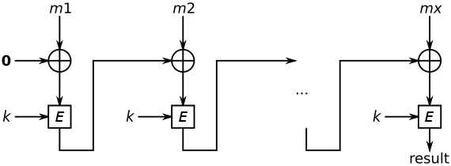
CBC-MAC will take the input message and compute the CBC encryption to the message, but since the idea of a MAC to shorten the input to a fixed size, CBC-MAC will only export the last block in the message. As you see above the previous output from e is xored with the new data, we are able to attack this MAC if we take the result from the original message m and xor m'1 with result. This would make the result cancel out the result xor that was in m'1. After we break the result with m'1 we are able to append anything with in m' to the end of m with the same signature.

CBC_MAC(k, m1,… ml) → (m,t) CBC_MAC(k,m'1(xor)t,…, m'l) = (m||m',t')
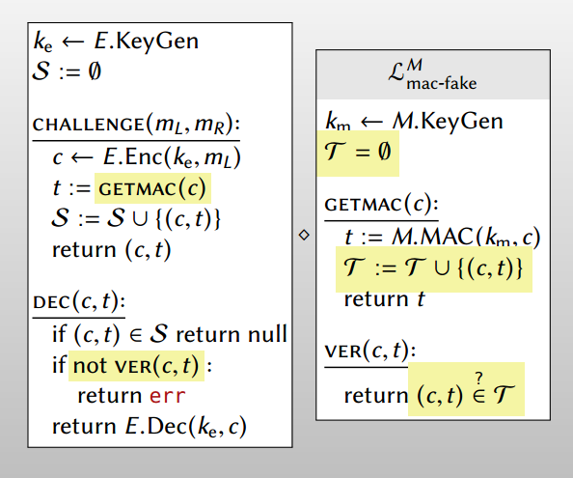
4)
a)
Because in the security proof the MAC has its own key made by the keygen completely separate from the Encryption keygen. If we use the same key from made form the keygen we would not be able to fully pull out the MAC process without pulling the key from the encryption process on the left. If we aren't able to fully pull the key out we are not able to securely create submodules to prove that the Encrypt-then-MAC is secure.

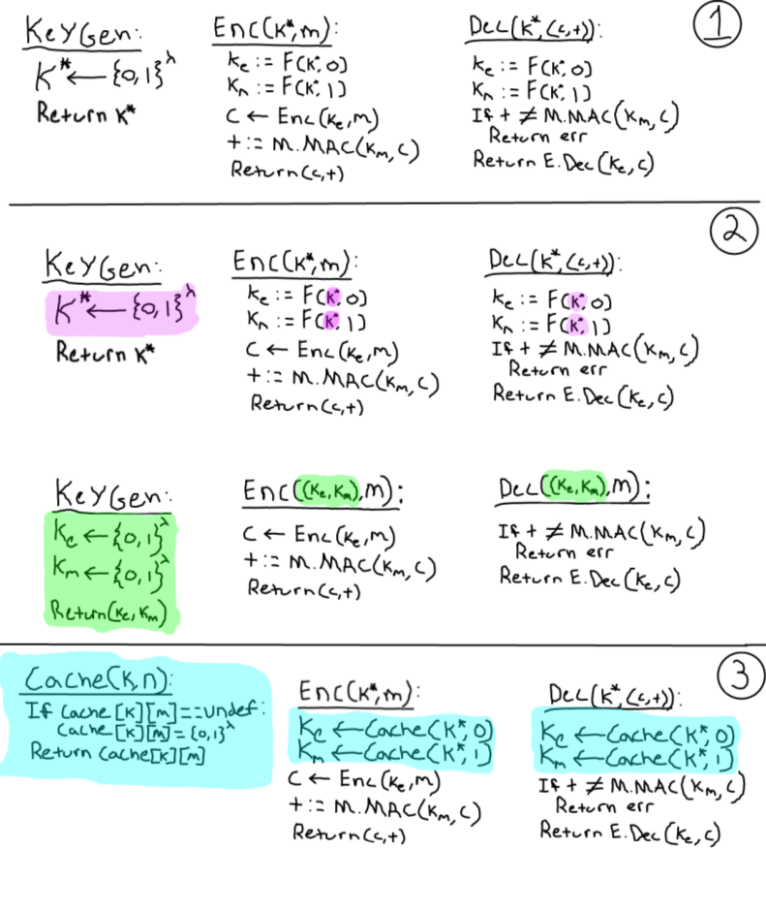
b) To prove that the given Encrypt-then-MAC function is secure I will walk through the proof below.
In step one you can see that the key generated by the keygen is passed to a PRF with a one bit message. Based on the deterministic nature of PRF if you pass the same value in you will get the same value out, which is how the DEC function retrieves its key. We described in part “a)” how for a secure Encrypt-then-MAC you must have separate keys for the encryption portion and the MAC portion. This is achieved with the 1 bit message that is passed and the output is a uniformly random number of length lambda, which is the length of the key. We know that if we adjust the keygen to return two keys (highlighted in green) one for the encryption and one for the MAC, then this Encrypt-then-MAC will be fully secure. To guarantee that we are not ruining our security here I have created a “cache” function that will be our secure PRF. The cache function will always create a uniformly random string the first time, and every other time given the same key return the string. Because the cache function will create random strings for both the encryption as well as the MAC we know that the we are secure in that regards. We have also shown that in step 3 the same value will be returned to the DEC function. With the “cache” function we are able to keep the same keygen function and only change the fact that we are no longer creating a lambda bit length key with one bit, but getting a uniformly random key.

