Team 2 (Quinn Tenorio, Aimee True, HaoXin Luo, Ramy Elzarad) Submission for Unit 12, Week 2

***List of Functionality Completed This Week:***

Completed API functionality (shown below):

* GET (get list of items being bartered) - http://localhost:3000/api/barter/user/:userid
* POST (add item that user wants to barter) - http://localhost:3000/api/barter/user/:userid/item/new
* PUT (edit item that user currently has up for barter) - http://localhost:3000/api/barter/user/:userid/item/:itemid
* DELETE (delete an item that user is currently bartering) - http://localhost:3000/api/barter/user/:userid/item/:itemid/delete

Completed login functionality:

* Can register for a new account
* Can logon to an existing account
* After logging on or registering, user can access user profile page with user information

Node/Express app created:

* DB created on MongoLab
* About/Home page with login, registration, and information
* User profile page that lists user information and items the user currently has up for barter
* Bartering page that lists all of the items that all users have up for barter and what they’re willing to trade for their item.
* Set up website on Heroku.

Still to do:

* Add Item Page
* Edit Item Page
* Delete item from user profile page
* Add functionality to actually complete barter between 2 users
* Design and overall look of app

***Postman API Calls:***

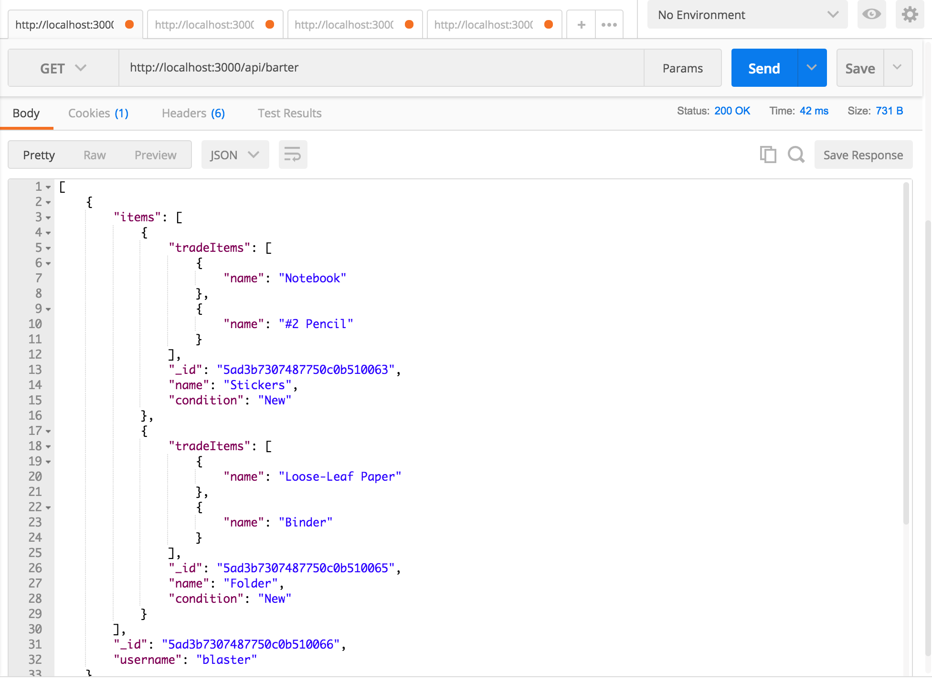

GET list of items up for barter (from all users)

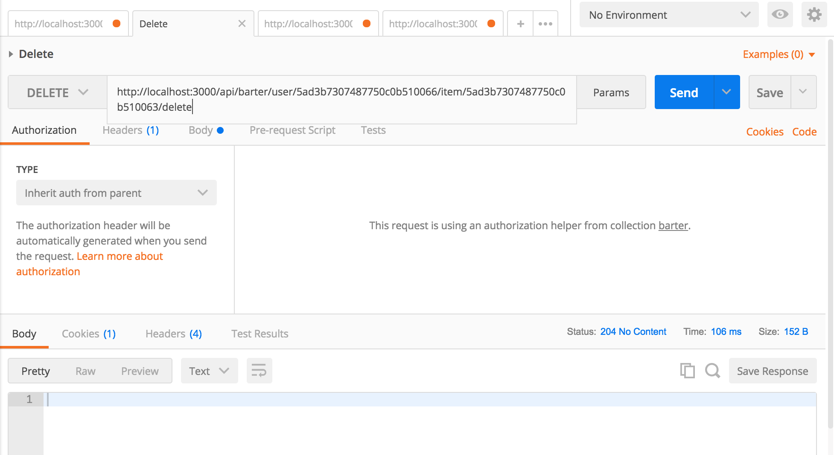

DELETE item, notice status code 204

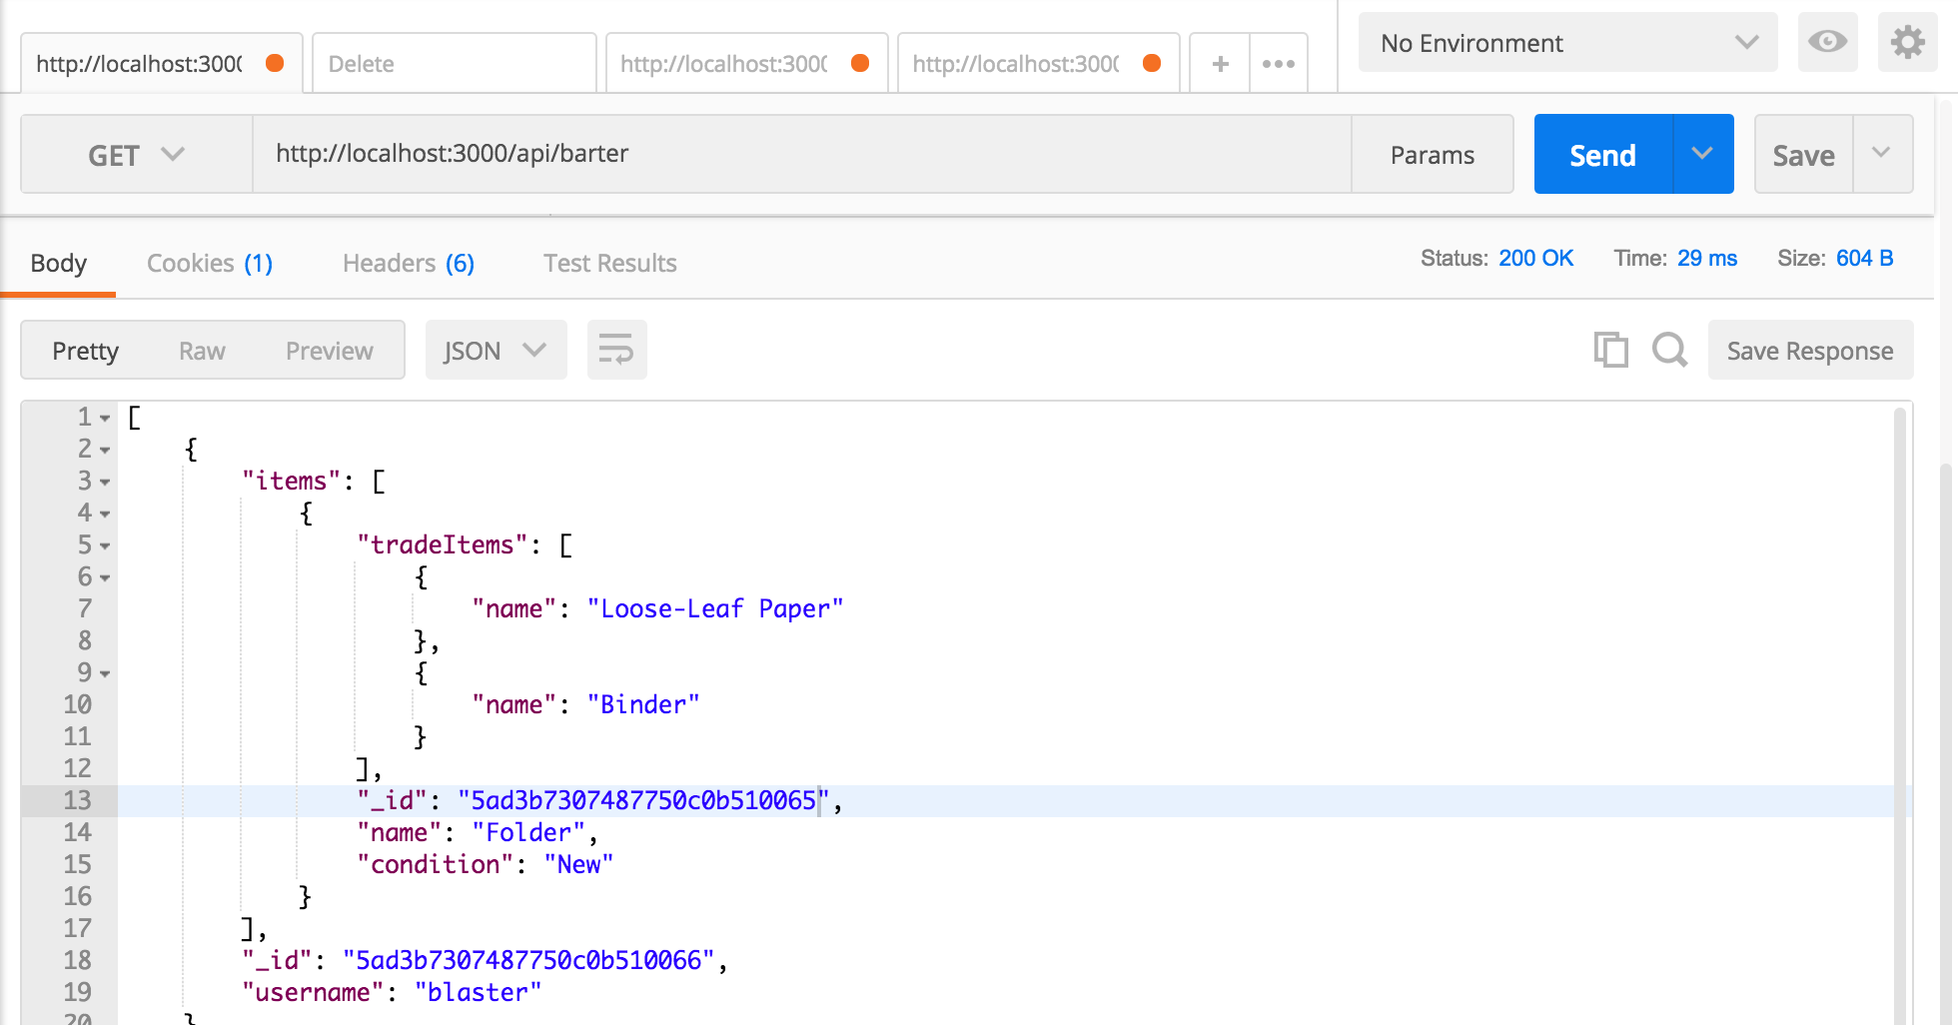

GET list of items up for barter again, after deleting an item, notice Stickers is no longer there

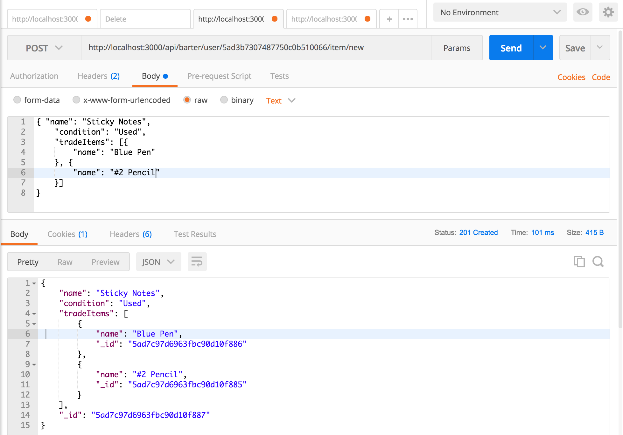

POST item (Sticky Notes), notice status code 201 created

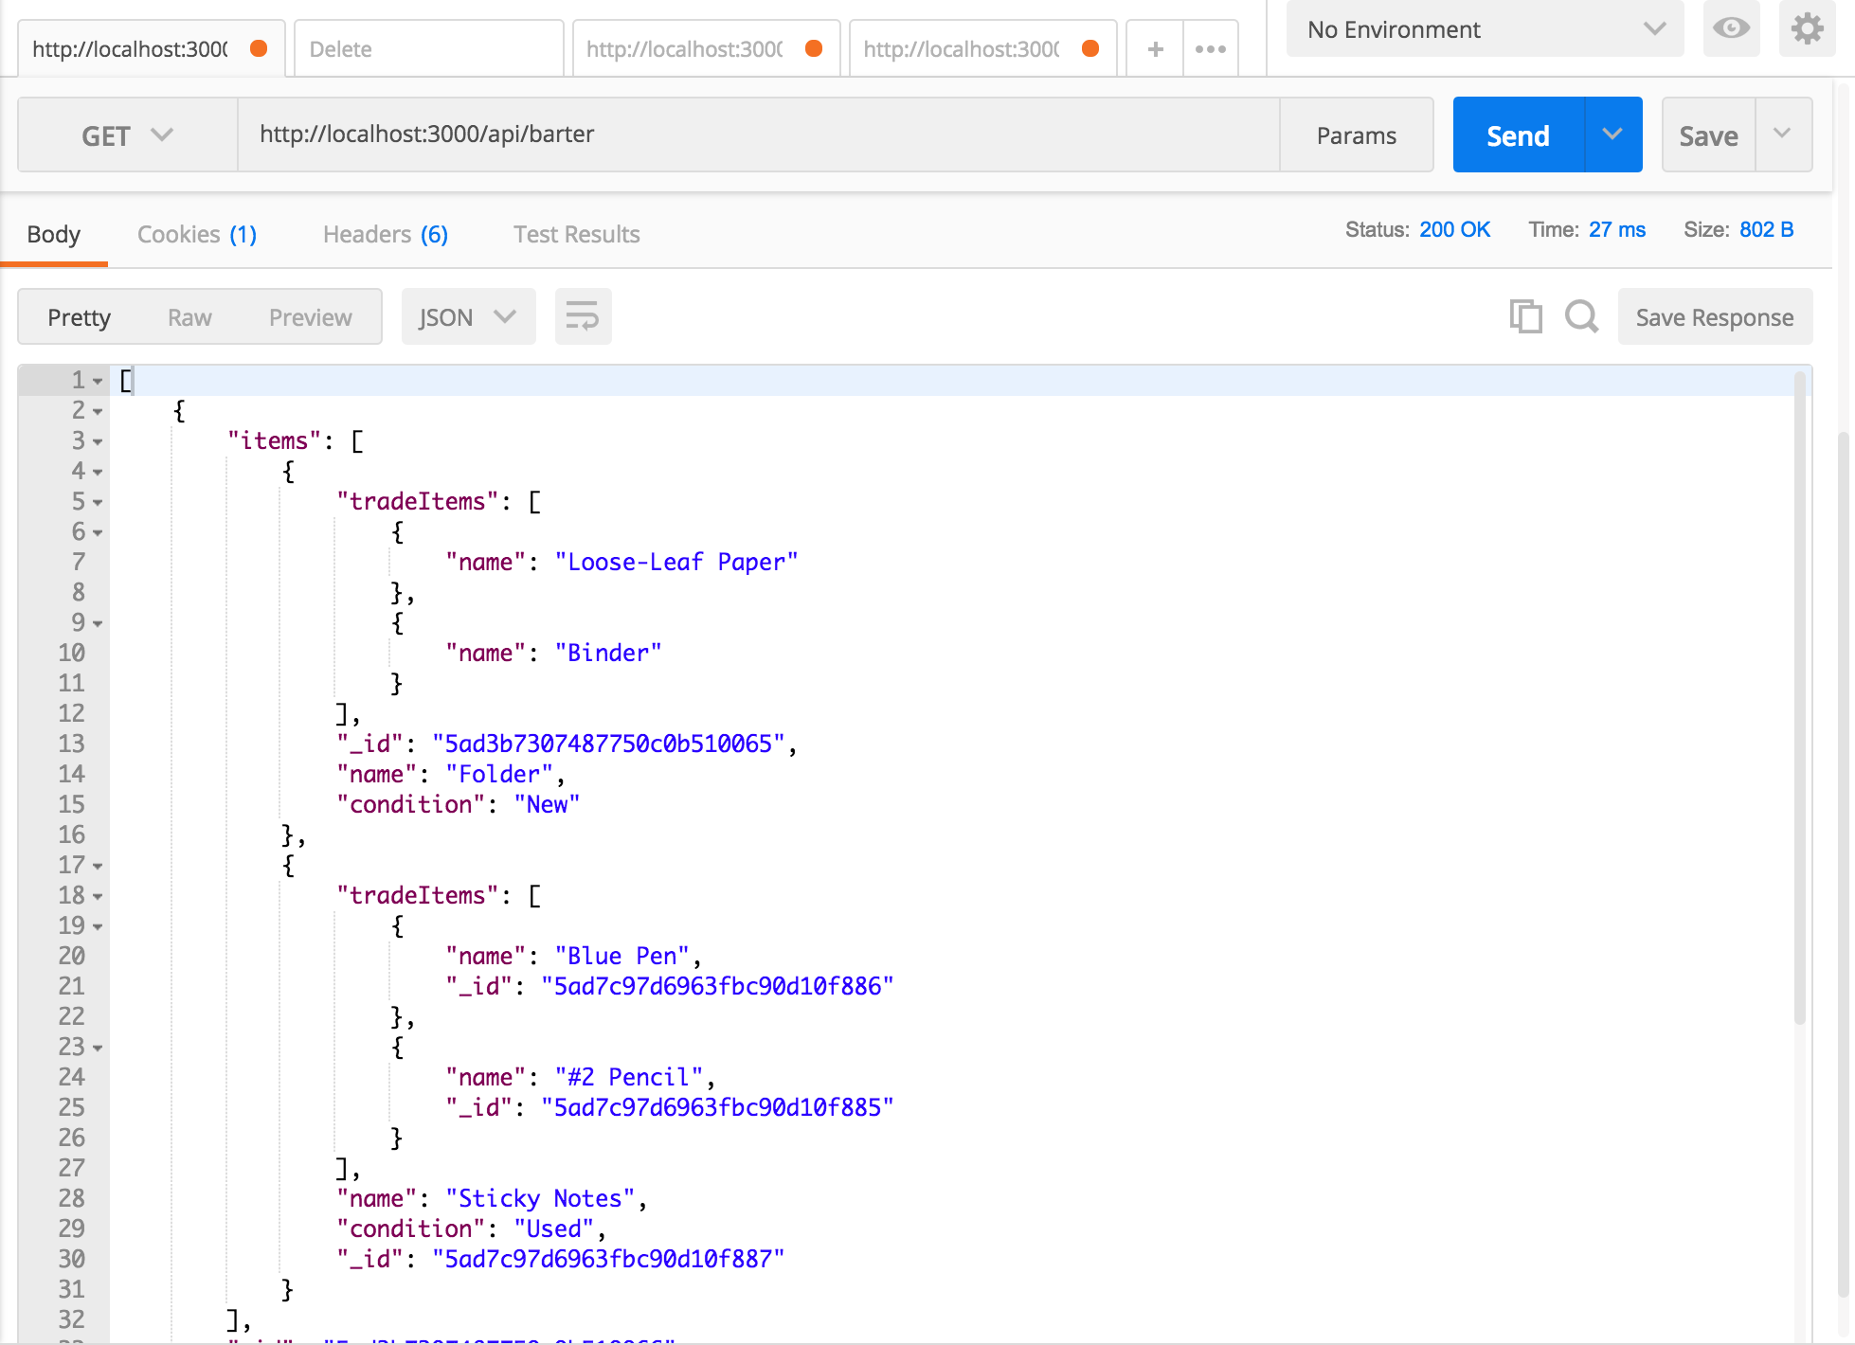

GET list of items after POST, notice Sticky Notes added

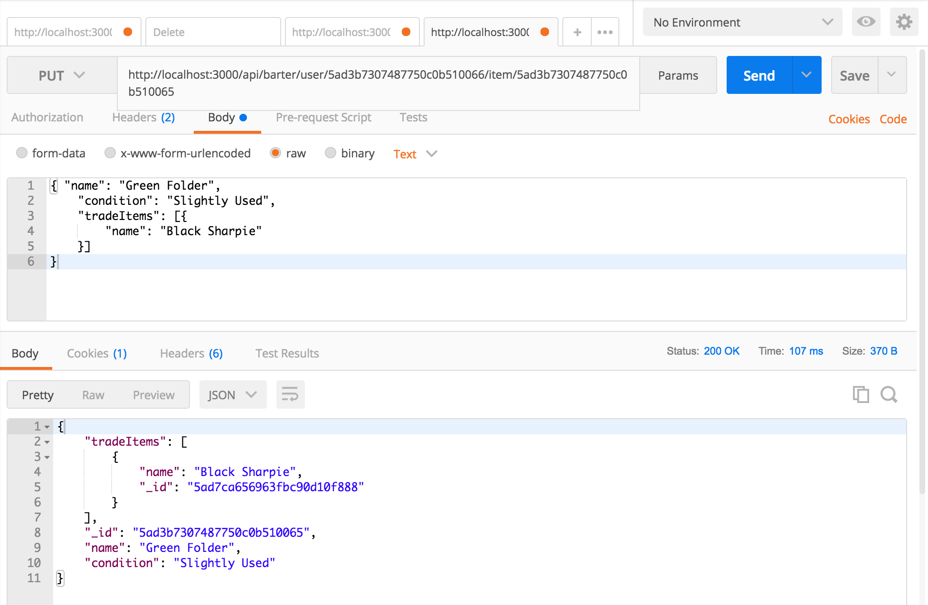

PUT item, notice all 3 fields updated (name, condition, and array of tradeItems), status 200 OK

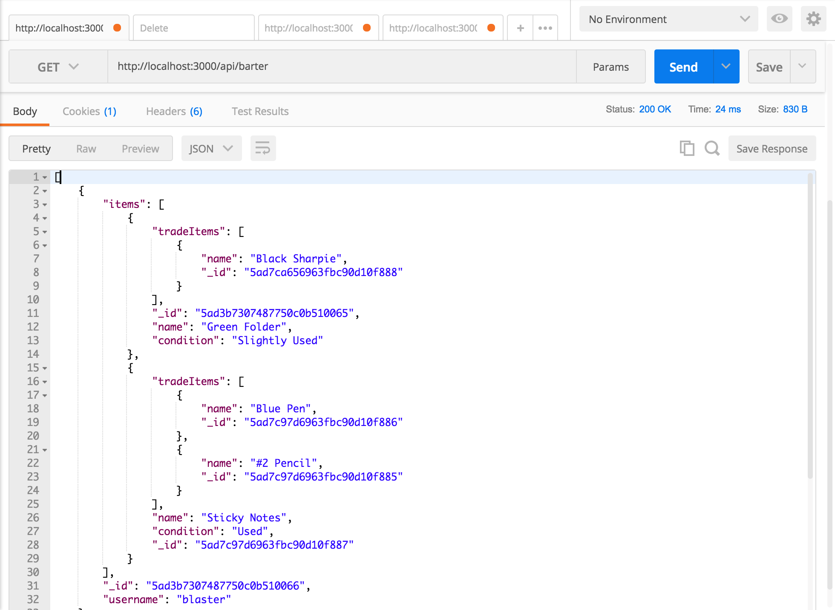

GET list of items after PUT, notice Folder updated to Green Folder and other fields also updated