Directions the work of ETLocal can go in:
ETLocal currently consists of three major components:

1. Visual mode
2. Dataset editor
3. The analyzes

These three components can all be expanded and even further developed. This document will describe what each direction solves and the difficulties that accompanies each step.

General information
Read: https://github.com/quintel/documentation/blob/master/modules/etlocal/README.md

The visual mode and the dataset editor are both accompanied by a map. The dataset editor of the map has four layers (in depth) of borderlines in the Netherlands. Depending on how far you zoom in, the layers become visible. The way this layering currently is:

1. Provinces
2. Municipalities
3. Districts
4. Municipalities

The visual mode has three separate layers which are basically compressed versions of the layers in the dataset editor:

1. Provinces
2. Municipalities
3. Districts

Expanding and improving the visual mode
Opinions that matter: Chael, Dorine, Joris?
The current visual mode is able to take values from each province, municipality and district of The Netherlands and is able to visualize them on a map. An example might be that you’d want to view the electricity consumption of each municipality of the Netherlands. This would look like:

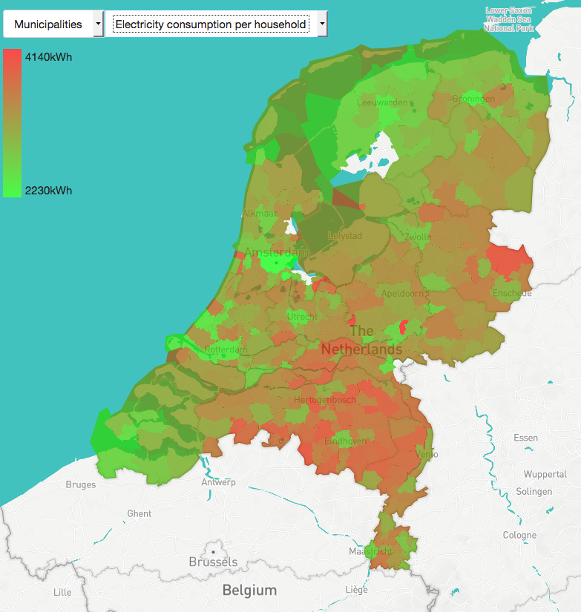
The view is static, there is a feature to move around, but you can’t zoom in or zoom out. It’s also possible to only show a single ‘visual’ layer at a time.

Possible improvements:
Make it possible to zoom in to the visualized layers
(especially for districts this might become handy, also adds the possibility to visualize neighborhoods, which are left out of the visual mode because of this reason). It would also be cool if the layers are enabled/disabled based upon the zoom-level. A lot of the paths seen on the above image are constrained until a certain zoom-level. This has to do with the loading of the amount of pixels and detail for a web-browser in OpenGL. I don’t know the technical details by heart but I can imagine this being such a constraint.

Make it possible to add multiple layers at once
This can become rather chaotic and ugly so I want to refrain from doing this. Of course it might just work like the Atlas maps ([0] and [1]) in which case it’s all up to the user to create something tremendously hideous.

Possible new features:
Adding layers from sources like Nationaal Georegister [2]. The implementation of these are rather easy, the only thing that needs deciding on is which maps and things are useful to plot.

Expanding and improving the dataset editor
Opinions that matter: Gerard, Anthony, Chael
The dataset editor contains multiple parts, it’s the dataset selector (the map with which you select a dataset) and of course the editor interface itself. The dataset selector is currently missing a key feature, which is opening a scenario with a dataset which doesn’t exist in ETSource.
Possible new features:
Make it possible to create a scenario from any dataset: https://gist.github.com/grdw/76ae3b8e3b0fd77d1195a5bd9370a691
Move the whole dataset editing interface to ETModel:
This is quite an undertaking, but it would imply that next to the current menu items that exist on the front-end you’d have an extra called: ‘Dataset’ like:
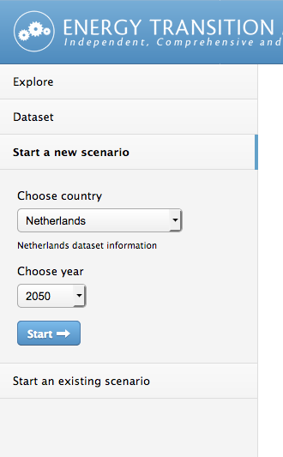
(Ignore ‘Explore’ for now).
This tab would let you use the map on the right hand side. The way this would work would be pretty similar to ETLocal.
Moderating edits to dataset
{ Add previous stories }

Expanding and improving the analyzes
Opinions that matter: Joris, Dorine, Alex, Berend
Need input from others for possible new features.

Moving ETLocal to ETModel
Opinions that matter: Anthony, Chael, Gerard
All of the interface elements of ETLocal need to be integrated into ETModel while ETLocal is still maintainable. The reason for this, is that ETLocal uses a lot of interface components which are already readily available in ETModel. For instance: the sliders and the slide-balancing. There are multiple approaches of moving all the elements over to ETModel of which 2 already exist.

The first one is where the chapter ‘exploring and improving the dataset editor’ already shed some light on. ETModel will expand with two main features on the front page, one is ‘Explore’ (which is the visual mode of ETLocal currently) and the other is ‘Dataset’ which is the dataset editor of ETLocal.

Sources:
0. http://www.atlasleefomgeving.nl/kaarten
1. http://www.atlasnatuurlijkkapitaal.nl/kaarten
2. http://www.nationaalgeoregister.nl/geonetwork/srv/dut/catalog.search#/home

