Parâmetros variando: delta, epsilon, p, c (respectivamente).

Número de iterações: 100

Pacientes: B07, B09, B08, B16, B17, B06, C05, C06, C09, C10

Os valores dos parâmetros variantes foram aproximados manualmente antes da execução da Evolução Diferencial (ED).

B07:

> GENERATION AVERAGE: 10.18345262811425

> GENERATION BEST: 10.183452114845705

> BEST SOLUTION: [0.14797321114047823, 0.999, 5.0, 19.727462614482434]

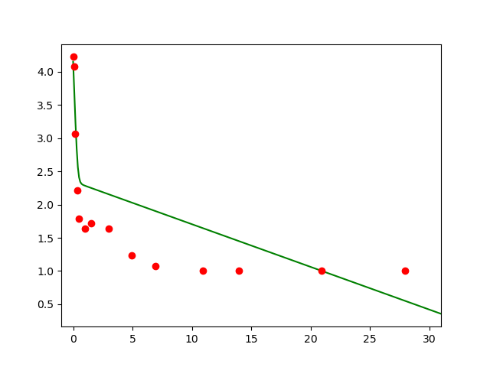

\*Tomando como referência o gráfico acima e observando os valores obtidos da primeira execução da evolução diferencial (ED) para este paciente, os valores dos parâmetros foram ajustados manualmente até que a curva se aproximasse dos dados coletados, então a ED foi executada novamente resultando nos valores abaixo:

> GENERATION AVERAGE: 4.929503690708293

> GENERATION BEST: 4.929461030255258

> BEST SOLUTION: [0.03144335813754956, 0.9963586991682227, 0.1, 15.907400989955224]

- Modelo ajustado para os parâmetros obtidos acima:

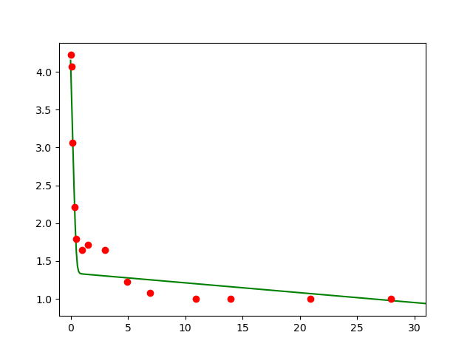

B09:

> GENERATION AVERAGE: 2.692504848362037

> GENERATION BEST: 2.6916623205657615

> BEST SOLUTION: [0.04380167129580946, 0.9983338398953014, 1.7622565140036548, 27.475379532875678]

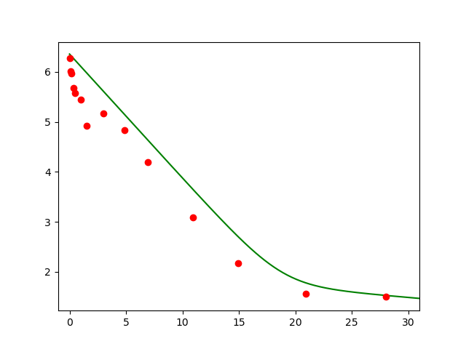

> GENERATION AVERAGE: 7.932952230197833

> GENERATION BEST: 7.932951447507904

> BEST SOLUTION: [0.14881784455781608, 0.995, 9.999988159205449, 27.27962311095181]

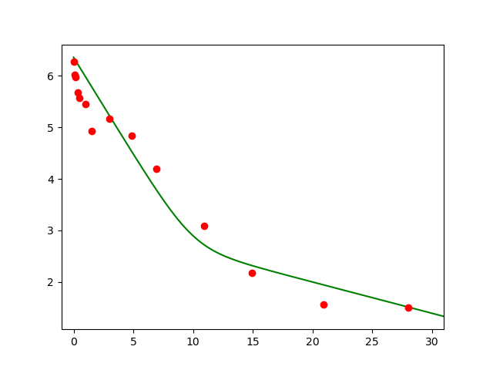

Rodando mais uma vez e usando os parâmetros acima com o chute inicial

> BEST SOLUTION: [0.06304300001056644, 0.997082540681797, 1.819451503602325, 27.37721550156263]

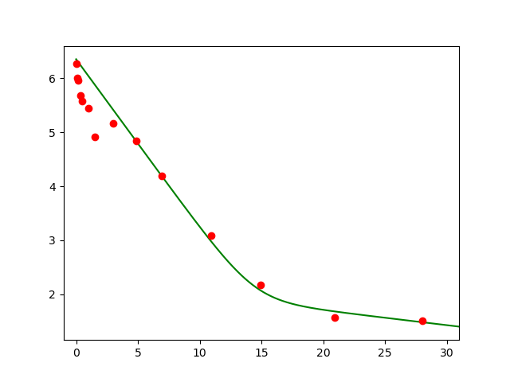

B08:

> GENERATION AVERAGE: 2.461868997753929

> GENERATION BEST: 2.4618676658583736

> BEST SOLUTION: [0.08004249862805599, 0.9966077189992079, 1.4922342609868975, 17.57472672602092]

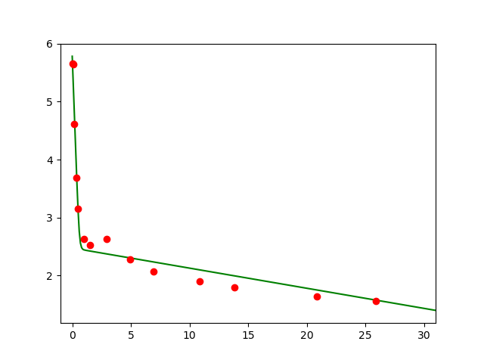

Rodando mais uma vez e usando os parâmetros obtidos acima com o chute inicial

> GENERATION AVERAGE: 2.4618674942400363

> GENERATION BEST: 2.4618669029061873

> BEST SOLUTION: [0.0800774102103146, 0.9981089122927345, 2.678618768647814, 17.575970332531632]

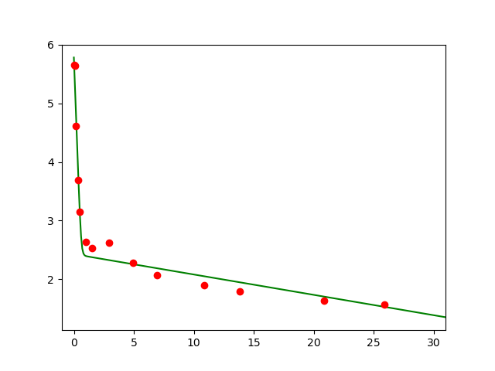

B16:

> GENERATION AVERAGE: 2.559951522856851

> GENERATION BEST: 2.559951036013624

> BEST SOLUTION: [0.11555207658434216, 0.9918712475051865, 5.387895068044262, 20.0]

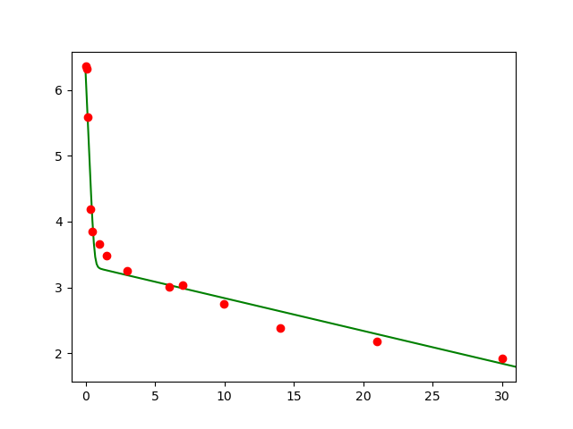

> GENERATION AVERAGE: 2.553875140691706

> GENERATION BEST: 2.553798201316865

> BEST SOLUTION: [0.11555135582019943, 0.9951195819505834, 8.75390726318059, 19.49793124504393]

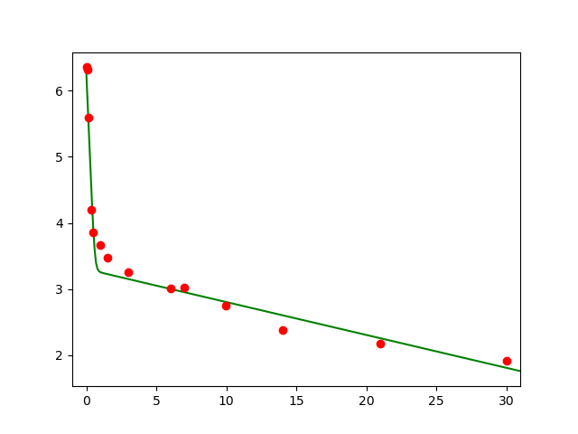

B17:

> GENERATION AVERAGE: 1.539708282702979

> GENERATION BEST: 1.539705203389599

> BEST SOLUTION: [0.1195214449849403, 0.9908012794158081, 3.4015820122046208, 20.414506981795473]

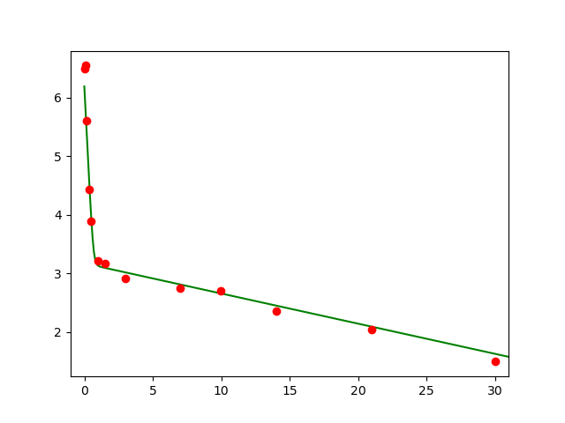

> GENERATION AVERAGE: 1.5397107498684495

> GENERATION BEST: 1.5397058848464273

> BEST SOLUTION: [0.11950610691822756, 0.9938355096544942, 5.076829260110383, 20.42238778081208]

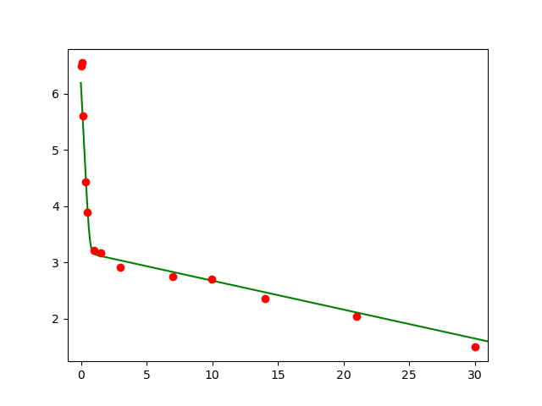

B06:

> GENERATION AVERAGE: 2.2093450965339976

> GENERATION BEST: 2.209344885269929

> BEST SOLUTION: [0.04048227383486473, 0.9919376691135855, 1.0, 21.634690847285285]

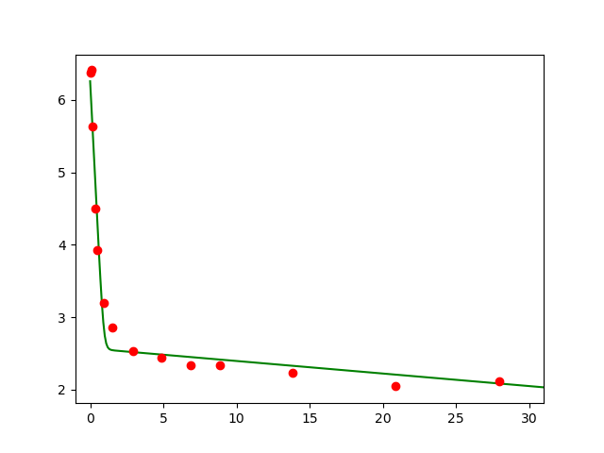

> GENERATION AVERAGE: 2.5423434937790192

> GENERATION BEST: 2.542335904978288

> BEST SOLUTION: [0.06006769133316052, 0.993238807615104, 1.6192187815979135, 21.4031893171954]

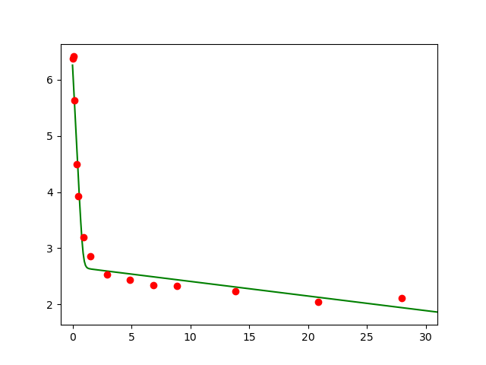

C05:

> GENERATION AVERAGE: 2.1264780770804896

> GENERATION BEST: 2.12647787456834

> BEST SOLUTION: [0.08643411168170902, 0.981289154508767, 1.4894703977480885, 20.86072738575572]

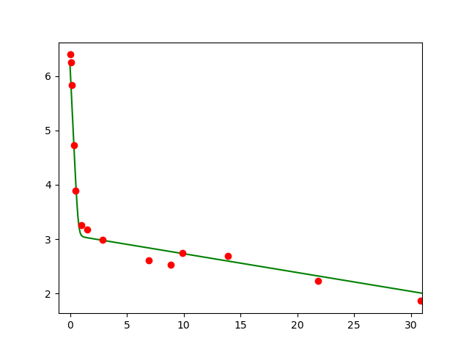

> GENERATION AVERAGE: 2.1264777739311214

> GENERATION BEST: 2.1264777333869977

> BEST SOLUTION: [0.08644512392345435, 0.981952194890088, 1.5443441288492066, 20.85862363970104]

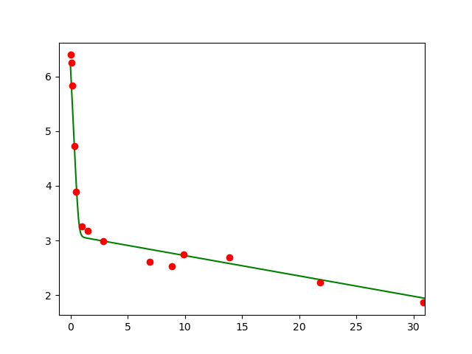

C06:

> GENERATION AVERAGE: 2.4406322232638855

> GENERATION BEST: 2.4406315961770773

> BEST SOLUTION: [0.11545916773135963, 0.9944773695863364, 2.870025782770531, 21.859482629369914]

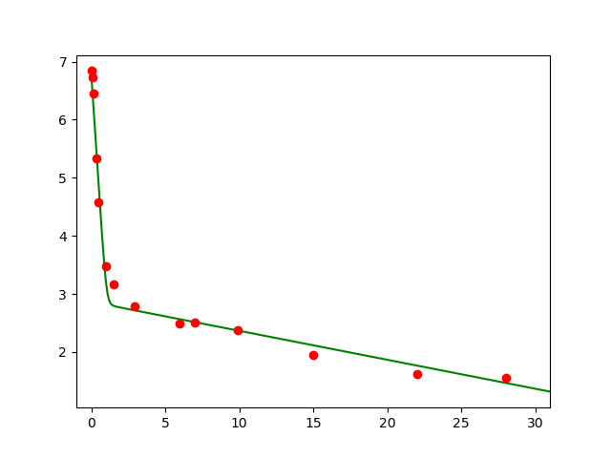

> GENERATION AVERAGE: 2.4406326277070303

> GENERATION BEST: 2.4406321859720896

> BEST SOLUTION: [0.11546285053695997, 0.9970377637392445, 5.35034460075957, 21.860583845740848]

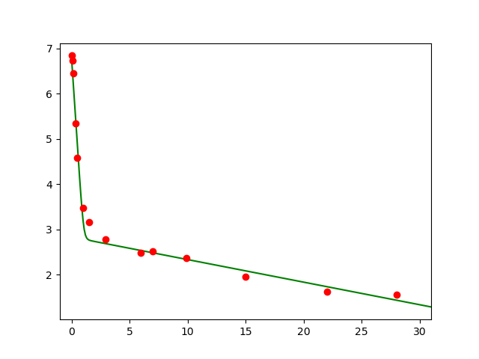

C09:

> GENERATION AVERAGE: 3.4829397209046866

> GENERATION BEST: 3.4829387488557044

> BEST SOLUTION: [0.12700115584478616, 0.9963445107199898, 3.25418607684492, 23.508728430254095]

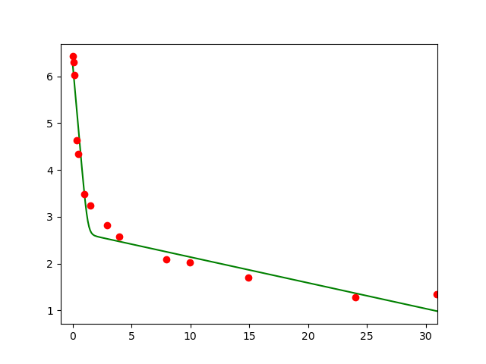

> GENERATION AVERAGE: 3.4829385227747998

> GENERATION BEST: 3.482938084740036

> BEST SOLUTION: [0.1269831364215781, 0.9975008422612572, 4.758640780807922, 23.508057318287424]

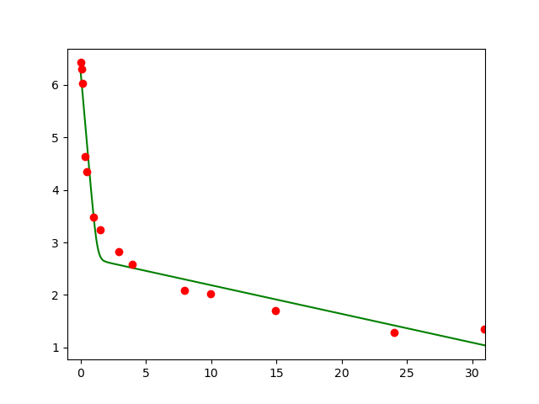

C10:

> GENERATION AVERAGE: 4.018747648652046

> GENERATION BEST: 4.018746048927657

> BEST SOLUTION: [0.06314708143505518, 0.9989871216840303, 1.0078092449604288, 20.4970285617378]

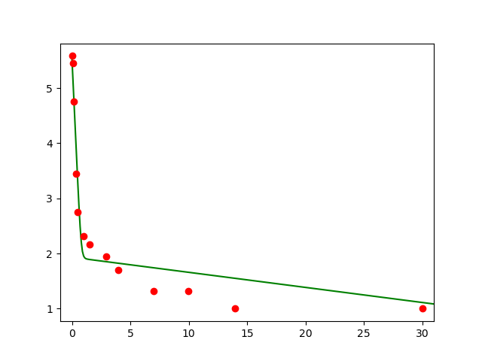

> GENERATION AVERAGE: 4.007852841864161

> GENERATION BEST: 4.00785284186416

> BEST SOLUTION: [0.06332512036207733, 0.999, 1.0, 20.0]

