CONTAINS
Installation ANPR manager on Windows P.2 – P.7
Installation recognizer on Windows P.8 -
Installation on Linux
Installation on Mac

Part 1: Installation on Windows 10.

step 1)
Download and install python3 or newer from ‘https://www.python.org/downloads/’

step 2)
Go through the installation process provided by the python installer.
Make sure to disable path length at the end of the installation

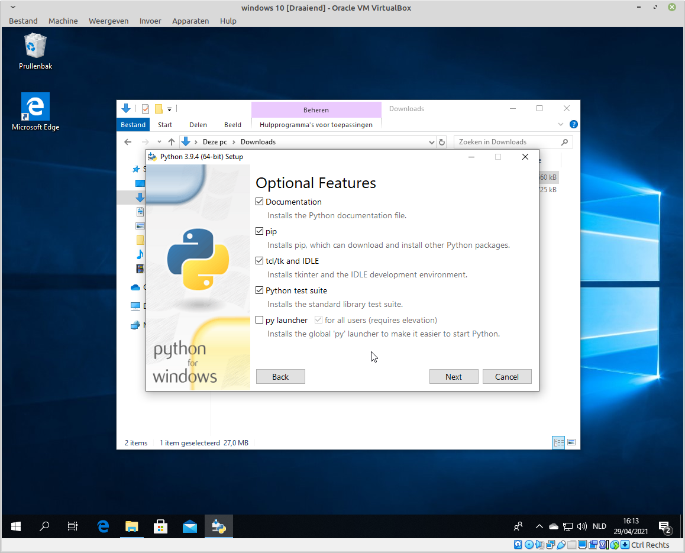

then select the same options here

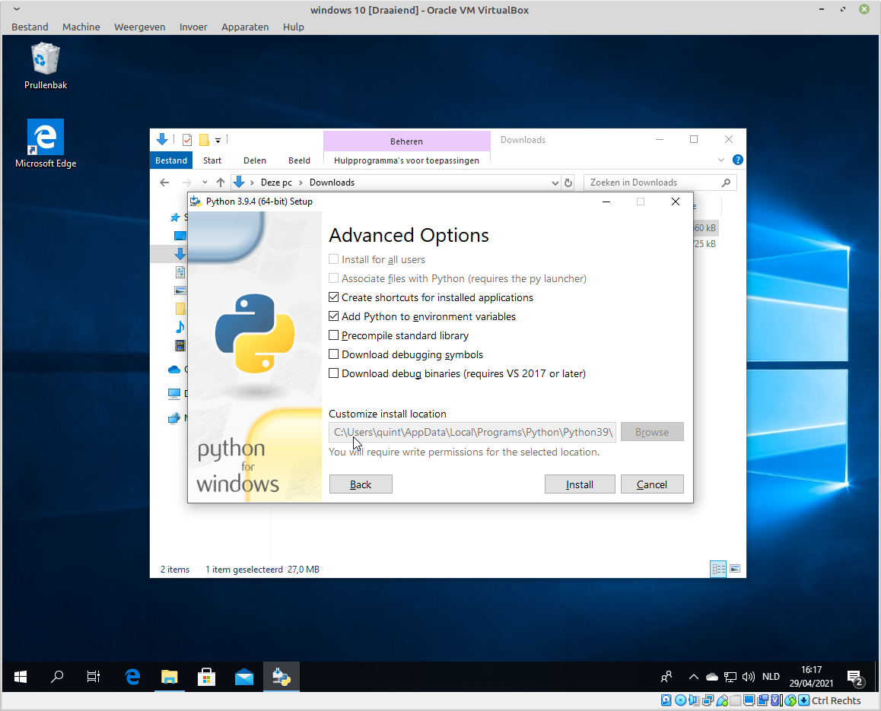
step 3)
now there are 2 options, option 1 you want to the database on the same computer, or 2 you want to have a database on another computer. If option 2 applies to you, skip to page 7.

Option 1) (database on the same computer)
step 1) download xampp from https://www.apachefriends.org/index.html
step 2) run the installation process, all default. Then open the control panel and
step 3) start the mysql and apache servers
step 4) click on admin in the control panel.
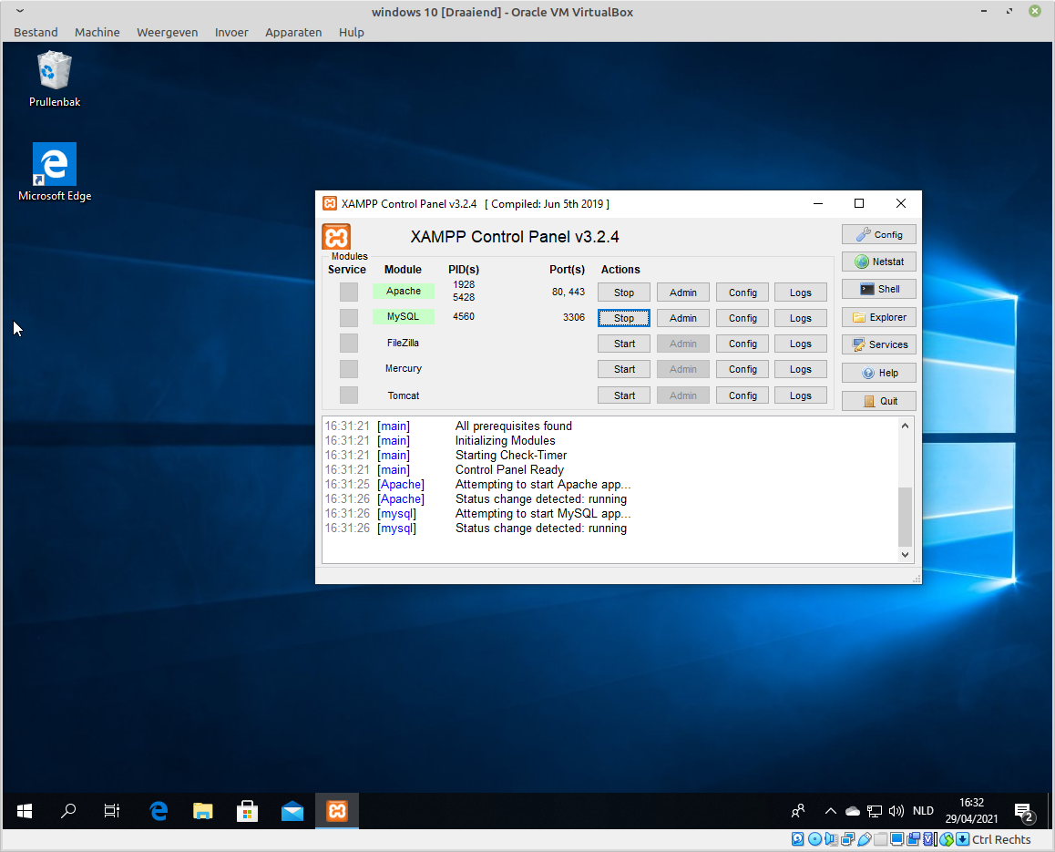

This will open the phpmyadmin webpage in the default browser, you will then need to create a user.
Do this by going to the sql tab and typing:
CREATE USER ‘username’@’localhost’ IDENTIFIED BY ‘password’;

Then write the following line underneath while making sure the username is the same.

GRANT ALL PRIVILEGES ON * . * TO ‘username’@’localhost’;

Then finally paste the line underneath into the sql field.

FLUSH PRIVILEGES;

And that’s it, you now have your very own user on the server. You can use this user to login. But you need to change the password encryption to native_mysql_password with the line underneath

ALTER USER 'username'@'localhost' IDENTIFIED WITH mysql_native_password BY 'password';

note the password in here can be the same as the one originally used in creating the account

it should look like this
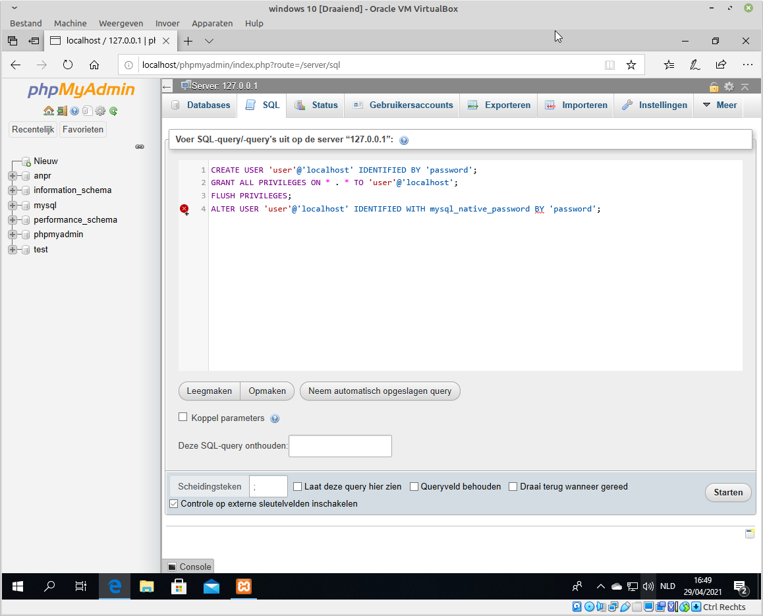
the red identation at line 4 is normal.
then press start, if all went to plan it should’ve created a user and not thrown any errors until line 4.
It may throw some notices though, The last line complains about a missing comma, but run it anyway.

Now click new in the left bar, it’s above the already present databases, something the installer creates, leave them alone.

Once you click new, give in the name ‘anpr‘, and click create.

Now click the anpr database in the left bar. And click it’s sql field and copy the following into the sql field

CREATE TABLE `anpr`.`gratiekapel` ( `ID` INT NOT NULL AUTO_INCREMENT , `naam` VARCHAR(35) NOT NULL , `nummerplaat` VARCHAR(12) NOT NULL , `startdatum` DATE NOT NULL , `einddatum` DATE NOT NULL , `pincode` INT(4) NOT NULL , `actief` BOOLEAN NOT NULL , PRIMARY KEY (`ID`)) ENGINE = InnoDB;

CREATE TABLE `anpr`.`agora` ( `ID` INT NOT NULL AUTO_INCREMENT , `naam` VARCHAR(35) NOT NULL , `nummerplaat` VARCHAR(12) NOT NULL , `startdatum` DATE NOT NULL , `einddatum` DATE NOT NULL , `pincode` INT(4) NOT NULL , `actief` BOOLEAN NOT NULL , PRIMARY KEY (`ID`)) ENGINE = InnoDB;

CREATE TABLE `anpr`.`middelheim` ( `ID` INT NOT NULL AUTO_INCREMENT , `naam` VARCHAR(35) NOT NULL , `nummerplaat` VARCHAR(12) NOT NULL , `startdatum` DATE NOT NULL , `einddatum` DATE NOT NULL , `pincode` INT(4) NOT NULL , `actief` BOOLEAN NOT NULL , PRIMARY KEY (`ID`)) ENGINE = InnoDB;

CREATE TABLE `anpr`.`brandijzer` ( `ID` INT NOT NULL AUTO_INCREMENT , `naam` VARCHAR(35) NOT NULL , `nummerplaat` VARCHAR(12) NOT NULL , `startdatum` DATE NOT NULL , `einddatum` DATE NOT NULL , `pincode` INT(4) NOT NULL , `actief` BOOLEAN NOT NULL , PRIMARY KEY (`ID`)) ENGINE = InnoDB;

CREATE TABLE `anpr`.`vekesstraat` ( `ID` INT NOT NULL AUTO_INCREMENT , `naam` VARCHAR(35) NOT NULL , `nummerplaat` VARCHAR(12) NOT NULL , `startdatum` DATE NOT NULL , `einddatum` DATE NOT NULL , `pincode` INT(4) NOT NULL , `actief` BOOLEAN NOT NULL , PRIMARY KEY (`ID`)) ENGINE = InnoDB;

CREATE TABLE `anpr`.`venusstraat` ( `ID` INT NOT NULL AUTO_INCREMENT , `naam` VARCHAR(35) NOT NULL , `nummerplaat` VARCHAR(12) NOT NULL , `startdatum` DATE NOT NULL , `einddatum` DATE NOT NULL , `pincode` INT(4) NOT NULL , `actief` BOOLEAN NOT NULL , PRIMARY KEY (`ID`)) ENGINE = InnoDB;

press start and let it do it’s work.

And done, you now have created a ready to use database.

Now for option 2, you want to use a database on another computer.
Step 1) open the databasemanager2.py in your favorite text editor
you will see a small bit of configuration under the imports, give the IP adress or server address instead of this configuration. (a static ip address is recommended).

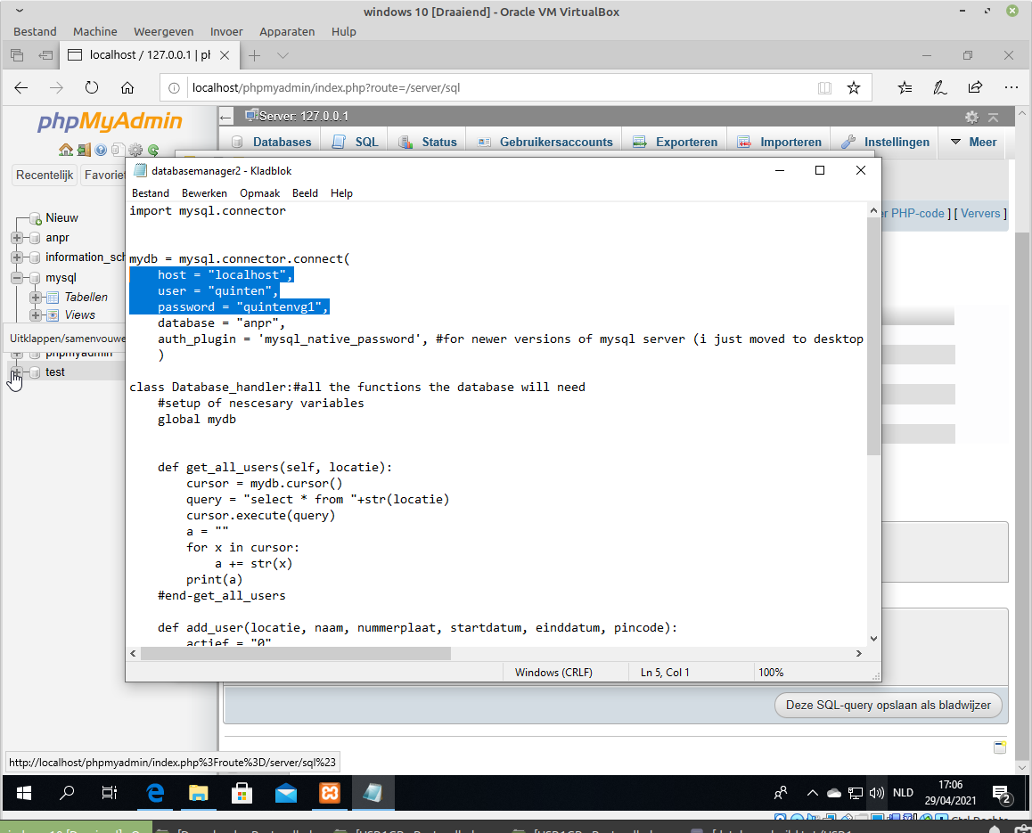
Save it close it and done.

