

**INTERNATIONAL SCHOOL**

**CAPSTONE PROJECT 1**

**CMU-CS 246 HIS**

**PROJECT PLAN DOCUMENT**

Version: 1.1

**CALCULATION SOFTWARE – CS**

**Mentor: Nguyen Dang Quang Huy**

***Team Member*:**

Lê Quang Anh

Trương Xuân Bảo

Phạm Quỳnh Chi

Bùi Tạ Hồng Đạt

Liễu Thị Thuỳ Trang

**Approved by Huy Nguyen Dang Quang**

**Project Plan Review Panel Representative:**

Name Signature Date

**Capstone Project 1- Mentor:**

Name Signature Date

Da Nang, 01/2024

**PROJECT INFORMATION**

|  |  |
| --- | --- |
| **Project Acronym** | CS |
| **Project Title** | Calculation Software | | | |
| **Start Date** | 25 – Jan –2024 | **End Date** | 19 – Fer –2024 | |
| **Lead Institution** | International School, Duy Tan University | | | |
| **Team Member** | **Name** | **Email** | | **Phone** |
| 28211100194 | Lê Quang Anh | lequanganhh1624@gmail.com | | 0329163990 |
| 28211133323 | Trương Xuân Bảo | [truongxuanbao2004@gmail.com](mailto:truongxuanbao2004@gmail.com) | | 0889606440 |
| 28209020840 | Phạm Quỳnh Chi | [quynhchihtk84@gmail.com](mailto:quynhchihtk84@gmail.com) | | 0835650230 |
| 28219002511 | Bùi Tạ Hồng Đạt | Datroobin@gmail.com | | 0795580904 |
| 28209024783 | Liễu Thị Thuỳ Trang | [tt1605589@gmail.com](mailto:tt1605589@gmail.com) | | 0353093304 |

**PROJECT PLAN DOCUMENT**

|  |  |  |  |
| --- | --- | --- | --- |
| **Document Title** | Project Plan Document | | |
| **Author(s)** | 246 HIS Team 1 | | |
| **Date** | Jan 26th, 2024 | **File name:** | C1SE.28_CS_ProjectPlan_v1.1.docx |
| **URL** | https://drive.google.com/drive/u/0/folders/1divRQwKtEeAWXxM2Dx5fuFPS8FIYdeZW | | |
| **Access** | Project and CMU Program | | |

**SIGNATURE**

**Document Approvals:** The following signatures are required for approval of this document.

|  |  |  |  |
| --- | --- | --- | --- |
| **Mentor** | Huy, Nguyen Dang Quang | **Signature:** |  |
| **Date:** |  |
| **Project Manage** | Quynh Chi Pham | **Signature:** |  |
| **Date:** |  |
| **ProDuct**  **Owner** | Huy Nguyen Dang Quang | **Signature:** |  |
| **Date:** |  |
| **Team member(s)** | Quang Anh, Xuan Bao | **Signature:** |  |
| **Date:** |  |
| Hong Dat, Thuy Trang | **Signature:** |  |
| **Date:** |  |

**TABLE OF CONTENTS**

**I. INTRODUCTION 5**

**1. PURPOSE 5**

**2. SCOPE 5**

**3. SCOPE 5**

**II. LIST OF USER INTERFACE 6**

**1. BUSINESS FUNCTION DIAGRAM: 6**

**2. WEB APP: 6**

**III. DESCRIBE USER INTERFACE 7**

**1. CALCULATION SELECTION PAGE 7**

**2. CALCULATION PAGE 8**

## 

# INTRODUCTION

## PURPOSE

* User interface design document for calculation functions
* Be the primary document driving the implementation of the user interfaces.
* Introduce interface design for the reader. Including the background, content information display, command buttons.

## SCOPE

* This document helps to better understand the interface of the System, detailed specification components and function of the System.
* With this document, the development team can understand the structure and composition to create a consistent and complete system.
* Overview of the stages and modules of the software and create a complete interface.

## SCOPE

This document is intended for the following audiences:

* Technical reviewers including:
* Scrum Master
* Product owner
* Implementer, including:
  + Developers.
  + Testers.

# LIST OF USER INTERFACE

## BUSINESS FUNCTION DIAGRAM:

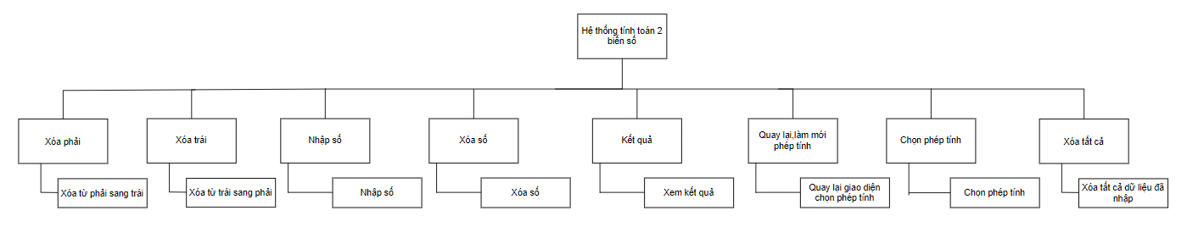

*Figure 1: Business Function diagram*

## WEB APP:

|  |  |  |
| --- | --- | --- |
| **User Interface ID** | **UI Name** | **Description** |
| UI-01 | Calculation selection page | This page is used to select calculations when you want to calculate |
| UI-02 | Addition page | This page is used to calculate addition of 2 numbers |
| UI-03 | Subtraction page | This page is used to calculate subtraction of 2 numbers |
| UI-04 | Multiplication page | This page is used to calculate multiplication of 2 numbers |
| UI-05 | Mod operation page | This page is used to calculate mod operation of 2 numbers |
| UI-06 | Division page | This page is used to calculate division of 2 numbers |
| UI-07 | Square page | This page is used to calculate the square of a number |
| UI-08 | Square root page | This page is used to calculate the square root of a number |

*Table 1: List of Interface*

# DESCRIBE USER INTERFACE

## 1. CALCULATION SELECTION PAGE

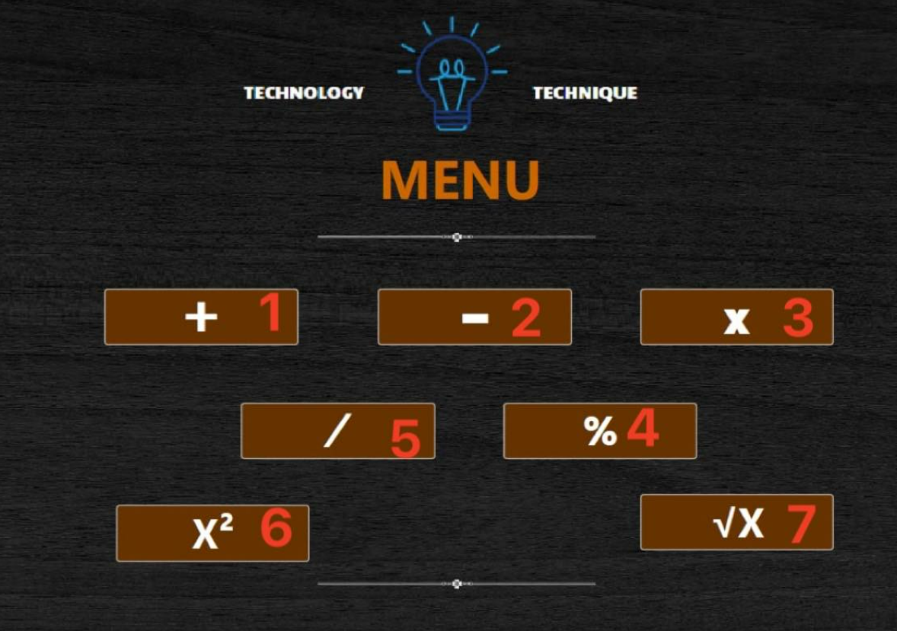

|  |  |  |  |
| --- | --- | --- | --- |
| **ID** | **Condition** | **Control Type** | **Target** |
| 1 | Press | Button | Click to go to the addition page |
| 2 | Press | Button | Click to go to the subtraction page |
| 3 | Press | Button | Click to go to the multiplication page |
| 4 | Press | Button | Click to go to the mod operation page |
| 5 | Press | Button | Click to go to the division page |
| **6** | **Press** | **Button** | **Click to go to the square page** |
| **7** | **Press** | **Button** | **Click to go to the square root page** |

Table 2: Describe User Interface Calculation page

## 2. CALCULATION PAGE

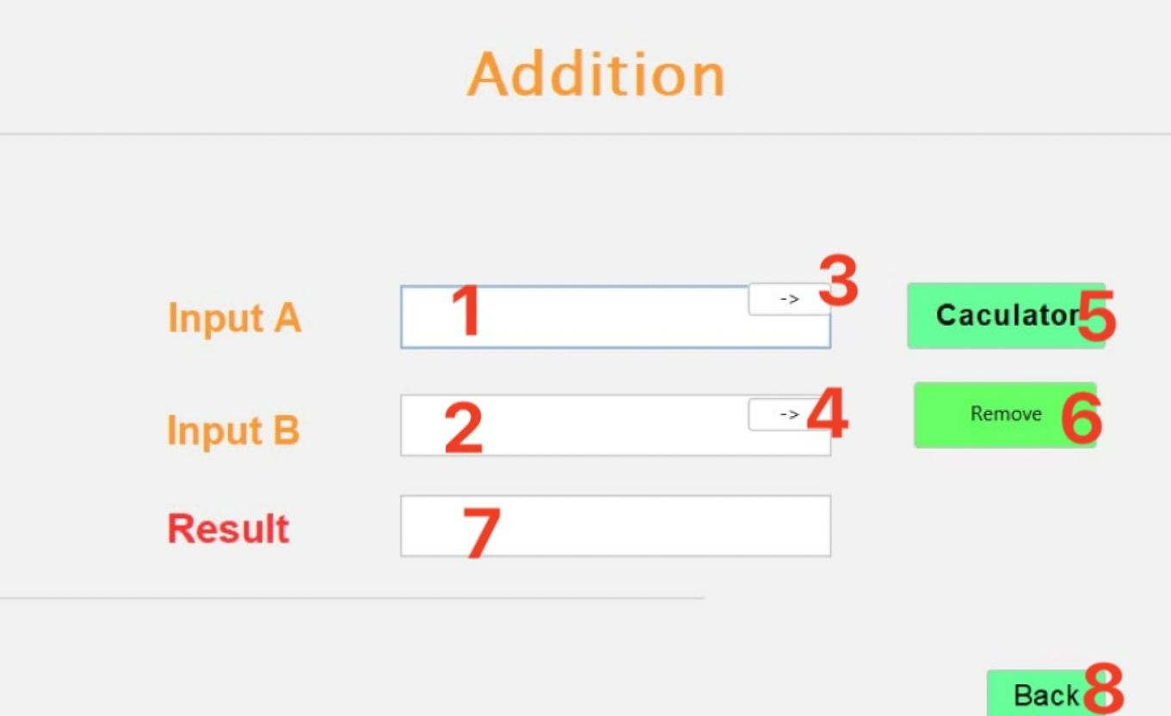

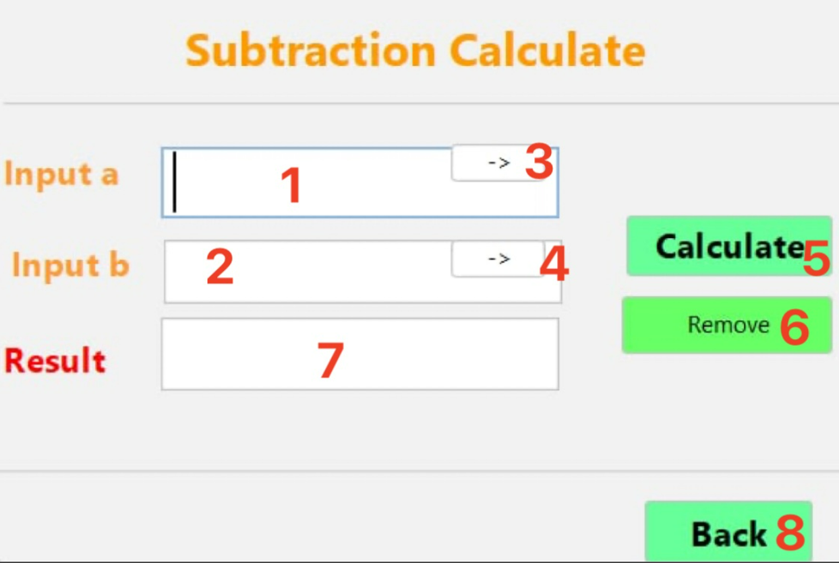

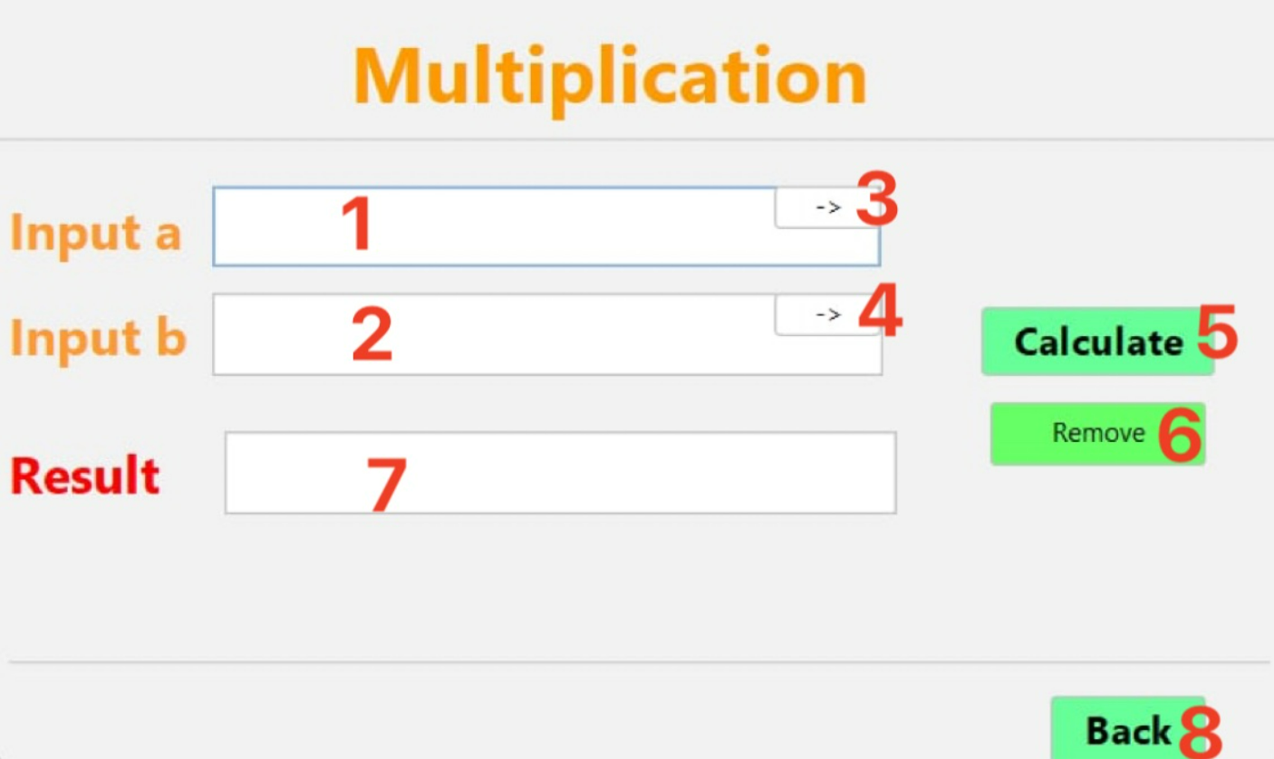

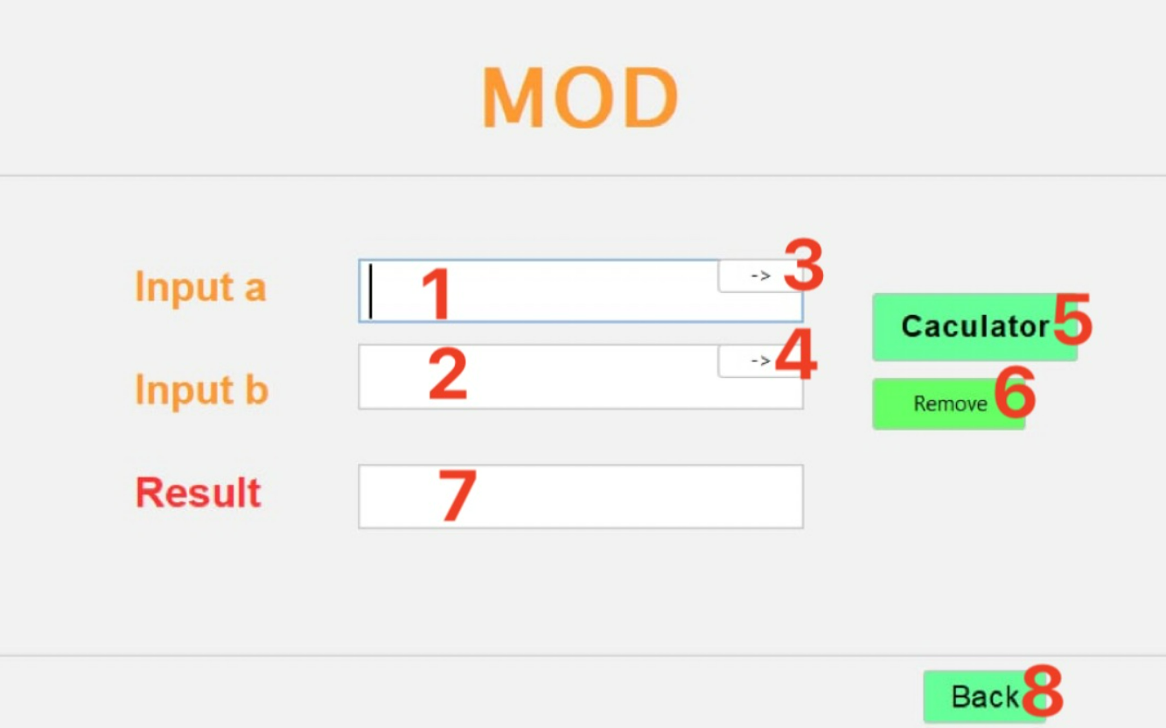

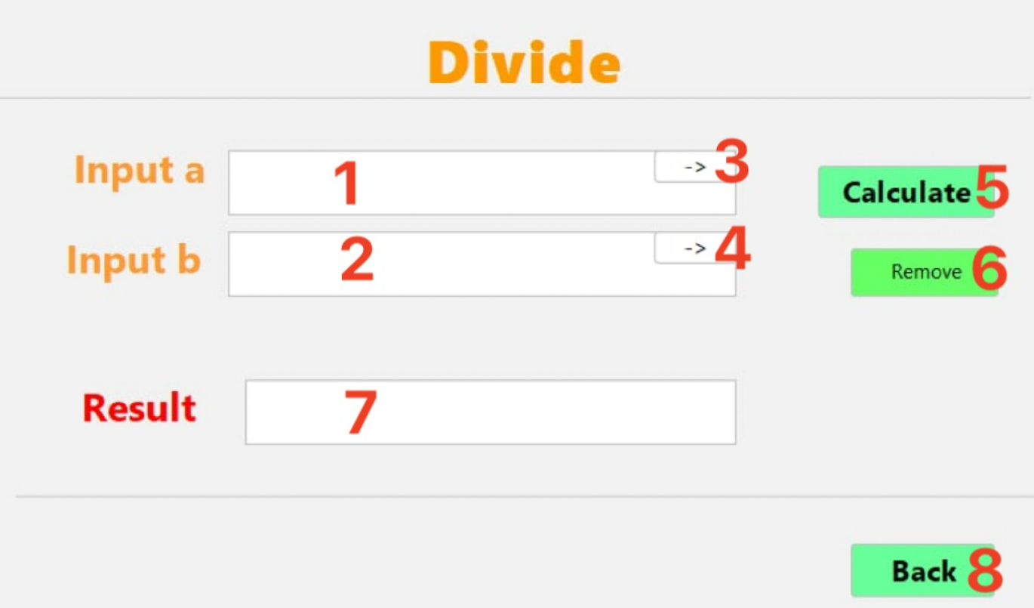

|  |  |  |  |
| --- | --- | --- | --- |
| **ID** | **Condition** | **Control Type** | **Target** |
| 1 | Press | Input text | Enter the first number |
| 2 | Press | Input text | Enter the second number |
| 3 | Press | Button | press to delete from left to right of the first number |
| 4 | Press | Button | press to delete from left to right of the second number |
| 5 | Press | Button | Click to display calculation result |
| 6 | Press | Button | Tap to delete all data |
| 7 | See | Label | Display calculation result |
| 8 | Press | Button | Click to go back to the calculation selection page |

Table 3: Describe User Interface addition, subtraction, multiplication, mod operation, division , square, square root page

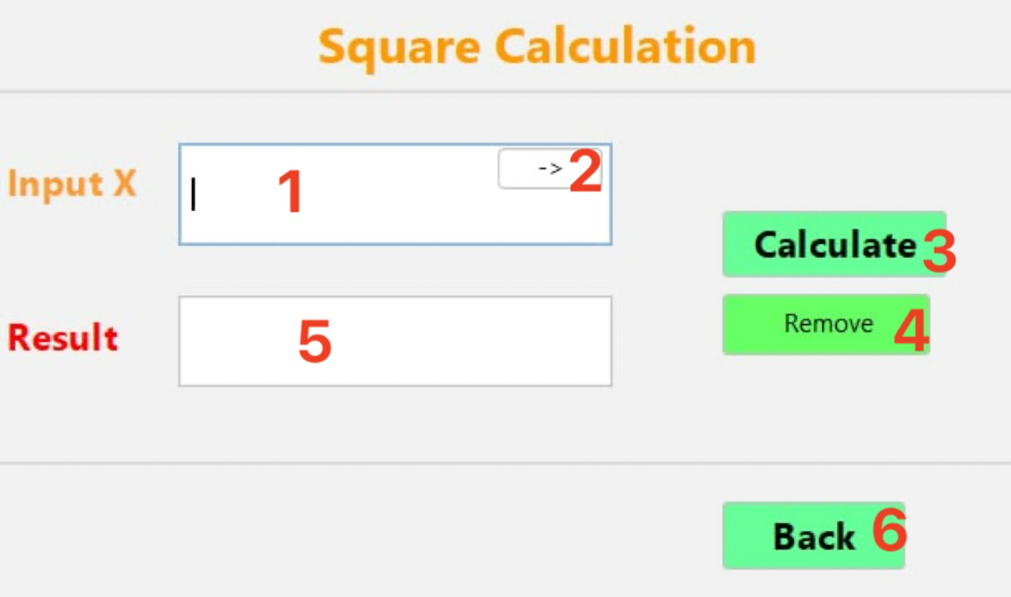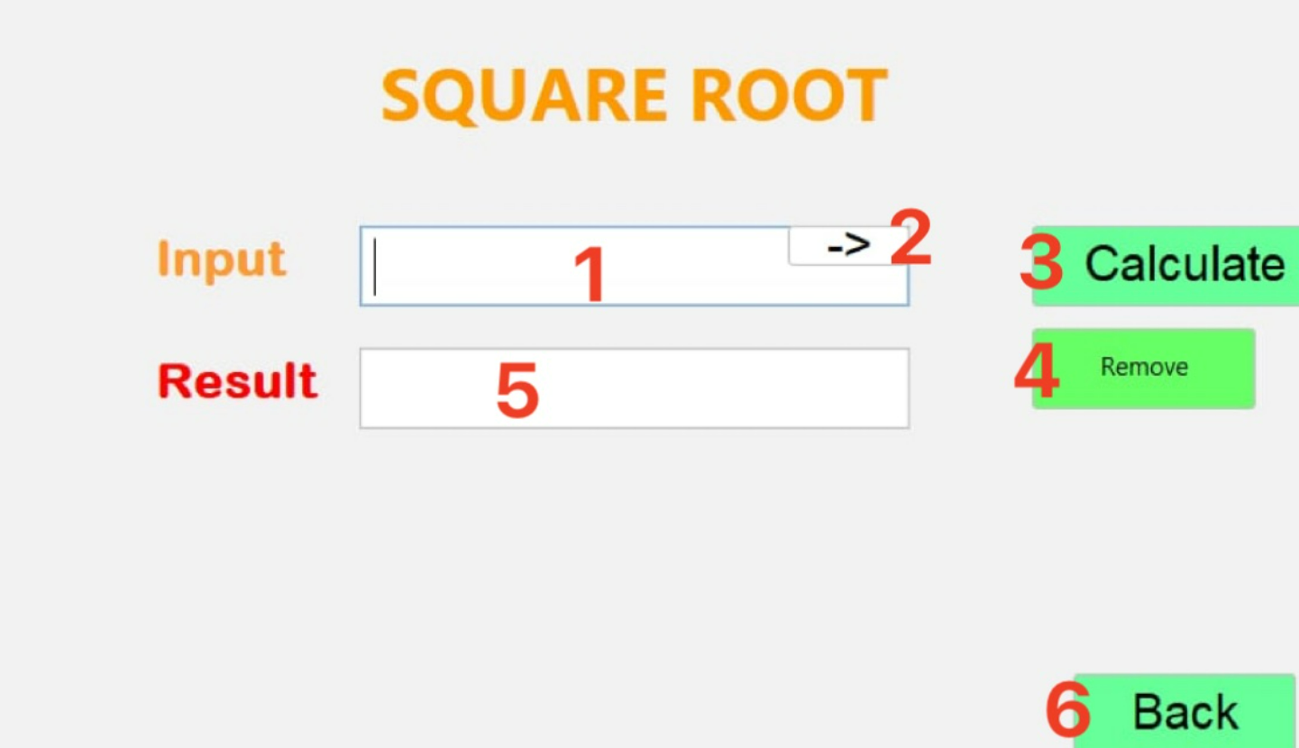

|  |  |  |  |
| --- | --- | --- | --- |
| **ID** | **Condition** | **Control Type** | **Target** |
| 1 | Press | Input text | Enter a number |
| 2 | Press | Button | press to delete from left to right of a number |
| 3 | Press | Button | Click to display calculation result |
| 4 | Press | Button | Tap to delete all data |
| 5 | See | Label | Display calculation result |
| 6 | Press | Button | Click to go back to the calculation selection page |

Table 3: Describe User Interface square, square root page