**CS2312 Assignment 3: Functional Programming**

**Prepared by: Shuai Cheng Li**

**Deadline: April 20th, 11 pm, 2019**

**Question 1** We can use nested lists to represent a binary tree. For example, we can represent the binary tree in Fig 1 with the list as

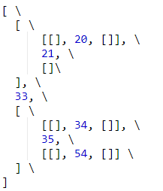

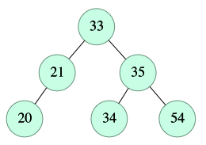

Figure 1. Binary tree

With the nested list representation of a tree, we hope to solve the following problems with recursions in python.

1. Define a function **swap(aTree)** to return the mirror image of a given a tree, i.e., all the left and right children are **swapped**.
2. Write a function **height(aTree)** to calculate if the binary tree
3. Write a function **isBST(aTree)** to check if a given tree is a binary search tree.
4. Write a function **count(aTree)** to count the number of non-empty elements in a given tree.

**Question 2**. We will use the higher order functions **map**, **reduce** and **filter** to solve the problems on a list of numbers. No recursions or loops are allowed in this question. You can define helper functions.

1. Write a function count(aList) to return the number of elements in a list.
2. Write a function isSorted(aList) check if the element in a list is sorted in non-decreasing order.
3. Write a function remDup(aList) to remove the duplicates in a sorted list in non-decreasing order. For example, remDup([1, 1, 1, 2, 3, 3]) will produce [1, 2, 3].
4. Write a function sumUp(aList) in python that sums up the elements in the list. When calculating the sum, sumUp will skip an element if it is negative. Also, an element will be skipped it is the same as its next element

For example sumUP([]) will return 0, sumUp([1, -1, 3, 4, 2, 2, 4]) will return 14.

**Submission Guidelines**

* Put your program in a file named assignment3.py and submit it to Canvas
* Your assignment may be missed and **may not be marked**.

*How do you mark my assignment?*

* For some problem, we have several test cases. Also, we will read your program.
* If your program does not show correct answers, some (or all) marks will be deducted depending on the mistakes/errors you make.

***What else I should know?***

**Each source program must start with the following comments:**

**# Name: (Your name)**

**# Student ID: (Your student ID)**