AVIATIONEXAM GUIDE

ATPL Sitting Planner
How to organise 13 subjects, six sittings and the 18-month window into a plan you can follow.
Choose your plan with two questions: how much time you have, and how comfortable you are with calculations. Each plan gives you the subjects for every sitting, the hours a day it needs and how much of the 18-month exam window it uses.

The rules your plan must fit
Every plan follows EASA Part-FCL.025.
Rule | What it means
13 subjects | Each examined separately by your competent authority, from 010 Air Law to 090 Communications.
KSA100 | Assessed by your ATO together with a mental maths test, not an exam subject. Pass it before you are recommended for your final exam at first attempt.
6 sittings | Maximum for the complete set of exams.
4 attempts | Maximum per subject.
18 months | To pass everything, counted from the end of the calendar month of your first exam attempt.
75% | Pass mark in each paper. No negative marking.

Choose your plan
The first answer sets your pace. The second decides how the calculation subjects are spread. Every plan puts the heavy foundation subjects first, each subject after the ones it builds on, and light subjects and Flight Planning at the end.
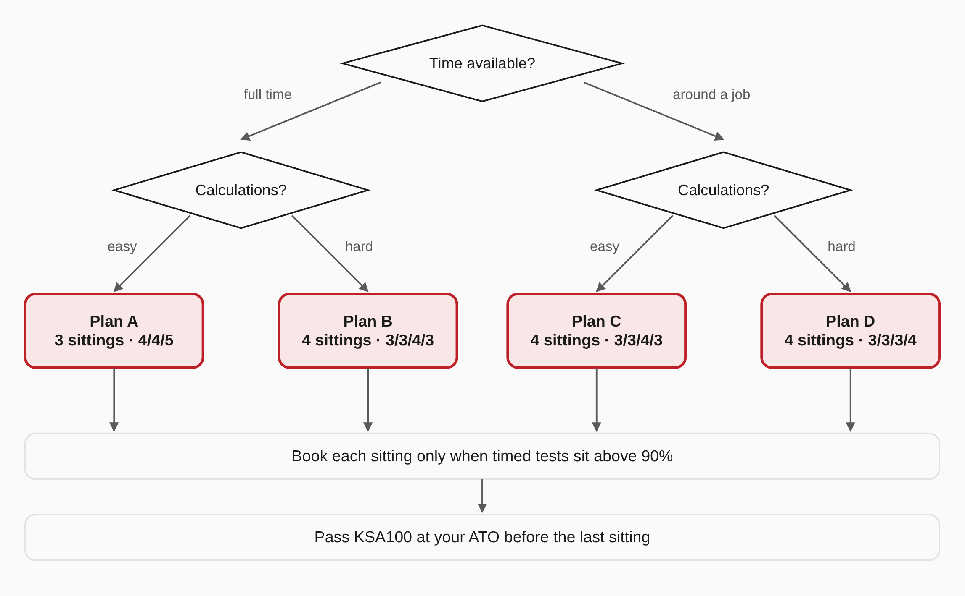

The four plans at a glance
Every plan totals around 1,000 hours and ends with Flight Planning. Hours a day are the reference pace; at a different pace the timeline stretches or shortens.
Plan | For | Sittings | Hours a day | Days a week | First exam | Exam clock used | Total
A | Full time, comfortable with calculations | 3 | 6 | 5 | Month 4 | 4 of 18 months | ~8 months
B | Full time, less comfortable with calculations | 4 | 5 | 5 | Month 4 | 6 of 18 months | ~10 months
C | Around a job, comfortable with calculations | 4 | 2 | 6 | Month 7 | 13 of 18 months | ~19 months
D | Around a job, less comfortable with calculations | 4 | 2 | 6 | Month 6 | 14 of 18 months | ~19 months

Plan A – Full time, three sittings
Full time, comfortable with calculations. The heavy foundation subjects come first, while the 18-month clock is not yet running. Light subjects and Flight Planning close the plan.
6 h a day, 5 days a week · first exam in month 4 · 4 of 18 months on the exam clock · ~8 months in total
Sitting | Subjects | Study hours | Weeks | Exam
Sitting 1 | ■ 081 Principles of Flight 100 h  ■ 021 Airframe, Systems, Electrics, Power Plant 100 h  ■ 061 General Navigation 100 h  ■ 022 Instrumentation 70 h | 370 h | 13 | Month 4
Sitting 2 | ■ 032 Performance 100 h  ■ 062 Radio Navigation 70 h  ■ 050 Meteorology 100 h  ■ 010 Air Law 70 h | 340 h | 12 | Month 6
Sitting 3 | Pass KSA100 at your ATO first  ■ 070 Operational Procedures 70 h  ■ 040 Human Performance & Limitations 40 h  ■ 031 Mass & Balance 40 h  ■ 090 Communications 40 h  ■ 033 Flight Planning and Monitoring 100 h | 290 h | 10 | Month 9

Plan B – Full time, four sittings
Full time, less comfortable with calculations. Heavy foundations first, and never more than one heavy calculation subject per sitting. Start using your flight computer from the first week, ten minutes a day.
5 h a day, 5 days a week · first exam in month 4 · 6 of 18 months on the exam clock · ~10 months in total
Sitting | Subjects | Study hours | Weeks | Exam
Sitting 1 | ■ 081 Principles of Flight 100 h  ■ 021 Airframe, Systems, Electrics, Power Plant 100 h  ■ 022 Instrumentation 70 h | 270 h | 11 | Month 4
Sitting 2 | ■ 061 General Navigation 100 h  ■ 010 Air Law 70 h  ■ 050 Meteorology 100 h | 270 h | 11 | Month 6
Sitting 3 | ■ 032 Performance 100 h  ■ 062 Radio Navigation 70 h  ■ 040 Human Performance & Limitations 40 h  ■ 070 Operational Procedures 70 h | 280 h | 12 | Month 8
Sitting 4 | Pass KSA100 at your ATO first  ■ 031 Mass & Balance 40 h  ■ 090 Communications 40 h  ■ 033 Flight Planning and Monitoring 100 h | 180 h | 8 | Month 10

Plan C – Around a job, calculation foundations first
Around a job, comfortable with calculations. Principles of Flight, AGK and General Navigation in the first sitting, while the clock is not running. Light subjects and Flight Planning close the plan.
2 h a day, 6 days a week · first exam in month 7 · 13 of 18 months on the exam clock · ~19 months in total
Sitting | Subjects | Study hours | Weeks | Exam
Sitting 1 | ■ 081 Principles of Flight 100 h  ■ 021 Airframe, Systems, Electrics, Power Plant 100 h  ■ 061 General Navigation 100 h | 300 h | 25 | Month 7
Sitting 2 | ■ 022 Instrumentation 70 h  ■ 062 Radio Navigation 70 h  ■ 032 Performance 100 h | 240 h | 20 | Month 11
Sitting 3 | ■ 050 Meteorology 100 h  ■ 010 Air Law 70 h  ■ 070 Operational Procedures 70 h  ■ 040 Human Performance & Limitations 40 h | 280 h | 24 | Month 16
Sitting 4 | Pass KSA100 at your ATO first  ■ 031 Mass & Balance 40 h  ■ 090 Communications 40 h  ■ 033 Flight Planning and Monitoring 100 h | 180 h | 15 | Month 20

Plan D – Around a job, calculation subjects spread out
Around a job, less comfortable with calculations. Concept foundations first. General Navigation, Performance and Flight Planning each go in a different sitting, so you never face two heavy calculation subjects together.
2 h a day, 6 days a week · first exam in month 6 · 14 of 18 months on the exam clock · ~19 months in total
Sitting | Subjects | Study hours | Weeks | Exam
Sitting 1 | ■ 081 Principles of Flight 100 h  ■ 021 Airframe, Systems, Electrics, Power Plant 100 h  ■ 040 Human Performance & Limitations 40 h | 240 h | 20 | Month 6
Sitting 2 | ■ 061 General Navigation 100 h  ■ 022 Instrumentation 70 h  ■ 010 Air Law 70 h | 240 h | 20 | Month 10
Sitting 3 | ■ 032 Performance 100 h  ■ 062 Radio Navigation 70 h  ■ 050 Meteorology 100 h | 270 h | 23 | Month 15
Sitting 4 | Pass KSA100 at your ATO first  ■ 070 Operational Procedures 70 h  ■ 031 Mass & Balance 40 h  ■ 090 Communications 40 h  ■ 033 Flight Planning and Monitoring 100 h | 250 h | 21 | Month 20

■ Concept: understand the mechanism ■ Calculation: practise with a timer ■ Memory: short daily repetition
Month numbers count from the day you start studying. Your authority publishes the actual exam calendar.

Use the time before your first exam
The 18-month window starts with your first exam attempt, not with your first class. Every month you prepare before that first sitting is outside the clock. Book your first sitting only when:
- every subject in it scores above 90% in timed practice tests, without notes, and
- you have already started the first subject of your second sitting.
In an integrated course your school sets the exam dates, so use the plan to decide what to prioritise inside each block. In a modular course you choose the dates. If you fail a subject, re-sit it in your next planned sitting and move one planned subject to the end.

Why the order matters
Arrows mean “study this first”. Flight Planning uses almost everything, so it goes last in every plan.
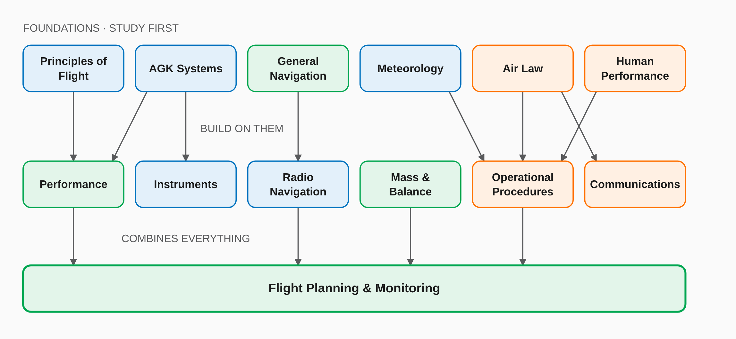

What each subject asks of you
Subject | Type | Workload | Study time
010 Air Law | Memory | Medium | ~70 h
021 Airframe, Systems, Electrics, Power Plant | Concept | Heavy | ~100 h
022 Instrumentation | Concept | Medium | ~70 h
031 Mass & Balance | Calculation | Light | ~40 h
032 Performance | Calculation | Heavy | ~100 h
033 Flight Planning and Monitoring | Calculation | Heavy | ~100 h
040 Human Performance & Limitations | Memory | Light | ~40 h
050 Meteorology | Concept | Heavy | ~100 h
061 General Navigation | Calculation | Heavy | ~100 h
062 Radio Navigation | Concept | Medium | ~70 h
070 Operational Procedures | Memory | Medium | ~70 h
081 Principles of Flight | Concept | Heavy | ~100 h
090 Communications | Memory | Light | ~40 h
Total |  |  | ~1,000 h
Around 1,000 hours in total: the EASA minimum of 650 h (modular) or 750 h (integrated) of theoretical instruction, plus question-bank practice. Subjects you already know well may need about 30% less.

One sitting, week by week
A sitting of four subjects (two heavy, two light) fits into 16 weeks. Stretch it to 20 weeks around a job, or compress it to 12 full time.
Weeks | Heavy subject 1 | Heavy subject 2 | Light subject 1 | Light subject 2
1–4 | First pass by learning objective, with notes | — | — | —
5–6 | Retake wrong answers, read flagged theory | First pass by learning objective, with notes | — | —
7–8 | Weekly review (30 min) | First pass by learning objective, with notes | — | —
9–10 | Weekly review (30 min) | Retake wrong answers, read flagged theory | First pass by learning objective, with notes | —
11–12 | Weekly review (30 min) | Weekly review (30 min) | Retake wrong answers, read flagged theory | First pass by learning objective, with notes
13 | Weekly review (30 min) | Weekly review (30 min) | Weekly review (30 min) | Retake wrong answers, read flagged theory
14–15 | Timed tests, no notes | Timed tests, no notes | Timed tests, no notes | Timed tests, no notes
16 | Exam | Exam | Exam | Exam

Disclaimer
Exam rules per EASA Part-FCL as published by Aviationexam. Workload and type labels are the Aviationexam author team's consensus, not an EASA classification. Whether a subject feels easy or hard is personal; move things around once you know yourself.

