Saturn
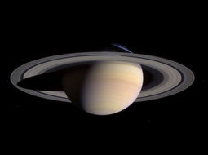
Figure 1 Saturn casts a shadow on its rings.

How big is Saturn
Saturn is 120,536 km or 9.449 Earths wide at the equator.

What are its Rings like
Saturn's rings are composed of rock and ice particles ranging in size from specks of dust to the size of a house. Some particles might even be a few kilometers wide! The particles in the rings are actually spaced far apart. It would be easy to pass through the rings.

How long is a day on Saturn
One day on Saturn is about 10 hours and 39 minutes in Earth time.

What is Saturn made of
Saturn has a rocky core. Around the core, there is ice. Above the ice is liquid metallic hydrogen. On top of that is gaseous hydrogen. There is no place where the hydrogen suddenly turns from a gas to a liquid.
The gaseous hydrogen makes up most of Saturn's atmosphere. Other gases there include helium and some other gases. There may be rain made of helium falling through the hydrogen.

Saturn Facts

- If you could find a bathtub big enough, Saturn would float in it.
- Some of Saturn's moons control the width of its rings. These are known as shepherd moons.
- Although it is made mostly of gases, scientists believe Saturn has a small rocky core.

http://www.nineplanets.org/saturn.html
http://solarsystem.nasa.gov/planets/profile.cfm?Object=Saturn&Display=Facts&System=Metric

