Uranus
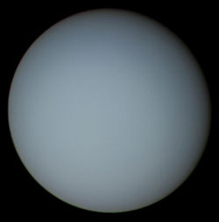
Figure 1 Uranus as seen from Voyager 2.

How big is the planet
Uranus is 51,118 kilometers or about four Earths wide. It is the third widest and fourth heaviest planet in the Solar System.

How long is a day on Uranus
One day on Uranus is about 17 Earth hours long. Uranus spins on its side, maybe because of a big impact early in the history of the Solar System.

How long is a year on Uranus
One year on Uranus would be 30,708 days or 84 years on Earth.

What is it made of
Unlike Jupiter and Saturn, Uranus is thought to be made mostly of rock and ice. The gases in its atmosphere are mostly hydrogen and helium. Other gases found in smaller amounts are ammonia, water, and methane. Uranus' blue color comes from methane clouds, which absorb red light and reflect blue light.

Uranus Facts

- Uranus's rings look white in pictures, but they are really made of asphalt-colored material.
- When it was first discovered, Uranus was mistaken for a star. It was named "34 Tauri".
- Uranus rotates on its side like Pluto.
- Uranus is the only planet to be named after a Greek god, not a Roman one.
- Uranus has 27 known moons.

Miranda is smallest and closest moon to Uranus.

