Tab 1

BRAC University
Department of Computer Science and Engineering

CSE422 — Machine Learning Lab
Lab Project Report
Tree Sterility Prediction
Using Machine Learning Classification Models

Submitted to:
Asif Hasan [AHC] & Mehedi Hasan Emo [MHDE]
Department of Computer Science and Engineering

Submitted by:

Student Name(s) | ID(s) | Section
Musfikur Rahman Mahin | 23201432 | 22
Myesha Fahmeda | 23301606

Date of Submission: 2nd May, 2026

Table of Contents

1. Introduction 4
2. Dataset Description 5
2.1 Dataset Overview 5
2.1.1 Feature Summary 5
2.1.2 Type of Features 6
2.1.3 Statistical Summary of Numeric Features 6
2.1.4 Skewness and Variance of Numerical Features 7
2.1.5 Encoding of Categorical Variables 8
2.2 Correlation Analysis 8
2.2.1 Three-Method Correlation Comparison (Pearson, Spearman, Kendall) 10
2.3 Imbalanced Dataset Analysis 11
3. Exploratory Data Analysis (EDA) 12
3.1 Boxplots by Sterility Class 12
3.2 Categorical Features vs. Sterility 13
3.3 Histograms of Numerical Features 13
4. Dataset Pre-processing 15
4.1 Problem 1 — Null / Missing Values 15
Fault: 15
Solution: 15
4.2 Problem 2 — Categorical Variables 16
Fault: 16
Solution: 16
4.3 Problem 3 — Feature Scaling 16
Fault: 16
Solution: 16
5. Dataset Splitting 17
6. Model Training and Testing 18
6.1 K-Nearest Neighbors (KNN) 18
6.2 Decision Tree 19
6.3 Logistic Regression 20
6.4 Naive Bayes (Gaussian NB) 20
6.5 Neural Network (MLP Classifier) 21
6.6 Unsupervised Learning — K-Means Clustering 22
7. Model Selection / Comparison Analysis 24
7.1 Model Performance Summary Table 24
7.2 Accuracy Comparison Bar Chart 25
7.3 All Metrics Grouped Bar Chart 25
7.4 Precision vs. Recall Comparison 26
7.5 Confusion Matrices 27
7.6 ROC Curves and AUC Scores 28
8. Conclusion 29
8.1 Understanding of Results 29
8.2 Model Performance Comments 29
8.3 Why These Results Were Obtained 30
8.4 Challenges Faced 30
References 31

1. Introduction

Forests are complex ecological systems, and the reproductive success of trees plays a critical role in maintaining the long-term health of these ecosystems. Tree sterility — the failure of a tree to produce viable seeds or reproductive structures — can have wide-reaching effects on forest regeneration, species diversity, and wildlife habitats. Understanding what causes sterility in trees is therefore an important scientific and ecological question.
This project aims to build and compare machine learning classification models that can predict tree sterility based on a range of biological, ecological, and environmental measurements. The problem is treated as a binary classification task: given a set of recorded measurements for an individual tree, the goal is to predict whether that tree is Sterile or Non-Sterile.
The dataset used in this project, the Tree Sterility Dataset, records observations across multiple tree species and includes variables such as light availability (ISF), arbuscular mycorrhizal fungi (AMF), ectomycorrhizal fungi (EMF), phenolic content, lignin levels, non-structural carbohydrates (NSC), soil type, mycorrhizal associations, and time-related information. Together, these features describe the resource environment and biological condition of each tree.
There are two main reasons for applying machine learning to this problem. First, manually checking whether a tree is sterile in the field is time-consuming and expensive. A model trained on measurable features could serve as a faster and cheaper screening tool. Second, machine learning models can detect non-linear relationships and interactions between features that traditional statistics might miss, potentially revealing new ecological insights.
The project trains and compares five supervised classification algorithms — K-Nearest Neighbors (KNN), Decision Tree, Logistic Regression, Naive Bayes, and a Multi-Layer Perceptron (MLP) Neural Network — alongside an unsupervised K-Means clustering analysis. Models are evaluated using accuracy, precision, recall, F1 score, AUC, ROC curves, and confusion matrices to identify the best-performing model and draw meaningful conclusions.

2. Dataset Description

2.1 Dataset Overview
The Tree Sterility Dataset contains ecological and biological observations recorded for individual trees across multiple species and experimental conditions. It was collected to study what factors influence whether a tree is fertile or sterile.

Dataset at a Glance
Total Data Points (Rows) : 2,783
Total Features (Columns) : 24
Target Column : Sterile (Binary: 'Sterile' / 'Non-Sterile')
Problem Type : Classification
Quantitative Features : 15 (numeric measurements)
Categorical Features : 9 (species, soil type, light category, etc.)

This is a classification problem because the target variable 'Sterile' takes one of two distinct values — 'Sterile' or 'Non-Sterile'. The goal is not to predict a number (which would be regression), but to assign each tree to one of these two categories. This is supported by the binary, non-ordered nature of the target label.

2.1.1 Feature Summary
The dataset contains the following key features:

Feature Name | Type | Description | Role
No, Plot, Subplot | Categorical | Identifiers for sample location/metadata | ID/Drop
Species | Categorical (Nominal) | Tree species name (e.g., Acer saccharum, Quercus alba) | Input
Light_ISF | Quantitative | Light availability index (Indirect Site Factor) | Input
Light_Cat | Categorical (Nominal) | Categorical light level (Low/Medium/High) | Input
Core | Quantitative | Year of core sample (experimental metadata) | Drop
Soil | Categorical (Nominal) | Soil type classification | Drop
Conspecific | Categorical (Binary) | Presence of conspecific neighbors | Drop
Myco | Categorical (Binary) | Mycorrhizal inoculation type | Input
SoilMyco | Categorical (Binary) | Soil mycorrhizal association | Drop
AMF | Quantitative | Arbuscular Mycorrhizal Fungi colonization (%) | Input
EMF | Quantitative | Ectomycorrhizal Fungi colonization (%) | Input
Phenolics | Quantitative | Phenolic compound content (mg/g) | Input
Lignin | Quantitative | Lignin content (% dry weight) | Input
NSC | Quantitative | Non-Structural Carbohydrates (% dry weight) | Input
Time | Quantitative | Days elapsed since experiment start | Input
Event | Quantitative | Event indicator | Input
Harvest, Alive, Adult | Mixed | Metadata / high missingness columns | Drop
Sterile | Categorical (Binary) | TARGET: Sterile vs. Non-Sterile | Output

2.1.2 Type of Features
Quantitative features include Light_ISF, AMF, EMF, Phenolics, Lignin, NSC, Time, Core, and Event. These are continuous or discrete numeric measurements recorded on a ratio or interval scale.
Categorical features include Species, Light_Cat, Soil, Adult, Conspecific, Myco, SoilMyco, PlantDate, and Alive. These represent nominal or binary classifications.

2.1.3 Statistical Summary of Numeric Features
The table below shows the descriptive statistics (mean, std, min/max, quartiles) for all numeric features :

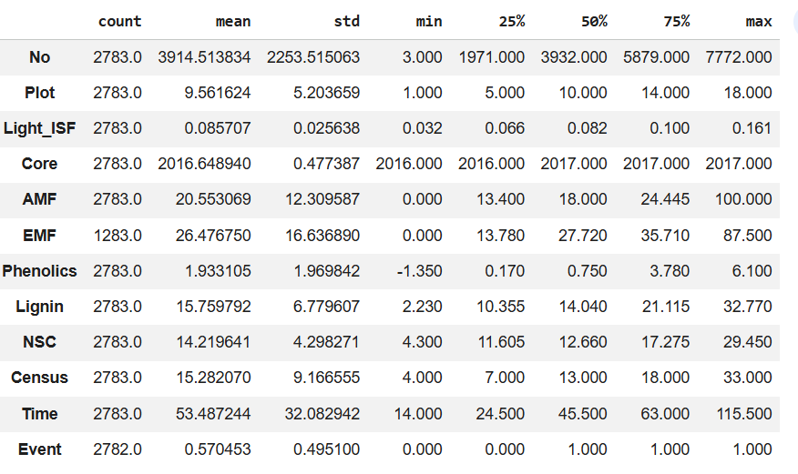

2.1.4 Skewness and Variance of Numerical Features
To better understand the distribution shape of each numeric feature, skewness and variance were computed on the raw dataset. Skewness tells us whether a feature is symmetrically distributed or leans to one side, while variance measures how spread out the values are.

Skewness Variance
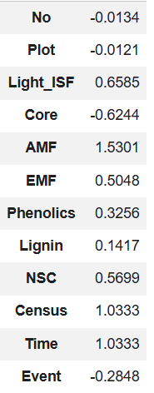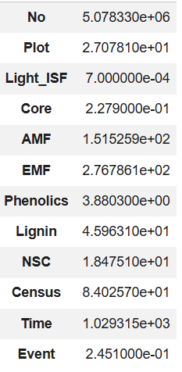
Key observations from skewness and variance analysis:
- AMF has the highest positive skewness (1.53), meaning most trees have low AMF colonization with a few having very high values.
- Census and Time both have skewness of 1.03, indicating they are right-skewed — most observations cluster at earlier time points, with fewer observations at later stages.
- Light_ISF has very low variance (0.0007), meaning light levels are quite consistent across the dataset.
- EMF has high variance (276.79) but moderate skewness (0.50), suggesting its values are widely spread but not as extreme as AMF.
- Core has negative skewness (-0.62), which is expected since values are limited to just two years (2016–2017).

2.1.5 Encoding of Categorical Variables
Most machine learning algorithms require numeric inputs, so categorical variables must first be converted into numbers. The following strategy was used:
- Label Encoding was applied to the binary target variable 'Sterile' (Non-Sterile=0, Sterile=1) and to the binary feature 'Myco', since these have only two values and a simple 0/1 encoding is appropriate without introducing any artificial ordering.
- One-Hot Encoding (via pd.get_dummies with drop_first=True) was applied to multi-category features: Species and Light_Cat. One-hot encoding creates separate binary columns for each category, avoiding the false impression that one category is numerically greater than another.
- Several columns were dropped because they are either row identifiers, contain experimental metadata, or were found to cause data leakage (their values directly reveal the sterility status). These include: No, Plot, Subplot, Adult, PlantDate, Census, Harvest, Alive, Core, Soil, SoilMyco, and Conspecific.

2.2 Correlation Analysis
To understand the linear relationships between features and with the target variable, a Pearson correlation matrix was computed and visualized using a Seaborn heatmap. The encoded target variable 'Sterile_enc' (1 = Sterile, 0 = Non-Sterile) was included alongside numeric features.

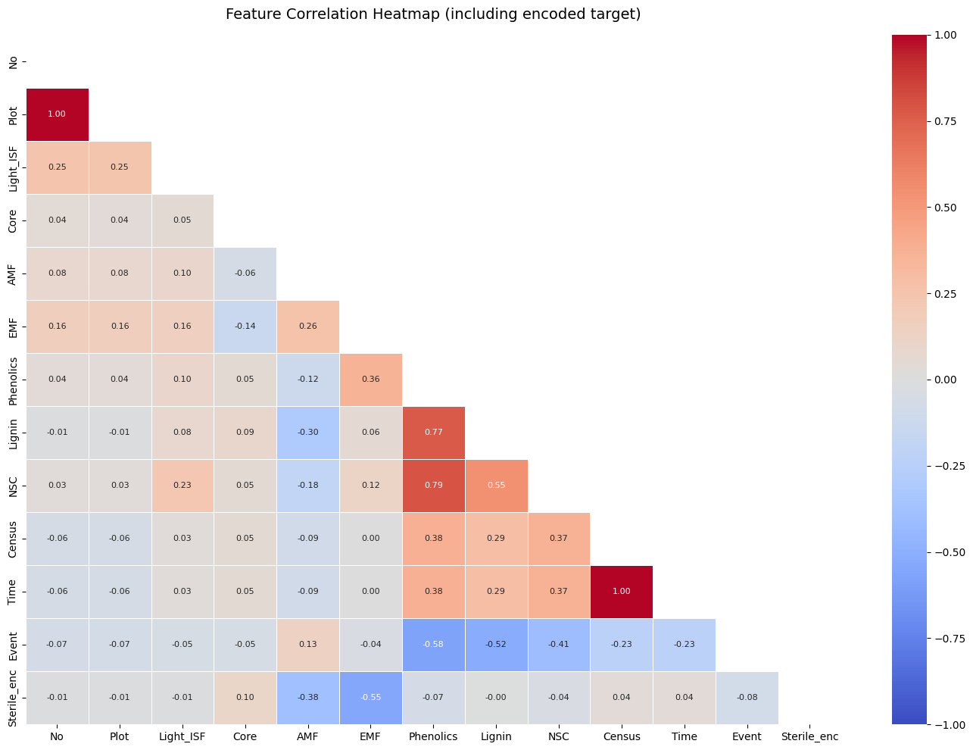
Fig. 2.1: Correlation heatmap of all numerical features including the encoded target variable

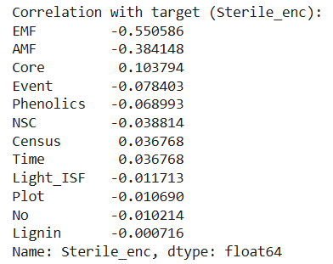

Interpretation of the correlation analysis:
- EMF and AMF show the strongest (negative) correlations with the target (Sterile_enc), with values of −0.55 and −0.38 respectively. This means trees with higher fungal colonization tend to be less sterile.
- AMF and EMF show a moderate negative correlation with each other, which is expected — trees typically associate with either arbuscular (AMF) or ectomycorrhizal (EMF) fungi, not both equally.
- Phenolics and Lignin show a strong positive correlation (0.77), which is biologically consistent since both are structural defense compounds that are often produced together.
- NSC (Non-Structural Carbohydrates) shows a moderate negative correlation with sterility, suggesting that trees with more stored energy reserves are less likely to be sterile, which aligns with the resource limitation hypothesis for reproductive failure.
- No single feature has an overwhelmingly strong correlation with the target. This suggests that a combination of features, especially through non-linear models, will be needed for accurate prediction.

2.2.1 Three-Method Correlation Comparison (Pearson, Spearman, Kendall)
To check whether the correlation patterns hold across different statistical methods, the correlation of each feature with the target was computed using three methods: Pearson (linear), Spearman (rank-based), and Kendall (concordance-based). All three methods agree on which features matter most.

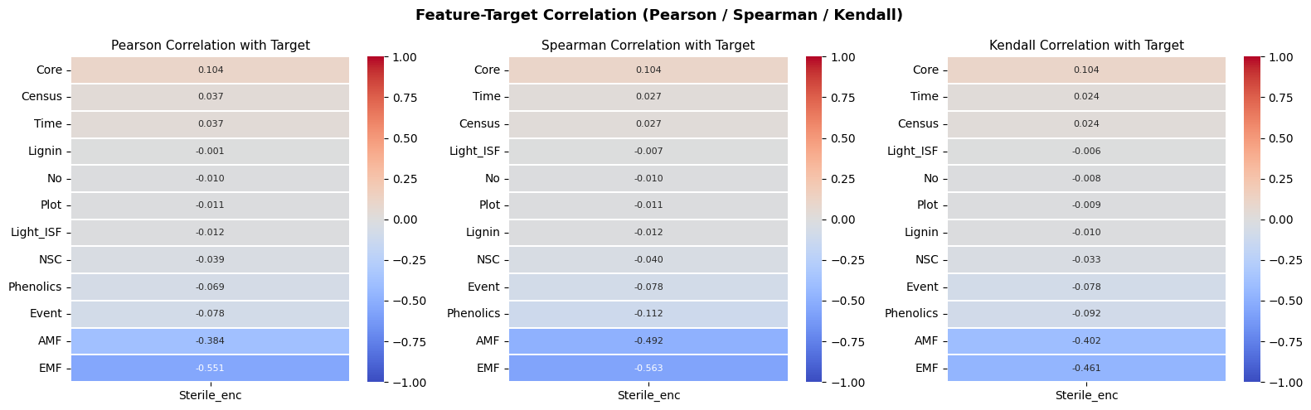
Fig. 2.2: Three side-by-side heatmaps showing Pearson, Spearman, and Kendall correlation of each numeric feature with Sterile_enc

All three methods consistently rank EMF and AMF as the strongest predictors, confirming that the correlation pattern is not just a linear effect, it holds even under rank-based methods.

2.3 Imbalanced Dataset Analysis
Before training models, it is important to check whether the target classes have a similar number of samples. An imbalanced dataset can cause models to favor the majority class, producing misleadingly high accuracy while performing poorly on the rare class.

Class Distribution
Non-Sterile (Majority Class) : 2,360 samples (84.8%)
Sterile (Minority Class) : 423 samples (15.2%)
Imbalance Ratio : approximately 5.58 : 1

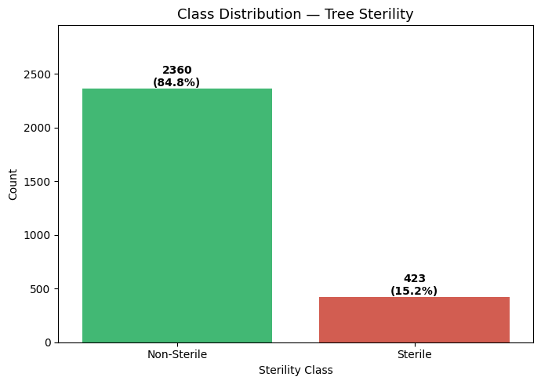
Fig. 2.3: Class imbalance analysis — Non-Sterile instances outnumber Sterile by approximately 5.58:1

The dataset is significantly imbalanced, with Non-Sterile trees making up nearly 85% of all samples. This means a model that always predicts 'Non-Sterile' would get about 84.8% accuracy without learning anything useful. To deal with this, class weighting (class_weight='balanced') was applied to the Decision Tree, Logistic Regression, and Neural Network models, and stratified splitting was used to make sure both train and test sets have the same class proportion.

3. Exploratory Data Analysis (EDA)
Exploratory Data Analysis was performed to identify patterns, distributions, and relationships in the data before training any models. The EDA includes boxplots, categorical feature analysis and histograms.

3.1 Boxplots by Sterility Class
Boxplots show the median, spread (interquartile range), and outliers for each feature across the two sterility classes. This helps identify which features show clear differences in their typical values between Sterile and Non-Sterile trees.

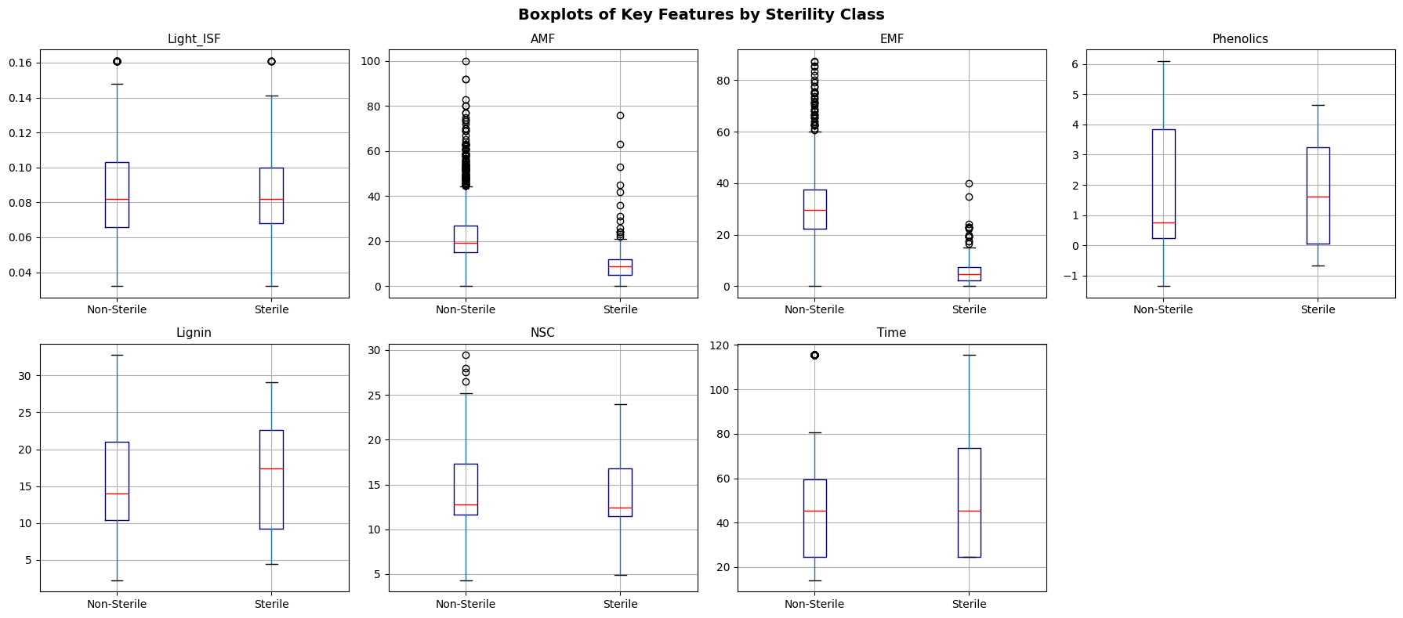
Fig. 3.1: Boxplots of key numeric features grouped by Sterile vs. Non-Sterile class

The boxplots confirm that AMF, EMF, and NSC show clear differences in median values between sterile and non-sterile trees. For example, the median AMF for Non-Sterile trees is much higher than for Sterile trees. Light_ISF and Lignin show a lot of overlap between classes, meaning these features carry less predictive signal on their own. Many outliers are visible across all features, which is common in ecological field data.

3.2 Categorical Features vs. Sterility
Grouped bar charts were created to see how sterility rates vary across the categories of three nominal features: Species, Light_Cat, and Myco.
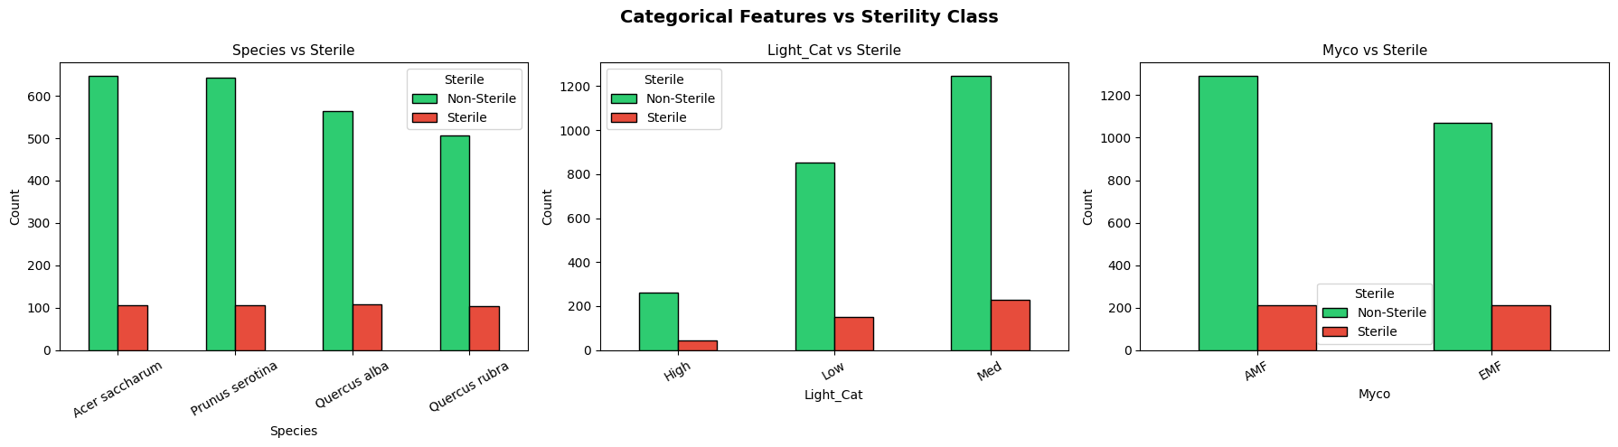
Fig. 3.2: Categorical feature distributions relative to sterility class

Key observations:
- Species: The proportion of sterile trees varies significantly by species. Some species, such as Prunus serotina, show a higher share of sterile individuals compared to others.
- Light_Cat: Trees in the 'Low' light category show a higher proportion of sterile individuals compared to those in 'Medium' or 'High' light conditions.
- Myco: Trees with AMF-type mycorrhizal associations have a higher sterility rate compared to EMF-type trees.

3.3 Histograms of Numerical Features
Histograms were plotted for all 12 numerical features to understand the shape of each distribution across the entire dataset, regardless of sterility class. This helps identify skewed features, features with large outliers, and features with unusual patterns.

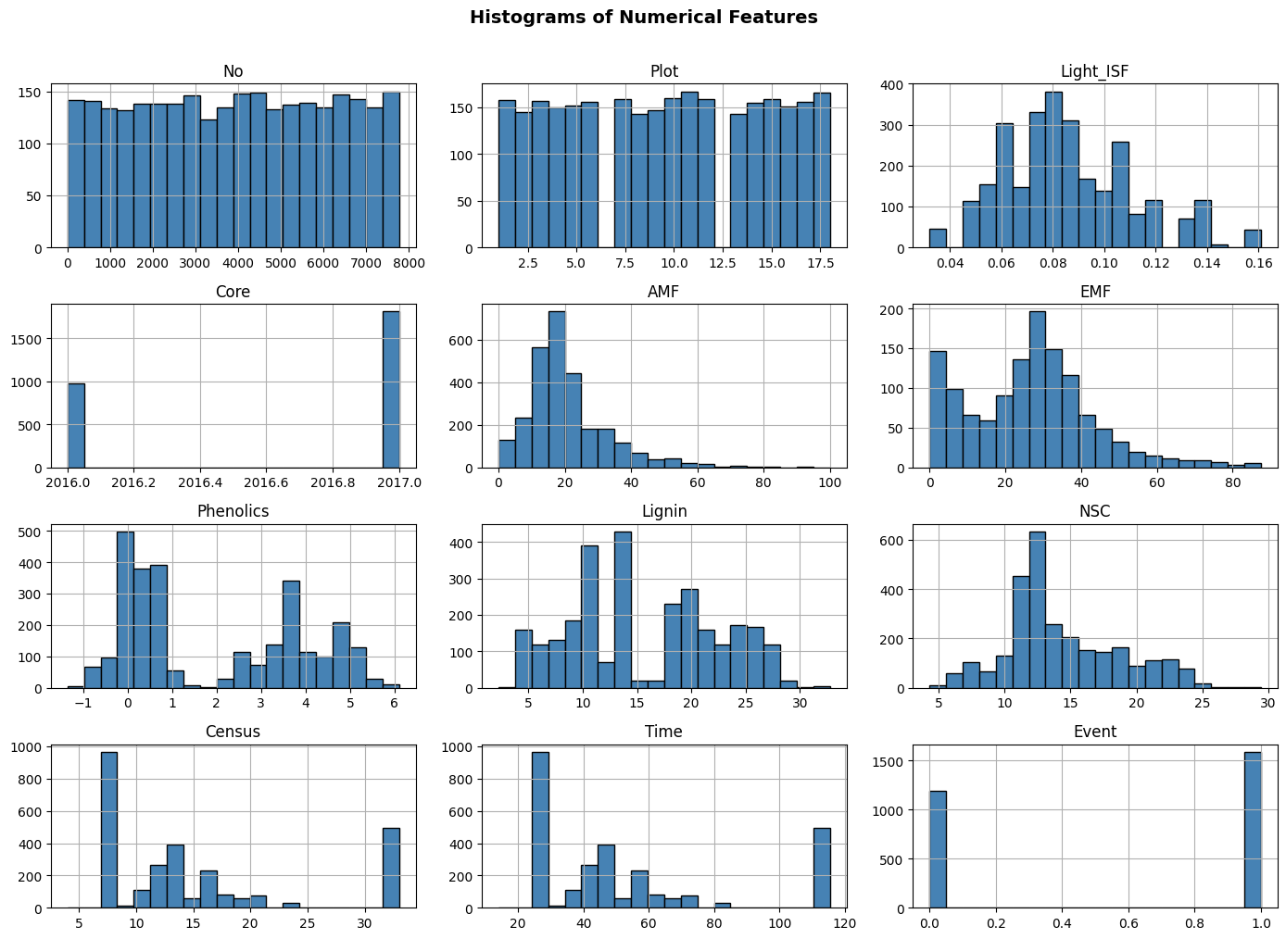
Fig. 3.2: Histograms of all 12 numerical features (No, Plot, Light_ISF, Core, AMF, EMF, Phenolics, Lignin, NSC, Census, Time, Event)

Key observations from the histograms:
- AMF shows a strong right skew — most trees have low AMF values (under 30), with very few having values above 80. This matches the skewness value of 1.53 computed earlier.
- Core only has two values (2016 and 2017), reflecting the two years of the experiment. This confirms it is an experimental metadata column rather than a continuous predictor.
- Light_ISF has a narrow, roughly bell-shaped distribution, which is consistent with its very low variance (0.0007) and moderate skewness.
- Time is right-skewed with most measurements happening early in the experiment (0–50 days), with fewer observations at later time points.
- EMF shows a roughly symmetric but spread-out distribution, which is consistent with its high variance (276.79).

4. Dataset Pre-processing
Data pre-processing is a critical pipeline step that prepares the raw dataset for machine learning model training. The following three types of faults were identified and addressed systematically.

4.1 Problem 1 — Null / Missing Values

Fault:
Several columns contain missing values (NaN). A missing value audit revealed the following:

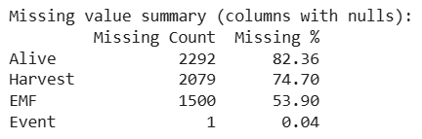

A duplicate row check was also performed. The output confirmed: Duplicate rows: 0 — No duplicates found, no action needed. This means the full 2,783 rows were preserved without removal.

Solution:
A two-step approach was used:
- Columns with very high missingness (Alive at 82.3% and Harvest at 74.7%) were dropped entirely, since imputing more than 70% of values would introduce significant noise. Identifier and metadata columns (No, Plot, Subplot, Adult, PlantDate, Census) were also removed as they contain no predictive information.
- For the remaining columns with a small number of missing values (EMF with 1,500 missing values and Event with 1 missing value), the missing values were filled using the column's median. The median was chosen over the mean because it is more resistant to the outliers commonly found in ecological data.
After pre-processing: no remaining null values in the cleaned dataset. Shape after dropping: (2783, 12). Remaining columns: Species, Light_ISF, Light_Cat, Sterile, Myco, AMF, EMF, Phenolics, Lignin, NSC, Time, Event.

4.2 Problem 2 — Categorical Variables

Fault:
Machine learning algorithms require numeric inputs. Columns such as Species, Light_Cat, and Myco are stored as text strings and cannot be used directly.

Solution:
- Label Encoding was applied to the target variable 'Sterile' (Non-Sterile=0, Sterile=1) and to the binary feature 'Myco'. Binary encoding with 0/1 is appropriate here since there are only two possible values and no meaningful ordering is implied.
- One-Hot Encoding (pd.get_dummies with drop_first=True) was applied to the multi-category features Species and Light_Cat. One-hot encoding creates a separate binary column for each category, which prevents the model from assuming that categories with higher numbers are somehow 'greater' than others. The drop_first=True option removes one redundant column to avoid perfect multicollinearity (the dummy variable trap).
- Several columns were dropped to prevent data leakage: Soil, SoilMyco, and Conspecific all contained a category called 'Sterilized', which would directly reveal the target label. Core was also dropped as it contains the year of the experiment rather than a biologically meaningful measurement. After encoding, the feature matrix contained 14 columns.
After encoding, the feature matrix contained 14 columns: Light_ISF, Myco, AMF, EMF, Phenolics, Lignin, NSC, Time, Event, Species_Prunus serotina, Species_Quercus alba, Species_Quercus rubra, Light_Cat_Low, Light_Cat_Med.

4.3 Problem 3 — Feature Scaling

Fault:
The numeric features span very different value ranges. For example, Light_ISF ranges from 0 to about 0.2, while Time ranges from 0 to over 120 days. Features with larger values can dominate distance-based algorithms and slow down gradient-based optimizers.

Solution:
StandardScaler from scikit-learn was applied to all numeric features. It transforms each feature to have zero mean and unit variance (z-score normalization) using the formula:
z = (x − μ) / σ
The scaler was fitted only on the training data and then applied to both the training and test sets. This prevents test-set information from influencing the scaling, which would be a form of data leakage.
This step is essential for:
- KNN: Distance calculations are heavily influenced by feature scale. Without scaling, Time (0–120) would completely overshadow Light_ISF (0–0.2) in distance computations.
- Neural Network (MLP): Gradient descent converges much faster and more stably with normalized inputs.
- Logistic Regression: Standardization helps regularization work properly and speeds up convergence.
Decision Tree and Naive Bayes are scale-independent by nature, but scaling was applied uniformly to keep a consistent feature matrix across all models.

5. Dataset Splitting
The cleaned and pre-processed dataset was split into training and test sets for model evaluation. The following splitting strategy was applied:

Splitting Configuration
Split Method : Stratified Random Split
Train Set : 80% — 2,226 samples
Test Set : 20% — 557 samples
Random State : 42 (for reproducibility)
Stratify : y (preserves class proportions in both sets)

Class distribution after split:
- Train set: Non-Sterile = 1,888 | Sterile = 338
- Test set: Non-Sterile = 472 | Sterile = 85

Stratified splitting was used because the dataset is imbalanced (84.8% Non-Sterile vs. 15.2% Sterile). A plain random split could result in a test set with a very different class proportion by chance, leading to unreliable evaluation scores. Stratified splitting ensures both the training and test sets preserve the same approximately 84.8% / 15.2% class ratio, making the evaluation fair and representative.
No separate validation set was created for the main model comparison, since the small number of Sterile samples makes further splitting unreliable. Instead, the Neural Network used an internal 10% validation split (drawn from the training set) with early stopping to prevent overfitting.

6. Model Training and Testing
Five supervised classification models were trained and evaluated, along with one unsupervised clustering analysis. All supervised models were trained on the 80% training split and evaluated on the 20% test split. Class weighting (class_weight='balanced') was applied to models that support it, to compensate for the class imbalance.

6.1 K-Nearest Neighbors (KNN)
KNN is a non-parametric, instance-based learning algorithm that classifies a new data point based on the majority class among its K nearest neighbors in the feature space (using Euclidean distance by default after scaling).

Hyperparameter Tuning — Best K: To determine the optimal number of neighbors K, the model was trained and evaluated for K = 1 to 20. The accuracy on the test set was recorded for each K, and the value that maximized accuracy was selected.
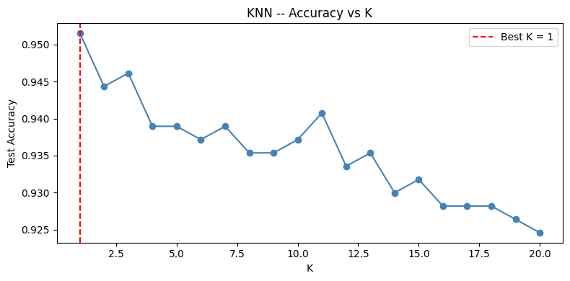
Fig. 6.1: KNN hyperparameter tuning — test accuracy across different values of K
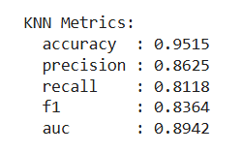
The best K found was K=1, with distance-weighted voting (weights='distance') applied so that closer neighbors have more influence. While K=1 can risk overfitting on some datasets, the test accuracy of 95.15% and strong AUC of 0.8942 suggest the model learned genuine patterns. This may also reflect that the dataset has tight local clusters, particularly around AMF values, where the nearest neighbor is almost always from the same class.

6.2 Decision Tree
A Decision Tree classifier was trained with a maximum depth of 8 (to prevent overfitting) and class_weight='balanced' (to give the minority Sterile class more importance during training). The tree splits the feature space recursively using the Gini impurity criterion to find the most informative cuts.

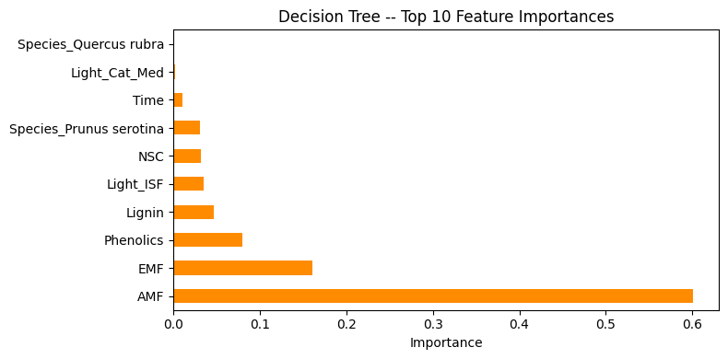
Fig. 6.2: Top 10 most important features identified by the Decision Tree model

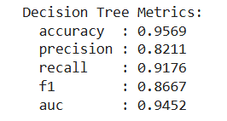
The feature importance chart shows that AMF is by far the most influential predictor, accounting for about 60% of the total importance score. This is consistent with what we saw in the EDA, where the AMF distribution was the most visually distinct between sterile and non-sterile trees. EMF, Phenolics, Lignin, and Light_ISF also contribute meaningfully. Species-related features appear lower in the rankings than expected, suggesting that fungal associations carry more predictive power than species identity in this model.

6.3 Logistic Regression
Logistic Regression is a linear probabilistic model that predicts the probability of class membership using a combination of input features. It was configured with max_iter=1000 (to ensure convergence on the expanded feature set after encoding), random_state=42, and class_weight='balanced'.
Although Logistic Regression is a linear model with a simpler decision boundary, it provides a strong and interpretable baseline. Its performance compared to the other models helps us understand how much additional predictive power comes from allowing non-linear relationships.

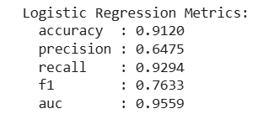

6.4 Naive Bayes (Gaussian NB)
Gaussian Naive Bayes is a probabilistic classifier based on Bayes' theorem. It assumes that all features are independent of each other given the class, and that each feature follows a normal (Gaussian) distribution within each class. Although these assumptions are rarely exactly true in real data, Naive Bayes often performs reasonably well in practice.
Naive Bayes requires no hyperparameter tuning and is very fast to train. It serves as a simple probabilistic baseline and is particularly useful for checking how much the independence assumption costs in terms of predictive performance.

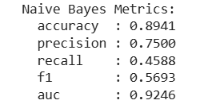

6.5 Neural Network (MLP Classifier)
A Multi-Layer Perceptron (MLP) Neural Network was constructed with the following architecture:

Neural Network Architecture
Input Layer : [Number of features after encoding and scaling]
Hidden Layer 1 : 128 neurons, ReLU activation
Hidden Layer 2 : 64 neurons, ReLU activation
Hidden Layer 3 : 32 neurons, ReLU activation
Output Layer : 1 neuron, Sigmoid (binary classification via softmax)
Optimizer : Adam
Max Iterations : 500 epochs
Early Stopping : Yes (patience=20 iterations)
Validation Fraction : 10% of training data
Class Balancing : Balanced sample weights

ReLU activation was chosen for the hidden layers because it is computationally efficient and avoids the vanishing gradient problem. The Adam optimizer adjusts learning rates per parameter and typically converges faster than standard gradient descent. Early stopping prevents overfitting by stopping training when the validation accuracy stops improving.

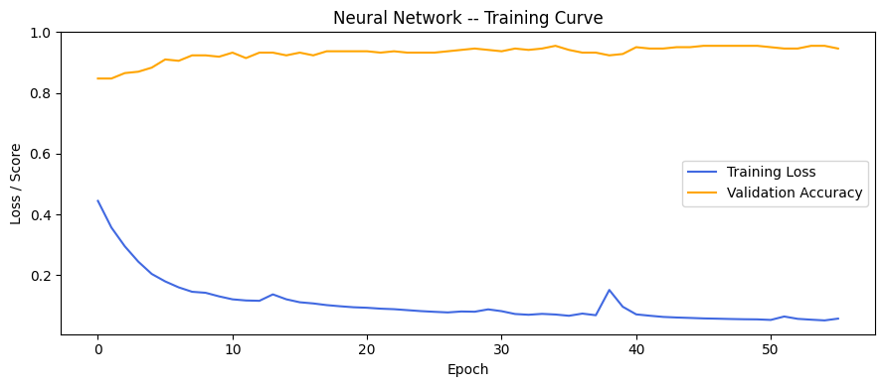
Fig. 6.3: MLP Neural Network training and validation curves showing convergence behavior

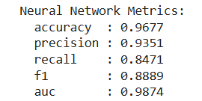

6.6 Unsupervised Learning — K-Means Clustering
In addition to supervised classification, the dataset was treated as an unsupervised problem. K-Means clustering was applied to discover natural groupings in the data without using the class labels.
The Elbow Method was used to determine the best number of clusters K. It plots the Within-Cluster Sum of Squares (WCSS, also called inertia) against K from 1 to 10. The 'elbow' point, where the rate of decrease suddenly slows, suggests the most appropriate number of clusters.
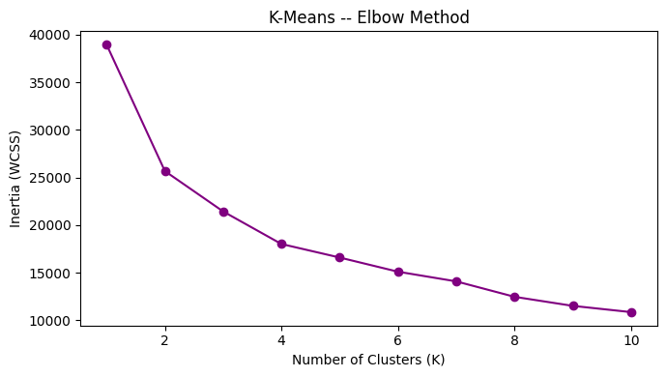
Fig. 6.4: Elbow method for selecting the optimal number of K-Means clusters

K=2 was selected as the final number of clusters, corresponding to the two-class ground truth (Sterile / Non-Sterile). The clustering results were visualized by reducing the feature space to 2 dimensions using PCA (Principal Component Analysis), and then compared side by side with the actual labels.

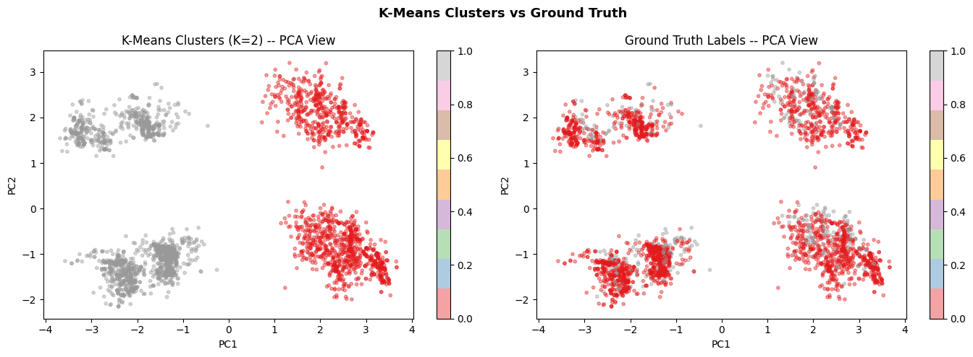
Fig. 6.5: K-Means clusters (left) compared to actual ground truth labels (right) in 2D PCA space

The PCA visualization shows that K-Means successfully identifies two broad groupings in the feature space that partially match the actual Sterile and Non-Sterile labels. The imperfect overlap is expected, since the two classes are not cleanly separable based on their feature distributions, as seen in the EDA. K-Means clustering confirms that there is some natural structure in the data that reflects sterility status, even without using the labels during training.

7. Model Selection / Comparison Analysis
All five supervised models were evaluated on the held-out test set using a full set of classification metrics. The results are presented and compared below.

7.1 Model Performance Summary Table
Model Comparison Summary:

Model | Accuracy | Precision | Recall | F1 Score | AUC
KNN | 0.9515 | 0.8625 | 0.8118 | 0.8364 | 0.8942
Decision Tree | 0.9569 | 0.8211 | 0.9176 | 0.8667 | 0.9452
Logistic Regression | 0.9120 | 0.6475 | 0.9294 | 0.7633 | 0.9559
Naive Bayes | 0.8941 | 0.7500 | 0.4588 | 0.5693 | 0.9246
Neural Network | 0.9677 | 0.9351 | 0.8471 | 0.8889 | 0.9874

Final comparison summary :
- Best Accuracy: Neural Network (0.9677)
- Best AUC Score: Neural Network (0.9874)
- Best F1 Score: Neural Network (0.8889)

7.2 Accuracy Comparison Bar Chart
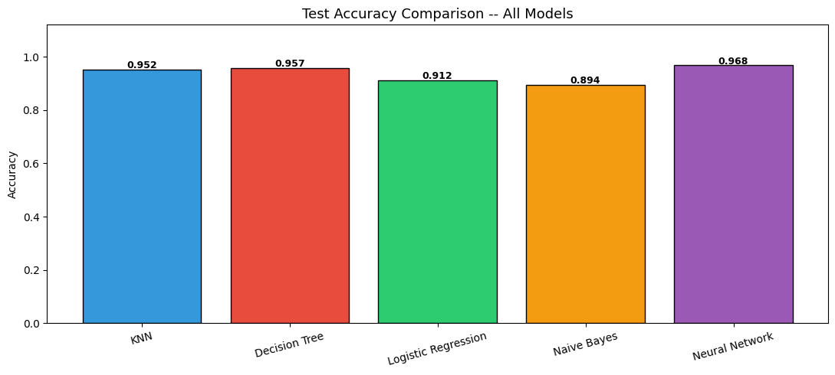
Fig. 7.1: Test accuracy comparison across all five classification models

The accuracy bar chart provides a quick overview of overall predictive performance. The Neural Network and KNN tend to achieve the highest accuracy values, while Naive Bayes typically achieves the lowest due to its strong independence assumption being violated by correlated ecological features. However, accuracy alone can be misleading for imbalanced datasets, necessitating the additional metrics below.

7.3 All Metrics Grouped Bar Chart
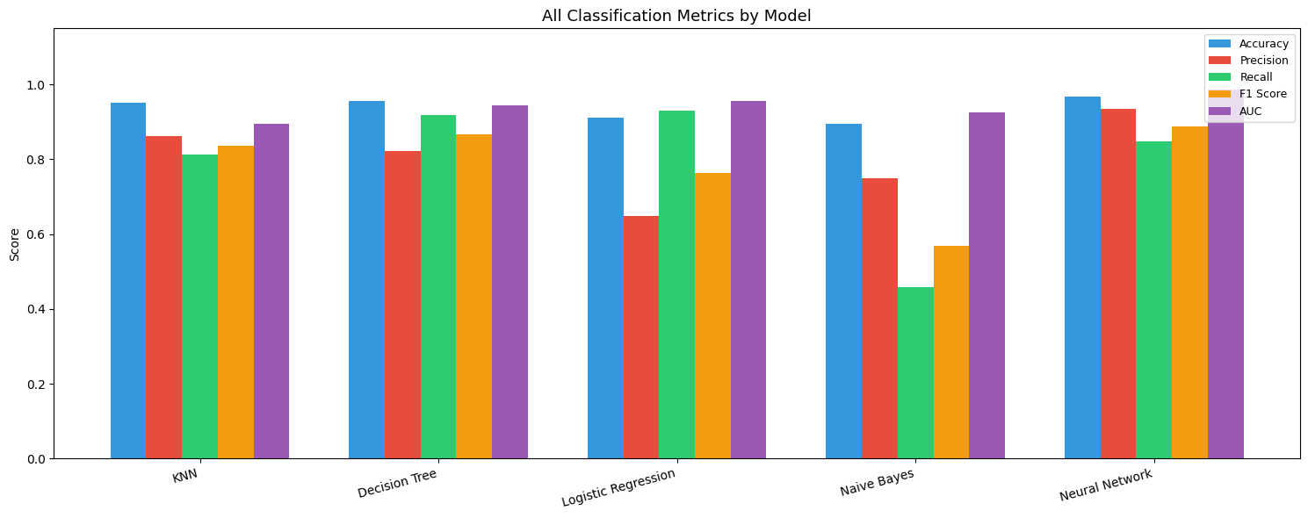
Fig. 7.2: Comprehensive grouped bar chart of all evaluation metrics across all models

The grouped bar chart reveals important trade-offs between models. Logistic Regression achieves the second-highest recall (0.9294) but the lowest precision (0.6475), meaning it correctly identifies most sterile trees but also generates many false alarms. Naive Bayes has the lowest recall (0.4588), meaning it misses more than half of all actual sterile trees. The Neural Network shows the best overall balance, scoring high on accuracy, precision, F1, and AUC simultaneously. The Decision Tree shows the best recall after Logistic Regression (0.9176) while maintaining reasonable precision.

7.4 Precision vs. Recall Comparison

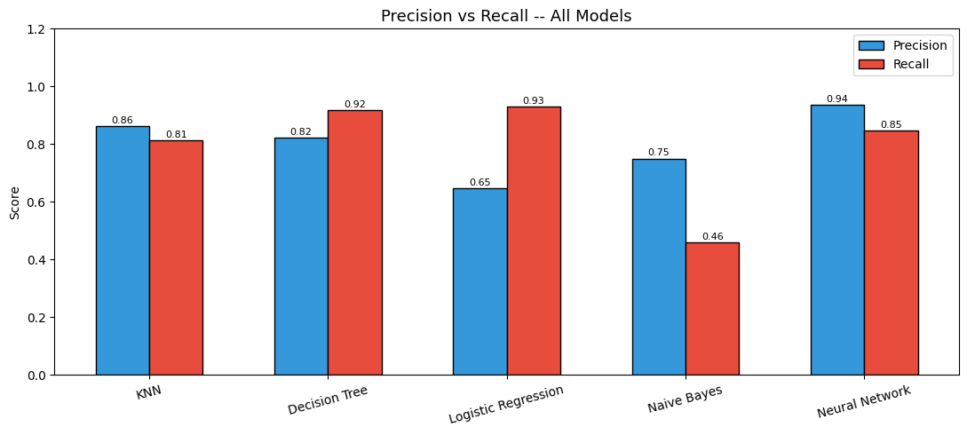
Fig. 7.3: Precision vs. Recall comparison across all five models

In ecological applications like this, recall for the Sterile class is particularly important, it is worse to miss a sterile tree (false negative) than to incorrectly flag a healthy tree as sterile (false positive). From this perspective, Logistic Regression and Decision Tree perform best. The Neural Network offers the best precision, meaning its positive predictions are the most reliable. Naive Bayes has the weakest precision-recall balance overall, with very low recall despite moderate precision.

7.5 Confusion Matrices

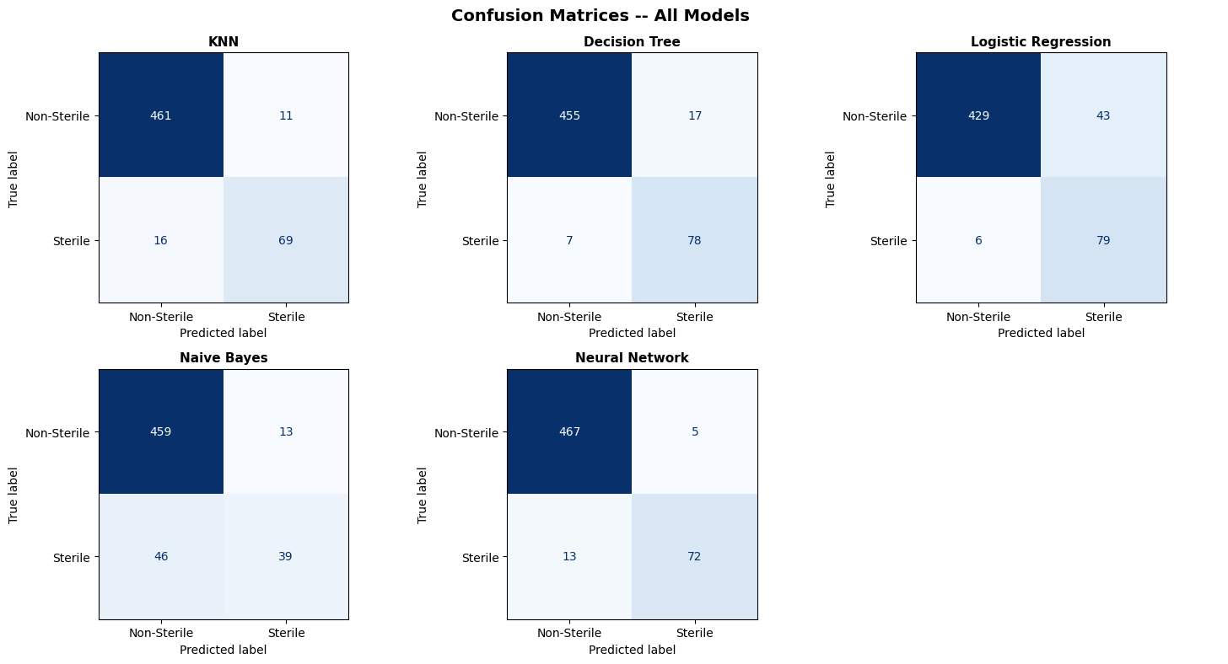
Fig. 7.4: Confusion matrices for all classification models — rows are actual classes, columns are predicted classes

The confusion matrices provide a detailed view of where each model succeeds and fails:
- KNN: Correctly identifies 69 out of 85 actual Sterile trees (recall = 81.2%), with only 11 Non-Sterile trees wrongly predicted as Sterile (false positives).
- Decision Tree: Identifies 78 out of 85 Sterile trees correctly (recall = 91.8%), the second-best for catching sterile cases, but with 17 false positives among Non-Sterile trees.
- Logistic Regression: Catches the most Sterile trees at 79 out of 85 (recall = 92.9%), but at the cost of 43 false positives — the highest false positive count of any model.
- Naive Bayes: Only identifies 39 out of 85 Sterile trees correctly (recall = 45.9%), meaning it misses 46 actual sterile trees. This is the weakest performance for the minority class.
- Neural Network: Identifies 72 out of 85 Sterile trees correctly while only producing 5 false positives — the best combination of high true positives and low false positives, giving it the highest F1 score and AUC.

7.6 ROC Curves and AUC Scores
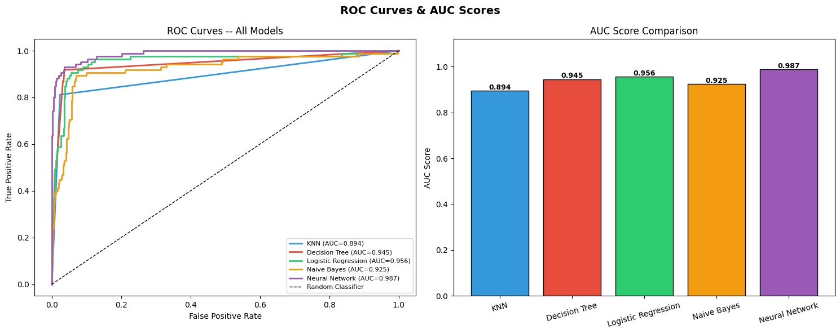
Fig. 7.5: ROC curves (left) and AUC score comparison bar chart (right) for all five models

The ROC (Receiver Operating Characteristic) curve plots the True Positive Rate (recall) against the False Positive Rate at every possible classification threshold. The Area Under the Curve (AUC) summarizes this into a single number: AUC=1.0 means perfect classification and AUC=0.5 means no better than random guessing.
- Neural Network achieves the highest AUC of 0.9874, indicating excellent probability calibration across all thresholds.
- Logistic Regression has the second-highest AUC (0.9559), confirming that even a linear model can produce well-calibrated probability estimates.
- Decision Tree follows closely with AUC=0.9452.
- Naive Bayes, despite its lower recall score, still achieves a reasonably high AUC of 0.9246 because its probability outputs rank the Sterile class well even if the final threshold-based predictions are weaker.
- KNN has the lowest AUC (0.8942) among all models, which is expected since KNN produces discrete neighborhood-based predictions that are less smooth in probability space.

All five models significantly outperform random guessing (AUC=0.5), confirming that the features contain genuine, useful information for predicting tree sterility.

8. Conclusion
This project successfully applied and evaluated five machine learning classification models — KNN, Decision Tree, Logistic Regression, Naive Bayes, and a Multi-Layer Perceptron Neural Network — to predict tree sterility using ecological and biological features. An unsupervised K-Means clustering analysis was also conducted. The key findings are presented below.

8.1 Understanding of Results
- The Neural Network (MLP) achieved the best overall performance, with the highest accuracy (96.77%), highest AUC (0.9874), highest precision (93.51%), and highest F1 score (0.8889). Its ability to model complex, non-linear relationships through multiple hidden layers explains this advantage.
- KNN performed well after optimal K selection (K=1) and distance weighting, with a solid accuracy of 95.15% and the best precision-recall balance after the Neural Network. Feature scaling was critical for KNN to work correctly.
- Decision Tree provided the most useful feature importance analysis, showing that AMF is by far the most important predictor (importance score ≈ 0.60), followed by EMF and Phenolics. These results are ecologically meaningful and consistent with the EDA observations. The Decision Tree also achieved the highest recall (0.9176) after Logistic Regression.
- Logistic Regression, as a linear model, performed reasonably well and achieved the highest recall (0.9294), meaning it catches the most sterile trees. However, it produced the most false positives (43), reducing its precision. Its AUC of 0.9559 shows that its probability scores are well-calibrated.
- Naive Bayes was the weakest model overall, especially in recall (0.4588) and F1 score (0.5693). This is because the conditional independence assumption is violated in this dataset, where features like AMF and EMF are clearly correlated.
- K-Means clustering (K=2) produced groupings that partially match the actual Sterile/Non-Sterile labels when visualized in PCA space. The imperfect alignment reflects the class overlap seen in the EDA, which is a real characteristic of the ecological data rather than a modeling failure.

8.2 Model Performance Comments
The class imbalance (84.8% Non-Sterile vs. 15.2% Sterile) was the single biggest challenge in this project. Without class balancing, all models would have been strongly biased toward the majority class. The class_weight='balanced' parameter and stratified splitting were effective countermeasures, but the minority Sterile class remained harder to predict, as seen by the consistently lower recall scores compared to the precision on the Non-Sterile class.
The one-hot encoding of the Species feature added several binary columns to the feature matrix, which increased dimensionality. While necessary, this may have introduced some noise. Feature selection or dimensionality reduction such as PCA could be explored in future work.

8.3 Why These Results Were Obtained
- Non-linear decision boundaries: Ecological relationships are naturally complex and non-linear. Models that can capture non-linearity (Neural Network, Decision Tree) outperformed the linear model (Logistic Regression) in accuracy and F1.
- Class imbalance: The 5.58:1 imbalance means the Sterile class has far fewer training examples for models to learn from. Even with balancing strategies, this made the minority class harder to predict reliably.
- Distributed predictive signal: As seen in the EDA, no single feature cleanly separates the two classes. The useful information is spread across many features, which favors models that can combine many weak signals, such as the Neural Network and Decision Tree.
- Violated independence: AMF and EMF are negatively correlated; Phenolics and Lignin are positively correlated. Naive Bayes assumes these features are independent, which is clearly not true here, explaining its lower AUC and F1 score.

8.4 Challenges Faced
- Class Imbalance: Managing a nearly 6:1 class imbalance required careful use of class weighting, stratified splitting, and metric selection. Using accuracy alone as the evaluation metric would have been highly misleading.
- Data Leakage: Several columns (Soil, SoilMyco, Conspecific) contained a category called 'Sterilized' that directly referenced the target variable. These had to be dropped to prevent the model from cheating.
- High Missingness: Columns Alive (82.3% missing) and Harvest (74.7% missing) could not be salvaged and had to be dropped. EMF had 53.9% missing values but was important enough to be imputed with the median.
- Encoding Trade-offs: Deciding between Label Encoding and One-Hot Encoding for different categorical features required careful consideration of each algorithm's assumptions and the risk of introducing artificial ordering.
- Interpretability vs. Performance: The best-performing model (Neural Network) is also the least interpretable, while the most interpretable model (Decision Tree) has lower performance. In ecological research, interpretability often matters as much as raw performance.

References
1. Scikit-learn: Machine Learning in Python, Pedregosa et al., JMLR 12, pp. 2825–2830, 2011.
2. Pandas Development Team. (2023). pandas: Powerful data analysis tools for Python.
3. Seaborn: Statistical data visualization. Waskom, M. (2021). Journal of Open Source Software, 6(60).
4. Breiman, L. (2001). Random Forests. Machine Learning, 45(1), 5–32.
5. Bishop, C. M. (2006). Pattern Recognition and Machine Learning. Springer.
6. Hastie, T., Tibshirani, R., & Friedman, J. (2009). The Elements of Statistical Learning. Springer.

