GitHub Repository: <https://github.com/quisitor/HomeAutomationControllor.git>

1. Development Tasks
   1. Create general system sketch to help understand requirements (Done)
   2. Create user console interface mockups keeping in mind the requirements (Done)
      1. Use as a roadmap for user validation testing
   3. Stock up on coffee supplies and snacks for the software dev team (Done)
   4. Create a solution in Visual Studio 2019 and add version control (Done)
   5. Create an test.cpp to perform unit testing (Done)
   6. Implement the user console interface (Done)
      1. Stub-out responses to create skeleton
   7. Implement the Sequential and Random File I/O and CRUD interfaces (Partial)
      1. Inventory Database (Done)
         1. csvSmartNodeInventoryList.txt
            1. Create (Done)
            2. Read (Done)
            3. Update – Not Implemented
            4. Delete – Not Implemented
      2. Scheduler Database – Not Implemented
   8. Create the Smart-Device Object Classes (Partial)
      1. Implement Message Handling (Partial)
      2. Implement the Device CRUD portion of the objects (Partial)
         1. Device Name (Validate, Add, Read)
         2. IP Address (Validate, Add, Read)
         3. Subnet Mask (Validate, Add, Read)
         4. Gateway Address (Validate, Add, Read)
         5. MAC Address (Validate, Add, Read)
         6. Device ID (Primary Key in Inventory dBase) – Not Implemented
   9. Implement the Controller – Manual Controls functionality – Not Implemented
   10. Implement the Health Status Dispatcher system (Partial)
   11. Create an main.cpp to drive the code and simulate sensor events to demonstrate the functionality of the application and that all the requirements have been meant. (Done)
   12. Document the running application, screenshots, etc.
   13. Deliver the application and documentation.
2. Known Defects
   1. Known defects at this point.
      1. Menu System – can hit enter without any text and cursor will go below the prompt, doesn’t affect proper choice but menu should redraw and enforce the input to stay just to the right of the input prompt >>>
      2. Menu System – in the add device menu, e.g. deviceName, input that exceeds the valid length requires hitting enter twice to repaint the screen, initial enter goes to line below, second enter clears screen and redraws the menu and prompt for the correct input.
3. Test sequence inside ValidationLibrary_UnitTests.cpp

//Run Tests

testMACAddressValidation(); //Commented out currently

std::cin.get();

testIPV4AddressValidation(); //Commented out currently

std::cin.get();

testIPV4SubnetMaskValidation(); //Commented out currently

std::cin.get();

testDeviceNameValidation(); //Commented out currently

std::cin.get();

testNetworkObject(); //Commented out currently

std::cin.get();

testMainMenuDisplay(); //Commented out currently

std::cin.get();

test_tempNewSmartNodeContainerDataCollection(); Starts the app automatically, commented out

1. Week 7 Screen Shots.
   1. Text

      Description automatically generated
   2. Text

      Description automatically generated
   3. Graphical user interface

      Description automatically generated
   4. Graphical user interface

      Description automatically generated
   5. Text

      Description automatically generated
   6. Text

      Description automatically generated
   7. Text

      Description automatically generated
   8. Text

      Description automatically generated
   9. Text

      Description automatically generated
   10. Text

       Description automatically generated
   11. Text

       Description automatically generated
   12. Text

       Description automatically generated
   13. Text

       Description automatically generated
   14. Text

       Description automatically generated
   15. Text

       Description automatically generated
   16. Text

       Description automatically generated
   17. Graphical user interface, text

       Description automatically generated
   18. Text

       Description automatically generated
   19. Text

       Description automatically generated
   20. 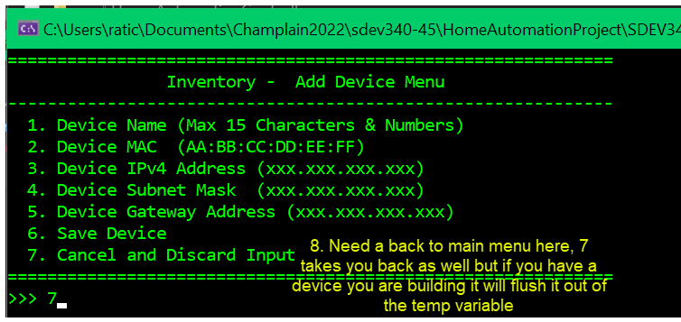
   21. Text

       Description automatically generated
   22. Text

       Description automatically generated
   23. Graphical user interface

       Description automatically generated
   24. Graphical user interface

       Description automatically generated
   25. Text

       Description automatically generated
   26. Text

       Description automatically generated
   27. Text

       Description automatically generated
   28. Text

       Description automatically generated
   29. A screenshot of a computer

       Description automatically generated with medium confidence
   30. Graphical user interface, text

       Description automatically generated
   31. Text

       Description automatically generated
   32. New Start – Demonstrate the autoload of the inventory into the application
   33. Graphical user interface, application

       Description automatically generated
   34. Text

       Description automatically generated
   35. Graphical user interface

       Description automatically generated
   36. 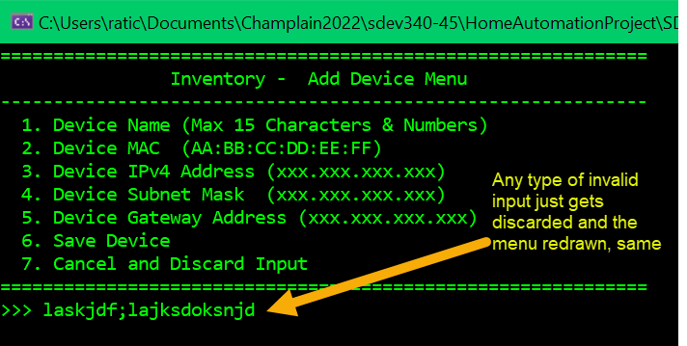
   37. Text

       Description automatically generated