**Sql-practice.com Solution**

**🡪Prepared by @balwant singh**

**req tables in the problems :-**

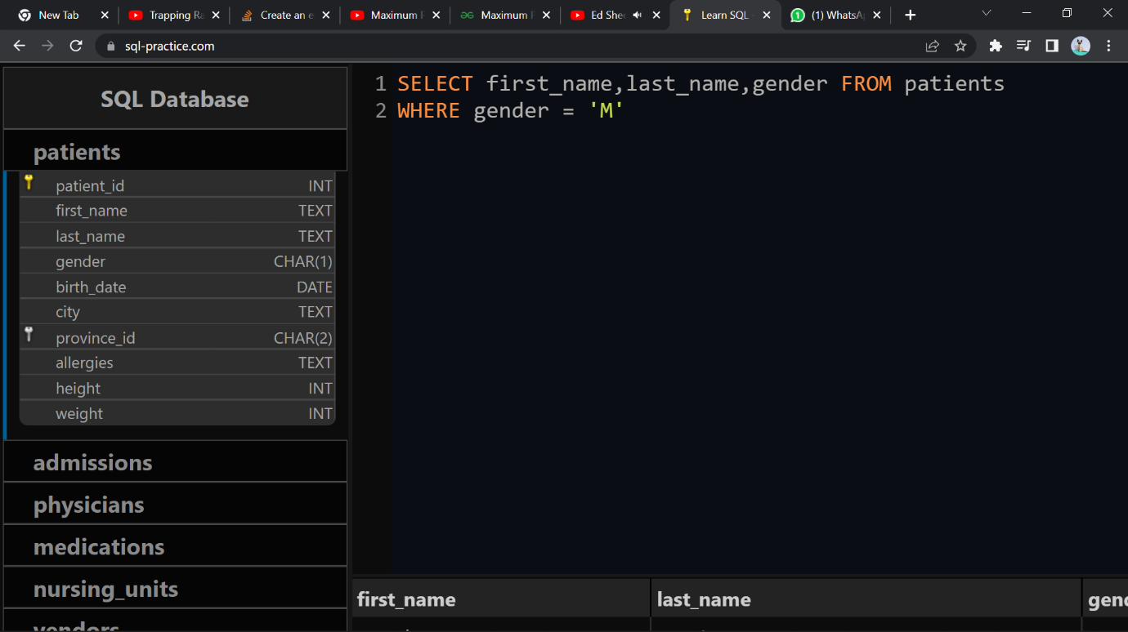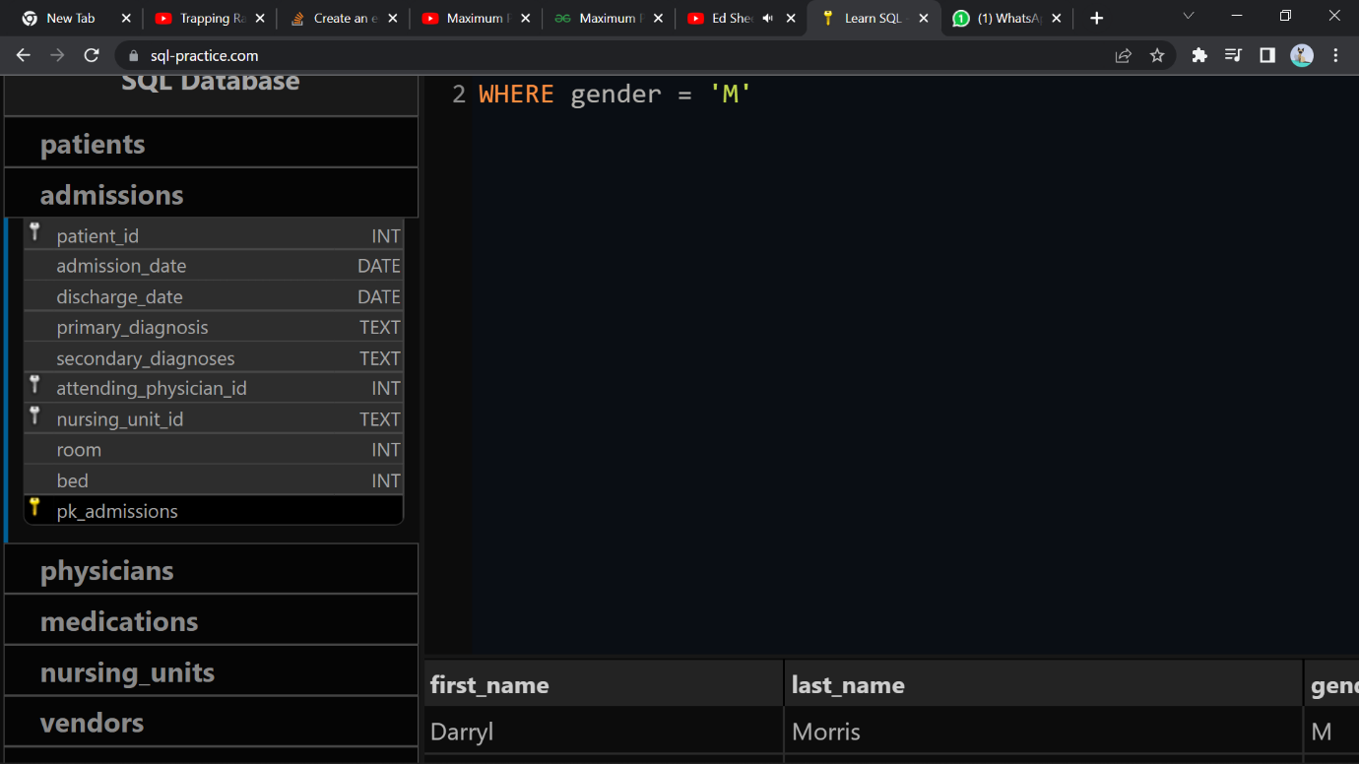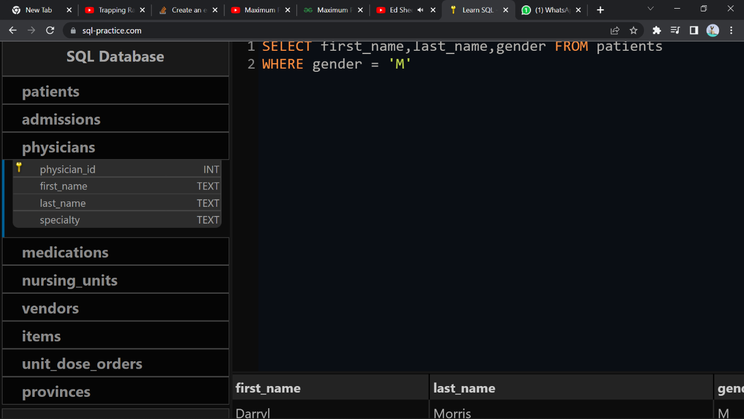

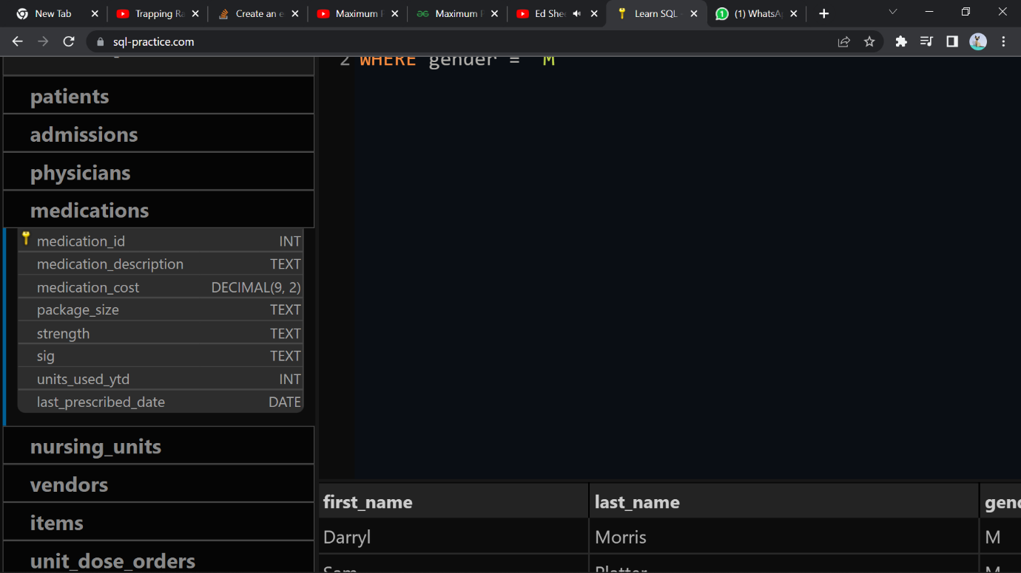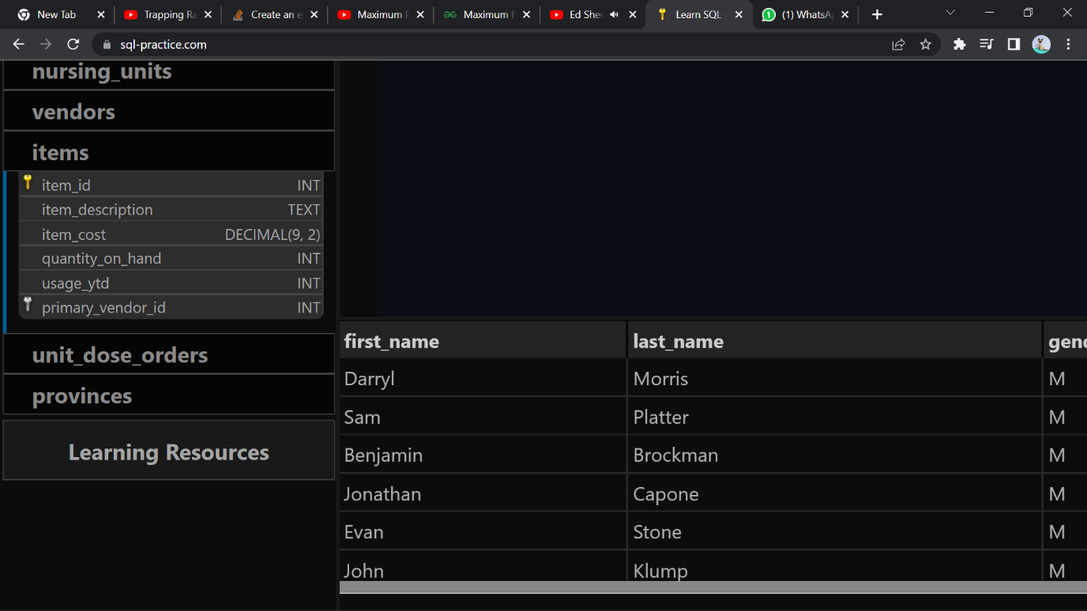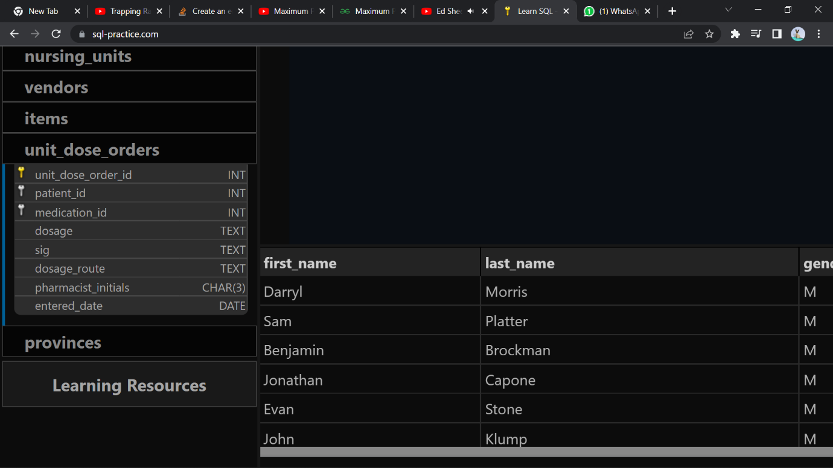

Easy ->

Show first name, last name, and gender of patients who's gender is 'M'

select

first_name,last_name,gender

from patients

where gender = 'M'

Show first name and last name of patients who does not have allergies (null).

select

first_name,last_name

from patients

where allergies is null

Show first name of patients that start with the letter 'C'

Select

first_name

from patients

where first_name like 'C%'

Show first name and last name of patients that weight within the range of 100 to 120 (inclusive)

select

first_name,last_name

from patients

where weight between 100 and 120

Update the patients table for the allergies column. If the patient's allergies is null then replace it with 'NKA'

update patients

set allergies = 'NKA'

where patient_id in (select patient_id from patients where allergies is null)

Show first name and last name concatinated into one column to show their full name.

select concat(first_name," ",last_name) full_name

from patients

Show first name, last name, and the **full** province name of each patient.  
  
Example: 'Ontario' instead of 'ON'

select

first_name,last_name,pr.province_name

from patients

join provinces pr on pr.province_id = patients.province_id;

Show how many patients have a birth_date with 2010 as the birth year.

select count(patient_id)

from patients

where birth_date like "2010%"

Show the first_name, last_name, and height of the patient with the greatest height.

select

first_name,last_name,height

from patients

where patient_id = (select patient_id from patients order by height desc limit 1)

Show all columns for patients who have one of the following patient_ids:  
1,45,534,879,1000

select *

from patients

ywhere patient_id in (1,45,534,879,1000)

Show the total number of admissions

select

count(patient_id)

from admissions

Show all the columns from admissions where the patient was admitted and discharged on the same day.

select *

from admissions

where admission_date = discharge_date

Show the total number of admissions for patient_id 573.

select

patient_id, count(admission_date) as total_admissions

from admissions

where patient_id = 573 group by patient_id

Based on the cities that our patients live in, show unique cities that are in province_id 'NS'?

select

distinct city

from patients

where province_id = "NS"

Medium ->

Show unique birth years from patients and order them by ascending.

select

distinct year(birth_date)

from patients

order by birth_date

Show unique first names from the patients table which only occurs once in the list.  
  
For example, if two or more people are named 'John' in the first_name column then don't include their name in the output list. If only 1 person is named 'Leo' then include them in the output.

select

first_name

from patients

group by first_name

having count(*)=1

Show patient_id and first_name from patients where their first_name start and ends with 's' and is at least 6 characters long.

select

patient_id,first_name

from patients

where first_name like 's____%s'

Show patient_id, first_name, last_name from patients whos primary_diagnosis is 'Dementia'.  
  
Primary diagnosis is stored in the admissions table.

select

patients.patient_id,first_name,last_name

from patients

join admissions on patients.patient_id = admissions.patient_id

where primary_diagnosis = 'Dementia';

Display every patient's first_name.  
Order the list by the length of each name and then by alphabetically

select

first_name

from patients

order by length(first_name),concat(first_name,last_name)

Show the total amount of male patients and the total amount of female patients in the patients table.  
Display the two results in the same row.

select (select count(*) from patients where gender = "M") male, (select count(*) from patients where gender = "F")

Show first and last name, allergies from patients which have allergies to either 'Penicillin' or 'Morphine'. Show results ordered ascending by allergies then by first_name then by last_name.

select

first_name,last_name,allergies

from patients where allergies in ("Penicillin","Morphine")

order by allergies,first_name,last_name

Show patient_id, primary_diagnosis from admissions. Find patients admitted multiple times for the same primary_diagnosis.

select

patient_id,primary_diagnosis

from admissions

group by primary_diagnosis,patient_id

having count(patient_id)>1

Show the city and the total number of patients in the city in the order from most to least patients.

select

city,count(*)

from patients

group by city

order by count(*) desc

Show first name, last name and role of every person that is either patient or physician.  
The roles are either "Patient" or "Physician"

select

first_name,last_name,'patient' role

from patients

union

select

first_name,last_name,'physician' as role

from physicians

Show all allergies ordered by popularity. Remove 'NKA' and NULL values from query.

SELECT

allergies,

COUNT(*) AS total_diagnosis

FROM patients

WHERE

NOT allergies = 'NKA'

AND allergies NOT NULL

GROUP BY allergies

ORDER BY total_diagnosis DESC

Show all patient's first_name, last_name, and birth_date who were born in the 1970s decade. Sort the list starting from the earliest birth_date.

SELECT

first_name,

last_name,

birth_date

FROM patients

WHERE

YEAR(birth_date) BETWEEN 1970 AND 1979

ORDER BY birth_date ASC;

We want to display each patient's full name in a single column. Their last_name in all upper letters must appear first, then first_name in all lower case letters. Separate the last_name and first_name with a comma. Order the list by the first_name in decending order  
EX: SMITH,jane

select

concat(upper(last_name),",",lower(first_name))

from patients

order by first_name desc

Show the province_id(s), sum of height; where the total sum of its patient's height is greater than or equal to 7,000.

select

province_id,sum(height)

from patients

group by province_id

having sum(height)>=7000

Show the difference between the largest weight and smallest weight for patients with the last name 'Maroni'

select

max(weight)-min(weight)

from patients

where last_name = 'Maroni';

Show all of the month's day numbers and how many admission_dates occurred on that number. Sort by the day with most admissions to least admissions.

select

day(admission_date) , count(admission_date)

from admissions

group by day(admission_date)

order by count(admission_date) desc

Show the patient_id, nursing_unit_id, room, and bed for patient_id 542's most recent admission_date.

select

patient_id,nursing_unit_id,room,bed

from admissions

where patient_id = 542

order by admission_date desc

limit 1

Show the nursing_unit_id and count of admissions for each nursing_unit_id. Exclude the following nursing_unit_ids: 'CCU', 'OR', 'ICU', 'ER'.

select

nursing_unit_id , count()

from admissions

where nursing_unit_id not in ('CCU','OR','ICU','ER')

group by nursing_unit_id

Show patient_id, attending_physician_id, and primary_diagnosis for admissions that match one of the two criteria:  
1. patient_id is an odd number and attending_physician_id is either 1, 5, or 19.  
2. attending_physician_id contains a 2 and the length of patient_id is 3 characters.

select

patient_id,attending_physician_id,primary_diagnosis

from admissions

where (patient_id%2<>0 and attending_physician_id in (1,5,19)) or (attending_physician_id like "%2%" and len(patient_id) =3)

Hard ->

Show all of the patients grouped into weight groups.  
Show the total amount of patients in each weight group.  
Order the list by the weight group decending.  
  
For example, if they weight 100 to 109 they are placed in the 100 weight group, 110-119 = 110 weight group, etc.

SELECT

FLOOR(t.weight/10) * 10 as weightGroup, count(*) as cnt

FROM patients t

GROUP BY FLOOR(t.weight/10)

ORDER BY FLOOR(t.weight/10) DESC

Show patient_id, weight, height, isObese from the patients table.  
  
Display isObese as a boolean 0 or 1.  
  
Obese is defined as weight(kg)/(height(m)2) >= 30.  
  
weight is in units kg.  
  
height is in units cm.

select

patient_id,weight,height,

case

when (weight/power(height/100.,2))>=30 then 1

else 0

end

as isObese

from

patients

Show patient_id, first_name, last_name, and attending physician's specialty.  
Show only the patients who has a primary_diagnosis as 'Dementia' and the physician's first name is 'Lisa'  
  
Check patients, admissions, and physicians tables for required information.

select

patients.patient_id,patients.first_name,patients.last_name,ph.specialty

from patients

join admissions on admissions.patient_id = patients.patient_id

join physicians ph on ph.physician_id = admissions.attending_physician_id

where primary_diagnosis = "Dementia" and ph.first_name = "Lisa"

All patients who have gone through admissions, can see their medical documents on our site. Those patients are given a temporary password after their first admission. Show the patient_id and temp_password.  
  
The password must be the following, in order:  
1. patient_id  
2. the numerical length of patient's last_name  
3. year of patient's birth_date

select

distinct p.patient_id,concat(p.patient_id,len(p.last_name),year(p.birth_date))

from patients p

join

admissions a

on a.patient_id = p.patient_id

Each admission costs $50 for patients without insurance, and $10 for patients with insurance. All patients with an even patient_id have insurance.  
  
Give each patient a 'Yes' if they have insurance, and a 'No' if they don't have insurance. Add up the admission_total cost for each has_insurance group.

select

case

when patient_id%2=0 then 'Yes'

when patient_id%2<>0 then 'No'

end

as has_insurance,

sum(

case

when patient_id%2=0 then 10

when patient_id%2<>0 then 50

end

)

as cost_after_insurance

from admissions

group by has_insurance

Show the provinces that has more patients identified as 'M' than 'F'. Must only show full province_name

Select

p.province_name

from provinces p

join patients pa on pa.province_id = p.province_id

group by p.province_name

having count(case when gender = "M" then 1 end)>count(case when gender = "F" then 1 end)

We are looking for a specific patient. Pull all columns for the patient who matches the following criteria:  
- First_name contains an 'r' after the first two letters.  
- Identifies their gender as 'F'  
- Born in February, May, or December  
- Their weight would be between 60kg and 80kg  
- Their patient_id is an odd number  
- They are from the city 'Halifax'

select *

from patients

where first_name like "__r%" and gender="F"

and month(birth_date) in (02,05,12)

and weight between 60 and 80

and patient_id%2<>0

and city = 'Halifax'

Show the percent of patients that have 'M' as their gender. Round the answer to the nearest hundreth number and in percent form.

SELECT

CONCAT( ROUND((

SELECT COUNT(*)

FROM patients

WHERE gender = 'M'

) / CAST(COUNT(*) as float),

4

) * 100,

'%'

) as percent_of_male_patients

FROM patients;

Show the patient_id and total_spent for patients who spent over 150 in medication_cost. Sort by most total_spent to least total_spent.

select

patient_id,sum(medication_cost)

from medications m join unit_dose_orders u on m.medication_id = u.medication_id

group by patient_id

having sum(medication_cost)>150

order by sum(medication_cost) desc

Provide the description of each item, along with the total cost of the quantity on hand (rounded to the nearest whole dollar), and the associated primary vendor. Sort the output by the most spent to the least spent on inventory.

SELECT

i.item_description,

ROUND(i.item_cost * i.quantity_on_hand, 0) as total_cost,

v.vendor_name

FROM items i

JOIN vendors v ON i.primary_vendor_id = v.vendor_id

GROUP BY i.item_description

ORDER BY total_cost DESC;