[ TITLE — to be decided ]
Group [NN]
CITS4012 Group Project · report framework · 14 October 2026
这份文档是论文的框架，不是最终稿。
章节顺序完全按作业要求的 Suggested Structure 排。每一节开头有一条带颜色的 owner 条，写明谁负责。蓝色的部分已经有初稿，红色和绿色的部分写着具体要求，请各自在 Word 里写好内容再填进来。
页数提醒：这份 Word 不是页数参考。最终提交的是 ACL 双栏 10pt，密得多，大约两页 Word 等于一页 ACL。硬上限是 6 页（含图表，不含 Team Contributions 和 References）。写的时候请尽量精炼。

分工总表 Who writes what
 | 章节 | 状态 | 截止
Daniel | Abstract · 2 Methodology · 3.1 3.2 3.3 3.5 · Team Contributions · 合稿 | 初稿已写 | 已完成
Ray | 2.4 2.5 的 attention 部分修订 · 2.7 补充引用 · 4.2 Ablation · 4.3 Attention 可视化 | 待写 | 10 月 16 日
Vika | 1 Introduction · 3.4 Baselines · 4.1 Overall comparison · 5 Conclusion | baseline 已有 validation 结果 | 10 月 16 日

Daniel
1. 第 2 章和第 3 章的初稿已经在文档里，数字更新到 10 月 14 日。
2. Abstract 和 Team Contributions 最后写，等 test 数字出来。
3. 负责合稿：把三个人的 Word 内容合并到 Overleaf 的 ACL 模板里，控制在 6 页。
4. 负责合并 notebook，确保在全新的 Colab 上能从头跑通，且所有 cell 都有保存的输出。

Ray
1. 你对 goal attention 做的三个公式修改，请写进 2.4。文档里已经留好位置和格式要求。
2. 2.4 和 2.5 现有的描述是按修改前的模型写的，请通读并改成和你实际代码一致。作业明确写了报告与代码不一致会扣分。
3. 2.7 的 provenance 表：你一定参考了别的 paper，请把来源和你改了什么填进表里，并把引用发给 Daniel 加进 references。
4. 4.2 Ablation：集中在 attention 上。use_goal 那一组我们决定不做了。
5. 4.3 Attention 可视化：需要一个对的例子和一个错的例子，图和数字都要。
6. 你的所有实验都在 validation 上，test 最后统一跑一次。

Vika
1. Baseline 的 validation 结果已经很完整，质量很好。但有四处要改，写在 3.4 里面了。
2. 最大的一件：所有 baseline 需要在 test set 上重跑一次。详细说明在 3.4。
3. Introduction 和 Conclusion 你先写初稿，Daniel 和 Ray 再补充。
4. 4.1 的总对比表要等 test 跑完才能填。
5. 你用到的所有引用（Liu et al. RoBERTa、Qwen tech report 等）发给 Daniel。

时间表
日期 | 做什么 | 谁
10 月 15 日 | Ray 的 ablation 跑完，最终配置确定并冻结 | Ray
10 月 15 日 | Vika 的 baseline 定稿，不再调参 | Vika
10 月 16 日 | test set 解锁，所有系统一次性跑完 | 全组一起
10 月 16 日 | 所有人的 Word 内容交给 Daniel | 全组
10 月 17 日 | 合稿、控页数、检查报告与代码是否一致 | Daniel
10 月 18 日 | 提交，23:59 AWST | Daniel

test set 只能跑一次，而且必须在所有配置冻结之后。跑完之后无论结果好坏，都不再调模型。这是作业的硬性要求，也已经写进报告的 3.1 节。

Abstract
DANIEL · write last
Five sentences, written once the test numbers are final: the task and why near-duplicate candidates make it hard; what we built; the headline number against the floor and the baselines; the ablation finding worth remembering; one honest limitation.

1 Introduction
VIKA · 第一稿，Daniel 和 Ray 补充
篇幅大约 0.75 页 ACL。作业要求这一节覆盖：任务是什么、为什么重要、难在哪里、有什么应用、本项目的目标、模型和实验的简要概述、主要发现的总结，以及相关文献的引用。
可以直接引用的已测数据：16,113 条训练 / 1,838 条测试；两个候选项的平均 Jaccard 重合度 0.653；57.9% 的题两个选项相差不超过三个词；词重合启发式只能到 0.5259。
Related Work 不单独开一节，相关文献在这里和第 2 章引用即可。
结尾请写一个 contribution 列表。评分标准要求我们区分自己的贡献，三条式列表是最省事的答法。参考：(a) 一个共享的三输入编码器，用同一套权重给两个候选项打分；(b) 一个针对 PIQA 近似重复结构的候选项互对齐残差，且不增加任何参数；(c) 一套受控的超参和消融实验，每个配置跑三个 seed 并与实测的噪声底线对比。

2 Methodology
DANIEL

2.1 Task formulation and notation
A PIQA instance consists of a goal g, which states a short physical task, together with two candidate solutions s₁ and s₂ of which exactly one is correct, and a label y in {1, 2} identifying the correct candidate (Bisk et al., 2020). We formulate the problem as scoring rather than as classification over a concatenated input. A single function f takes the goal, one candidate and the competing candidate, and returns a scalar expressing how well that candidate answers the goal; the model then predicts whichever candidate receives the higher score,
ŷ = argmaxₖ f(g, sₖ, s₃₋ₖ), k ∈ {1, 2} (1)
Both candidates pass through the same function, so their scores are produced on a common scale and are directly comparable, and because the formulation is symmetric in the two candidates, the prediction does not depend on the order in which they are presented.

2.2 The characteristics of PIQA that drive the design
The design of our model follows from a single measured property of the data, namely that the two candidate solutions in a PIQA instance are near-duplicates of one another. Figure 1(a) shows a representative training instance, chosen because it is typical of the dataset rather than unusual: the two candidates differ by one word, and that word determines the answer.
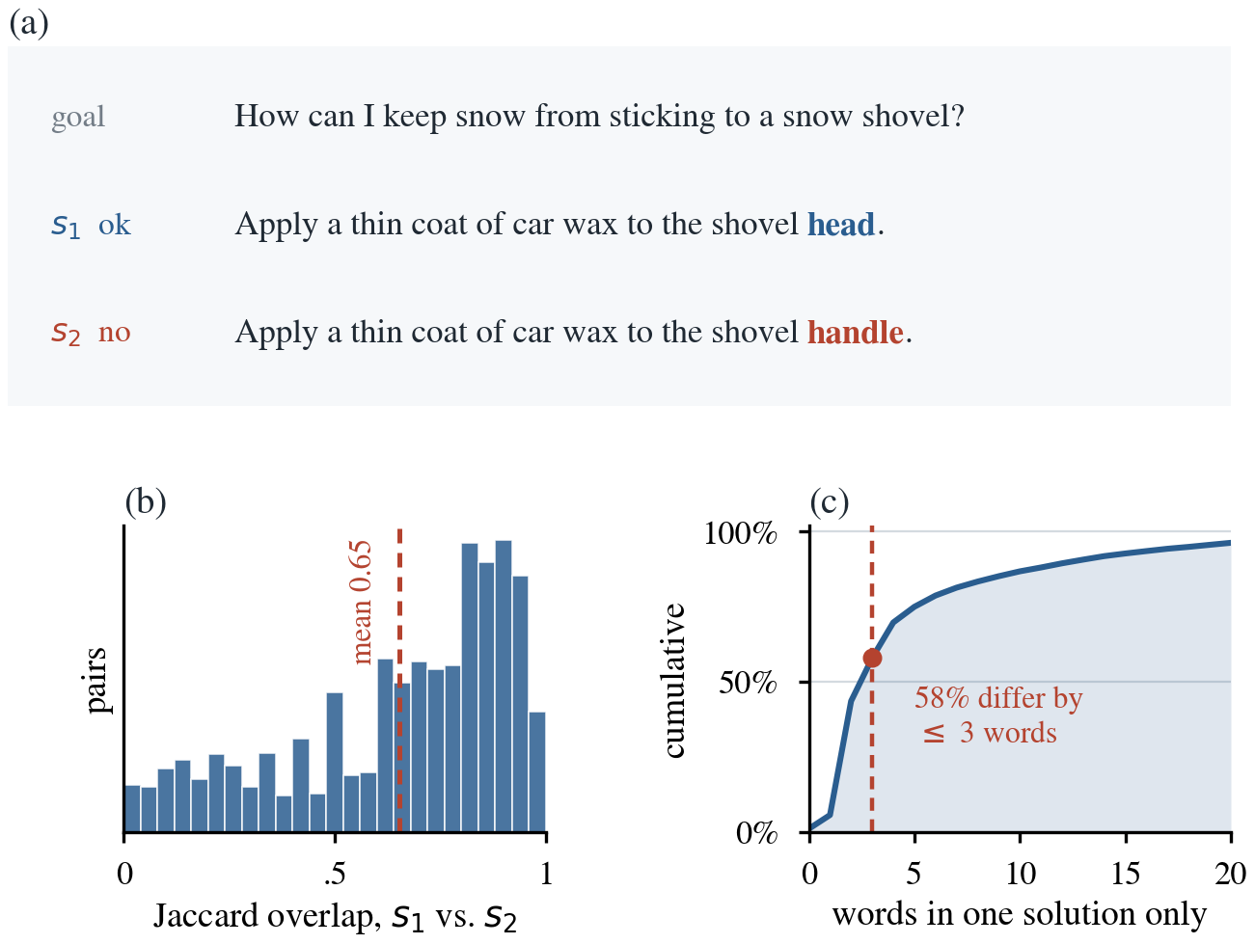
Figure 1. (a) A representative training instance in which the two candidates differ by a single word. (b) Jaccard overlap between the word sets of s₁ and s₂ across the 16,113 training instances, mean 0.653. (c) Cumulative distribution of the number of words appearing in only one of the two candidates.
Across the training split the mean Jaccard overlap between the word sets of the two candidates is 0.653, the candidates differ by three words or fewer in 57.9% of instances, and the overlap exceeds 0.8 in 37.5% of them (Figure 1b, c). A model that encodes each candidate independently and scores it in isolation will therefore present its scorer with two nearly identical vectors, and most of the evidence that separates them is destroyed before the decision is taken. Given these characteristics, our architecture rests on the three design decisions set out in Table 1.
 | Design decision | Rationale
D1 | A single encoder and a single scorer are shared across all three inputs | Sharing weights between the two candidates ensures that any difference the model reports originates in the text rather than in two parameter sets that have drifted apart during training. We extend the sharing to the goal as well, which many question answering architectures encode with a separate tower, so that the goal and the candidates occupy one representation space and the bilinear query of Section 2.4 relates comparable vectors.
D2 | The goal determines which words of a candidate matter | The goal averages 7.1 words and is the only thing that makes one candidate correct rather than the other, so it is used to construct the attention query rather than being concatenated alongside the candidate and left for the scorer to exploit.
D3 | The two candidates attend to each other | The discriminative signal lies in the few positions at which the candidates disagree, so the scorer is given that residual directly rather than being asked to recover it from two pooled vectors.
Table 1. The three design decisions and the dataset characteristics behind them.
We regard D3 as the component specific to this task, since near duplication is precisely the condition under which an alignment residual carries most of the available signal.

2.3 Shared encoder
Tokens are mapped through an embedding matrix E of size V by d, trained from scratch, in which index 0 is reserved for padding and its row is held at zero throughout training. A single bidirectional LSTM (Hochreiter and Schmidhuber, 1997) then encodes all three inputs, producing hidden state matrices of size Lᵍ by 2H for the goal and Lₛ by 2H for each candidate, with Lᵍ = 20, Lₛ = 60, d = 100 and H = 100. Sharing the encoder implements D1 and follows the Siamese arrangement of Mueller and Thyagarajan (2016), which we extend from two inputs to three. Wherever a sequence has to be reduced to a single vector we average over the non-padding positions, and padding is masked at every such step so that it never contributes to any vector the scorer receives.
The choice of a recurrent encoder, and of the LSTM cell within that family, was made deliberately rather than by default. Table 2 records the four encoders we considered and the basis on which each was adopted or set aside.
Encoder | Why it was considered | Outcome
Vanilla RNN | The simplest recurrent baseline, and the cheapest to train. | Set aside once we measured our own sequence lengths. Candidates run to 60 tokens with a 95th percentile of 54, and a simple recurrent cell loses gradient information across sequences of that length (Hochreiter and Schmidhuber, 1997).
LSTM | Gating preserves gradient over long sequences, which the candidate lengths require. | Adopted. Used for every experiment reported in this paper.
GRU | Fewer gates than an LSTM, cheaper to train, and frequently matches it in practice. | Tested. It reaches 0.5922 ± 0.0060 against 0.6003 ± 0.0032 for the LSTM, a difference that falls inside the noise floor of Section 3.2, so the cell type is not where the available improvement lies.
Transformer | The strongest sequence encoder in current use, and the obvious alternative to recurrence. | Set aside on data-scale grounds. Self-attention carries no inherent notion of order and must learn positional structure from data, whereas a recurrent encoder is given it. Our training split holds 13,696 instances and our embeddings are initialised randomly, so there is no pretrained representation to meet that demand.
Table 2. Encoder options considered, with the basis on which each was adopted or set aside.

2.4 Attention over the candidate and over the goal
DANIEL → RAY · Daniel 写的初稿，Ray 修订
Ray，这一节有两件事要做。
一、下面的描述是按你修改之前的模型写的。请通读一遍，把和你实际代码不一致的地方改掉。
二、你对 goal attention 加的三个公式修改，请写成一个新的小节 2.4.1，按下面的格式：
• 改之前是什么，为什么要改（一句话就够）
• 三个公式本身，编号接着 (2) 往下排
• 每个符号是什么、形状多少、增加了多少参数
• 这个改法是你自己想的，还是参考了哪篇 paper？如果是后者，引用写上，并说明你改了什么
说明一下：你说改完之后所有 attention 都开的结果最好。这个结论很重要，但必须有 4.2 的消融数据支撑，否则在报告里站不住。请把代码和数字一起发给 Daniel。
The attention mechanisms in the model share a common form. A query q scores every position of a sequence H, padding positions are suppressed with a large negative constant before the softmax, and the resulting weights pool the sequence into a single vector:
α = softmax(H q), c = Σᵢ αᵢ hᵢ (2)
What distinguishes the mechanisms is where the query comes from.
A1, goal-conditioned attention. The query is formed from the goal vector by a learned bilinear projection, q = W g, and the pooled output cₖ is the summary of the candidate currently being scored. This is the general scoring function of Luong et al. (2015), applied here between two sequences rather than within a decoder, and it is what implements D2, since the goal rather than a fixed saliency pattern decides which words of the candidate matter. W is the only parameter the mechanism introduces, and because it is shared across candidates and across instances, a candidate never seen during training is queried at test time with a query constructed from its own goal.
A2, self-attention over the goal. Averaging treats every word of the goal as equally informative. As an alternative we learn a single query vector qᵍ and apply Equation 2 to the goal, following the word-level attention of Yang et al. (2016); we omit the sentence level of that model, since a PIQA goal is a single short clause.
2.4.1 [ RAY — 你对 goal attention 的修改写在这里 ]
[ 三个公式 + 说明 + 引用 ]

2.5 Cross-attention between the candidates
DANIEL → RAY · Daniel 写的初稿，Ray 核对
A3 implements D3. Each position of one candidate attends over the whole of the other candidate, and what the other candidate cannot account for is retained. Following the soft alignment of Chen et al. (2017),
h̃ᵢᵏ = Σⱼ βᵢⱼ hⱼ³⁻ᵏ, βᵢⱼ = softmaxⱼ ( hᵢᵏ · hⱼ³⁻ᵏ ) (3)
and dₖ is the masked average of Hᵏ minus H̃ᵏ. Since h̃ᵢᵏ is the part of position i that the other candidate can explain, the difference is the part that it cannot, which is exactly the signal the near-duplicate structure of the dataset concentrates into a handful of positions. Equation 3 introduces no parameters at all.
Our use of the mechanism differs from ESIM in two respects. ESIM aligns a premise against a hypothesis, two texts that occupy different roles, whereas we align two texts that occupy the same role, with the consequence that exchanging the candidates exchanges the outputs and changes nothing else. ESIM also feeds a four-part concatenation into a second recurrent layer, while we retain only the difference term and pool it directly, which avoids the second recurrent pass entirely.

2.6 Interaction features and scoring
DANIEL
The goal vector, the attended candidate summary and the alignment residual are combined using the interaction features of Conneau et al. (2017), who introduced them for natural language inference and whose four-part combination has since become the conventional way of matching two encoded sentences:
uₖ = [ g ; cₖ ; g ⊙ cₖ ; | g − cₖ | ; dₖ ] ∈ ℝ¹⁰ᴴ (4)
The elementwise product and the absolute difference supply the scorer with an explicit measure of agreement and of disagreement between the goal and the candidate, rather than requiring it to learn such a measure from the concatenation alone. A two-layer feed-forward network with dropout then maps uₖ to a single scalar, using a ReLU activation in the hidden layer. ReLU is the appropriate choice for a scorer of this depth because it does not saturate for positive inputs, so gradients reach the attention and encoder parameters undiminished, whereas sigmoid and tanh flatten at both extremes and attenuate them.
The two scalars are passed through a softmax and the model is trained with cross-entropy against y. Figure 2 shows the complete architecture.
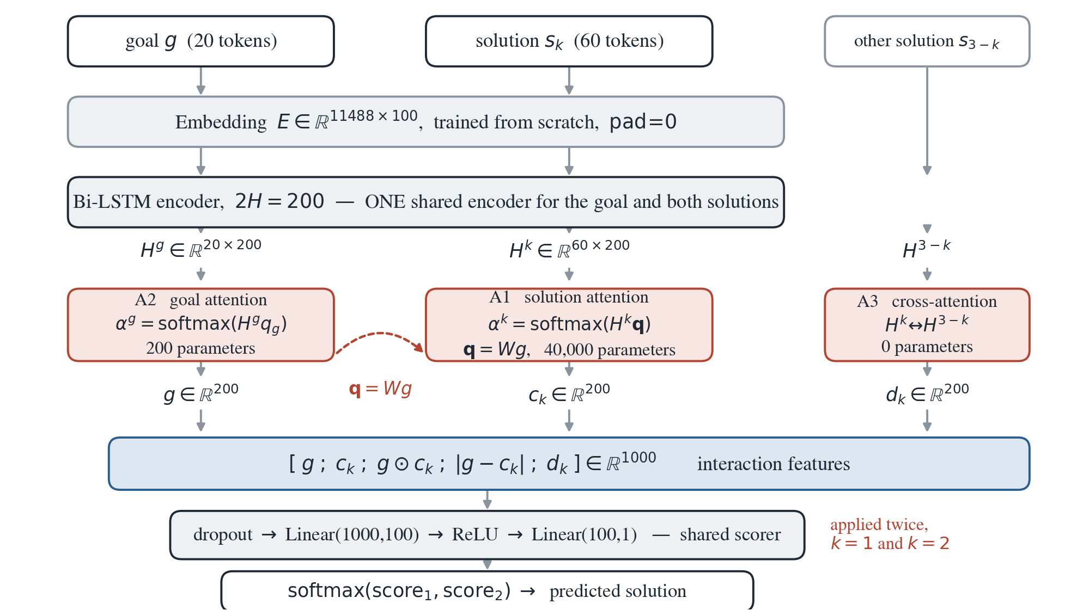
Figure 2. Model architecture. One embedding matrix and one bidirectional LSTM encode the goal and both candidates, and one scorer is applied to each candidate in turn. The three attention mechanisms are shaded. A3 introduces no parameters.
Ray：这张架构图是按修改前的模型画的。你的三个公式改完之后，如果 A2 那一格的内容变了，告诉 Daniel 重画。另外参数总数也会变，下面 Table 3 需要更新。
With every component enabled the model holds 1,451,001 parameters, distributed as shown in Table 3. Close to four fifths of what the model must learn is therefore the word representations themselves, which is the context for the limitations discussed in Section 2.8.
Component | Parameters | Share
Embedding matrix, 11,488 by 100 | 1,148,800 | 79.2%
Bidirectional LSTM, one layer | 161,600 | 11.1%
Scorer, two linear layers | 100,201 | 6.9%
A1 bilinear projection W | 40,000 | 2.8%
A2 and A3 query vectors | 400 | under 0.1%
A3 cross-attention | 0 | 0%
Total | 1,451,001 | 100%
Table 3. Parameter count with every component enabled.

2.7 Relation to existing work
DANIEL → RAY · Daniel 写的，Ray 补充自己的那一行
Table 4 separates the components we adapted from published work from the decisions that are our own. No implementation code was taken from any of these papers or from their released repositories.
Component | Adapted from | What we changed, and why
Shared encoder | Mueller and Thyagarajan (2016) | Extended from two inputs to three, so that the goal and both candidates pass through one encoder and candidate scores remain comparable.
A1 attention | Luong et al. (2015) | Applied across two sequences rather than within a decoder, with the query constructed from the goal so that attention is conditioned on the question being asked.
A2 attention | Yang et al. (2016) | Word level only. The sentence level is dropped, since a PIQA goal is a single short clause.
A2 modification | [ RAY — 引用写这里 ] | [ RAY — 你改了什么，为什么 ]
A3 cross-attention | Chen et al. (2017) | Applied between two candidates that occupy the same role rather than between a premise and a hypothesis, which makes it symmetric, and reduced to the difference term alone, pooled directly instead of passed through a second recurrent layer.
Interaction features | Conneau et al. (2017) | Used unchanged, between the goal and the attended candidate.
Overall design | ours | The combination of a shared three-input encoder, a goal-conditioned query and a candidate-versus-candidate residual, with each component placed behind a switch so that its contribution can be measured in isolation.
Table 4. Provenance of each component.

2.8 Assumptions and limitations
DANIEL
Three limitations follow directly from the design. The embedding matrix is trained from scratch on 13,696 instances and holds 79.2% of the parameters, so the model possesses no physical knowledge beyond what co-occurrence within that training set supplies, and this is the structural difference between our model and the pretrained baselines of Section 3.4. Truncation at Lₛ = 60 discards part of 3.5% of candidates, and for those instances the alignment residual is computed on incomplete text. Finally, Equation 3 is quadratic in candidate length, which is inexpensive at Lₛ = 60 but would prevent the component transferring unchanged to a dataset with long candidates.

3 Experimental Setup

3.1 Dataset and preprocessing
DANIEL
We use the PIQA release provided for this project, which contains 16,113 labelled training instances and 1,838 labelled test instances and has no official validation split. Both splits are balanced: the second candidate is the correct one in 50.0% of training instances and 50.5% of test instances, so a constant predictor scores 0.500 and accuracy is not distorted by a class prior. Table 5 reports the statistics we measured directly from the provided files.
 | train | test
Instances | 16,113 | 1,838
Proportion with y = 2 | 0.500 | 0.505
Goal length in words, mean / 95th percentile | 7.1 / 13 | not measured
Candidate length in words, mean / 95th percentile | 19.6 / 54 | not measured
Jaccard overlap between candidates, mean | 0.653 | not measured
Instances whose candidates differ by 3 words or fewer | 57.9% | not measured
Vocabulary: words appearing at least twice | 11,488 | —
Table 5. Dataset statistics. Candidate length is the longer of the two candidates. The vocabulary keeps every word occurring at least twice in the training split; rarer words map to an unknown token.
The only test-set quantities we examined before the final evaluation are its size and its label balance, both of which are needed to justify the choice of metric. We computed no length, overlap or vocabulary statistics on it, since inspecting the distribution of a held-out set is itself a route by which it can influence design decisions.
Splits. The test set is reserved for a single final evaluation. We partition the training set 85/15 with stratification on the label, which yields 13,696 training and 2,417 validation instances, and every design decision, hyperparameter choice and ablation reported in this paper was made on that validation split. The test set was unlocked once, on [DATE], for the evaluation reported in Table 7.
Preprocessing. Text is lower-cased, punctuation is replaced by whitespace, and tokens are obtained by splitting on whitespace. The vocabulary is built from the training split alone and contains 11,488 types; any token not present in it maps to an unknown index at evaluation time. Sequences are truncated and zero-padded to Lᵍ = 20 and Lₛ = 60, both of which sit above the 95th percentile of their respective distributions at 13 and 54 words, so that truncation affects 0.2% of goals and 3.5% of candidates. These lengths are short enough to keep the quadratic cross-attention inexpensive and long enough that truncation is not a material source of error.

3.2 Training procedure
DANIEL
Models are trained with Adam (Kingma and Ba, 2015) at a batch size of 32, using cross-entropy loss with dropout applied to the scorer input. Adam suits this model because it maintains a separate adaptive step size for each parameter, and our dominant component is an embedding matrix whose rows receive a gradient only in the minority of batches containing their word; a single global learning rate would update frequent and rare words at the same pace.
Epoch budget. Every configuration is trained for a fixed budget of 15 epochs and we retain the epoch at which validation accuracy is highest. Because selecting the best epoch inflates the figure reported, and the inflation grows with the budget, the budget is held constant across every comparison. The value of 15 was established empirically: training the reference configuration over ten seeds for 25 epochs shows the mean curve flattening by the fifth epoch and fluctuating without sustained improvement thereafter, with individual runs peaking anywhere between the fifth and the twenty-fourth epoch at a median of 13.5. Extending the budget from 15 to 25 epochs is worth only 0.0019 in mean best accuracy, well inside the noise floor defined below, so 15 epochs sits on the plateau at 60% of the computational cost.
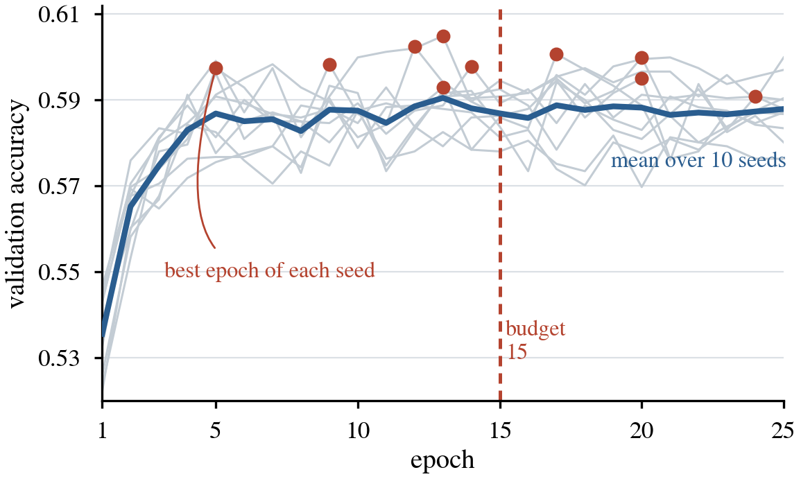
Figure 3. Validation accuracy of the reference configuration over 25 epochs for ten seeds. Grey lines are individual runs, the blue line is their mean, and the red markers show where each run reached its own best value. The dashed line marks the 15 epoch budget used throughout.
The same experiment exposes a limitation of our protocol. The reference configuration scores 0.6003 when averaged over the three seeds used throughout this paper, but 0.5961 when averaged over ten, which means the three seeds fixed at the outset happen to be a favourable draw. The discrepancy of 0.0043 falls inside the threshold we apply to every comparison, and since all configurations are evaluated on the same three seeds the bias is common to all of them and does not disturb the ordering we report. It is nonetheless a concrete reminder that a three-seed mean carries real uncertainty, and it is the reason we treat small differences as unresolved rather than as findings.
Reproducibility. The project was developed by three people working in separate Google Colab sessions, on hardware that is reassigned between runs, so a number produced by one member had to be comparable with a number produced by another on a different day. Every result is a mean over seeds 0, 1 and 2, and Python, NumPy and PyTorch are seeded at the start of each run. We additionally set cudnn.deterministic and disable cudnn.benchmark, since without the latter cuDNN re-benchmarks its kernels on each run and may select a different algorithm, while the LSTM backward pass is itself non-deterministic. Before these settings were introduced, repeated runs of the same seed differed by as much as 0.015 accuracy, which exceeds several of the effects we report. With them in place a configuration re-run several days later in a new session returned the same three seed accuracies to four decimal places. All experiments ran on a single Tesla T4 with torch 2.11.0+cu130 and cuDNN 9.27.0.
Noise floor. Deciding when two configurations genuinely differ requires an estimate of how much a result moves when nothing changes. Each configuration yields one standard deviation over its three seeds, but three observations estimate a standard deviation poorly, and across our sixteen configurations these individual values range from 0.0002 to 0.0083, a spread that reflects sampling variability rather than any real change in the level of noise. We therefore pool the sixteen estimates into a single figure of 0.0049 accuracy, on the assumption that seed-to-seed variation does not depend on which hyperparameter is being varied. Two configurations are treated as indistinguishable when their means differ by less than 0.0099, twice the pooled value, and differences exceeding that are tested with Welch's t-test. This single pooled figure governs every comparison in the paper. Because every comparison is made on the same fixed validation split, the sampling error of the split itself, which is approximately 0.010 at an accuracy of 0.60 with 2,417 instances, is common to all configurations and does not enter the comparison, although it does bound the precision of the absolute figures we report.

3.3 Hyperparameter selection
DANIEL
Hyperparameters were selected one at a time around a fixed reference configuration, on the validation split and with attention disabled, so that the backbone was settled before any attention component was evaluated. Figure 4 shows every value tested; the shaded band marks the noise floor, and a point falling within it cannot be separated from the reference.
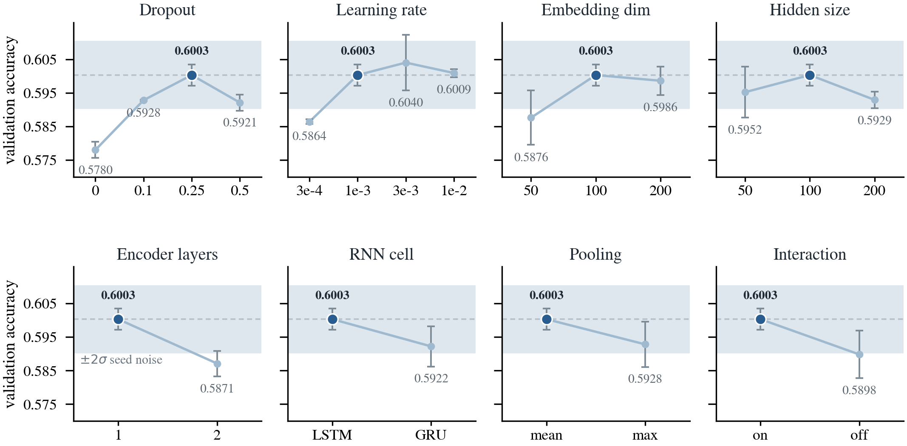
Figure 4. Validation accuracy for every hyperparameter value tested, around the no-attention reference configuration. Three seeds per point, error bars show one standard deviation, the dashed line is the reference and the shaded band spans two pooled standard deviations of seed noise. The dark marker indicates the value adopted.
Two settings warrant comment, because in each case the value adopted was not the one with the highest mean. A learning rate of 0.003 scored above 0.001, but the gap of 0.0037 lies inside the noise floor while its spread across seeds was two and a half times wider, so we preferred the more stable setting. Hidden size was flat across the entire range tested, and we took the smallest value on that plateau rather than the highest-scoring one, since additional capacity that buys no measurable accuracy only increases the risk of overfitting a training set of this size. Table 6 records the final configuration together with the evidence behind each choice.
Setting | Adopted | Evidence
Dropout | 0.25 | Inverted U over 0, 0.1, 0.25 and 0.5, with the peak at 0.25. Removing dropout altogether costs 0.0223, the largest effect we measured.
Learning rate | 0.001 | Accuracy collapses below 1e-3 and is flat above it. 0.003 has a marginally higher mean but two and a half times the spread.
Embedding width | 100 | 50 is clearly worse. 200 adds 1.1M parameters and recovers nothing.
Hidden size | 100 | Flat over 50, 100 and 200. Smallest value on the plateau.
Encoder layers | 1 | Two layers are worse by 0.0133.
Cell type | LSTM | GRU lies inside the noise band, so the cell type does not separate.
Pooling | mean | Max pooling lies inside the noise band.
Interaction features | on | Removing them costs 0.0105, which clears the threshold but does not reach significance under Welch's test.
Batch size | 32 | Fixed, not searched.
Epochs | 15 | Established in Section 3.2 rather than assumed.
Table 6. Final configuration and the evidence behind each choice. Where two values could not be separated we adopted the simpler or cheaper one.

3.4 Baseline models
VIKA
⚠ Vika：所有 baseline 必须在 TEST SET 上重跑一次
你现在的数字全部是 validation 上的。论文的总对比表必须是 test 的数字。
怎么跑：训练和选 epoch 继续用 validation（train_part1 训练，train_part2 选），训完之后把选好的模型在 test_input 上评一次。千万不要把 test 当成 val_input 传进 train_model，那等于用 test 选模型，直接违反作业规定。
什么时候跑：等 Ray 的消融定下最终配置之后，全组一起跑，只跑一次。跑完谁都不再改模型。
要跑哪些：B0 词重合（不用训练，几秒）、B1、3 个 seed、B2、3 个 seed、B3、1 次。
注意：test 上 P(y=2) = 0.505，所以恒定预测的那一行在 test 列应该写 0.505，不是 0.500。
表格请用下面这个格式（validation 和 test 两列都要）
System | Strategy | Seeds | Validation | Test
Random / majority | no learning | — | 0.5000 | 0.505
Lexical overlap | no learning | — | 0.5259 | [ ]
B1 bag of embeddings + MLP | learned, not pretrained | 0, 1, 2 | 0.5745 ± 0.0023 | [ ]
Our model (base, no attention) | ours | 0, 1, 2 | 0.6003 ± 0.0032 | [ ]
Our model (full) | ours | 0, 1, 2 | [ ] | [ ]
B2 DistilRoBERTa, fine-tuned | pretrained, fine-tuned | 0, 1, 2 | 0.6326 ± 0.0059 | [ ]
B3 Qwen2.5-3B, zero-shot | pretrained, no training | — | 0.7844 | [ ]
这张表是 §3.4 和 §4.1 共用的。Validation = 2,417 条，test = 1,838 条。两列都保留，因为前面所有的超参和消融数字都是 validation，只给 test 的话读者对不上。
你已经写好的那份草稿质量很高，四个策略齐全、checkpoint 名称精确、B3 用 log-likelihood 而不是解析文本（引 Bisk et al. 的做法）、两条 caveat 很诚实。「Reading the table」那段的 gap 分解是全文最强的部分，直接搬过来就行。以下四处请改一下：
一、验证集大小：你 B3 那段写的 2,417 是对的，开头那句 12,890 / 3,223 是从早期草稿里抄的，那个数字写错了。实际切分是 test_size = 0.15，13,696 / 2,417。整份文档已经改正，你把自己草稿开头那句改成 13,696 / 2,417 就行。
二、B1 的归因写反了。你写「any gap between B1 and the main model is attributable to the bidirectional LSTM and the attention mechanisms」，但你比的是 base（attention 全关）。所以那 0.0258 只是 Bi-LSTM 的贡献，不包含 attention。要么改成「LSTM 的贡献」，要么改成和 full model 比。
三、表里那一行标签矛盾。写的是「BiLSTM + attention (base)」，但 base 是 attention 全关的。
四、噪声数字过期。你用的是 0.005，现在是 0.0049，门槛 0.0099（16 个配置合并）。另外章节号现在是 §3.4，不是 2.4。

3.5 Evaluation metrics
DANIEL
We evaluate with accuracy. The task presents a forced choice between two candidates of which exactly one is correct, both labels are balanced to within half a percentage point in either split, and the two error types carry equal cost, so accuracy is the natural measure and it is the metric reported in the original PIQA work (Bisk et al., 2020). It is computed as the proportion of instances for which the argmax of f over the two candidates coincides with the gold label.
Precision, recall and F₁ would add nothing in this setting, since a forced choice between two candidates leaves no class to be precise about, and macro-F₁ on a balanced binary task is a monotone function of accuracy. Every configuration is reported as a mean over three seeds together with its standard deviation, and every comparison is judged against the 0.0099 threshold established in Section 3.2.
A majority-class predictor scores 0.500 by construction. A lexical overlap heuristic that selects whichever candidate shares more words with the goal reaches 0.5259 on our validation split, and we treat that figure rather than 0.500 as the floor a learned model must clear, since a model scoring 0.52 would have learned nothing beyond surface word matching.

4 Results and Analysis

4.1 Overall performance comparison
VIKA
用 §3.4 里那张表的 test 列。表后面跟一段讨论，这段是分数所在。
你草稿里「Reading the table」和「What this comparison shows」两段写得很好，换成 test 数字之后直接用。核心论点保留：floor 到 B1 是「有没有学习」的差距，B1 到我们是序列建模的差距，我们到 B2 是预训练的差距，B2 到 B3 是规模的差距。
所有比较用 0.0099 的门槛。差距小于这个数就写 not separable，不要写 slightly better。
注意：这张表要等 test 跑完才能填，而 test 要等 Ray 的消融定下 full model 的配置。

4.2 Ablation studies
RAY
消融集中在 attention 上。use_goal 那一组我们决定不做了。全部在 validation 上，每个配置 3 个 seed，除了要测的那一项之外其他全部保持 base 配置。
建议跑这几组：
base（attention 全关） — 参照点 0.6003
A1 单独开（goal-conditioned） — goal 决定看哪些词
A1 改成 self（关键对照） — 如果 self 一样好，说明 goal conditioning 没起作用
A2 单独开（你修改后的版本） — 你的三个公式到底值不值
A3 单独开（cross-attention） — 我们论文的核心主张
full model（全开） — 你说这个最好，需要数据
full − A1 / full − A2 / full − A3 — 留一法，测冗余
留一法很重要：单独开有用，不等于加在一起还有用。特别看 full − A3，如果它和 full 一样，说明 cross-attention 在有 A1 的情况下是冗余的，那 2.2 和 2.5 都要改写，请立刻告诉 Daniel。
每组消融写四行：Hypothesis（跑之前就写好）、Control（哪些东西保持不变）、Result（差值和 t 值）、Verdict（对照 0.0099 门槛是否可分辨）。作业原文明确要求说明每个消融的假设和控制条件。
已经测好的一组，直接放进同一张表：interaction features 关掉 = 0.5898 ± 0.0071，对 base 0.6003，差 −0.0105，t = −1.90，超过门槛但未达显著。

4.3 Qualitative analysis of attention
RAY
作业原文：需要同时展示成功和失败的预测，并给出输入、正确答案和模型预测，让读者能看懂可视化。
所以每个例子要有五样东西：goal、两个候选项、正确答案、我们的预测、attention 权重图。至少一个对的、一个错的。记下行号方便复现。
挑例子的时候选两个候选项只差几个词的，读者才看得出模型要区分的是什么。例子从 validation 里挑，不要用 test。
重要：除了图还要报一个数字。把 alpha 的最大值标在图旁边，和均匀分布对比。比如一个十个词的句子，均匀是 0.100，如果最大值只有 0.11 说明 attention 是平的、没起作用；如果是 0.45 说明它真的在选。
如果权重接近均匀，那是一个 finding，不是失败。有 attention 但权重均匀，等于模型在做平均池化，诚实写出来比一张好看但没内容的热力图值钱。
技术点：predict_all 只返回 alpha。cross-attention 的对齐矩阵要从 forward 的返回值里读 attention[“sol1_align”]，在几行样本上跳一次就行。

5 Conclusion
VIKA · 第一稿，Daniel 和 Ray 补充
大约半页 ACL。总结主要发现和学到的东西，指出主要成果，诚实承认局限，并给出未来方向。
已经确定、可以直接用的材料：模型明显超过词重合底线 0.5259；大部分骨干超参都落在噪声带内，说明提升空间不在编码器配置上；15 个 epoch 是测出来够用的，不是假设的。
诚实要写的局限：embedding 从零训练、只有 13,696 条数据、占 79.2% 的参数，所以模型没有超出这份数据的物理常识；没有测试 Transformer 编码器；cross-attention 是候选项长度的平方复杂度；三个 seed 的均值比十个 seed 高 0.0043。
B3 那个 0.7844 的解读很重要：那是预训练规模的优势，不是架构的优势，而且有数据污染的可能。你草稿里已经写得很好，搬过来。

Team Contributions
DANIEL · 最后写，不计页数
One or two sentences per member, matching what each person actually did.

References
Generated with BibTeX. Current entries:
Bisk, Y., Zellers, R., Le Bras, R., Gao, J., and Choi, Y. (2020). PIQA: Reasoning about Physical Commonsense in Natural Language. AAAI, 34(5), 7432–7439.
Chen, Q., Zhu, X., Ling, Z.-H., Wei, S., Jiang, H., and Inkpen, D. (2017). Enhanced LSTM for Natural Language Inference. ACL.
Conneau, A., Kiela, D., Schwenk, H., Barrault, L., and Bordes, A. (2017). Supervised Learning of Universal Sentence Representations from Natural Language Inference Data. EMNLP.
Hochreiter, S. and Schmidhuber, J. (1997). Long Short-Term Memory. Neural Computation, 9(8), 1735–1780.
Kingma, D. P. and Ba, J. (2015). Adam: A Method for Stochastic Optimization. ICLR.
Liu, Y., Ott, M., Goyal, N., Du, J., Joshi, M., Chen, D., Levy, O., Lewis, M., Zettlemoyer, L., and Stoyanov, V. (2019). RoBERTa: A Robustly Optimized BERT Pretraining Approach. arXiv:1907.11692.
Luong, T., Pham, H., and Manning, C. D. (2015). Effective Approaches to Attention-based Neural Machine Translation. EMNLP.
Mueller, J. and Thyagarajan, A. (2016). Siamese Recurrent Architectures for Learning Sentence Similarity. AAAI.
Qwen Team (2024). Qwen2.5: A Party of Foundation Models. Technical report, Alibaba Group.
Sanh, V., Debut, L., Chaumond, J., and Wolf, T. (2019). DistilBERT, a distilled version of BERT. NeurIPS EMC2 Workshop.
Yang, Z., Yang, D., Dyer, C., He, X., Smola, A., and Hovy, E. (2016). Hierarchical Attention Networks for Document Classification. NAACL.
Ray：你修改 goal attention 时参考的 paper，引用发给 Daniel 加进来。

Appendix 对照作业评分标准
不是论文的一部分，是内部检查用。五条评分标准逐条对应到章节、负责人和状态。

Criterion 1 Model design and implementation
作业要求 | 在哪里 | 谁 | 状态
Technically sound, clearly explained, correctly implemented | 2.1–2.6, Eq 1–4, Figure 2 | Daniel | 完成
Addresses the characteristics of the selected task | 2.2 和 Table 1 | Daniel | 完成
Thoughtful originality through adaptation or extension | 2.5 候选项互对齐；Table 4 区分自己和借鉴 | Daniel + Ray | 需 4.2 数据支撑
Meaningful integration of attention | 2.4 2.5 描述，4.2 逐个测量 | Ray | 待完成
Well-justified design decisions | Table 1, Table 2, 2.6, 3.2, 3.3 | Daniel | 完成
Model trained from scratch | 2.3 明确说明 embedding 随机初始化 | Daniel | 完成
Clear notation, equations, architecture diagram | 4 个编号公式 + Figure 2 | Daniel + Ray | Ray 补充公式

Criterion 2 Experimental investigation
作业要求 | 在哪里 | 谁 | 状态
Breadth, relevance and rigour | 3.2 收敛实验、10 seeds；3.3 八个超参；4.2 消融 | Daniel + Ray | Ray 待完成
Investigate informative baseline approaches | 3.4，四个不同策略 | Vika | validation 已有，test 待跑
All baseline results from our own experiments | 3.4 | Vika | 完成
Well-motivated and controlled ablation studies | 4.2，一次只改一个开关 | Ray | 待完成
Appropriate training and evaluation procedures | 3.2 固定预算、seed、确定性、噪声底线 | Daniel | 完成
Test set not used to guide design or model selection | 3.1 说明分割协议和读过什么 | Daniel | 完成
Reproducible implementation | 3.2 复现性段落 | Daniel | 完成

Criterion 3 Results and critical analysis
作业要求 | 在哪里 | 谁 | 状态
Overall performance comparison | 4.1 和 3.4 的表 | Vika | 等 test
Ablation results presented and discussed | 4.2 | Ray | 待完成
Attention visualisation, success AND failure | 4.3，两类例子都要 | Ray | 待完成
Insightful interpretation, evidence-supported | 3.3 解释为什么没选均值最高的 | Daniel | 3.3 完成
Critically discuss limitations | 2.8 三条结构性局限 | Daniel | 完成
Discuss unexpected findings | 3.2 三 seed 比十 seed 高 0.0043 | Daniel | 完成
Clear, appropriately labelled tables and figures | 4 图 7 表，全部有标题并在正文引用 | 全组 | 进行中

Criterion 4 Writing and presentation
作业要求 | 在哪里 | 谁 | 状态
Coherent, concise, well organised | 章节顺序完全按作业要求 | 全组 | 进行中
Clear technical explanations | 2.1–2.6 | Daniel | 完成
Appropriate referencing | BibTeX，11 条 | Daniel | Ray 和 Vika 补充
Effective use of tables, figures, equations, diagrams | 4 公式、4 图、7 表 | Daniel | 完成
ACL 模板，final 不是 review，只写组号 | 还没搬进 Overleaf | Daniel | 待做
不超过 6 页 | 三人写完后很可能超 | 全组 | 有风险

Criterion 5 Engagement with relevant research
作业要求 | 在哪里 | 谁 | 状态
Understanding and meaningfully applying published work | 2.3–2.6，每个组件有出处 | Daniel | 完成
Explain how the work relates to or extends existing approaches | Table 4，逐条写改了什么 | Daniel + Ray | Ray 补一行
Cite relevant publications, explain modifications | Table 4，2.5 的 ESIM 对比 | Daniel | 完成
Situate the task in the literature | Introduction | Vika | 待完成

必须做到、否则扣分的硬性要求
要求 | 谁 | 状态
报告必须准确描述实际实现，报告与代码不一致会扣分 | 全组 | 10/17 检查
训练和评估的 log 必须作为 cell 输出保存在 notebook 里 | 全组 | 进行中
notebook 必须在全新的 Colab 上能从头跑通 | Daniel | 待做
必须用提供的代码模板 | Daniel | 确认
不得引入额外数据集 | 全组 | 已遵守
baseline 不得用闭源 API（GPT / Claude / Gemini） | Vika | 已遵守
文件名 CITS4012_组号.pdf 和 .ipynb，一人提交 | Daniel | 待做

评分标准里最大的两条（Criterion 2 和 3）几乎全部压在 Ray 的消融和 Vika 的 test 重跑上。这两件事一旦完成，test run、§4.1 的表和整个第 4 章就全部解锁。

