# Wiring and configuration

## Wiring diagram

### Stepper drivers and motors

#### Stepper motor

Before you can connect the stepper motor to RADDS or SilentStep , you need some information on the stepper motor you have.  
  
Look at your motor, find its part number. Then Google it. Try to find a schematic or a data-sheet that will indicate which wire goes to which pole. Note the colors that correspond to each coil.

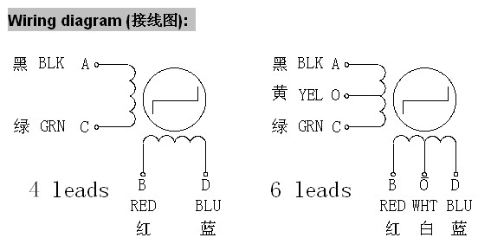  
*Wiring diagram for Wantai 42BYGHW609 stepper motor (from* [*www.wantamotor.com*](http://www.wantamotor.com)*).*   
  
If you can`t find the motor`s part number, you can use another method to find the motor`s pole pairs.  
When two wires for a pole (A +C or B+D) touch together it makes a closed circuit for that pole and it gets harder to turn the stepper motor.

1. Try to turn the motor when no cables touch together – it should turn freely.
2. Touch two of the cables together – if the motor gets harder to turn, you have found a pole pair. If not, try to touch two other cables together until the motor gets harder to move.
3. When you have two cables together that makes it harder to turn the motor, you have found a pole pair.

Note the colors for each pole pair (Pair 1 = 1A +1B, Pair 2 = 2A+2B)  
  
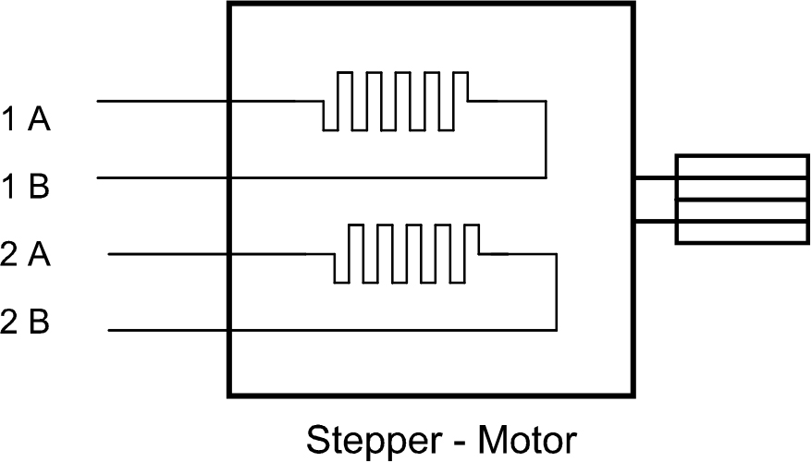  
  
On the Wantai 42BYGHw609 the colors are:   
1A = Black  
1B = Green  
2A = Blue  
2B = Red  
  
It does not matter if you swap the pole pairs. If the motor turns the wrong way, you can reverse it in the configuration file.

#### Micro stepping

A stepper motor always has a fixed number of steps. Microstepping is a way of increasing the number of steps by sending a sine/cosine waveform to the coils inside the stepper motor. In most cases, micro stepping allows stepper motors to run smoother and more accurately.

Microstepping between pole-positions is made with lower torque than with full-stepping, but has much lower tendency for mechanical oscillation around the step-positions and you can drive with much higher frequencies.

If your motors are near to mechanical limitations and you have high friction or dynamics, microsteps do not give you much more accuracy over half-stepping. When your motors are 'overpowered' and/or you do not have much friction, then microstepping can give you much higher accuracy over half-stepping. You can transfer the higher positioning accuracy to moving accuracy too  
  
Source: http://www.reprap.org/wiki/Stepper_motor#Micro_stepping

If you want to alter the micro stepping value on one or more axis, you have to set the correct value. When using SilentStep , you set it using the dipswitches on the SilentStep and modify the values in the configuration.h file

Each time you increase the stepping one level (sample: from 1/16 to 1/32) you have to multiply the steps per unit value by two.

Sample – You are using 1/16 steps per unit and the value is 80 and want to use 1/32 steps per unit.

If your steps per unit value is 80, you have to multiply 80 by two (2x80).

New steps per unit value = 160

// #define DEFAULT_AXIS_STEPS_PER_UNIT {78.7402,78.7402,200.0*8/3,760*1.1} // default steps per unit for Ultimaker

//#define DEFAULT_AXIS_STEPS_PER_UNIT {80,80,2560,107} // default steps per unit for OrdBot 1/16

#define DEFAULT_AXIS_STEPS_PER_UNIT {160,160,5120,214} // default steps per unit for OrdBot 1/32

This code sample is from Marlin.

The “default steps per unit for OrdBot 1/16” gives you the values for 1/16 micro stepping.

80, 80, 2560, 107   
X-Axis = 80 steps/mm  
Y-Axis = 80 steps/mm  
Z-Axis = 2560 steps/mm  
Extruder motor = 107 steps/mm (this is the setting for Bulldog Lite Extruder. You have to find the correct setting for the extruder you use)

In the next code line, you find “default steps per unit for OrdBot 1/32”. This is the settings when 1/32 microstepping are used. Here all values have been multiplied with two.

#### Set the micro stepping mode on RADDS 1.1

When you use stepper drivers like the A4988, DRV8825 (NOT WHEN USING EXTERNAL DRIVERS LIKE SILENTSTEP ) you have to set the micro stepping mode by cutting or connecting the traces on the back of the RADDS board.

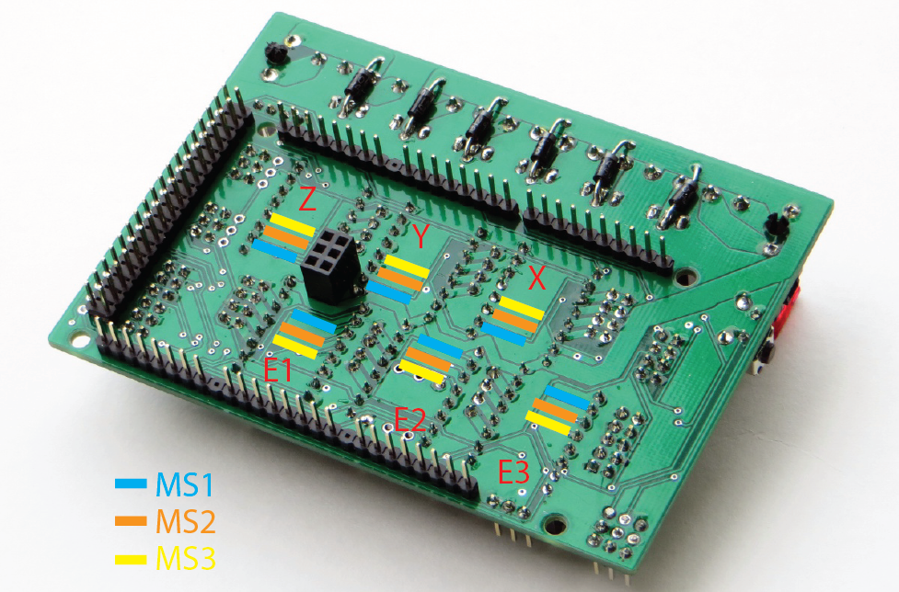

|  |  |  |  |  |  |  |  |  |  |
| --- | --- | --- | --- | --- | --- | --- | --- | --- | --- |
| A4988 | | | DRV8825 | | | RAPS128 | | |  |
| MS1 | **MS2** | **MS3** | **MS1** | **MS2** | **MS3** | **MS1** | **MS2** | **MS3** | **STEP** |
| L | L | L | L | L | L | L | L | L | **1** |
| H | L | L | H | L | L | H | L | L | **1/2** |
| L | H | L | L | H | L | L | H | L | **1/4** |
| H | H | L | H | H | L | H | H | L | **1/8** |
| H | H | H | L | L | H | L | L | H | **1/16** |
|  |  |  | H | H | H | H | L | H | **1/32** |
|  |  |  |  |  |  | L | H | H | **1/64** |
|  |  |  |  |  |  | H | H | H | **1/128** |

In this image, the traces have different colors to make it easier to find the correct traces.

In the table, you find the different stepping modes for the most used drivers.  
L = Open trace, H = Closed trace (MS pin = 3,3V = default)  
When using the DRV8825 the combinations HLH, LHH and HHH all gives 1/32 STEP

**IMPORTANT** you have to set the same stepping mode in the configuration.h file and update the controller software.

#### 1Mounting stepper drivers like A4988, DRV8825 or stepper driver adapters

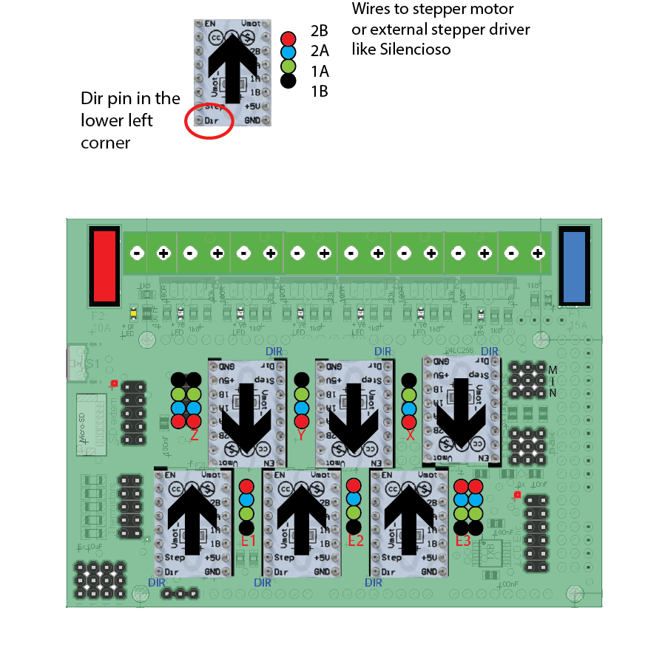

*SilentStep stepper driver adapters used as a sample in this wiring diagram, but the other drivers have the same pin labels.*  
  
Insert the stepper drivers/adapters (X, Y and Z) with the DIR pin in the upper right corner (upside down)

Insert the stepper drivers/adapters (E1, E2 and E3) with the DIR pin in the lower left corner.

The X, Y and Z motor cables have the black wire at the top

The E1, E2 and E3 wires have the red wire at the top

The Z and E3 have dual motor cable connections so you can connect two motors.

#### Normal setup when using external stepper drivers like RRD SilentStep

This is the normal way to connect a SilentStep driver and motor.

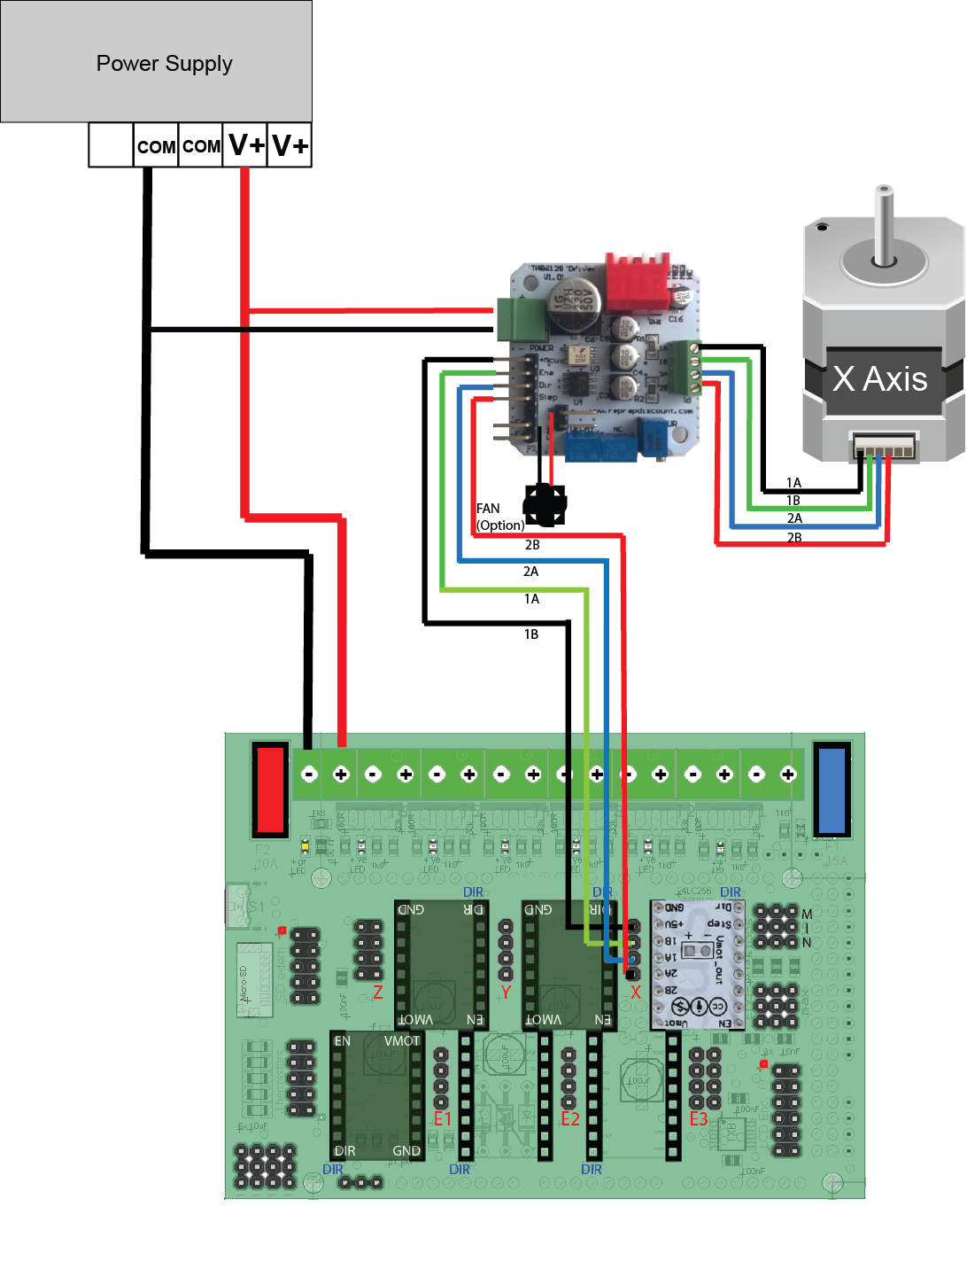

#### Dual Z stepper motor alternative 1 (dual SilentStep s)

Use this setup when the total current used by the two motors exceeds the current limit of one SilentStep 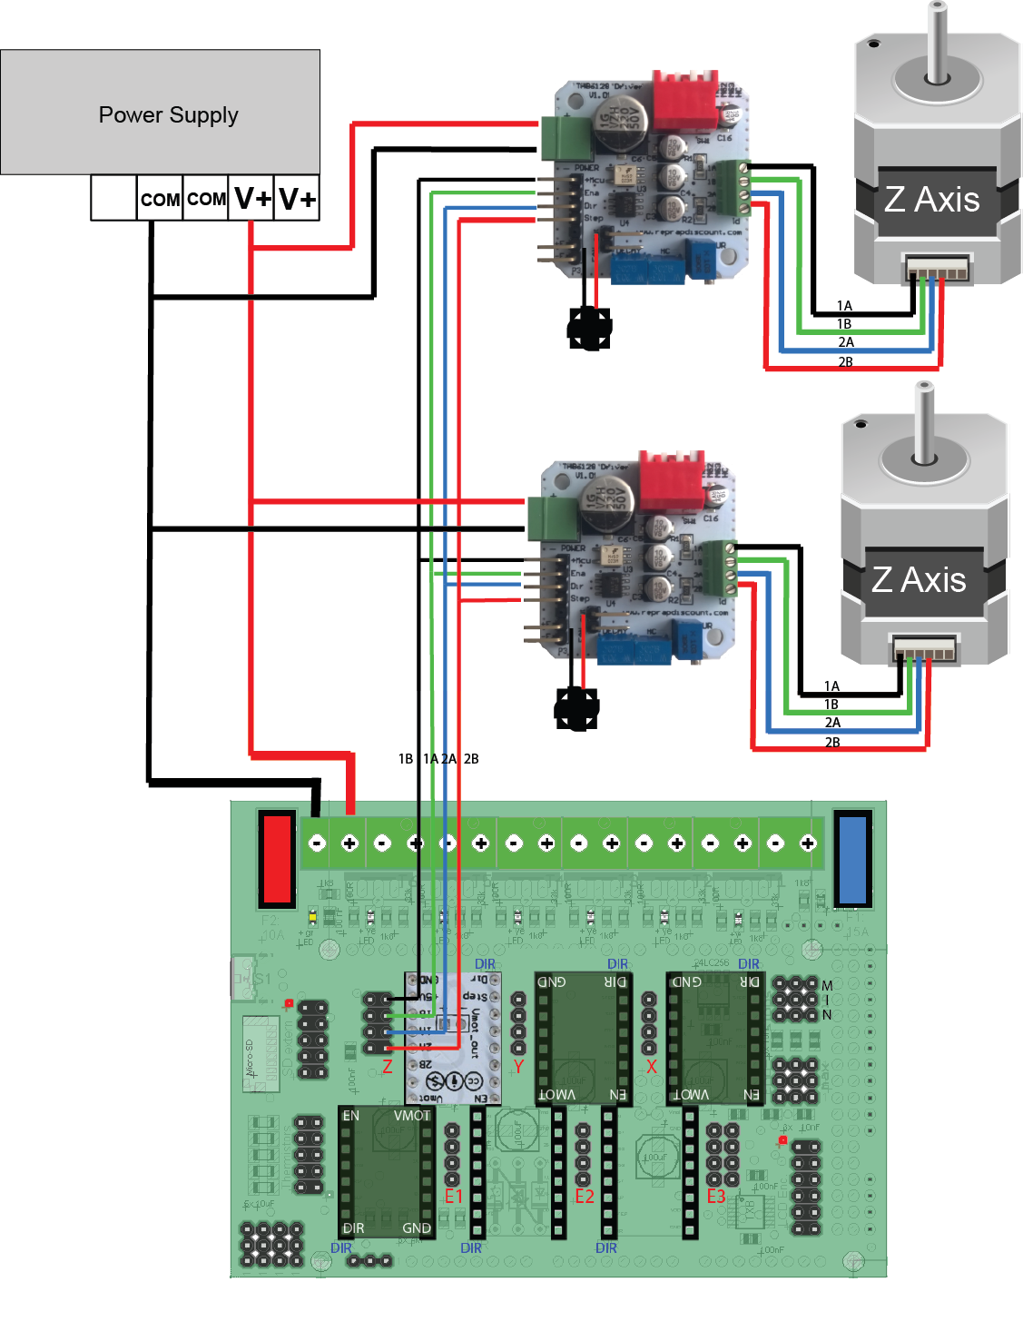

#### Dual Z stepper motor alternative 2

This is an option if the total current used by the two stepper motors are lower than the SilentStep max current limit.

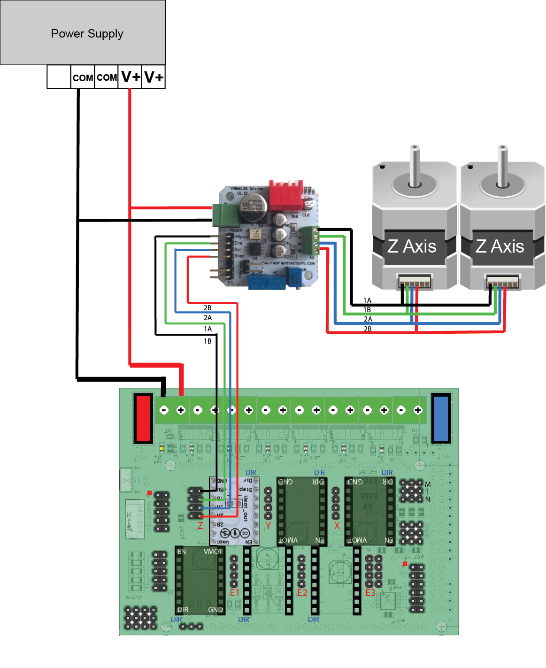

### RADDS + Endstops

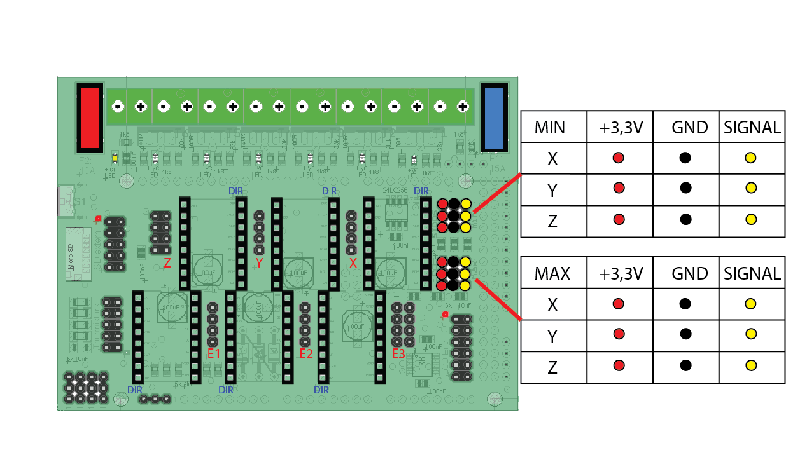

As default there is no pins soldered in the +3.3V as they`re not needed when using mechanical endstops.  
  
Mechanical endstops:  
Connect the mechanical endstops to the GND and Signal pins so they are normally closed (push = open)

Hal-O endstops (magnetic): 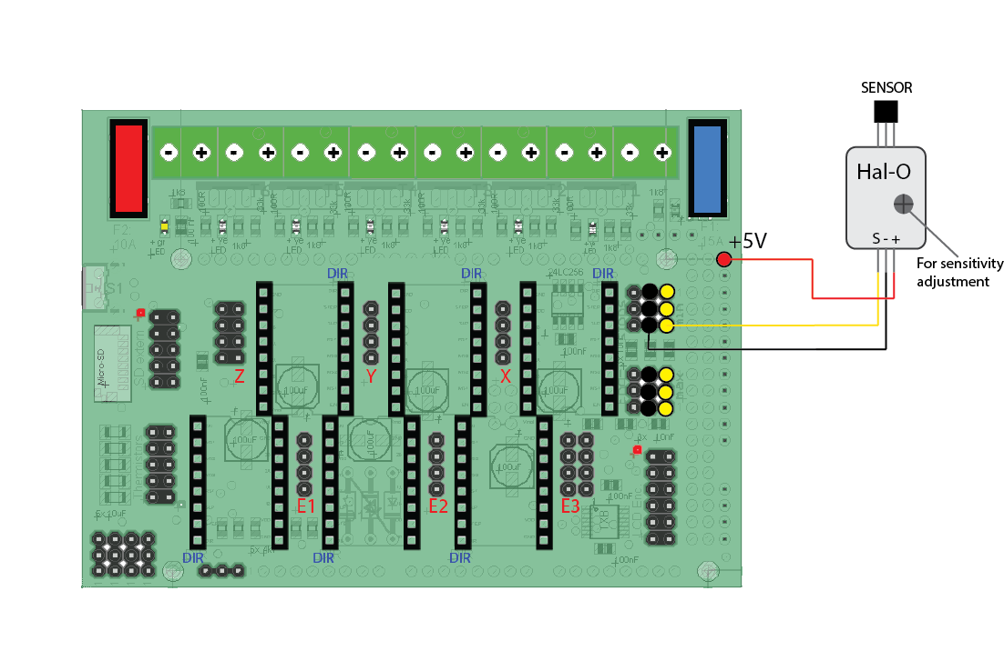  
When using the Hal-O endstops you have to connect the + pin on the Hal-O to the +5V pin.

IMPORTANT!!  
When using electronic endstops like the Hal-O, only use endstop that have max 3.3V out on the signal pin

### RADDS OrdBot Wiring diagram

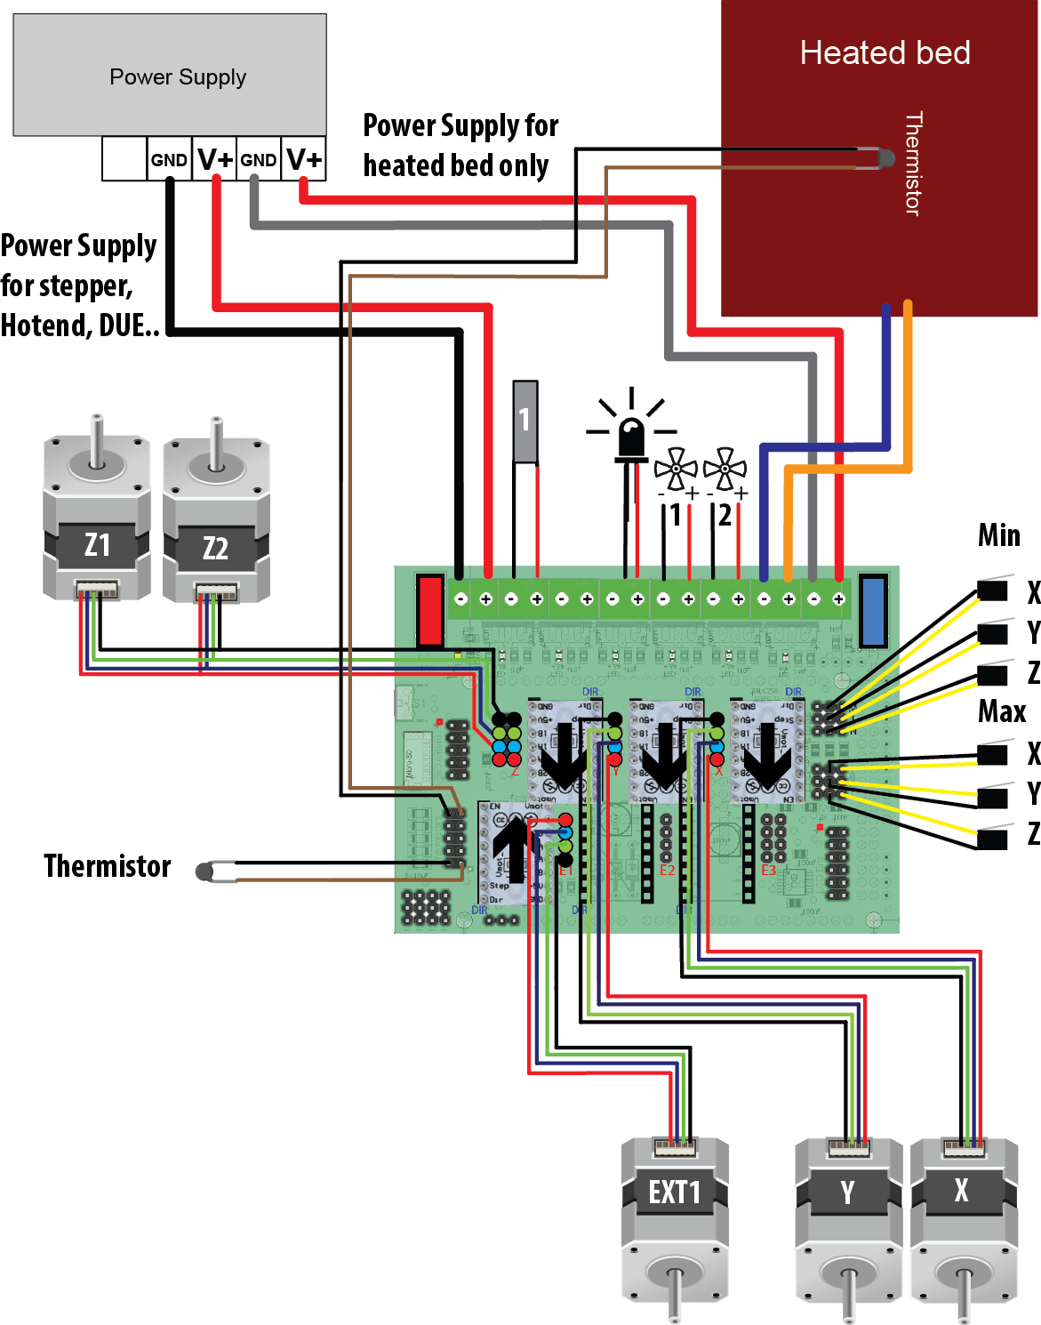

### Installation

* Upgrade the stepper motors with SilentStep stepper drivers (separate user guide)
* Connect the RADDS shield onto the Arduino DUE board
* Install the SilentStep stepper driver adapters (X, Y, Z and EXT1). Make sure the orientation is correct.
* Connect the RADDS LCD control panel
* Connect the stepper motors. In this sample dual SilentStep s are used for the dual Z stepper motors (2.1.4.3)
* Connect extruder motor to EXT1
* Connect the hotend heater element to heater element output 1
* Connect the hotend thermistor to thermistor input 1
* Connect the hotend Fan to Fan 1 output
* Connect the filament Fan to Fan 2 output
* Connect the 12V LED strip to heater output 3
* Connect HeatedBed thermistor to thermistor input 4
* Connect HeatedBed 12V to the HeatedBed 12V output
* Connect 12V from PSU to heated bed power input (right side)
* Connect the main power input from the PSU to 12V input (left side)
* Connect the USB cable to the programming port (the one in the lower left corner on the DUE)

**IMPORTANT** – before you power on your printer for the first time, you must finish the software setup.  
 **Make sure all wiring is correct. If you have connected something the wrong way, you may damage your electronics.**