**How to make a PowerPoint presentation in Windows 10**

1. Type PowerPoint in the Windows 10 search bar and click on PowerPoint. This will load the application.

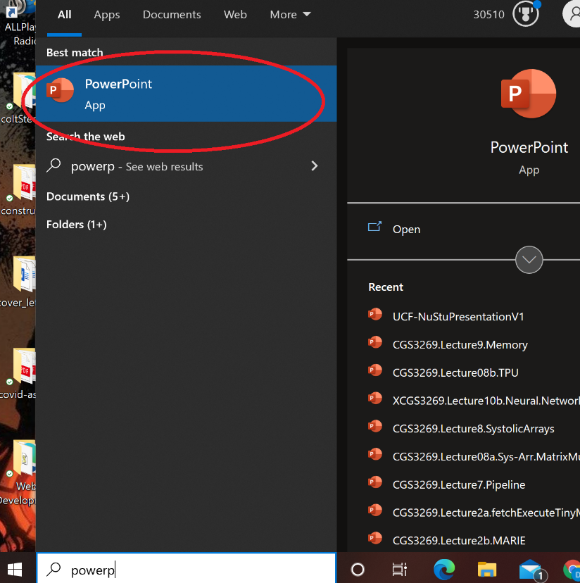

1. After the application is loaded, go to NEW and click BLANK PRESENTATION.

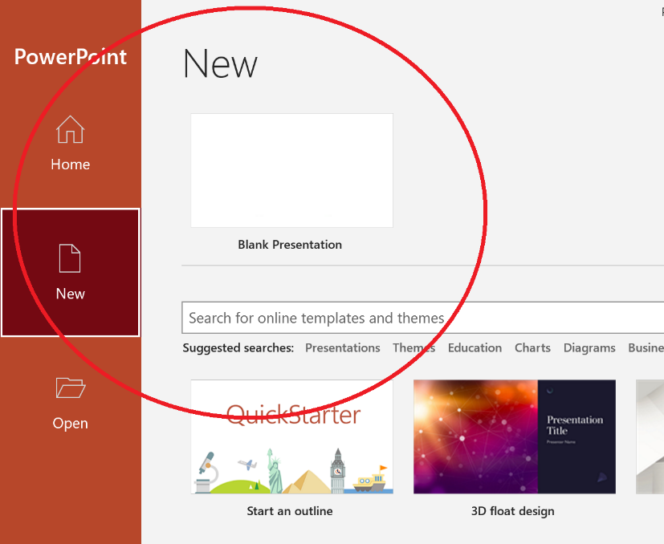

1. This will open a new blank slide to be used for the PowerPoint presentation.

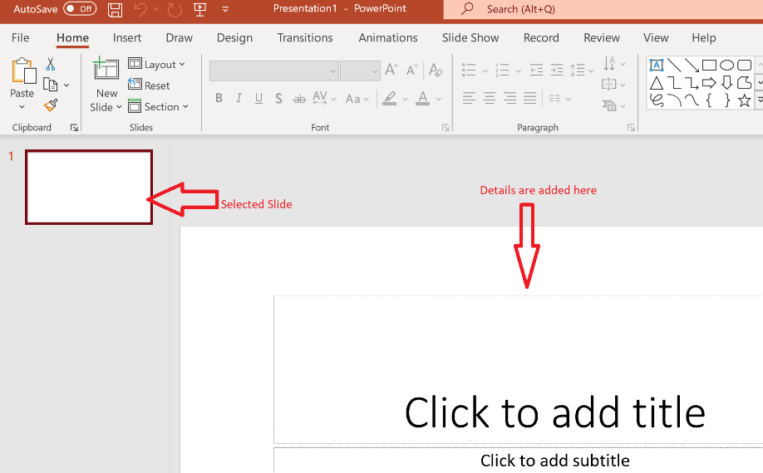

To add multiple slides, select any slide and hit the Enter button.

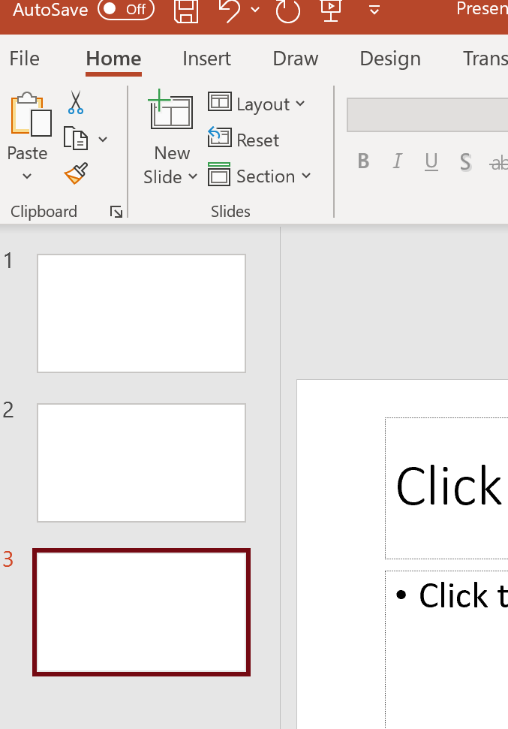

1. Now, it is time to choose a template or background. In the menu bar, click on DESIGN.

This will present numerous templates to choose from. PowerPoint also has a DESIGN IDEAS feature that will suggest additional templates. To pick a template, just click on it.

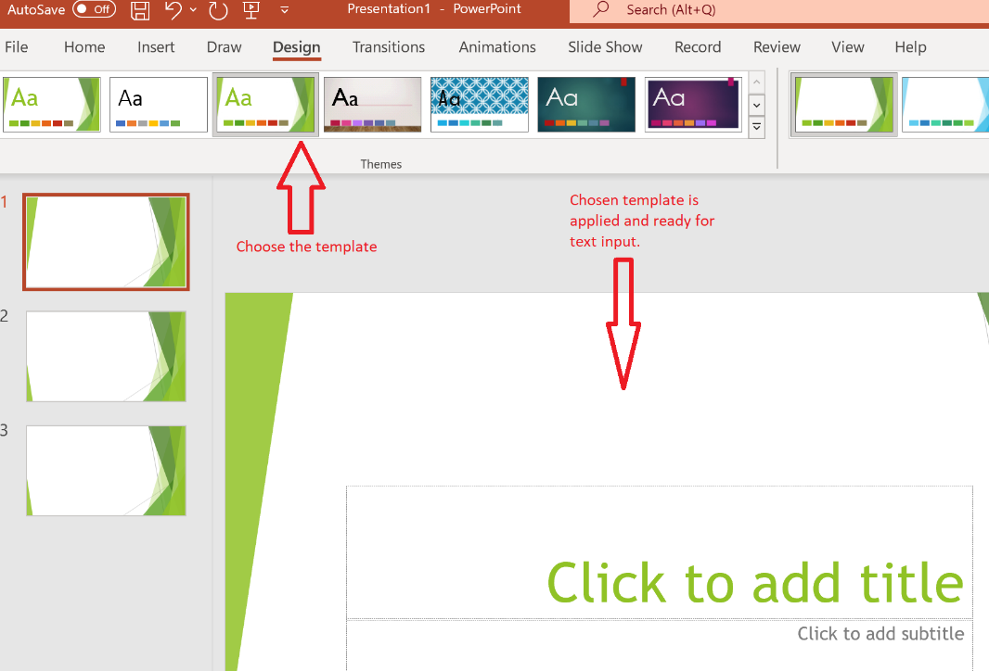

Now that the template is chosen, some additional features need to be added like transition effects, duration, animation.

1. Transitions are how PowerPoint changes from one slide to the next. Click on TRANSITIONS in the menu bar and choose from the options available. It is possible to choose one transition style throughout the presentation or use a different transition for each slide. To apply the same transition to all slides, highlight all slides, and then click on the preferred option.

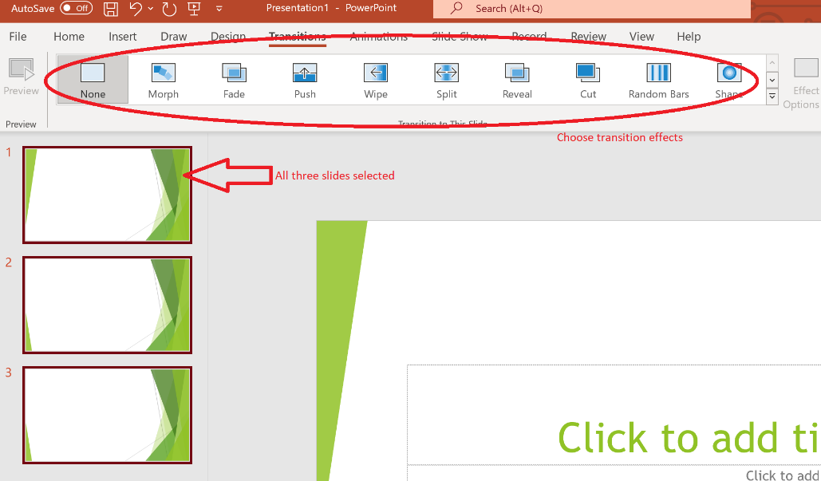

To apply transition effects one-by-one, just click the slide and click the transition style.

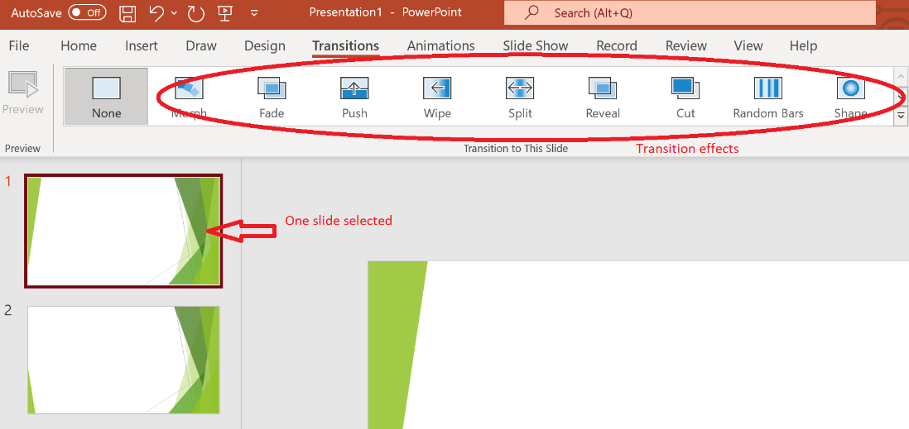

1. Now, it is time to apply some timing/duration effects. On the TRANSITION menu, there are additional options for adding sound effects, duration (how long each slide is shown before it changes to the next one), and an option to respond to Mouse Click.

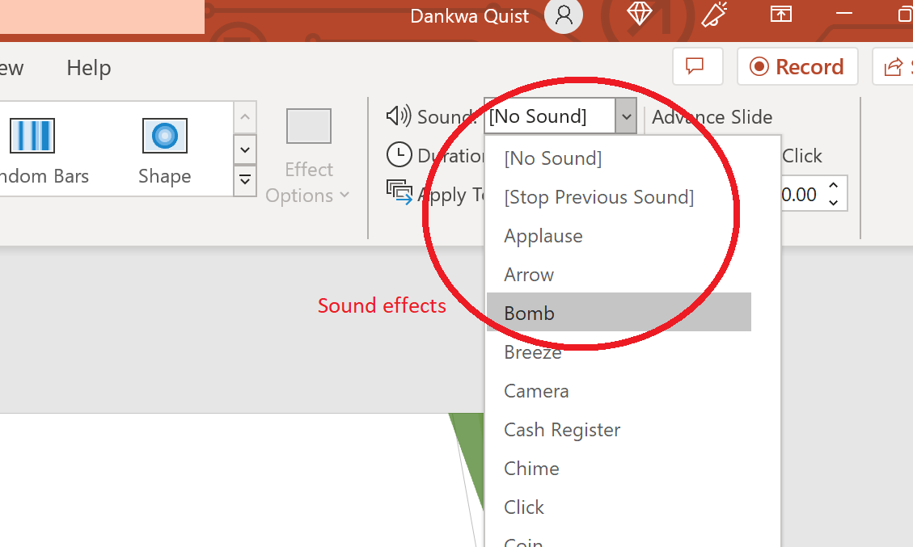

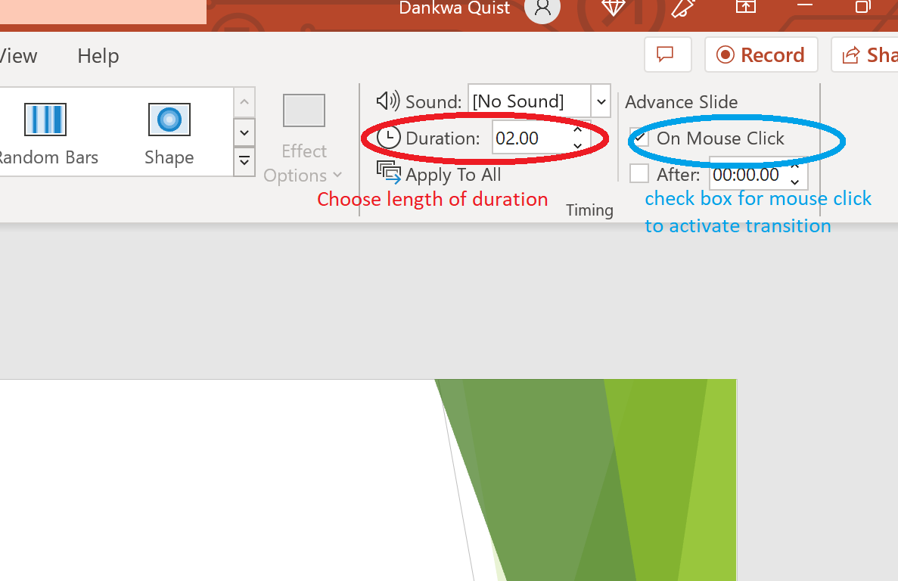

1. Animation effects can also be added. Animations determine how text in the slides appears in the presentation. In the menu bar, click on ANIMATIONS, highlight the text to be animated, and choose from the options available.

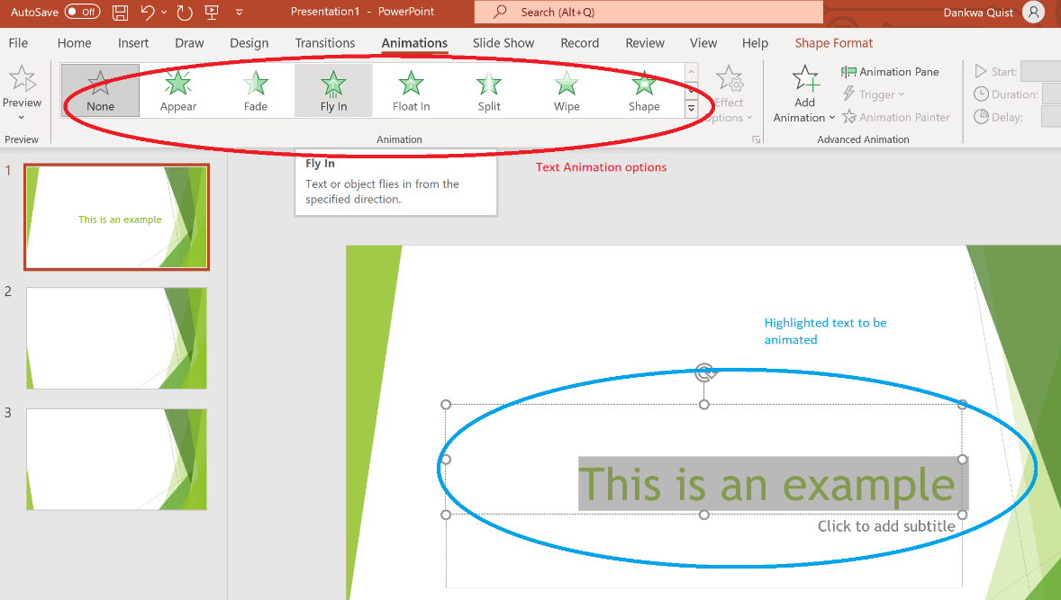

That’s it. You have created your first PowerPoint presentation. In order not to lose it, click on File, Save as, give the PowerPoint file a name and save it to your preferred location.

