Quick Start Guide

1. Navigate to [www.github.com](http://www.github.com). Sign-up if you are new or sign-in if you already have an account setup.

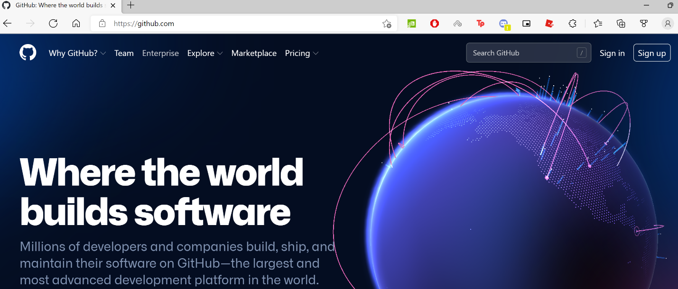

1. In the upper-right corner of any page, use the + drop-down menu, and select New repository.

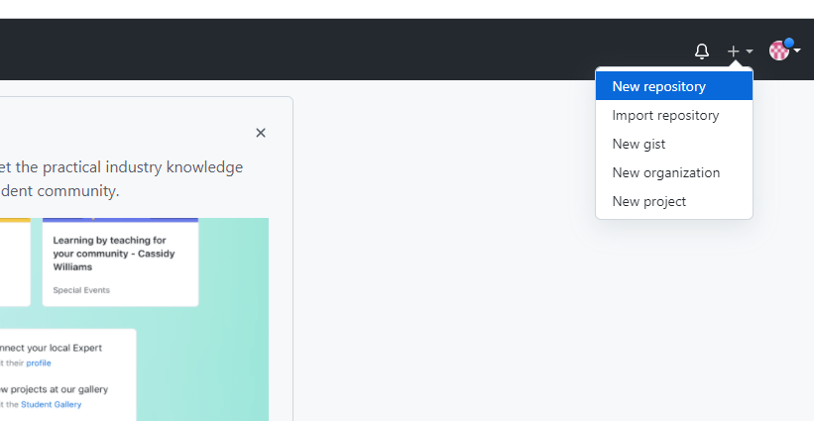

1. Enter *username.github.io* as the repository name. Replace username with your GitHub username. For example, if your username is **octocat**, the repository name should be ***octocat****.github.io*.

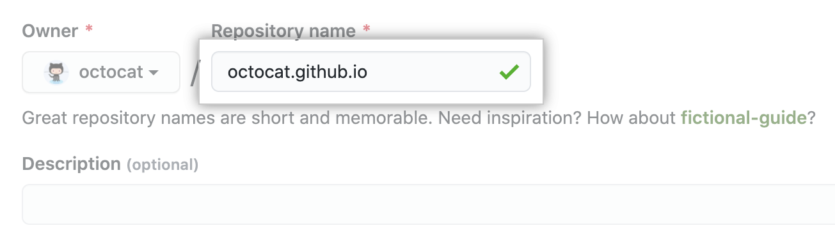

1. Under your repository name, click  **Settings**.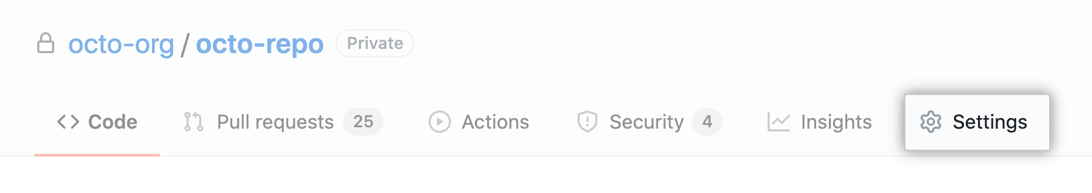
2. In the left sidebar, click **Pages**.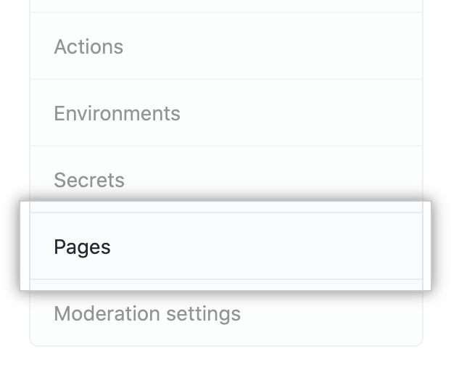
3. Click **Choose a theme**.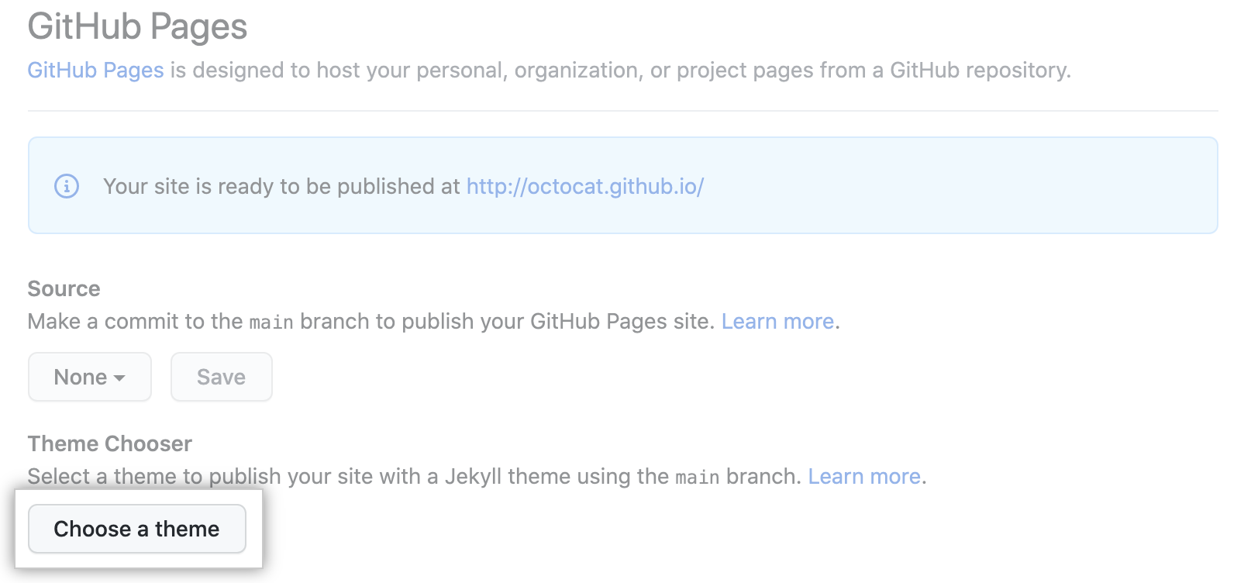
4. The Theme Chooser will open. Browse the available themes, then click **Select theme** to select a theme. It's easy to change your theme later, so if you're not sure, just choose one for now.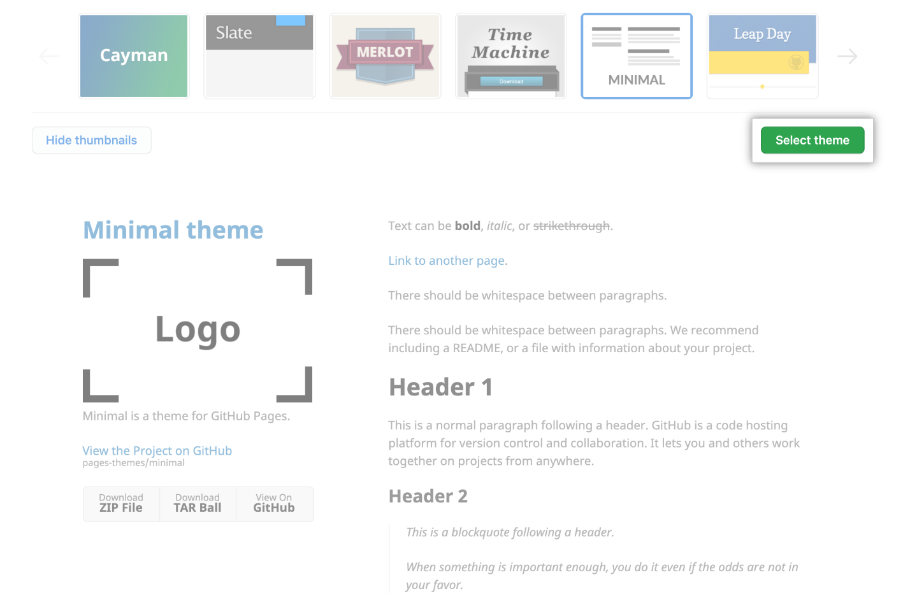
5. After you select a theme, your repository's README.md file will open in the file editor. The README.md file is where you will write the content for your site. You can edit the file or keep the default content for now.
6. When you are done editing the file, click **Commit changes**.
7. Visit username.github.io to view your new website. **Note:** It can take up to 20 minutes for changes to your site to publish after you push the changes to GitHub.