Mutual intelligibility of closely related languages in Europe: linguistic and non-linguistic determinants

A Database-driven Web Technology project
with a customer

Bas van der Meer (s1234567)
Marleen Oosterbaan (s987654)
Nienke Severins (s1777580)

Date: 31 January, 2012
Course: Database-driven Web Technology
Teacher: Ç. Çöltekin
Introduction

This research tool was written for the course Database-driven Web Technology 2011-2012. In this manual we will describe the research tool and give background information on PHP-MySQL, with an introduction to common SQL queries.

General description and layout

The research tool (website) runs on a server of the Rijksuniversiteit Groningen and can be seen at the following URL: XXXYYYZZ. During the creation of this site and its template we have aimed to make the site conform as much as possible to the house style of the RuG.

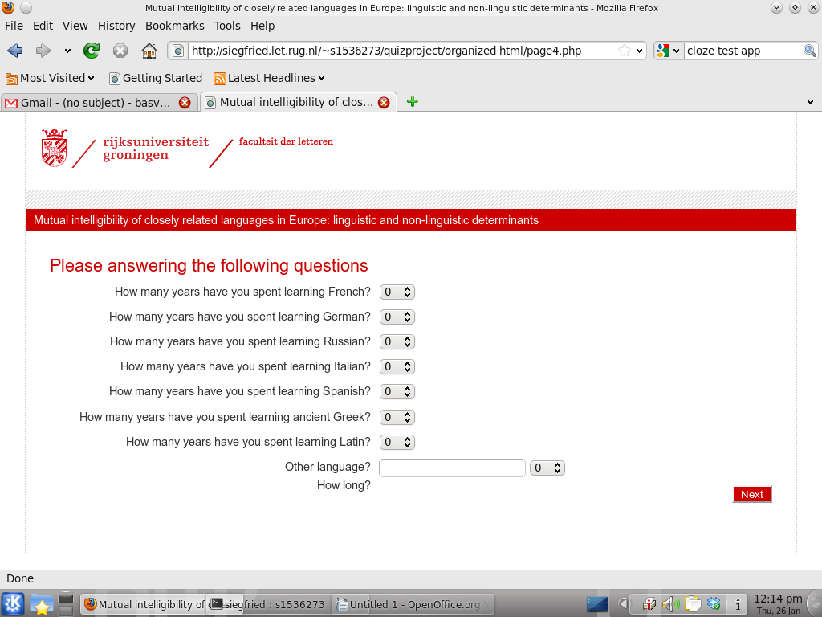
Figure 1

As seen in the screen shot (figure 1) the website is set up with the university and faculty information at the top. The read header contains the title of the questionnaire, the actual questions are placed in the centre, and the bottom will contain a progress bar.

The website consists of 30 pages of questions, taking roughly an hour to answer. All questions can be answered by either multiple choice radio buttons, drop-down menus allowing only one predetermined answer, or via text fields, allowing user input of all kind. The site is optimised to be as compatible as possible with a multitude of browsers and various configurations of computers. In order for the website to work as intended, the user must have cookies enabled.

As the site uses sound files in certain questions it was attempted to integrate those in the site and use the browser to play the sound files. This worked in certain test configuration but crashed when attempted in other configurations. Sound files are therefore visible as clickable links, opening in a new tab or window, allowing either the browser to play the file or the operating system to ask the user how to handle the file.

Scripting and Database Management

PHP-MySql
The website uses PHP-MySQL to insert answers given by users into the database. PHP-MySQL is one of the most common found combinations of scripting language and relational database management system. Both PHP and MySQL are free software, obtainable for free.

As the current website does not yet feature a user friendly back end that facilitates extracting information from the database, all queries need to be entered by hand. Using PHP-MyAdmin (another open source tool), MySQL can be managed via the web browser.

PHP-MyAdmin
In PHP-MyAdmin queries can be entered and the resulting answers exported. As the data generated will need a lot of specific statistical analysing, the export function will prove valuable, as results can be exported to the SPSS friendly .txt format.

Security

In order to prevent SQL injection, all user input is processed and cleaned before being inserted in the database, the same goes for all output. User input is not screened for sensibility of answers: when answering open questions a user can input whatever he wants, whether that is a valid answer or gobbledygook.
Session management is used to ensure a user gets a unique identifier. In general, the default security values and measurements were used, as they fulfilled our needs rather well.

Demands for the project

Our expectations
Initially we expected the demands of the project to be as follows:

- The system is able to store a large set of questions,
- The researcher should be able to add/modify the questions, or create a quiz by choosing questions from the database,
- Questions and answers can both be sound, images, video or text,
- The data from a quiz should be exportable in a format (likely to be a text-file) which is suitable for importing into a spreadsheet or statistical analysis application such as SPSS.

The client’s expectations
Then we got the information from the client. The demands became a bit more specified, but our expectations were quite correct. The experiment appears to be about the understanding of languages of the same language family as the native language, or languages that are in a different family.
First the participant needs to be asked about his language past. What languages has he learned, how much did he use those languages, and what is his attitude towards the researched languages. Then there will be a couple of tests, involving word translation tasks for both hearing and reading, picture tasks, Cloze tasks and some self evaluation. They would like the Cloze tests to be drag-and-drop. There should also be some kind of progress bar. It would be great if the output could be suitable for use in SPSS, and they would like to be able to select certain parts of the data to analyse separately. So:

- There is indeed a lot of data that can be picked from – everything will be available in 16 different languages.
- The researchers need to be able to add/modify their research data: since the task data is not yet fully available, we won't be able to enter that data. Also, if there are mistakes in questios or they want to replace/add questions, there has to be a possibility to do so.
- There will be hearing tasks, so sound must be available. There are no answers to be given with sound files. The picture tasks involve the participant clicking the correct picture, and of course there are questions with text. The questions do not contain video data.
- Output will indeed be used in SPSS, so output format should be suitable.

Final state of the project

HTML
We have reached a total of 25 basic webpages. Among them are introduction pages and thanking pages, pages with introductory questions about the user, pages with the explanation of the upcoming task, and pages that contain the actual tasks. We used cascading style sheets for the overall make-up of the pages, using the university's colours and the department's logo (Faculty of Arts).

Database
Our database contains the following tables:

- participant: personal information about the participant, and his knowledge prior to this test.

CREATE TABLE participant (
pID int(11) NOT NULL,
native_language varchar(255) DEFAULT NULL,
p_age int(100) DEFAULT NULL,
p_gender varchar(10) DEFAULT NULL,
p_study varchar(255) DEFAULT NULL,
p_country_lived_in varchar(255) DEFAULT NULL,
p_years_lived_in_country int(100) DEFAULT NULL,
p_language_to_mother varchar(255) DEFAULT NULL,
p_language_to_father varchar(255) DEFAULT NULL,
p_years_learning_english int(26) DEFAULT NULL,
p_years_learning_french int(13) DEFAULT NULL,
p_years_learning_german int(13) DEFAULT NULL,
p_years_learning_russian int(13) DEFAULT NULL,
p_years_learning_italian int(13) DEFAULT NULL,
p_years_learning_spanish int(13) DEFAULT NULL,
p_years_learning_ancientGreek int(13) DEFAULT NULL,
p_years_learning_latin int(13) DEFAULT NULL,
p_years_learning_other int(13) DEFAULT NULL,
p_using_english_in_speaking varchar(255) DEFAULT NULL,
p_using_english_watching_tv varchar(255) DEFAULT NULL,
p_using_english_playing_games varchar(255) DEFAULT NULL,
p_using_english_chatting varchar(255) DEFAULT NULL,
p_using_english_talking varchar(255) DEFAULT NULL,
p_using_english_reading varchar(255) DEFAULT NULL,
PRIMARY KEY (pID)
) ENGINE=InnoDB DEFAULT CHARSET=latin1;

- questions: containing the (additional information about the) test questions.

CREATE TABLE questions (
qID int(11) NOT NULL DEFAULT '0',
question_nr int(11) DEFAULT NULL,
questiontext varchar(255) DEFAULT NULL,
language_tag varchar(255) DEFAULT NULL,
correct_answer varchar(255) DEFAULT NULL,
question_type varchar(255) DEFAULT NULL,
PRIMARY KEY (qID)
) ENGINE=InnoDB DEFAULT CHARSET=latin1;

- user_given_answers: keeps track of the given answers on questions per user.

CREATE TABLE user_given_answers (
pID int(11) NOT NULL DEFAULT '0',
qID int(11) NOT NULL DEFAULT '0',
p_given_ans varchar(255) DEFAULT NULL,
PRIMARY KEY (pID,qID),
KEY qID (qID)
) ENGINE=InnoDB DEFAULT CHARSET=latin1;

PHP
blablabla

Users
We still have two types of users: researchers and participants.

What does it do?
Unfortunately, the data for the research was not yet available, so we were not able to check everything extensively. However, we created the code that will be needed, so if the data is added, everything should work just fine.
The session and session variables are solid: the participant table is being filled out nicely. This is already a great part of retrieving the information. A related language is being computed through the native language. The program is able to switch between languages for the tests. We didn’t actually have the tests available in other languages, so we used English and Dutch as output. This goes for the input of a native language too. However, only the language (basically being just some text) will need to be changed to get the desired output.
The word translation task works completely, except for one part: we could not get an actual timer to run for 5 seconds, then make the page submit itself and go on to the next page. We tried a few things, but it didn’t work out. However, we found that after re-learning MySQL and HTML and actually learning PHP, learning JavaScript for a relatively small part may be too intensive.
Spoken word translation task en soundgebeuren
The picture tasks (both written text and spoken text) are up and running.
Cloze test

For these tasks the questions will be retrieved from the questions table, and the answers will be sent to user_given_answers.
How’s the progress bar?

…........ welke taken die nu allemaal kan uitvoeren

Security

The security was handled as planned. In order to prevent SQL injection, all user input is processed and cleaned before being inserted in the database. The same goes for all output. User input is not screened for sensibility of answers: when answering open questions a user can input whatever he wants, whether that is a valid answer or, indeed, gobbledygook.
Session management is used to ensure a user gets a unique identifier. In general, the default security values and measurements were used, as they fulfilled our needs rather well.

Future work

Database design
Of course, there can always be looked at our database design. Since we are still quite inexperienced, we may have made rookie mistakes, or used methods that may be outdated or too simplistic. If mistakes are found, they will need to be corrected.

Ergonomics
It may be easier for the client to have a friendly user-interface for retrieving specific data from the databases. For now they will have to work with PHPMyAdmin, but since they are not familiar with MySQL, something “lay friendly” would be nice.

Coding

Cloze test
The desired drag-and-drop part for the Cloze test proved to be too intensive for this course. Drag-and-drop is not easy to implement, especially not in combination with a database. We decided to leave this to a more experienced worker, or, if one of us is going to continue this project, give ourselves a little more time. For now, we wanted to focus on getting all the other, managable parts functional and neat.

5-second timer
One of the demands was a (5 second-)timer, that would send the user to the next page automatically after a desired amount of (5) seconds. We found this would be done best with JavaScript. However, we failed to find a suitable code that would meet the demands. Going to the next page wasn’t a problem: preserving the given answer and writing it to the database was. After re-learning HTML and MySQL and actually learning PHP, we found it to be too intensive to also learn JavaScript, and decided to leave this to someone with more experience.

Security

