“A Shot of Hope”: How COVID-19 Vaccination Altered the Pandemic's Trajectory
Ruohan Qu
Background
“In early 2021, the world saw hope in the form of a needle.”
Since the start of 2020, COVID-19 has claimed countless lives and caused immense grief for many families. As a result, it has become a global pandemic that nations are working tirelessly to combat. By late 2020, vaccines were authorized and rolled out. However, many people doubt its effectiveness for the pandemic. Here’s the report on why you should trust the vaccination based on real-world data (Our World in Data, 2025).
Global Vaccination and Infection Trends: A Turning Point Begins
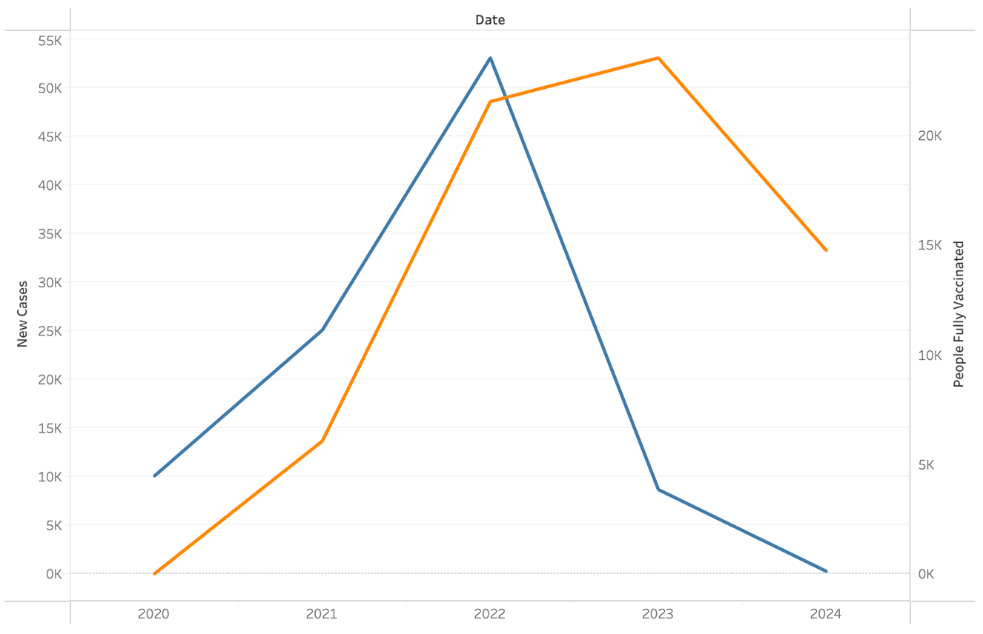
To understand the effectiveness of vaccination, we examine the relationship between global new COVID-19 cases and vaccination rates. This allows us to observe how increased vaccination efforts impacted infection trends.
Figure 1: Global COVID-19 Cases and Vaccination Rates Over Time
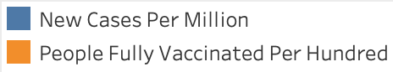
As shown in Figure 1, the global vaccination rate began rising sharply during 2021, while new COVID-19 cases initially continued to increase. However, following the widespread promotion and uptake of vaccines in 2021, the number of new cases declined significantly throughout 2022, demonstrating the critical role of vaccination in reducing COVID-19 infection rates.
More Shots, Fewer Deaths: Cross-Country Evidence of Vaccine Impact
While the global trend shows the success of vaccination in reducing the infection rate, examining individual countries would provide more evidence. For instance, by comparing the coverage of vaccination with the death population, we can observe how higher vaccination coverage correlates with lower mortality.
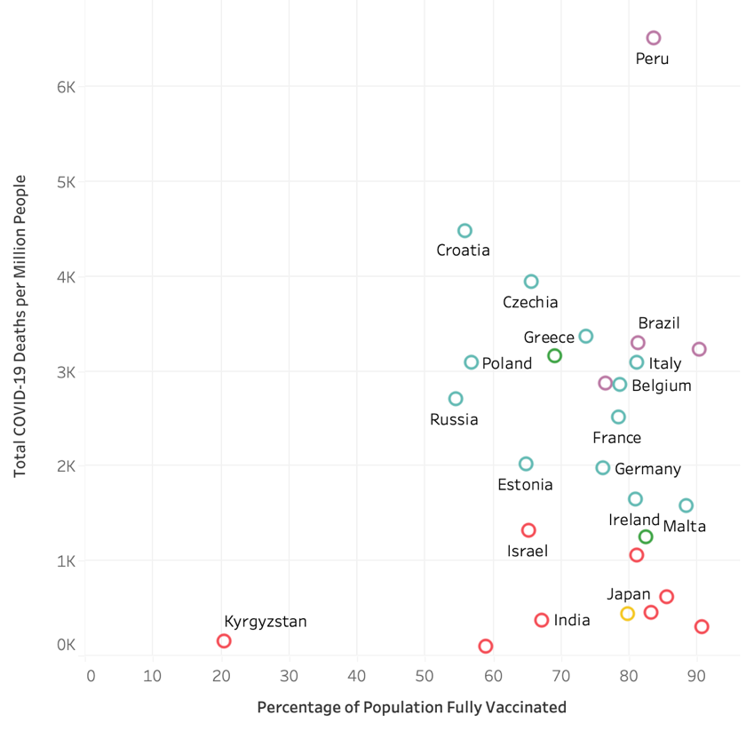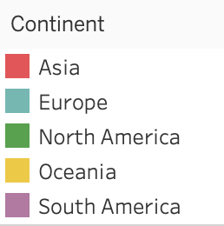
Figure 2:COVID-19 Vaccination Rates vs COVID-19 Death Rates by Country
As shown in Figure 2, countries with high coverage of vaccination tend to have significantly lower death rates. However, some variation exists due to healthcare system differences and reporting practices. The downward trend shows that vaccination promotion is essential in minimizing the mortality rate.
Milestones That Mattered: Vaccine Approvals and Global Case Trends
In addition to vaccination coverage rates, the timing of key vaccination milestones also played an important role in shaping the trajectory of the COVID-19 pandemic. By aligning significant events with case trends, we gain a clearer understanding of how vaccination efforts developed and impacted global outcomes.
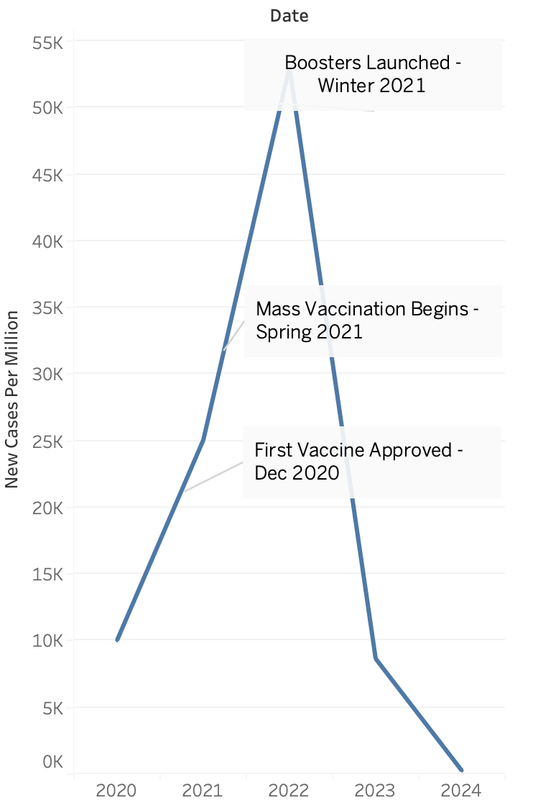
Figure 3:Timeline of Vaccine Milestones and Global COVID-19 Trends
As illustrated in Figure 3, the pandemic reached its peak in early 2022. Although the first vaccine was approved in late 2020, developed by Pfizer-BioNTech, and received emergency use authorization in December 2020 (U.S. Food and Drug Administration [FDA], 2020). At that time, new cases continued to rise. Mass vaccination campaigns began in spring 2021, especially in the U.S., U.K., and Europe around March–April 2021 (Centers for Disease Control and Prevention [CDC], 2021), during which case numbers also increased. However, the launch of booster doses in late 2021, authorized starting September–December 2021 (Centers for Disease Control and Prevention [CDC], 2021b), marked a critical turning point—after this milestone, global case numbers began to decline significantly. This pattern underscores the importance of both early approval and continued promotion of vaccines in managing the spread of COVID-19.
Immunization Saves Lives: How Vaccination Helped Reduce COVID-19 Death Rates
Beyond reducing infection rates, preventing deaths is another crucial measure of vaccination effectiveness. In this section, we examine the global COVID-19 death rate alongside vaccination coverage over time to understand how higher immunization rates contributed to saving millions of lives.
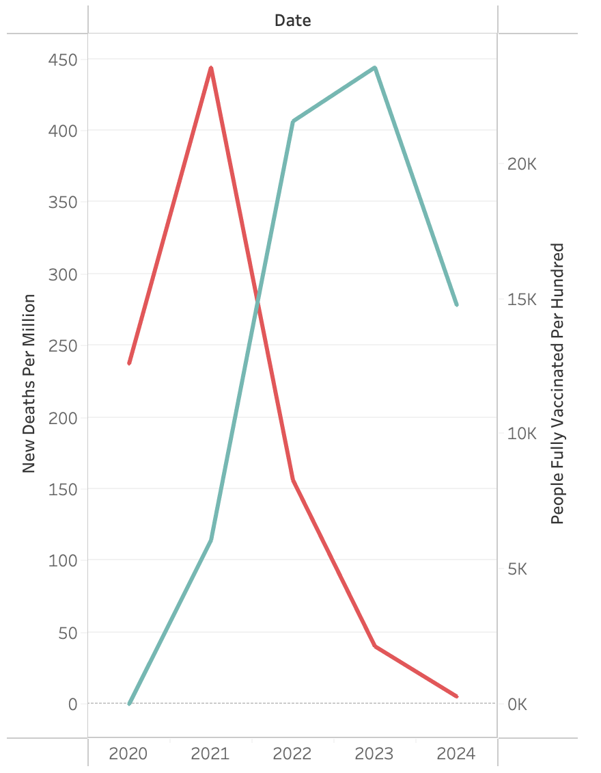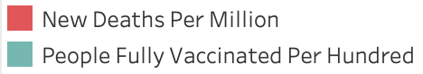
Figure 4:Global COVID-19 Deaths and Vaccination Rates Over Time
As shown in Figure 4, the global death rate peaked in 2021, just as vaccination efforts began to scale up. Following the mass promotion of vaccines that year, the death rate declined substantially, indicating that vaccination was effective in preventing fatalities during the pandemic. This trend highlights that vaccination not only reduces infection but also plays a vital role in saving lives.
Conclusion
The data visualizations in this report collectively demonstrate that COVID-19 vaccination has played a critical role in improving the global trajectory of the pandemic. By examining infection and death rates to vaccination coverage—and highlighting key milestones in vaccine rollout—we observe that the initial approval and mass distribution of vaccines marked a turning point in the fight against COVID-19. Notably, the global death rate declined significantly following widespread vaccination, underscoring the success of immunization in saving lives. While some variation remains and challenges persist, the evidence strongly reinforces that building trust in vaccines and supporting vaccination efforts is essential to ending the pandemic.
Reference
Centers for Disease Control and Prevention. (2021, March 15). COVID-19 vaccine distribution and administration progress in the United States. Centers for Disease Control and Prevention. https://www.cdc.gov/coronavirus/2019-ncov/vaccines/distributing.html
Centers for Disease Control and Prevention. (2021, November 19). CDC expands COVID-19 booster recommendations to all adults. Centers for Disease Control and Prevention. https://www.cdc.gov/media/releases/2021/s1119-booster-shots.html
Our World in Data. (2025). Coronavirus (COVID-19) vaccinations. Our World in Data. https://ourworldindata.org/covid-vaccinations
U.S. Food and Drug Administration. (2020, December 11). FDA takes key action in fight against COVID-19 by issuing emergency use authorization for first COVID-19 vaccine. U.S. Food and Drug Administration. https://www.fda.gov/news-events/press-announcements/fda-takes-key-action-fight-against-covid-19-issuing-emergency-use-authorization-first-covid-19

