CAD-AWARE ENGINEERING ASSISTANT

Shock Selector
Complete Functional Guide and
Microsoft 365 Copilot Cost Comparison
  - End-to-end explanation of the tab, engineering authority boundaries, context-aware assistance, evidence outputs and five-user operating cost

Prepared for | Product demonstration and internal review
Scope | Shock isolator selection, verification and supplier handoff
Current assistant | OpenAI GPT-5.4 mini with deterministic tools
Report date | 27 July 2026

Core position
This is a specialist engineering application, not a general-purpose office copilot. Its advantage comes from combining structured inputs, validated Python calculations, catalog rules, current UI state and bounded local RAG before the language model explains the result.
Internal engineering decision support. Not a certification or supplier approval.

Contents

In Microsoft Word, right-click the table of contents and choose Update Field if page numbers are not refreshed automatically.

Executive Summary
The Shock Selector tab turns a repetitive isolator-selection workflow into a controlled engineering sequence. The user enters the equipment and rack mass, mounting arrangement, shock pulse, available clearances and enclosure size. Deterministic Python then evaluates four load cases, checks transmitted shock, movement, catalog travel and static rating, and returns a recommended part or a clear failure state. The language model is used after this calculation to explain, compare, retrieve evidence and prepare communication; it is not the source of the numerical PASS/FAIL result.
The tab contains three operating modes: automatic catalog selection, manual verification of a chosen part, and normalization of custom vendor data. It also includes stale-result protection, a deterministic mount layout, a road-vibration screening panel, a context-aware assistant, a supplier enquiry pack and an optional explanatory image generator.
For five users, the public Microsoft 365 Copilot enterprise seat price is US$30 per user per month when paid yearly, so five seats are US$150 per month or US$1,800 per year. Microsoft also requires a separate qualifying Microsoft 365 plan. Under the expected usage scenario in this report, GPT-5.4 mini chat tokens cost approximately US$9.60 per month or US$115.20 per year. The nominal difference is therefore US$140.40 per month and US$1,684.80 per year. This is a marginal software-cost comparison, not total cost of ownership. Development, maintenance, hosting, security, image generation and support are excluded from the headline figure. [1][2]
Decision statement
Use this application as the specialist shock-isolation workflow. Retain Microsoft 365 Copilot only when the organization also needs its broad Word, Excel, PowerPoint, Outlook and Teams capabilities. The two products solve different problems.

Key Findings
- The engineering result is produced by validated equations and catalog rules, not by free-form LLM arithmetic.
- The assistant receives the current analysis snapshot automatically, so the user does not need to restate the part, load cases or assumptions.
- Local BGE-M3 retrieval restricts reference answers to the shock-mount corpus and returns stable source identifiers.
- The internal transformer attention layers are not modified. Guidance is applied at the application layer through prompts, tool schemas, structured inputs, controlled retrieval and short history.
- A frozen 170-case study showed that adding deterministic tools increased majority verdict accuracy from 38.6% to 82.1% with the selected local model; adding RAG increased it to 84.3% and reduced false-safe rate from 13.8% to 3.4%. [3]
- Those evaluation results validate the architecture with Qwen3.5 9B. They are not a direct benchmark of Microsoft Copilot or the current GPT-5.4 mini production model.

1. Purpose and Scope
This guide explains the Shock Selector tab from initial data entry to supplier handoff. It covers the manual-mass workflow in the Isolator Selector tab. The separate CAD + Shock tab can obtain mass, centre of gravity and bounding-box data from SolidWorks, but that CAD extraction path is outside the main operating sequence described here.

1.1 Intended users
- Mechanical engineers preparing an initial shock-isolator selection.
- Design engineers checking whether a specified vendor part is suitable.
- Project engineers preparing a structured enquiry for an isolator supplier.
- Reviewers who need an auditable calculation trail, assumptions and evidence boundaries.

1.2 What the tab does
Layer | Responsibility | Authority
Input layer | Captures mass, mount count, shock pulse, clearance, enclosure and vendor data. | User-supplied requirement
Physics layer | Runs the four-case shock model, unit conversion, static gate and catalog screening. | Authoritative for the software calculation
Assistant layer | Routes approved tools, explains the result and asks for missing information. | Advisory language output
RAG layer | Retrieves selected standards, workflow and vendor evidence. | Reference support with citations
Output layer | Shows results, layout, supplier pack and optional explanatory visual. | Communication and review

1.3 What the tab does not prove
A software PASS means the entered configuration passed the implemented deterministic gates. It does not prove nonlinear isolator behaviour, random-vibration endurance, fastener retention, bracket strength, equipment fragility, fatigue life, environmental resistance or road-trial performance. These remain supplier, laboratory or field-validation items.
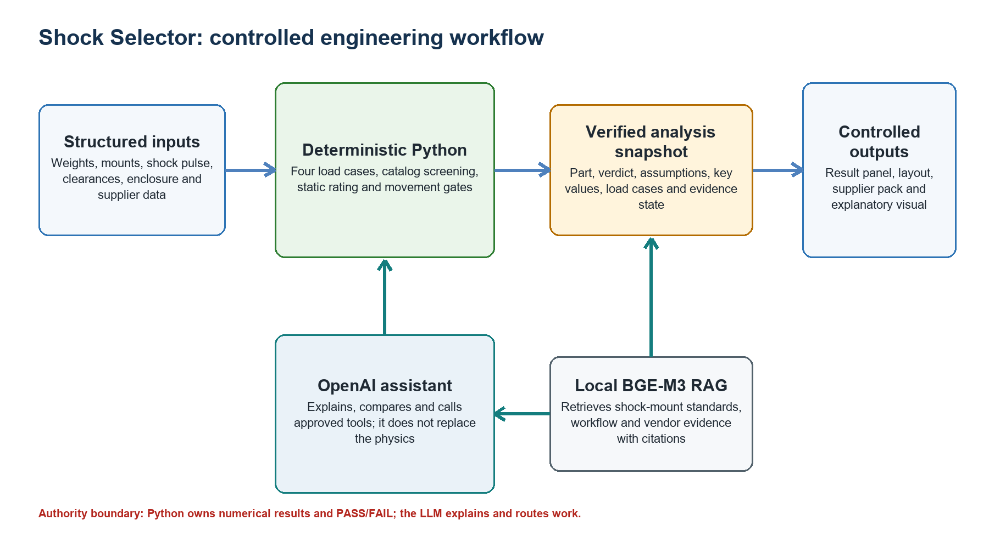
Figure 1. Controlled architecture and engineering-authority boundary.

1.4 Current runtime configuration
Component | Current role | Current implementation
Chat model | Natural-language interpretation, tool routing and explanation | OpenAI GPT-5.4 mini
Engineering tools | Shock physics, catalog lookup, custom data normalization | Local deterministic Python
RAG embedder | Query and document vectors for shock references | Local Ollama BGE-M3
Vector search | Top-k retrieval over stored shock-mount chunks | Exact cosine similarity JSON store
Image generation | Optional presentation-only concept visual | OpenAI GPT Image 2
UI | Data entry, results, exports and assistant | Streamlit

2. Shock Selector Tab: Head-to-Toe Guide
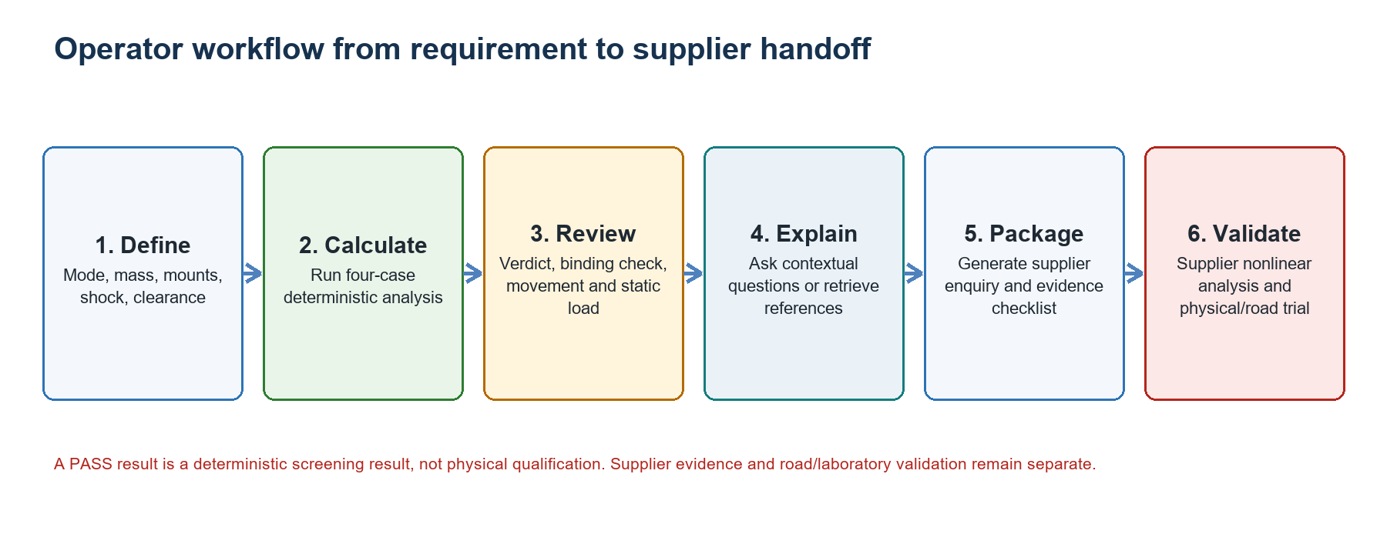
Figure 2. End-to-end operator workflow.

2.1 Step 1 - Choose the operating mode
Mode | Use when | What the software does
Auto - recommend best part | The engineer knows the requirement but has not selected a part. | Screens the chosen catalog and ranks only candidates that pass all four cases and hard gates.
Manual - verify a specific part | A supplier, past project or engineer has already nominated a part. | Runs the same four-case analysis for that one catalog entry and reports pass or fail.
Custom vendor data | The part is outside the built-in catalog or the supplier publishes data in another format. | Converts vendor units, derives stiffness when permitted, labels the validation level and runs the common physics engine.
Recommended default
Use Auto for an initial recommendation, Manual for an independent check of a proposed part, and Custom vendor data only when the source and assumptions are recorded.

2.2 Step 2 - Enter the weights
Enter the equipment weight and the rack or chassis weight separately. The tab adds them to obtain total system mass M. Separating the two values makes the requirement easier to review and update when payload changes. The current selector distributes the relevant mass across the bottom and wall mounts according to the four implemented load cases.
- Equipment weight: payload such as servers, network equipment, power modules and accessories.
- Rack or chassis weight: frame, enclosure, shelves, doors and structural hardware.
- Total mass: equipment plus rack. Do not enter force units or include an unapproved safety factor here.
Missing or uncertain mass
Do not guess. Record the source, use a controlled conservative value only when approved, and rerun the analysis when measured mass becomes available.

2.3 Step 3 - Select the catalog scope and objective
In Auto mode, Catalog filter limits which isolator families are considered. The default selection scope excludes optional families that require explicit inclusion. Selection objective changes how already-valid parts are ranked; it does not relax clearance, shock, travel or static-load gates.
Objective | Engineering meaning | Typical reason
Least movement / maximum clearance | Prefers a valid part with lower calculated movement. | Tight internal or neighbouring-equipment clearance.
Lowest transmitted shock | Prefers the softest valid solution with lower transmitted acceleration. | Fragile protected equipment and sufficient movement allowance.

2.4 Step 4 - Define the mount configuration
Enter the number of bottom mounts and wall mounts, then choose the wall face used by the layout drawing. The mount counts affect load per isolator and therefore natural frequency, transmitted shock, movement and static utilization. The wall face affects the conceptual layout only; it does not replace a detailed bracket or moment analysis.
- Bottom mounts carry the full compression-bottom load in the validated model.
- Wall and roll cases use the approved mass-sharing rule from the reference calculation.
- Gang count alone does not uniquely determine a valid arrangement. Use actual project geometry.
- Wall stabilizer height and centre of gravity are requested later in the supplier pack because they require supplier or structural review.

2.5 Step 5 - Enter custom vendor data when applicable
Custom vendor mode accepts compression and shear data independently. Each direction can use direct stiffness, rated load at natural frequency, or force at deflection. The backend normalizes the data to SI units and states whether the result is based on direct validated stiffness or a screening-only derivation.
Input method | Derived quantity | Use and limitation
Direct stiffness K | Vendor K converted to N/m | Preferred when the supplier publishes direction-specific stiffness.
Rated load at natural frequency | K = m x (2 x pi x fn)^2 | Useful for screening; depends on interpretation of the vendor rating.
Shock force at deflection | K = F / displacement | Secant approximation for screening; does not reproduce a nonlinear force-deflection curve.
Enter compression and shear travel, the optional static compression rating and a source note. If a vendor does not publish a static rating, the software reports the calculated static load per bottom mount and marks supplier confirmation as pending.

2.6 Step 6 - Enter enclosure dimensions
Width, depth and height create the deterministic three-dimensional mount-layout and movement envelope. These dimensions support communication and interference review; they are not a manufacturing drawing. Use external rack dimensions or the approved installation envelope, and record the coordinate convention used.

2.7 Step 7 - Define the shock environment
Field | Meaning | Review point
Input shock Ao (G) | Peak acceleration applied to the supporting structure. | Use the approved transport or equipment requirement.
Pulse duration (ms) | Duration of the idealized shock pulse. | The model-facing unit is milliseconds to avoid decimal truncation.
Transmitted-G limit | Maximum accepted output acceleration at the protected equipment. | Treat as the equipment fragility requirement, not a universal default.
Pulse profile | Saw-tooth or half-sine idealization used to calculate impact velocity. | Match the requirement or supplier model.
Shock and vibration are different
Passing the shock pulse does not prove random-vibration compliance. The road-vibration panel is a separate screening calculation and still requires an approved profile and evidence.

2.8 Step 8 - Enter installation clearance
X, Y and Z clearances are hard pass/fail gates. A zero value means that the corresponding clearance is ignored, not that zero movement is allowed. Before the final run, the tab can show a movement hint based on a no-clearance candidate. The hint helps the engineer estimate required space; it is not the final result.
- Clearance is the available gap to neighbouring structure or equipment.
- Rated travel is the isolator's own permitted movement.
- The valid limit is the more restrictive applicable constraint.

2.9 Step 9 - Run the calculation
Select best isolator runs the catalog recommendation. Run analysis verifies a selected part. Run custom analysis normalizes the vendor row and uses the same four-case engine. The result is stored with an analysis key derived from the inputs.

2.10 Step 10 - Respond to stale-result warnings
If an input changes after calculation, the visible result is marked stale. Context actions, supplier-pack generation and explanatory visuals are disabled or warned until the engineer updates or clears the result. This prevents an old PASS result from being discussed as if it belonged to the new mass, pulse or mount arrangement.

2.11 Step 11 - Read the result summary
Result item | How to interpret it
Recommended part | First valid catalog candidate under the selected objective and scope.
Closest-to-fail check | Highest utilization among the implemented constraints; closest to 100% is governing.
Worst transmitted shock | Largest GT relative to the entered transmitted-G limit.
Worst movement | Largest calculated displacement relative to catalog travel or entered clearance.
Static load per mount | Bottom-mount static load compared with the catalog rating when available.
Review next | Explicit supplier, geometry, vibration or evidence items that remain open.

2.12 Step 12 - Review the four load cases
All four cases must pass. Each row shows the mass per isolator, natural frequency, transmitted shock, movement, limit, utilization and binding constraint. The Binding column identifies the constraint closest to failure in that row.
Case | Direction | Mass rule | Why it is reviewed
Compression - bottom | Vertical | M / n_bottom | Primary static and vertical shock condition.
Compression - wall | Lateral | M / n_wall / 2 | Wall-mount compression condition.
Roll - wall | Lateral roll | M / n_wall / 2 | Wall-mount response under the implemented roll sharing rule.
Roll - bottom | Vertical roll component | M / n_bottom / 2 | Bottom-mount response under roll.

2.13 Step 13 - Inspect layout and movement envelope
The deterministic Plotly view shows the enclosure, bottom mounts, wall mounts, calculated dynamic movement and entered clearance envelope. It is useful for explaining the proposed arrangement and spotting obvious interference. It does not calculate bracket stress, exact fastener load paths, local structural deformation or supplier mounting details.

2.14 Step 14 - Review road-vibration screening
When catalog vibration stiffness is available, the panel estimates natural frequency and continuous-vibration transfer ratio. A transfer ratio below 1.0 indicates attenuation; above 1.0 indicates amplification. This is a screening indication only. Qualification requires the correct random-vibration spectrum, duration, axis, operating state and acceptance criteria.

2.15 Step 15 - Open detailed calculations and comparisons
The catalog comparison shows why alternatives passed or failed. The full physics report exposes the numerical calculation for review and traceability. These outputs are useful when checking an Excel calculation, discussing the result with a supplier or investigating a governing constraint.

2.16 Step 16 - Ask about the current result
Four contextual actions queue a question through the existing shock assistant: explain the result, explain why the part was selected, compare alternatives and identify next checks. The same assistant and visible chat history are reused. The current analysis snapshot is attached automatically only when the result is current.
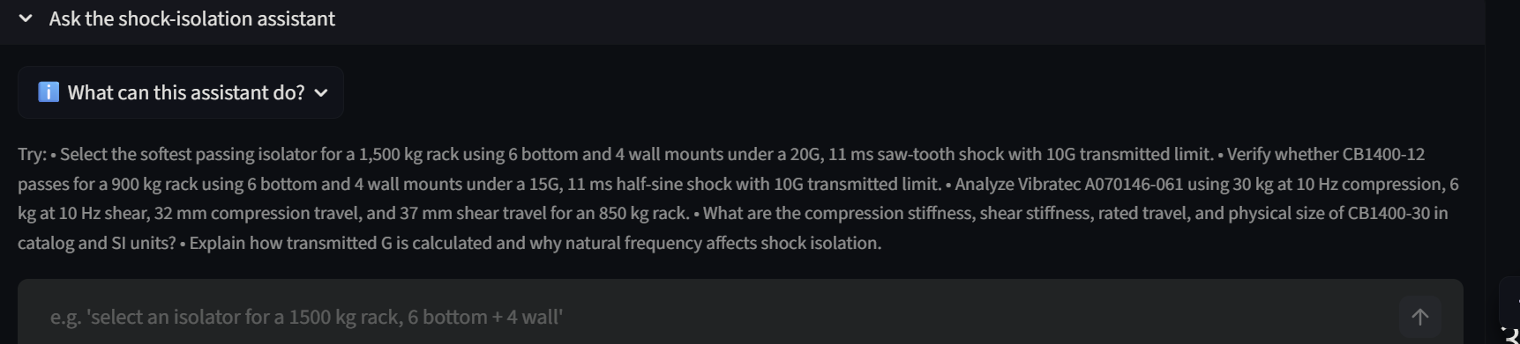
Figure 3. Integrated shock-isolation assistant inside the Shock Selector workflow.

2.17 Step 17 - Generate the supplier enquiry pack
The supplier pack is generated deterministically from the current analysis. The engineer adds project metadata, centre of gravity, wall-stabilizer height, vibration requirement, equipment operating state, interface requirements, environmental requirements and road-trial status. The output separates known inputs, assumptions, missing requirements and evidence levels instead of presenting every field as approved.
- Four load cases and current screening verdict.
- Conceptual mount coordinates and installation envelope.
- Questions requesting nonlinear curves, per-axis extrema, fasteners, service life and environmental limits.
- Supplier response record and road-trial acceptance record.

2.18 Step 18 - Generate an explanatory visual
The optional image panel is separate from the text assistant. The engineer chooses the visual purpose, viewpoint, additional visual direction, quality and an optional approved physical reference image. The prompt enforces a wire-rope-isolator concept and prohibits the image from changing the selected part, mount coordinates, calculation or PASS/FAIL result.
Visual purpose | Suitable use | Engineering limitation
Shock attenuation | Training explanation of input shock and reduced equipment response. | Not a measured acceleration plot.
Mounting arrangement | Communicating bottom and wall stabilizer concepts. | Not a dimensioned installation drawing.
Wire-rope mechanism | Showing repeated cable loops and deformation concept. | Not a supplier-approved product representation without a reference image.

2.19 Step 19 - Use the floating UI guide
The floating Shock Selector UI Guide answers how-to questions such as where to start, which inputs are required, when to use Auto or Manual mode, and how to read the Binding column. It is separate from the engineering assistant so product guidance does not compete with engineering calculations.

3. Engineering Calculation Explained

3.1 Calculation chain
The implemented calculation follows the validated project reference. The pulse produces an impact velocity. Each candidate's directional stiffness and mass per isolator determine natural frequency. Natural frequency and impact velocity then determine transmitted shock and peak movement.
Quantity | Plain-text equation | Meaning
Impact velocity V | Pulse-shape factor x g x Ao x pulse duration | Velocity change represented by the idealized shock pulse.
Natural frequency fn | (1 / (2 x pi)) x square root(K / m) | Mounted isolator-system frequency for the case.
Transmitted shock GT | (2 x pi x fn x V) / g | Acceleration transmitted to the protected equipment.
Peak movement | V / (2 x pi x fn) | Calculated isolator displacement demand.

3.2 Why softer is not always better
Lower stiffness reduces natural frequency and therefore reduces transmitted acceleration in this shock model. However, lower natural frequency increases movement. A softer part may therefore fail rated travel or installation clearance even while improving transmitted-G performance. Static rating can also become the governing condition.

3.3 Selection rule
The default engineering rule is the softest valid isolator within the selected catalog scope. A candidate is valid only when every implemented load case satisfies transmitted-G, movement, catalog travel, entered clearance and applicable static-load requirements. The objective then ranks candidates that are already valid; it cannot convert a failed part into a pass.

3.4 Validated reference point
Regression anchor
For the 850 kg, six-bottom and four-wall reference configuration using CB1400-15, the validated calculation reproduces 6.296 G transmitted shock and 18.85 mm movement for the reference condition. Changes to the physics engine are regression-tested against the approved model.

4. How the AI Assistance Is Controlled

4.1 The LLM is a controller and explainer
The model reads the user's request, sees the permitted tool descriptions and returns either a tool call with structured arguments or a natural-language response. When a tool is called, Python validates the arguments, performs the calculation and returns structured result text. The model then explains that result. This prevents the critical numerical answer from being based only on next-token prediction.

4.2 What 'more guided attention' actually means
Technical correction
The application does not modify or retrain GPT-5.4 mini's transformer attention layers. The model is guided by controlling what information enters its context and what actions it may take.
Guidance mechanism | How it narrows the task
Domain system prompt | Defines shock-isolation scope, safety rules, missing-input behaviour and evidence boundaries.
Tool descriptions and schemas | Present only approved engineering operations and named parameters with units.
Structured UI inputs | Provide exact mass, mount count, pulse and clearance instead of relying on prose extraction.
Current analysis snapshot | Supplies the selected part, verdict, assumptions and load cases without requiring the user to repeat them.
Local RAG top-k | Adds only the closest shock-mount reference chunks when knowledge lookup is required.
Short chat history | Limits model input to the last three turns for stateful engineering chat.
Stale-state guard | Blocks contextual actions when the visible result no longer matches the inputs.
This controlled-context design can reduce ambiguity and irrelevant information. It does not guarantee correctness, which is why deterministic calculations, citations, response assurance and formal evaluation remain necessary.

4.3 How RAG is used
RAG is exposed as a knowledge tool rather than an always-on preprocessing step. When the user asks for standards, workflow, catalog interpretation or vendor evidence, the question is embedded locally with BGE-M3, compared with stored shock-mount vectors, and the top matching passages are returned with source identifiers. Numerical selection questions are handled by engineering tools rather than by retrieving prose.
- Convert the information question into a local BGE-M3 query vector.
- Compare it with vectors stored for the approved shock-mount knowledge chunks.
- Retrieve the top matching passages within the shock_mount topic.
- Return passage text and stable chunk identifiers to the language model.
- Generate an explanation with citations and evidence-boundary warnings.

4.4 Response assurance and traceability
The UI retains visible tool calls and results in the chat transcript. Linked contextual answers can be associated with the analysis ID and snapshot used to create them. Exports can preserve the conversation and tool trace. This makes a response easier to review than a standalone general chat answer, although human approval remains required.

5. Comparison with Microsoft 365 Copilot
The fair comparison is between an out-of-the-box Microsoft 365 Copilot subscription and this specialist shock-isolation application. Microsoft Copilot can be extended using Copilot Studio, connectors and agents, but that would be a separate implementation and may introduce metered agent usage. The custom application should not be presented as a replacement for the broad Microsoft 365 product.
Dimension | Shock Selector assistant | Microsoft 365 Copilot
Primary purpose | Shock-isolator selection, verification, evidence and supplier handoff. | General productivity across Microsoft 365 and business data.
Engineering context | Built-in shock inputs, catalog, tools, current analysis and local corpus. | Requires the user, files or a custom agent to provide shock-specific context.
Numerical authority | Deterministic Python returns the implemented calculation and verdict. | General assistant output is not automatically tied to this validated physics engine.
Current UI state | Analysis snapshot is passed automatically and blocked when stale. | Does not automatically know this Streamlit tab state without integration.
Tool restrictions | Only approved shock/CAD tools and schemas are exposed. | Broad capabilities; domain restrictions depend on configuration.
Reference grounding | Local BGE-M3 retrieves bounded shock chunks with source IDs. | Can use web, Microsoft 365 data, files, connectors and custom agents.
Traceability | Tool calls, arguments, calculation output, analysis ID and evidence status. | Strong enterprise governance; engineering trace depends on the workflow built around it.
Supplier output | Deterministic shock-specific Word enquiry pack and road-trial record. | Can draft documents, but the shock-specific schema must be supplied or built.
Image support | Explicit evidence-bounded concept visual separate from calculations. | General content creation; engineering boundary must be prompted or configured.
Breadth | Narrow specialist product. | Broad Word, Excel, PowerPoint, Outlook and Teams integration.
Commercial model | Usage-based OpenAI tokens plus internal hosting/maintenance. | Per-user license; US$30/user/month paid yearly for the enterprise plan.

5.1 Where the custom application is stronger
- The form captures required engineering variables and units before the model responds.
- The same deterministic physics and catalog rules are used in the UI, assistant tools and supplier pack.
- A current analysis snapshot gives the assistant exact project context without copy-and-paste.
- The model can abstain or ask for missing engineering inputs instead of inventing them.
- RAG is limited to curated shock-mount references and retains stable citation identifiers.
- The application exposes the governing constraint, load cases and evidence gaps directly.
- Usage-based API cost can be substantially lower than purchasing five broad productivity seats when the requirement is only this workflow.

5.2 Where Microsoft Copilot is stronger
- Broad integration with Word, Excel, PowerPoint, Outlook and Teams.
- Enterprise identity, administration, data protection, compliance and adoption analytics.
- Access to wider business data through Microsoft 365 and configured connectors.
- Vendor-supported platform operations rather than a project-owned application stack.
- Better fit when users need a general assistant for many workflows, not only shock isolation.

5.3 Accuracy claims that are justified
The project has formal evidence that deterministic tools and bounded RAG improve the selected local model on the frozen shock benchmark. It does not have a controlled head-to-head benchmark against Microsoft 365 Copilot. Therefore, the defensible claim is that the custom application provides more relevant context, deterministic calculations and traceability for this specific workflow, not that it is universally more intelligent.
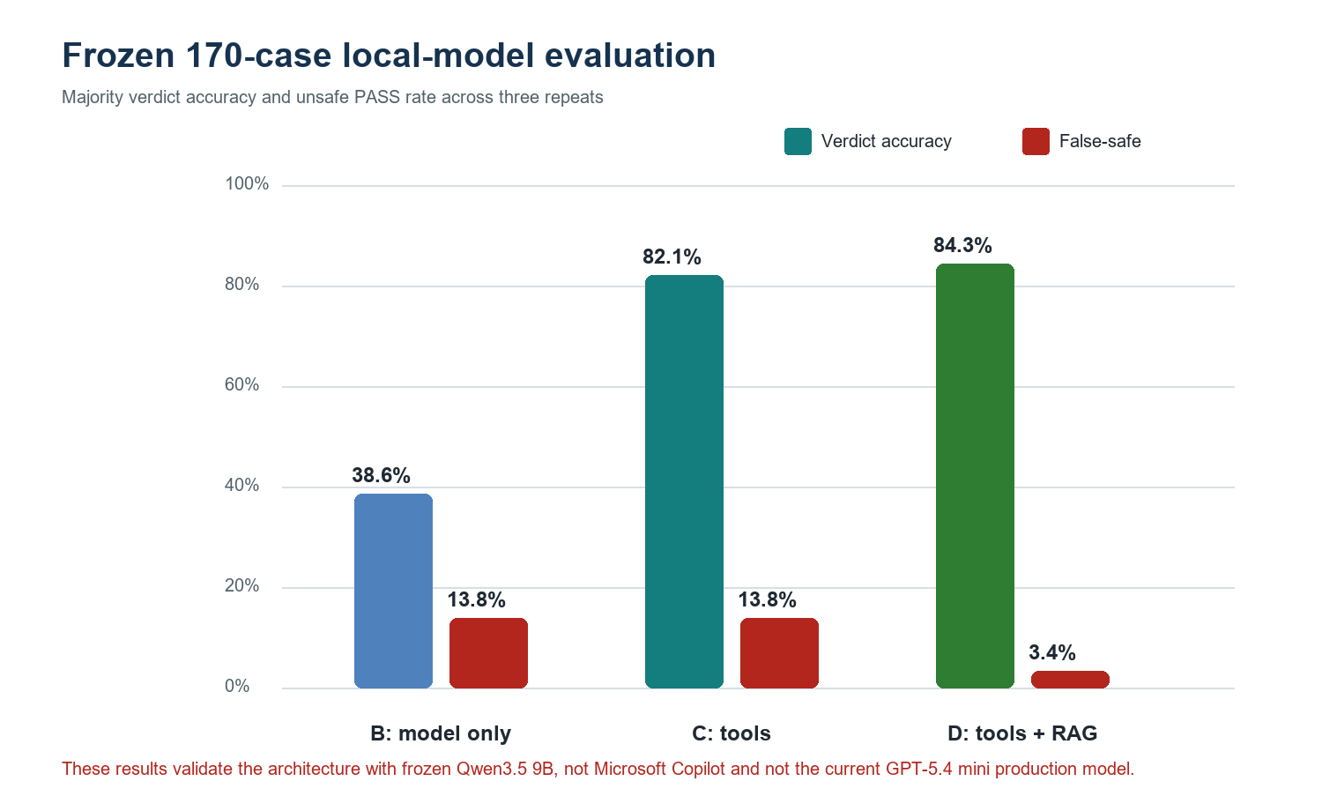
Figure 4. Frozen architecture evaluation using Qwen3.5 9B, 170 cases and three repeats.
System | Configuration | Verdict accuracy | False-safe rate
B | Qwen3.5 9B only | 38.6% (54/140) | 13.8% (4/29)
C | Same model plus deterministic tools | 82.1% (115/140) | 13.8% (4/29)
D | Same model plus tools and BGE-M3 RAG | 84.3% (118/140) | 3.4% (1/29)
The B-to-C improvement was 43.6 percentage points with exact McNemar p < 0.0001. The C-to-D increase was 2.1 points with p = 0.6291, so the overall accuracy increase from RAG was not statistically significant in this benchmark. RAG nevertheless reduced the measured false-safe rate and System D retrieval Hit@3 was 86.7%. These results are screening and software-evaluation evidence, not physical certification. [3]

6. Five-User Cost Comparison
Cost boundary
The numbers below compare Microsoft 365 Copilot enterprise seat charges with GPT-5.4 mini chat-token charges. They are not a full total-cost-of-ownership model.

6.1 Public pricing used
Item | Public price used | Source condition
Microsoft 365 Copilot | US$30 per user per month | Paid yearly; separate qualifying Microsoft 365 plan required. [1]
GPT-5.4 mini input | US$0.75 per 1 million tokens | Standard API text-token rate. [2]
GPT-5.4 mini cached input | US$0.075 per 1 million tokens | Not credited in the conservative scenario calculations. [2]
GPT-5.4 mini output | US$4.50 per 1 million tokens | Standard API text-token rate. [2]
Regional processing | 10% uplift | Applies to GPT-5.4 mini regional data-residency endpoints. [2]
The Microsoft baseline assumes the organization already owns a qualifying Microsoft 365 plan and is considering five additional Copilot licenses. If it does not own that plan, the full Microsoft cost is higher. Microsoft also offers Copilot Chat at no additional cost for eligible Entra users with an eligible Microsoft 365 subscription; the cost-saving comparison does not apply against that included chat product. Copilot Chat and a deterministic specialist engineering application are also not functionally equivalent. [1]

6.2 Calculation method
Monthly Microsoft Copilot cost = number of users x monthly seat price.
Monthly custom chat cost = input tokens / 1,000,000 x input price + output tokens / 1,000,000 x output price.
Monthly difference = Microsoft Copilot seat cost - custom chat-token cost.

6.3 Usage assumptions
Scenario | Interactions per month | Input tokens per interaction | Output tokens per interaction
Light | 500 | 6,000 | 500
Expected | 1,000 | 8,000 | 800
Heavy | 2,000 | 10,000 | 1,200
The expected scenario is five engineers x ten assistant interactions per working day x twenty working days = 1,000 interactions per month. Token assumptions include the domain prompt, tool schemas, short history, current snapshot, selected retrieval passages and final answer. Actual usage must be measured from API response metadata before procurement.

6.4 Scenario results
Scenario | Custom API / month | Custom API / year | Difference / month | Difference / year | Lower than US$150 baseline
Light | US$3.38 | US$40.50 | US$146.63 | US$1,759.50 | 97.8%
Expected | US$9.60 | US$115.20 | US$140.40 | US$1,684.80 | 93.6%
Heavy | US$25.80 | US$309.60 | US$124.20 | US$1,490.40 | 82.8%
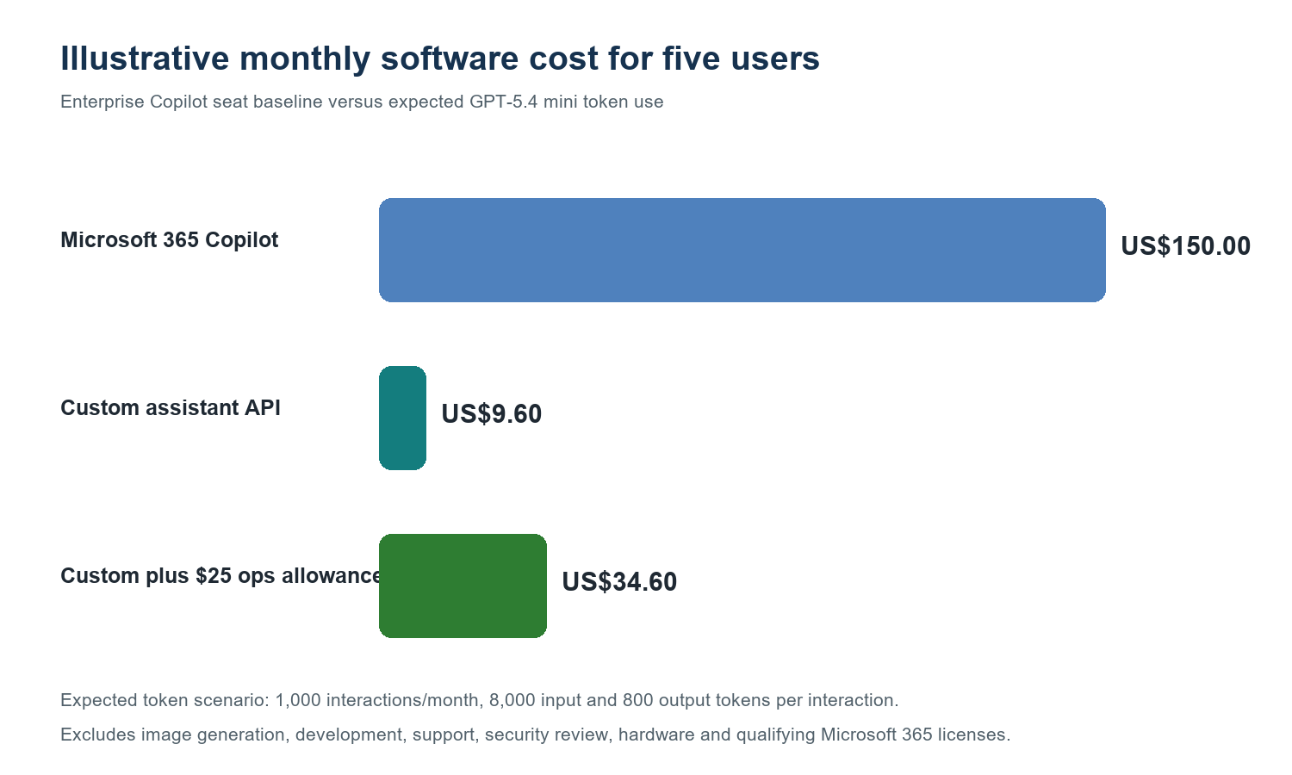
Figure 5. Illustrative monthly cost comparison for five users.

6.5 Expected case with an operating allowance
If management adds an illustrative US$25 per month allowance for internal hosting and monitoring, the expected monthly custom operating estimate becomes US$34.60. The difference from five Microsoft 365 Copilot enterprise seats becomes US$115.40 per month or US$1,384.80 per year. The US$25 allowance is not a vendor quote; replace it with the organization's actual server, monitoring and support allocation.

6.6 Costs excluded from the headline saving
- Initial software development, testing and documentation.
- Ongoing maintenance when catalogs, standards, prompts, tools or APIs change.
- Security review, access control, audit logging, secrets management and data-retention controls.
- Internal server or cloud hosting, backups, networking and support desk time.
- Existing GPU depreciation and electricity for local BGE-M3 embeddings.
- Optional GPT Image 2 calls, which are explicit user-triggered actions.
- Supplier engineering fees, laboratory tests, instrumentation and road trials.
- Microsoft 365 qualifying-plan cost, regional taxes, currency conversion and negotiated enterprise discounts.

6.7 How to obtain a procurement-grade cost
- Log actual input and output tokens per assistant request for at least four weeks.
- Count active users, daily requests, tool-only runs, RAG calls and image generations separately.
- Add measured internal hosting, support, security and maintenance effort.
- Obtain the organization's actual Microsoft enterprise quote and applicable qualifying licenses.
- Compare total annual cost together with measured engineering time saved and error reduction.

7. Business Value Beyond Subscription Cost

7.1 Immediate workflow value
Current friction | Shock Selector response | Potential benefit
Repeated spreadsheet entry | Structured form and consistent equations | Lower re-entry effort and fewer unit mistakes
Manual catalog comparison | Automated four-case screening | Faster first-pass recommendation
Result explanation depends on individual experience | Contextual assistant and governing-check summary | More consistent review and knowledge transfer
Supplier enquiries vary by engineer | Deterministic Word enquiry pack | More complete and comparable supplier responses
Evidence is mixed with assumptions | Explicit evidence levels and missing-item list | Better traceability and handoff
Visual explanation is time-consuming | Controlled optional concept visual | Faster client and training communication

7.2 Productivity saving formula
Potential monthly labour saving = active engineers x working days x minutes saved per engineer per day / 60 x loaded hourly cost.
Example only: if five engineers save ten minutes per day over twenty days, the workflow saves approximately 16.7 engineering hours per month. At an illustrative loaded rate of US$60 per hour, that is approximately US$1,000 per month or US$12,000 per year. This figure is not yet measured and must not be presented as a realized saving until a timed pilot is completed.

7.3 Recommended pilot metrics
- Median time from requirement receipt to first-pass part recommendation.
- Number of manual spreadsheet cells or copy-and-paste actions avoided.
- Rate of unit, parameter and omitted-input errors detected before supplier submission.
- Percentage of supplier enquiry fields complete on first submission.
- Agreement between software result, approved Excel calculation and supplier response.
- False-safe, abstention and unsupported-claim rate in assistant responses.
- User adoption, correction frequency and perceived review effort.
- Actual GPT token and image-generation cost per completed enquiry.

8. Risks, Controls and Deployment Conditions
Risk | Current control | Recommended deployment action
Incorrect input | Structured fields, units, hints and stale-result guard | Add project data review and named approver
LLM invents a value | OMIT rules, validation, deterministic tools and missing-input behaviour | Monitor traces and retain assurance feedback
Outdated catalog or standard | Versioned corpus and frozen evaluation artifacts | Assign an owner and change-control process
Unsupported physical claim | Evidence-boundary tables and supplier-confirmation warnings | Require supplier/lab/road evidence before release
Cloud data exposure | Local embeddings; approved OpenAI path for chat/image | Confirm enterprise API terms, retention, region and approved data classes
Cost growth | Usage-based pricing and explicit image action | Set spend limits and monthly usage dashboard
Single developer dependency | Tests, documentation, manifests and reproducible environment | Create maintenance runbook and second maintainer

8.1 Recommended positioning for management
Positioning statement
The Shock Selector is a focused engineering decision-support product that combines validated calculations, bounded company knowledge and a language interface. It complements broad enterprise copilots by owning one high-value workflow end to end.

9. Conclusion
The principal advantage of the Shock Selector is not that it uses a different language model from Microsoft Copilot. Its advantage is the system around the model: structured engineering inputs, validated deterministic calculations, controlled catalog rules, current UI context, bounded local retrieval, evidence classification and workflow-specific outputs.
For a five-person team using only this shock-isolation workflow, the expected GPT-5.4 mini token cost is much lower than five Microsoft 365 Copilot enterprise seats. The expected marginal difference is approximately US$140.40 per month or US$1,684.80 per year before hosting, maintenance and governance costs. The application therefore has a credible cost case as a specialist tool, provided that management evaluates total ownership cost and does not treat it as a substitute for Microsoft 365 Copilot's broader capabilities.
The next commercial step is a measured five-user pilot. Instrument actual token use and task time, compare outputs with the approved Excel method and supplier reports, and track user corrections. That pilot converts the illustrative business case into defensible operational evidence.

Appendix A - Glossary
Term | Meaning in this system
Ao | Input shock acceleration in multiples of gravitational acceleration.
GT | Calculated transmitted acceleration at the protected equipment.
fn | Natural frequency of the mass and directional isolator stiffness for a load case.
Movement / peak deflection | Calculated displacement demand during the idealized shock.
Binding constraint | Constraint closest to its permitted limit.
False-safe | Software returns PASS when the gold engineering verdict is FAIL.
Tool calling | LLM returns a structured request for an approved Python function.
RAG | Retrieval-augmented generation: selected external passages are added to the model context.
Embedding | Numerical vector used to compare semantic similarity between a question and knowledge chunks.
Analysis snapshot | Immutable structured summary of the current calculation used by contextual actions.
Stale result | Stored result whose analysis key no longer matches the visible inputs.

Appendix B - Evidence and Source Locations
Evidence | Repository or web location
Current Shock Selector implementation | C:\Users\qujia\Documents\GitHub\CAD-Agent-MPD\app.py
Physics engine | C:\Users\qujia\Documents\GitHub\CAD-Agent-MPD\physics_engine.py
Catalog and selection rules | C:\Users\qujia\Documents\GitHub\CAD-Agent-MPD\catalog.py
Assistant tools and prompts | C:\Users\qujia\Documents\GitHub\CAD-Agent-MPD\agent.py
Supplier pack generator | C:\Users\qujia\Documents\GitHub\CAD-Agent-MPD\supplier_enquiry_report.py
Explanatory image boundary | C:\Users\qujia\Documents\GitHub\CAD-Agent-MPD\shock_concept_image.py
Formal evaluation verification | C:\Users\qujia\Documents\GitHub\CAD-Agent-MPD\evaluation\FINAL_RELEASE_VERIFICATION.md
Frozen evaluation record | C:\Users\qujia\Documents\GitHub\CAD-Agent-MPD\evaluation\FREEZE.md
Shock knowledge corpus | C:\Users\qujia\Documents\GitHub\CAD-Agent-MPD\knowledge\shock_mount

Appendix C - External Pricing Sources
[1] Microsoft. Microsoft 365 Copilot plans and pricing for enterprise. Microsoft enterprise pricing page Accessed 27 July 2026.
[2] OpenAI. GPT-5.4 mini model documentation and token pricing. OpenAI GPT-5.4 mini model page Accessed 27 July 2026.
[3] Project evidence. Final Evaluation Release Verification. C:\Users\qujia\Documents\GitHub\CAD-Agent-MPD\evaluation\FINAL_RELEASE_VERIFICATION.md

Appendix D - Cost Worksheet
Variable | Expected value | Replace with actual
Active users | 5 | ________
Working days per month | 20 | ________
Interactions per user per day | 10 | ________
Average input tokens | 8,000 | ________
Average output tokens | 800 | ________
Monthly chat API cost | US$9.60 | ________
Monthly hosting/monitoring | Not in headline | ________
Monthly image API cost | Not in headline | ________
Monthly support/maintenance | Not in headline | ________
Actual Microsoft quote for 5 users | US$150 list baseline | ________
Measured minutes saved per user per day | Not yet measured | ________

