Assignment #3. Methodology and Core Practical Implementation
Student(s): Ashkenov Nurgaly, Orazbek Ulan
Group: SE-2406
Core practical track: Other Technical Experiment (controlled performance benchmark / testbed)
Repository: https://github.com/qulanoraz/state_bench

1. Final / Revised Research Title
Frame Rendering Performance of BLoC and Riverpod in Flutter Under High-Frequency State Updates: A Controlled Comparison on Low-End and Mid-Range Android Devices
The title is the same as in Assignment 2. No change of topic or research question was made.

2. Primary Research Question, Aim and Objectives
Primary research question (RQ). How do the BLoC and Riverpod state management architectures compare in frame build time, raster time and jank percentage in a Flutter application on Android as the state update frequency increases from 10 to 120 updates per second?
SQ1. To what extent are differences in jank percentage associated with differences in memory allocation rate and garbage-collection frequency?
SQ2. Does the difference between the two architectures change between a low-end and a mid-range Android device?
Aim. To determine how the choice between the BLoC and Riverpod state management architectures affects the frame rendering performance of a Flutter application as the state update frequency increases, and to explain any difference through memory allocation and garbage-collection behaviour.
Objectives.
- O1. To develop a controlled Flutter testbed in which an identical user interface and synthetic update generator are implemented once with BLoC and once with Riverpod, so that the state management layer is the only difference between the two versions.
- O2. To compare frame build time, raster time (mean and 95th percentile) and jank percentage of the two architectures at 10, 30, 60 and 120 updates per second. (→ RQ, H1)
- O3. To examine the memory allocation rate and GC frequency of each architecture and assess their association with jank percentage. (→ SQ1, H2)
- O4. To determine whether the differences between the two architectures change between a low-end and a mid-range Android device. (→ SQ2, H3)
Note on O3. The objective is unchanged, but while building the testbed we found that measuring allocations inside the timed runs disturbs the frame timings (Section 9.6). Allocation rate is therefore collected in separate diagnostic runs, while GC frequency is collected in every timed run.

3. Research Approach and Design
The study is quantitative and experimental. The specific design is a controlled laboratory experiment with a full factorial design: 2 architectures (BLoC, Riverpod) × 4 update frequencies (10, 30, 60, 120 updates/s) × 2 device classes (low-end, mid-range), 16 conditions in total. The RQ asks how a measurable outcome changes when two factors vary, so we need to set those factors ourselves and keep everything else constant. The UI, the update generator and its seed, the Flutter SDK and the build mode are the same in every condition; only the state layer is swapped. A difference in the outcome can then be attributed to the manipulated factor (Wohlin et al., 2012).
Unit of analysis: one benchmark run, i.e. one app launch in one condition with a 30-second measurement window. Frames are recorded but aggregated into run-level values, because frames inside one run are not independent and treating thousands of them as observations would make almost any difference "significant" (Kalibera & Jones, 2013).
Evidence produced: distributions of run-level frame and memory metrics per condition, effect sizes and significance tests.
Rejected alternative: a comparative case study of existing open-source BLoC and Riverpod apps. It is more realistic, but such apps differ in screens, features and code quality, so a difference could not be traced to the library, and none of them lets us set the update rate.

4. Sample / Dataset / Cases / Research Context
Research material: (1) the testbed app state_bench, a 48-tile live dashboard similar to telemetry or trading screens, in two variants; (2) two physical Android phones; (3) the benchmark runs. The target population is Flutter apps on Android that update the UI continuously and run on low-end and mid-range phones.
Inclusion and exclusion criteria.
 | Inclusion | Exclusion
Devices | Android 10 or newer; refresh rate can be locked to 60 Hz; USB debugging available. Low-end: ≤ 4 GB RAM, entry-level SoC. Mid-range: 6–8 GB RAM, mid-tier SoC. | Emulators (host CPU and emulated GPU make frame times unrealistic); rooted phones or custom ROMs; vendor "game/performance" modes that cannot be turned off.
Runs | Run finished without error; achieved update rate ≥ 95 % of the nominal rate; display at 60 Hz during the run. | Failed or interrupted runs; battery below 50 %. Excluded runs are logged in run_log.csv and repeated, not silently removed.

Sample size: 30 runs per condition, 240 per device, 480 in total. Thirty repetitions is the common minimum for noisy software experiments (Arcuri & Briand, 2011; Georges et al., 2007); earlier Flutter studies used two (Zulistiyan et al., 2024) or twenty runs (Puryanto & Akbar, 2025). A run takes about 2–2.5 minutes with build and cooldown, so one phone needs 9–10 hours spread over several evenings (the runner resumes where it stopped). Our lower limit is 20 runs if the pilot shows low variance.
Selection and access: purposive sampling, one phone per class, because we compare hardware classes rather than estimate all Android phones. Both team members use iPhones, so two Android phones that meet the criteria will be borrowed from classmates for the main runs; their models are recorded automatically in environment.json. Until then, the pilot is run on an Android emulator in GitHub Actions (Section 9.5), only to check the pipeline.
Bias: (1) with one phone per class, vendor and SoC effects mix with the class effect, so we report exact models and treat SQ2 as exploratory; (2) a phone heats up during a session, so run order is randomised, runs are separated by a cooldown and battery temperature is logged; (3) we wrote both variants, so both follow the official documentation patterns (Bloc Library, n.d.; Riverpod, n.d.) and equivalence tests check that they behave the same.

5. Variables / Constructs / Measures / Instruments / Metrics
Independent variables: architecture (BLoC / Riverpod); update frequency (10, 30, 60, 120 updates/s – well below, half of, equal to and double the 60 Hz refresh rate); device class (low-end / mid-range).
Dependent variables (O2): build time (UI thread) and raster time (raster thread), each as mean and 95th percentile per run; jank %, the share of frames where build or raster time exceeds the 16.67 ms budget at 60 Hz. The threads form a pipeline, so either stage being slow makes the frame miss its vsync, which is also how DevTools marks slow frames (Flutter, n.d.-a). Callan and Petke (2021) used similar measures.
Secondary variables (O3): GC events per second, peak resident memory (RSS) and, in diagnostic runs, allocation rate.
Controls: SDK and pinned library versions (flutter_bloc 9.1.1, flutter_riverpod 2.6.1), profile build, identical UI, one selector per tile in both variants, seed 42, 60 Hz display, airplane mode, fixed brightness, battery ≥ 50 %, cooldown, randomised order. Manipulation checks: achieved update rate and refresh rate in every run.
Measure | Instrument / source | Evidence for
Build and raster time per frame | FrameTiming objects reported by the Flutter engine via SchedulerBinding.addTimingsCallback (Flutter, n.d.-c) | O2, O4
Jank % | Computed from the same FrameTiming data against the budget 1/refresh rate | O2, O3, O4
GC count | new_gen_gc_count, old_gen_gc_count from Flutter TimelineSummary recorded with traceAction (Flutter, n.d.-b) | O3
Peak RSS | ProcessInfo.currentRss (dart:io), sampled once per second | O3
Allocation rate | Flutter DevTools Memory view, separate diagnostic runs | O3
Achieved update rate, refresh rate | Generator counter / stopwatch; FlutterView.display.refreshRate | O1 (validity check)
Battery level and temperature | adb shell dumpsys battery before every run | Control

Raw per-frame data are recorded because the TimelineSummary gives only the 90th and 99th percentiles.

6. Data Collection / Preparation / Experimental Procedure
The procedure, in chronological order:
- Environment. Flutter stable on Windows 11 / VS Code; the runner saves the exact version (flutter --version --machine) to environment.json; libraries are pinned in pubspec.yaml and pubspec.lock.
- Testbed check (O1). flutter test runs the equivalence tests: both variants must render the same 48 tiles and values after the same update.
- Device preparation each session (Appendix E): 60 Hz, airplane mode, fixed brightness, other apps closed, battery ≥ 50 %.
- Pilot. One run per condition with a 10-second window (run_matrix.py --pilot) to test the chain and see the variance. The first pilot ran on an Android emulator in GitHub Actions because no Android phone was available yet; it checks the pipeline only and is repeated on the physical phones.
- Main runs. The runner shuffles the 240 (architecture, frequency, repetition) combinations of a device with seed 2026 and calls flutter drive --profile --no-dds for each, passing the condition as --dart-define. In a run the app starts, the test binding switches to the benchmarkLive frame policy so frames follow the device vsync, the generator runs for 5 s warm-up plus a 30 s window, and after a 2 s flush the data go to the host. Two JSON files are saved; exit code, battery level and temperature are logged; then a 60 s cooldown.
- Diagnostic runs (O3). Three extra runs per condition with the DevTools Memory view for allocation rate; not used for timings.
- Data preparation. Raw files are never edited. The analysis script removes warm-up frames by their vsync timestamps, computes run-level metrics and writes runs.csv. Failed runs keep an error log and are repeated.
Fairness. Both variants get the same value sequence, render the same widget tree and use one selector per tile. Both live in the same binary, and every run is a fresh process, so heap state does not carry over. All raw data, logs and scripts are kept in the Git repository.

7. Data Analysis Plan
The analysis uses run-level values (runs.csv). Frame metrics are skewed and jank % is bounded at zero, so we use non-parametric statistics (Arcuri & Briand, 2011); α = 0.05.
Descriptives: median and IQR per condition, plus mean and SD for comparison with earlier studies; plots of each metric against frequency.
O1: equivalence tests pass, the code diff is limited to lib/variants/, and runs with achieved rate < 95 % of nominal or refresh ≠ 60 Hz are flagged and reported.
O2 (H1): for each device, frequency and metric (build p95, raster p95, jank %), a two-sided Mann–Whitney U test compares BLoC with Riverpod. Effect size is Vargha–Delaney A12, the probability that a random BLoC run scores higher than a random Riverpod run (0.56/0.64/0.71 = small/medium/large; Vargha & Delaney, 2000). The four tests per metric are Holm-corrected (Holm, 1979). Whether the difference grows with frequency is tested by permutation: the statistic is the slope of the median difference over log2(frequency), compared with 5,000 shuffles of library labels within each frequency. H1 is supported if differences are significant at higher frequencies and the slope has p < 0.05.
O3 (H2): Spearman ρ between GC events per second and jank % per architecture and device, and Mann–Whitney tests on GC/s; allocation rate is reported descriptively. This shows association, not causation.
O4 (H3): O2 is repeated per device and |A12 − 0.5| is compared between devices; H3 is supported if the effect is consistently larger on the low-end phone (exploratory).
Error analysis: for the worst run per condition we inspect the timeline in DevTools to see whether slow frames are build- or raster-bound and coincide with GC.

8. Research Quality, Ethics, Privacy and Reproducibility
Internal validity: one factor changes between paired conditions, confirmed by equivalence tests and manipulation checks; randomised order and cooldowns protect against heat and battery drift. Small environment details can change results (Mytkowicz et al., 2009), so the environment is fixed and recorded each session.
Measurement validity and reliability: timings come from the engine in profile mode, since debug builds are much slower (Flutter, n.d.-a); 30 runs per condition and reporting dispersion make results stable; allocation tracing is off in timed runs so the measurement does not distort what it measures.
External validity: synthetic workload, Android only, two phones; we do not generalise beyond similar dashboards and devices.
Reproducibility: pinned versions, pubspec.lock, fixed seeds, raw data, run log and scripts are in the repository; re-running analyze.py on our raw data gives the same tables.
Ethics and privacy: no human participants and no personal data; the app generates synthetic values and records only timings and memory. On our personal phones it reads nothing else, airplane mode is on, and the runner does not store the adb serial number. Data stay in the team repository until the end of the diploma project.
AI tools: used, as course rules allow, for language checking and code review; only our own code and synthetic data were shared. We checked every decision and can explain it at the defence.

9. Core Practical Component / Initial Implementation
Track: Other Technical Experiment. The required artifact is the testbed and the measurement pipeline: environment and configuration, a comparison condition, test scenarios, measurable outcomes, first outputs and reproducible scripts. The component directly supports O1 and builds the measurement chain for O2–O4.

9.1 What was implemented
Component | File(s) | Purpose | Status
Run configuration | lib/bench/config.dart | LIB, HZ, seed, warm-up and window passed by --dart-define | Done
Shared state + generator | lib/bench/telemetry.dart | Immutable DashboardState; TelemetrySink interface; seeded UpdateGenerator | Done
Shared UI | lib/ui/dashboard.dart | 48-tile grid; TileView (value + bar) | Done
BLoC variant | lib/variants/bloc_variant.dart | Bloc with SampleArrived event; BlocSelector per tile | Done
Riverpod variant | lib/variants/riverpod_variant.dart | Notifier + NotifierProvider; Consumer with select() per tile | Done
Frame recorder | lib/bench/frame_recorder.dart | Raw FrameTiming + 1 Hz RSS | Done
Equivalence tests (O1) | test/equivalence_test.dart | Same tiles, same values, same seed sequence | Done; 3/3 tests pass (CI)
Benchmark run + driver | integration_test/, test_driver/ | One timed run; writes frames + timeline summary | Done; 8/8 pilot runs completed
Run matrix | tool/run_matrix.py | Randomised order, cooldown, battery log, resume | Done
Analysis pipeline | analysis/*.py | Metrics, Mann–Whitney, A12, Holm, permutation, Spearman, plots | Done; 10/10 tests pass (CI)

9.2 Architecture and data flow
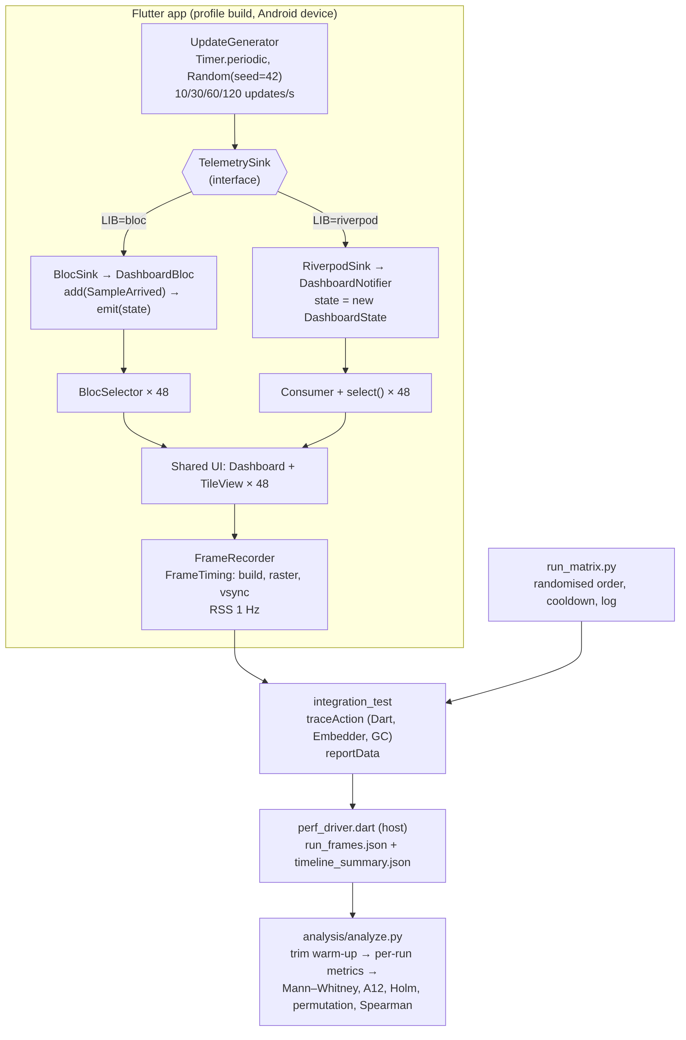
Figure 1. Testbed architecture. The generator only knows the TelemetrySink interface; LIB decides which implementation is created. Everything outside the two variant boxes is shared code.

9.3 Key implementation decisions
- One interface between generator and state layer. UpdateGenerator calls only TelemetrySink.push(). The BLoC sink turns the sample into an event (bloc.add), the Riverpod sink calls the notifier method. The cost of generating values is therefore identical, and the measured difference is the cost of propagating the state.
- Same rebuild scope. Prayoga et al. (2021) showed that where state is scoped matters as much as the library. Each tile therefore subscribes to its own value in both variants (BlocSelector vs ref.watch(provider.select(...))). The natural difference stays: BLoC creates an event object and delivers it asynchronously through a stream, while Riverpod updates the state synchronously. That is part of the architecture we want to measure.
- Frame policy. By default, Flutter integration tests show only frames requested by the test (fadePointers policy). We switch to benchmarkLive after start-up so that the app and the engine schedule frames as on a normal device.
- Raw frames and timestamp-based warm-up. FrameTiming reports arrive in batches, so a batch that reaches us after the warm-up can still contain warm-up frames. We therefore record everything from the start and cut the first 5 seconds in the analysis using each frame’s vsync timestamp.

9.4 Build and test evidence (GitHub Actions)
Every push to the repository starts a GitHub Actions workflow (.github/workflows/ci.yml) that installs Flutter, compiles the project, runs static analysis, the O1 equivalence tests and the pipeline tests, and then runs the pilot (Section 9.5). Logs are stored in evidence/ci and results in the ci-results branch. Run used for this report: https://github.com/qulanoraz/state_bench/actions/runs/40109634908 (24 October 2026).
$ flutter analyze
No issues found! (ran in 8.0s)
$ flutter test --reporter expanded
00:00 +0: bloc: renders all 48 tiles and applies an update
00:00 +1: riverpod: renders all 48 tiles and applies an update
00:01 +2: same seed gives the same update sequence for both variants
00:01 +3: All tests passed!
The pipeline itself was tested on small hand-made inputs with known answers (e.g. 20 frames of 1–20 ms must give p95 = 19.05 ms; Holm values were checked by hand; a frame exactly on budget is not jank; a 10 ms frame is fine at 60 Hz but janky at 120 Hz). These fixtures check the code only and are not experimental results:
test_pipeline_runs_on_file_format ... ok
test_budget_follows_refresh_rate ... ok
test_exactly_on_budget_is_not_jank ... ok
test_jank_uses_build_or_raster ... ok
test_p95_linear_interpolation ... ok
test_warmup_trimming ... ok
test_a12_extremes ... ok
test_holm_matches_hand_computation ... ok
test_permutation_detects_growing_difference ... ok
test_permutation_no_difference ... ok
Ran 10 tests in 0.927s
OK

9.5 First pilot results (Android emulator)
Setup: Android 14 emulator (API 34, x86_64, Pixel 6 profile, software GPU swiftshader) on a GitHub-hosted Ubuntu runner; Flutter 3.47.8 stable, Dart 3.13.7, profile build; one run per condition, 5 s warm-up + 10 s window, random order (seed 2026), 15 s pause between runs. Values below are copied from results/pilot/analysis/runs.csv.
Lib | Hz | Achieved Hz | Frames (fps) | Build mean / p95, ms | Raster mean / p95, ms | Jank % | GC/s
bloc | 10 | 9.9 | 151 (15.1) | 7.6 / 18.8 | 65.7 / 98.7 | 100.0 | 3.06
riverpod | 10 | 9.9 | 147 (14.7) | 6.4 / 14.0 | 67.3 / 99.6 | 100.0 | 3.06
bloc | 30 | 27.8 | 152 (15.2) | 12.5 / 25.8 | 63.9 / 94.3 | 100.0 | 4.35
riverpod | 30 | 27.1 | 152 (15.2) | 10.4 / 20.8 | 63.7 / 92.7 | 100.0 | 4.24
bloc | 60 | 45.3 | 151 (15.1) | 10.7 / 25.2 | 64.5 / 99.4 | 100.0 | 4.47
riverpod | 60 | 44.2 | 149 (14.9) | 12.0 / 33.0 | 65.6 / 95.1 | 100.0 | 4.35
bloc | 120 | 74.2 | 150 (15.0) | 10.7 / 22.9 | 65.5 / 97.9 | 100.0 | 4.47
riverpod | 120 | 71.4 | 150 (15.0) | 9.9 / 19.2 | 65.0 / 95.9 | 100.0 | 4.47
Table 1. Emulator pilot, one run per condition. Used to check the pipeline only; no statistical conclusions are drawn.
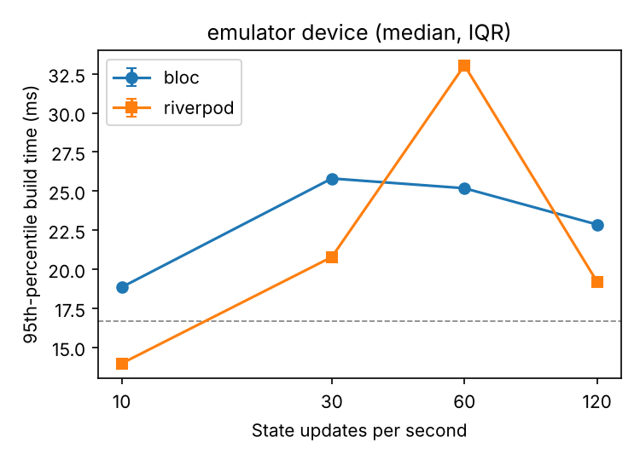
Figure 2. 95th-percentile build time per condition in the emulator pilot (output of analyze.py; dashed line = 16.67 ms budget).
What the pilot shows. The whole chain works: all 8 runs finished with exit code 0, each produced about 150 frames in the window, and analyze.py turned the raw files into tables and plots without manual steps. Apart from the first run, which included the initial Gradle build (243 s), one run took about 46 s. At the same time, the pilot shows clearly why the emulator cannot answer the RQ. It renders only about 15 frames per second, raster time is 64–67 ms on average and never below 24 ms, so 100 % of frames are janky in every condition, and this is caused by the software GPU, not by the state layer. Build times are in a realistic range (mean 6–12 ms, p95 14–33 ms) and differ between conditions, but with one run per cell these differences are noise, not results. GC activity was almost the same for both architectures (3.1 GC/s at 10 Hz, 4.2–4.5 GC/s at 30–120 Hz, no old-generation collections).

9.6 Problems and limitations found during the first implementation
- The standard summary is not enough. TimelineSummary gives 90th/99th percentiles and its own missed-budget count, but no 95th percentile. We added our own recorder for raw FrameTiming data.
- Timers do not guarantee the update rate. Dart’s Timer.periodic may fire less often than requested when the UI isolate is overloaded, so at 120 updates/s the real rate may be lower than nominal. We now count emitted samples and flag runs below 95 %. If this happens often at 120 Hz, the frequency factor itself becomes weaker, which we will report.
- Refresh rate of modern phones. Many phones run at 90 or 120 Hz, which changes the frame budget (8.3 ms at 120 Hz). The budget is now computed from the measured refresh rate, the phones are locked to 60 Hz, and runs at other rates are flagged.
- Lazy grid. GridView.builder builds only visible tiles; on a small screen some of the 48 tiles might never be built, which would make the workload depend on the screen size. The equivalence test uses a 393 × 851 dp surface and checks that all 48 tiles are built; before the main runs we check this on both phones.
- Allocation rate inside timed runs. Connecting to the VM service from inside the app conflicts with the Dart Development Service used by flutter drive, and allocation tracing adds overhead to every frame. Allocation rate was therefore moved to separate diagnostic runs (Section 6, step 6). CPU load, a secondary metric in Assignment 2, is read in the same diagnostic runs.
- Emulator rendering makes frame data useless. In the pilot every frame was raster-bound (raster time > 16.67 ms in 100 % of frames, build time in only 3–15 %). This confirms the decision to exclude emulators from the main experiment; the emulator is kept only as an automatic smoke test.
- The update rate is not reached under load (confirmed). Achieved rates were 9.9 (10 Hz), 27–28 (30 Hz), 44–45 (60 Hz) and 71–74 (120 Hz) updates/s. The generator timer shares the UI isolate with frame building, so when frames are slow the timer fires late. On physical phones the gap should be smaller, but the achieved rate will be reported as a covariate, and if needed the generator will be moved to a separate isolate.
- A bug in our own analysis script. The pilot flagged all runs as “not 60 Hz”, although the display reported 60.0000038 Hz: the script compared floating-point numbers exactly. It now uses a ±0.5 Hz tolerance.
- Test hang in CI. The first CI run hung in flutter test because the BLoC was closed inside the fake-async test zone, where its stream never completes. Disposal now runs in tester.runAsync, and the CI has time limits.

9.7 Reproducibility record and next steps
Flutter 3.47.8 (stable, framework revision 737ba8f885), Dart 3.13.7; flutter_bloc 9.1.1 (bloc 9.2.1), flutter_riverpod 2.6.1 (riverpod 2.6.1); Python 3.12 in CI with numpy, scipy, pandas, matplotlib; generator seed 42, order seed 2026; emulator API 34 x86_64. All commands are in the README and the CI workflow. Next steps: borrow the two Android phones, repeat the pilot on them to see the real variance, fix the number of repetitions (20–30), and then run the main experiment; consider moving the generator to a separate isolate if the achieved rate is still too low.

10. Methodology Alignment Table
Research Objective | Data / Evidence Needed | Source / Sample / Dataset | Collection / Instrument | Analysis Method | Evidence for RQ
O1. Controlled testbed | Proof that only the state layer differs; achieved update rate; refresh rate | state_bench code; all runs | flutter test (equivalence tests); code diff; generator counter; display.refreshRate | Tests pass/fail; share of runs with achieved Hz ≥ 95 % and 60 Hz | Makes the comparison valid: differences can be attributed to the architecture
O2. Compare frame metrics at 10–120 Hz | Build and raster time (mean, p95), jank % per run | 2 libs × 4 Hz × 30 runs per device | FrameTiming via addTimingsCallback; integration_test + run_matrix.py | Median/IQR; Mann–Whitney U + Holm; Vargha–Delaney A12; permutation test of slope | Directly answers the RQ and tests H1
O3. Allocation, GC and jank | GC events/s, peak RSS, allocation rate, jank % | Same runs + 3 diagnostic runs per condition | TimelineSummary GC counts; ProcessInfo RSS; DevTools Memory | Spearman ρ (GC/s vs jank); Mann–Whitney on GC/s; descriptive allocation rate | Explains the mechanism behind differences (SQ1, H2)
O4. Device class | O2 metrics on both phones | Low-end and mid-range phone (purposive) | Same protocol on both devices | O2 tests per device; comparison of |A12 − 0.5| between devices | Shows the boundary condition of the answer (SQ2, H3)

11. References
Agathon, M. A. N., Nurlaili, A. L., & Al Haromainy, M. M. (2025). Comparative analysis of memory and render performance: BLoC vs Provider on low-end devices. bit-Tech, 8(2), 2442–2451. https://doi.org/10.32877/bt.v8i2.3268
Arcuri, A., & Briand, L. (2011). A practical guide for using statistical tests to assess randomized algorithms in software engineering. In Proceedings of the 33rd International Conference on Software Engineering (ICSE ’11) (pp. 1–10). ACM. https://doi.org/10.1145/1985793.1985795
Bloc Library. (n.d.). Bloc documentation. Retrieved October 2026, from https://bloclibrary.dev
Callan, J., & Petke, J. (2021). Improving Android app responsiveness through automated frame rate reduction. In U.-M. O’Reilly & X. Devroey (Eds.), Search-Based Software Engineering. SSBSE 2021 (Lecture Notes in Computer Science, Vol. 12914, pp. 136–150). Springer. https://doi.org/10.1007/978-3-030-88106-1_10
Flutter. (n.d.-a). Flutter performance profiling. Retrieved October 2026, from https://docs.flutter.dev/perf/ui-performance
Flutter. (n.d.-b). Measure performance with an integration test. Retrieved October 2026, from https://docs.flutter.dev/cookbook/testing/integration/profiling
Flutter. (n.d.-c). FrameTiming class [API documentation]. Retrieved October 2026, from https://api.flutter.dev/flutter/dart-ui/FrameTiming-class.html
Georges, A., Buytaert, D., & Eeckhout, L. (2007). Statistically rigorous Java performance evaluation. In Proceedings of the 22nd ACM SIGPLAN Conference on Object-Oriented Programming Systems, Languages and Applications (OOPSLA ’07) (pp. 57–76). ACM. https://doi.org/10.1145/1297027.1297033
Holm, S. (1979). A simple sequentially rejective multiple test procedure. Scandinavian Journal of Statistics, 6(2), 65–70.
Kalibera, T., & Jones, R. (2013). Rigorous benchmarking in reasonable time. In Proceedings of the 2013 International Symposium on Memory Management (ISMM ’13) (pp. 63–74). ACM. https://doi.org/10.1145/2464157.2464160
Mytkowicz, T., Diwan, A., Hauswirth, M., & Sweeney, P. F. (2009). Producing wrong data without doing anything obviously wrong! In Proceedings of the 14th International Conference on Architectural Support for Programming Languages and Operating Systems (ASPLOS ’09) (pp. 265–276). ACM. https://doi.org/10.1145/1508244.1508275
Prayoga, R. R., Syalsabila, A., Munawar, G., & Jumiyani, R. (2021). Performance analysis of BLoC and Provider state management library on Flutter. Jurnal Mantik, 5(3), 1591–1597. https://iocscience.org/ejournal/index.php/mantik/article/view/1539
Puryanto, J. A., & Akbar, H. (2025). Performance analysis of Provider and Riverpod state management library on Flutter applications. Journal of Technology and Informatics (JoTI), 7(2), 190–200. https://doi.org/10.37802/joti.v7i2.1164
Riverpod. (n.d.). Riverpod documentation. Retrieved October 2026, from https://riverpod.dev
Vargha, A., & Delaney, H. D. (2000). A critique and improvement of the CL common language effect size statistics of McGraw and Wong. Journal of Educational and Behavioral Statistics, 25(2), 101–132. https://doi.org/10.3102/10769986025002101
Wohlin, C., Runeson, P., Höst, M., Ohlsson, M. C., Regnell, B., & Wesslén, A. (2012). Experimentation in software engineering. Springer. https://doi.org/10.1007/978-3-642-29044-2
Zulistiyan, M., Adrian, M., & Wibowo, Y. F. A. (2024). Performance analysis of BLoC and GetX state management library on Flutter. Journal of Information System Research (JOSH), 5(2), 583–591. https://doi.org/10.47065/josh.v5i2.4698

12. Appendix

Appendix A. Repository structure
state_bench/
pubspec.yaml pinned versions (flutter_bloc 9.1.1, flutter_riverpod 2.6.1)
lib/bench/config.dart run parameters from --dart-define
lib/bench/telemetry.dart DashboardState, TelemetrySink, UpdateGenerator
lib/bench/frame_recorder.dart
lib/bench/bench_app.dart BenchController, BenchApp
lib/ui/dashboard.dart shared UI
lib/variants/bloc_variant.dart
lib/variants/riverpod_variant.dart
test/equivalence_test.dart
integration_test/benchmark_test.dart
test_driver/perf_driver.dart
tool/run_matrix.py
analysis/metrics.py stats_tools.py analyze.py test_pipeline.py
results/<pilot|main>/<low|mid>/ raw JSON, run_log.csv, environment.json

Appendix B. Code excerpts
B.1 BLoC variant (lib/variants/bloc_variant.dart)
sealed class DashboardEvent {}

final class SampleArrived extends DashboardEvent {
SampleArrived(this.sample);
final TelemetrySample sample;
}

class DashboardBloc extends Bloc<DashboardEvent, DashboardState> {
DashboardBloc(int tiles) : super(DashboardState.initial(tiles)) {
on<SampleArrived>(
(event, emit) => emit(DashboardState.fromSample(event.sample)),
);
}
}

class BlocSink implements TelemetrySink {
BlocSink(int tiles) : bloc = DashboardBloc(tiles);
final DashboardBloc bloc;

@override
void push(TelemetrySample sample) => bloc.add(SampleArrived(sample));

@override
Future<void> dispose() => bloc.close();
}
tileBuilder: (i) => BlocSelector<DashboardBloc, DashboardState, double>(
selector: (s) => s.values[i],
builder: (_, v) => TileView(index: i, value: v),
B.2 Riverpod variant (lib/variants/riverpod_variant.dart)
class DashboardNotifier extends Notifier<DashboardState> {
@override
DashboardState build() => DashboardState.initial(ref.watch(tilesProvider));

void apply(TelemetrySample sample) =>
state = DashboardState.fromSample(sample);
}

final dashboardProvider =
NotifierProvider<DashboardNotifier, DashboardState>(DashboardNotifier.new);
tileBuilder: (i) => Consumer(
builder: (_, ref, __) => TileView(
index: i,
value: ref.watch(dashboardProvider.select((s) => s.values[i])),
B.3 Update generator (lib/bench/telemetry.dart)
void start() {
final period =
Duration(microseconds: (Duration.microsecondsPerSecond / hz).round());
_clock.start();
_timer = Timer.periodic(period, (_) => emitOnce());
}

/// Produces and pushes one sample (also used directly by unit tests).
void emitOnce() {
_tick++;
final values = List<double>.generate(
tiles,
(_) => _rng.nextDouble() * 100,
growable: false,
);
sink.push(TelemetrySample(_tick, values));
B.4 One benchmark run (integration_test/benchmark_test.dart)
binding.framePolicy = LiveTestWidgetsFlutterBindingFramePolicy.benchmarkLive;

final display = tester.view.display;
final rssBefore = ProcessInfo.currentRss;

await binding.traceAction(
() async {
recorder.start();
controller.start();
await Future<void>.delayed(
Duration(seconds: cfg.warmupSeconds + cfg.measureSeconds),
);
controller.stop();
// Let the engine flush the last batch of FrameTiming reports.
await Future<void>.delayed(const Duration(seconds: 2));
recorder.stop();
},
streams: const <String>['Dart', 'Embedder', 'GC'],
reportKey: 'timeline',
B.5 Jank and percentile computation (analysis/metrics.py)
def frame_metrics(frames: list[dict], refresh_hz: float = 60.0) -> dict:
if not frames:
raise ValueError("no frames in measurement window")
budget_us = US_PER_S / refresh_hz
build = np.array([f["build_us"] for f in frames], dtype=float) / 1000
raster = np.array([f["raster_us"] for f in frames], dtype=float) / 1000
janky = (build > budget_us / 1000) | (raster > budget_us / 1000)
return {
"frames": int(len(frames)),
"build_mean_ms": float(build.mean()),
"build_p95_ms": float(np.percentile(build, 95, method="linear")),
"raster_mean_ms": float(raster.mean()),
"raster_p95_ms": float(np.percentile(raster, 95, method="linear")),
"jank_pct": float(100 * janky.mean()),
"budget_ms": budget_us / 1000,

Appendix C. O1 equivalence test (test/equivalence_test.dart)
for (final lib in StateLib.values) {
testWidgets('${lib.name}: renders all 48 tiles and applies an update',
(tester) async {
// Typical phone surface (393 x 851 dp) so that all tiles are laid out.
tester.view.physicalSize = const Size(1080, 2340);
tester.view.devicePixelRatio = 2.75;
addTearDown(tester.view.reset);

final controller =
BenchController(BenchConfig(lib: lib, hz: 60, tiles: 48));
await tester.pumpWidget(BenchApp(controller: controller));

expect(find.byType(GridView), findsOneWidget);
expect(find.text('0.0'), findsNWidgets(48));

final values = List<double>.generate(48, (i) => i + 0.4);
controller.sink.push(TelemetrySample(1, values));
await tester.pump(); // BLoC delivers the event asynchronously
await tester.pump();

expect(find.text('0.4'), findsOneWidget); // first tile
expect(find.text('47.4'), findsOneWidget); // last tile
expect(find.text('0.0'), findsNothing); // every tile was updated
expect(find.textContaining('tick 1'), findsOneWidget);

// Close streams outside the fake-async zone, otherwise the test hangs.
await tester.runAsync(controller.dispose);

Appendix D. Data dictionary (runs.csv)
Column | Unit | Meaning
run_id | – | device class_lib_Hz_repetition, e.g. low_bloc_60_07
device, lib, hz | – | Independent variables
frames, fps | count, 1/s | Frames in the 30-s window and frames per second
build_mean_ms, build_p95_ms | ms | UI-thread build time per frame: mean and 95th percentile
raster_mean_ms, raster_p95_ms | ms | Raster-thread time per frame: mean and 95th percentile
jank_pct | % | Frames with build or raster time > budget
budget_ms | ms | 1000 / refresh rate (16.67 at 60 Hz)
achieved_hz, refresh_rate_hz | 1/s, Hz | Manipulation checks
gc_new, gc_old, gc_per_s | count, 1/s | GC events in the traced period
peak_rss_mb | MB | Highest resident memory sample

Appendix E. Device preparation checklist (per session)
- USB debugging on; phone connected by cable; adb devices shows it
- Display refresh rate locked to 60 Hz; adaptive brightness off, brightness 50 %
- Airplane mode on; all other apps closed; battery saver and game modes off
- Battery ≥ 50 %; phone on a table, no case; room temperature noted
- All 48 tiles visible on screen without scrolling (checked once per phone)
- Run: python tool/run_matrix.py --device <id> --device-class <low|mid>

Appendix F. Pilot evidence
F.1 run_log.csv (written by run_matrix.py; battery values are those reported by the emulator)
run_id,lib,hz,rep,started,seconds,exit_code,battery_level,battery_temp_c,note
emulator_riverpod_60_01,riverpod,60,1,2026-10-24T16:05:17,242.8,0,100,25.0,
emulator_riverpod_120_01,riverpod,120,1,2026-10-24T16:09:35,46.6,0,100,25.0,
emulator_bloc_120_01,bloc,120,1,2026-10-24T16:10:36,47.2,0,100,25.0,
emulator_bloc_10_01,bloc,10,1,2026-10-24T16:11:39,46.0,0,100,25.0,
emulator_riverpod_30_01,riverpod,30,1,2026-10-24T16:12:40,45.6,0,100,25.0,
emulator_riverpod_10_01,riverpod,10,1,2026-10-24T16:13:40,45.1,0,100,25.0,
emulator_bloc_60_01,bloc,60,1,2026-10-24T16:14:40,45.5,0,100,25.0,
emulator_bloc_30_01,bloc,30,1,2026-10-24T16:15:41,46.3,0,100,25.0,
F.2 analyze.py console output
8 runs loaded; results in results/pilot/analysis
WARNING: achieved update rate < 95% of nominal in runs: emulator_bloc_120_01, emulator_bloc_30_01, emulator_bloc_60_01, emulator_riverpod_120_01, emulator_riverpod_30_01, emulator_riverpod_60_01
F.3 Jank and raster plots produced by analyze.py
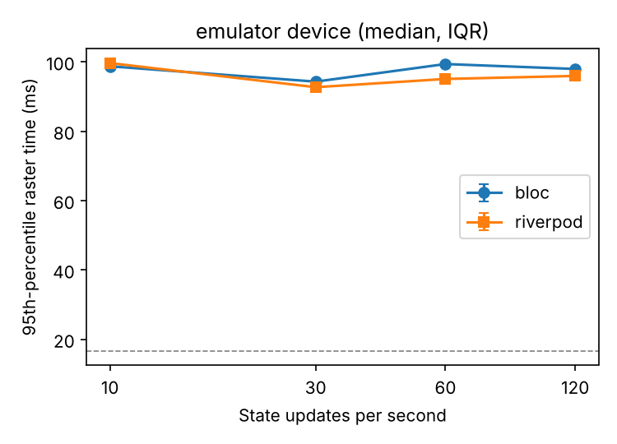
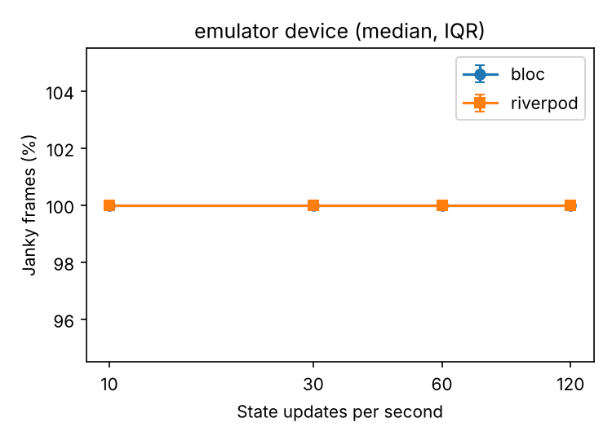
Figure 3. Raster p95 and jank % in the emulator pilot: the software GPU keeps raster time far above the budget, so jank is 100 % everywhere.
F.4 Environment record (results/pilot/emulator/environment.json, excerpt)
{
"recorded_at": "2026-10-24T16:05:17",
"device_class": "emulator",
"model": "sdk_gphone64_x86_64",
"android_release": "14",
"sdk_int": "34",
"flutter": {
"frameworkVersion": "3.47.8",
"channel": "stable",
"frameworkRevision": "737ba8f885dc774b53b442759999a312c9461e4e",
"dartSdkVersion": "3.13.7"
}
}

