**Deliverable #2:**

1. **Name:** Quinlin McNatt
2. **Project Tracker:** Fitness Tracker
3. **Project Summary:** The goal of my semester project is to create a fitness tracker app that I can use to track statistics on workouts, health, and nutrition.
4. **Project Features:**

|  |  |  |  |
| --- | --- | --- | --- |
| **Functionality ID #** | **Requirement ID #** | **User Requirement:** | **Implemented: (TRUE, FALSE)** |
| 1 | 1A | User can create account | FALSE |
| 2 | 2A | User can login to account | FALSE |
| 3 | 3A | User can input information | TRUE |
| 4 | 4A | User can view logging history | TRUE |
| 5 | 5A | User can set goals | TRUE |
| 5 | 5B | User can change goals | TRUE |
| 6 | 6A | User can add nutrition | TRUE |
| 6 | 6B | User can change nutrition | FALSE |
| 7 | 7A | User sees visual analytics on log | TRUE |
| 8 | 8A | User can search created workouts | FALSE |
| 8 | 8A | User can search created nutrition | TRUE |
| 9 | 9A | User can log nutrition | TRUE |
| 9 | 9B | User can log weight | TRUE |
| 10 | 10A | User can browse workouts | FALSE |
| 10 | 10B | User can browse nutririon | TRUE |

Basically, the features that were not implemented were all of the workout features, as this would be a carbon copy of the nutrition, I just ran out of time, and a login feature as the project is just for myself, and implementing a login would not be difficult.

Note: For part 5, I rotated the diagram since it’s too large to fit on the pdf in the right way.

%3CmxGraphModel%3E%3Croot%3E%3CmxCell%20id%3D%220%22%2F%3E%3CmxCell%20id%3D%221%22%20parent%3D%220%22%2F%3E%3CmxCell%20id%3D%222%22%20value%3D%22%22%20style%3D%22endArrow%3Dopen%3BendFill%3D1%3BendSize%3D12%3Bhtml%3D1%3BexitX%3D0.526%3BexitY%3D-0.012%3BexitPerimeter%3D0%3BentryX%3D0.25%3BentryY%3D1%3B%22%20edge%3D%221%22%20parent%3D%221%22%3E%3CmxGeometry%20width%3D%22160%22%20relative%3D%221%22%20as%3D%22geometry%22%3E%3CmxPoint%20x%3D%22538%22%20y%3D%22761%22%20as%3D%22sourcePoint%22%2F%3E%3CmxPoint%20x%3D%22745%22%20y%3D%22533%22%20as%3D%22targetPoint%22%2F%3E%3C%2FmxGeometry%3E%3C%2FmxCell%3E%3C%2Froot%3E%3C%2FmxGraphModel%3E

**Class Diagram:**

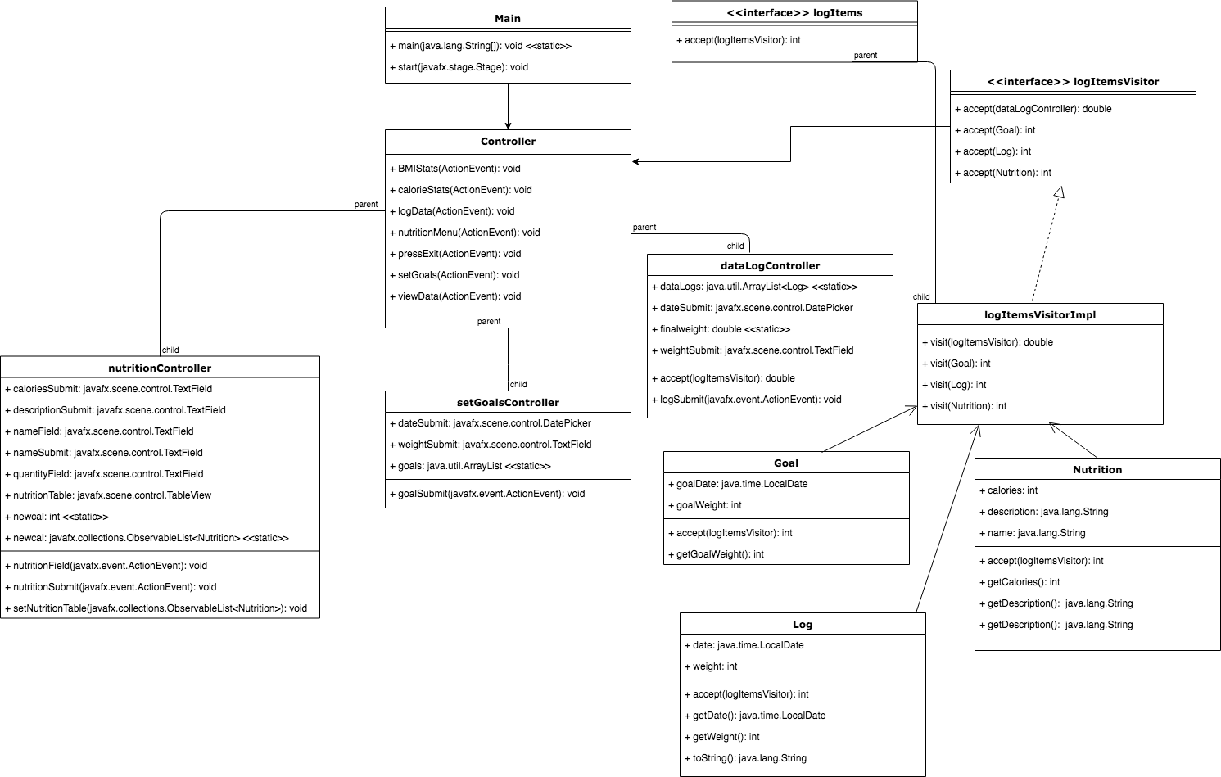

**Part 6:**

For my design pattern, I implemented visitor. As you can see I have a visitor interface, then an interface class that lists all of the functions of each class I “visit”. The reason I wanted to use visitor, was it provided me to be able to write methods for classes without writing in the classes themselves, therefore if I wanted to add analytical features with my controllers in the future, I wouldn’t have to change the base classes, only add methods to my visitor class to produce more analytics. Here is the class diagram for visitor:

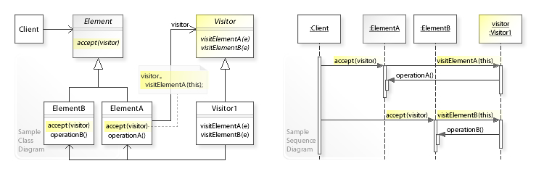

The classes that implement my design pattern are:

* logItemsVisitor
* logItemsImpl
* logItems
* Log
* Nutrition

The Log and Nutrition classes have accept() methods which allow the visitor to access instances of the class. For every analytical method I wrote out a visitor method to do the calculations.

Another design pattern I half-implemented was observer, as for my nutrition table, I needed a way to update the table every time a new instance of nutrition was added. I used an observable list and imported the java.observer class inorder to update the list.

**Part 7:**

Overall, the main thing I learned and wish I had done better is planning. I had very little comprehension of object oriented design. At the beginning of the project, I had no idea I would even need controllers in order to code a UI. I have learned a ton about design patterns, and java, a language I had never touched. I think the best way to tackle this project would be to pick a design pattern, and shape your project around it, as I was not thinking about this before, I had to re-format my project in order to implement one. Overall the project was super insightful and I learned a lot about Object Oriented Analysis and Design.