1. What is our independent variable? What is our dependent variable?

Independent variables are congruent words condition and incongruent condition.

Dependent variable is the time it takes to name the ink colors in equally-sized lists.

2. What is an appropriate set of hypotheses for this task? What kind of statistical test do you expect to perform? Justify your choices.

Null hypothesis: $H_{0}$: $μ_{incongruent} - μ_{congruent} = 0$

$μ_{incongruent}$: incongruent population mean, i.e. the average time it takes to name the ink colors in equally-sized lists in incongruent population.

: congruent population mean, i.e. the average time it takes to name the ink colors in equally-sized lists in congruent population.

The incongruent words condition will not increase the time people spend to name the ink colors in equally-sized lists compared to congruent words condition.

Alternative hypothesis: $H_{Α}$: $μ_{incongruent} - μ_{congruent} > 0$

$μ_{incongruent}$: incongruent population mean, i.e. the average time it takes to name the ink colors in equally-sized lists in incongruent population.

: congruent population mean, i.e. the average time it takes to name the ink colors in equally-sized lists in congruent population.

The incongruent words condition will increase the time people spend to name the ink colors in equally-sized lists compared to congruent words condition.

I will perform a one-tailed test in the positive direction. It is a dependent test. Test assumptions are as follows:

* Random sampling from a defined population
* Performances are normally distributed in the population

The incongruent words condition is more likely to confuse people, thus cause incongruent population to spend more time on average to fulfill the task.

3. Report some descriptive statistics regarding this dataset. Include at least one measure of central tendency and at least one measure of variability.

$\overline{y}=22.02$ $\overline{x}=14.05$

$S_{y} = 4.80$ $S_{x} = 3.56$

$\overline{y}$: incongruent sample mean

$\overline{x}$: congruent sample mean

$S_{y}$: standard deviation of incongruent sample

$S_{x}$: standard deviation of congruent sample

4. Provide one or two visualizations that show the distribution of the sample data. Write one or two sentences noting what you observe about the plot or plots.

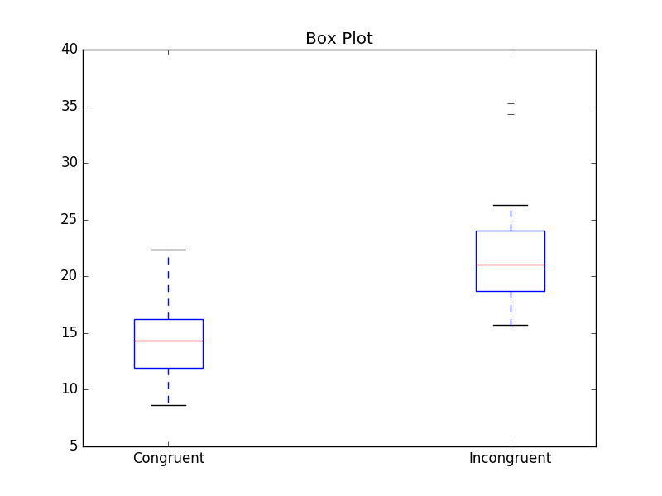

As we can see in the box plot, the median of incongruent group is much higher than that of congruent group.

5. Now, perform the statistical test and report your results. What is your confidence level and your critical statistic value? Do you reject the null hypothesis or fail to reject it? Come to a conclusion in terms of the experiment task. Did the results match up with your expectations?

1. Calculate the difference between the two observations on each pair, $d_{i}=y_{i}-x_{i}$

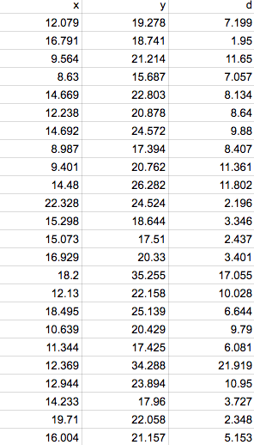

1. Calculate the mean difference, $\overline{d}=7.96$
2. Calculate the standard deviation of the differences, $s_{d}=4.86$, and use this to calculate the standard error of the mean difference, $SE\left(\overline{d}\right)=\frac{s_{d}}{\sqrt{n}}=0.99$
3. Calculate the t-statistic, $T=\frac{\overline{d}}{SE\left(\overline{d}\right)}=8.04$, t-critical value ($α=0.05)=1.714$
4. p-value = 0.0001, p-value < $α$, so we reject the null hypothesis.
5. Conclusion: by the criteria, this difference is considered to be extremely statistically significant. Compared to congruent words condition, incongruent words condition will increase the time people spend to name the ink colors in equally-sized lists. The results match up with my expectations.

6. Optional: What do you think is responsible for the effects observed? Can you think of an alternative or similar task that would result in a similar effect? Some research about the problem will be helpful for thinking about these two questions!

I think the incongruent words condition is responsible for the effects observed. When they encounter an incongruent word, they tend to speak out the word itself, however they will immediately find the word does not present the color of the ink correctly. Only after this process will they focus on the color of the ink (it costs some time), and then speak it out.

We can take a similar task: the participant’s task is to write down the color of the ink in which the word is printed. And other process is the same as the previous task.