Ho va ten: Nguyen Quoc Bao
MSSV: 22001745

- Factory Method
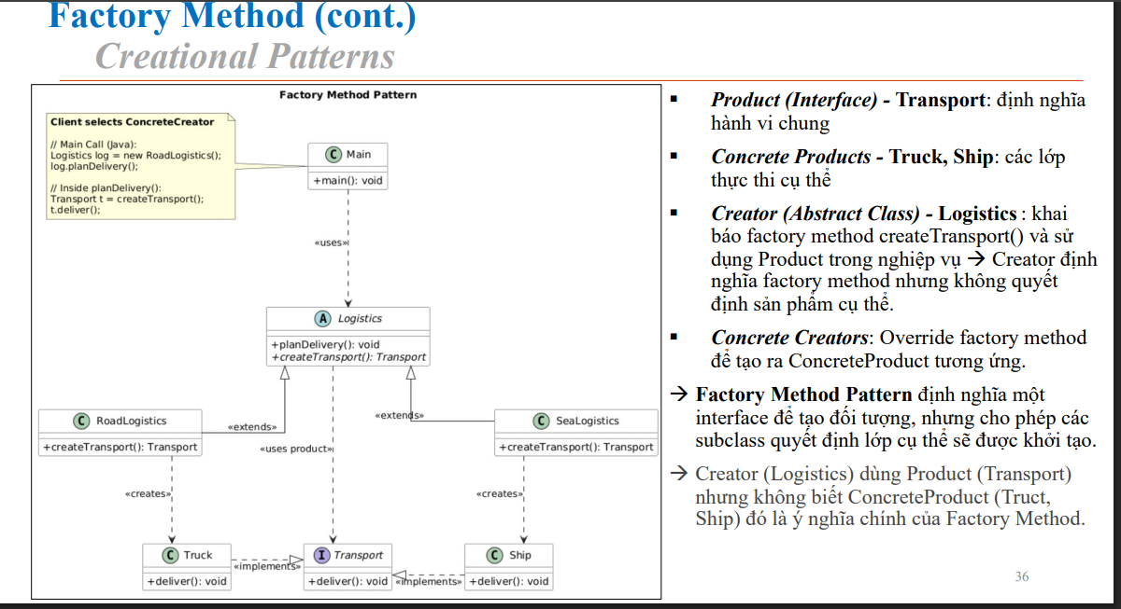
- Cau truc thu muc
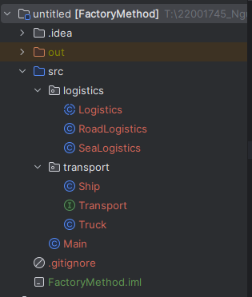
- Ket qua chuong trinh
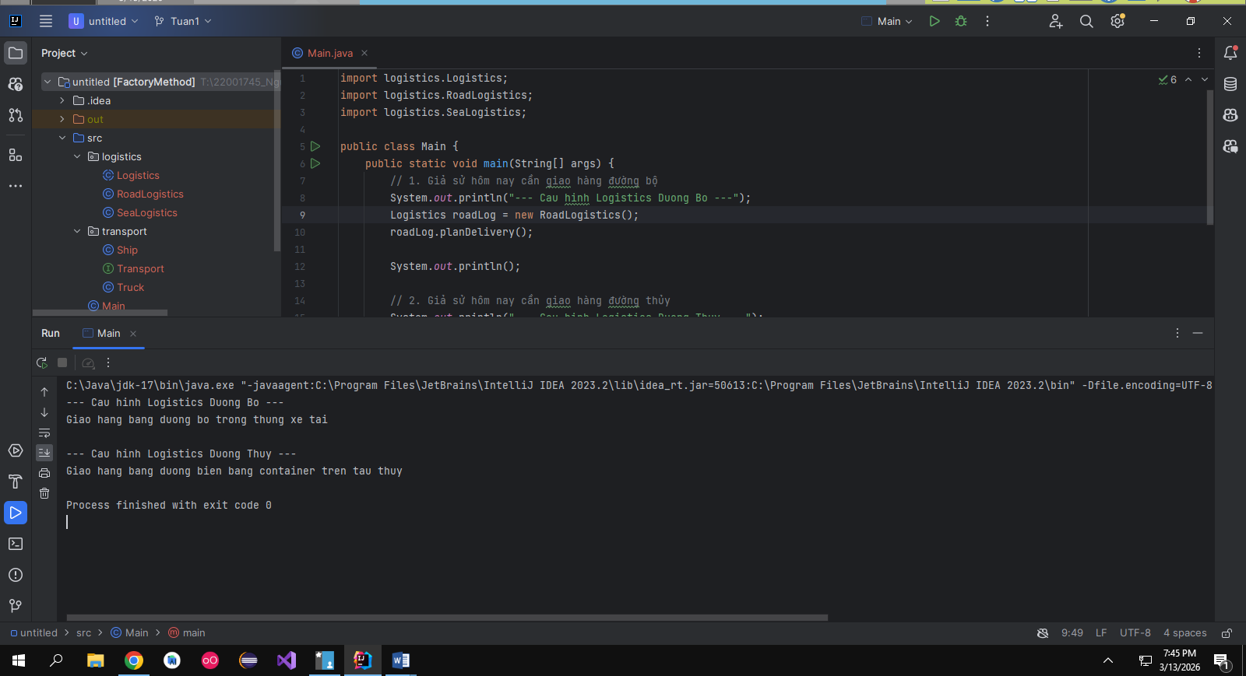

- AbstractFactoryPattern
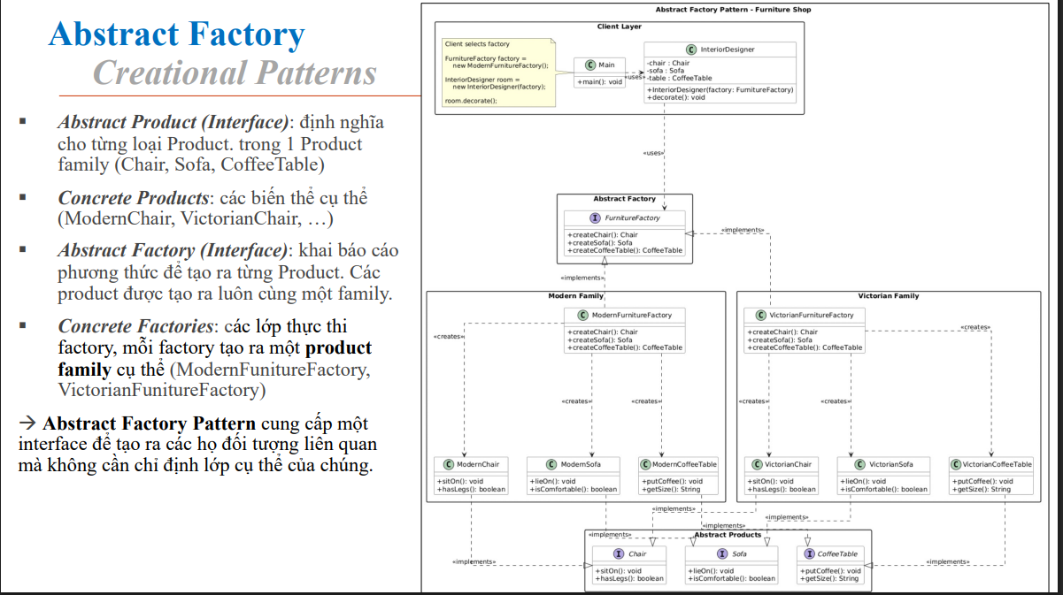

- Cau truc chuong trinh
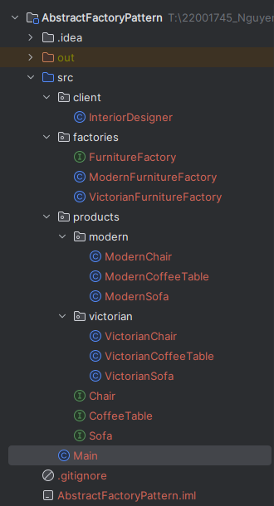
- Ket qua chuong trinh
