INFS3200 Advanced Database Systems

**Prac 2: Distributed Databases (5%)**

*Semester 1, 2023*

**Student’s name: Nguyen Van Quoc Chuong**

**ID: 47787810**

***Task 1:***

Mapping:

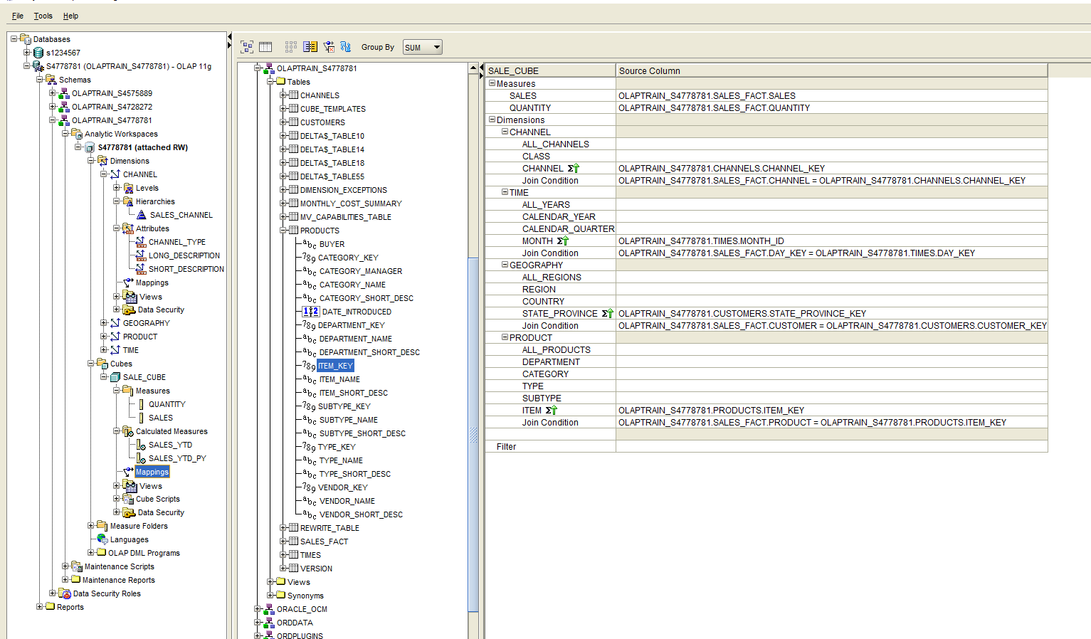

Sale_YTD calculated measure:

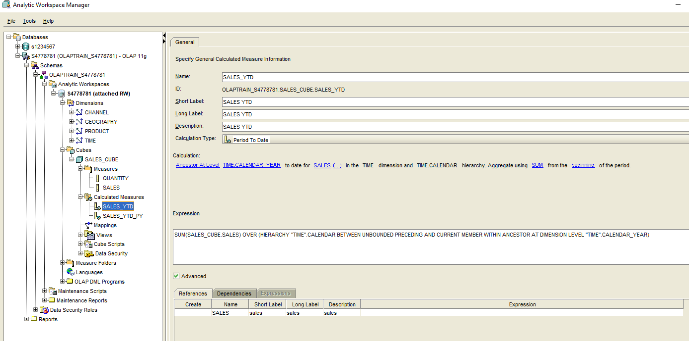

SALES_YTD_PY calculated measure: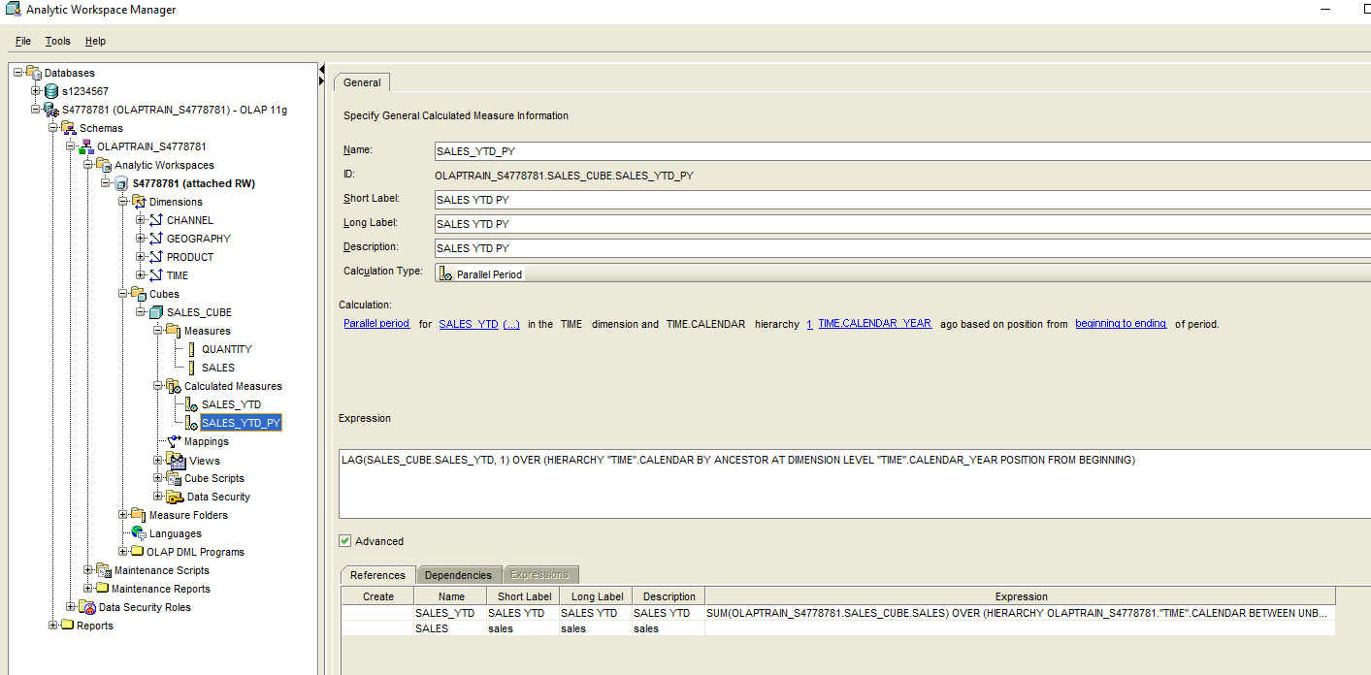

***Task 2:***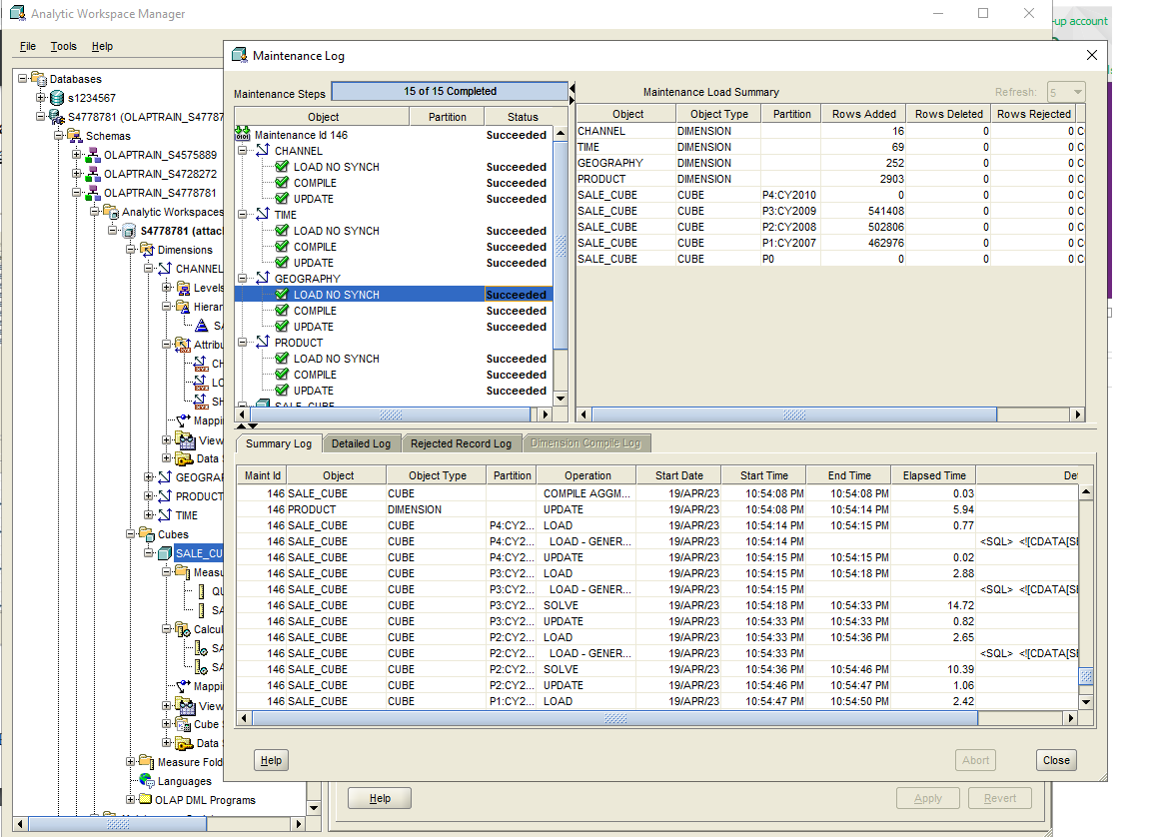

***Task 3:***

**1/**

a/ Roll-up: I do the roll-up operation to change view from Type to Category dimension in Product and from State_Province to Country in the Geography dimension.

Before: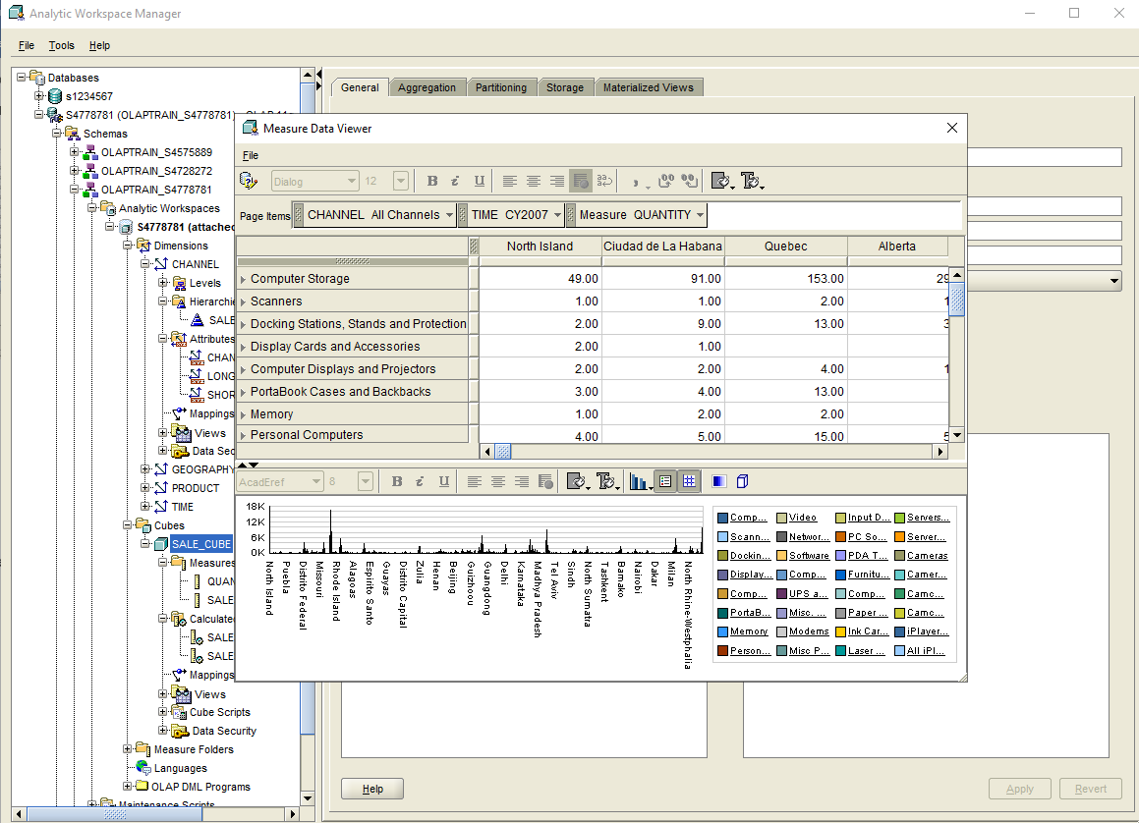

After:

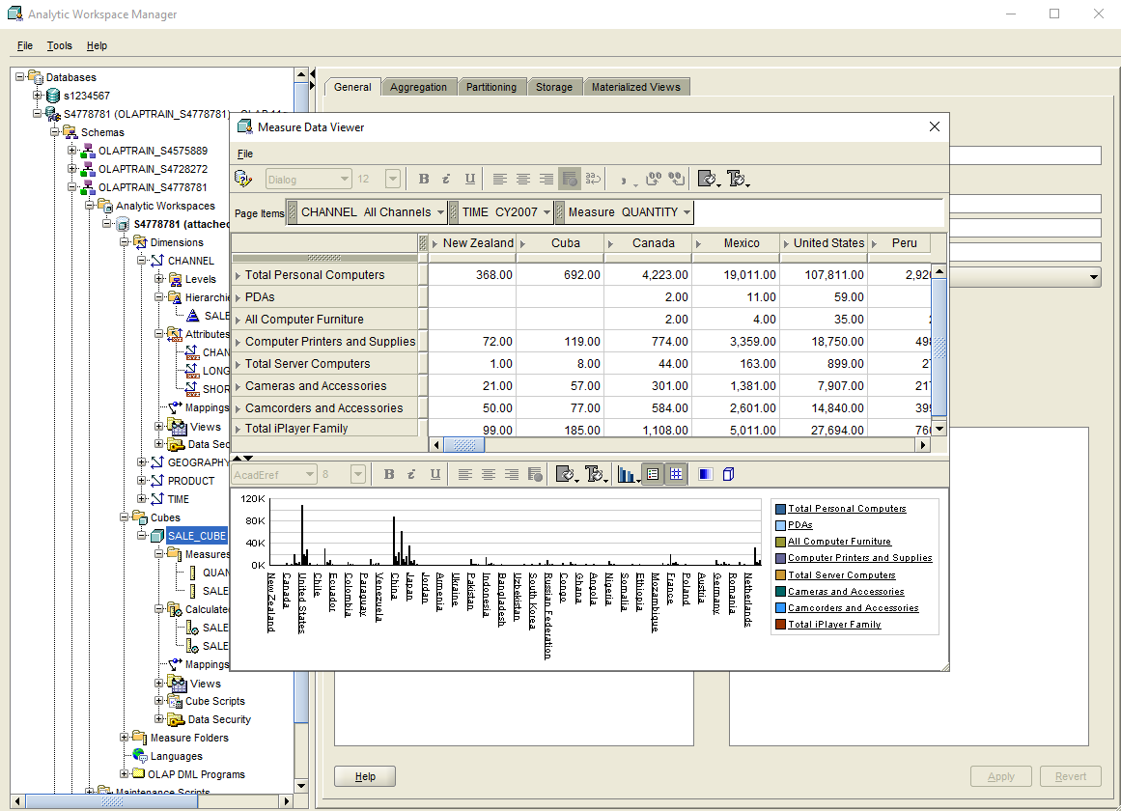

b/ Drill-down: I do the drill-down process to change the view from Annual to Monthly in dimension Time.

Before (Annual):

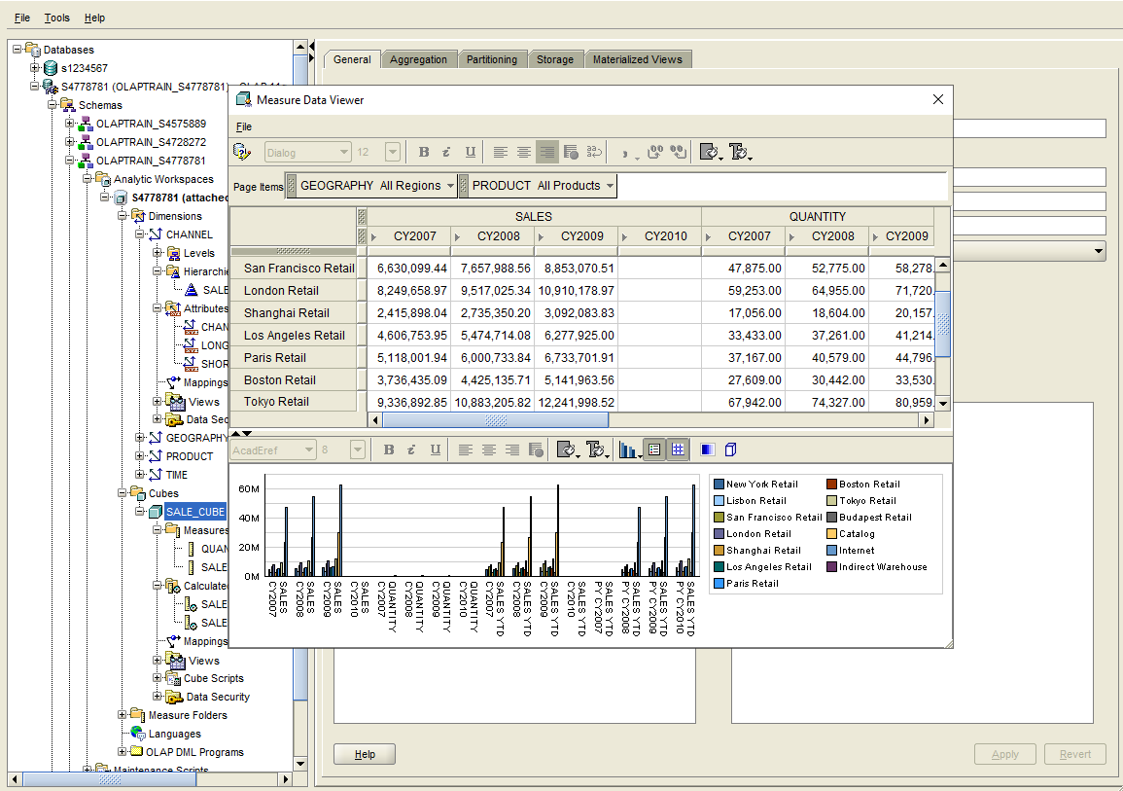

After (Monthly):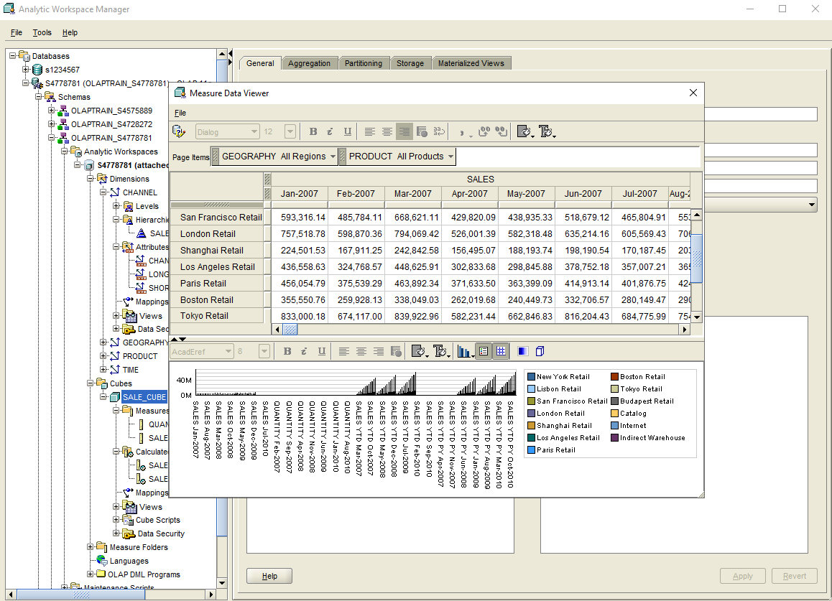

a/ Pivot: I do the pivot operation to swap the Product and Geography positions (swap columns and rows). The position of the Time dimension will not change.

Before:

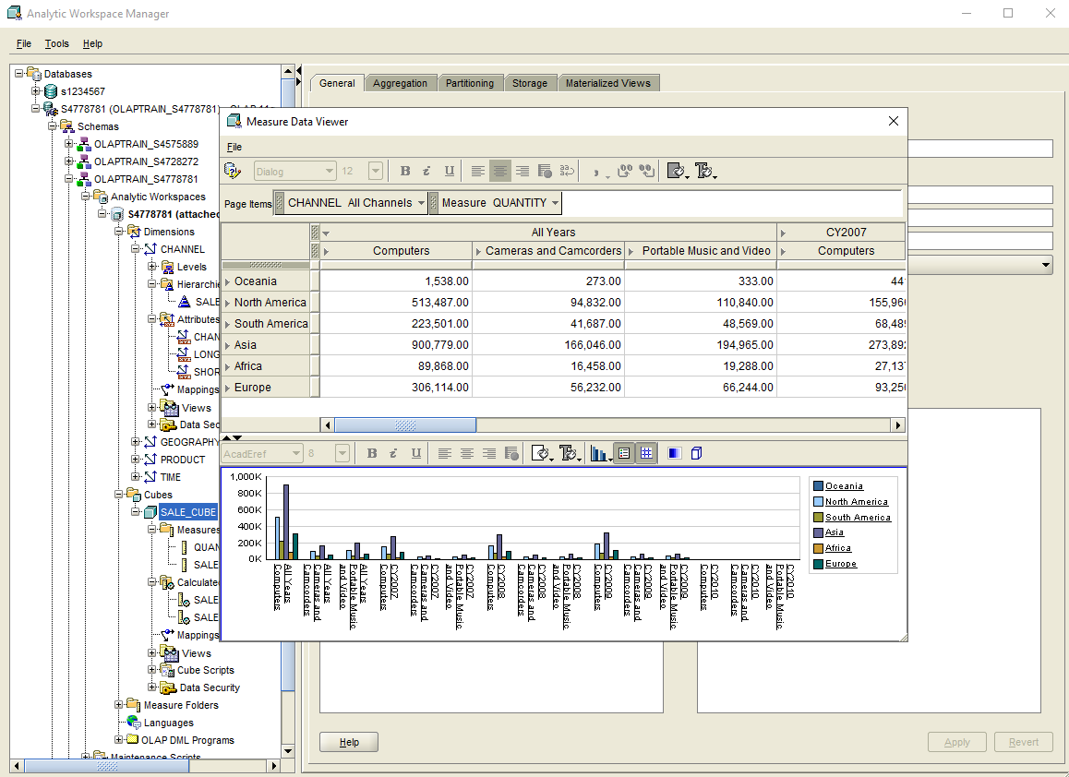

After:

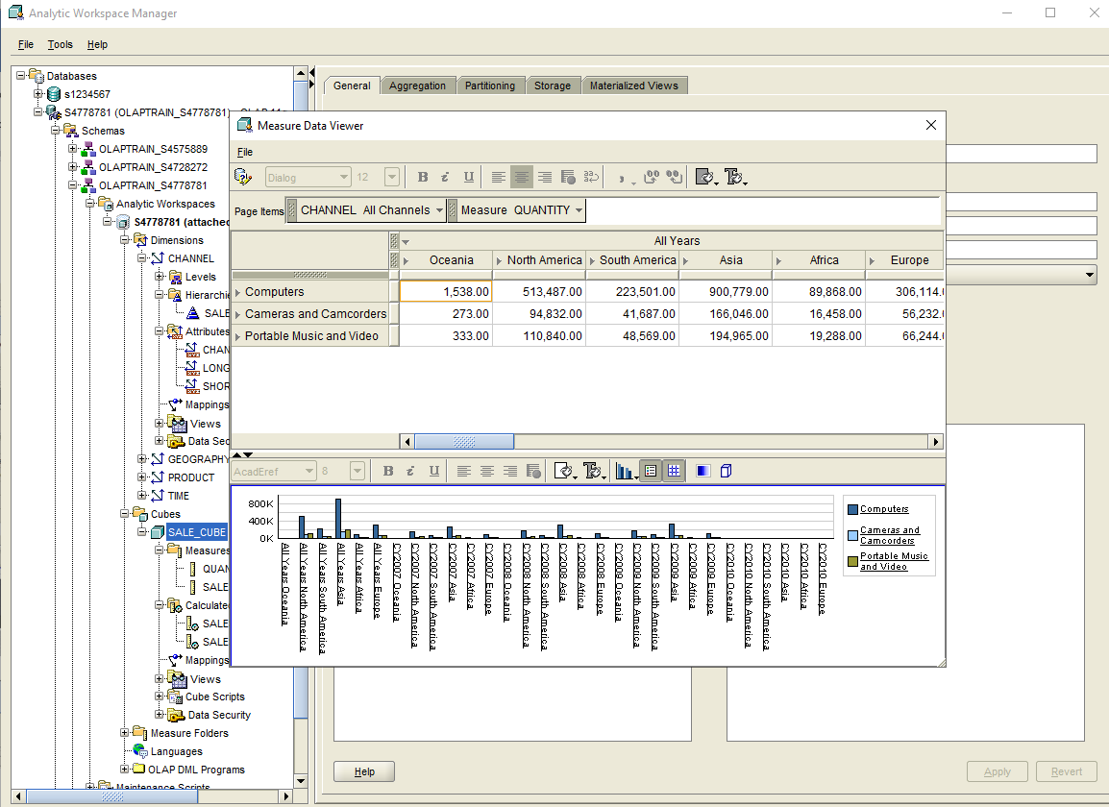

**2/** Adjust your Data Viewer window until it is identical (the value can be different) to the following two views (Hint: your viewer windows must be identical to get full mark and you may need help from the Query Builder, shown below). Take a screenshot for each view you made and put them in your document.

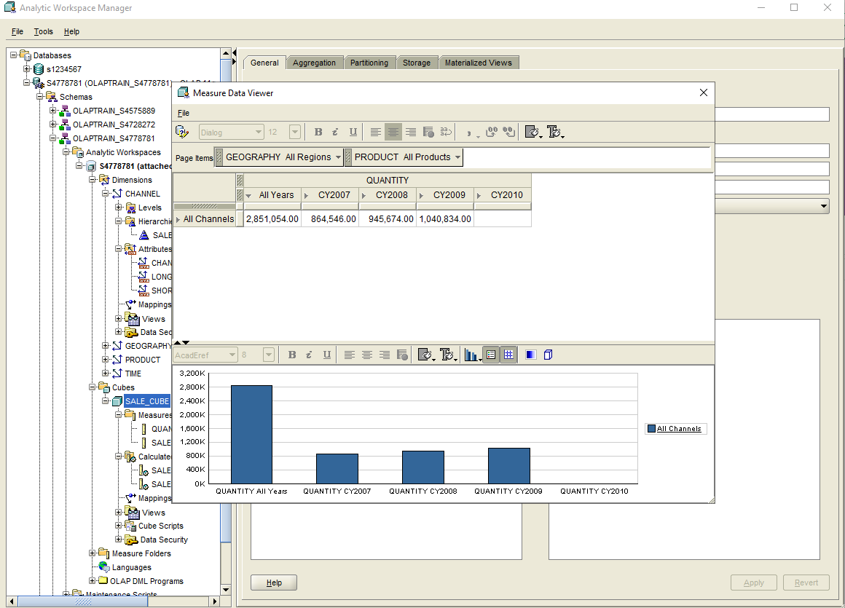

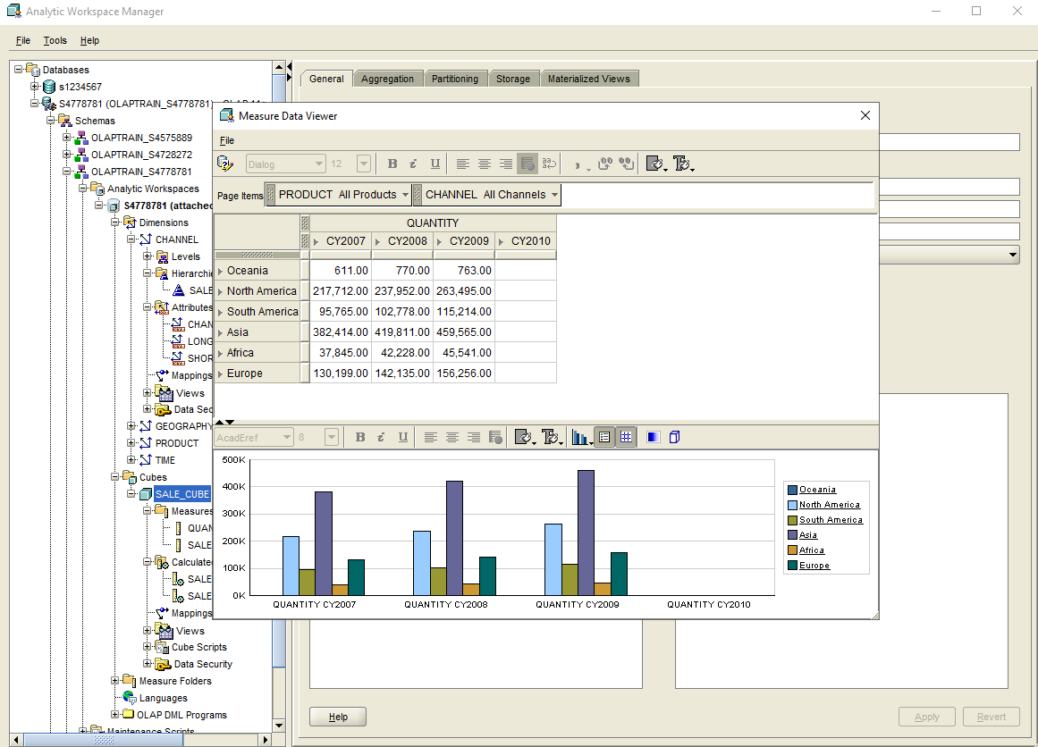

***Task 4:***

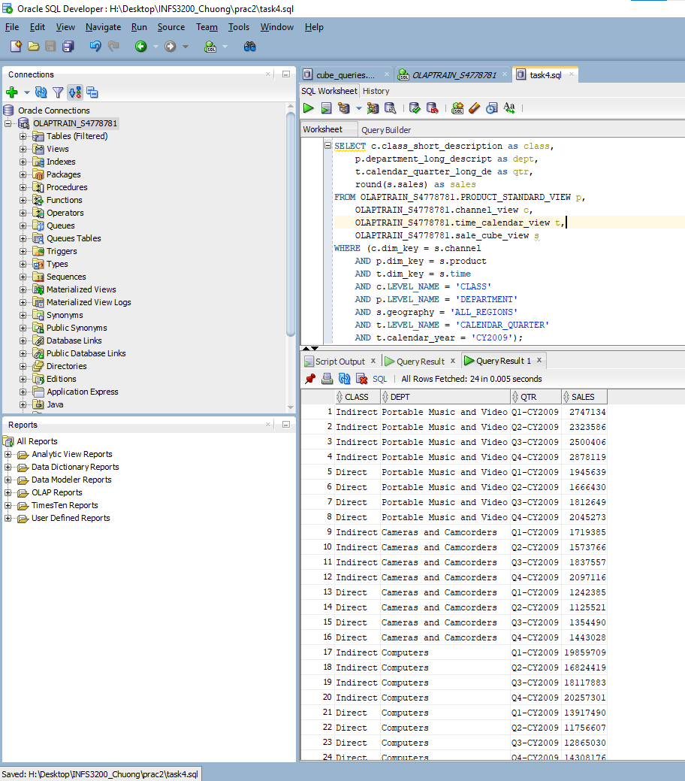

Query:

SELECT c.class_short_description as class,

p.department_long_descript as dept,

t.calendar_quarter_long_de as qtr,

round(s.sales) as sales

FROM OLAPTRAIN_S4778781.PRODUCT_STANDARD_VIEW p,

OLAPTRAIN_S4778781.channel_view c,

OLAPTRAIN_S4778781.time_calendar_view t,

OLAPTRAIN_S4778781.sale_cube_view s

WHERE (c.dim_key = s.channel

AND p.dim_key = s.product

AND t.dim_key = s.time

AND c.LEVEL_NAME = 'CLASS'

AND p.LEVEL_NAME = 'DEPARTMENT'

AND s.geography = 'ALL_REGIONS'

AND t.LEVEL_NAME = 'CALENDAR_QUARTER'

AND t.calendar_year = 'CY2009');