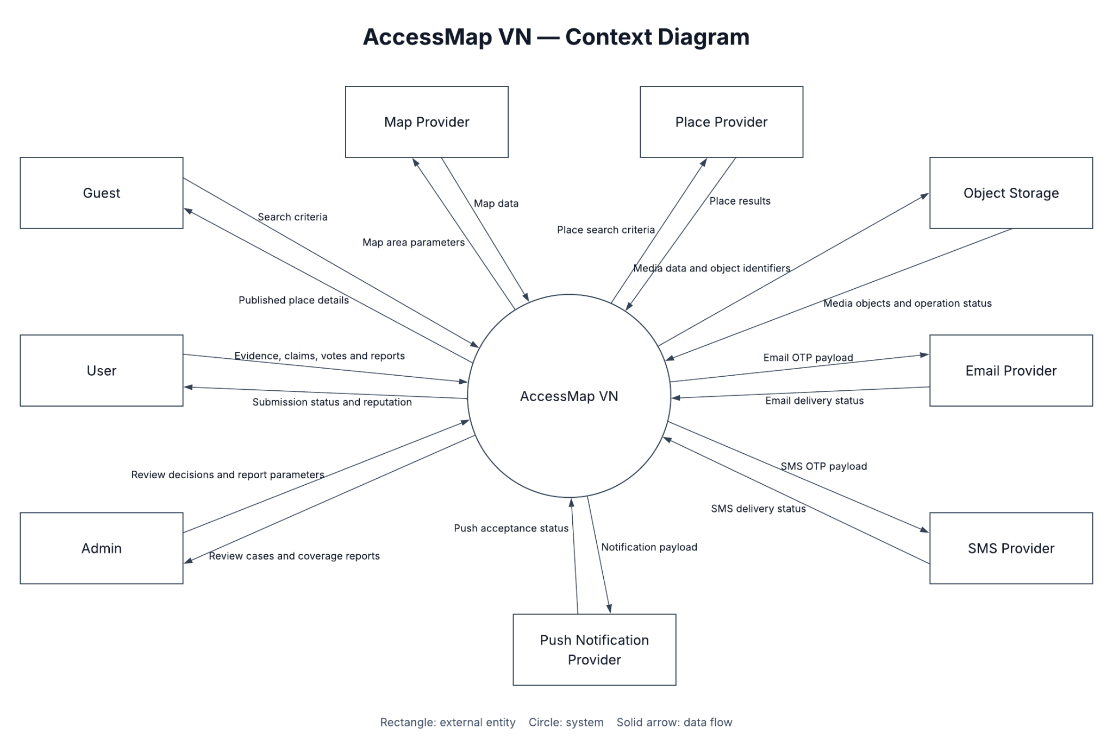
Figure 1.1 – System context diagram of AccessMap VN
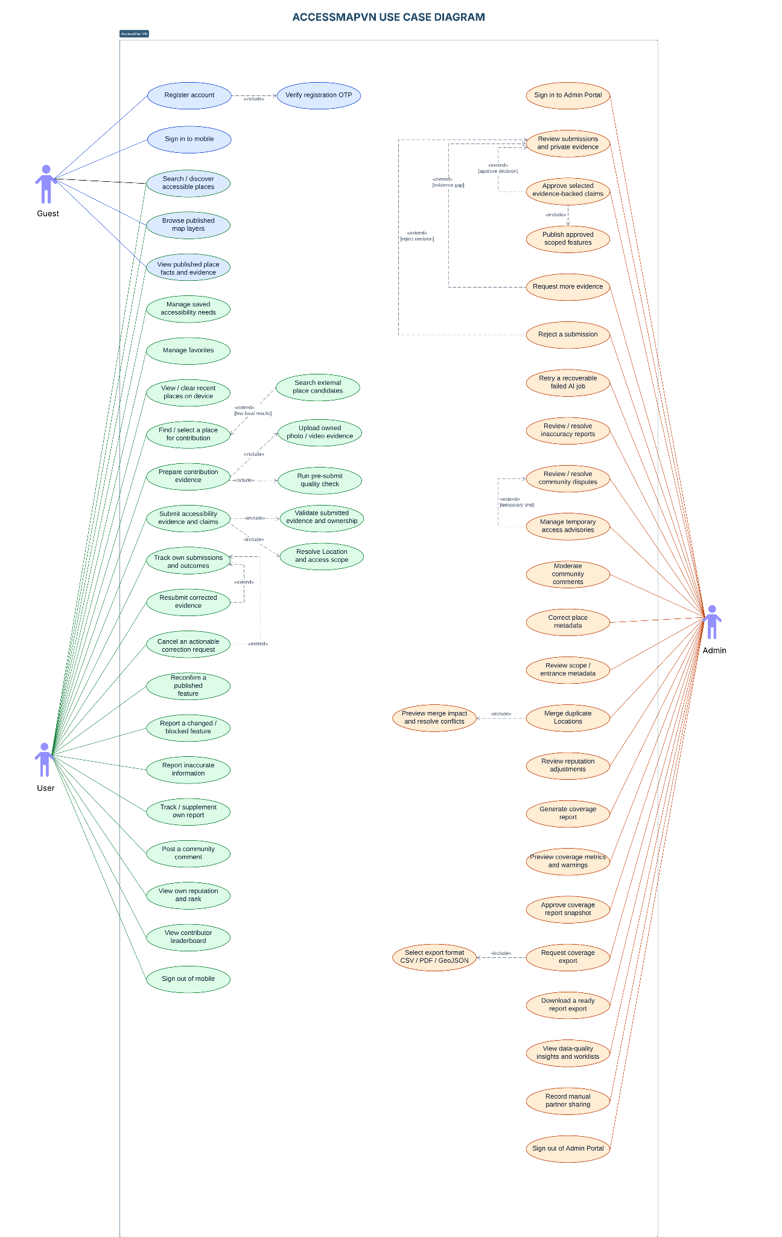
Figure 2.1 – Use case diagram of AccessMap VN
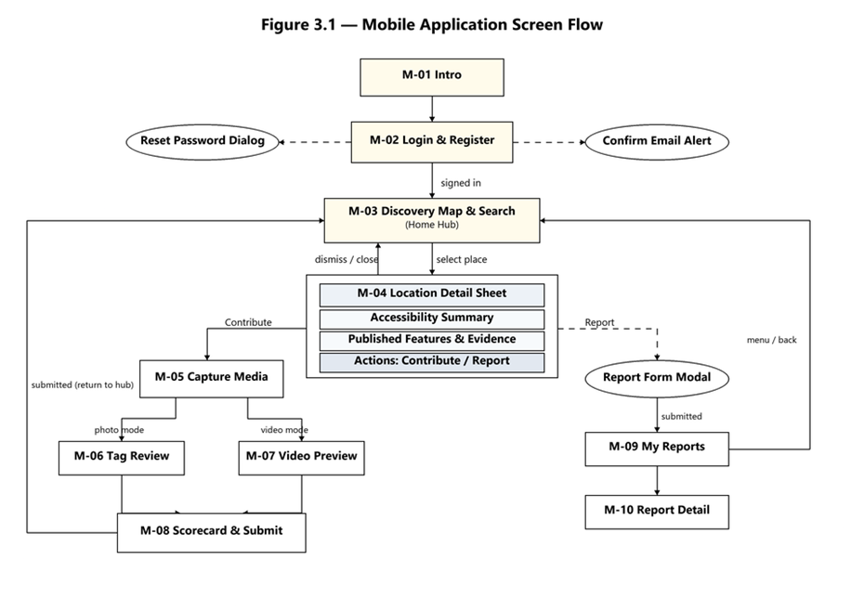
Figure 3.1 – Mobile app screen flow
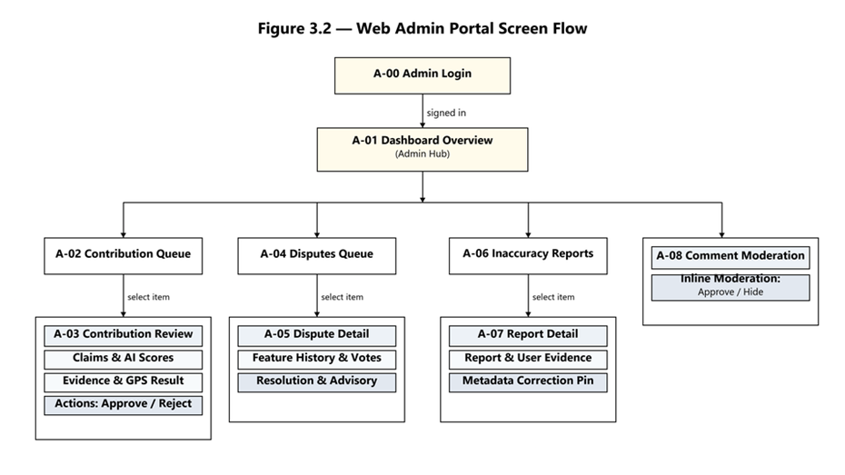
Figure 3.2 – Web Admin Portal screen flow

Figure 3.3 – System Main Entity Relationship Diagram
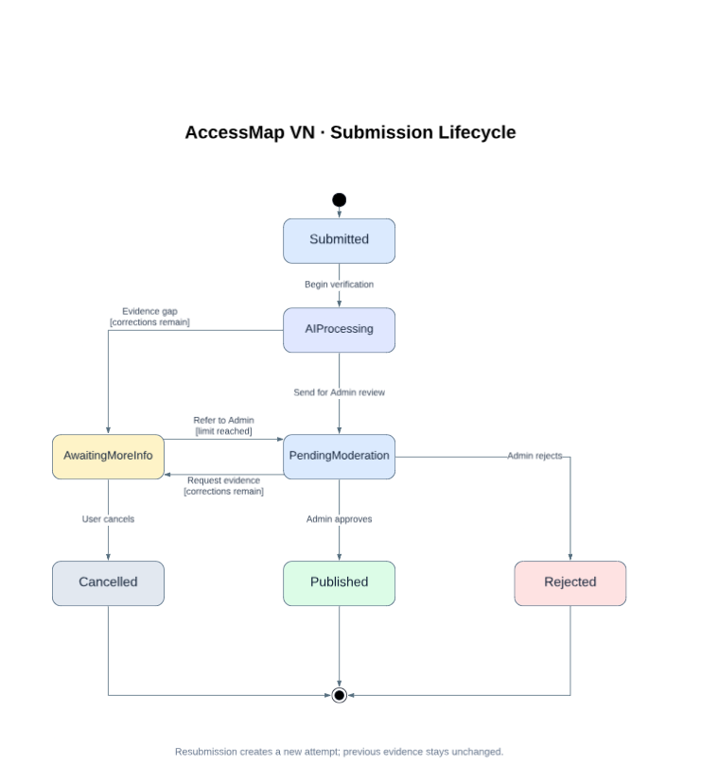
Figure 5.1 – Submission lifecycle
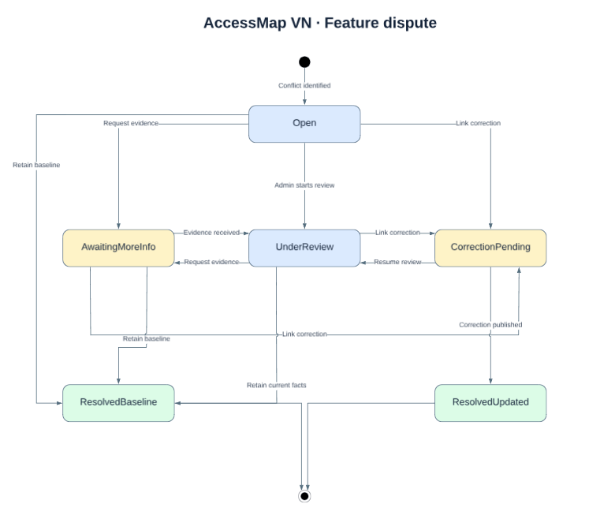
Figure 5.2 – Dispute case lifecycle
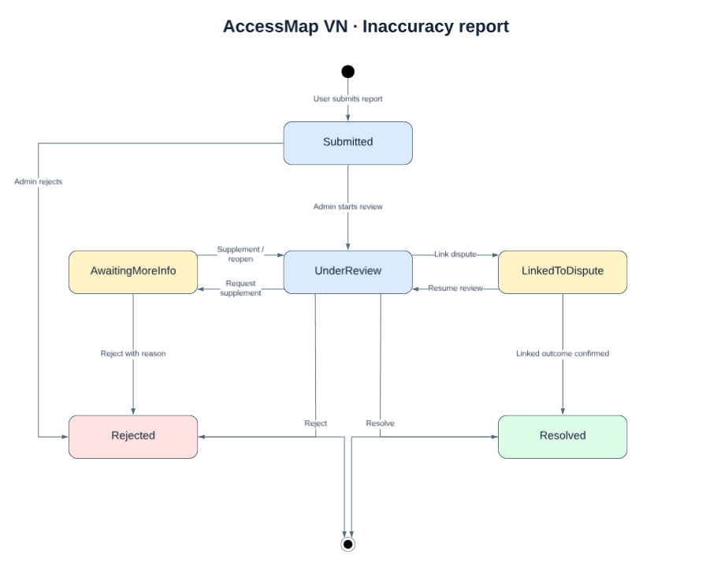
Figure 5.3 – Inaccuracy report lifecycle
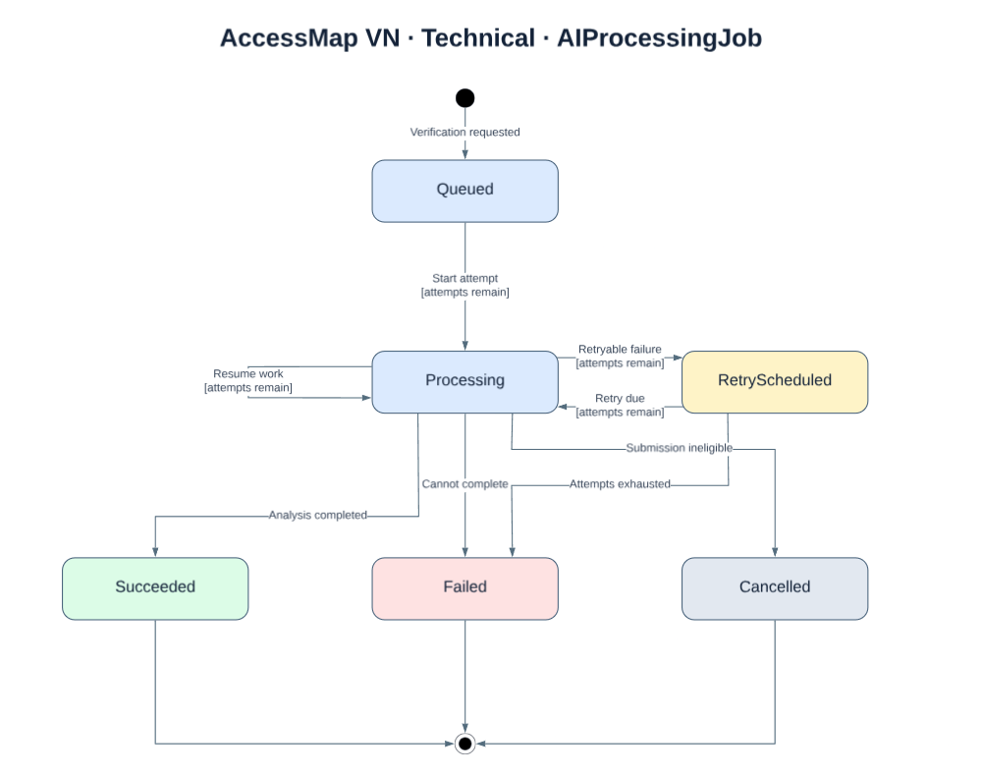
Figure 5.4 – AI processing job lifecycle
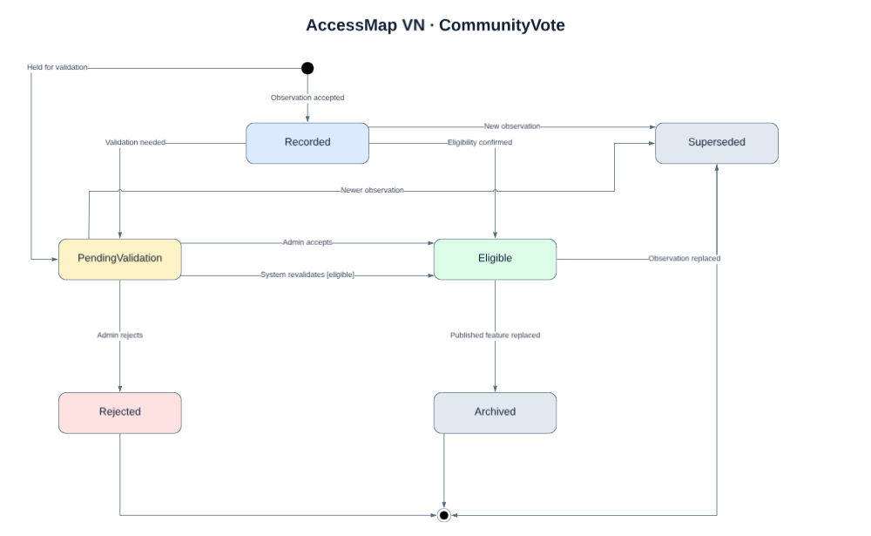
Figure 5.5 – Community vote lifecycle
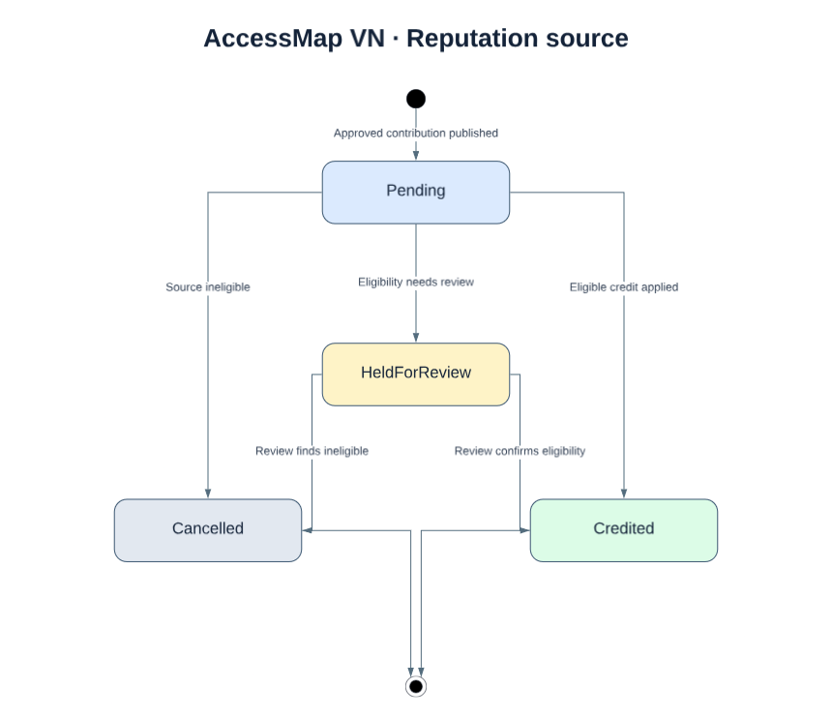
Figure 5.6 – Reputation source event lifecycle
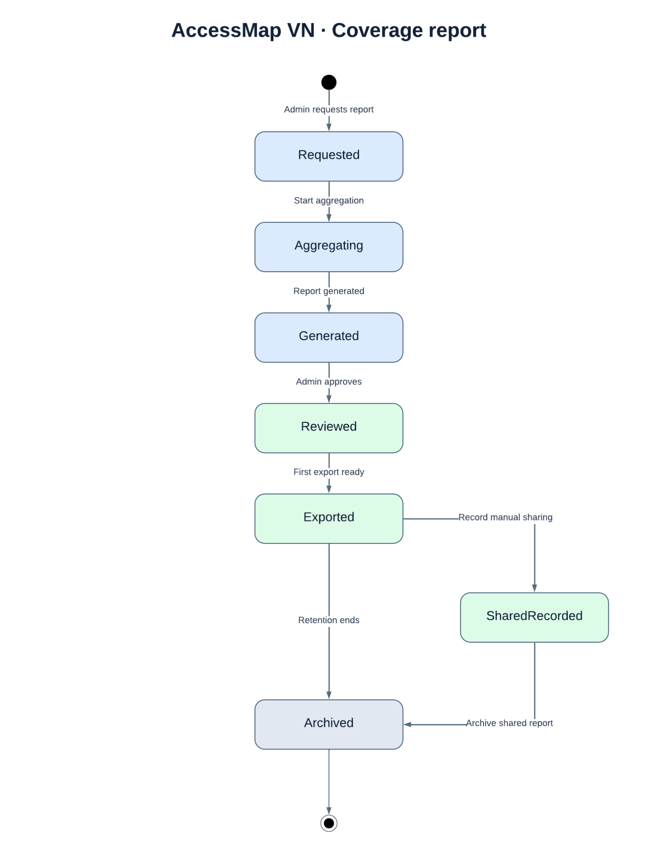
Figure 5.7 – Coverage report lifecycle
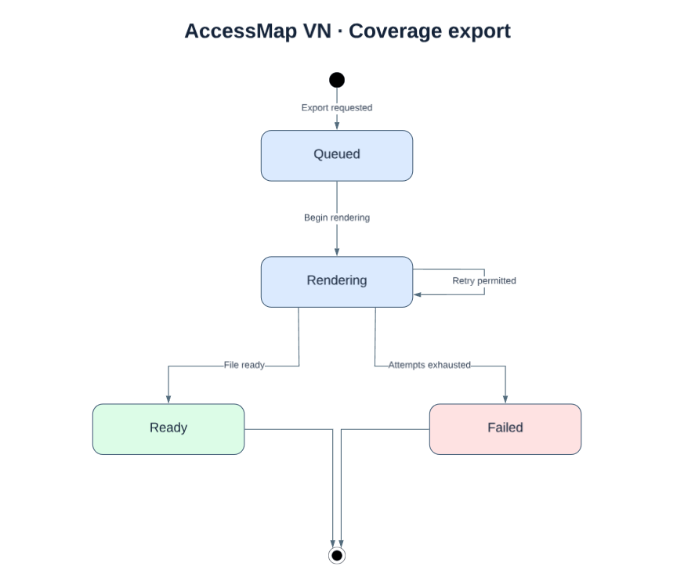
Figure 5.8 – Coverage export lifecycle


