

CAPSTONE PROJECT REPORT
Report 3 – Software Requirement Specification

– Ho Chi Minh City, October 2026 –
Table of Contents
I. Record of Changes 2
II. Software Requirement Specification 3
1. Product Overview 3
1.1 Introduction 3
1.2 Context Diagram 3
1.3 Major Features 4
1.4 Operating Environment, Constraints and Assumptions 4
2. User Requirements 5
2.1 Actors 5
2.2 Use Cases 6
3. Functional Requirements 9
3.1 System Functional Overview 9
3.2 Feature 1 – Account and Access 15
3.3 Feature 2 – Place Search and Discovery 17
3.4 Feature 3 – Contribute Accessibility Information 19
3.5 Feature 4 – Community Validation 23
3.6 Feature 5 – Reputation and Points 26
3.7 Feature 6 – Coverage Analytics and Export [Planned / Phase 2] 27
4. Non-Functional Requirements 28
4.1 External Interfaces 28
4.2 Quality Attributes 29
5. Requirement Appendix 30
5.1 Business Rules 30
5.2 Common Requirements 32
5.3 Application Messages List 32
5.4 Other Requirements 34

I. Record of Changes
Date | A*  M, D | In charge | Change Description
17/10/26 | A | Team | Initial version of the Software Requirement Specification (Report 3)
*A - Added M - Modified D - Deleted

II. Software Requirement Specification

1. Product Overview

1.1 Introduction
AccessMap VN is a community platform for assessing the accessibility of public places in Vietnam for people with mobility limitations, such as wheelchair users, people who walk with difficulty and older adults. In Vietnam most public buildings, restaurants and shopping malls lack ramps, wide doors or reliable elevators, and there is no centralized, trustworthy source of this information. People with mobility limitations usually find out by trial, or depend on family members to accompany them. Generic map applications do not systematically capture this data. The product focuses on mobility accessibility only.
AccessMap VN lets the community contribute photos, short videos and structured observations about the accessibility features of a place, verifies them with an AI engine combined with a rule-based verification matrix and administrator moderation, keeps the published data fresh through community votes, reports and disputes, and presents the result as a searchable, trustworthy accessibility map. The product consists of three parts:
- Mobile application (Expo SDK 57 / React Native with Expo Router) for people who look for accessible places and for contributors.
- Web Admin Portal (ReactJS) for moderating contributions, reports, disputes and comments.
- Backend and AI services: an ASP.NET Core REST API with Hangfire background jobs, a Python FastAPI AI service (YOLOv8 and OpenCV for images and video, a PhoBERT NLP classifier for Vietnamese descriptions), Supabase Auth, PostgreSQL with PostGIS.
A contribution is evidence, not automatically public truth. Only a controlled publication operation, after AI verification and either an automatic rule check or an administrator decision, updates the published accessibility record of a place.

1.2 Context Diagram
The context diagram shows the system boundary and the data flows between AccessMap VN and the people and external services around it. The boundary contains the mobile and web clients, the backend API, the owned AI service, background workers and the database.
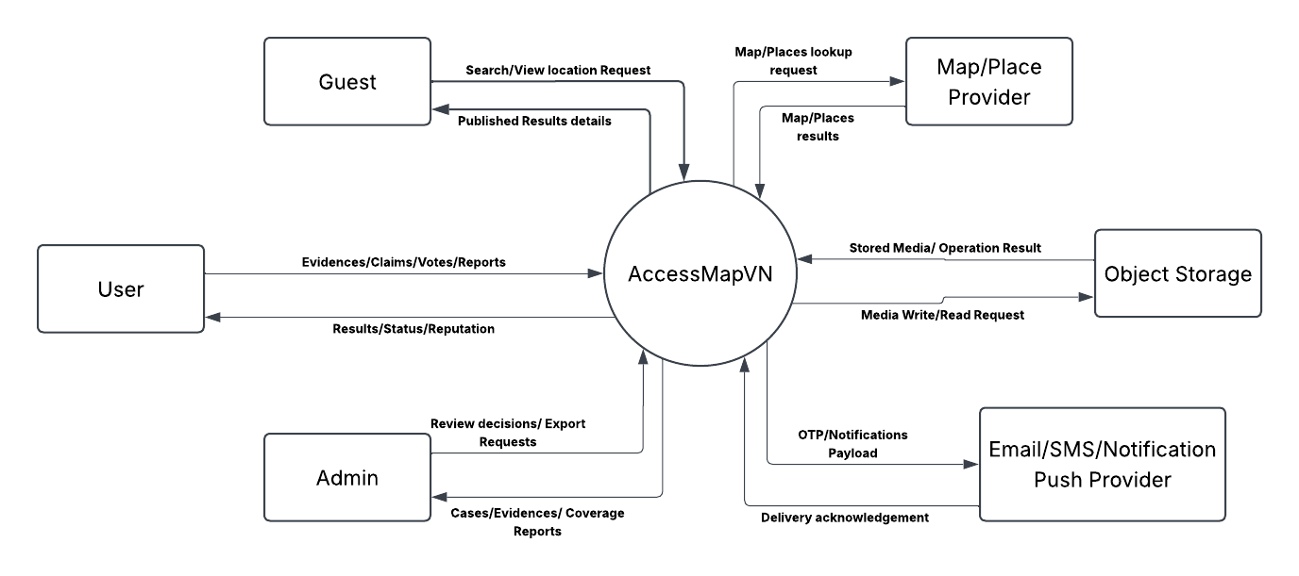
Figure 1.1 – System context diagram of AccessMap VN

1.3 Major Features
The requirements are grouped into six features. Section 2.2.2 states the delivery status of every use case; features and functions marked [Planned / Phase 2] are specified for completeness and are not committed for the current capstone delivery.
Table 1 – Major features of AccessMap VN
# | Feature | Summary | Source workflow
F1 | Account and Access | Registration and login with email and password through Supabase Auth, role-based access (User, Admin). | Shared
F2 | Place Search and Discovery | Search places by name or address, explore the map by area, view published accessibility features, evidence and warnings. Saved needs and favorites are [Planned / Phase 2]. | WF-03
F3 | Contribute Accessibility Information | Capture photos and a short video, pre-scan, review QCVN tags and measurements, submit; AI verification, confidence routing, publication and Admin review. | WF-01
F4 | Community Validation | Confirm or challenge published features, report inaccuracies, public comments, freshness, disputes and temporary advisories, with Admin handling. | WF-02
F5 | Reputation and Points | Points and reputation for published contributions. Push notifications, vouchers and account reviews are [Planned / Phase 2]. | WF-04
F6 | Coverage Analytics and Export | [Planned / Phase 2] Coverage reports and CSV/PDF/GeoJSON export for the Admin. | Admin Portal

1.4 Operating Environment, Constraints and Assumptions
Table 2 – Operating environment, constraints and assumptions
Item | Description
Client platforms | Mobile app built with Expo SDK 57 (React Native, Expo Router, NativeWind) for Android and iOS; Admin Portal built with ReactJS for a desktop browser.
Server platform | ASP.NET Core REST API (/api/v1) with Hangfire background jobs; Python FastAPI AI service; PostgreSQL with PostGIS; Docker for containerised deployment.
External services | Supabase Auth (email and password, JWT); OpenStreetMap place data ingested into PostGIS through Overpass; MapLibre with OpenFreeMap vector tiles; Supabase Storage and S3-compatible storage (MinIO) for media.
Constraints | The product covers mobility accessibility only (wheelchair users, limited mobility, older adults); visual and hearing accessibility are out of scope. Place data supplies identity only, never the truth of an accessibility feature. Published truth is written only by the controlled publication transaction. Media are exposed through short-lived authorised links.
Assumptions | Threshold values (scores, the 50 m GPS proximity limit, media limits) are configuration defaults that must be calibrated with field data. Users have a camera and location permission when they contribute. The project is delivered by a team of 4 to 5 students over a 15-week capstone period.
Out of scope | Road accessibility, route contribution and navigation, building-wide accessibility scoring, claiming legal compliance from a photo, direct partner API, automatic sending of reports to authorities.

2. User Requirements

2.1 Actors
The system defines two authorization roles, User and Admin. A User may act as an accessibility seeker (searching and viewing the accessibility of places) or as a contributor (submitting photos, measurements and reports) without a separate account, so these personas of the project proposal are unified under the User actor. The AI service and the background workers are internal components of the system, not actors; they are described in section 3.1.4.
Table 3 – System actors
# | Actor | Description
1 | User | Explores places on the map, inspects accessibility information and evidence, submits photos and measurements, confirms or challenges published information, reports inaccuracies, comments and earns points. Signs in with a Supabase account (email and password).
2 | Admin | Reviews submitted contributions, verifies evidence, resolves community disputes, corrects place metadata and moderates comments in the Web Admin Portal. Inherits User capabilities.

The following external systems support the use cases.
Table 4 – External supporting systems
# | External system | Role
1 | Supabase Auth | Manages credentials and registration, password reset and issues JWT tokens that authenticate every request.
2 | OpenStreetMap (Overpass) | Supplies the point-of-interest data that seeds the place directory.
3 | OpenFreeMap tile provider | Delivers the vector map tiles rendered by the mobile app.
4 | Object storage | Stores contribution photos and videos and gives access through signed links.

2.2 Use Cases

2.2.1 Diagram(s)
The diagram shows the use cases of the two actors: User and Admin. Section 2.2.2 lists the use cases with their delivery status.
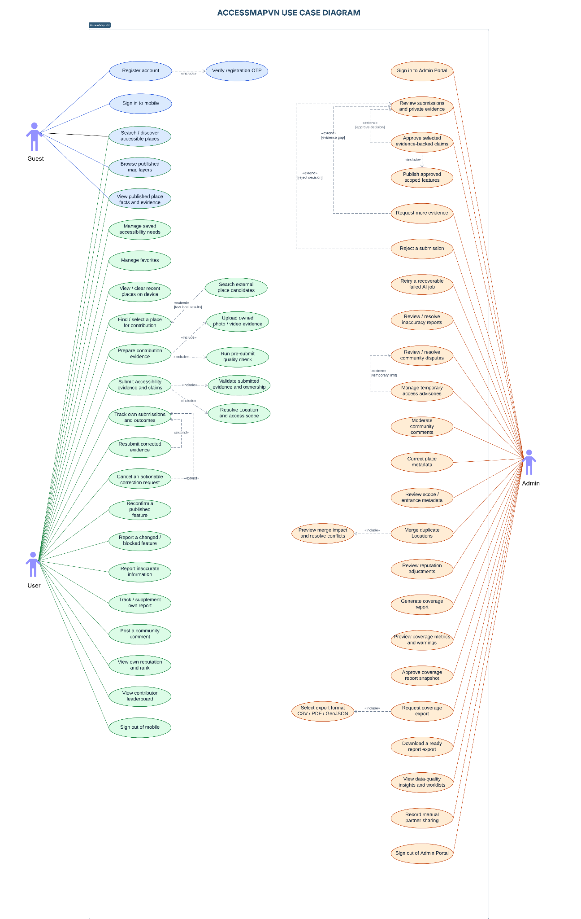
Figure 2.1 – Use case diagram of AccessMap VN

2.2.2 Descriptions
Table 5 – Use case descriptions and delivery status
ID | Use Case | Actors | Use Case Description | Status
UC-01 | Register account | User (new) | Create an account with an email address and password (minimum 6 characters) through Supabase Auth. When no session is returned the user must confirm the email and then sign in. | Implemented
UC-02 | Log in / log out | User, Admin | Sign in with email and password; the app uses the JWT bearer token for every API call. | Implemented
UC-03 | Search places by name or address | User | Find places by text query, optionally ranked by distance from a given point (GET /places/search). | Implemented
UC-04 | Explore the map | User | Browse places inside the visible map area, filtered by category (GET /places with bounds and zoom level). | Implemented
UC-05 | View place detail and accessibility summary | User | Open a place to see published features, an accessibility label for wheelchair users and approved photo evidence. | Implemented
UC-06 | Filter places by mobility needs | User | Narrow places by category and accessibility tags. Personalised filtering by saved needs is not available yet. | Partial
UC-07 | Manage saved mobility needs | User | Save mobility needs and default criteria. | Planned (Phase 2)
UC-08 | Manage favorite places | User | Save and list favorite places. | Planned (Phase 2)
UC-09 | Contribute accessibility evidence | User | Capture photos and a 5 to 10 second video at a place, review QCVN tags and measurements, see the verification scorecard and submit. | Implemented
UC-10 | Pre-scan media | User | Included in UC-09. Get advisory blur and quality feedback on photos before submission. | Implemented
UC-11 | Track submission status | User | Read the status and verification result of a submission (GET /submissions/{id}/status). A dedicated "my submissions" screen is not available yet. | Partial
UC-12 | Cancel or resubmit a submission | User | Cancel an actionable submission or resubmit corrected evidence as a linked attempt. Only idempotent re-send of the same submission exists today. | Planned (Phase 2)
UC-13 | Confirm or challenge a published feature | User | Record "still accurate" or "changed" for a published feature (API implemented; dedicated mobile screen not available yet). | Partial
UC-14 | Report an inaccuracy | User | File a report about incorrect, missing or outdated information, add evidence and follow its status in My Reports. | Implemented
UC-15 | Post a community comment | User | Post a public comment on a place; comments wait for Admin review (API implemented; mobile screen not available yet). | Partial
UC-16 | View reputation and points | User | Points (50 per published contribution) and reputation are recorded; no screen shows them yet. | Partial
UC-17 | Redeem a voucher | User | Exchange points for a partner voucher. | Planned (Phase 2)
UC-18 | Review contributions | Admin | Inspect claims, AI results, scores and evidence; approve (publish), reject, request more information or send a reminder. | Implemented
UC-19 | Review reports and metadata corrections | Admin | Handle inaccuracy reports, view evidence and correct a place's address, pin or entrance with an audited history. | Implemented
UC-20 | Handle disputes and advisories | Admin | Decide disputes opened by conflicting community votes and create time-bounded advisories (maximum 60 days). | Implemented
UC-21 | Moderate comments | Admin | Approve or hide public comments with an audited reason. | Implemented
UC-22 | Manage voucher offers and rewards | Admin | Maintain offers, terms and stock. | Planned (Phase 2)
UC-23 | Restrict or review accounts | Admin | Investigate fraud and restrict an account with an appeal path (only an active flag exists today). | Planned (Phase 2)
UC-24 | Generate coverage report | Admin | Aggregate accessibility data coverage by region and period. | Planned (Phase 2)
UC-25 | Export coverage report | Admin | Export an approved snapshot as CSV, PDF or GeoJSON. | Planned (Phase 2)
UC-26 | Verify a submission (system) | User (triggers) | Background job that calls the AI service, scores the submission and routes it. | Implemented

3. Functional Requirements

3.1 System Functional Overview

3.1.1 Screens Flow
Mobile application. The Discovery Map (M-03) is the hub: the user selects a place to open its Location Detail sheet (M-04), from which a contribution (M-05 to M-08) or an inaccuracy report (M-09, M-10) can be started. The four contribution steps are states of one screen route.
Rectangles are screens, ovals are pop-up dialogs, a box divided into sections is a screen that shows several groups of information, and the colour groups the screens by feature (yellow account, blue discovery, orange contribution, green community, purple admin).
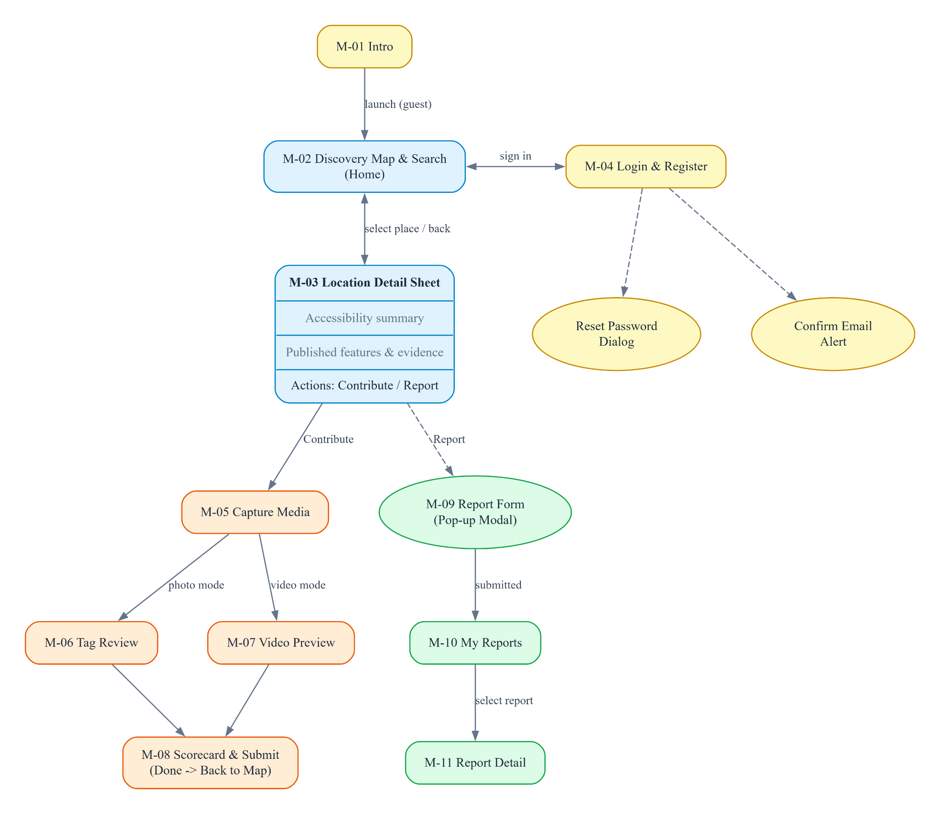
Figure 3.1 – Mobile app screen flow
Web Admin Portal. The dashboard links to the moderation work areas; each queue opens a detail page.
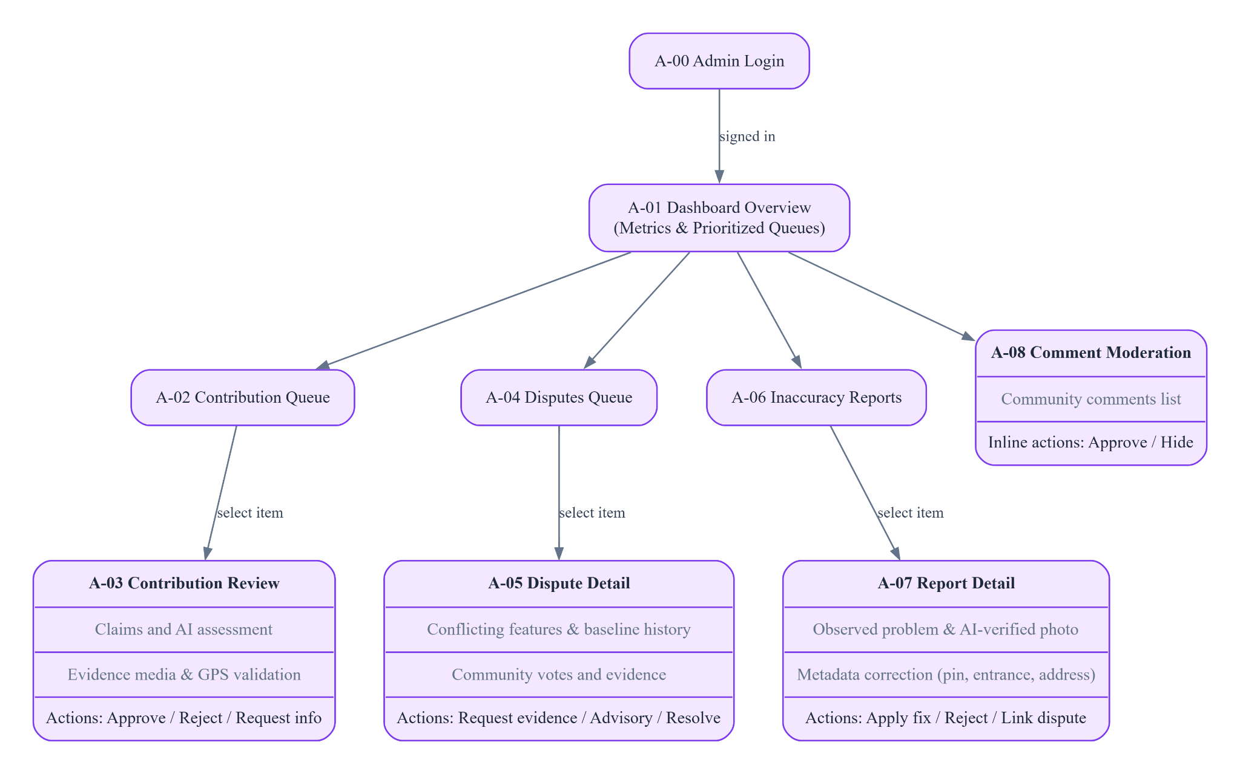
Figure 3.2 – Web Admin Portal screen flow

3.1.2 Screen Descriptions
Table 6 – Mobile application screens
ID | Feature | Screen | Route | Description
M-01 | Account | Intro | / | Onboarding presentation of the app with entry to login or to the map.
M-02 | Account | Login & Register | /login | Email and password sign-in and registration through Supabase Auth; password reset by email; shows the confirm-email message when no session is returned.
M-03 | Place Search and Discovery | Discovery Map & Search | /map | Map with place markers and clusters for the visible area, search bar by name or address, category chips and navigation to reports.
M-04 | Place Search and Discovery | Location Detail Sheet | /map (bottom sheet) | Place information, accessibility summary label for wheelchair users, published features and approved evidence photos; actions Contribute and Report.
M-05 | Contribute Accessibility Information | Capture Photos | /contribute/camera (step camera) | Camera capture of up to 3 photos, pre-scan feedback (blur, size), face blurring and GPS fix.
M-06 | Contribute Accessibility Information | Tag Review | /contribute/camera (step tag_review) | Review the QCVN 10:2014 tags per feature (present, absent, unknown, not applicable), optional description and measurements (door width, ramp slope).
M-07 | Contribute Accessibility Information | Video Preview | /contribute/camera (step video_preview) | Record and preview the 5 to 10 second video and accept or retake it.
M-08 | Contribute Accessibility Information | Scorecard & Submit | /contribute/camera (step scorecard) | Shows the verification matrix result (computer vision, text context, spatial proximity) and the expected routing, then submits.
M-09 | Community Validation | My Reports | /reports | List of the inaccuracy reports of the user with status.
M-10 | Community Validation | Report Detail | /reports/[id] | Report status, history timeline and attached evidence.

Table 7 – Web Admin Portal screens
ID | Feature | Screen | Route | Description
A-01 | Administration | Dashboard | /admin | Overview cards and charts. Currently populated with mock data.
A-02 | Contribution moderation | Contribution Queue | /admin/ho-so-dong-gop | List of submissions with filters and status; Admin review SLA target of 120 minutes.
A-03 | Contribution moderation | Contribution Review | /admin/ho-so-dong-gop/[id] | Claims, AI results, scores, evidence, GPS result and navigation between items; actions Approve, Reject, Request information and Remind.
A-04 | Community moderation | Disputes | /admin/tranh-chap-tiep-can | Queue of community disputes with status.
A-05 | Community moderation | Dispute Detail | /admin/tranh-chap-tiep-can/[id] | Feature history, votes and evidence; decision with reason, optionally creating a temporary advisory.
A-06 | Community moderation | Inaccuracy Reports | /admin/bao-cao-sai-lech | Queue of inaccuracy reports.
A-07 | Community moderation | Report Detail & Metadata Correction | /admin/bao-cao-sai-lech/[id] | Report, evidence (authorised access) and decision; correction of place address, pin or entrance.
A-08 | Community moderation | Comment Moderation | /admin/binh-luan-cong-dong | Review and approve or hide public comments.

Table 8 – Planned screens
Client | Planned screens (Phase 2)
Mobile | Vote on a feature, community comments, saved needs, favorite places, display settings (text size and contrast), reputation and points, notification list, submission list with cancel and resubmit, voucher catalog and redemption.
Web Admin | Reputation and users, voucher inventory, coverage reports and export, incident alerts, system settings (route placeholders exist and show "coming soon").

3.1.3 Screen Authorization
X = allowed. Admin pages require the Admin role (policy Wf02.Moderate).
Table 9 – Screen authorization matrix
Screen / group | User | Admin
M-01 Intro; M-02 Login & Register | X | X
M-03 Discovery Map & Search; M-04 Location Detail | X | X
M-05 to M-08 Contribution | X | X
M-09, M-10 Reports | X | X
A-01 to A-08 Web Admin Portal |  | X

3.1.4 Non-Screen Functions
The AI service (FastAPI) and the Hangfire background workers are internal components of the system, not actors. The functions they run are listed below.
Table 10 – Non-screen functions
# | Function | Runs in | Description
1 | Media upload | Mobile / API | Contribution media go directly from the app to the Supabase Storage bucket contributions-media; a fallback upload through the API (/media/upload, base64) is used offline or in development. Community evidence uses S3 pre-signed PUT links valid 15 minutes with SHA-256 validation.
2 | Pre-scan | AI service (sync) | POST /ai/pre-scan and /ai/pre-scan/video: blur (Laplacian variance), resolution and size checks and face blurring. Target response under 2 seconds. Advisory only.
3 | Geofence check | API | On submission, validates the capture location against the place: 50 m for an entrance, otherwise a category fallback (250 m hospital, university, mall, park and campus; 100 m museum, office and station; 50 m others). A violation returns HTTP 422.
4 | Idempotent submission | API | A submission with the same ClientSubmissionId and identical payload returns the existing record; a different payload is rejected as a conflict.
5 | Verification job | Hangfire (queue default, 2 retries) | SubmissionVerificationJob calls POST /ai/verify (YOLOv8, OpenCV, PhoBERT), stores the result and routes the submission. If the AI service fails the job ends and the submission stays PendingModeration.
6 | Scoring | AI service / mobile | AI service fuses 60% computer vision and 40% NLP per feature. The mobile scorecard shows a three-pillar estimate (50% vision, 20% text context, 30% spatial proximity) with penalties. See business rules BR-09 to BR-11.
7 | Publication transaction | API (serializable) | One transaction writes location_features, location_feature_history, the place summary flags, community state reset, claim status, a 50-point transaction, the submission status and an outbox message.
8 | Community evaluation | Hangfire (queue wf02-community) | Wf02EvaluationJob recomputes the community assessment of a feature from reputation-weighted, recency-weighted votes.
9 | Freshness scan | Hangfire recurring, daily 02:00 UTC | Marks features without confirmation for 90 days as NeedsRecheck.
10 | Reconciliation | Hangfire recurring, every minute | Re-queues stalled or queued assessment jobs.
11 | Advisory maintenance | Hangfire recurring, every minute | Activates scheduled advisories and expires overdue ones (Scheduled, Active, Expired).
12 | [Planned / Phase 2] Notification outbox dispatcher | Background service (disabled by configuration) | Reads outbox_messages and delivers push notifications. The business events are already stored in the outbox, but no push provider is enabled, so nothing is delivered today.
13 | Rate limiting | API | Votes 10 per 10 minutes, reports 5 per day, report evidence 10 per hour, comments 10 per hour.
14 | Place ingestion | Script / database | Node script reads OpenStreetMap places through Overpass and calls the PostgreSQL function bulk_upsert_places (PostGIS points).
15 | Idempotency records | API | Stores responses of mutating requests with an idempotency key so retries do not repeat effects.

3.1.5 Entity Relationship Diagram
The database has 38 tables in PostgreSQL with PostGIS. The diagram shows the core entities of the system across the contribution, verification, publication and community validation workflows in crow's-foot notation (lookup, audit and infrastructure tables are omitted for readability). Every table is described in the Entities Description table. Observation data produced by the AI service and the app (AI results, client tags, measurements, media URLs) is stored as JSON/JSONB columns of the submissions table instead of separate child tables.
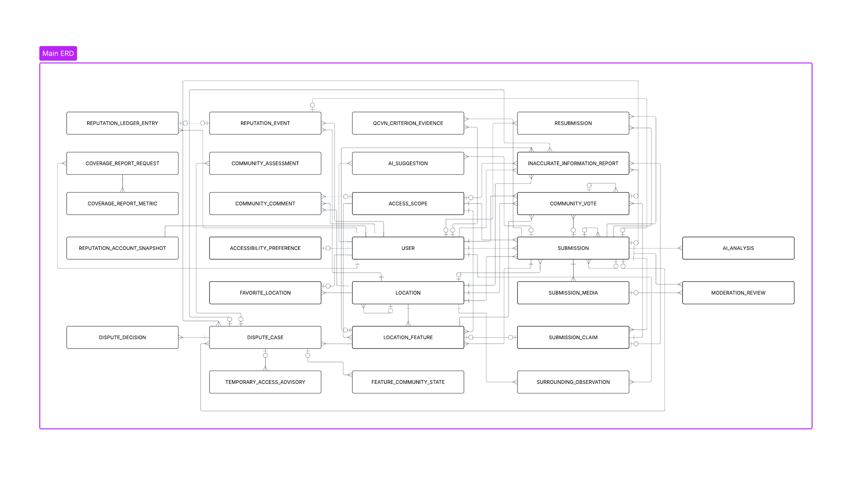
Figure 3.3 – System Main Entity Relationship Diagram

Entities Description
Table 11 – Entity descriptions
# | Table | Workflow | Description
1 | places | WF-01/02 | Place directory (OpenStreetMap-derived): name, category, address, PostGIS point and summary accessibility flags.
2 | submissions | WF-01 | Contribution attempt with status and points; JSON columns measurements_json, client_observations_json, ai_observations_json, plus tags and media URLs.
3 | point_transactions | WF-01 | Ledger of points awarded (50 per published contribution).
4 | access_points | WF-01 | Entrances, ramps, elevators and restrooms of a place.
5 | access_point_kinds | WF-01 | Lookup of access point kinds.
6 | location_sources | WF-01 | Lookup of coordinate sources (user pin, survey EXIF, place centre).
7 | media_kinds | WF-01 | Lookup of media kinds (photo, video).
8 | measurement_units | WF-01 | Lookup of units (mm, cm, percent, count).
9 | measurement_methods | WF-01 | Lookup of measuring methods (tape, laser, AR ruler, visual estimate).
10 | measurement_features | WF-01 | Lookup of measurable features (door clear width, ramp slope, step height, corridor width).
11 | measurement_feature_units | WF-01 | Valid units for each measurable feature.
12 | measurement_observations | WF-01 | Append-only measurements taken by contributors with evidence media URLs (JSON).
13 | measurement_evidence | WF-01 | Media linked to a measurement with privacy status (not required, blurred, pending review, failed).
14 | place_measurements | WF-01 | Consolidated measurement values per place used for reading.
15 | app_users | Shared | Local projection of the Supabase user: display name, role (User, Admin), active flag, reputation score, tier and policy version.
16 | access_scopes | WF-02 | Entrance, floor or area of a place that a feature applies to.
17 | submission_claims | WF-02 | Claim for one feature extracted from a submission.
18 | owned_media | WF-02 | Media assets of users with SHA-256 hash.
19 | upload_intents | WF-02 | Pre-signed upload lifecycle.
20 | location_features | WF-02 | Published accessibility features (Available, Limited, NotAvailable, Unknown) with version.
21 | location_feature_history | WF-02 | Versioned history of published features.
22 | community_votes | WF-02 | Votes StillAccurate or Changed with reputation snapshot.
23 | community_vote_status_history | WF-02 | History of vote status changes.
24 | feature_community_states | WF-02 | Current consensus label and freshness factor of a feature.
25 | community_assessments | WF-02 | Snapshots of consensus calculations (decision_snapshot_json).
26 | feature_assessment_jobs | WF-02 | Queue of community re-evaluation jobs.
27 | dispute_cases | WF-02 | Disputes opened when votes conflict.
28 | dispute_case_votes | WF-02 | Links votes to a dispute.
29 | dispute_decisions | WF-02 | Admin decision on a dispute.
30 | temporary_access_advisories | WF-02 | Time-bounded advisories on a feature.
31 | inaccurate_information_reports | WF-02 | Inaccuracy reports from users.
32 | report_status_history | WF-02 | History of report status changes.
33 | report_evidence | WF-02 | Evidence attached to reports.
34 | location_metadata_history | WF-02 | History of address, pin and entrance corrections (before_json, after_json).
35 | community_comments | WF-02 | Public comments on a place.
36 | community_comment_status_history | WF-02 | History of comment moderation decisions.
37 | idempotency_records | Infrastructure | Stored responses for idempotent requests (response_body).
38 | outbox_messages | Infrastructure | Transactional outbox of events for push notifications (payload_json).

3.2 Feature 1 – Account and Access

3.2.1 Register account
Use case: UC-01 Screens: M-02
Function trigger
A new user taps Register on the login screen.
Function description
Creates an account with an email address and password through Supabase Auth.
Screen layout
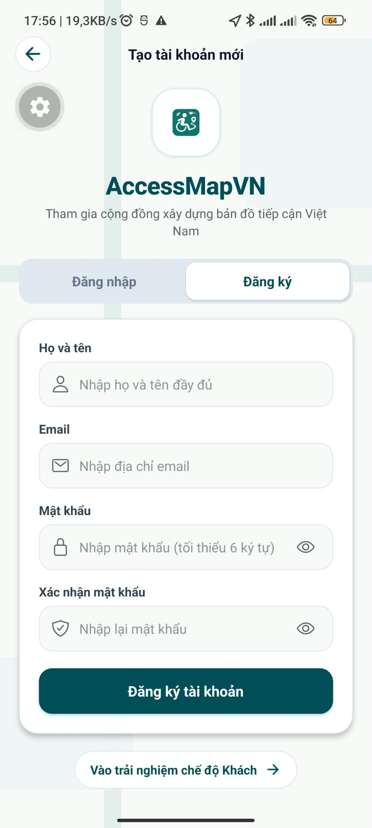
Function details
- Fields: email and password (minimum 6 characters, checked on the client). No phone number is collected.
- Supabase Auth owns the credentials; the API only trusts the JWT it issues and keeps a local app_users record (display name, role, active flag, reputation).
- When the sign-up does not return a session, the account needs email confirmation before the first sign-in.
Main flow
- The user enters email and password and presses Register.
- Supabase creates the account; the app shows the result (signed in, or "check your email to confirm").
Alternative and error flows
- Email already used or invalid input: show the error message from the service (MSG06 to MSG08).
- Service failure: show MSG09 and allow retry.

3.2.2 Log in, log out and reset password
Use case: UC-02 Screens: M-02
Function trigger
User opens the app or the Web Admin Portal, or taps Log out.
Function description
Authenticates a user and ends the session; the role (User or Admin) is resolved on the server.
Screen layout
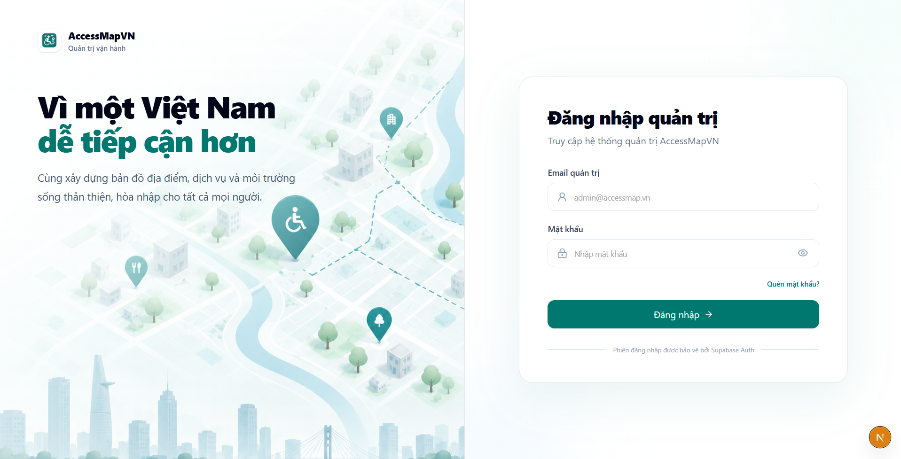
Function details
- Credentials: email and password with signInWithPassword; password reset by email.
- The API validates every JWT: issuer (Supabase), audience authenticated, expiry (60 s clock skew) and HMAC-SHA256 signature.
- Roles: User and Admin only. Admin endpoints use policy Wf02.Moderate (active Admin in app_users or an admin claim); requests from other users are denied.
- Contribute and Report require a signed-in user and redirect to M-02 otherwise.
Main flow
- User submits credentials; the app stores the session and opens the map; an Admin opens the Web Admin Portal.
Alternative and error flows
- Wrong credentials: show MSG10. Inactive account: access denied (MSG17). Token expired: MSG23.

3.2.3 [Planned / Phase 2] Display and accessibility settings
Use case: – Screens: Planned screen
Function trigger
User opens Settings.
Function description
Lets the user adjust text size and contrast. Screen-reader labels (accessibilityLabel, role and hint) already exist on the main controls; text scaling and a high-contrast mode are not implemented yet.
Function details
- Options: text size and high-contrast mode, stored on the device.
Main flow
- User changes a setting; the whole app applies it.

3.3 Feature 2 – Place Search and Discovery

3.3.1 Search places by name or address
Use case: UC-03 Screens: M-03
Function trigger
User types in the search bar of the map screen.
Function description
Returns places from the local database. Search is read-only and never creates a place.
Screen layout
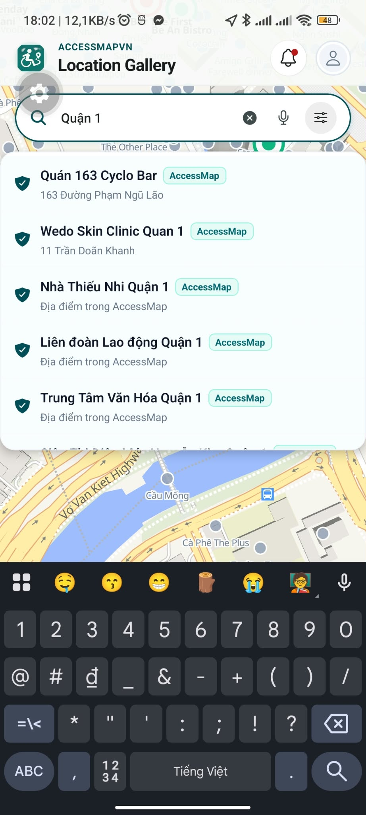
Function details
- Endpoint GET /api/v1/places/search with q, optional lat, lng for distance ranking and limit (default 10).
- Place records come from OpenStreetMap ingested into PostGIS; the search matches name and address.
- Each result shows name, category and whether accessibility data is available.
Main flow
- User enters a query; the app lists matching places; selecting one centres the map and opens M-04.
Alternative and error flows
- No result: show MSG01. Network or service error: MSG03.

3.3.2 Explore the map
Use case: UC-04 Screens: M-03
Function trigger
User opens, pans or zooms the map.
Function description
Shows the places inside the visible area with clustering by zoom level.
Screen layout
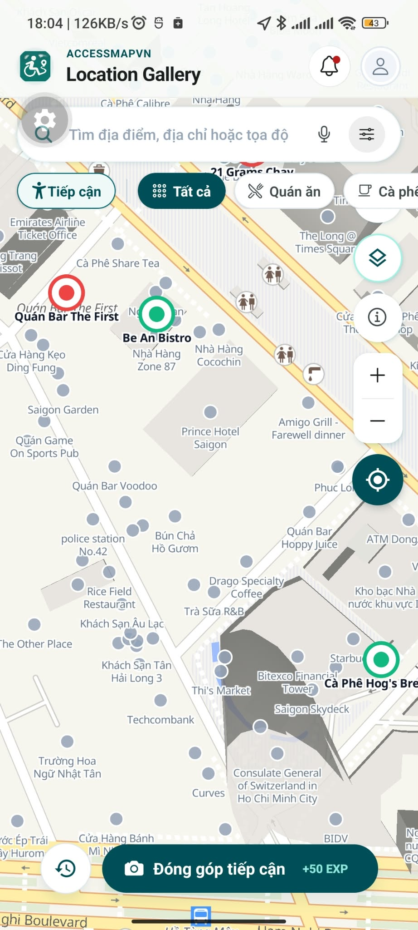
Function details
- Endpoint GET /api/v1/places with minLng, minLat, maxLng, maxLat, zoomLevel (default 14) and optional categories.
- The map renders OpenFreeMap vector tiles with MapLibre; where MapLibre is not available (Expo Go, web) a vector canvas fallback is used.
- The default spatial search radius of the spatial service is 5,000 m.
Main flow
- Map loads and requests the places of the viewport; tapping a marker opens M-04.
Alternative and error flows
- Tiles or API unavailable: show MSG03 and keep the search bar usable.

3.3.3 View place detail and accessibility summary
Use case: UC-05 Screens: M-04
Function trigger
User selects a place on the map or in the results.
Function description
Presents the published accessibility record of a place with its evidence and entry points to contribution and reporting.
Screen layout

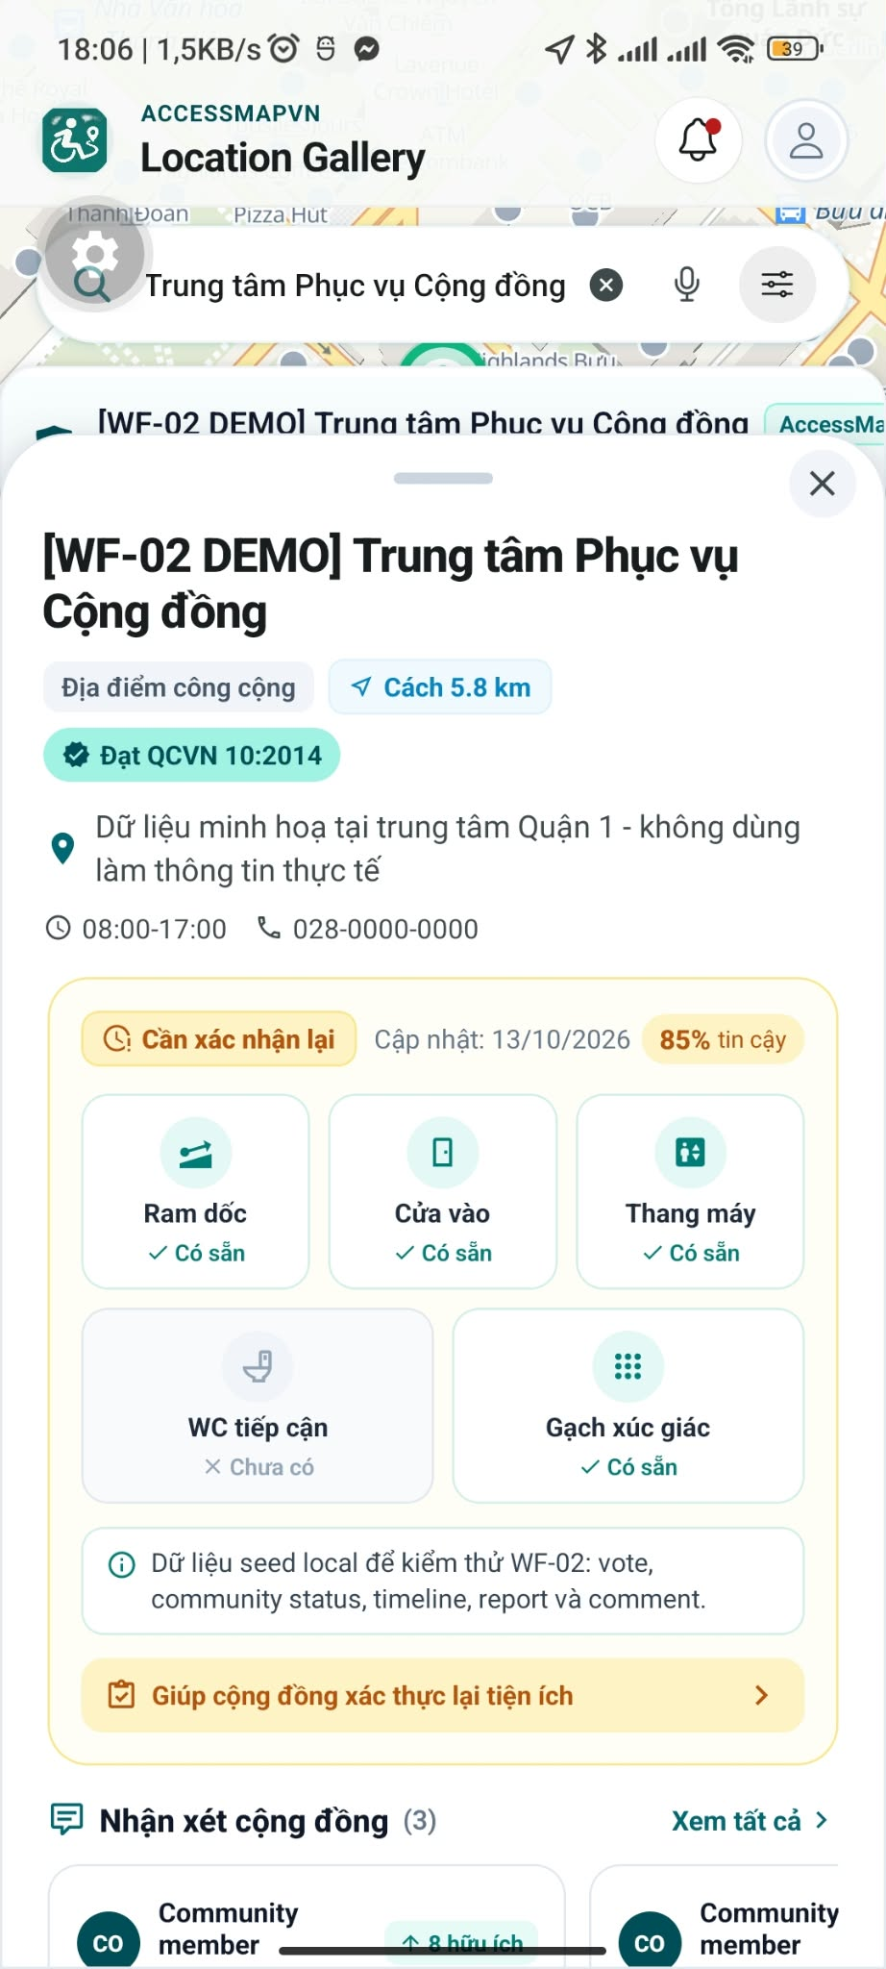 | 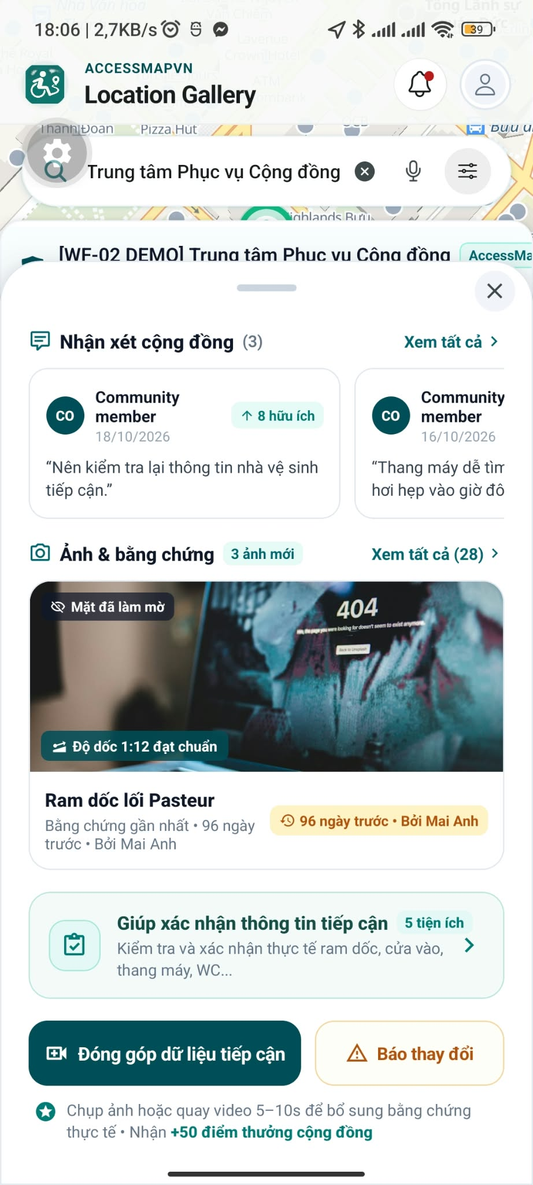

Function details
- Endpoints GET /places/{id} and GET /places/{id}/evidence (approved photo evidence).
- The accessibility summary gives a label for wheelchair users: suitable and safe to use independently (measurements verified against QCVN 10:2014), needs caution (not yet verified, bring a helper), or no data yet.
- Published feature statuses: Available, Limited, NotAvailable, Unknown. Features covered are Ramp, Entrance Door, Elevator and Accessible Restroom.
- Contribute and Report require a signed-in user.
Main flow
- User opens the place; the sheet shows the summary, features and evidence.
Alternative and error flows
- Place without published data: show MSG04 and an invitation to contribute.

3.3.4 Filter places by mobility needs
Use case: UC-06 Screens: M-03
Function trigger
User selects a category chip or a tag filter on the map.
Function description
Narrows the places on the map by category and by accessibility information. Filtering by a personal need profile is not available yet.
Screen layout
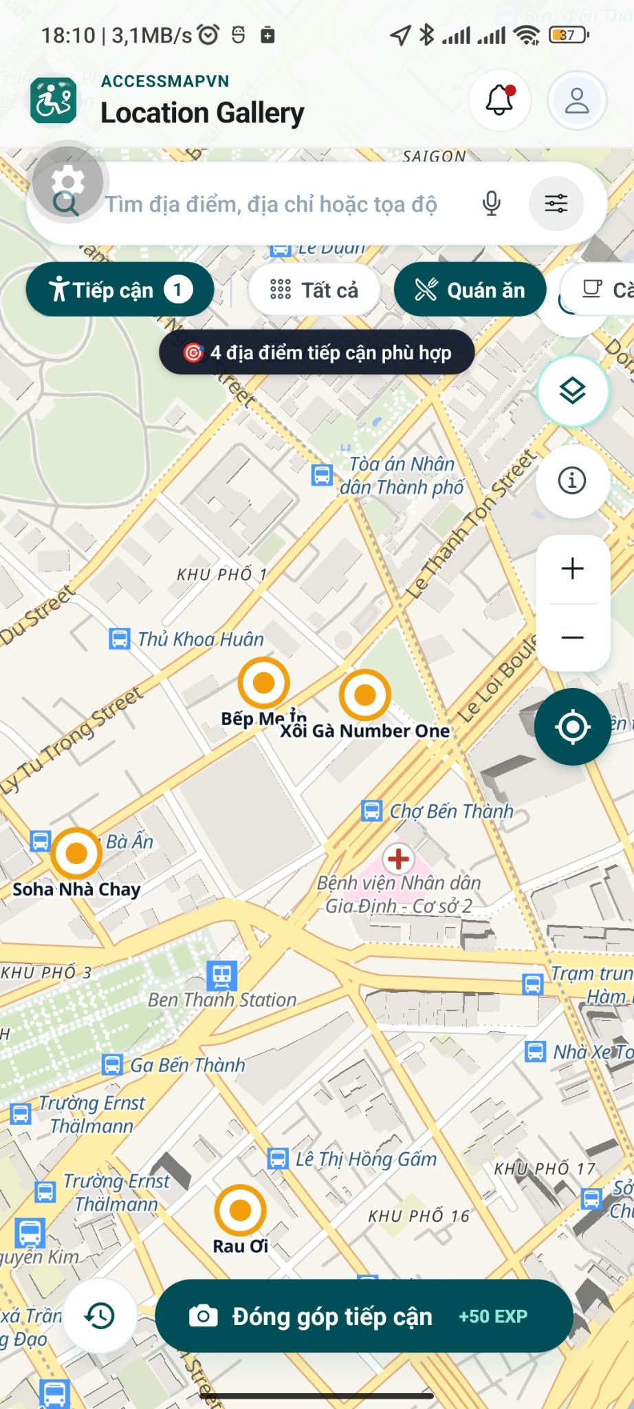
Function details
- Category filter is sent as categories to the places endpoint.
- Places without data are labelled "no accessibility data yet", never "not suitable".
Main flow
- User selects a chip; the map reloads with the filtered places.

3.3.5 [Planned / Phase 2] Saved needs and favorite places
Use case: UC-07, UC-08 Screens: Planned screens
Function trigger
User opens Saved Needs or taps the heart on a place.
Function description
Stores a user's mobility needs and favorite places. No table, endpoint or screen exists yet.
Function details
- Saved need: name, preset (wheelchair, limited mobility, older adult) and required features; favorites: one record per user and place.
Main flow
- User saves a need or a place; later searches prefill the filter.

3.4 Feature 3 – Contribute Accessibility Information
A contribution is evidence, not published truth. The submission status lifecycle is shown in section 5.4.1.

3.4.1 Capture photos and pre-scan
Use case: UC-09, UC-10 Screens: M-05
Function trigger
User taps Contribute on a place detail.
Function description
Collects up to 3 photos with a GPS fix and gives advisory quality feedback.
Function details
- Allowed photos: JPEG, PNG or WebP, at most 10 MB each, at least 100 px on both sides; 1 to 3 photos per submission.
- Pre-scan (POST /ai/pre-scan): blur check by Laplacian variance (threshold 80), resolution and size checks, and automatic face blurring (Gaussian kernel 51). Target response under 2 seconds.
- The pre-scan is advisory; the user can retake a photo or continue.
- Photos are uploaded directly to the Supabase Storage bucket contributions-media.
Main flow
- User takes photos; the app uploads them and shows pre-scan feedback; the user continues to tag review.
Alternative and error flows
- Unsupported type or too large: MSG11. Upload failure: MSG12 with retry. Camera or location permission denied: MSG13.

3.4.2 Review tags and measurements
Use case: UC-09 Screens: M-06
Function trigger
User continues from photo capture.
Function description
The user states what the evidence shows using the QCVN 10:2014 tags and optional measurements.
Function details
- Feature groups: entrance door (clear width, flat threshold, automatic door or lever handle), ramp (exterior ramp present, comfortable slope), steps (steps present), elevator (accessible elevator), restroom (accessible stall, grab bars, sink clearance), plus parking space and lowered counter as amenities.
- Each tag has a state: present, absent, unknown or not applicable.
- Measurements: door clear width (mm or cm) and ramp slope as a percentage (rise and run), with the method used (tape, laser, AR ruler or visual estimate).
- An optional Vietnamese description is analysed by the PhoBERT NLP classifier.
Main flow
- User sets the tags and measurements and continues.

3.4.3 Record a video
Use case: UC-09 Screens: M-07
Function trigger
User continues from tag review.
Function description
Records a short walk-through video of the entrance.
Function details
- MP4 (H.264), 5 to 10 seconds (the AI service tolerates 4.5 to 10.5 s), at most 30 MB, shortest side 240 px at least and longest 4,096 px at most.
- Video pre-scan (POST /ai/pre-scan/video) extracts key frames and checks sharpness (minimum 20).
Main flow
- User records, previews and accepts or retakes the video.
Alternative and error flows
- Video shorter than 5 s or too large: show MSG11 and ask to retake.

3.4.4 Scorecard and submit
Use case: UC-09 Screens: M-08
Function trigger
User continues from video preview.
Function description
Shows the verification matrix result and submits the contribution.

Function details
- The app evaluates a three-pillar score: computer vision 50%, text context 20%, spatial proximity 30%. Score >= 90 is expected to be AutoVerified, 60 to 89 PendingModeration, below 60 NeedsSupplement (BR-09, BR-10).
- Submit calls POST /api/v1/submissions with a ClientSubmissionId; the same id with the same payload is idempotent, a different payload is a conflict.
- The backend checks the geofence (50 m for an entrance, otherwise a category fallback) before accepting the submission.
Main flow
- User reviews the scorecard and presses Submit; the app confirms with MSG14 and returns to the map.
Alternative and error flows
- Geofence violation: MSG15 with the allowed distance. Network failure: retry with the same ClientSubmissionId.

3.4.5 AI verification and publication (system)
Use case: UC-26 Screens: – (system function)
Function trigger
A new submission is committed.
Function description
A Hangfire job verifies the evidence with the AI service and routes the submission; approved features are published.
Screen layout

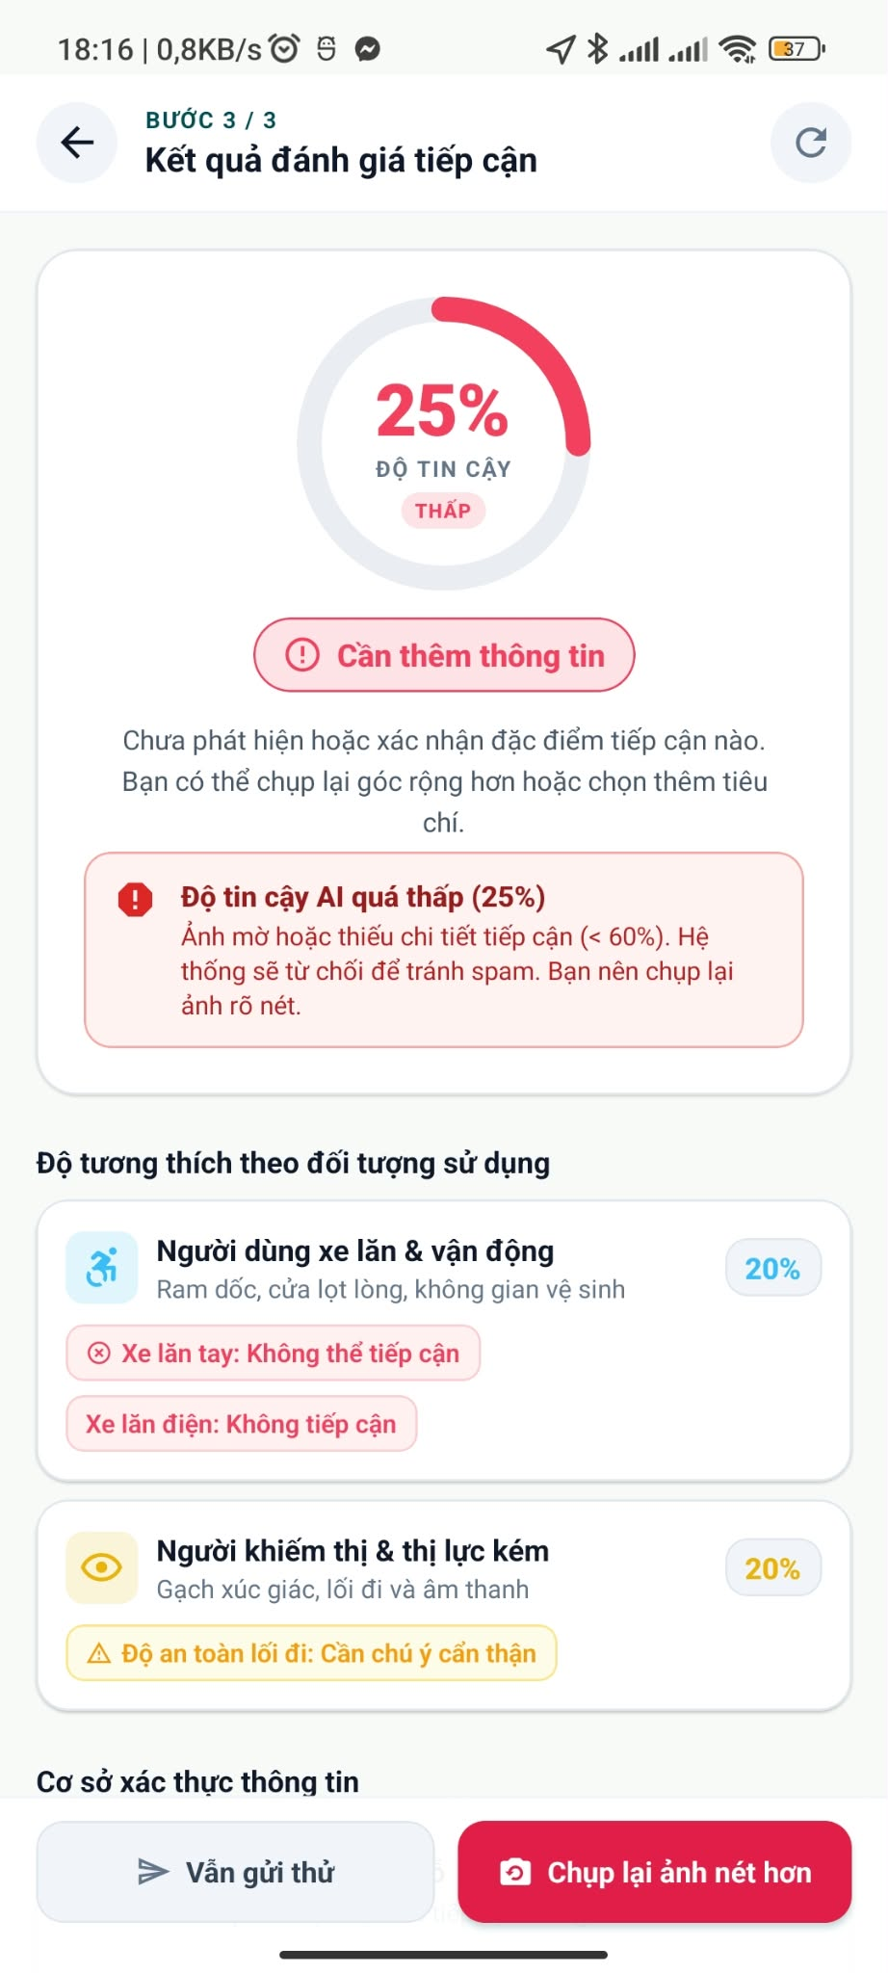 | 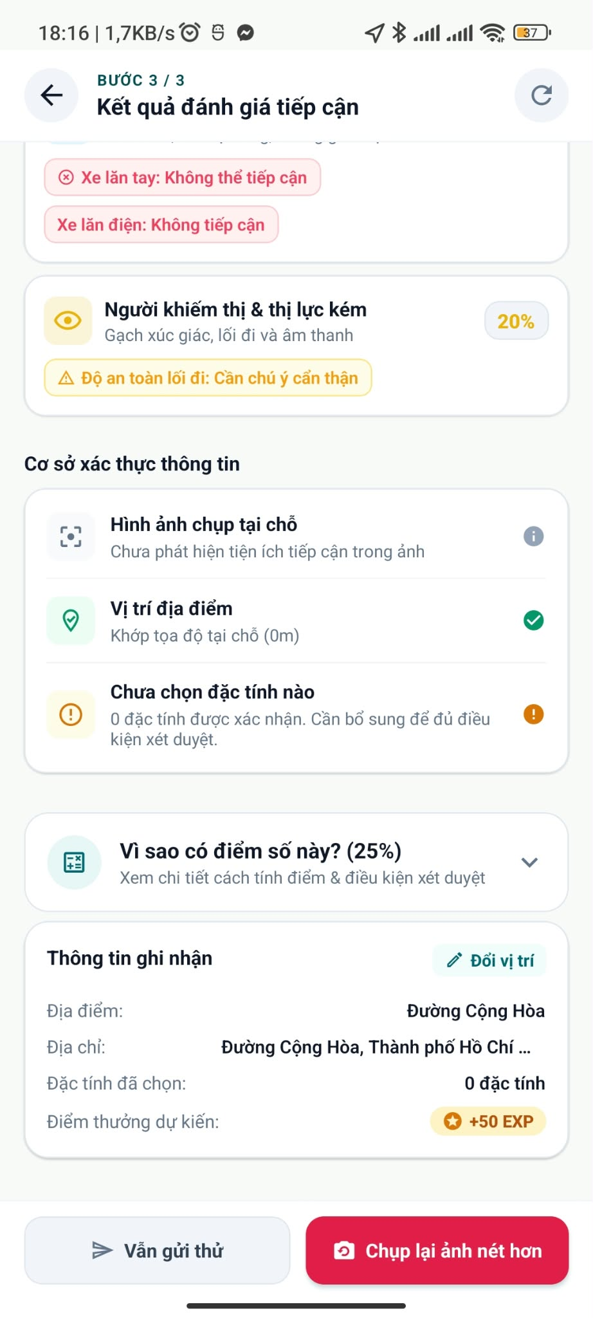

Function details
- SubmissionVerificationJob (queue default, 2 automatic retries) calls POST /api/v1/ai/verify. If the service is unavailable or returns an error the job stops and the submission stays PendingModeration.
- The AI service detects ramps, steps, doors, elevators and restroom signs with YOLOv8/OpenCV and fuses per feature 0.6 x vision confidence + 0.4 x NLP confidence; contradictions between vision and text lower the confidence and set the value to unknown.
- Publication runs in one serializable transaction: write location_features and history, update the place summary flags, reset the feature community state, mark the claim Published, add a 50-point transaction, set the submission to Published and add an outbox message.
Main flow
- Worker verifies, routes and publishes (AutoVerified) or queues for Admin review.
Alternative and error flows
- Duplicate job delivery is harmless because publication is transactional and versioned.

3.4.6 Review contributions (Admin)
Use case: UC-18 Screens: A-02, A-03
Function trigger
Admin opens an item in the Contribution Queue.
Function description
The Admin inspects the evidence and decides.
Screen layout
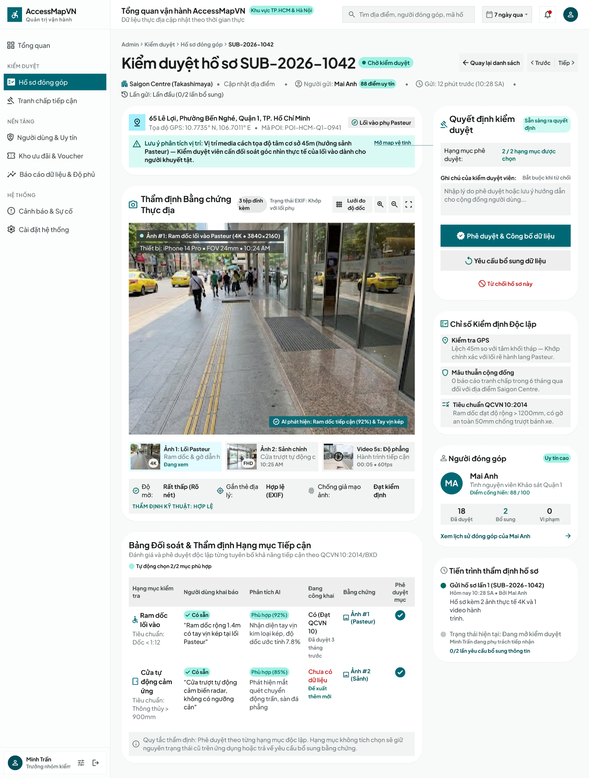
Function details
- Endpoints under /api/v1/admin/submissions: list, detail, navigation to previous/next, approve, reject, request-info, remind.
- Transitions: PendingModeration to Published, Rejected or NeedsSupplement; NeedsSupplement to Published or Rejected.
- Approval publishes the features, awards the 50 points and adds 10 to the contributor's reputation score.
- The Admin review SLA target is 120 minutes.
Main flow
- Admin opens the item, reviews claims, AI results and evidence, selects an action and confirms; an outbox message is stored for the contributor (push delivery is planned).
Alternative and error flows
- Item already decided: MSG16. Not an Admin: MSG17.

3.4.7 Track, cancel or resubmit a submission
Use case: UC-11, UC-12 Screens: Planned screen
Function trigger
The app polls the status of a submission.
Function description
The status and verification result can be read through the API. Cancelling and resubmitting corrected evidence are planned.
Function details
- GET /api/v1/submissions/{id}/status returns the status (Submitted, AutoVerified, PendingModeration, NeedsSupplement, Rejected, Published) and verification result.
- [Planned / Phase 2] Cancel a submission, resubmit as a linked attempt with a limit on attempts, and a "my submissions" list.
Main flow
- The app reads the status after submission or from a notification.

3.5 Feature 4 – Community Validation
Votes and reports are observations. They never edit published truth directly; only an Admin decision or a verified new submission can change a published feature. Community confidence is separate from the contribution score: it is a reputation- and recency-weighted result of independent votes with a 90-day freshness check.

3.5.1 Confirm or challenge a published feature
Use case: UC-13 Screens: Planned screen
Function trigger
User votes on a feature of a place.
Function description
Records "StillAccurate" or "Changed" for a published feature. The API is implemented; a dedicated mobile screen is planned.
Function details
- Endpoints: GET /locations/{id}/features/{type}/community, POST .../votes, DELETE .../votes/mine, POST /community-votes/{id}/link-submission. Limit: 10 votes per 10 minutes.
- One counting vote per user per feature version; a new vote supersedes the previous one and keeps history.
- Weight = reputation (clamped 1 to 100) x tier factor x recency weight, with recency weight = 2^(-age in days / 180). Consensus needs 90% agreement.
Main flow
- User chooses an option; the community state is recomputed by a background job.
Alternative and error flows
- Duplicate vote on the same version: MSG19. Feature changed meanwhile: MSG20.

3.5.2 Report an inaccuracy
Use case: UC-14 Screens: M-04, M-09, M-10
Function trigger
User taps Report on a place.
Function description
Files a report about incorrect, missing or outdated information and follows its status.
Screen layout
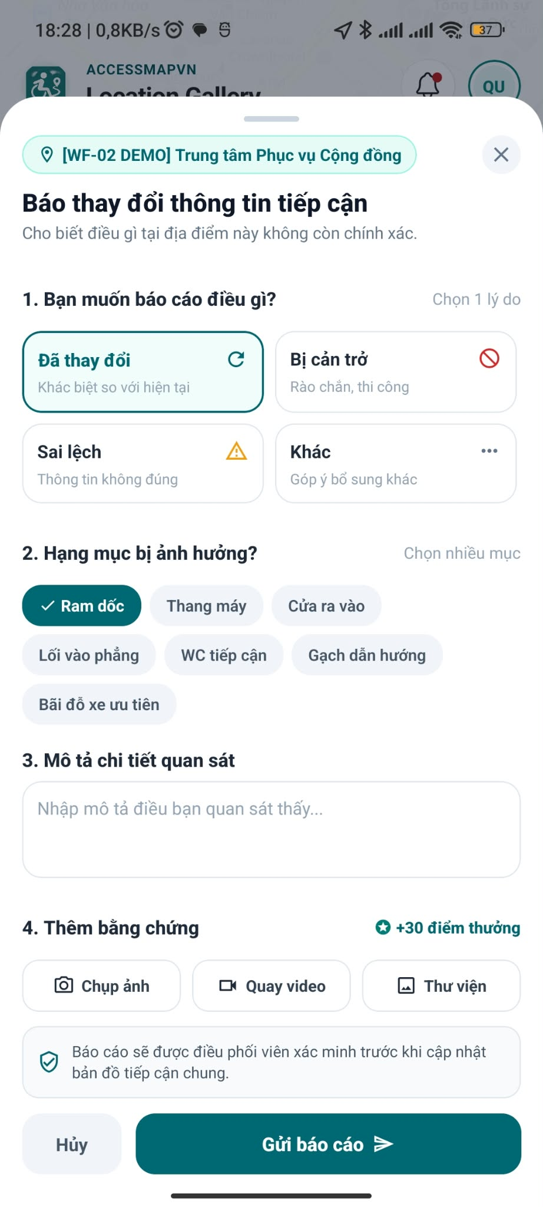
Function details
- Reasons: IncorrectFeature, MissingFeature, OutdatedInformation, WrongAddressOrPin, Other. Limits: 5 reports per day, 10 evidence items per hour.
- Statuses: Submitted, UnderReview, AwaitingMoreInfo, LinkedToDispute, Resolved, Rejected; each change is stored in the report history.
- Endpoints: POST /locations/{id}/reports, GET /reports/{id}, POST /reports/{id}/evidence.
- The Admin may request more evidence; an outbox message is stored for the user (push delivery is planned).
Main flow
- User fills the report and submits; the report appears in My Reports with its status.
Alternative and error flows
- Missing reason: inline validation. Rate limit reached: MSG22.

3.5.3 Post a community comment
Use case: UC-15 Screens: Planned screen
Function trigger
User posts a comment on a place.
Function description
Adds a public comment that becomes visible after Admin approval. The API is implemented; a mobile screen is planned.
Function details
- Endpoints: GET and POST /locations/{id}/comments. Initial status PendingReview, at most 2,000 characters, 10 comments per hour.
Main flow
- User posts; the Admin approves or hides the comment.
Alternative and error flows
- Over-length text: inline validation.

3.5.4 Freshness, disputes and advisories (system)
Use case: UC-20 Screens: – (system function)
Function trigger
Daily freshness scan; new votes.
Function description
Keeps published data honest over time and escalates disagreement.
Function details
- A feature without confirmation for 90 days becomes NeedsRecheck (daily job at 02:00 UTC); the freshness factor then decays with a 180-day half-life.
- A dispute opens automatically when at least 2 independent voters contradict the published state. Statuses: Open, UnderReview, AwaitingMoreInfo, CorrectionPending, ResolvedBaseline, ResolvedUpdated.
- A temporary advisory is created by an Admin dispute decision, lasts at most 60 days and moves Scheduled, Active, Expired (checked every minute).
Main flow
- The scheduler labels features, opens disputes and expires advisories.

3.5.5 Decide disputes and advisories (Admin)
Use case: UC-20 Screens: A-04, A-05
Function trigger
Admin opens a dispute from the Disputes queue.
Function description
Resolves a dispute with a reasoned, audited decision.
Function details
- Endpoints: GET /admin/community-disputes, GET /admin/community-disputes/{id}, PATCH /admin/community-disputes/{id}.
- The Admin may request more evidence, retain the baseline, link a correction, or create an advisory, always with a reason.
Main flow
- Admin reviews votes and evidence, selects a decision and confirms; affected users are notified.
Alternative and error flows
- Case already decided: MSG16.

3.5.6 Review reports, metadata corrections and comments (Admin)
Use case: UC-19, UC-21 Screens: A-06, A-07, A-08
Function trigger
Admin opens Reports or Comment Moderation.
Function description
Decides on reports, corrects place metadata and moderates comments.
Screen layout
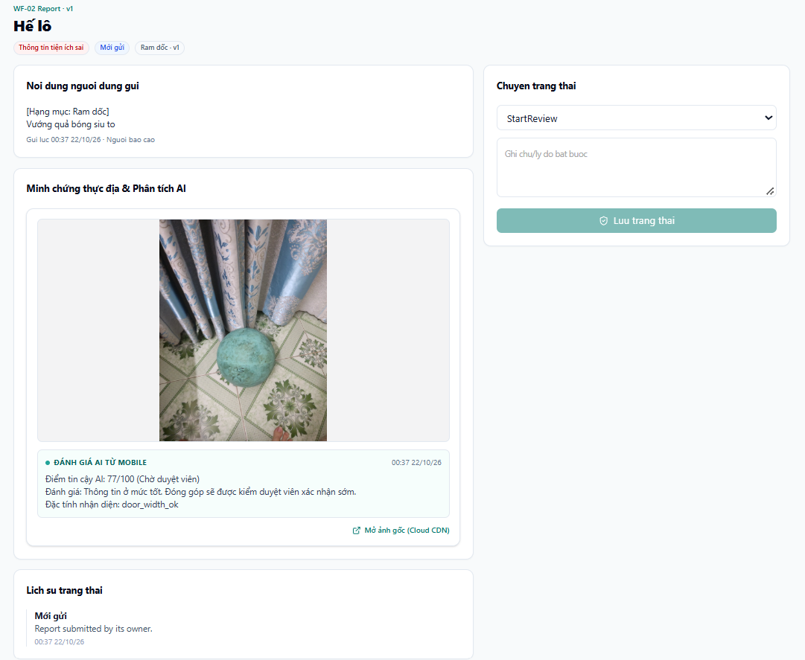
Function details
- Report decisions use PATCH /admin/reports/{id}; evidence is opened through an authorised link (GET /admin/reports/{id}/evidence/{evidenceId}/access).
- Metadata correction PATCH /admin/locations/{id}/metadata changes address, pin or entrance and stores before and after values in the history.
- Comments: POST /admin/locations/{id}/comments/{commentId}/moderation with Approve or Hide and a reason.
Main flow
- Admin selects an item, decides and confirms.

3.6 Feature 5 – Reputation and Points

3.6.1 Points and reputation
Use case: UC-16 Screens: – (screen planned)
Function trigger
A submission is published.
Function description
Awards points and reputation for published contributions.
Function details
- A published contribution adds a point_transactions record of 50 points.
- An Admin approval adds 10 to ReputationScore of the contributor (default 0). Only the Baseline tier exists; the reputation score is the weight of the user's votes.
- There is no screen that shows points and reputation yet.
Main flow
- The publication transaction records points; the score influences later votes.

3.6.2 [Planned / Phase 2] Push notifications
Use case: – Screens: – (system function)
Function trigger
A business event is written to the outbox.
Function description
Business events (report decisions, evidence requests, metadata corrections, advisories) are stored in a transactional outbox. Delivering them as push messages is planned.
Function details
- Events are written to outbox_messages in the same transaction as the business change, so a notification problem can never roll back business data.
- The dispatcher exists in the backend but is disabled by configuration; the mobile app does not subscribe to notifications yet.
Main flow
- Not part of the current delivery.

3.6.3 [Planned / Phase 2] Vouchers and account reviews
Use case: UC-17, UC-22, UC-23 Screens: Planned screens
Function trigger
User opens the voucher catalog; Admin opens rewards or account reviews.
Function description
Exchange of points for partner vouchers and investigation of fraud. Only an IsActive flag on app_users exists; no voucher table, endpoint or screen is implemented.
Function details
- Voucher offers with cost, terms and unique-code stock; redemption debits spendable points once per confirmed request.
- Account restriction needs evidence, reason, scope and an appeal path.
Main flow
- Not part of the current delivery.

3.7 Feature 6 – Coverage Analytics and Export [Planned / Phase 2]

3.7.1 [Planned / Phase 2] Coverage report and export
Use case: UC-24, UC-25 Screens: Planned screens
Function trigger
Admin opens Coverage Reports.
Function description
Aggregates the coverage of accessibility data per region and period and exports it as CSV, PDF or GeoJSON. The Web Admin route is a placeholder and the dashboard uses mock data; no endpoint exists.
Function details
- Inputs: region, period and feature filters; the result is an immutable snapshot with explicit denominators.
- Export is allowed only for an approved snapshot; sharing with authorities is manual.
Main flow
- Not part of the current delivery.

4. Non-Functional Requirements

4.1 External Interfaces

4.1.1 User interfaces
- The mobile app (Expo / React Native) and the Web Admin Portal (ReactJS) follow a consistent visual style; the map is the primary canvas of the mobile app.
- Interactive controls carry accessibilityLabel, role and hint for screen readers.
- Errors, confirmations and warnings use the messages in section 5.3 as inline text, toast or dialog.

4.1.2 Hardware interfaces
- Phone camera for photos and short videos; device GPS at capture time; network connectivity for upload.
- The Web Admin Portal runs in a desktop browser; no special hardware is required.

4.1.3 Software interfaces
Table 12 – External software interfaces
Interface | Provider | Purpose and rules
Authentication | Supabase Auth | Email and password sign-up, sign-in and password reset; issues JWT bearer tokens validated by the API.
Place data | OpenStreetMap (Overpass) in PostGIS | Place identity, address and coordinates ingested with bulk_upsert_places and served by /api/v1/places. Never a source of accessibility truth.
Map | MapLibre with OpenFreeMap vector tiles | Basemap rendering in the mobile app; style URL configurable; vector canvas fallback when MapLibre is unavailable.
AI service | Python FastAPI (YOLOv8, OpenCV, PhoBERT) | Endpoints /api/v1/ai/pre-scan, /pre-scan/video, /verify, /blur, /health, /health/ready. Called by the mobile app (pre-scan) and the backend worker (verify). Output is a suggestion.
Object storage | Supabase Storage (contributions-media), MinIO / S3 | Contribution media, community evidence with pre-signed links valid 15 minutes.
Push notifications | [Planned / Phase 2] Push provider | Business notifications from the transactional outbox. The dispatcher is disabled by configuration.
Database | PostgreSQL with PostGIS | Relational data and spatial queries with geography(Point,4326).

4.1.4 Communication interfaces
- REST over HTTPS, JSON payloads, versioned under /api/v1; clients are authenticated with bearer tokens.
- Write operations carry an idempotency key or a client submission id; cross-origin access is limited to configured origins (CORS).
- Media travel directly between the client and object storage; the API only issues or validates the links.
4.2 Quality Attributes

4.2.1 Usability
- The mobile app is usable with a screen reader for the main flows (labels, roles and hints on buttons, inputs, list items and markers).
- Colour is never the only way to convey a status; labels accompany it.
- [Planned / Phase 2] Adjustable text size and a high-contrast mode (not implemented yet).
- Messages are short, state what happened and what to do next.

4.2.2 Reliability
- Verification jobs retry 2 times; if the AI service stays unavailable the submission remains PendingModeration for Admin review and is never published unverified.
- Business events are stored in a transactional outbox, so a notification problem can never roll back business data (push delivery is planned).
- A recurring reconciliation job (every minute) re-queues stalled community evaluation jobs.
- Submissions are idempotent by ClientSubmissionId, and publication runs in one serializable transaction.

4.2.3 Performance
- Photo pre-scan targets a response under 2 seconds; images are downscaled to 1,024 px for analysis.
- AI service timeouts: HTTP 30 s, video processing 30 s, video request 60 s. Submit returns once the submission is stored; verification is asynchronous.
- Lists and search use limits and paging; the map loads only the visible area, with spatial indexes in PostGIS.
- The Admin review SLA target for a pending contribution is 120 minutes.

4.2.4 Security
- HTTPS redirection outside development; JWT validated on every request (issuer, audience, expiry, signature).
- Authorization by role: [Authorize] for authenticated actions and policy Wf02.Moderate for Admin endpoints.
- Rate limits: 10 votes per 10 minutes, 5 reports per day, 10 evidence uploads per hour, 10 comments per hour.
- Media are private; links are pre-signed and short-lived (15 minutes); faces in photos are blurred.
- Every Admin decision, metadata change and status change is stored in append-only history.

4.2.5 Privacy and data trustworthiness
- Public history and evidence previews show approved media only and do not reveal the contributor.
- GPS and capture data are used for verification and are visible only to Admins.
- A photo is evidence of what existed at capture time and never a statement of legal compliance.

4.2.6 Maintainability, portability and scalability
- Layered backend with separate API, workers and AI service, each containerised with Docker.
- Spatial data in PostGIS so that further cities can be added without schema changes.
- Thresholds are configuration options (for example Wf02Options, AI service config.py) so they can change without code changes.
5. Requirement Appendix

5.1 Business Rules
Table 13 – Business rules
ID | Rule Definition
BR-01 | Search is read-only and never creates a place.
BR-02 | Place data (OpenStreetMap-derived records) supplies identity only; it is never evidence of an accessibility feature.
BR-03 | A user registers with an email address and a password of at least 6 characters through Supabase Auth; new accounts may need email confirmation.
BR-04 | API requests are authenticated with Supabase JWTs. The roles are User and Admin; Admin endpoints require the policy Wf02.Moderate.
BR-05 | Features covered are Ramp, Entrance Door, Elevator and Accessible Restroom (mobility only). Published status is Available, Limited, NotAvailable or Unknown.
BR-06 | Photos: JPEG, PNG or WebP, up to 10 MB, 1 to 3 per submission, at least 100 px per side. Video: MP4/H.264, 5 to 10 s, up to 30 MB, 240 to 4,096 px. Blur threshold 80 (photo) and 20 (video).
BR-07 | Capture GPS must be within 50 m of the entrance; without an entrance the fallback radius is 250 m (hospital, university, mall, park, campus), 100 m (museum, office, station) or 50 m (others). A violation returns HTTP 422. GPS accuracy is deducted from the distance.
BR-08 | The AI service fuses 60% computer vision and 40% NLP per feature; a contradiction between vision and text sets the value to unknown and lowers confidence.
BR-09 | The mobile scorecard uses 50% computer vision, 20% text context and 30% spatial proximity. Penalties: score capped at 75 when the GPS check fails, 25 when no feature is selected, 35 when tags contradict the vision result; a stepped entrance without a ramp reduces the wheelchair score by 40.
BR-10 | Routing by score: >= 90 AutoVerified, 60 to 89 PendingModeration, < 60 NeedsSupplement.
BR-11 | If the AI service fails, the submission stays PendingModeration; it is never published without verification.
BR-12 | A submission with the same ClientSubmissionId and the same payload returns the existing record; a different payload is a conflict.
BR-13 | Admin transitions: PendingModeration to Published, Rejected or NeedsSupplement; NeedsSupplement to Published or Rejected.
BR-14 | Publication is one serializable transaction. A published contribution awards 50 points; an Admin approval adds 10 reputation.
BR-15 | Votes and reports are observations; only an Admin decision or a verified submission changes published truth.
BR-16 | Vote weight = reputation (1 to 100) x tier factor x 2^(-age days / 180); consensus requires 90% agreement.
BR-17 | A feature without confirmation for 90 days becomes NeedsRecheck.
BR-18 | A dispute opens when at least 2 independent voters contradict the published state.
BR-19 | A temporary advisory lasts at most 60 days.
BR-20 | Comments start as PendingReview, have at most 2,000 characters and become public only after approval.
BR-21 | Rate limits: 10 votes / 10 min, 5 reports / day, 10 report evidence / hour, 10 comments / hour.
BR-22 | Every Admin decision records actor, reason and time.
BR-23 | Media are private and reached through pre-signed links valid 15 minutes.
BR-24 | [Phase 2] Voucher redemption requires an approved offer and stocked unique codes and debits spendable points once per confirmed request.
BR-25 | [Phase 2] Only an approved coverage snapshot can be exported; sharing with authorities is manual.

5.2 Common Requirements
- Identifiers and time: entities use UUIDs; timestamps are stored in UTC.
- API conventions: versioned /api/v1, JSON bodies, idempotency for writes, stable error codes with a human message.
- Configuration: every threshold in this document is a configuration option calibrated with test media before production.
- Auditing: state changes of submissions, features, votes, disputes and reports are stored in history tables.
- Language: user-facing text of the app is Vietnamese; the descriptions analysed by the NLP model are Vietnamese.

5.3 Application Messages List
Table 14 – Application messages
# | Message code | Message type | Context | Content
1 | MSG01 | Inline | Search returns no place | No places found. Try another name or move the map.
2 | MSG02 | Dialog | Device location unavailable | We could not get your location. Choose a point on the map instead.
3 | MSG03 | Toast | Map or network unavailable | Service is temporarily unavailable. Please try again.
4 | MSG04 | Inline | Place has no published data | No accessibility data yet. Be the first to contribute.
5 | MSG05 | Inline | Invalid input | Please check the highlighted fields.
6 | MSG06 | Inline | Duplicate email | This email is already registered.
7 | MSG07 | Inline | Weak or invalid password | The password must have at least 6 characters.
8 | MSG08 | Inline | Invalid email format | Enter a valid email address.
9 | MSG09 | Toast | Registration or sign-in service failure | We could not complete the request. Please try again.
10 | MSG10 | Inline | Wrong credentials | Incorrect email or password.
11 | MSG11 | Inline | Media type, size or length not allowed | This file is not supported or does not meet the size or length limit.
12 | MSG12 | Toast | Upload failed | Upload failed. Check your connection and retry.
13 | MSG13 | Dialog | Camera or location permission denied | Allow camera and location access in settings.
14 | MSG14 | Toast | Submission sent | Submitted. Your contribution is being verified.
15 | MSG15 | Dialog | Outside the allowed distance | You appear to be too far from this place. Move closer and try again.
16 | MSG16 | Toast | Item already decided | This item was already handled. The list has been refreshed.
17 | MSG17 | Inline | Permission missing | You do not have permission for this action.
18 | MSG18 | Toast | Report sent | Thank you. Your report will be reviewed.
19 | MSG19 | Inline | Duplicate vote | You have already voted on this information.
20 | MSG20 | Dialog | Feature changed after display | This information has been updated. Review it and vote again.
21 | MSG21 | Toast | Comment awaiting review | Your comment will appear after review.
22 | MSG22 | Toast | Rate limit reached | You are doing this too often. Please try again later.
23 | MSG23 | Dialog | Session expired | Your session has expired. Please log in again.

5.4 Other Requirements

5.4.1 State lifecycles
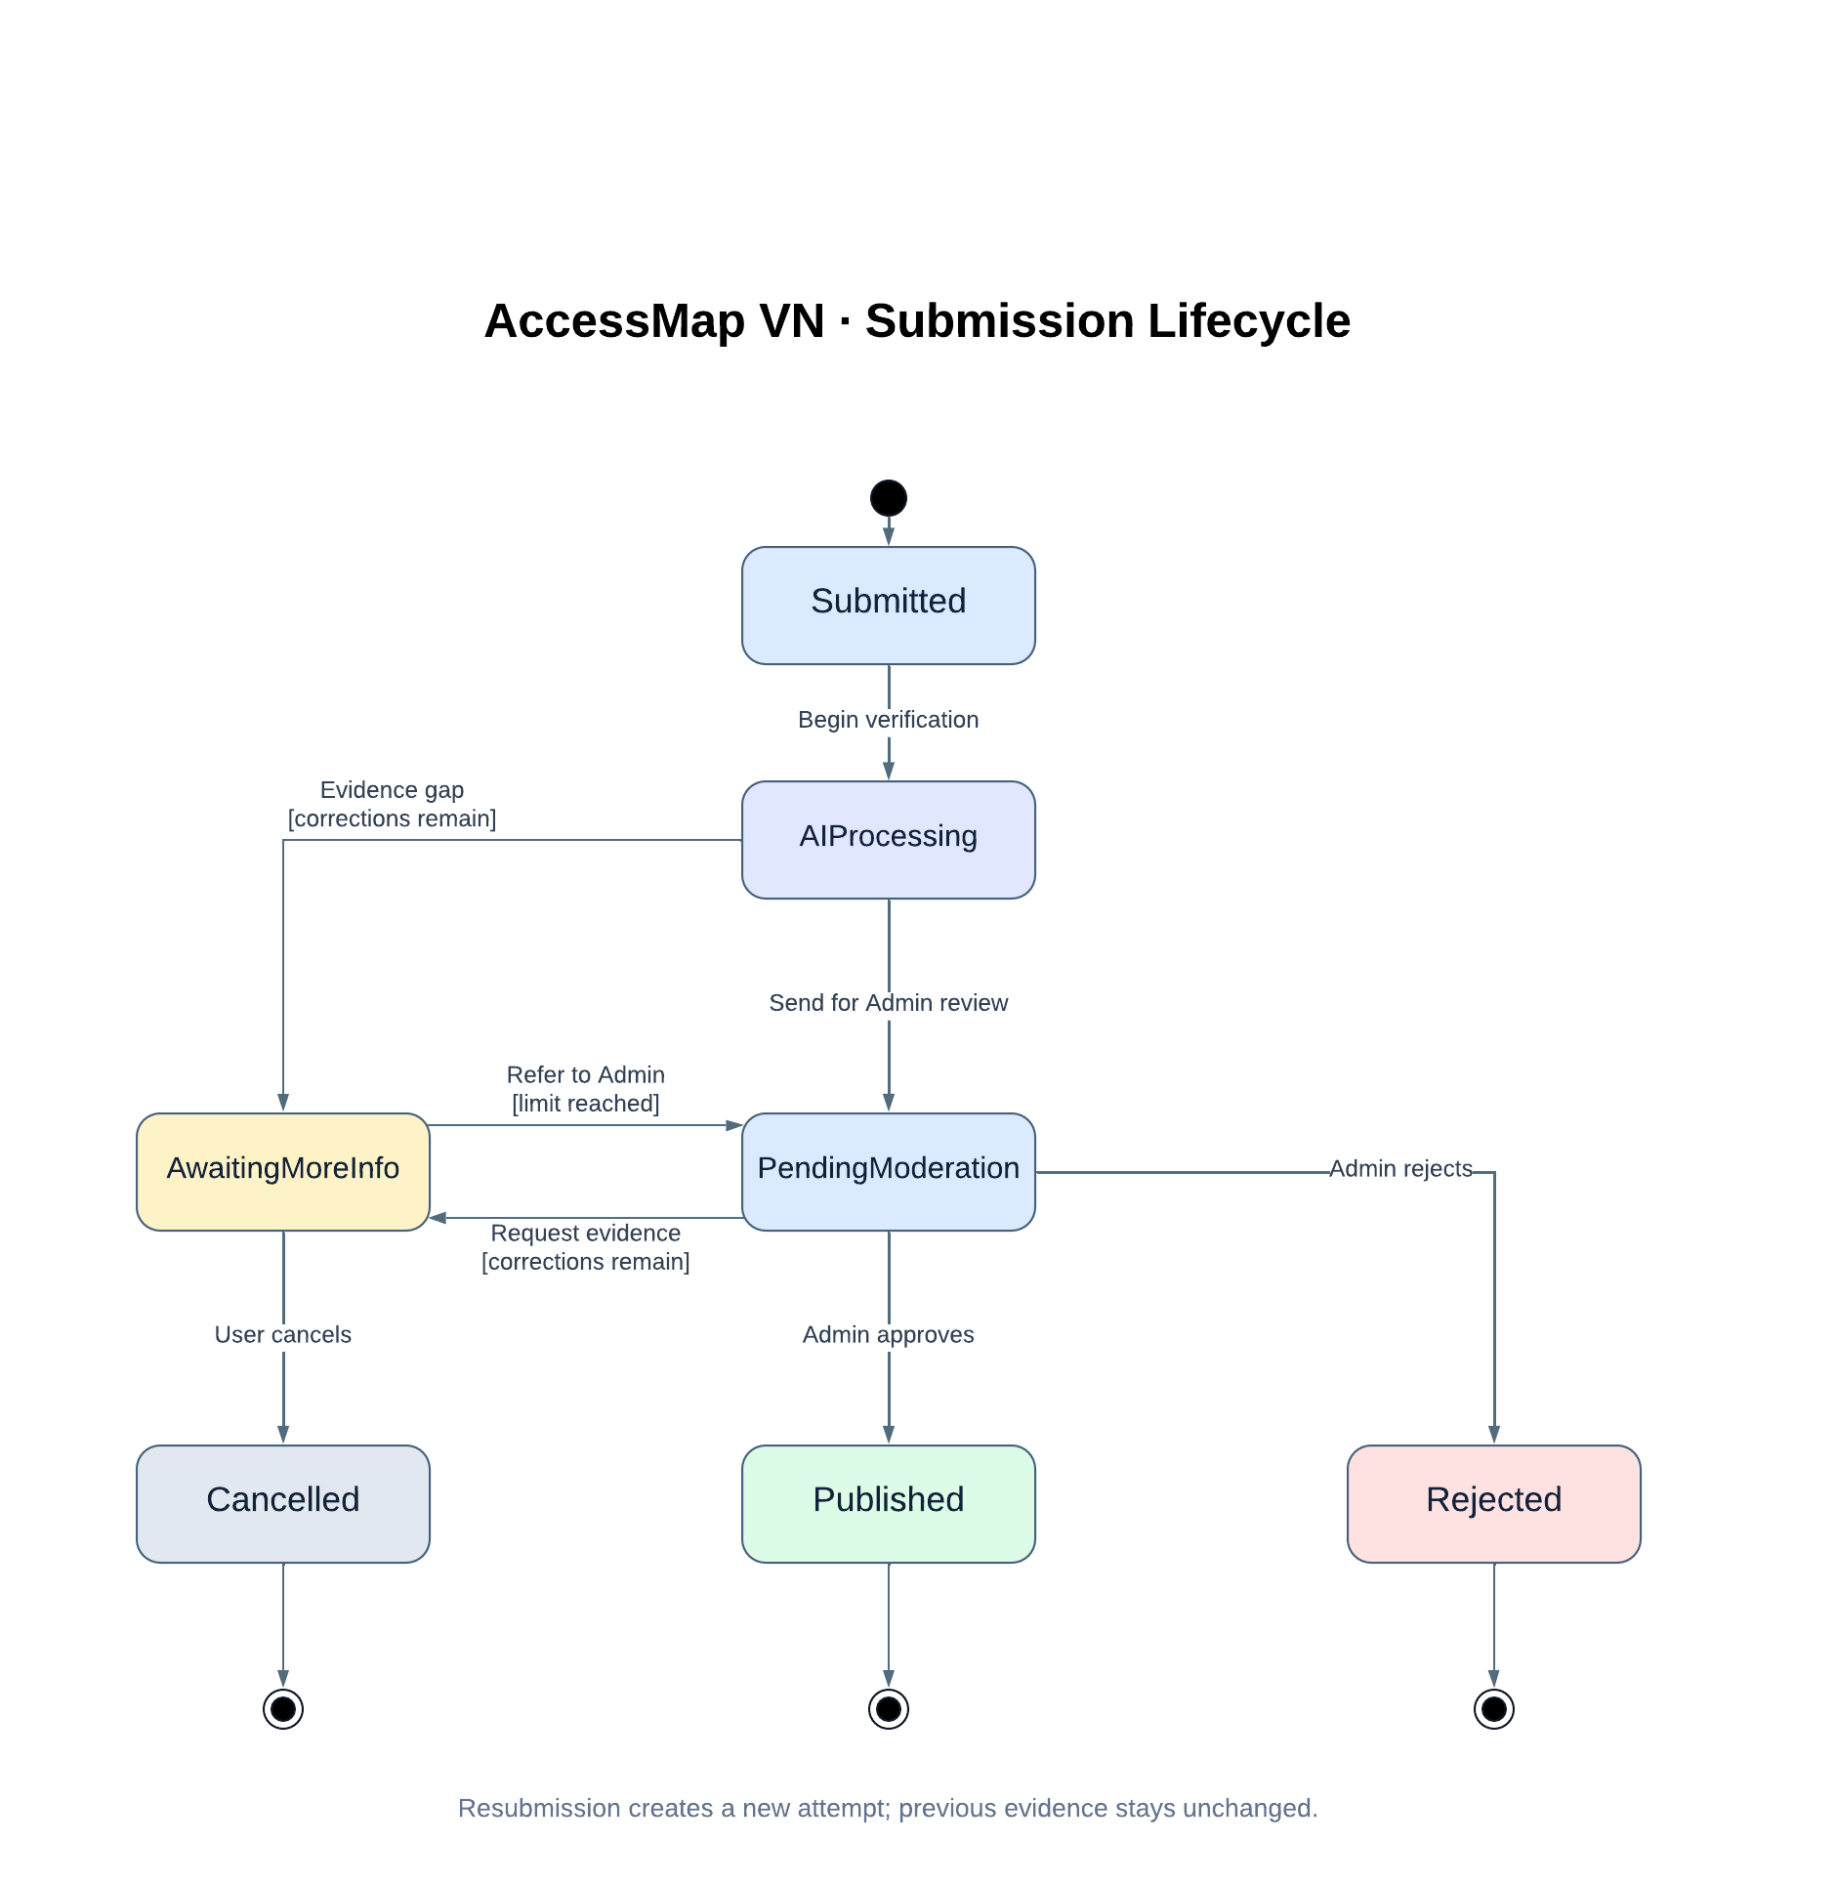
Figure 5.1 – Submission lifecycle
The dispute and report lifecycles below are taken from the community validation design.
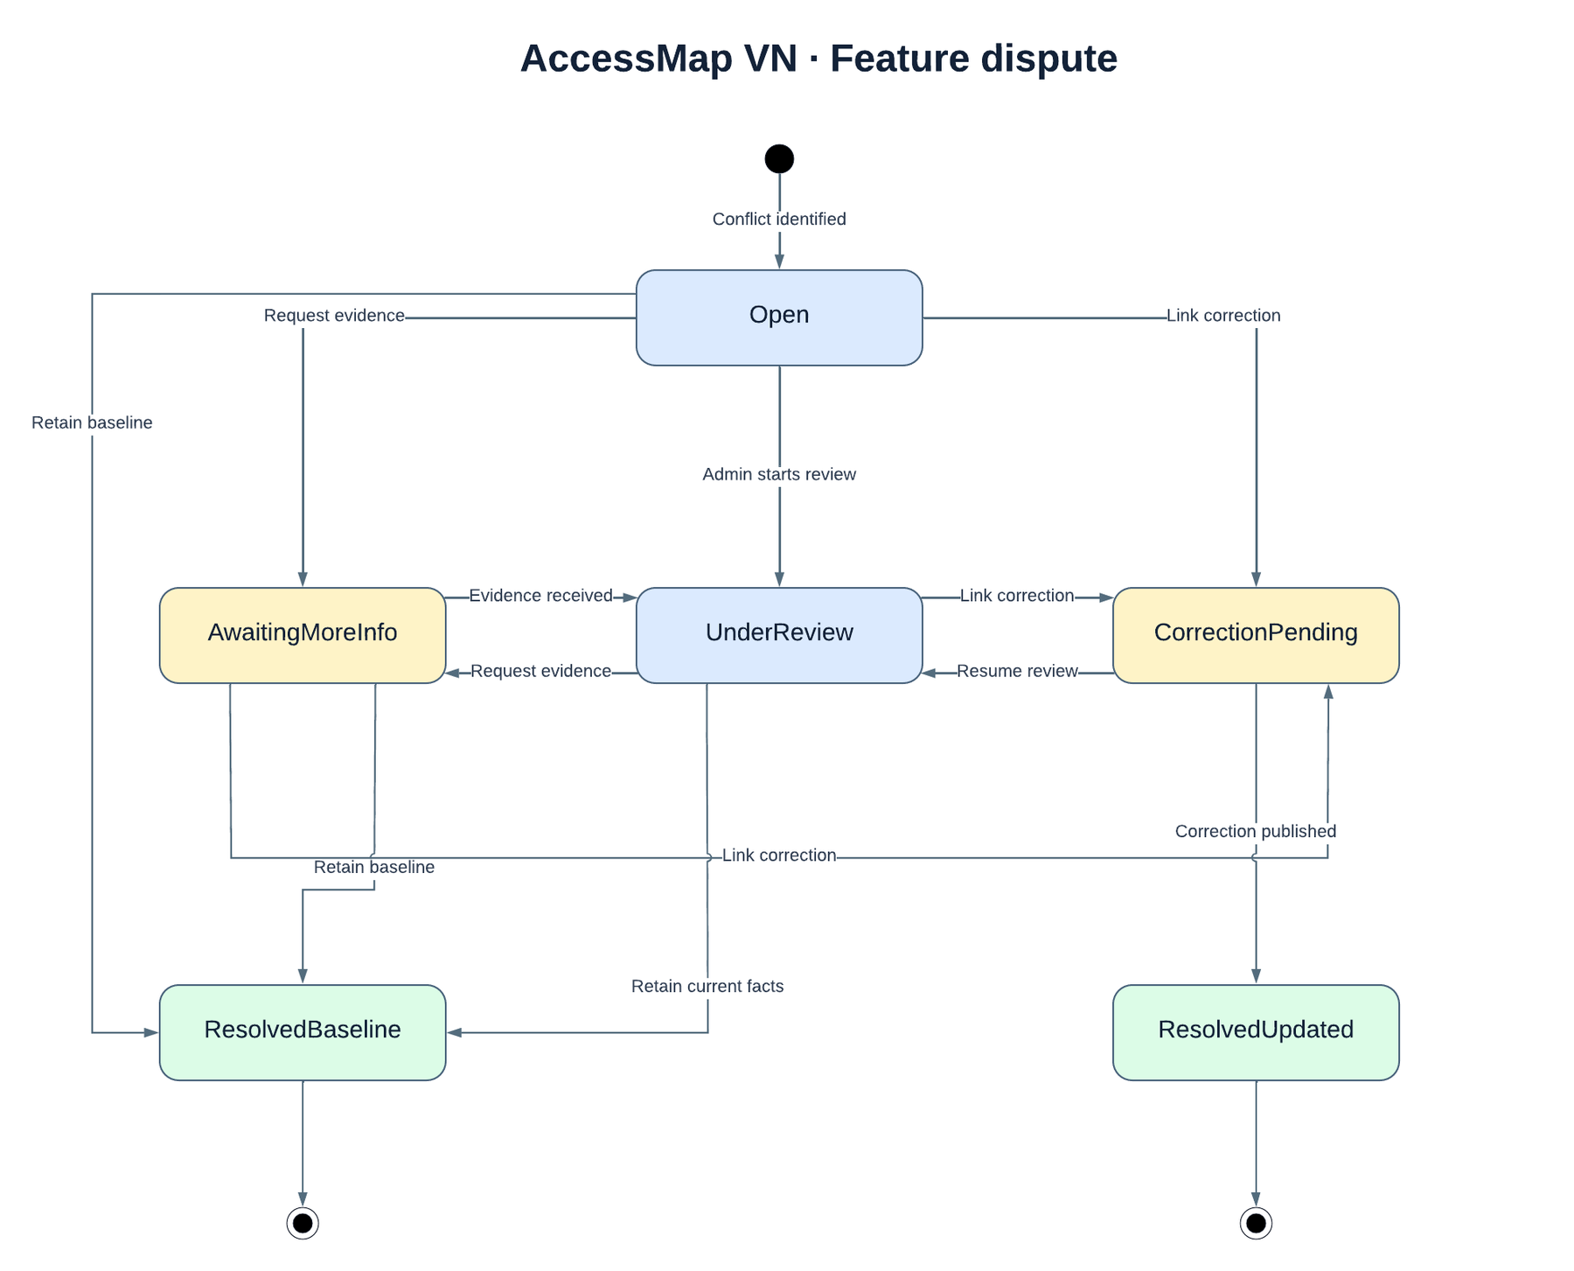
Figure 5.2 – Dispute case lifecycle
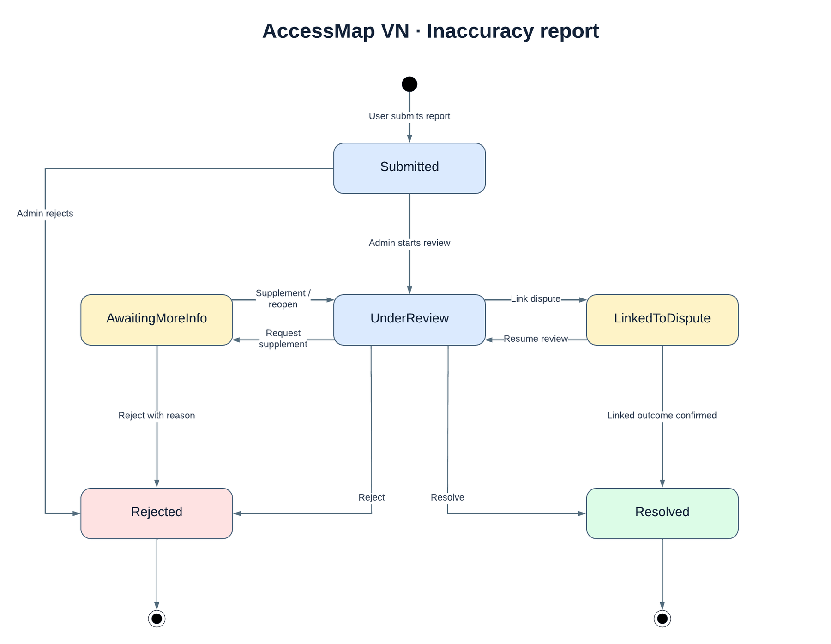
Figure 5.3 – Inaccuracy report lifecycle

5.4.2 Configuration defaults
Table 15 – Configuration defaults
Parameter | Value | Used in
Geofence: entrance / fallback by category | 50 m / 250, 100 or 50 m | BR-07
Mobile score weights (vision / text / proximity) | 50 / 20 / 30 | BR-09
AI weights (vision / NLP) | 60 / 40 | BR-08
AutoVerified / moderation thresholds | 90 / 60 | BR-10
Photo limits | 10 MB; 1 to 3 photos; 100 px minimum | BR-06
Video limits | MP4/H.264; 5-10 s; 30 MB; 240-4096 px | BR-06
Blur threshold (photo / video) | 80 / 20 | BR-06
Verification job retries | 2 | 3.4.5
RecheckAfterDays | 90 | BR-17
Vote recency half-life / agreement | 180 days / 90% | BR-16
Dispute minimum independent voters | 2 | BR-18
Advisory maximum duration | 60 days | BR-19
Points per published contribution / reputation per approval | 50 / 10 | BR-14

