Borot

Chat Bot Project

# System Description

## Borot

**Borot** is a Chat bot project that it is designed to accept raw string query and return user’s intent and relevant info that is queried from static database.

Borot is built based on 2 NLP/NLU ideas: **Name-Entity-Recognition NER** and **Intent-Classification IC**. Also, Borot is built upon **Python Flask server** to host Machine Learning models. Briefly, when users activates Borot by typing “command”, the raw “command” is feed into NER to detect proper entities (Location, Person, etc.) and to feed into IC to detect intents. The detected entities are used to search for relevant information in Database. The final output to the user is the combination of intent, proper entities, and queried relevant info. Also, Borot is designed as a server that accept JSON-format data for GET/POST requests for Questions-Answering. The Borot’s architecture is available in Figure 2.

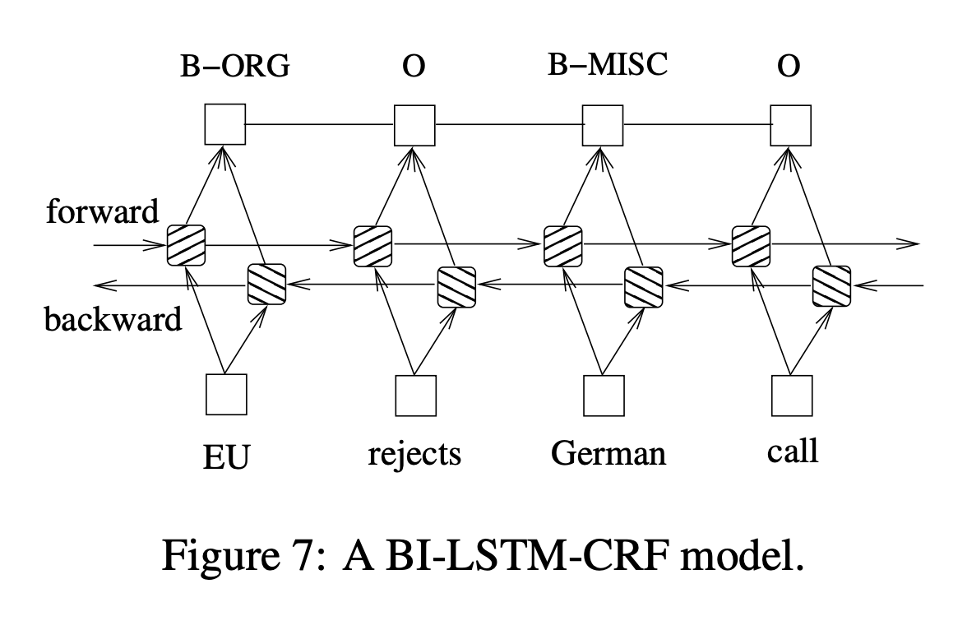

Figure 1 BiLSTM-CRF for NER

# Question & Answering Approach

The design goal of Borot is to accept query (question) and return answers (response). Hence, I attempted to implement as much as Machine Learning to help Borot to answer questions naturally. Hence, the Borot contains 3 core modules:

* Name Entity Recognizer NER
* Intent Classification IC
* Knowledge Base

## Name Entity Recognition NER

Name Entity Recognition is a NLP task to determine the proper entities (Location, Person, Time, etc.). Instead of using Dependency Parse, NER is implemented as a Deep Learning model (exactly name BiLSTM-CRF) following the research paper [1]. The model utilizes Bidirectional recurrent networks to extract Word Embeddings and classify each token for its potential entity. In the model, instead of TF-IDF (based on stats), Word Embeddings represent text as a vector for each token that it is optimized through training. The BiLSTM-CRF architecture is in Figure 1. The training and inference process is implemented in a separate Github repo that I implemented before Borot that is available [here](https://github.com/quocdat32461997/BiLSTM_CRF).

## Intent Classification IC

Intent Classification is a NLP task to determine the user’s intent in a sentence/conversation. I solved this task by training a standard Support-Vector-Machine classifier upon the dataset [2]. In [2], there are 150 predefined intents (fraud_report, book_hotel, book_flight). This model is trained based on Scikit-Learn with training-accuracy at 97% and validation & test accuracies around 80%. Overfitting exists here; which means that there is likely the model makes incorrect predictions.

## Knowledge Base

Knowledge base is implemented based on Term-Frequency and Inverse-Document Frequency (TF-IDF). TF-IDF is originally designed to select important keywords based on its popularity in the document and its sparsity across corpus. The 10 documents scrapped from CNET are stored and used to compute their TF-IDFs. Given TF-IDFs, they are used to extract documents consisting detected entities by sorting TF-IDF values. The knowledge base is stored into a Pandas DataFrame in order to reduce the project complexity that the reviewers may face difficulties in setting up Borot.

# References

[1] Bidirectional LSTM-CRF for Sequence Tagging, Huang et al. <https://arxiv.org/pdf/1508.01991v1.pdf>

[2] Stefan Larson, Anish Mahendran, Joseph J. Peper, Christopher Clarke, Andrew Lee, Parker Hill, Jonathan K. Kummerfeld, Kevin Leach, Michael A. Laurenzano, Lingjia Tang, and Jason Mars. 2019. An evaluation dataset for intent classification and out-of-scope prediction. In Proceedings of EMNLP-IJCNLP.

# Instructions

* Download NER model weight following this [link](https://drive.google.com/file/d/14jZElk4UlQp4u3-EHRX2eJ4uBUYgye3n/view?usp=sharing)
* Download [Postman](https://www.postman.com/) to make REQUEST to Borot after the last step.
* Unzip the weight model and put in the folder **borot/lib/borot_ai/BiLSTM_CRF**
* Go to folder having file **app.py.** Then, install dependencies by typing **pip3 install -re requirements.txt**
* Type **python3 app.py** to run the Borot

# Sample Interactions

* Initialize the new user by making POST request to [**http://127.0.0.1:5000/user**](http://127.0.0.1:5000/user)

with given JSON-format data:

REQUEST:

{

"first_name" : "Donal",

"last_name" : "Trump",

"email" : "president@us.com"

}

RESPONSE:

"Welcome to Borot"

* To place questions/command to Borot, making POST request to [**http://127.0.0.1:5000/ask**](http://127.0.0.1:5000/ask)with given JSON-format data

REQUEST:

{

"query" : "How are you"

}

RESPONSE:

{

"response": {

"Entities": {

"geo": [

"who"

],

"nat": [

"am"

],

"per": [

"i"

]

},

"Intent": "pto_request_status",

"Relevant_info": null

},

"status_code": 200

}

* The answer from Borot is in JSON format including:
  + Entities: Detected entities such as Geo (Location), Nat (country), and Per (proper name)
  + Intent: one of 150 predefined intents
  + Relevant info: either Null or text if found.

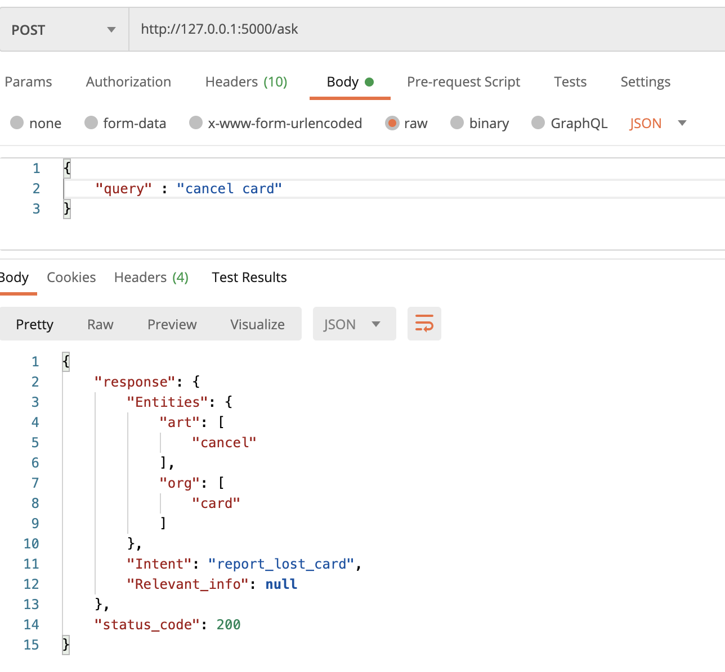

Figure 2 Interaction of Borot to query "cancel card"

# Evaluation

The chatbot I chose to implement is limited in terms of generating natural text response given questions. This is the challenging NLP problem. In order to improve the chatbot intelligence, it is a need to collect more data and perform training Machine Learning algorithms to help the chatbot detect intents better. Also, it is necessary to frequently update the knowledge base of the chatbot. Because the knowledge base serves as the answer of the chat bot the user.

## Comprehensive capabilities

The model is capable of detecting 150 intents and classifying 15 Name Entities thanks to NER and IC modules. These 2 modules are hosted within local server that could quickly perform tasks. The limit of the chatbot is when users make out-of-scope questions; that means users’ questions are not seen by the 2 NER and IC modules before. If that is the case, the chatbot may make irrelevant answers.

## Complexity

Borot is a complicated system that is embedded multiple Github repos that I created in the past. Also, the past Github repos I created are mostly for training Machine Learning with good validation performance. However, by observing the chatbot interactions, it performs worse. This could be explained due to the limited dataset when training Machine Learning.

## Speed

Despite a complex system, Borot is almost similar to current Chatbot systems (I believe) in terms of structure. NER and IC are 2 must-have steps in any chatbot systems. Despite the complexity, the model still response fast.

## User-Computer Interaction

As I designed Borot the chatbot as a local server, it requires users to perform RESTful requests that it is not user-friendly. It requires users to understand and know how to make REQUESTS to the server.

# Dependencies

* tensorflow==2.3.1
* numpy==1.18.5
* Flask==1.1.2
* pandas==1.1.3
* boto3==1.16.6
* tensorflow_addons==0.11.2
* nltk==3.5
* mysql_connector_repackaged==0.3.1
* scikit_learn==0.23.2

# Predefined Intent list

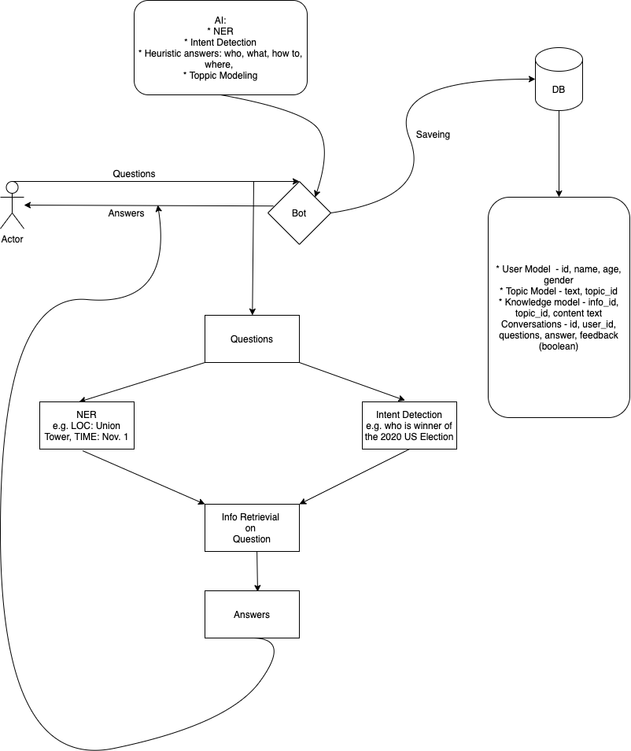

Figure 3 Architecture of Borot

1. play_music
2. next_song
3. application_status
4. plug_type
5. gas
6. order
7. credit_limit_change
8. directions
9. meaning_of_life
10. greeting
11. calculator
12. change_ai_name
13. insurance
14. reset_settings
15. weather
16. oil_change_how
17. date
18. pto_balance
19. reminder
20. todo_list
21. order_checks
22. yes
23. do_you_have_pets
24. spending_history
25. what_can_i_ask_you
26. maybe
27. rewards_balance
28. schedule_meeting
29. recipe
30. goodbye
31. cancel
32. mpg
33. report_lost_card
34. restaurant_suggestion
35. tell_joke
36. bill_due
37. book_flight
38. ingredients_list
39. change_accent
40. interest_rate
41. book_hotel
42. last_maintenance
43. what_is_your_name
44. international_visa
45. timer
46. expiration_date
47. direct_deposit
48. car_rental
49. card_declined
50. pin_change
51. account_blocked
52. user_name
53. definition
54. tire_pressure
55. calendar_update
56. smart_home
57. income
58. change_language
59. cook_time
60. accept_reservations
61. restaurant_reviews
62. meal_suggestion
63. w2
64. no
65. alarm
66. what_song
67. todo_list_update
68. transfer
69. thank_you
70. international_fees
71. measurement_conversion
72. freeze_account
73. spelling
74. new_card
75. transactions
76. pto_used
77. text
78. tire_change
79. find_phone
80. balance
81. replacement_card_duration
82. change_volume
83. where_are_you_from
84. food_last
85. ingredient_substitution
86. next_holiday
87. change_speed
88. what_are_your_hobbies
89. exchange_rate
90. timezone
91. apr
92. translate
93. uber
94. reminder_update
95. traffic
96. travel_notification
97. damaged_card
98. bill_balance
99. flight_status
100. whisper_mode
101. gas_type
102. fun_fact
103. improve_credit_score
104. routing
105. time
106. travel_alert
107. pay_bill
108. taxes
109. meeting_schedule
110. order_status
111. payday
112. sync_device
113. oos
114. schedule_maintenance
115. lost_luggage
116. update_playlist
117. calories
118. distance
119. roll_dice
120. nutrition_info
121. change_user_name
122. cancel_reservation
123. pto_request
124. jump_start
125. travel_suggestion
126. share_location
127. are_you_a_bot
128. rollover_401k
129. redeem_rewards
130. shopping_list_update
131. who_made_you
132. who_do_you_work_for
133. min_payment
134. credit_limit
135. how_busy
136. report_fraud
137. carry_on
138. insurance_change
139. pto_request_status
140. how_old_are_you
141. confirm_reservation
142. shopping_list
143. repeat
144. flip_coin
145. calendar
146. restaurant_reservation
147. oil_change_when
148. vaccines
149. current_location
150. credit_score
151. make_call

Borot is tested and run well on MacOS system. If you encounter any difficulty on running Borot. Please contract me.