Dinosaurs!

Introduction
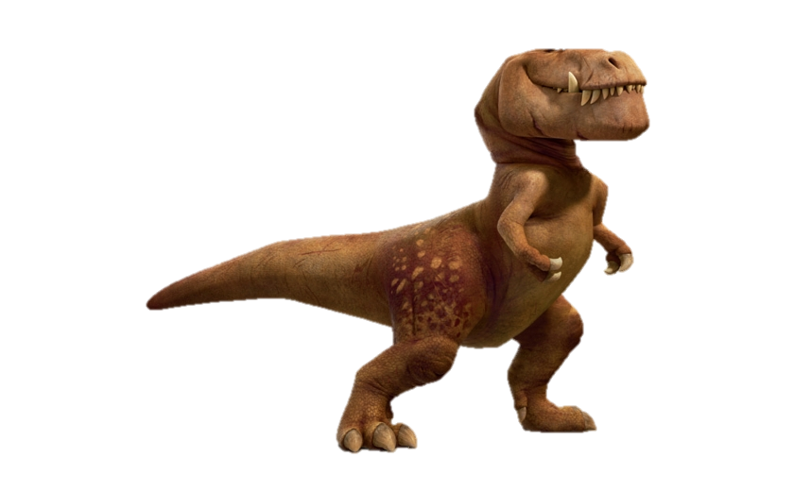
Dinosaurs were the main animals on Earth for more than 150 million years. They were lizard like reptiles. Some of them were the largest and scariest creatures that ever walked on land. The word dinosaur comes from Greek words meaning “terrible lizard.”
The last dinosaurs became extinct, or died out, about 65.5 million years ago. Fossils of dinosaurs were first discovered in the early 1800s. Fossils are remains or impressions of a plant or animal that have been preserved in rock.

When and Where Dinosaurs Lived
The study of the history and physical features of Earth is called geology. Earth began forming about 4.6 billion years ago. Earth underwent many changes from then until the present. Geologists call this vast time period geologic time. They break geologic time into smaller time periods.
Dinosaurs lived throughout the world, and their fossils have been found on every continent. They lived in all different kinds of environments as well, ranging from tropical forests to dry, sandy deserts.

Extinction
The last dinosaurs died out about 65.5 million years ago. Scientists still do not agree about why this happened. Some scientists think that dinosaurs died out because the temperature on Earth got too hot or too cold for them. Others believe that a huge asteroid collided with Earth. The collision could have produced dust that blocked the Sun’s heat and light for months or even years. Plants would have stopped growing, and plant-eating dinosaurs would have died from lack of food. So would have the meat eaters that hunted them.
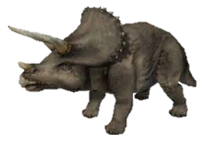
Some animals lived through the time when the dinosaurs disappeared. The ancestors of today’s frogs, turtles, lizards, and snakes found a way to survive. Birds also survived. Scientists do not know why some animals lived but the dinosaurs did not.

Physical Features and Behavior
Dinosaurs were all different sizes. Some dinosaurs were smaller than a chicken. Others weighed as much as 100 tons—more than 10 times as much as the largest elephants.

Saurischian Dinosaurs
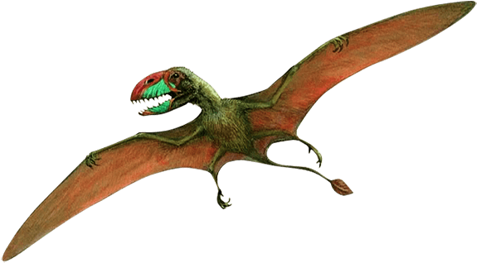
The saurischians had hips that look like the hips of today’s reptiles. But they also had some features in common with today’s birds. In fact, scientists believe that the saurischians are more closely related to birds than to some other dinosaurs. The earliest bird, Archaeopteryx, was a saurischian. The saurischians are divided into the meat-eating theropods and the plant-eating sauropods.

Sauropods
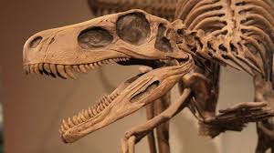
Sauropods were not only the largest of all dinosaurs. They were also the largest land animals that ever lived. Sauropods were plant eaters that walked on four legs. Brachiosaurus, Diplodocus, and Apatosaurus are examples of sauropods.
Sauropod Dinosaurs | Apatosaurus
 | Brachiosaurus
 | Diplodocus
 | Giraffatitan
 | Jobaria
 | Macrurosaurus
 | Mamenchisaurus
 | Seismosaurus
 | Zigongosaurus

Sauropods had a very small head and brain when compared to their huge body. But they had a long neck, which let them reach leaves on even the tallest trees. They had thick, strong legs, like those of an elephant. Many sauropods probably could stand up on their back legs to reach even higher into the trees. They used their long, muscular tail to balance themselves when standing. Some sauropods also might have used the tail as a whiplike weapon.

Theropods
The theropods include all the meat-eating dinosaurs. Among them is the fierce Tyrannosaurus rex, which weighed as much as 8 tons. Giganotosaurus and Spinosaurus were even larger. Theropods walked on their two back legs. Most of them were built to hunt. They used their short front arms to catch and tear prey. Their fingers and toes had long, sharp claws. They had powerful jaws and sharp teeth for tearing flesh.
Theropods normally hunted alone. They caught and ate smaller, plant-eating dinosaurs. Sometimes they hunted in groups and attacked larger dinosaurs.

Ornithischian Dinosaurs
Many of the ornithischian dinosaurs had special features. Some, such as Triceratops, had horns like a modern rhinoceros. Euoplocephalus had a huge club at the end of its tail. Stegosaurus had large, triangular bony plates sticking out of its back.
- Description
  - "Bird-hip”
  - Predentary
  - Other characteristics
  - Developed a narrow eyebrow
    - Had reduced, or even closed-off, antorbital fenestrae
    - Had "leaf-shaped" cheek teeth.
- Classification
  - Fabrosauridae: is not a natural grouping of dinosaurs, and instead consist of unrelated genera.
  - Description: were relatively small ornithischian dinosaurs, averaging about 1–2 meters in body length

Geologic eras
This table incredibly long period of time, measured in "millions of years ago," saw the development of dinosaurs, marine reptiles, fish, mammals, flying animals. The largest dinosaurs did not emerge until the Cretaceous period, which started over 100 million years after the start of the "age of dinosaurs."
1. Triassic: 251–201 million years ago
2. Jurassic: 201–145 million years ago
3. Cretaceous: 145–66 million years ago
4. Cenozoic: 66 million years ago.
Dinosaur | Geologic Period
Plateosaurus | 2.Jurassic
Presbyornis | 4.Cenozoic
Barosaurus | 2.Jurassic
Coleophysis | 1.Triassic
Ornitholestes | 2.Jurassic
Camarasaurus | 2.Jurassic
Albertosaurus | 3.Cretaceous
Diplodocus | 2.Jurassic
Diatryma | 4.Cenozoic
Ankylosaurus | 3.Cretaceous
Allosaurus | 2.Jurassic

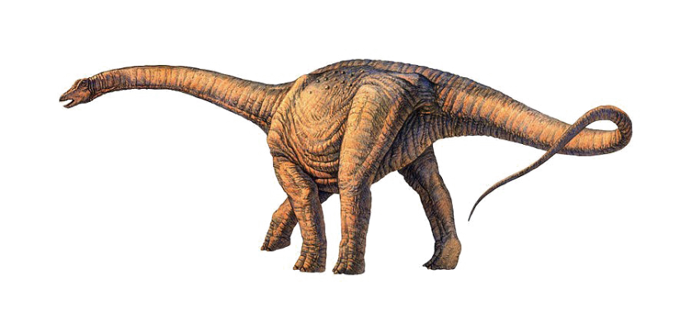

Life Cycle
Most, if not all, dinosaurs laid eggs. Some dinosaurs built large nests to keep their babies together. Young dinosaurs grew very fast. Many reached full size in seven or eight years. Large dinosaurs might have lived almost 100 years.

Kids love dinosaurs
Kids who love dinosaurs have higher intelligence; study suggests. Children with an 'intense interest' in dinosaurs may have a higher intelligence level, a report has found. If you know a little one that is obsessed with prehistoric animals, then it may be that they're an extremely smart child.

