Tesla, Inc.
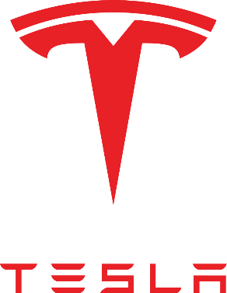
Tesla, Inc. is an American electric vehicle and clean energy company based in Austin, Texas, United States.
Tesla designs and manufactures electric cars, battery energy storage from home to grid-scale, solar panels and solar roof tiles, and related products and services. Tesla is one of the world's most valuable companies and remains the most valuable automaker in the world with a market cap of nearly $1 trillion. The company had the most sales of battery electric vehicles and plug-in electric vehicles, capturing 16% of the plug-in market (which includes plug-in hybrids) and 23% of the battery-electric (purely electric) market. Through its subsidiary Tesla Energy, the company develops and is a major installer of photovoltaic systems in the United States. Tesla Energy is also one of the largest global suppliers of battery energy storage systems, with 3 gigawatt-hours (GWh) installed in 2020.
Founded in July 2003 by Martin Eberhard and Marc Tarpenning as Tesla Motors, the company's name is a tribute to inventor and electrical engineer Nikola Tesla. In February 2004, via a US$6.5 billion investment, X.com co-founder Elon Musk became the largest shareholder of the company and its chairman. He has served as CEO since 2008. According to Musk, the purpose of Tesla is to help expedite the move to sustainable transport and energy, obtained through electric vehicles and solar power. Tesla began production of its first car model, the Roadster, in 2009. This was followed by the Tesla Model S sedan in 2012, the Tesla Model X SUV in 2015, the Tesla Model 3 sedan in 2017, and the Tesla Model Y crossover in 2020. The Tesla Model 3 is the all-time best-selling plug-in electric car worldwide, and, in June 2021, became the first electric car to sell 1 billion units globally.{ Tesla's global vehicle sales were 499,550 units in 2020, a 35.8% increase over the previous year. In October 2021, Tesla's market capitalization reached US$1 trillion, the sixth company to do so in U.S. history.
Tesla has been the subject of several lawsuits and controversies arising from statements and acts of CEO Elon Musk and from allegations of creative accounting, whistleblower retaliation, worker rights violations, and unresolved and dangerous technical problems with their products. In September 2021, the National Highway Traffic Safety Administration (NHTSA) ordered Tesla to submit data pertaining to all sold US vehicles equipped with Autopilot.

Technology
Tesla develops many components in-house, such as batteries, motors, and software.
- Vehicle batteries
- Motors
- Autopilot
- Full self-driving
- Glass

Partners
Tesla's major partner is Panasonic, which is the main developer of battery cells for the company.
Panasonic
Panasonic Energy Company President Naoto Noguchi presented Tesla CTO JB Straubel with the first lithium-ion cells from Panasonic's facility in Suminoe-ku, Osaka, Japan, 2010.
Tesla and Panasonic also collaborated on the manufacturing and production of photovoltaic (PV) cells and modules at the Giga New York factory in Buffalo, New York. The partnership started in mid-2017 and ended in early 2020, before Panasonic exited the solar business entirely in January 2021.
In March 2021, the outgoing CEO of Panasonic stated that the company plans to reduce its reliance on Tesla as their battery partnership evolves.
Other current partners
In September 2020, Tesla signed a sales agreement with Piedmont Lithium to buy high-purity lithium ore for up to ten years, specifically to supply "spodumene concentrate from Piedmont's North Carolina mineral deposit".
Tesla also has a range of minor partnerships, for instance working with Airbnb and hotel chains to install destination chargers at selected locations.

Summary of main facilities

