top 5 Best Places To Visit
Jun 3, 2021
More people are being vaccinated every day and travel is already top of mind. Suddenly, the whole world feels in reach again, even if travel restrictions haven’t quite been lifted yet.
Most travel experts expect travel to re-open incrementally rather than all at once. We’ll see some countries loosening restrictions early on and others late to follow. At your destination, attractions and local protocols will change in phases, too.
Remember, even if you’re vaccinated, not everyone else will be when you arrive at your destination.

Alentejo, Portugal
You’ll find one stunning landscape after another in the mostly rural Alentejo province of Portugal. With soft hills and calm-inducing sunsets, you’ll find an easy-going culture and not a lot of stress (exactly what you need after the year we’ve had).
Take things in slowly by cycling past beaches, lighthouses and fishing villages—or head inland for wineries, castles and farmers’ markets. Rent bikes in Évora and design your own route or book a complete package to have luggage transfers and accommodations taken care of for you.

Algeria
Sitting along the Mediterranean, Algeria offers incredible Roman ruins without any of the crowds. As if that’s not enough, you can also head into the Sahara Desert or Hoggard Mountains to add a dose of nature to your adventure.
Visas are required for entry, but a little paperwork is worth it for access to 7 UNESCO World Heritage Sites and heart-warming hospitality.

Alta, Norway
Known as the “aurora borealis city”, Alta offers conditions just right for northern lights hunting. Activity is high and, unlike other Scandinavian destinations, it offers a disproportionate number of clear nights for viewing. There are even “arctic dome” hotels (high-end glamping tents with transparent walls) that are friendlier on your wallet than glass igloos in other locales.
When you’re this far north, aurora season is longer than you might expect, stretching from September through March. Still, a winter visit is recommended so you can enjoy dog-sledding, snowshoeing and reindeer sleigh rides while you’re there.

Arkansas’ Ozarks
Natural beauty abounds in the northwest corner of Arkansas, where you’ll find the Ozark Mountains. This is one of the largest wilderness areas in the eastern United States, so it’ll come as no surprise that there are plenty of opportunities for hiking, mountain biking and other activities.

Assam, India
Assam is closer to the Himalayas than the Taj Mahal, which keeps this part of India decidedly off-the-beaten-track. Ecotourism is the main reason to visit, with wild animals a surprising draw. You can search for an Indian one-horned rhinoceros at Kaziranga National Park or explore evergreen forest at the Hoollongapar Gibbon Sanctuary.
The same fertile ground that makes it a good home for wildlife also makes the region ideal for agriculture. Add a tea plantation to your stay. The estates are beautiful and can be a great way to enjoy some of the smaller villages in northeast India.

RELATED TOPICS
- Cheap travel destinations
- Best places to vacation
- Places to travel in 2022
- End of season winter vacation offers
- Top 10 tourist destinations
- 10 best travel destinations
- Top travel destinations
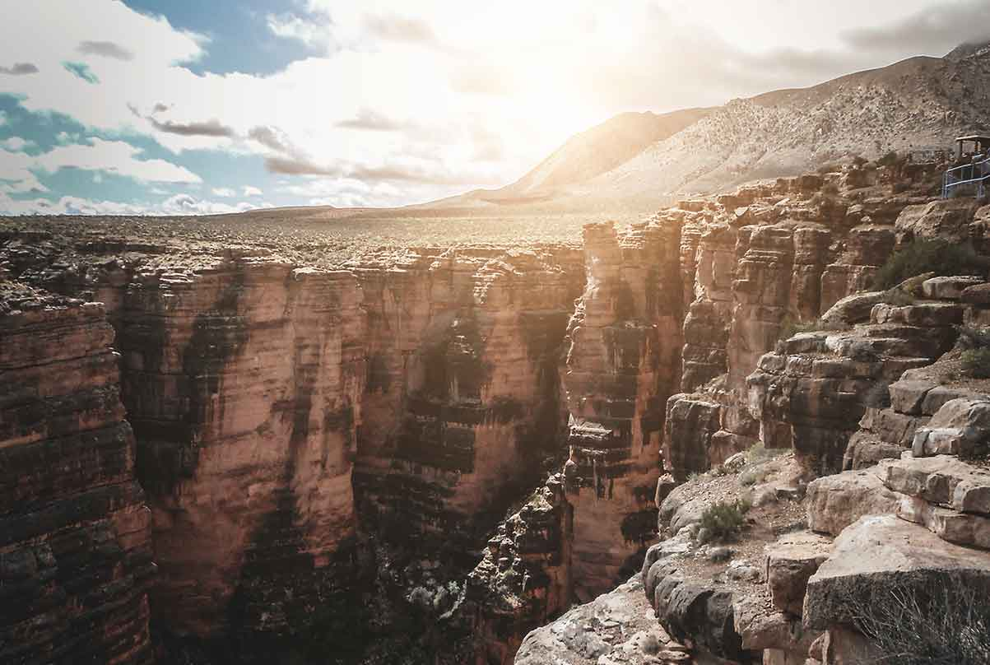
- Best places for solo travel
By: Becky Pokora, Caroline Lupini
Last updated in Jun 3, 2021

