BT3

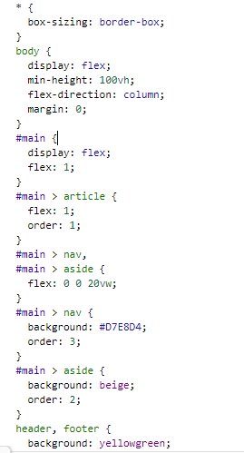

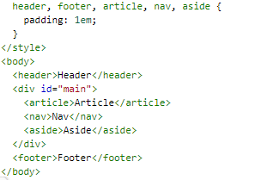

BT4

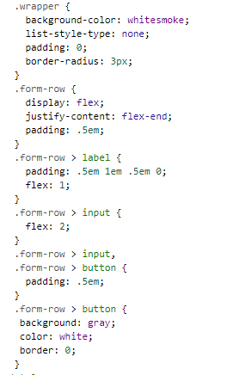

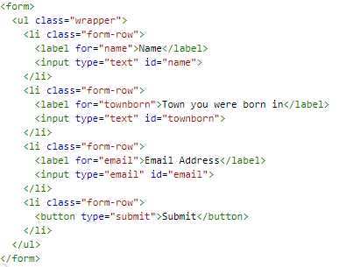

BT5

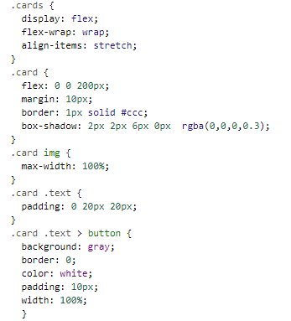

<main class="cards">

<article class="card">

<img src="[chọn nguồn hình của bạn]" alt="Sample photo">

<div class="text">

<h3>Seamlessly visualize quality</h3>

<p>Collaboratively administrate empowered markets via plug-and-play networks.</p>

<button>Here's why</button>

</div>

</article>

<article class="card">

<img src=" chọn nguồn hình của bạn " alt="Sample photo">

<div class="text">

<h3>Completely Synergize</h3>

<p>Dramatically engage seamlessly visualize quality intellectual capital without superior collaboration and idea-sharing.</p>

<button>Here's how</button>

</div>

</article>

<article class="card">

<img src=" chọn nguồn hình của bạn " alt="Sample photo">

<div class="text">

<h3>Dynamically Procrastinate</h3>

<p>Completely synergize resource taxing relationships via premier niche markets.</p>

<button>Read more</button>

</div>

</article>

<article class="card">

<img src=" chọn nguồn hình của bạn " alt="Sample photo">

<div class="text">

<h3>Best in class</h3>

<p>Imagine jumping into that boat, and just letting it sail wherever the wind takes you...</p>

<button>Just do it...</button>

</div>

</article>

<article class="card">

<img src=" chọn nguồn hình của bạn " alt="Sample photo">

<div class="text">

<h3>Dynamically innovate supply chains</h3>

<p>Holisticly predominate extensible testing procedures for reliable supply chains.</p>

<button>Here's why</button>

</div>

</article>

<article class="card">

<img src=" chọn nguồn hình của bạn " alt="Sample photo">

<div class="text">

<h3>Sanity check</h3>

<p>Objectively innovate empowered manufactured products whereas parallel platforms.</p>

<button>Stop here</button>

</div>

</article>

</main>

Bt6.

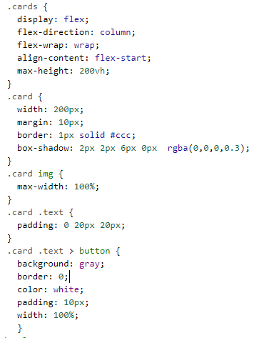

<main class="cards">

<article class="card">

<img src="chọn nguồn hình của bạn " alt="Sample photo">

<div class="text">

<h3>Seamlessly visualize quality</h3>

<p>Collaboratively administrate empowered markets via plug-and-play networks.</p>

<button>Here's why</button>

</div>

</article>

<article class="card">

<img src=" chọn nguồn hình của bạn " alt="Sample photo">

<div class="text">

<h3>Completely Synergize</h3>

<p>Dramatically engage seamlessly visualize quality intellectual capital without superior collaboration and idea-sharing.</p>

<button>Here's how</button>

</div>

</article>

<article class="card">

<img src="/ chọn nguồn hình của bạn " alt="Sample photo">

<div class="text">

<h3>Dynamically Procrastinate</h3>

<p>Completely synergize resource taxing relationships via premier niche markets.</p>

<button>Read more</button>

</div>

</article>

<article class="card">

<img src="/ chọn nguồn hình của bạn " alt="Sample photo">

<div class="text">

<h3>Best in class</h3>

<p>Imagine jumping into that boat, and just letting it sail wherever the wind takes you...</p>

<button>Just do it...</button>

</div>

</article>

<article class="card">

<img src="/ chọn nguồn hình của bạn " alt="Sample photo">

<div class="text">

<h3>Dynamically innovate supply chains</h3>

<p>Holisticly predominate extensible testing procedures for reliable supply chains.</p>

<button>Here's why</button>

</div>

</article>

<article class="card">

<img src="/ chọn nguồn hình của bạn " alt="Sample photo">

<div class="text">

<h3>Sanity check</h3>

<p>Objectively innovate empowered manufactured products whereas parallel platforms.</p>

<button>Stop here</button>

</div>

</article>

</main>