Step by step execution Demo application

1. Open cmd and navigate to the project folder. Then, execute “mvnw”  
   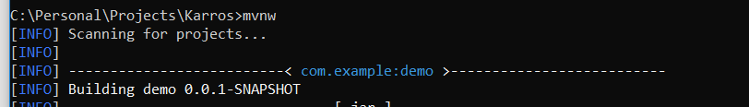
2. Wait a bit until you see “Started Demo application in… ”  
   
3. Open browser and navigate to following URL: localhost:9080. You will see a screen to upload file  
   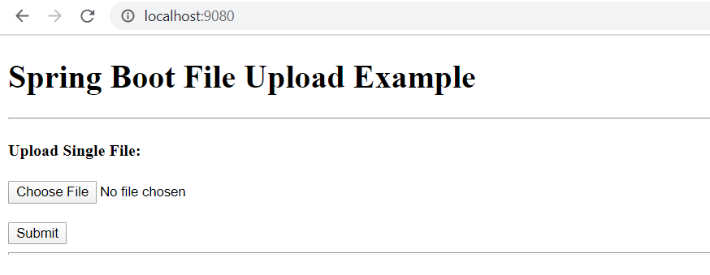
4. Browse “sample.gpx” file using “Choose File” button and click “Submit” button  
   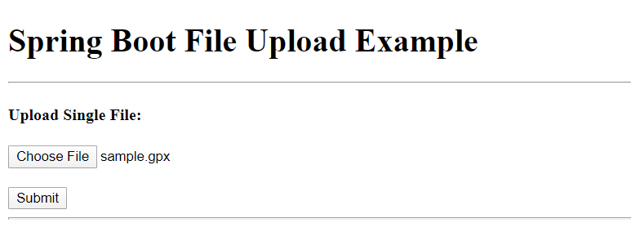
5. You will see the success message below  
   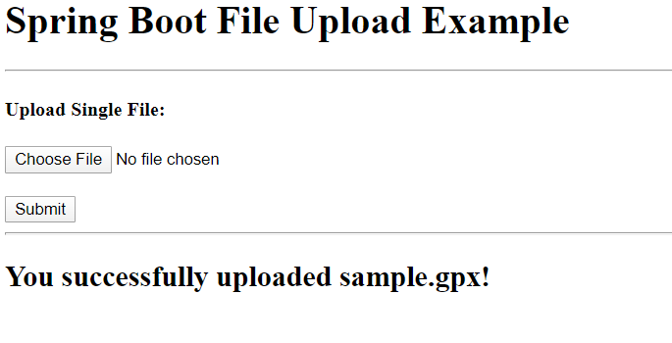
6. Navigate to h2 console to check inserted data  
   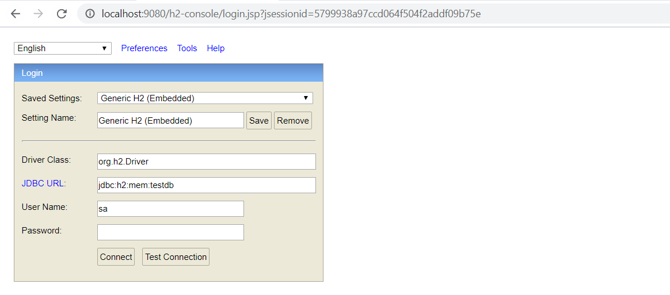  
   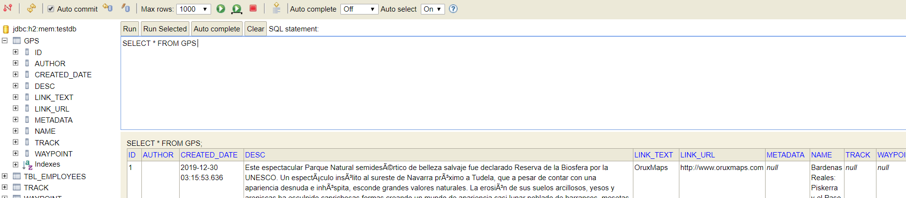  
   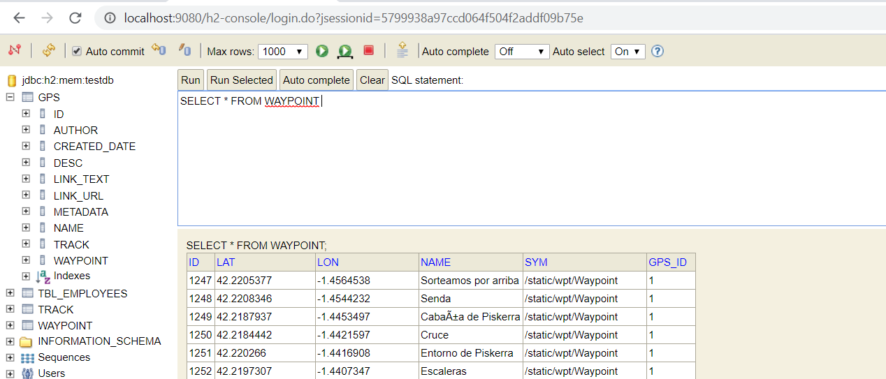  
   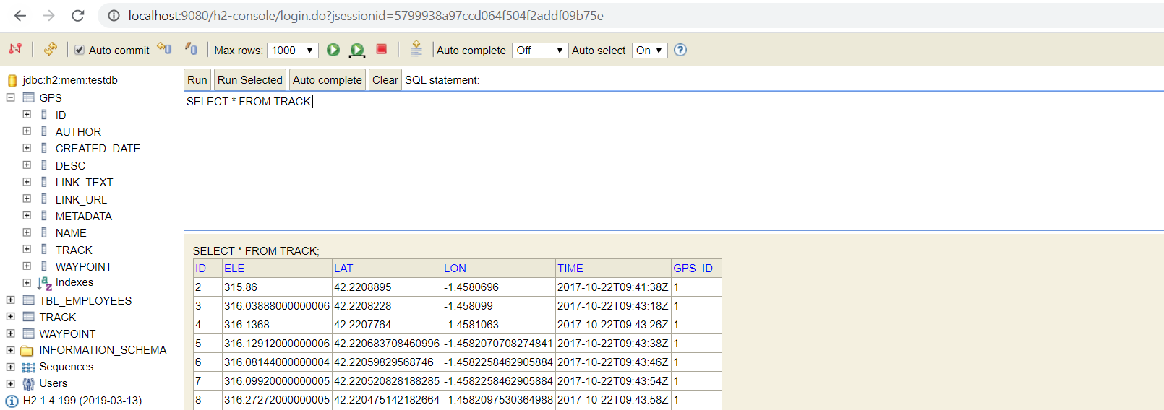
7. Navigate to ***localhost:9080/tracks*** to get data of recently tracks (default is top 10 items)  
   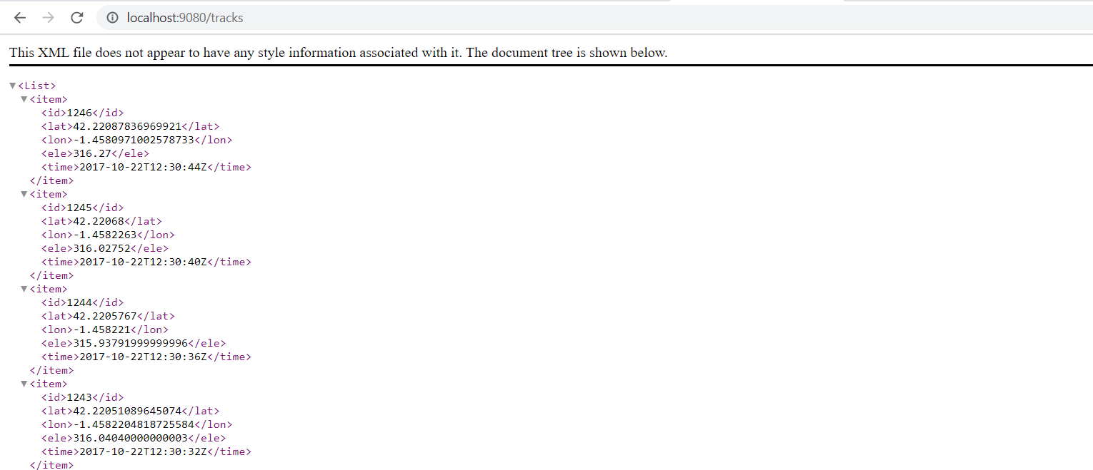
8. Navigate to ***localhost:9080/gps/1*** to get detail of a gpx file (id = 1)  
   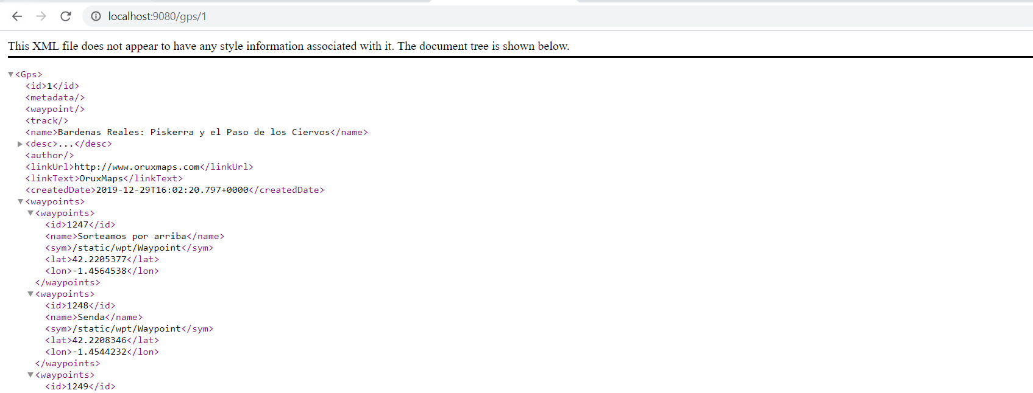

**Some notes:**

* The unit tests are under src/test/java. They cover the logic of some services and controllers but not all of them due to time limitation
* The exception handling is not implemented in this project.
* There are some TODO notes in source code for improvement later.
* The code is not cleaned up and JavaDoc is not put on every class/method/variable.
* There are a lot of assumptions when doing this exercise.