Instructions

**Prerequisites**

* Java 8
* Maven
* Docker (The image is at: https://hub.docker.com/repository/docker/quocfx/stablyproject)

**Configure**

1. Open “[PROJECT_ROOT]/src/main/resources/globalconfig.properties”, and make sure value of globalconfig.host is correct.

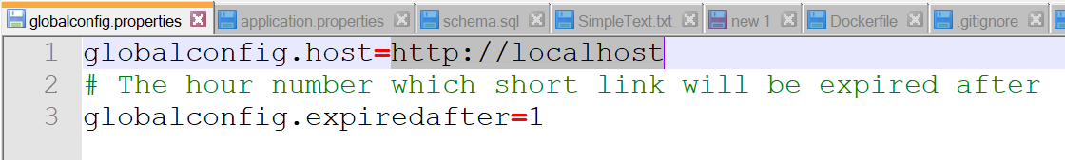

1. Open “[PROJECT_ROOT]/src/main/resources/ application.properties”, and make sure value of server.port is correct.

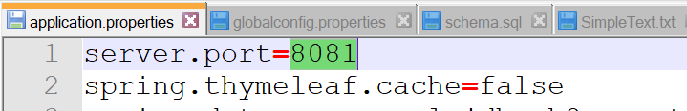

**Deploy project using Maven wrapper**

1. Open a terminal and navigate to [PROJECT_ROOT] folder. Then, execute “mvnw”  
   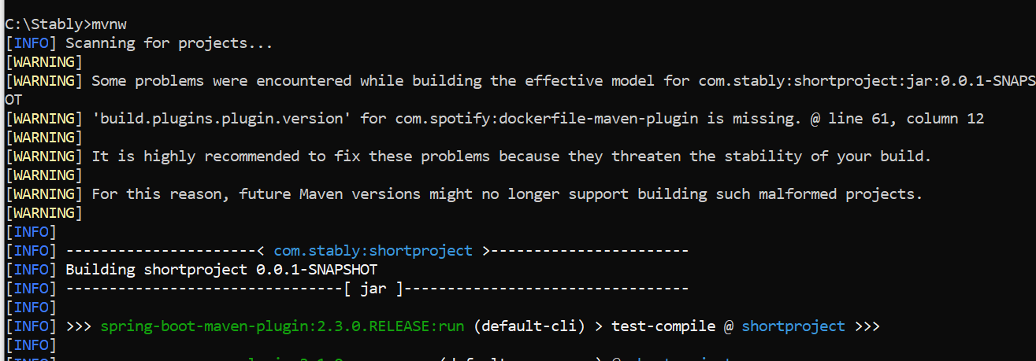
2. Wait a bit until you see “Started Shortproject Application in… ”  
   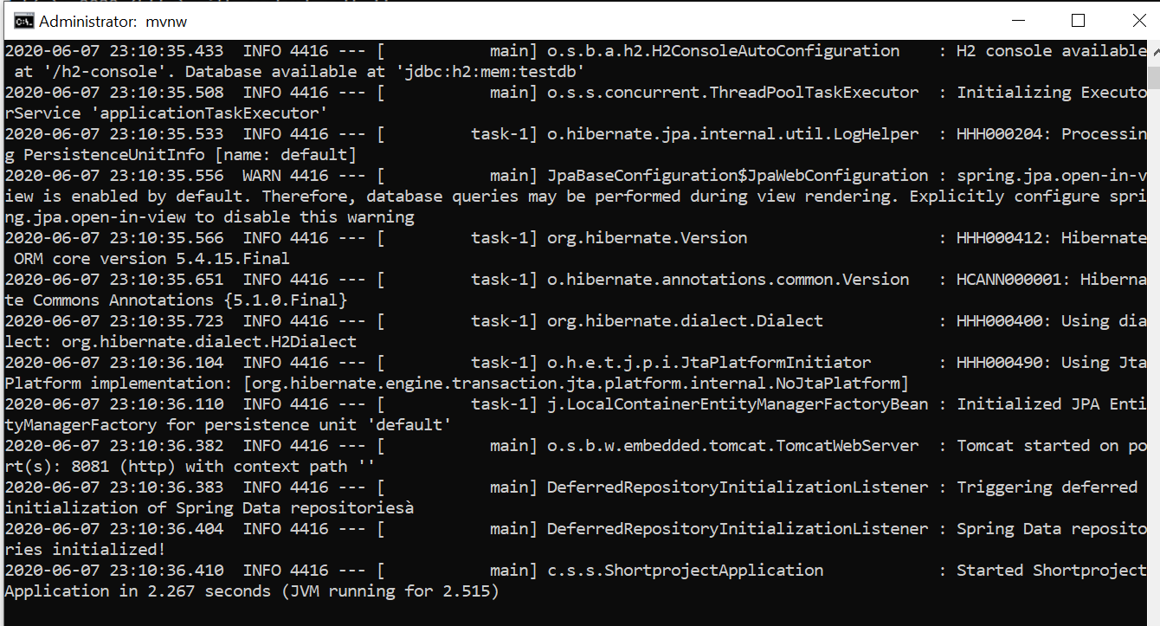
3. Open browser and navigate to following URL: localhost:8081 (the value should be the same as value on step#1 and step#2). You will see a screen below:  
   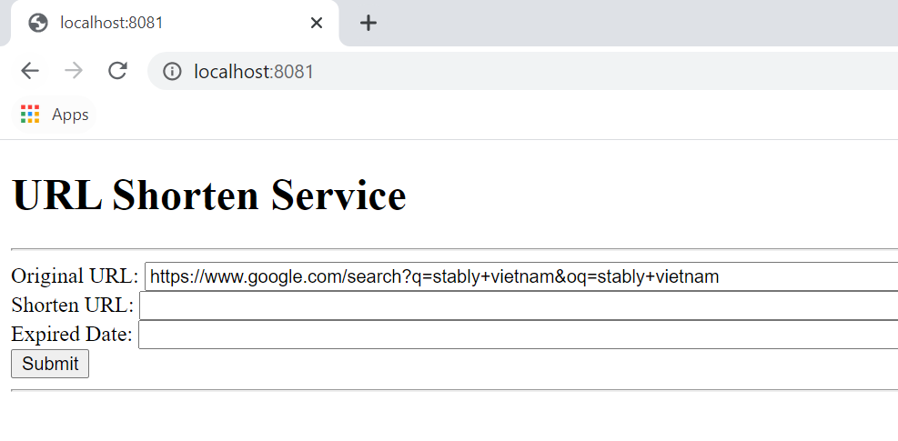
4. Input an URL on “Original URL” and click “Submit” button. We will have “Shorten URL” and “Expired Date”  
   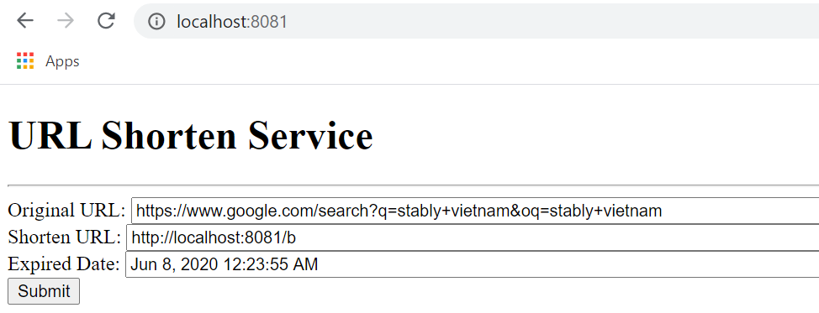
5. Input “Shorten URL” value into browser address and “Enter”. The browser will redirect to original URL  
   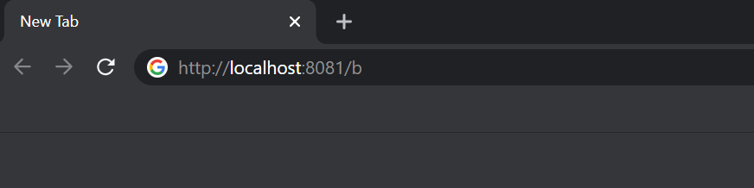

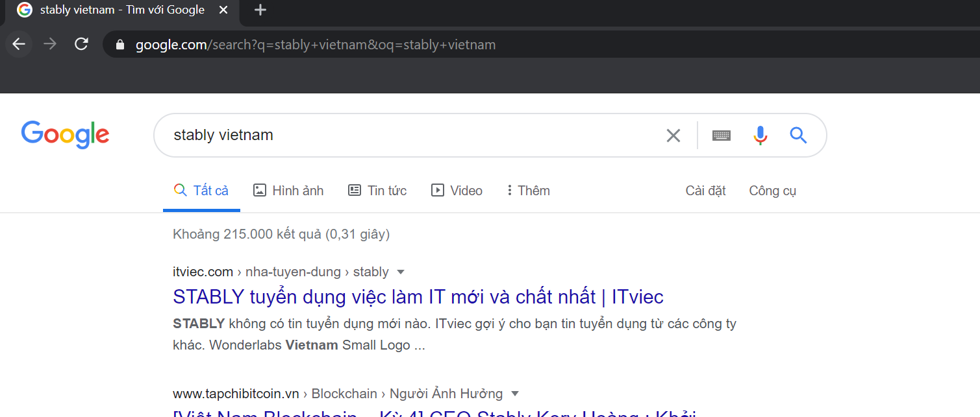

1. If the link is not correct or expired, below screen is shown  
   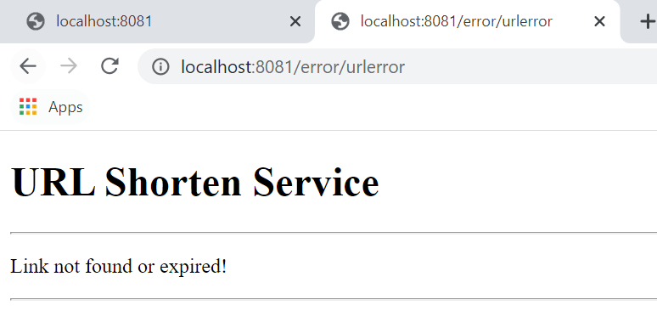

**Deploy project using Docker**

1. We still need to build the project using maven. Open a terminal and navigate to [PROJECT_ROOT] folder. Then, execute “mvn clean package”

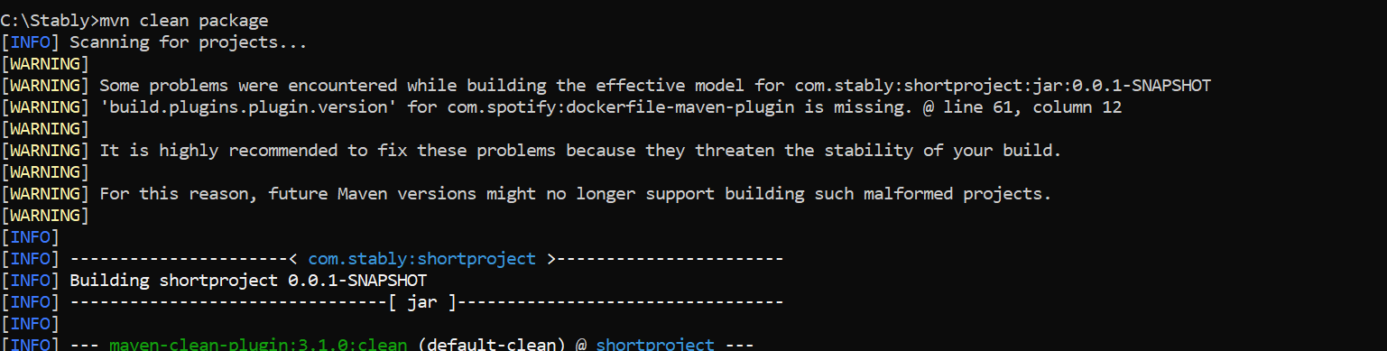

1. Execute “docker build -t stably/shortproject .” to build the image

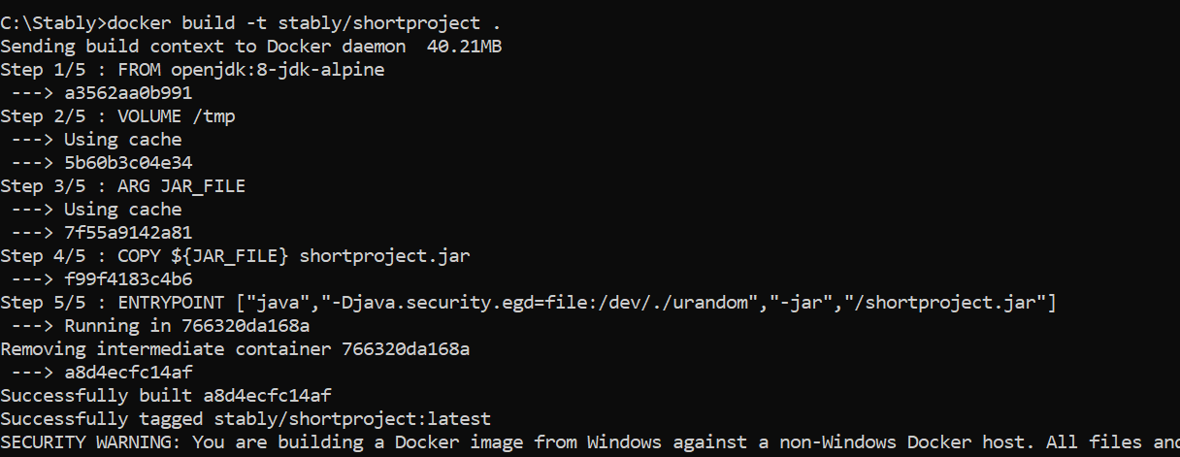

1. Ensure that we have it in local images

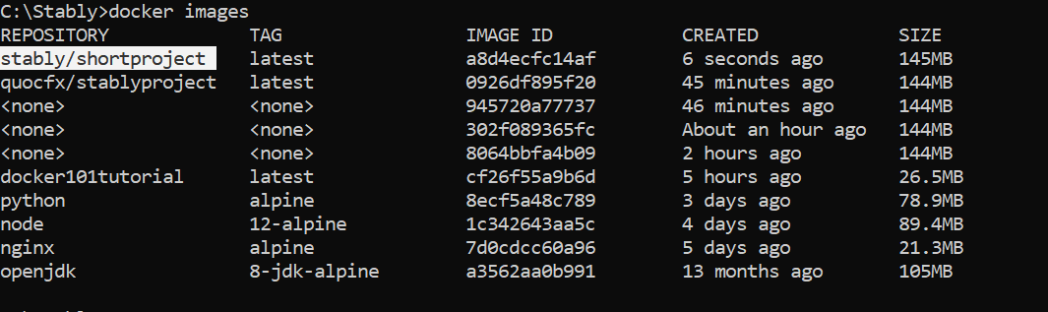

1. Execute “mvn install dockerfile:build” to install jar file into new image

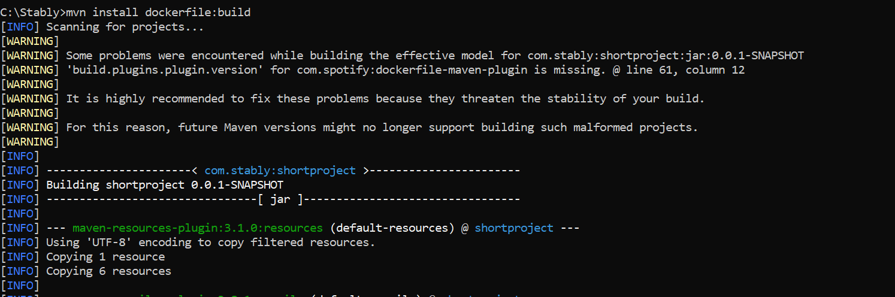

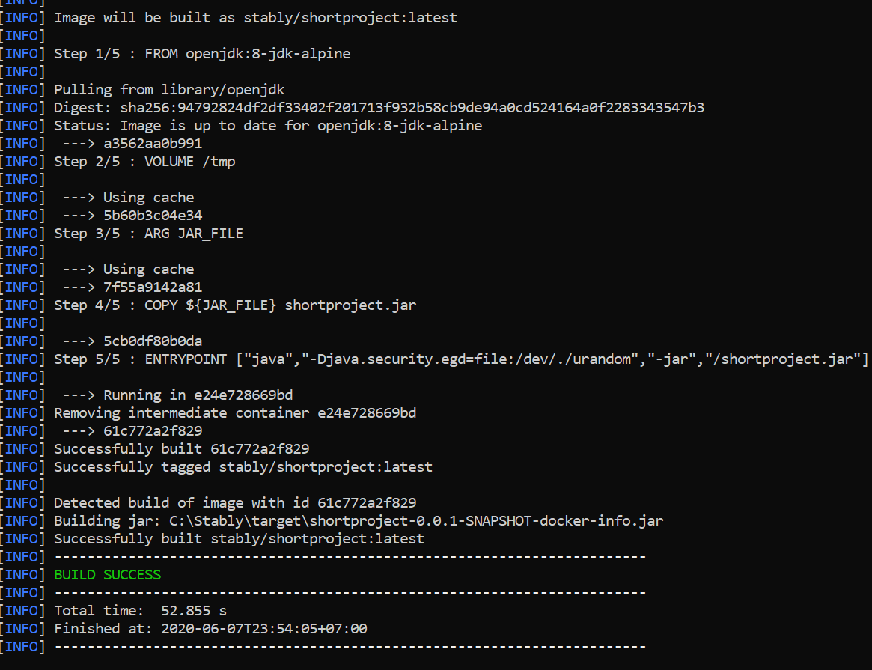

1. Execute “docker run -p 8081:8081 -t stably/shortproject” to run the image

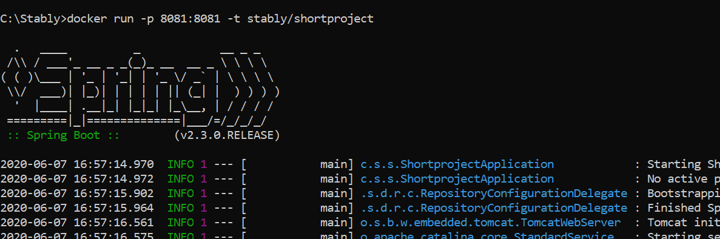

1. Ensure you can access <http://localhost:8081/> (default value)
2. I also push the image to Docker hub at https://hub.docker.com/repository/docker/quocfx/stablyproject

**Some notes**

* There is no unit test
* The exception handling is not well-handling in this project
* There are some TODO notes in source code for improvement later.
* For transfer file from PC to mobile, I use <https://www.mediafire.com/> as a public host and upload file to there. Then, shorten the URL using the same service here.