|  |  |  |  |
| --- | --- | --- | --- |
|  |  | With Crime | Without Crime |
| RMSE | Binary Split | 802790.601 | 1191100.1203 |
| MAE |  | 140862.3899 | 157958.8224 |
| RMSE | Combined Split | 808843.0399 | 1217504.8325 |
| MAE |  | 146382.1229 | 177538.5849 |

The results show that the decision tree model can explain dependent variable when including crime attributes. Although, crime attributes only appear in level 3 of the tree, their coefficients are still statistically significant.

*Example from decision tree model with crime data binary split*

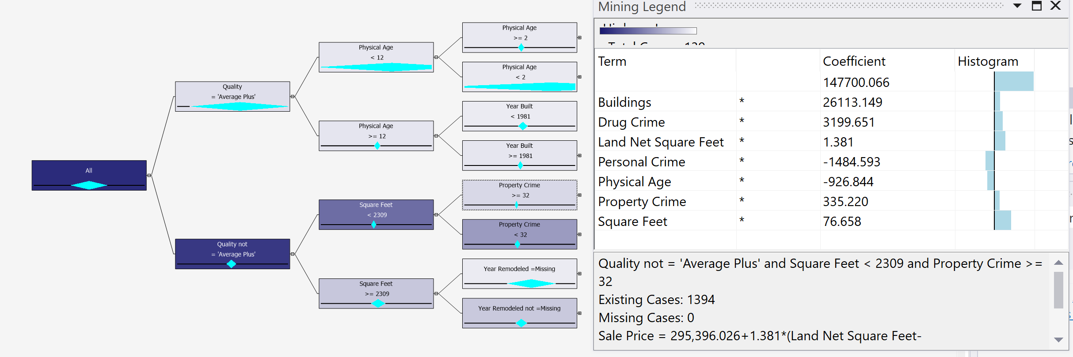

*Final Data with Crime binary split*

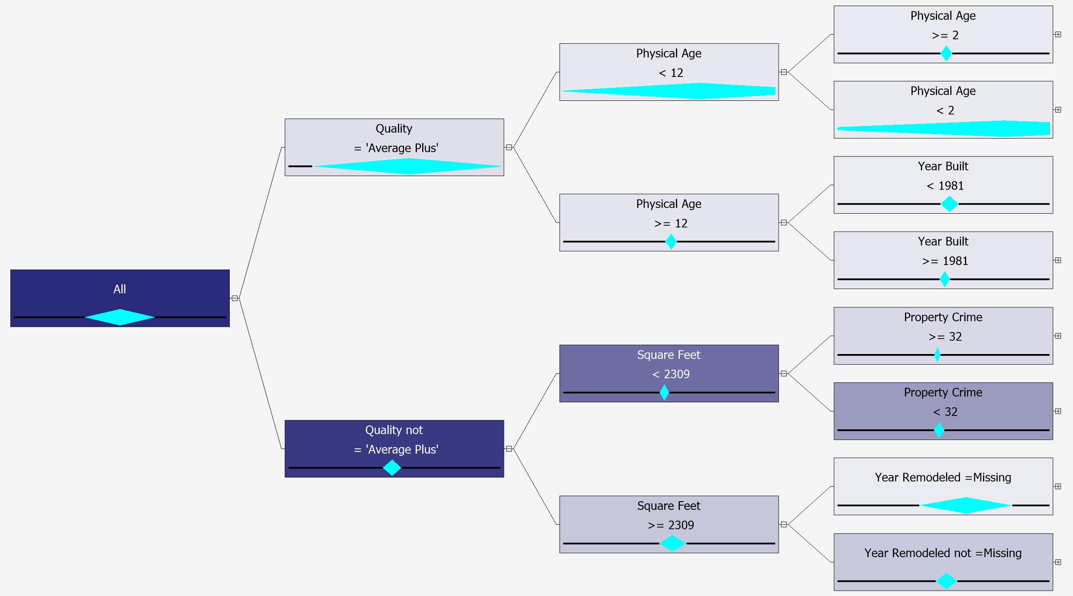

Final data with crime combined split

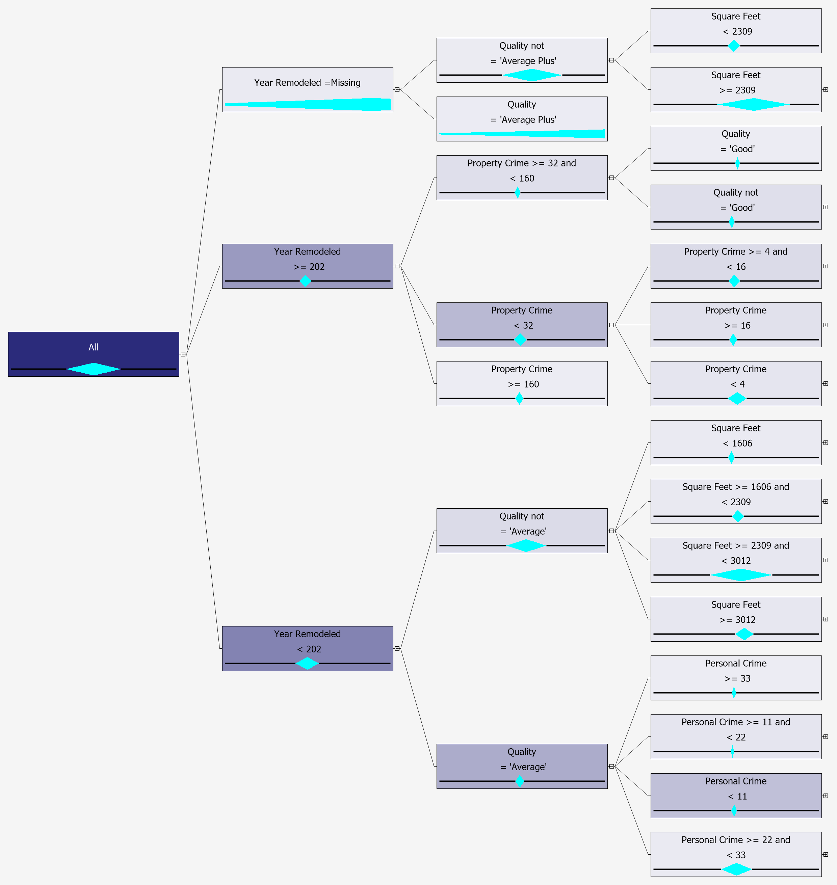

Final Data without crime binary split

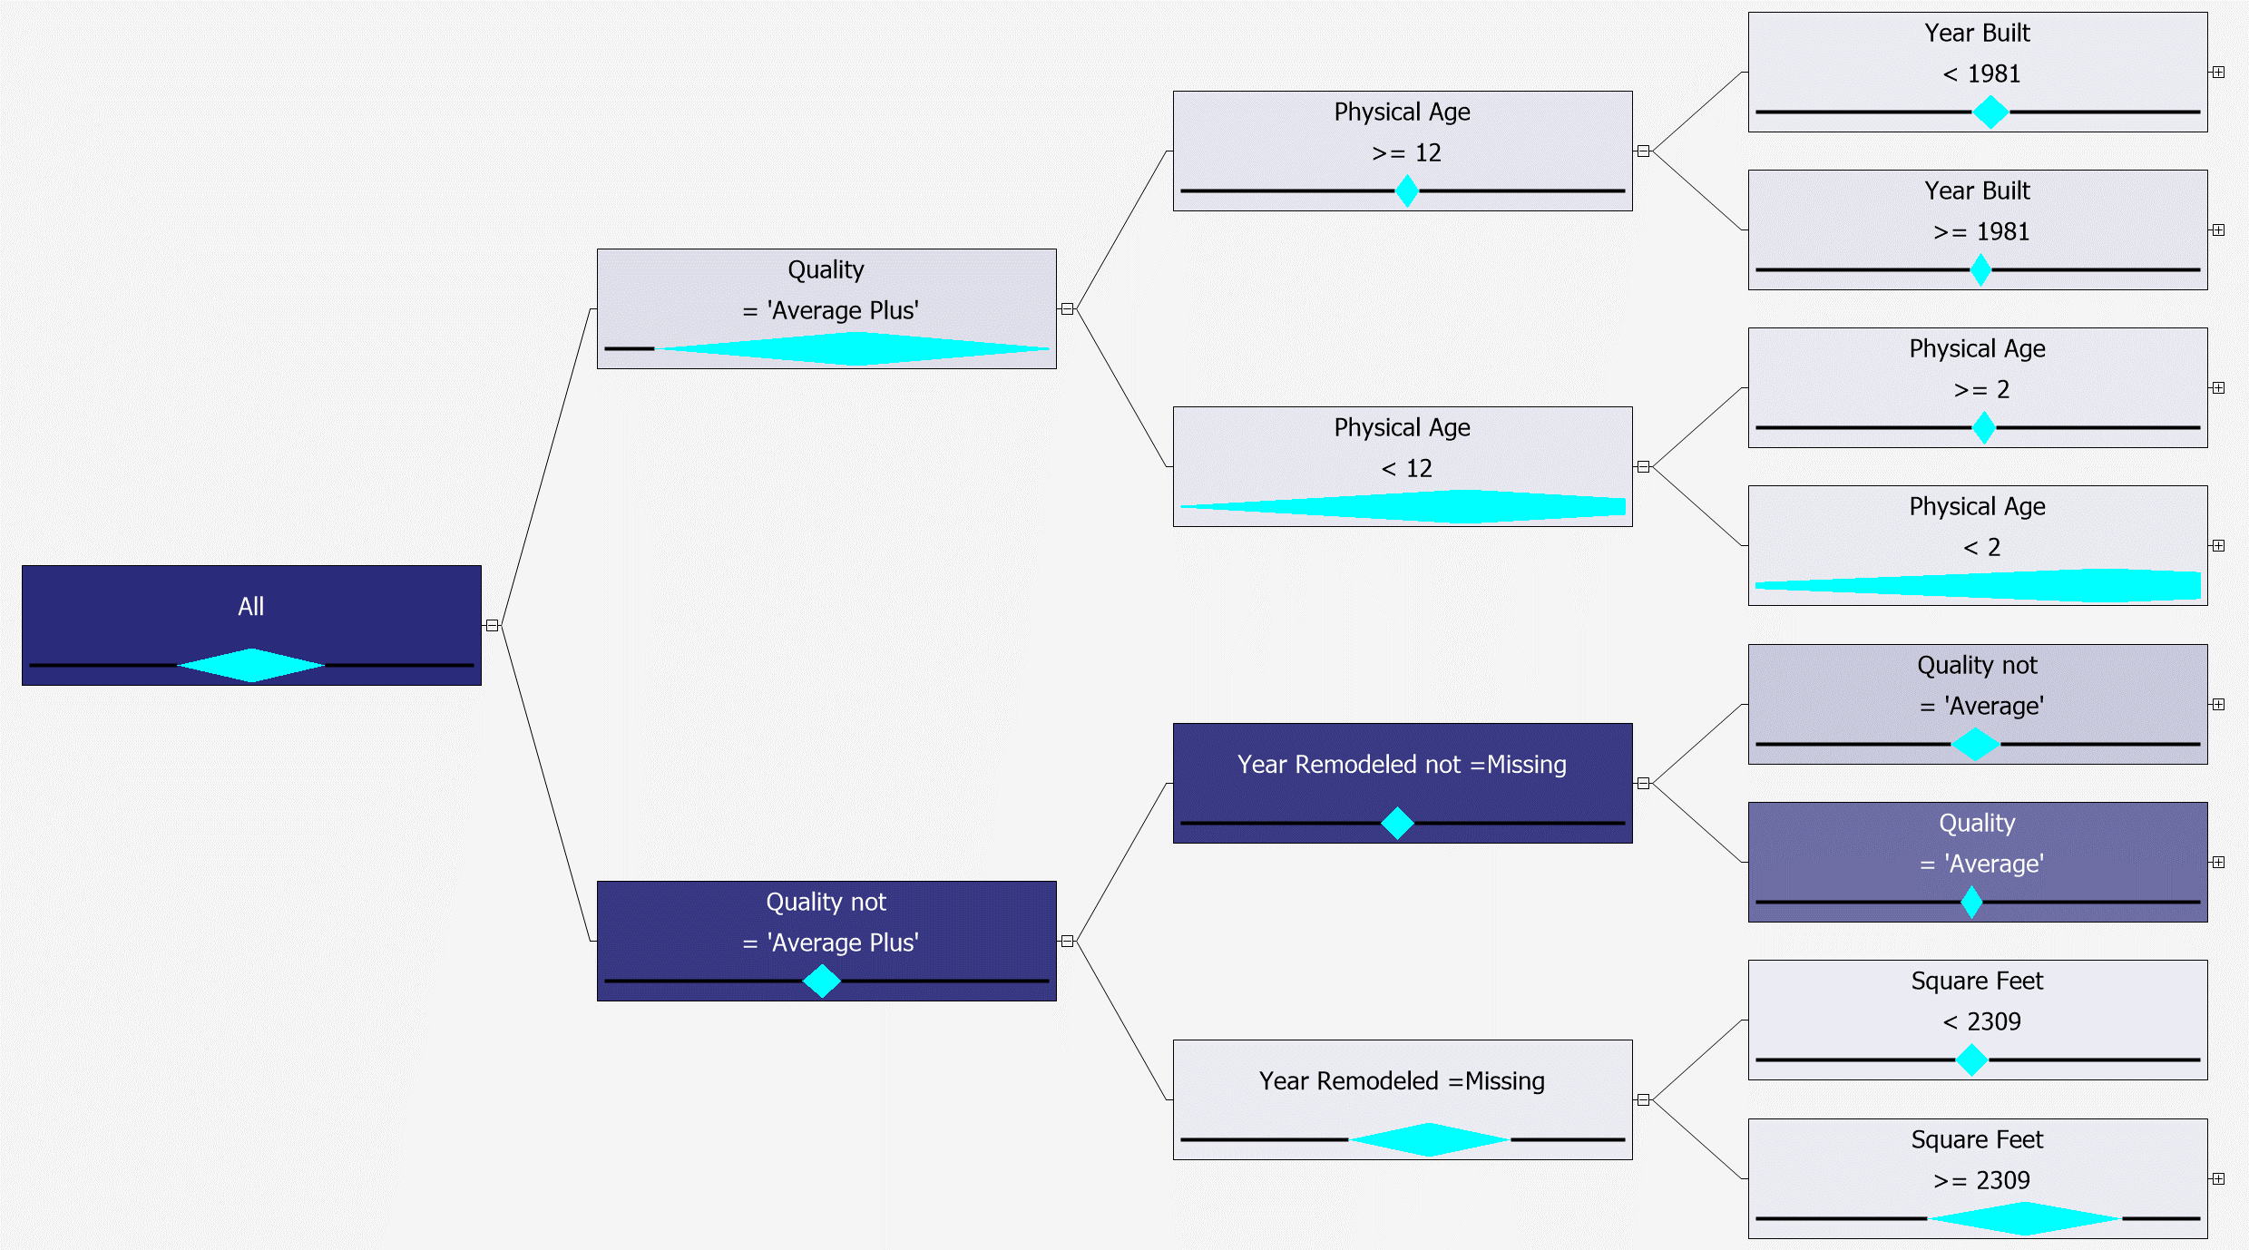

Final Data without crime combined split

