LÂM QUỐC KHÁNH -18110304

Ứng dụng gồm 1 edit text (id là ***editTextName***) để nhập tên, 1 button submit (id là ***btnSubmit***), 1 textview hiển thị (id là ***textViewResult***)

Khi người dùng không nhập tên mà bấm nút submit thì textview hiển thị “Your name is empty”, còn khi nhập tên vào thì hiển thị một lời chào và lời chúc trên text view. Do khi dùng hàm setText() cho text view dùng html code để in đậm tên người nhập vào.

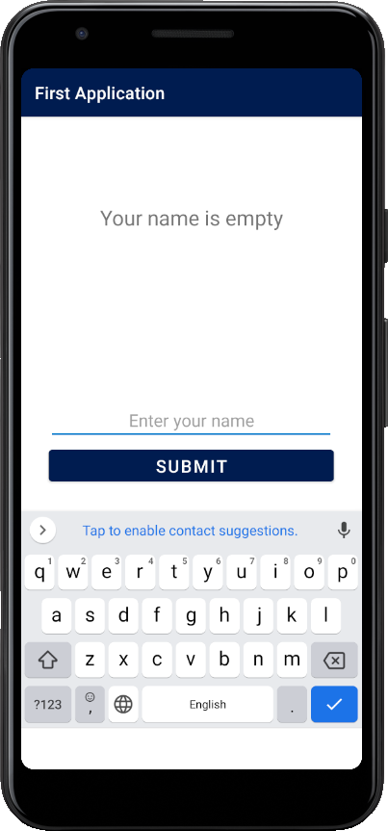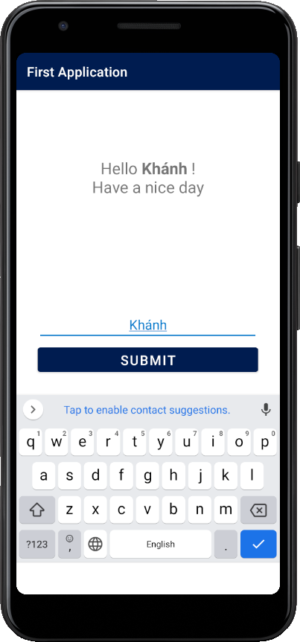

Code giao diện

*<?***xml version="1.0" encoding="utf-8"***?>*<**androidx.constraintlayout.widget.ConstraintLayout xmlns:android="http://schemas.android.com/apk/res/android"  
 xmlns:app="http://schemas.android.com/apk/res-auto"  
 xmlns:tools="http://schemas.android.com/tools"  
 android:layout_width="match_parent"  
 android:layout_height="match_parent"  
 tools:context=".MainActivity"**>  
  
 <**TextView  
 android:id="@+id/textViewResult"  
 android:layout_width="0dp"  
 android:layout_height="wrap_content"  
 android:layout_marginStart="24dp"  
 android:layout_marginTop="100dp"  
 android:layout_marginEnd="24dp"  
 android:textAlignment="center"  
 android:textAppearance="@style/TextAppearance.AppCompat.Display1"  
 android:textColor="@color/light_blue"  
 android:textSize="24sp"  
 app:layout_constraintEnd_toEndOf="parent"  
 app:layout_constraintStart_toStartOf="parent"  
 app:layout_constraintTop_toTopOf="parent"** />  
  
 <**EditText  
 android:id="@+id/editTextName"  
 android:layout_width="0dp"  
 android:layout_height="wrap_content"  
 android:layout_marginStart="32dp"  
 android:layout_marginEnd="32dp"  
 android:layout_marginBottom="2dp"  
 android:ems="10"  
 android:hint="@string/edit_text_name_hint"  
 android:inputType="textPersonName"  
 android:textAlignment="center"  
 android:textAllCaps="false"  
 android:textColor="@color/light_blue"  
 android:textColorHighlight="@color/dark_blue"  
 android:textColorLink="@color/dark_blue"  
 android:textCursorDrawable="@color/dark_blue"  
 android:textSize="20sp"  
 app:layout_constraintBottom_toTopOf="@+id/guideline9"  
 app:layout_constraintEnd_toEndOf="parent"  
 app:layout_constraintHorizontal_bias="1.0"  
 app:layout_constraintStart_toStartOf="parent"** />  
  
 <**Button  
 android:id="@+id/btnSubmit"  
 android:layout_width="0dp"  
 android:layout_height="wrap_content"  
 android:layout_marginStart="32dp"  
 android:layout_marginTop="2dp"  
 android:layout_marginEnd="32dp"  
 android:text="@string/btn_submit_content"  
 android:textSize="20sp"  
 app:layout_constraintEnd_toEndOf="parent"  
 app:layout_constraintStart_toStartOf="parent"  
 app:layout_constraintTop_toTopOf="@+id/guideline9"** />  
  
 <**androidx.constraintlayout.widget.Guideline  
 android:id="@+id/guideline9"  
 android:layout_width="wrap_content"  
 android:layout_height="wrap_content"  
 android:layout_marginTop="24dp"  
 android:orientation="horizontal"  
 app:layout_constraintGuide_percent="0.5"  
 app:layout_constraintTop_toTopOf="parent"** />  
  
</**androidx.constraintlayout.widget.ConstraintLayout**>

Code xử lý

**public class** MainActivity **extends** AppCompatActivity {  
  
 **private** TextView **textViewResult**;  
 **private** EditText **editTextName**;  
 **private** Button **buttonSubmit**;  
  
 @Override  
 **protected void** onCreate(Bundle savedInstanceState) {  
 **super**.onCreate(savedInstanceState);  
 setContentView(R.layout.***activity_main***);  
  
 initView();  
 }  
  
 **void** initView() {  
 **textViewResult** = findViewById(R.id.***textViewResult***);  
 **editTextName** = findViewById(R.id.***editTextName***);  
 **buttonSubmit** = findViewById(R.id.***btnSubmit***);  
  
 **buttonSubmit**.setOnClickListener(**new** View.OnClickListener() {  
 @Override  
 **public void** onClick(View v) {  
 buttonSubmitOnClick(v);  
 }  
 });  
 }  
  
 **void** buttonSubmitOnClick(View v) {  
 String userInputName = String.*valueOf*(**editTextName**.getText()).trim();  
 String message = **""**;  
 **if** (userInputName.isEmpty()) {  
 message = getResources().getString(R.string.***empty_name_text***);  
 } **else** {  
 message = getResources().getString(R.string.***hello_text***)  
 + **" <b style=\"color: #000;\">"** + userInputName + **" </b>!<br/>"** + getResources().getString(R.string.***message_text***);  
 }  
 **textViewResult**.setText(Html.*fromHtml*(message));  
 }  
}

Thay đổi color của textview trong file xml

<**TextView  
 android:id="@+id/textViewResult"  
 android:layout_width="0dp"  
 android:layout_height="wrap_content"  
 android:layout_marginStart="24dp"  
 android:layout_marginTop="100dp"  
 android:layout_marginEnd="24dp"  
 android:textAlignment="center"  
 android:textAppearance="@style/TextAppearance.AppCompat.Display1"  
 android:textColor="@color/light_blue"  
 android:textSize="24sp"  
 app:layout_constraintEnd_toEndOf="parent"  
 app:layout_constraintStart_toStartOf="parent"  
 app:layout_constraintTop_toTopOf="parent"** />

