**I. Tasks done:**

- Create a textBox for user input

- Create an OK button so that when the input is done, push through the JSON file

- Create a Label “Choose a file” for users to upload files

- CSS for the above objects

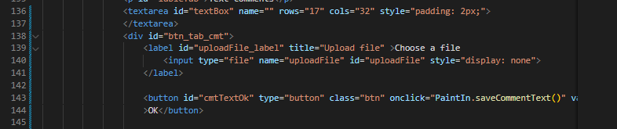

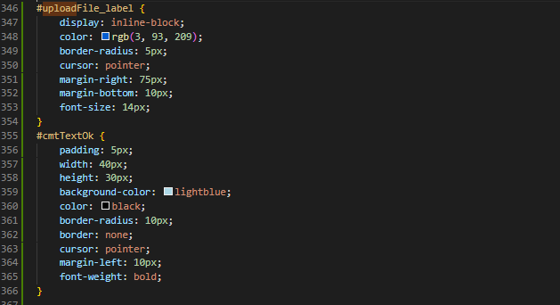

- Create saveCommentText() for OK Button

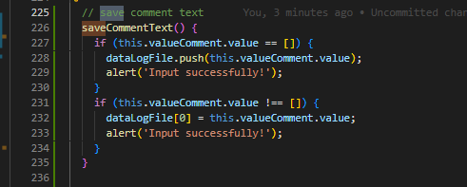

- Create algorithm for “Choose a file”

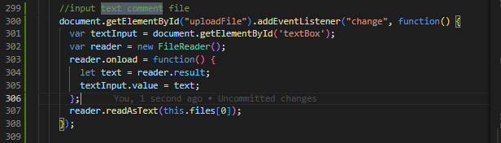

- Function saveTextFile(): save text comment into file myFile.txt

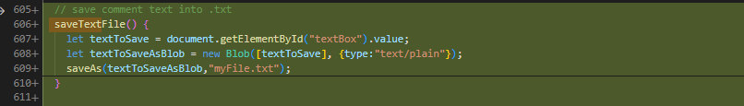

- Change the OK button to the Save text button



**II. HTML CSS through bootcamp course on Udemy**

- Create a website My resume

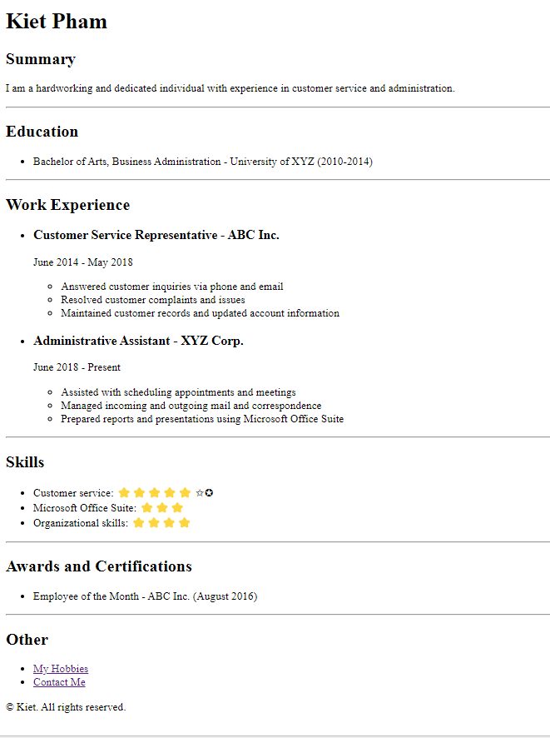

+ Use tags h1, h2, ...

+ Especially nesting and indentation

+ Distinguish ul, ol tag

- Create a website Kiet's Portfolio

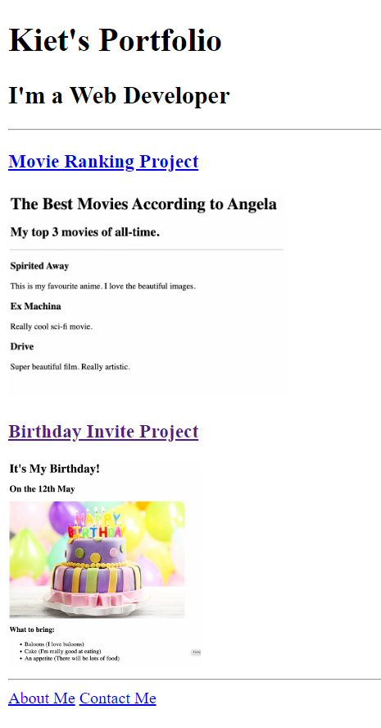

+ The highlight is the multi-page Website. Click on “Movie Ranking Project”, “Birthday Invite Project”, “About Me”, “Contact Me” will open another html page

- Create website "CSS Flag Project":

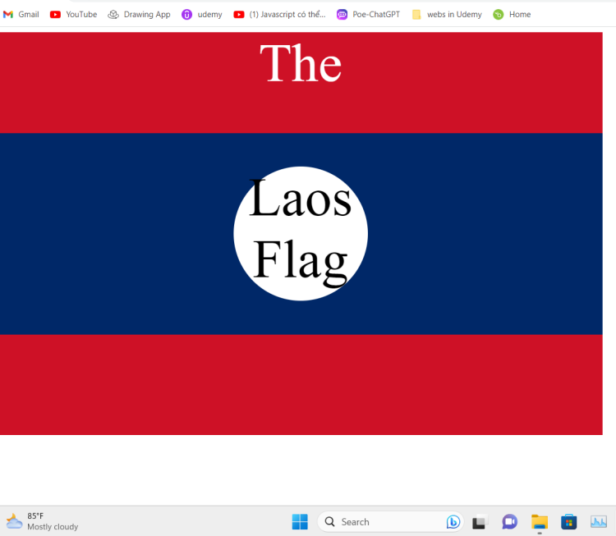

+ CSS: distinguish static, relative, absolute of position

+ Combine Selcctor: distinguish child and descendant

- Create a website "Agency":

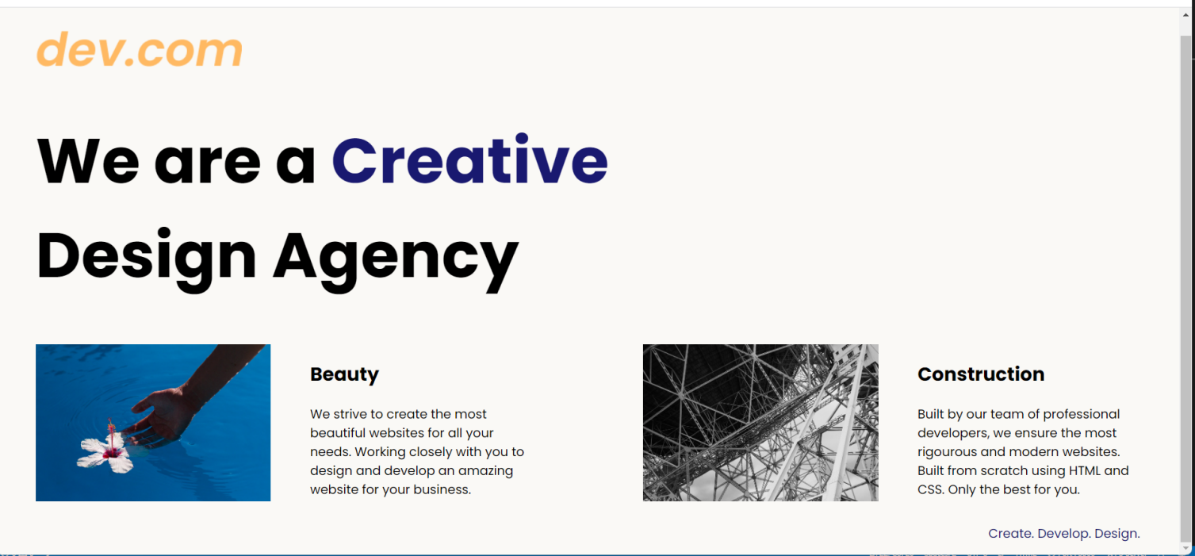

+ CSS float left for 2 images

+ Use Media Queries and Flexbox to create Responsive Website

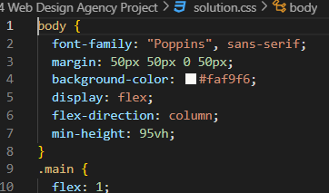 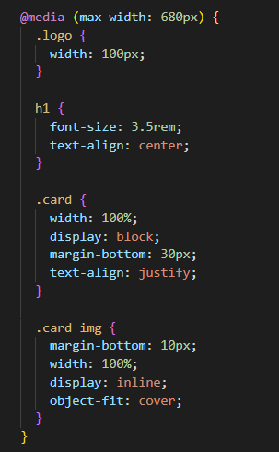

- Create a TinDog website:

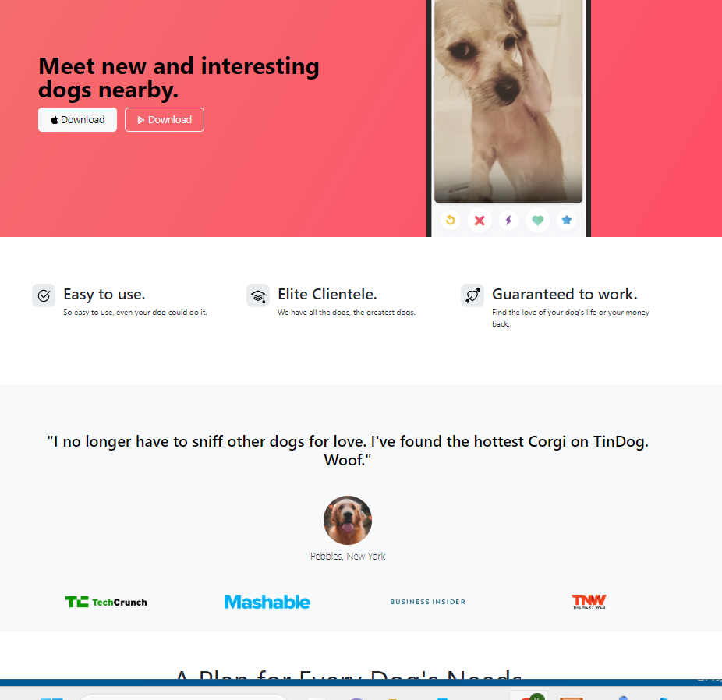

+ Use Bootstrap in website *getbootstrap.com.*

+ Link the Bootstrap CSS file via the link tag

+ Use the components tab to copy html commands

+ Use tab Example to mimic available examples

- Create a similar web from Akselos Offshore Wind web:

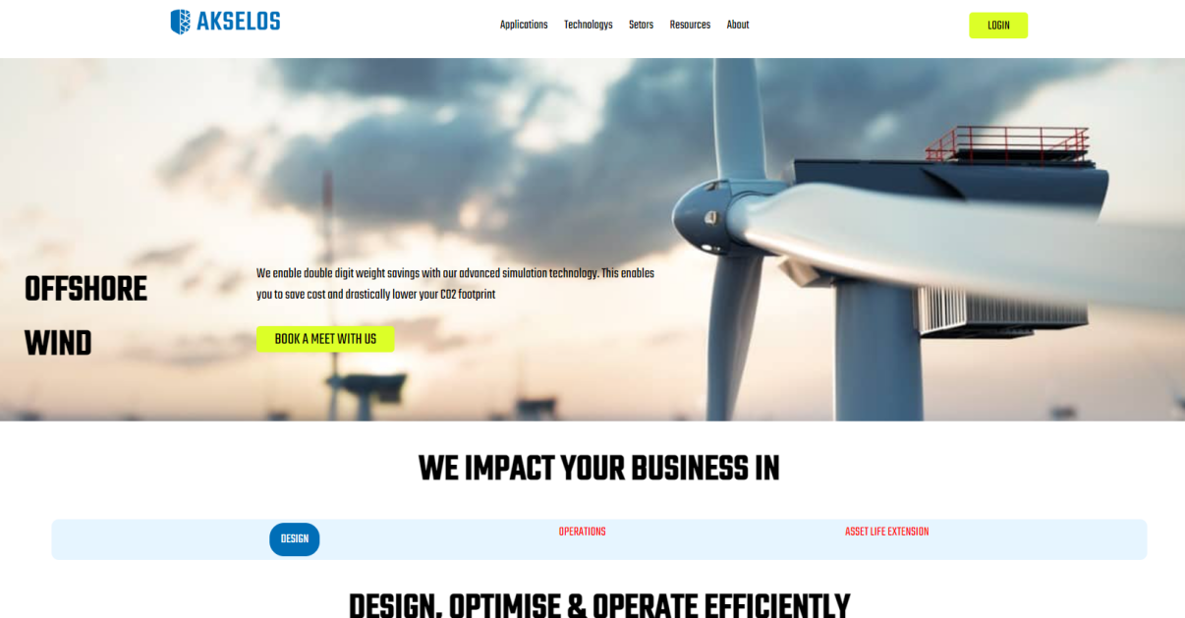

+ There is hover at the buttons

**III. JS through bootcamp course on Udemy**

- Create a Dice game website:

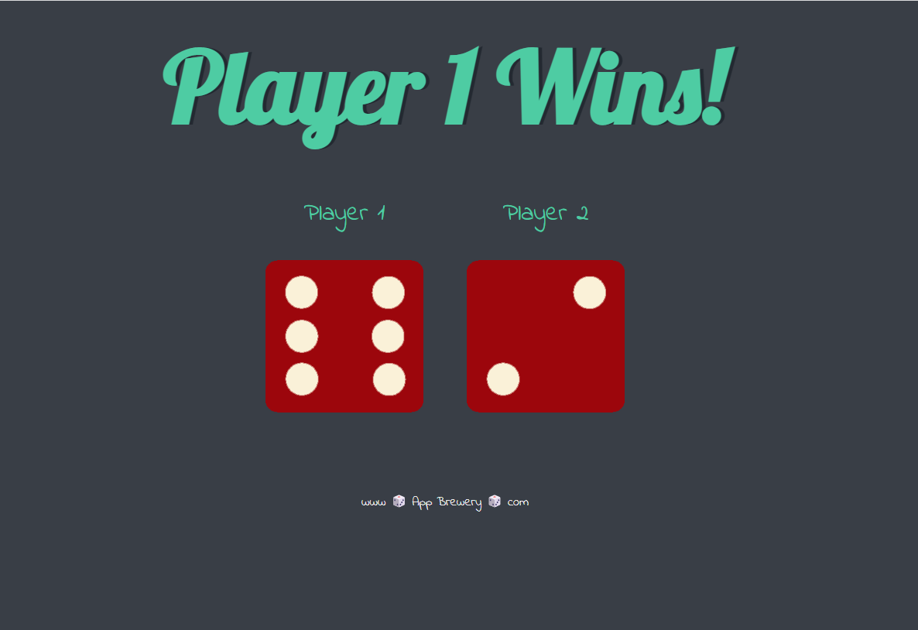

+ Know how to combine JS with CSS, HTML

+ Distinguish Get element by querySelector(…), querySelectorAll()

+ Use querySelectorAll set attribute for img tag

+ Use querySelector to change attribute innerHTML for h1 tag

