I. Employee management website

- Create class Employee to store information of employees, in file Employee.js

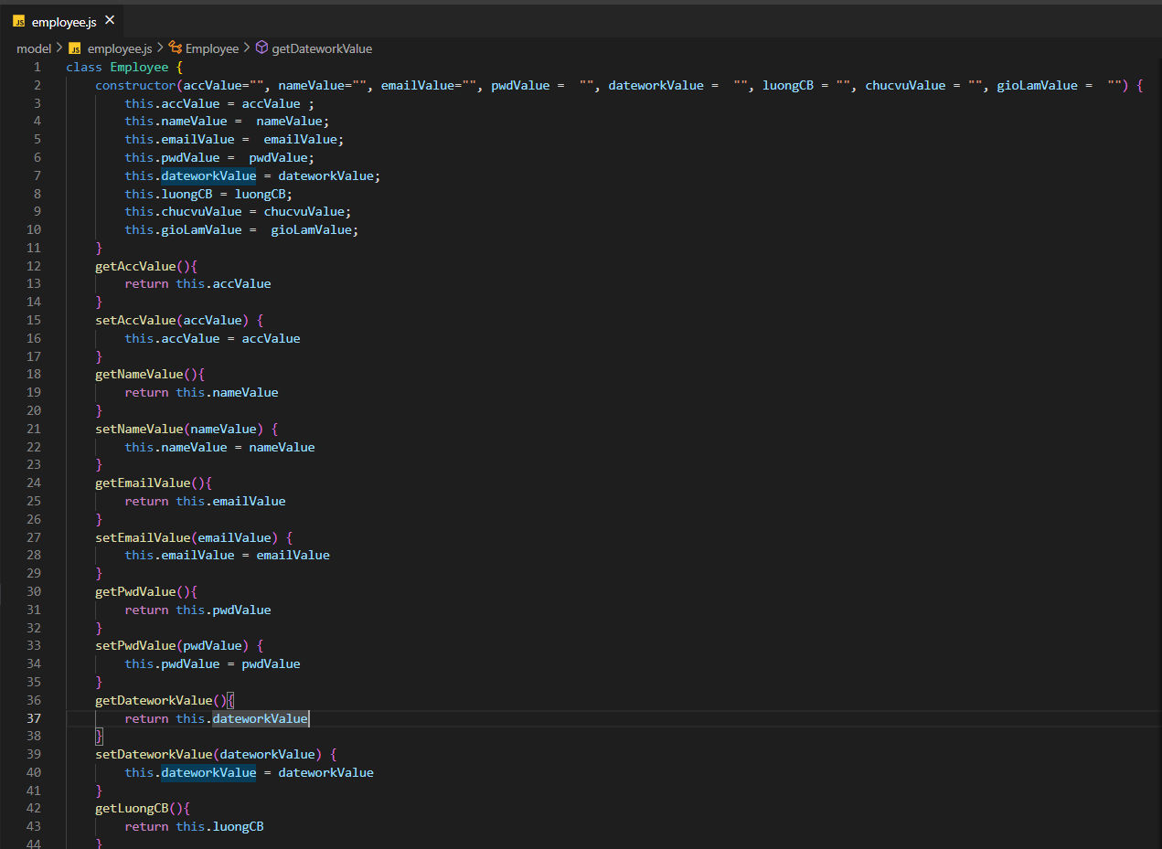

+ Contains properties, accValue, nameValue, emailValue, pwdValue, dateworkValue, luongCB, chucvuValue, gioLamValue, and has get() and set() methods

- Create function when we click “Thêm người dùng” button

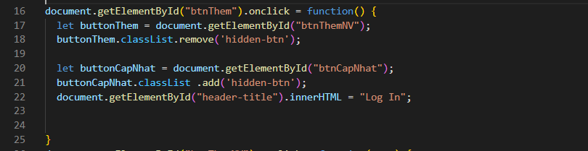

- Create a function when we click the "Thêm nhân viên" button in the modal:

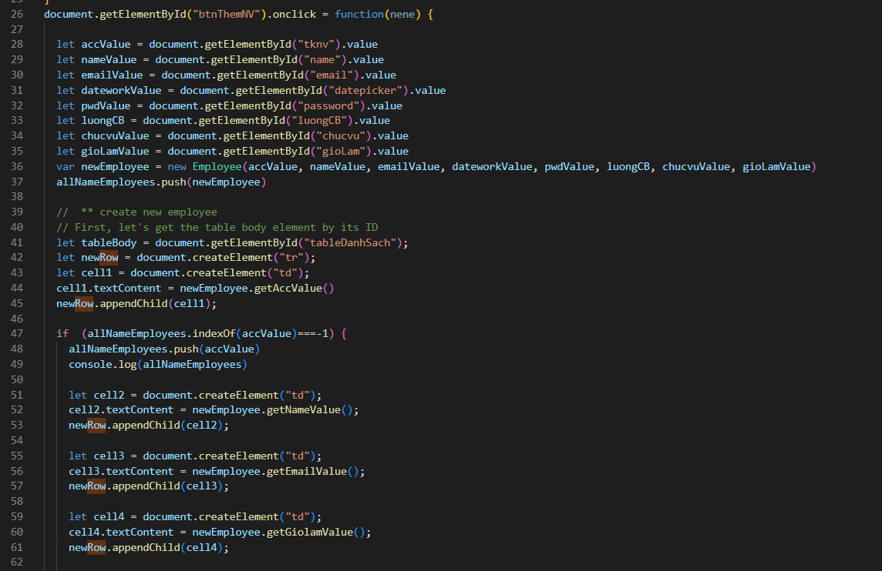

+ Save input values in modal, then display a table, each row is an employee of 8 cells

- Function when clicking Delete button:

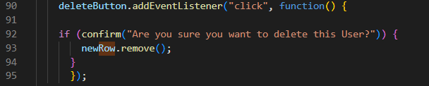

- Function when clicking the Edit button: 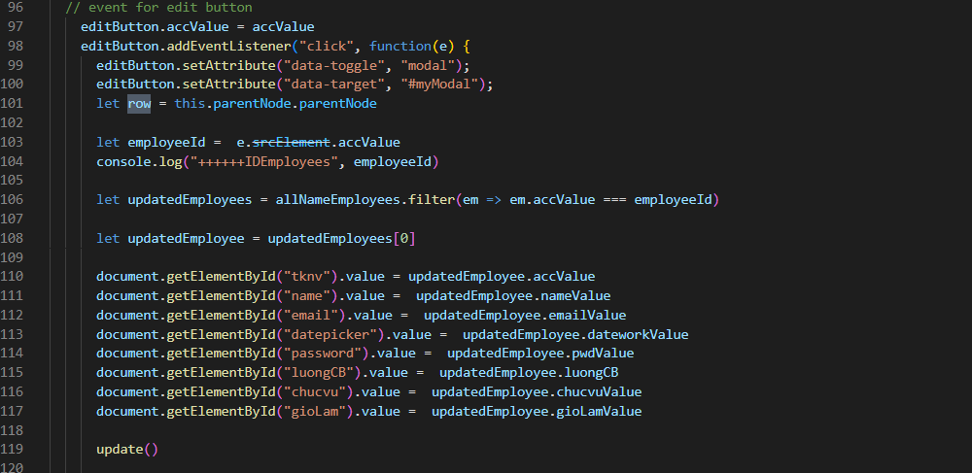

+ Change modal to update modal

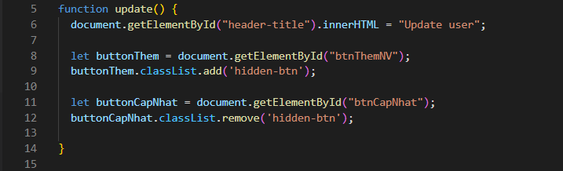

- Function when clicking the Update button, save the changed values:

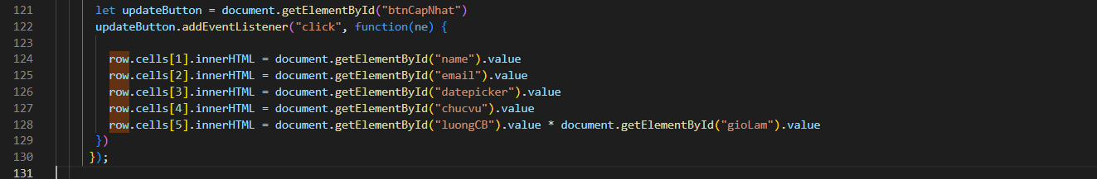

- Click “Lưu danh sách” button:

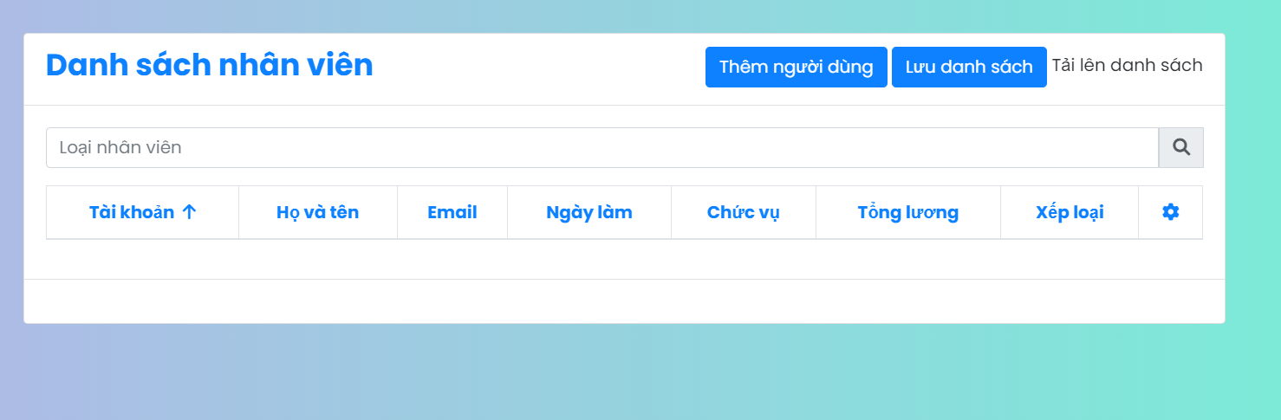

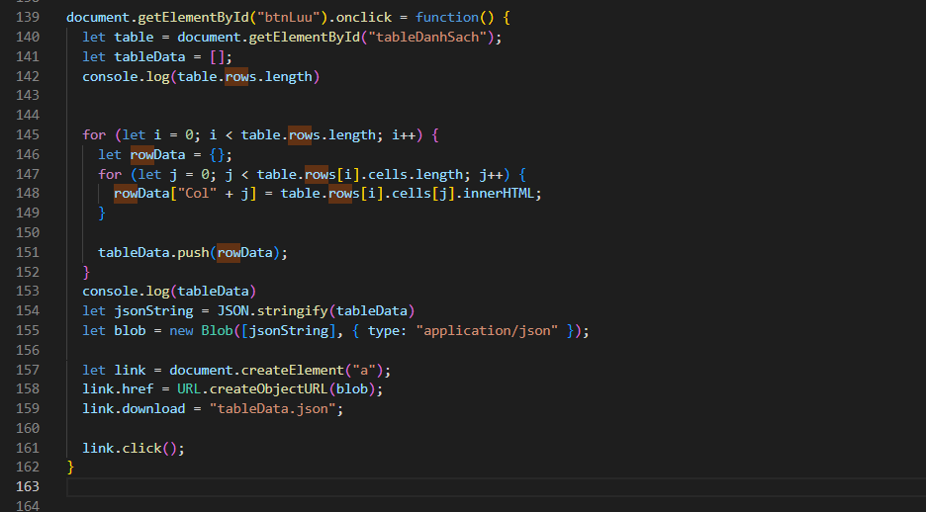

+ Save the information in the table into the file "tableData.json"

- Function when clicking "Upload list" button:

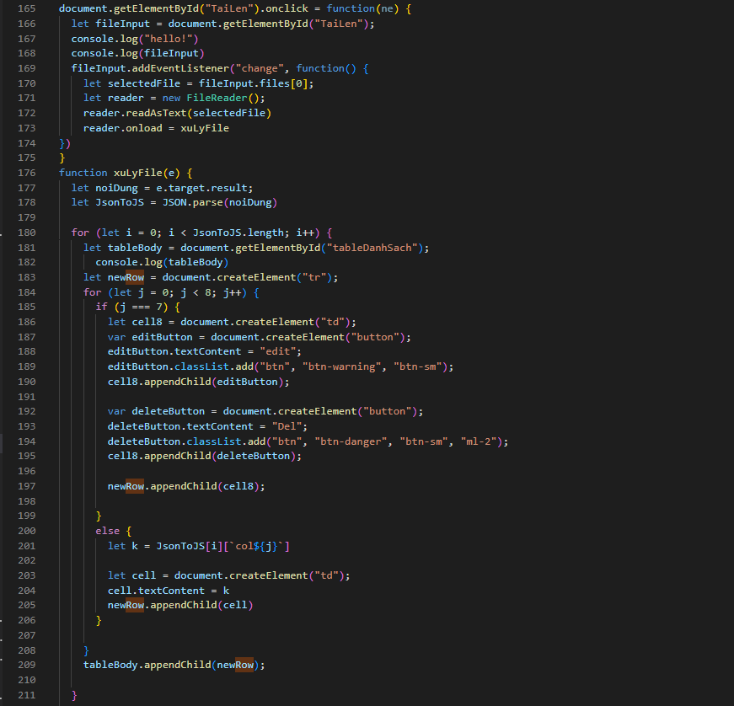

+ Select the JSON file, then the "List of employees" will appear.