

CAPSTONE 1

PROPOSAL DOCUMENT

Version 1.2

Date: Aug 22th, 2018

**ROOMY SYSTEM MANAGEMENT**

MENTOR : MSc. Phan Van Son

TEAM’S MEMBER : Huynh Quoc Nhat

Le Hoang Quoc

Ho Trung Anh

Huynh Vu Ha Lan

Huynh Thi Thanh Van

Contents

Project Information 3

Proposal Document 4

1 Introduction 6

1.1 Purpose 6

1.2 Scope 6

1.3 Reference 6

2 Project Overview 7

2.1 Project Definition 7

2.2 Business needs/ User needs 7

2.3 Prior art 8

2.4 Proposed solution 9

2.4.1 Project goal 9

2.4.2 System overviews 9

2.4.3 Technical constrains 11

3 Development Process 12

3.1 Reason for selecting process: 12

3.2 Scrum Process 12

3.3 Master plan 13

3.4 Organization management 14

3.4.1 Team information 14

3.4.2 Cost Estimation 14

# Project Information

|  |  |  |  |
| --- | --- | --- | --- |
| Project acronym | RSM | | |
| Project Tittle | Roomy System Management | | |
| Start Date | 15/08/2018 | End Date | 05/12/2018 |
| Lead Institution | International School, Duy Tan University | | |
| Project Mentor | Phan Van Son  Email: [sonpvs@duytan.edu.vn](mailto:sonpvs@duytan.edu.vn)  Tel: 01675373265 | | |
| Scrum Master  & contact details | Huynh Vu Ha Lan  Email: [huynhvuhalan.97@gmail.com](mailto:huynhvuhalan.97@gmail.com)  Tel: 0989342173 | | |
| Partner  Organization | Duy Tan university | | |
| Team members | Name | Email | Tel |
| Le Hoang Quoc | [quocle28292@gmail.com](mailto:quocle28292@gmail.com) | 01657708105 |
| Huynh Quoc Nhat | [huynhquocnhat97@gmail.com](mailto:huynhquocnhat97@gmail.com) | 0905740256 |
| Ho Trung Anh | [hotrunganhht1912@gmail.com](mailto:hotrunganhht1912@gmail.com) | 09055258534 |
| Huynh Thi Thanh Van | [thanhvandb97@gmail.com](mailto:thanhvandb97@gmail.com) | 01229444661 |
|  | Huynh Vu Ha Lan | [huynhvuhalan.97@gmail.com](mailto:huynhvuhalan.97@gmail.com) | 01675373265 |

# Proposal Document

|  |  |  |  |
| --- | --- | --- | --- |
| Document Title | Proposal |  |  |
| Reporting Period | August, 2018 |  |  |
| Author(s) | All Members | |  |
| Team Members | Name | Role |  |
| Huynh Vu Ha Lan | Scrum Master |  |
| Huynh Thi Thanh Van | Member |  |
| Huynh Quoc Nhat | Member |  |
| Le Anh Quoc | Member |  |
| Ho Trung Anh | Member |  |
| Date | Aug 15, 2018 | Filename | Proposal_v1.2.docx |
| Access | Project and CMU Program | |  |

|  |  |  |  |
| --- | --- | --- | --- |
| Version | Person | Date | Description |
| V1.0 | Team | Aug 22, 2018 | Draft for Document |
| V1.1 | Team | Aug 31, 2018 | Update header page, structure of the document |
| V1.2 | Team | Sep 02,2018 | Update header page, structure of the document |

Document Approvals: The following signatures are required for approval of this document.

|  |  |  |  |
| --- | --- | --- | --- |
| Mentor | Phan Van Son | Signature: |  |
|  | Date: |  |
| Scrum Master | Huynh Vu Ha Lan | Signature: |  |
|  | Date: |  |
| DEV Team’s Member | Huynh Quoc Nhat | Signature: |  |
|  | Date: |  |
| Ho Trung Anh | Signature: |  |
|  | Date: |  |
| Le Hoang Quoc | Signature: |  |
|  | Date: |  |
|  | Huynh Thi Thanh Van | Signature: |  |
|  |  | Date: |  |

# Introduction

## Purpose

The purposes of the proposal are to:

* + Define the business need and problem in detail.
  + Provide solutions for business needs and show the overview of system architecture.
  + Provide overview about resources, schedule, solution and budget for the project.

## Scope

This document provides an overview of project will be developed. It includes overview of the product, overview of the process and overview of the project team.

This document provides a plan for each stage of software development process based on Scrum process include: start time, end time and number of working days. This is the general plan and will be updated with detail of the software development process in the next version of document. Proposal includes the introduction of solutions; determine the best way to develop software that we make the total estimated costs, payback period, and break even volume for the project.

## Reference

|  |  |  |
| --- | --- | --- |
| No. | References | Document Information |
| 1 | Scrum  Framework | * + - * <https://www.scrum.org/>       * [https://www.scrumguides.org](https://www.scrumguides.org/) |
| 2 | MySQL | - [www.mysql.com](http://www.mysql.com/) |
| 3 | Android | - https://www.android.com/ |

# Project Overview

## Project Definition

Developing an accommodation search system helping user finds their location quickly and conveniently. The system helps users locate, display accommodation around the user with information, images real.

## Business needs

*Problems:*

*Renter:

* Today, the number of students and workers in large cities is increasing, so finding an accommodation to live is a necessity for them.
* Finding accommodation will be very difficult for first-year students and those from other places come large cities to live.
* Accommodation is scarce make the renter difficult in the search process.
* Finding accommodation is difficult even on the websites: after reading a rental newsletter, the renter must visit a separate map to locate them.

*Landlord

* It is difficult to find the rental object who meet requirement of them.
* Advertising just is at way word of mouth or have someone post on internet.

*Admin

* It is hard to manage the information posted to the system.

*Needs:*

*Renters

* Can find the accommodation by location, area, price.
* Information, images must be exactly as posted on the system.
* The price is in line with the finances for renter.
* Can see their exact location and the accommodation around them.
* Can report for admin about accommodations.
* Be protected their informations account.
* Can see the status of the room wanted to rent.
* Can book room right on the system.

*Landlords:

* Show exact information about their accommodation.
* Can input information about the accommodation they need to rent.
* Manage their accommodations.
* Be protected their information account.
* Can report about troubles in the post.
* Can list to have the statistics of rooms by item (rooms are being rented, room available, room near expire).

*Admins:

* List to have statistics of total landlords in system.
* List to have statistics of total rooms for each accommodation.
* Manage all accounts.
* View user’s reports.
* Create an account.

## Prior art

* Up till, there are many websites that support the search for such as chotot.com, muaban.net, mogi.vn ... Most of them have the main functions are: rental rooms, rental housing, find roommate. Based on that availability, we will create a website for rooms with similar functionality
* However, these websites are mostly single pictures of the place of rental and can’t help the tenants know the exact location to where they want it to be.
* To overcome these problems, we want to make a system with high practicality.
* The whole system of the program is built in form: Website.
* Users will create the function to display each room, the rental house directly on the map together with 360 ° image so that users can easily view the necessary information as well as the panoramic image of the room.
  + For Landlord, they can manage their rooms by statistics the number of rooms (rooms are being rented, room available, room near expired).
  + For Landlord, they can manage their rooms by statistics the number of rooms (rooms are being rented, room available, room near expired).
* In addition, when the user enters detail address, the system will show accommodations around there.
* For renters, they can book room directly on the system.

## Proposed solution

To solve these problems, the system can help users locate and show rooms around them with necessary information and visuals.

Our team is based on the requirements and come up with a solution and implement the project.

### Project goal

The goal of the project is to build the website and application with main features that meet the business need within the budget and deliver on time:

1. **The application determines user's location by GPS**: The system will locate the user on the map via GPS.

2. **Statistic**: The system will help Landlord, they can manage their rooms by statistics the number of rooms (rooms are being rented, room available, room near expired) as well as Admin, they can statistic the total number of rooms and statistic total number of renters in each post.

3. **Display information, live images**: The system will help users to see the room information and the actual image on the map.

4. **Display rooms around**: The system will show accommodation rooms around when the user enters a specific address

### System overviews

#### System context

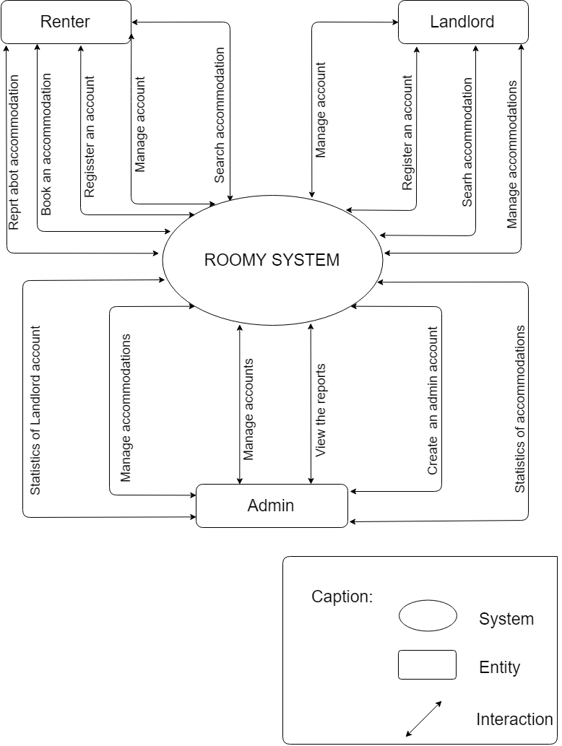

*Figure 1: Roomy Management context diagram*

#### System context description

* Renter:
* Renters can login, logout, register and update their account.
* Renters can search for information about accommodation.
* Renters can book an accommodation right on system.
* Renters can report for admin about accommodation.
* Landlord:
* Landlords can login, logout, register and update their account.
* Landlords can manage their accommodations.
* Landlords can list to have statistics of rooms.
* Landlords can add rooms.
* Landlords can delete rooms.
* Landlords can update rooms.
* Landlords can search information about accommodation.
* Admin:
* Admin can login, logout and update their account.
* Admin can manage accounts
* Admin can search accounts.
* Admin can delete an account.
* Admin can manage accommodations.
* Admin can search accommodations
* Admin can delete an accommodation.
* Admin can list to have statistics of accommodations.
* Admin can list to have statistics of Landlords account.
* Admin can view the customer reports.
* Admin can create an account for new admin to manage the system together.

### Technical constrains

Technical to develop

* Language: PHP, HTML, CSS, Java, Android, JavaScript.
* Database Management System: MySQL
* Develop tool: Sublime Text, Notepad++, Android studio, Xampp.
* Operating: Multi-platform

Environment

* Web browsers: Internet Explorer, Mozilla Firefox, Apple Safari, Google Chrome, and so on.
* Operator systems: Microsoft Windows, Linux, and Apple Mac OS.

Other Constraints

* Resource: 5 people.
* Budget: Limited.
* Time: The project must be completed within 3 months frame.
* Area: Viet Nam

# Development Process

## Reason for selecting process:

- We use Scrum to do the project Website find the accommodation room. Because Scrum is a process suitable for small and medium software, implementation time short and easy change request Scrum is a process popular in present with the advantages and benefits such as: Timeline Flexibility- can later or earlier than originally planned. Good product quality and reduce production risk, low-cost. Interoperability between clients and developers, among the team members are set to high. The growth rate faster, saving time and errors detected earlier.

## Scrum Process

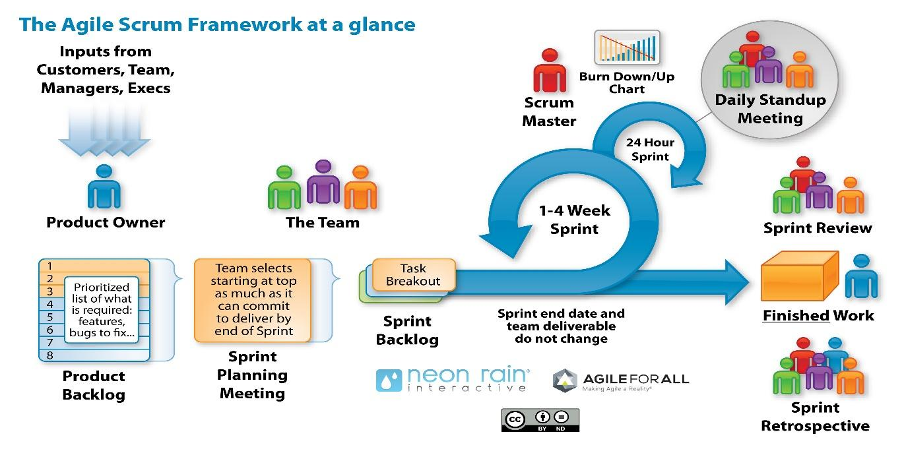

*Figure 2: The General Scrum process*

* Scrum is an iterative and incremental agile software development framework for managing software projects and product or application development.
* Scrum focuses on project management institutions where it is difficult to plan ahead.
* Mechanisms of empirical process control, where feedback loops that constitute the core management technique are used as opposed to traditional command-and-control management.
* Its approach to planning and managing projects is by bringing decision-making authority to the level of operation properties and certainties.
* Benefit of the methodology:
  + - Project can respond easily to change.
    - Problems are identified early.
    - Customer gets most beneficial work first.
    - Work done will better meet the customer’s needs.
    - Improved productivity.
    - Ability to maintain a predictable schedule for delivery.

## Master plan

|  |  |  |  |  |
| --- | --- | --- | --- | --- |
| NO. | Task Name | Duration | Start | Finish- |
| 1 | Start Up | 7 days | 15/08/2018 | 22/08/2018 |
| 1.1 | Project Kick Off Meeting | 1 day | 24/08/2018 | 24/08/2018 |
| 1.2 | Discuss about project ideal | 3 days | 25/08/2018 | 27/08/2018 |
| 1.3 | Create Proposal document | 3 days | 28/08/2018 | 30/08/2018 |
| 2 | Development | 96 days | 01/09/2018 | 05/12/2018 |
| 2.1 | Sprint 0 | 4 days | 01/09/2018 | 04/09/2018 |
| 2.2 | Sprint 1 | 29 days | 05/09/2018 | 3/10/2018 |
| 2.3 | Sprint 2 | 28 days | 4/10/2018 | 31/10/2018 |
| 2.4 | Sprint 3 | 30 days | 1/11/2018 | 30/11/2018 |
| 3 | Final Release | 5 days | 1/12/2018 | 05/12/2018 |

## Organization management

### Team information

|  |  |  |  |
| --- | --- | --- | --- |
| Full Name | Phone | Email | Position |
| Phan Van Son | 0905151655 | [sonpvs@duytan.edu.vn](mailto:sonpvs@duytan.edu.vn) | Mentor |
| Huynh Vu Ha Lan | 01675373265 | [huynhvuhalan.97@gmail.com](mailto:huynhvuhalan.97@gmail.com) | Scrum Master |
| Huynh Quoc Nhat | 0905740256 | [huynhquocnhat97@gmail.com](mailto:huynhquocnhat97@gmail.com) | Member |
| Le Hoang Quoc | 01657708105 | [quocle28292@gmail.com](mailto:quocle28292@gmail.com) | Member |
| Ho Trung Anh | 09055258534 | [hotrunganhht1912@gmail.com](mailto:hotrunganhht1912@gmail.com) | Member |
| Huynh Thi Thanh Van | 01229444661 | [thanhvandb97@gmail.com](mailto:trantoyen1997@gmail.com) | Member |

### Cost Estimation

#### Cost Person/Hours

|  |  |  |
| --- | --- | --- |
| Full Name | Role | Salary Rate (USD/hour) |
| Huynh Vu Ha Lan | Scrum Master | 1 |
| Huynh Quoc Nhat | Team Member | 1 |
| Le Hoang Quoc | Team Member | 1 |
| Ho Trung Anh | Team Member | 1 |
| Huynh Thi Thanh Van | Product Owner | 1 |

#### Total Cost Estimate

|  |  |  |  |  |
| --- | --- | --- | --- | --- |
| No | Criteria | Price | Amount | Total (USD) |
| 1 | Working hours | 1 | 2060 | 2060 |
| Total cost | | |  | 2060 |

|  |  |  |
| --- | --- | --- |
| Description | Amount | Unit |
| Number of members | 5 | Person |
| Number of working hour per day | 4 | Hour |
| The cost per member per week | 1 | USD |
| The duration of the project | 3 | Month |
| The number of working days | 103 | Day |

Explain:

* + - Amount of working hours = 5 members * 4 hours * 103 days