

**CAPSTONE ROJECT 1**

**ROOMY SYSTEM MANAGEMENT**

**Breaking Story into Tasks**

Version 1.1

Date: Sep 8th , 2018

**MENTOR** **: MSc. Phan Van Son**

**PROJECT TEAM** : **Blue team**

**TEAM’S MEMBER** : Huynh Quoc Nhat

Ho Trung Anh

Le Hoang Quoc

Huynh Vu Ha Lan

Huynh Thi Thanh Van

**INTERNATIONAL SCHOOL**

**Project Information**

|  |  |  |  |  |  |
| --- | --- | --- | --- | --- | --- |
| **Project acronym** | RSM | | | | |
| **Project Tittle** | Roomy System Management | | | | |
| **Start Date** | Aug 15th , 2017 | | **End Date** | | Dec 5th , 2018 |
| **Lead Institution** | International School, Duy Tan University | | | | |
| **Project Mentor & contact details** | MSc. Phan Van Son  Email: [sonpvs@duytan.edu.vn](mailto:sonpvs@duytan.edu.vn)  Tel: 0905151655 | | | | |
| **Scrum Master & contact details** | Huynh Vu Ha Lan  Email: [huynhvuhalan.97@gmail.com](mailto:huynhvuhalan.97@gmail.com)  Tel: 01675373265 | | | | |
| **Team members** | **Name** | **Email** | | **Tel** | |
| Huynh Quoc Nhat | [huynhquocnhat97@gmail.com](mailto:huynhquocnhat97@gmail.com) | | 0905740256 | |
| Le Hoang Quoc | [quocle28292@gmail.com](mailto:quocle28292@gmail.com) | | 01686230218 | |
| Ho Trung Anh | [hotrunganhht1912@gmail.com](mailto:hotrunganhht1912@gmail.com) | | 09055258534 | |
|  | Huynh Thi Thanh Van | [thanhvandb97@gmail.com](mailto:thanhvandb97@gmail.com) | | 01229444661 | |

**Breaking Story into Tasks Document**

|  |  |  |  |
| --- | --- | --- | --- |
| **Document Title** | Breaking Story Document |  |  |
| **Reporting Period** | Aug 28th , 2018 |  |  |
| **Author(s) &**  **project** | Huynh Vu Ha Lan  Scrum Master | |  |
| **Team Information** | **Name** | **Role** |  |
| Huynh Quoc Nhat | Member |  |
| Ho Trung Anh | Member |  |
| Le Hoang Quoc | Member |  |
|  | Huynh Thi Thanh Van | Member |  |
| **Date** | Aug 28,2018 | **Filename** | BreakingIntoTask_v1.0 |
| **Access** | Project and CMU Program | |  |

|  |  |  |
| --- | --- | --- |
| Document History | | |
| **Version** | **Date** | **Comments** |
| V1.0 | Aug 28th ,2018 | Create Breaking Into Task v1.0 |
| V1.1 | Sep 08th ,2018 | Update Breaking Into Task v1.1 |

**Document Approvals**

The following signatures are required for approval of this document.

|  |  |  |
| --- | --- | --- |
| MSc. Son, Phan Van  *Mentor* |  |  |
| Lan, Huynh Vu Ha  *Scrum Master* |  |  |

Contents

**1.** **BREAKING STORY INTO TASKS** 7

**1.1.** **User story S.1: Login** 7

**1.2.** **User story S.2: Register** 8

**1.3.** **User story S.3: View Information** 10

**1.4.** **User story S.4: Update Information** 11

**1.5.** **User story S.5: Searching information about accommodation** 11

**1.6.** **User story S.6: Manage Zone** 12

**1.7.** **User story S.7: Add Zone** 13

**1.8.** **User story S.8: Update Zone** 13

1.9. **User story S.9: Delete Zone** 14

**1.10.** **User story S.10: Add room** 15

**1.11.** **User story S.11: Update Room** 17

**1.12.** **User story S.12: Delete Room** 18

**1.13.** **User story S.13: View detail about accommodation** 18

**1.14.** **User story S.14: Report for admin about accommodation** 20

**1.15.** **User story S.15: Booking room** 21

**1.16.** **User story S.16: Accept booking room** 21

**1.17.** **User story S.17: Terminate the rental** 22

**1.18.** **User story S.18: History of booking** 23

**1.19.** **User story S.19: Login for admin** 23

**1.20.** **User story 1.20: Home page of admin** 24

**1.21.** **User story 1.21: Create a new admin account** 24

**1.22.** **User story 1.22: View list zone** 25

**1.23.** **User story S.23: Zone statistic** 26

**1.24.** **User story S.24: View list users account** 27

**1.25.** **User story 1.25: View report** 27

# **BREAKING STORY INTO TASKS**

**Home Page**

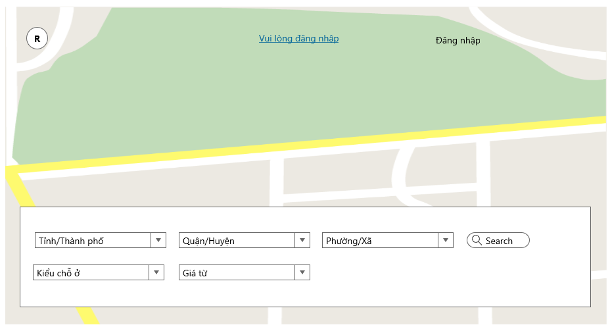

## **User story S.1: Login**

|  |
| --- |
| Login |
| If the user already have a Facebook account, just click the "Facebook" button to login  Or users can use their account during the registration process to system to login  Input username and password  Read username and password from database  Compare username and password  If correct  Show notification “Bạn đăng nhập thành công” and displayhome page  Else  Display notification username or password error |

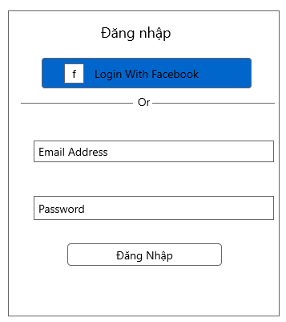

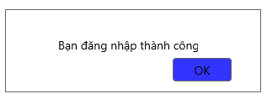

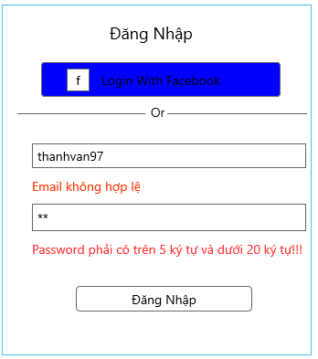

## **User story S.2: Register**

|  |  |
| --- | --- |
| Register |  |
| If the first time users use the system, they can register by clicking on the “Đăng kí” field of the system and registration frame will appear.  Enter "Họ tên, "Email", "Số điện thoại", "Mật khẩu", "Nhập lại mật khẩu"  Click button “Tạo tài khoản”  If correct  Show notification "Bạn đăng kí tài khoản thành công và Vui lòng đăng nhập" and the user will use that account to login the system and the home page will be displayed.  Else  Display notification one of the fields are experiencing errors | |

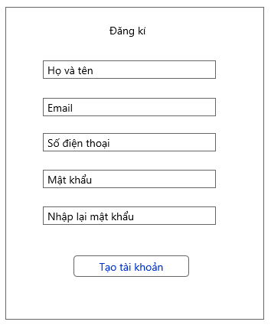

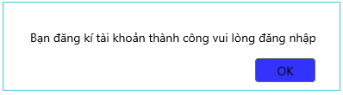

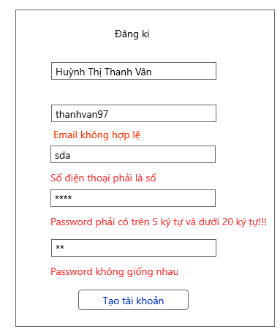

## **User story S.3: View Information**

|  |  |
| --- | --- |
| View Information |  |
| User click “Thông tin cá nhân” to view the information of them.  This button is on the menu of the website. It will show a page “Thông tin cá nhân”.  These functions let the user view information user in the system. | |

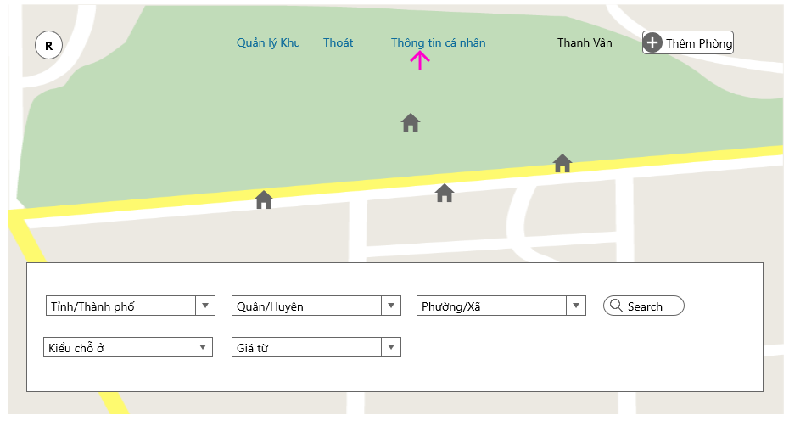

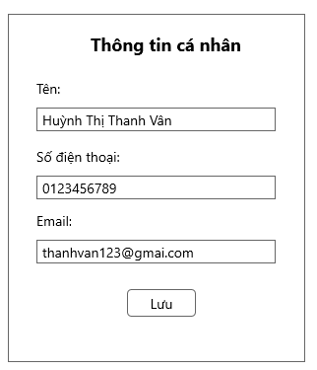

## **User story S.4: Update Information**

|  |  |
| --- | --- |
| Update Information |  |
| In the field "Thông tin cá nhân" users can update the account as they want to include: "Tên", "Số điện thoại", "Mật khẩu"  After the user has finished updating their information, click the "Lưu" button so the system can change their information. System will notification “Cập nhật thành công”. | |



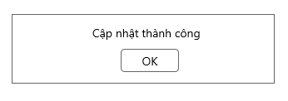

## **User story S.5: Searching information about accommodation**

|  |  |
| --- | --- |
| Searching information about accommodation |  |
| As Landlord, Renter  Select the category: province/city, county/district, wards/commune, type, price and select the "Search" button to show the location information user want to search. The accommodation will be displayed on the map at that location as well as the system will suggest some other nearby places | |

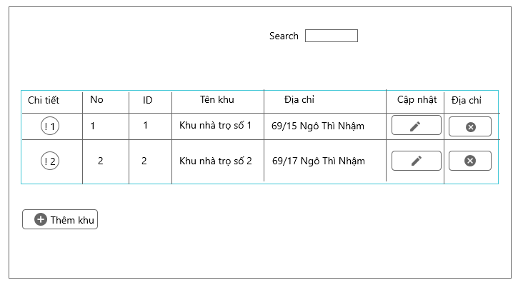

* 1. **User story S.6: Manage Zone**

|  |  |
| --- | --- |
| Manage Accommodation |  |
| As Landlord  When the user clicks on "Quản lý khu", the form will be displayed, including: “Chi tiết”, “Số thứ tự”, ”ID”, "Địa Chỉ". Then the Landlord could see the whole interface so that they could manage their zone as well as their accommodation in a convenient way. | |



## **User story S.7: Add Zone**

|  |  |
| --- | --- |
| Add Zone |  |
| If Landlord wants to add a new zone, click "Thêm Khu" button in form “Quản lý chỗ ở”. The form "Thêm Khu" will be displayed. User complete full fields: "Tên Khu", "Địa chỉ", "Tỉnh/Thành phố", "Quận/ Huyện", "Xã/ Phường". After when complete full information, the user click on the "Save" button, the screen will show full user entered information. | |

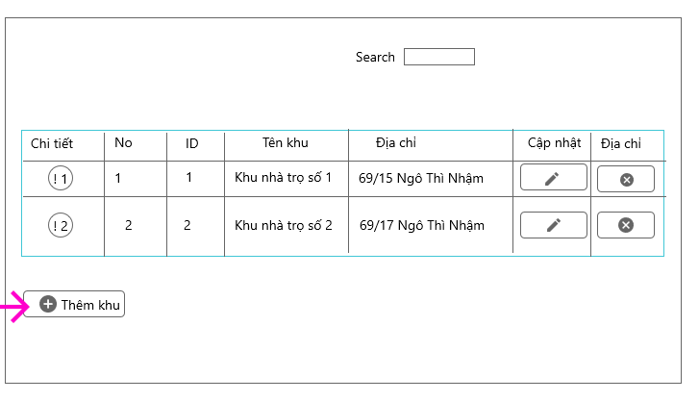

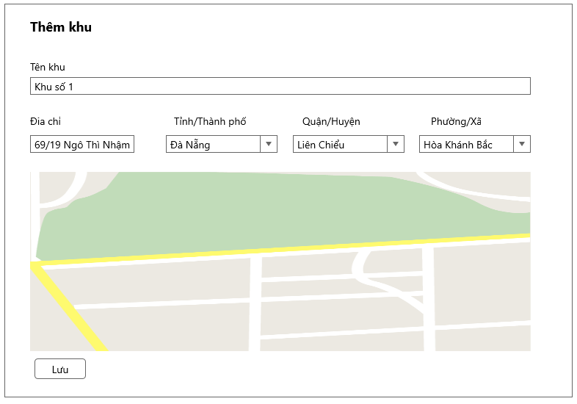

## **User story S.8: Update Zone**

|  |  |
| --- | --- |
| Update Zone |  |
| If Landlord want to add a new zone, click button "Cập nhật khu". Form "Thêm Khu" will be displayed. User complete full fields: "Khu", "Loại Phòng", "Số nhà và tên đường", "Thành phố", "Quận / Huyện", "Xã/ Phường", "Diện Tích". After when complete full information, User click on the node "Cập nhật" and Form report will show and message "Bạn đã cập nhật thành công". | |

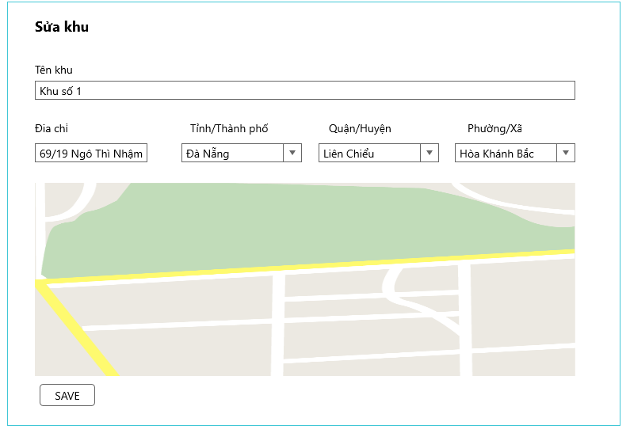

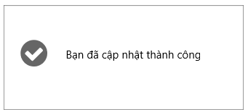

* 1. **User story S.9: Delete Zone**

|  |  |
| --- | --- |
| Delete Zone |  |
| If Landlord want to add a new zone, click button "Cập nhật khu". Form "Thêm Khu" will be displayed. User complete full fields: "Khu", "Loại Phòng", "Số nhà và tên đường", "Thành phố", "Quận / Huyện", "Xã/ Phường", "Diện Tích". After when complete full information, User click on the node "Cập nhật" and Form report will show and message "Bạn đã cập nhật thành công". | |

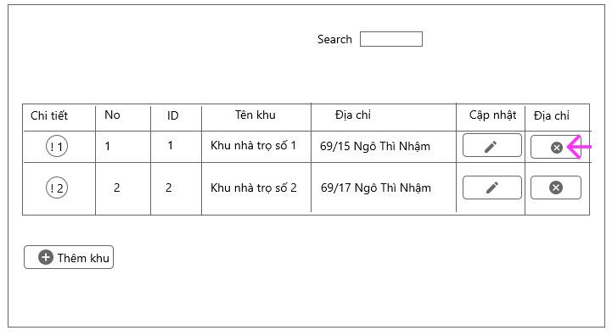

* 1. **User story S.10: Add room**

|  |  |
| --- | --- |
| Add Room |  |
| The Landlord's wish to add a room to a particular area, the user clicks the "Thêm phòng" button, then the "Thêm Phòng" form displays includes the fields "Tên phòng", "Mô tả", "Loại", "Tình trạng", "Vị trí", "Giá", “Hình ảnh". Users must fill out all fields.  If:  Users who do not fill out or fill out wrong the information will display the message error  else  Show notification and full information user entered. | |

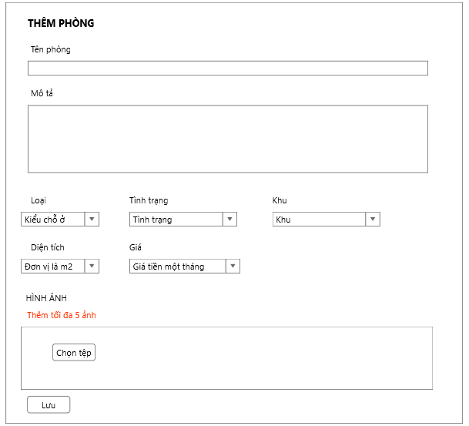

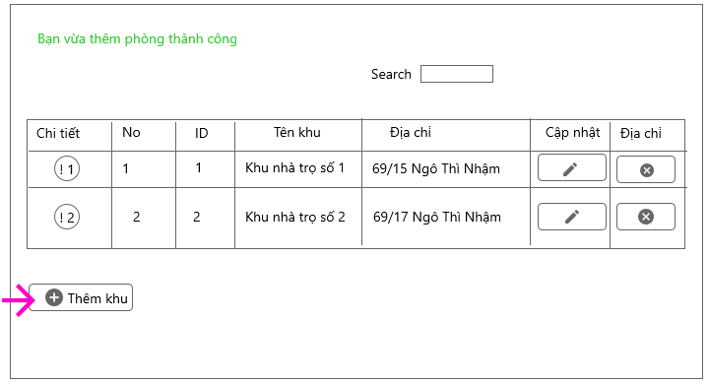

* 1. **User story S.11: Update Room**

|  |  |
| --- | --- |
| Update Room |  |
| The Landlord's wish to update a room to a particular zone, the user clicks the "Cập nhật" button, then the "Sửa phòng" form displays includes the fields "Tên phòng", "Mô tả", "Loại", "Tình trạng", "Vị trí", "Giá", “Hình ảnh". The users correct the information that they want to edit.  If:  Users who do not fill out or fill out wrong the information will display the message error  else  Show notification and full information user entered. | |

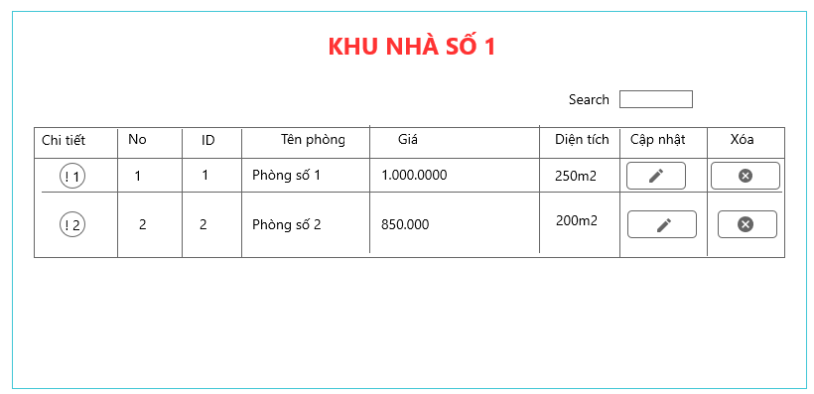

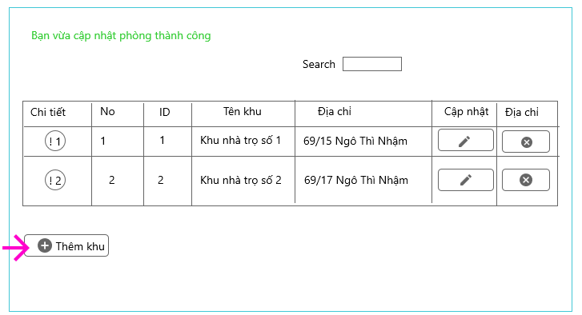

* 1. **User story S.12: Delete Room**

|  |  |
| --- | --- |
| Delete Room |  |
| The Landlord wants to delete a room when the room is no longer active, click on the "X" button, the message form will appear. It will ask the landlord, "Do you want to delete the room?"  If the Landlord wants to delete, click on "Yes" immediately the room will be deleted  else  The room remains the same | |

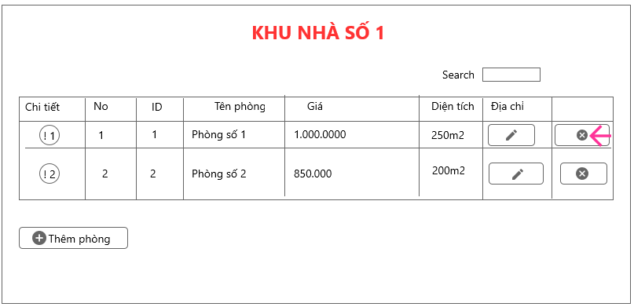

* 1. **User story S.13: View detail about accommodation**

|  |  |
| --- | --- |
| View detail about accommodation |  |
| As Landlord, Renter  Landlords want to see the details of their individual places by clicking the "Chi tiết" button, the "Chi tiết" form will appear, including the details of each accommodation along with pictures of it. | |

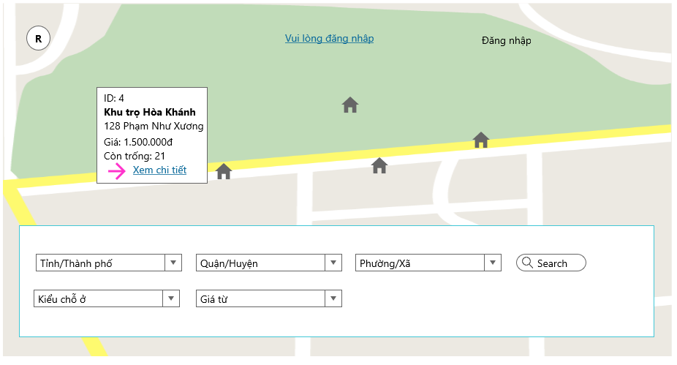

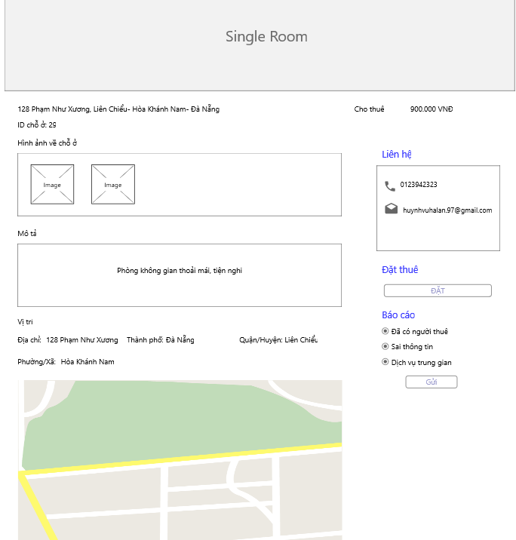

* 1. **User story S.14: Report for admin about accommodation**

|  |  |
| --- | --- |
| Report for admin about accommodation |  |
| As Renter  In the process the renter knows the person who posted the untrue with the post. The tenant will report by: Click on that post, in the post will have reported to the admin. The tenants only need to choose the case they want to report as: "Sai thông tin", "Đã có người thuê", ... and choose "Gửi" then the report will be sent to admin so they can review this article need to be taken down | |

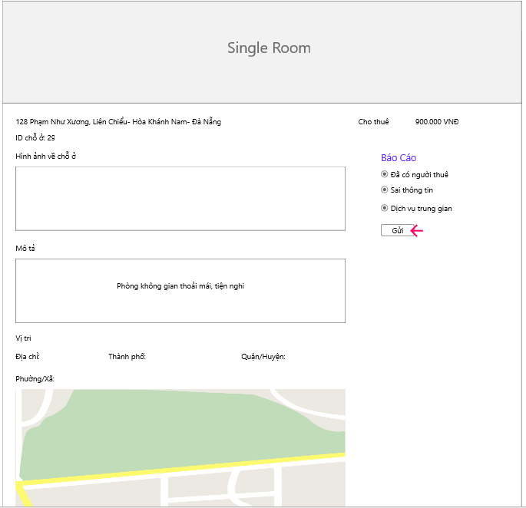

* 1. **User story S.15: Booking room**

|  |  |
| --- | --- |
| Booking room |  |
| As Renter  The renter wants to book the room by click "Đặt " button of field "Đặt phòng" in detail room. The request will be sent to the landlord and wait for the landlord to confirm the reservation. | |

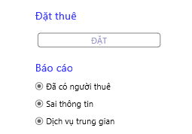

* 1. **User story S.16: Accept booking room**

|  |  |
| --- | --- |
| Accept booking room |  |
| As Landlord  Landlord receive notification book the room of renter. If the host agrees to rent the room, click on the "Đồng ý" button. The form will be displayed and the Landlord press the "confirm" button to rent the room. | |

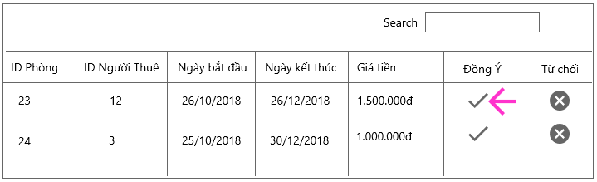

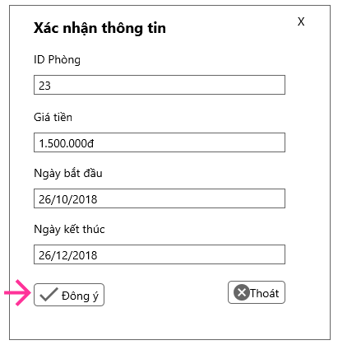

* 1. **User story S.17: Terminate the rental**

|  |  |
| --- | --- |
| Terminate the rental |  |
| As Landlord  The landlord wants to terminate the rental process earlier than the time limit in case of a problem with the tenant by clicking on the "Kết thúc sớm" button. Cancellation process will be made at the discretion of the owner | |

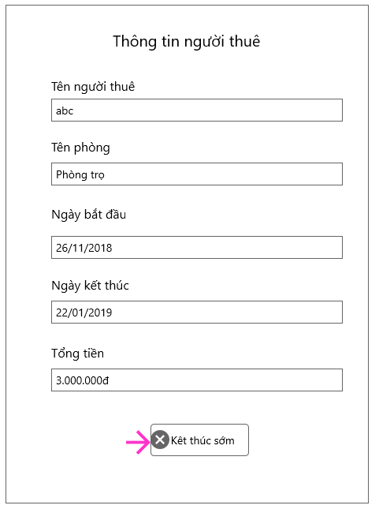

* 1. **User story S.18: History of booking**

|  |  |
| --- | --- |
| History of booking |  |
| As Landlord  The Landlord wants to see all history booking room of renter. After when renter set room, the system will save of history with fields "ID phòng", "ID người thuê", "Ngày bắt đầu", "Ngày kết thúc",' "Giá tiền một tháng", "Tổng tiền" for landlords to easy manage | |

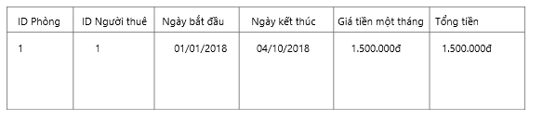

* 1. **User story S.19: Login for admin**

|  |  |
| --- | --- |
| Login for admin |  |
| Input username and password  Read username and password from database  Compare username and password  If correct  Display home page of admin  Else  Display notification username or password error | |

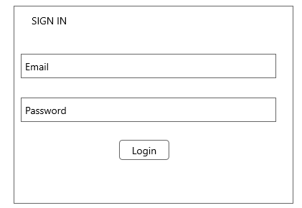

* 1. **User story 1.20: Home page of admin**

|  |  |
| --- | --- |
| Home page of admin |  |
| After login successful, home page of admin will display. And Admin can manage system. | |

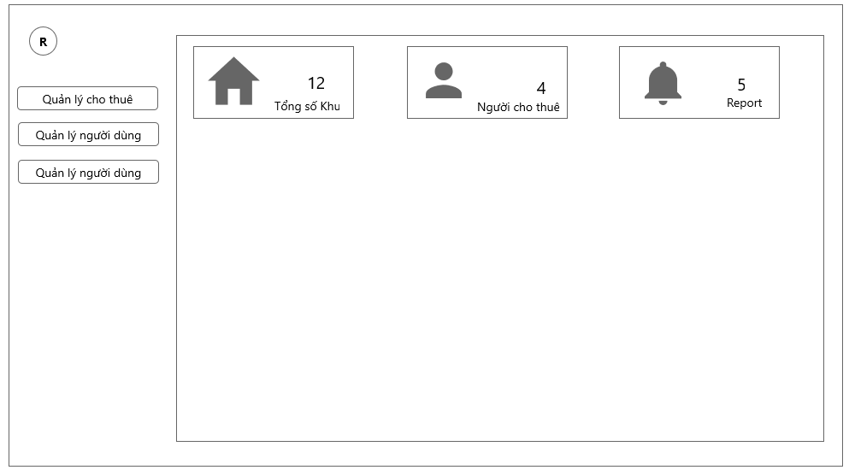

* 1. **User story 1.21: Create a new admin account**

|  |  |
| --- | --- |
| Create a new admin account |  |
| As an admin, after click on “Tạo tài khoản Admin”:   * Enter the informations in the form. * “Tên đăng nhập”: The user enters the name that they want to use in the system. That does not match the name that exists in the system, does not contain special characters and spaces. * “Mật khẩu”: user enter password for login. That password does not contain special characters, space, password can not be less than 6 characters * "Email" users enter their email. Email must conform to convention ten_e_mail@x_mail.com * "Số điện thoại:" the user enters a phone number whose phone number contains only the number, the telephone number must not exceed 15 characters. * Text boxes which have symbol “*” is not null. * Click on “Tạo” button to create a new admin account. * The screen display a message box to notice that account is saved in the system. * The user clicks on “OK” button. * Click on “Hủy” button to cancel and exit the form. | |

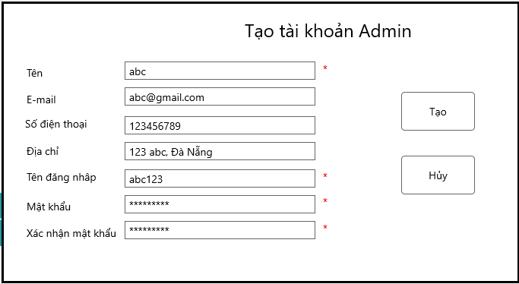

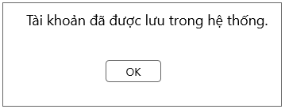

* 1. **User story 1.22: View list zone**

|  |  |
| --- | --- |
| View list zone |  |
| admin would like to see a list of all the zones that Landlord entered into the system by clicking "Quản lý khu" then select "Khu trọ". List of zones will be displayed so admin can be easily managed. | |

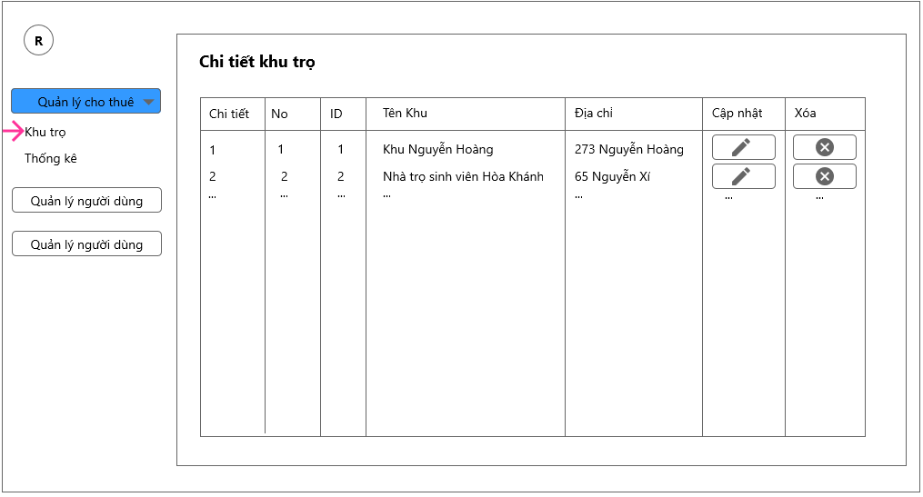

* 1. **User story S.23: Zone statistic**

|  |  |
| --- | --- |
| Zone statistic |  |
| The admin page will display a statistics chart room status of all zones including fields: "Đã thuê", "Còn trống". | |

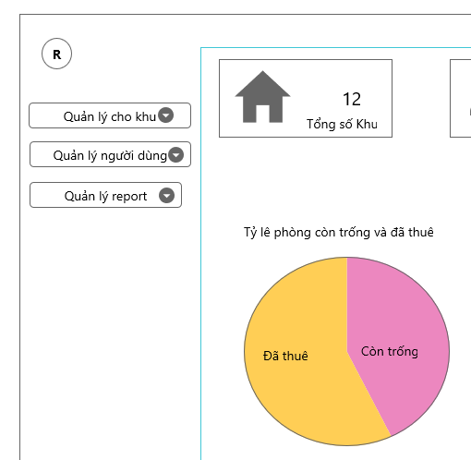

* 1. **User story S.24: View list users account**

|  |  |
| --- | --- |
| View list user account |  |
| Admin would like to see a list of all users account of the system by clicking "Quản lý người dùng" then select "Tài khoản ". List of zones will be displayed so admin can be easily managed. | |

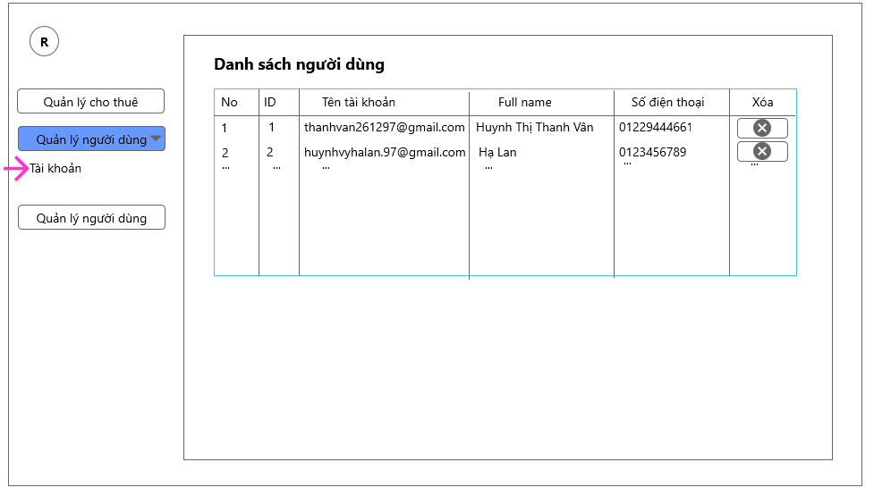

* 1. **User story 1.25: View report**

|  |  |
| --- | --- |
| View list zone |  |
| The admin would like to view a list of all tenants' reports about accommodation by clicking on "Manage Report" and selecting "Report List". List of reports to be displayed for administration can be  Consider whether the accommodation will be deleted if reported multiple times. | |

