

**CAPSTONE PROJECT 1**

**ROOMY**

**Product Backlog Document**

Version 1.0

Date: Sep 2nd, 2017

**MENTOR** **: MSc. Phan Van Son**

**PROJECT TEAM** : **Blue team**

**TEAM’S MEMBER** : Huynh Quoc Nhat

Ho Trung Anh

Le Hoang Quoc

Huynh Vo Nhat Lan

Huynh Thi Thanh Van

**INTERNATIONAL SCHOOL**

**Project Information**

|  |  |  |  |  |  |
| --- | --- | --- | --- | --- | --- |
| **Project acronym** | RMY | | | | |
| **Project Tittle** | Roomy | | | | |
| **Start Date** | Aug 17, 2018 | | **End Date** | | Dec 5, 2018 |
| **Lead Institution** | International School, Duy Tan University | | | | |
| **Project Mentor & contact details** | Msc. Son, Phan Van  Email: [sonpvs@duytan.edu.vn](mailto:sonpvs@duytan.edu.vn)  Tel: 01675373265 | | | | |
| **Scrum Master & contact details** | Huynh Vu Ha Lan  Email: [huynhvuhalan.97@gmail.com](mailto:huynhvuhalan.97@gmail.com)  Tel: 0989342173 | | | | |
| **Team members** | **Name** | **Email** | | **Tel** | |
| Le Hoang Quoc | [quocle28292@gmail.com](mailto:quocle28292@gmail.com) | | 01657708105 | |
| Huynh Quoc Nhat | [huynhquocnhat97@gmail.com](mailto:huynhquocnhat97@gmail.com) | | 0905740256 | |
| Ho Trung Anh | [hotrunganhht1912@gmail.com](mailto:hotrunganhht1912@gmail.com) | | 09055258534 | |
|  | Huynh Thi Thanh Van | [thanhvandb97@gmail.com](mailto:thanhvandb97@gmail.com) | | 01229444661 | |

**Product Backlog Document**

|  |  |  |  |
| --- | --- | --- | --- |
| **Document Title** | Product Backlog Document |  |  |
| **Reporting Period** | August, 2018 |  |  |
| **Author(s) &**  **project** | Huynh Thi Thanh Van,  Huynh Vu Ha Lan | |  |
| **Team Information** | **Name** | **Role** |  |
| Le Hoang Quoc | Member |  |
| Huynh Quoc Nhat | Member |  |
| Ho Trung Anh | Member |  |
|  | Huynh Thi Thanh Van | Product Owner |  |
| **Date** | Aug 29, 2018 | **Filename** | Productbacklog_Ver1.0.docx |
| **Access** | Project and CMU Program | |  |

|  |  |  |
| --- | --- | --- |
| Document History | | |
| **Version** | **Date** | **Comments** |
| V1.0 | Aug 29, 2019 | Draft for Document |
|  |  |  |

**Document Approvals**

The following signatures are required for approval of this document.

|  |  |  |
| --- | --- | --- |
| MSc. Vo Van Son  *Mentor* |  | Date: |
| Huynh Vu Ha Lan  *Scrum Master* |  | Date: |

Table of Contents

1. Introduction 6

1.1. Purpose 6

1.2. Scope 6

1.3. References 6

2. Product Backlog 7

2.1. Product Backlog Specification 7

3. Breakdown into Sprint Backlog: 10

4. Constraint 12

5. Stack holders and User Descriptions Summary 13

1. **Introduction**

The agile product backlog in Scrum is a prioritized features list, containing short descriptions of all functionality desired in the product. When applying Scrum, it’s not necessary to start a project with a lengthy, upfront effort to document all requirements. Typically, a Scrum team and its product owner begin by writing down everything they can think of for agile backlog prioritization. This agile product backlog is almost always more than enough for a first sprint. The Scrum product backlog is then allowed to grow and change as more is learned about the product and its clients.

* 1. **Purpose**
* Provide a prioritized features list, containing short description of all functionality desired in the product.
* Lists everything that the product owner and Scrum team feels should be included in the software they are developing.
  1. **Scope**
* Lists the user’s role.
* Write all the user’s requirements.
* Lists some main function of website.
* Short description of all the functionality desired in the product.
* Given the priority of each feature and function of the product.
  1. **References**

***Table 1: References***

|  |  |  |
| --- | --- | --- |
| **No** | **Reference** | **Note** |
| 1 | <http://agilebench.com/blog/the-product-backlog-for-agile-teams> | How to create product backlog |
| 2 | <http://www.mountaingoatsoftware.com/agile/scrum/product-backlog/example/> | Product Backlog Example |

1. **Product Backlog**
   1. **Product Backlog Specification:**

**Priority and Estimates**

Priorities are set from 1 to 4.

◦ The maximum priorities are 1

◦ The minimum prioritiies are 4

◦ Priorities of some user stories can be the same with others

◦ If a user story has dependencies, it must have lower priority than its dependencies

[**Work breakdown structure**](https://en.wikipedia.org/wiki/Work_breakdown_structure)

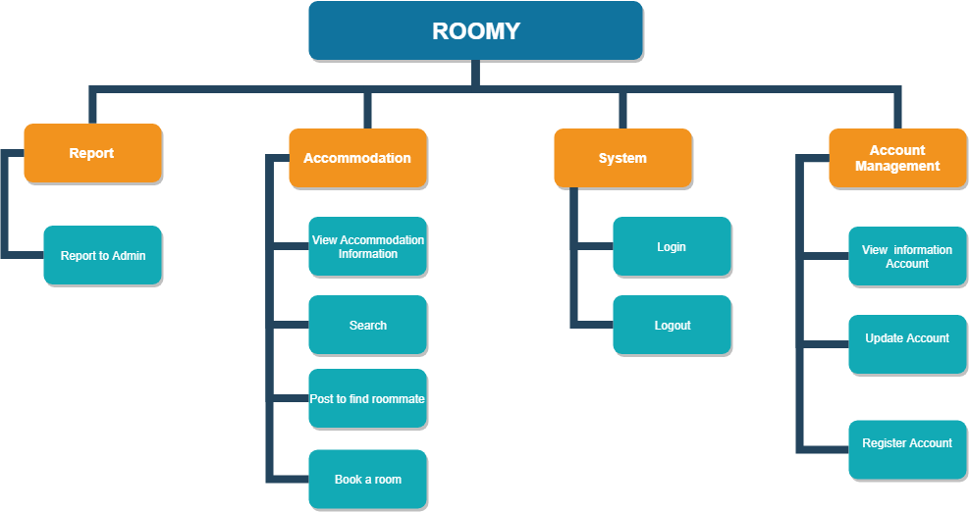

*Figure 1. Renter Diagram*

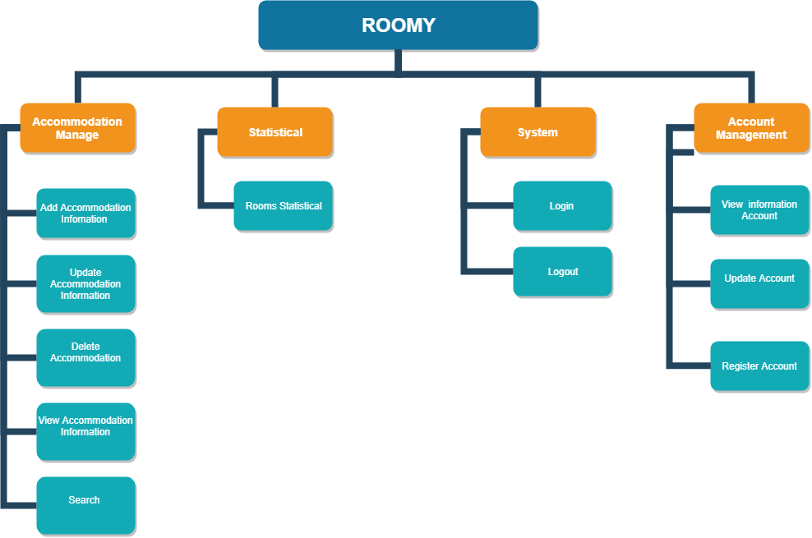

*Figure 2. Landlord Diagram*

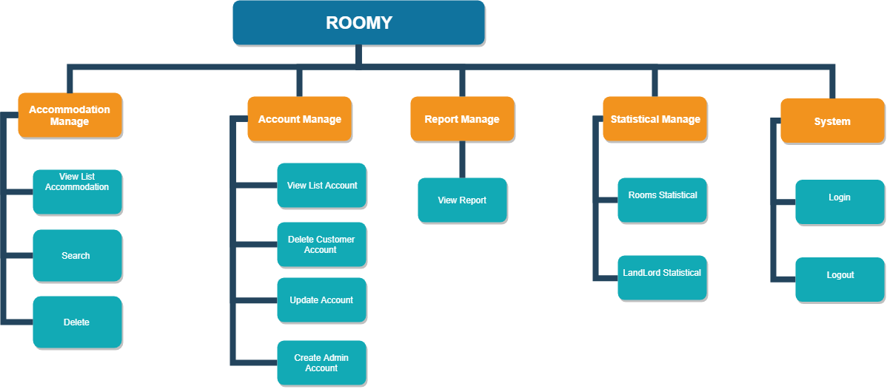

*Figure 2. Admin Diagram*

***Table 1: Product Backlog Specification (Renter)***

|  |  |  |  |  |  |
| --- | --- | --- | --- | --- | --- |
| **ID** | **Theme** | **As a/an** | **I want to** | **So that** | **Priority** |
| **Report** | | | | | |
| PB01 | Sent report to Admin | Renter | Sent report to Admin about accommodation | I can report to the Admin about the quality of accommodation | 1 |
| **Accommodation** | | | | | |
| PB03 | View accommodation | Renter | View about information and location of accommodation | I can see all information about accommodation: address, image ... and its location | 1 |
| PB04 | Search | Renter | Search about accommodation | I can search about information accommodation | 2 |
| PB06 | Post to find Roomate | Renter | Post to find roommate | I can post to find a roommate suitable for me | 4 |
| PB07 | Book a accommodation | Renter | Booking an accommodation | I want to book an accommodation before I come to view that accommodation. |  |
| **System** | | | | | |
| PB05 | Login. | Renter | Access to the system | I can use the system | 3 |
| PB05 | Logout. | Renter | Log out my account from system | I can stop using system and I can log in later | 3 |
| **Account** | | | | | |
| PB07 | Update Account | Renter | Edit account information of myself or password | I can edit any account information such as username, name, address, phone number… or password | 3 |
| PB08 | Register. | Renter | Register account | I can register account to access system | 3 |
| PB09 | View information account | Renter | View detail account information of myself. | I can know information of me such as username, password, name, address, phone number… | 1 |

***Table 2: Product Backlog Specification (Landlord)***

|  |  |  |  |  |  |  |
| --- | --- | --- | --- | --- | --- | --- |
| **ID** | **Theme** | **As a/an** | **I want to** | **So that** | **Priority** | |
| **Statistic** | | | | | | |
| PB01 | Statistics on rooms | Landlord | Statistic on each room | I can list to have the statistics of rooms by item (rooms are being rented, room available, room near expire). | 1 | |
| **Report** | | | | | | |
| PB02 | Sent report for Admin about accommodation | Landlord | Report about accommodation when posting has troubles. | I want to report for admin when the posting has troubles. | 4 | |
| **Accommodation** | | | | | | |
| PB04 | Add room | Landlord | Add room for zone | I want to add the rooms for my each zone in the system if I need to. | 3 | |
| PB05 | Delete room | Landlord | Delete room for zone | I want to delete rooms of my each zone in the system when it not longer active | 3 | |
| PB06 | Update room | Landlord | Update room for zone | I want to update room for my each zone in the system |  | |
| PB07 | Add zone | Landlord | Add zone | I want to add zone in the system if I need to. |  | |
| PB08 | Update zone | Landlord | Update zone | I want to update zone in the system |  | |
| PB09 | Delete zone | Landlord | Delete zone | I want to delete zone in the system when it not longer active |  | |
| PB07 | Search | Landlord | Search information about accommodation | I want to see accommodations information by searching based on location, area and price of them. | 3 | |
| PB08 | View Accommodation Information | Landlord | View about information and location of accommodation | I can see all information about accommodation: address, image ... and its location | 2 | |
| **System** | | | | | | |
| PB08 | Login | Landlord | Access to the system | I can use the system | 3 | |
| PB09 | Logout | Landlord | Log out my account from system | I can stop using system and I can log in later | 3 | |
| **Account** | | | | | | |
| PB10 | Register | Landlord | Register account | I can register account to access system | | 3 | |
| PB11 | View information | Landlord | View detail account information of myself. | I can know information of me such as username, password, name, address, phone number… | | 1 | |
| PB12 | Update Account | Landlord | Edit account information of myself or password | I can edit any account information such as username, name, address, phone number… or password | | 3 | |

***Table 3: Product Backlog Specification (Admin)***

|  |  |  |  |  |  |
| --- | --- | --- | --- | --- | --- |
| **ID** | **Theme** | **As a/an** | **I want to** | **So that** | **Priority** |
| **View** | | | | | |
| PB01 | View list accommodation | Admin | View list about accommodation of Landlord | I can see the list of accommodation by the user | 2 |
| PB02 | View customer report | Admin | View user reports about accommodation as well as system | I want to see all reports on the accommodation as well as the system based on the user response | 4 |
| **Accommodation** | | | | | |
| PB03 | Search accommodation | Admin | Searching list of accommodation in the system by ID | I want to search an accommodation base on ID. | 2 |
| PB05 | Deletele accommodation | Admin | Delete accommodation | When there is an accommodation had a lot of reports, I want to delete that accommodation from the system | 2 |
| **System** | | | | | |
| PB06 | Login | Admin | Access to the system | I can use my username/password to login into the system, I can use the function of the system. | 3 |
| PB07 | Logout | Admin | Log out my account from system | I can stop using system and I can log in later | 3 |
| PB08 | Create account | Admin | Create account for new admin | I can create account for new admin to manage the system with me | 3 |
| Admin | | | | | |
| PB09 | Delete User account | Admin | Delete the user's account | I can delete the user’s account when users have not used for a long time | 3 |
| PB10 | Update account | Admin | Update account password and information | I can update the password and information for my account | 3 |
| PB11 | View list account | Admin | View list user account | I want to see the all list of user accounts | 3 |
| **Statistic** | | | | | |
| PB12 | Statistic about Landlord account | Admin | Listing to have statistics of Landlords account | I want to list to have statistics of all landlords accounts in the system | 1 |
| PB13 | Statistic about accommodation | Admin | Listing to have statistics of  accommodations | I want to list to have statistics of all accommodations in the system and total of room . | 1 |

1. **Breakdown into Sprint Backlog:**

***Table 4: Breakdown into Sprint Backlog***

|  |  |  |  |
| --- | --- | --- | --- |
| **Sprint** | **Function** | **Started Date** | **Due Date** |
|  | Sprint Planning Meeting | Sep 6, 18 | Sep 6, 18 |
| Daily Meeting | Sep 6, 18 | Oct 3, 18 |
| Create Sprint Backlog | Sep 7, 18 | Sep 7, 18 |
| Create Test Plan document for Sprint 1 | Sep 8, 18 | Sep 8, 18 |
| Create Database document | Sep 8, 18 | Sep 12, 18 |
| Review Database document | Sep 12, 18 | Sep 12,18 |
| **Design user interface** |  |  |
| Design user interface of Home page | Sep 13, 18 | Sep 13, 18 |
| Design user interface of Register Account | Sep 14, 18 | Sep 14, 18 |
| Design user interface of Login | Sep 14, 18 | Sep 14, 18 |
| Design user interface of View Accommodation Information | Sep 15, 18 | Sep 15, 18 |
| Design user interface of Booking Accommodation | Sep 15, 18 | Sep 15, 18 |
| **Test Design Interface** | **Sep 16, 18** | **Sep 17, 18** |
| Test Design user interface of Home page | Sep 16, 18 | Sep 16, 18 |
| Test Design user interface of Register Account | Sep 16, 18 | Sep 16, 18 |
| Test Design user interface of Login | Sep 17, 18 | Sep 17, 18 |
| Test Design user interface of View Accommodation | Sep 17, 18 | Sep 17, 18 |
| Test Design user interface of Booking Accommodation | Sep 17, 18 | Sep 17, 18 |
| **Coding** |  |  |
| Code front-end for Home page | Sep 17, 18 | Sep 17, 18 |
| Code back-end for Home page | Sep 17, 18 | Sep 18, 18 |
| Code front-end for Register Account | Sep 17, 18 | Sep 17, 18 |
| Code back-end for Register Account | Sep 17, 18 | Sep 17, 18 |
| Code front-end for Login | Sep 18, 18 | Sep 18, 18 |
| Code back-end for Login | Sep 19, 18 | Sep 20, 18 |
| Code front-end View Accommodation | Sep 19, 18 | Oct 20, 18 |
| Code Back-end for View Accommodation | Sep 20, 18 | Sep 22, 18 |
| Code front-end Booking Accommodation | Sep 20, 18 | Sep 21, 18 |
| Code back-end Booking Accommodation | Sep 21, 18 | Sep 22, 18 |
| **Testing** |  |  |
| Design Test Case for Homepage | Sep 23, 18 | Sep 23, 18 |
| Design Test Case for Register | Sep 23, 18 | Sep 23, 18 |
| Design Test Case for Login | Sep 23, 18 | Sep 23, 18 |
| Design Test Case for View Accommodation | Sep 23, 18 | Sep 23, 18 |
| Design Test Case for Booking Accommodation | Sep 22, 18 | Sep 23, 18 |
| **Fix Bug & Release** |  |  |
| Implement Test Case | Sep 24, 18 | Sep 27, 18 |
| Fix bugs and Report | Sep 27, 18 | Sep 30, 18 |
| Retest | Oct 1, 18 | Oct 2, 18 |
| Closing | Oct 3, 18 | Oct 3, 18 |
| Sprint 2 | **Design user interface** |  |  |
| Design user interface of Post to find Rommate (Renter) | Oct 6, 18 | Oct 6, 18 |
| Design user interface of Search accommodation information( Renter) | Oct 6, 18 | Oct 6, 18 |
| Design user interface of Add accommodation information(Landlord) | Oct 6, 18 | Oct 7, 18 |
| Design user interface of Update accommodation information(Landlord) | Oct 6, 18 | Oct 7, 18 |
| Design user interface of Delete accommodation information (Landlord) | Oct 6, 18 | Oct 7, 18 |
| Design user interface of Search accommodation information (Landlord) | Oct 7, 18 | Oct 8, 18 |
| Design user interface of View accommodation information (Landlord) | Oct 7, 18 | Oct 8, 18 |
| Design user interface of Update Account | Oct 8, 18 | Oct 8, 18 |
| Design user interface of View Account Information | Oct 8, 18 | Oct 8, 18 |
| Design user interface of Statistics on rooms | Oct 8, 18 | Oct 8, 18 |
| **Coding** |  |  |
| Code front-end of Post to find Rommate(Renter) | Oct 9, 18 | Oct 9, 18 |
| Code back-end of Post to find Rommate(Renter) | Oct 10, 18 | Oct 12, 18 |
| Code front-end of Search accommodation information( Renter) | Oct 9, 18 | Oct 9, 18 |
| Code back-end of Search accommodation information( Renter) | Oct 10, 18 | Oct 12, 18 |
| Code front-end Add accommodation information(Landlord) | Oct 10, 18 | Oct 11, 18 |
| Code back-end of Add accommodation information(Landlord) | Oct 12, 18 | Oct 13, 18 |
| Code front-end of Update accommodation information(Landlord) | Oct 12, 18 | Oct 12, 18 |
| Code back-end of Update accommodation information(Landlord) | Oct 14, 18 | Oct 16, 18 |
| Code front-end of Delete accommodation information(Landlord) | Oct 13, 18 | Oct 13, 18 |
| Code back-end of Delete accommodation information(Landlord) | Oct 14, 18 | Oct 14, 18 |
| Code front-end of View accommodation information(Landlord) | Oct 14, 18 | Oct 14, 18 |
| Code back-end of View accommodation information(Landlord) | Oct 15, 18 | Oct 17, 18 |
| Code front-end of Search accommodation information (Landlord) | Oct 15, 18 | Oct 16, 18 |
| Code back-end of Search accommodation information (Landlord) | Oct 17, 18 | Oct 19, 18 |
| Code front-end of View Account Information | Oct 17, 18 | Oct 17, 18 |
| Code back-end View Account Information | Oct 18, 18 | Oct 18, 18 |
| Code front-end of Update Account | Oct 18, 18 | Oct 18, 18 |
| Code back-end of Update Account | Oct 1, 18 | Oct 19, 18 |
| Code front-end of Statistics on rooms | Oct 16, 18 | Oct 17, 18 |
| Code back- end of Statistics on rooms | Oct 20, 18 | Oct 20, 18 |
| **Testing** |  |  |
| Design Test Case for Post to find Rommate (Renter) | Oct 21, 18 | Oct 21, 18 |
| Design Test Case for Search Accommodation (Renter) | Oct 21, 18 | Oct 21 , 18 |
| Design Test Case for Add the accommodation (Landlord) | Oct 21, 18 | Oct 21, 18 |
| Design Test Case for Update the accommodation (Landlord) | Oct 21, 18 | Oct 21, 18 |
| Design Test Case for Delete the accommodation (Landlord) | Oct 21, 18 | Oct 21, 18 |
| Design Test Case for View accommodation (Landlord) | Oct 22, 18 | Oct 22, 18 |
| Design Test Case for Search the accommodation (Landlord) | Oct 22, 18 | Oct 22, 18 |
| Design Test Case for Update Account Information | Oct 22, 18 | Oct 22, 18 |
| Design Test Case for View Account Information | Oct 22, 18 | Oct 22, 18 |
| Design Test Case for Statistics on rooms | Oct 22, 18 | Oct 22, 18 |
| **Fix Bug and Release** |  |  |
| Implement Test Case | Oct 23, 18 | Oct 25, 18 |
| Fix bugs and Report | Oct 26, 18 | Oct 29, 18 |
| Retest | Oct 29, 18 | Oct 30, 18 |
|  | Closing | Oct 31,18 | Oct 31, 18 |
| Sprint 3 | **Design user interface** |  |  |
| Design user interface of Statistic about accommodation | Nov 4, 18 | Nov 4, 18 |
| Design user interface of Statistic about Landlord Account | Nov 4, 18 | Nov 4, 18 |
| Design user interface of View List Accommodation | Nov 4, 18 | Nov 4, 18 |
| Design user interface of Search accommodation(Admin) | Nov 4, 18 | Nov 4, 18 |
| Design user interface of Delete Accommodation | Nov 5, 18 | Nov 5, 18 |
| Design user interface of Login (Admin) | Nov 5, 18 | Nov 5, 18 |
| Design user interface of Create Account (Admin) | Nov 5, 18 | Nov 5, 18 |
| Design User Interface of Delete User Account | Nov 5, 18 | Nov 5, 18 |
| Design user interface of View List User Account | Nov 5, 18 | Nov 5, 18 |
| Design User Interface of Update Account (Admin) | Nov 5, 18 | Nov 5, 18 |
| Design User interface of Report (Renter, Landlord) | Nov 6, 18 | Nov 6, 18 |
| Design User Interface of View list Report (Admin) | Nov 6, 18 | Nov 6, 18 |
| **Coding** |  |  |
| Code front-end Statistic about accommodation | Nov 5, 18 | Nov 5, 18 |
| Code back-end of Statistic about accommodation | Nov 6, 18 | Nov 8, 18 |
| Code front-end of Statistic about Landlord Account | Nov 5, 18 | Nov 5, 18 |
| Code back-end of Statistic about Landlord Account | Nov 6, 18 | Nov 8, 18 |
| Code front-end of View List Accommodation | Nov 6, 18 | Nov 6, 18 |
| Code back-end of View List Accommodation | Nov 6, 18 | Nov 7, 18 |
| Code front-end of Search accommodation(Admin) | Nov 7, 18 | Nov 9, 18 |
| Code back-end of Search accommodation(Admin) | Nov 8, 18 | Nov 9, 18 |
| Code front-end of Delete Accommodation | Nov 6, 18 | Nov 6, 18 |
| Code back-end of Delete Accommodation | Nov 8, 18 | Nov 8, 18 |
| Code front-end of Create Account (Admin) | Nov 9, 18 | Nov 9, 18 |
| Code back-end of Create Account (Admin) | Nov 10, 18 | Nov 10, 18 |
| Code front-end of Delete Account (Admin) | Nov 7, 18 | Nov 7, 18 |
| Code back-end of Delete Account (Admin) | Nov 7, 18 | Nov 8, 18 |
| Code front-end of Login (Admin) | Nov 11, 18 | Nov 11, 18 |
| Code Back-end of Login (Admin) | Nov 11, 18 | Nov 12, 18 |
| Code back-end View List User Account (Admin) | Nov 11, 18 | Nov 11, 18 |
| Code Back-end of Code back-end View List User Account (Admin) | Nov 12, 18 | Nov 12, 18 |
| Code front-end of Report (Renter, landlord) | Nov 11, 18 | Nov 11, 18 |
| Code back-end of Report (Renter,Landlord) | Nov 12, 18 | Nov 13, 18 |
| Code front-end of View List Report(Admin) | Nov 13, 18 | Nov 13, 18 |
| Code back-end of View List Report (Admin) | Nov 14, 18 | Nov 15, 18 |
| Code back-end of Log out | Nov 15, 18 | Nov 15, 18 |
| **Testing & Fix Bug** |  |  |
| Design Test Case for Statistic about accommodation | Nov 16, 18 | Nov 16, 18 |
| Design Test Case for Statistic about Landlord Account | Nov 16, 18 | Nov 16, 18 |
| Design Test Case for View List Accommodation | Nov 16, 18 | Nov 16, 18 |
| Design Test Case for Search accommodation(Admin) | Nov 16, 18 | Nov 16, 18 |
| Design Test Case for Delete Accommodation | Nov 17, 18 | Nov 17, 18 |
| Design Test Case for Create Account (Admin) | Nov 17, 18 | Nov 17, 18 |
| Design Test Case for Delete Account (Admin) | Nov 17, 18 | Nov 17, 18 |
| Design Test Case for Login (Admin) | Nov 17, 18 | Nov 17, 18 |
| Design Test Case for View List User Account (Admin) | Nov 18, 18 | Nov 18, 18 |
| Design Test Case for of Report (Renter, landlord) | Nov 18, 18 | Nov 18, 18 |
| Design Test Case for View List Report(Admin) | Nov 18, 18 | Nov 18, 18 |
| Design Test Case for Log out | Nov 18, 18 | Nov 18, 18 |
| Implement Test Case | Nov 19, 18 | Nov 20, 18 |
| Fix bugs and Report | Nov 21, 18 | Nov 26, 18 |
| Retest | Nov 26, 18 | Nov 28, 17 |
| **Release Sprint 3** |  |  |
| Sprint 3 Review Meeting | Nov 28, 18 | Nov 28, 18 |
| Sprint 3 Retrospective | Nov 29, 18 | Nov 29, 18 |

1. **Constraint**

**Table 5: Constraint**

|  |  |
| --- | --- |
| **Constraint** | **Condition** |
| **Time** | Project completion time limit in 3 months so time to complete project be restricted |
| **People constraint** | 4 people working together to finish the project |
| **Requirements** | According to Product owner’s Requirements |

1. **Stack holders and User Descriptions Summary**

***Table 6: Stakeholders and User Descriptions Summary***

|  |  |  |
| --- | --- | --- |
| **Name** | **Description** | **Role** |
| **Product Owner** | The Person who give the Requirement | Provide information to develop the website. Make the decision to accept and implement the project, do the unit test |
| **Scrum Master** | This is the stakeholder who leading, manage the website development Team | Controlling, managing, monitoring, make sure the project complete on time, within budget, according to plan and according to requirements |
| **Requirement Analyzer** | This is a stakeholder that works with the Analysts to correctly translate requests or needs into requirements to be used for design | Specifies the details of one or more a parts of the website’s functionality by describing one or the aspects of the requirements,  This will include functional and non-functional |
| **Software Architect** | This is a stakeholder that is primary for leading the website development | Responsible for the software architecture, which includes the key technical decisions that constrain the overall design for the project |
| **Coder** | This is a stakeholder that programs the software | Implement the project |